SUPPLEMENTS: Polygenic risk for depression is associated with neural stress responses and sex-specific stress adaptation

Marina Giglberger, PhD^{1┿}, Gina-Isabelle Henze, PhD^{2,3┿}, Christoph Bärtl, PhD^{2,3}, Hannah L. Peter, PhD¹, Julian Konzok, PhD¹, Sandra Zänkert, PhD⁴, Peter Kirsch, PhD^{5,6}, Josef Frank, Dipl.-psych.⁷, Brigitte M. Kudielka, PhD¹, Henrik Walter, MD, PhD^{2,3}, Fabian Streit^{5,8,9}, Stefan Wüst, PhD^{1*}

¹ Institute of Psychology, University of Regensburg, Regensburg, Germany
² Department of Psychiatry and Neurosciences CCM, Charité - Universitätsmedizin Berlin, Corporate Member of Freie Universität Berlin and Humboldt-Universität zu Berlin, Berlin, Germany
³ German Center for Mental Health (DZPG), Partner Site Berlin - Potsdam, Berlin, Germany
⁴ ZB MED – Information Center for Life Sciences, Cologne, Germany
⁵ German Center for Mental Health (DZPG), Partner Site Mannheim - Heidelberg - Ulm, Mannheim, Germany
⁶ Department of Clinical Psychology, Central Institute of Mental Health, Medical Faculty Mannheim, University of Heidelberg, Heidelberg, Germany
⁷ Department of Genetic Epidemiology in Psychiatry, Central Institute of Mental Health, Medical Faculty Mannheim, Heidelberg University, Mannheim, Germany
⁸ Department of Psychiatry and Psychotherapy, Central Institute of Mental Health, Medical Faculty Mannheim, Heidelberg University, Mannheim, Germany
⁹ Hector Institute for Artificial Intelligence in Psychiatry, Central Institute of Mental Health, Medical Faculty Mannheim, Heidelberg University, Mannheim, Germany

Running title: Genetic depression risk and neural stress response

┿ Both authors contributed equally to this paper

*Correspondence concerning this article should be addressed to:
Stefan Wüst, Institute of Psychology, Universitätsstraße 31, 93053 Regensburg, Germany
E-Mail: Stefan.wuest@ur.de
Phone: +49 941 943 5646 | Fax: +49 941 943 5641

Distributions of parameters

Distribution of polygenic score for depression
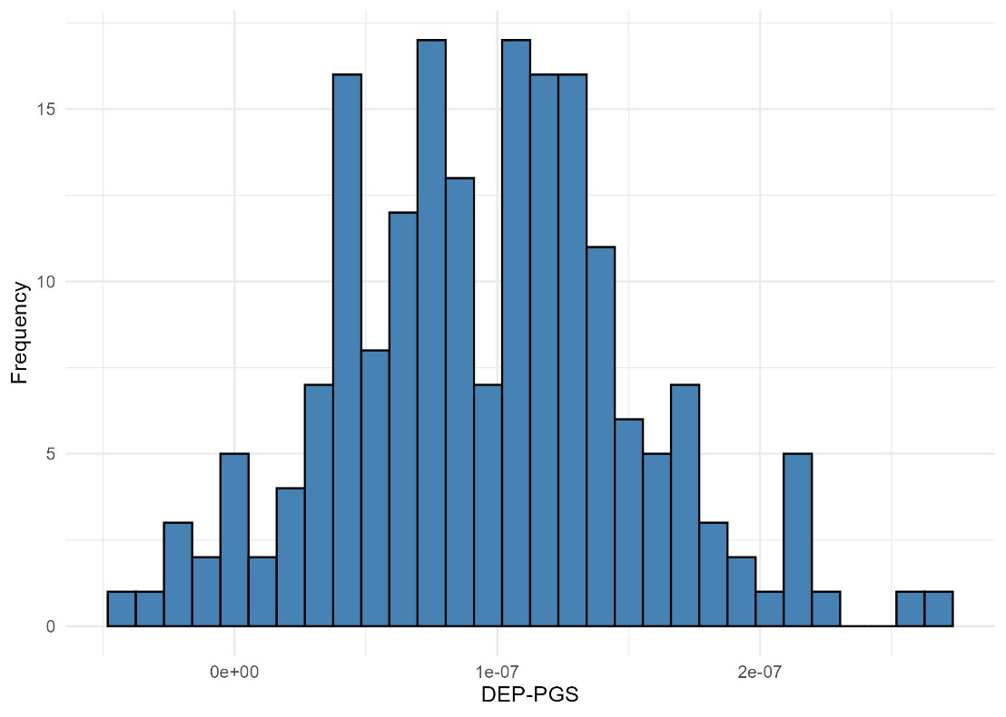
Figure S1. Histogram of the polygenic score for depression.

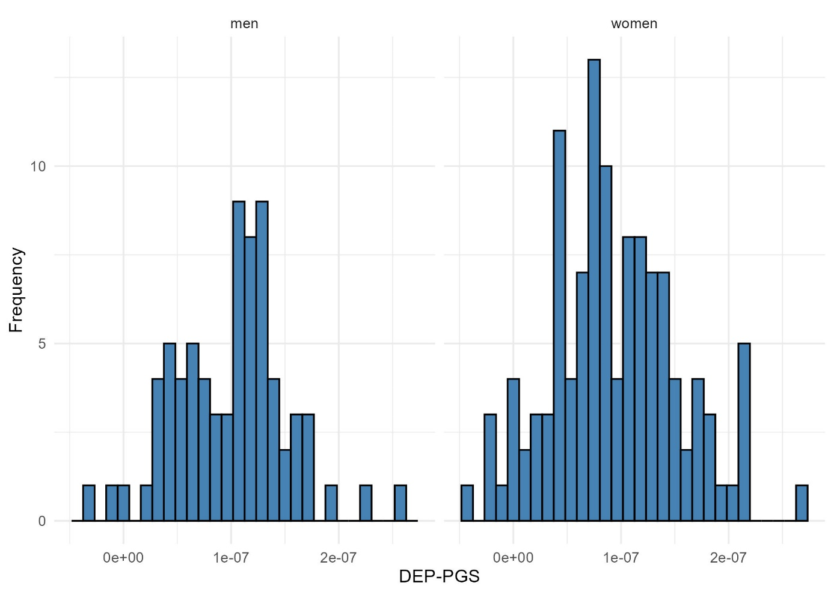
Figure S2. Histogram of the polygenic score for depression divided by sex.

Distribution of depression scores
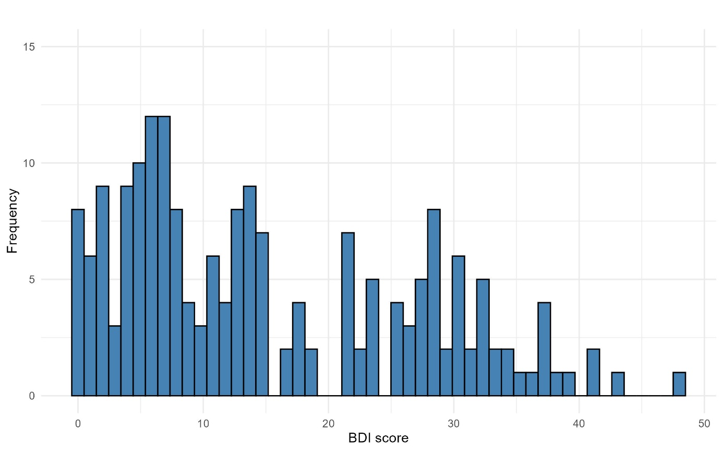
Figure S3. Histogram of depression score (Beck Depression Inventory; BDI).

Associations of polygenic scores for depression and depression scores with neural responses

Associations of polygenic scores for depression and neural stress responses
Brain structure |  |  |  | Voxel coordinates
 |  | k | z |  | X | Y | Z
Ncl caudatus/ Ncl. accumbens | right | 11 | -4.34 |  | 42 | 76 | 37
Table S1. Structures showing (de)activation during ScanSTRESS for the totals sample with polygenic score for depression as covariate including cluster size, individual z-values and localization of peak voxels. False-discovery rate (FDR, p < .05) correction at z_{FDR} > 3.70.
Note. k = cluster size
Brain structure |  |  |  | Voxel coordinates
 |  | k | z | X | Y | Z
Precuneus | right | 25 | 4.62 | 44 | 40 | 57
Table S2. Structures showing sex-dependent (men > women) activation during ScanSTRESS with polygenic score for depression as covariate including cluster size, individual z-values and localization of peak voxels. False-discovery rate (FDR, p < .05) correction at z_{FDR} > 4.26.
Note. k = cluster size

Associations of depression scores and neural stress responses
Table S3. Structures showing (de)activation during ScanSTRESS for the totals sample with depression score (BDI-II) as covariate including cluster size, individual z-values and localization of peak voxels. False-discovery rate (FDR, p < .05) correction at z_{FDR} > 3.89.
Brain structure |  |  |  | Voxel coordinates
 |  | k | z | X | Y | Z
Supramarginal gyrus | right | 27 | 4.94 | 21 | 43 | 60
Thalamus | right | 17 | 4.41 | 40 | 53 | 43
Postcentral gyrus | right | 17 | 4.82 | 21 | 56 | 55
Ncl. caudatus | right | 10 | 4.60 | 58 | 62 | 52
Postcentral gyrus | right | 10 | 4.68 | 74 | 58 | 56
Note. k = cluster size

Polygenic score for depression and time-exposure effect
Table S4. Exposure-time effect results (run 1 > run 2): Structures showing more activations (stress > control) in the first run compared to the second run of ScanSTRESS for the totals sample with polygenic score for depression as covariate including cluster size, individual z-values and localization of peak voxels. False-discovery rate (FDR, p < .05) correction at z_{FDR} > 2.36.
Brain structure |  |  |  | Voxel coordinates
 |  | k | z | X | Y | Z
Insula | right | 64 | 3.21 | 31 | 59 | 42
Paracingulate cortex | right | 62 | 3.56 | 45 | 93 | 47
Superior frontal gyrus | right | 50 | 3.30 | 46 | 77 | 65
Anterior cingulate cortex (ACC) | right | 42 | 2.91 | 47 | 63 | 60
Paracingulate cortex / ACC | right | 40 | 3.34 | 43 | 77 | 54
Precentral gyrus | right | 39 | 3.45 | 20 | 61 | 59
Fusiform gyrus | right | 29 | 3.27 | 65 | 29 | 30
ACC | right | 27 | 3.10 | 50 | 85 | 47
Frontal medial cortex | right | 27 | 4.09 | 46 | 82 | 25
Thalamus | right | 27 | 4.09 | 46 | 82 | 25
Thalamus | right | 26 | 3.79 | 45 | 54 | 39
ACC | right | 19 | 2.86 | 50 | 72 | 56
Thalamus | right | 18 | 2.99 | 52 | 55 | 39
Inferior frontal gyrus | right | 17 | 2.98 | 19 | 77 | 46
Inferior frontal gyrus | right | 17 | 3.33 | 25 | 78 | 40
Superior frontal gyrus | right | 16 | 2.97 | 52 | 75 | 65
ACC | right | 15 | 3.60 | 44 | 80 | 50
Parahippocampus | right | 14 | 3.07 | 36 | 50 | 28
Frontal pole | right | 12 | 3.23 | 54 | 83 | 29
ACC | right | 11 | 3.05 | 53 | 85 | 44
Thalamus | right | 10 | 3.01 | 54 | 59 | 40
Note. k = cluster size

Table S5. Sex-dependent Exposure-time effect results (run 1 > run 2): Structures showing sex-dependent (men > women) more activations (stress > control) in the first run compared to the second run of ScanSTRESS with polygenic score for depression as covariate including cluster size, individual z-values and localization of peak voxels. False-discovery rate (FDR, p < .05) correction at z_{FDR} > 2.36.
Brain structure |  |  |  | Voxel coordinates
 |  | k | z | X | Y | Z
Putamen | right | 106 | 3.52 | 36 | 71 | 38
Frontal orbital cortex | right | 61 | 3.42 | 25 | 80 | 33
Insula | right | 53 | 4.35 | 30 | 64 | 38
Fusiform gyrus | right | 38 | 3.40 | 63 | 51 | 26
Inferior frontal cortex | right | 37 | 3.27 | 24 | 71 | 41
Temporal pole | right | 31 | 3.63 | 24 | 75 | 28
Inferior temporal gyrus | right | 30 | 3.37 | 24 | 42 | 32
Precuneus | right | 29 | 3.18 | 45 | 37 | 49
Paracingulate cortex | right | 27 | 3.80 | 47 | 74 | 63
Fusiform gyrus | right | 27 | 3.02 | 61 | 46 | 32
Frontal pole | right | 24 | 3.06 | 34 | 94 | 50
Inferior temporal gyrus | right | 24 | 3.56 | 26 | 54 | 29
Fusiform gyrus | right | 24 | 3.41 | 30 | 46 | 33
Parietal Operculum | right | 24 | 3.43 | 67 | 54 | 49
Parahippocampus | right | 24 | 3.28 | 36 | 50 | 31
Hippocampus | right | 24 | 3.32 | 37 | 59 | 28
Posterior cingulate cortex (PCC) | right | 23 | 3.48 | 50 | 56 | 56
Insula | right | 23 | 3.69 | 31 | 70 | 35
Frontal pole | right | 22 | 3.57 | 33 | 96 | 42
 | right | 22 | 2.85 | 50 | 63 | 64
Parietal operculum | right | 21 | 3.22 | 74 | 55 | 47
Superior temporal gyrus | right | 20 | 3.53 | 77 | 54 | 40
Thalamus | right | 18 | 2.93 | 42 | 56 | 39
Fusiform gyrus | right | 17 | 3.12 | 29 | 31 | 30
Middle temporal gyrus | right | 16 | 3.43 | 15 | 55 | 28
Fusiform gyrus | right | 15 | 2.70 | 63 | 41 | 31
Frontal pole | right | 15 | 4.28 | 44 | 101 | 42
Ncl. caudatus | right | 15 | 2.74 | 56 | 74 | 43
Frontal pole | right | 14 | 2.84 | 74 | 84 | 37
Superior temporal gyrus | right | 14 | 2.89 | 14 | 48 | 42
Parietal Operculum | right | 14 | 2.93 | 70 | 50 | 49
Anterior cingulate cortex (ACC) | right | 13 | 2.90 | 45 | 85 | 42
Insula | right | 13 | 2.95 | 69 | 60 | 44
Middle temporal gyrus | right | 12 | 3.42 | 20 | 41 | 34
Frontal pole | right | 12 | 3.07 | 61 | 95 | 48
Inferior temporal gyrus | right | 11 | 3.03 | 21 | 45 | 33
Superior frontal gyrus | right | 10 | 3.33 | 54 | 73 | 68
Frontal pole | right | 10 | 2.91 | 30 | 91 | 53
Frontal orbital cortex | right | 10 | 2.65 | 31 | 77 | 34
Parahippocampus | right | 10 | 2.64 | 37 | 66 | 31
Caudatus | Right | 10 | 2.72 | 40 | 70 | 46
Note. k = cluster size

