SUPPLEMENTARY MATERIAL

Supplementary Table 1: Complete raw and Bonferroni-adjusted p-values of 𝛼- diversity measure using Shannon.
Condition | Metric | Reference group | Target group | Mean reference | Mean target | Median reference | Median target | SD target | Wilcoxon p_value | Bonferroni adjusted p_value
50 mM NaCl | Shannon | G0 6_weeks | G1 2_weeks | 3.18857439 | 2.47944644 | 2.61974661 | 2.55212781 | 0.40012717 | 0.67610331 | 1
50 mM NaCl | Shannon | G0 6_weeks | G1 4_weeks | 3.18857439 | 2.98948368 | 2.61974661 | 2.98758461 | 0.1895535 | 0.21007504 | 1
50 mM NaCl | Shannon | G0 6_weeks | G2 2_weeks | 3.18857439 | 2.81284733 | 2.61974661 | 2.75848192 | 0.49401307 | 0.83453162 | 1
50 mM NaCl | Shannon | G0 6_weeks | G2 4_weeks | 3.18857439 | 1.82978819 | 2.61974661 | 1.81402604 | 0.26340863 | 0.02157175 | 0.172573984
50 mM NaCl | Shannon | G0 6_weeks | G3 2_weeks | 3.18857439 | 2.5034847 | 2.61974661 | 2.4526494 | 0.54262418 | 0.71330317 | 1
50 mM NaCl | Shannon | G0 6_weeks | G3 4_weeks | 3.18857439 | 2.10868937 | 2.61974661 | 2.11557621 | 0.06363555 | 0.07363827 | 0.589106161
50 mM NaCl | Shannon | G0 6_weeks | G4 2_weeks | 3.18857439 | 1.49584753 | 2.61974661 | 1.41624444 | 0.34720849 | 0.01218578 | 0.097486243
50 mM NaCl | Shannon | G0 6_weeks | G4 4_weeks | 3.18857439 | 2.6946572 | 2.61974661 | 2.60469755 | 0.19412651 | 0.78419123 | 1
50 mM NaCl | ObservedASV_richness | G0 6_weeks | G1 2_weeks | 485.6 | 167.4 | 241 | 161 | 68.7480909 | 0.29626987 | 1
50 mM NaCl | Observed_ASV_richness | G0 6_weeks | G1 4_weeks | 485.6 | 144.8 | 241 | 146 | 23.2529568 | 0.09469294 | 0.757543541
50 mM NaCl | Observed_ASV_richness | G0 6_weeks | G2 2_weeks | 485.6 | 115 | 241 | 110 | 22.8801224 | 0.02157175 | 0.172573984
50 mM NaCl | Observed_ASV_richness | G0 6_weeks | G2 4_weeks | 485.6 | 73.6 | 241 | 64 | 23.9018828 | 0.01218578 | 0.097486243
50 mM NaCl | Observed_ASV_richness | G0 6_weeks | G3 2_weeks | 485.6 | 115 | 241 | 122.5 | 64.6889996 | 0.03733642 | 0.298691327
50 mM NaCl | Observed_ASV_richness | G0 6_weeks | G3 4_weeks | 485.6 | 117 | 241 | 117 | 3 | 0.03688843 | 0.295107406
50 mM NaCl | Observed_ASV_richness | G0 6_weeks | G4 2_weeks | 485.6 | 101.8 | 241 | 103 | 13.9892816 | 0.01218578 | 0.097486243
50 mM NaCl | Observed_ASV_richness | G0 6_weeks | G4 4_weeks | 485.6 | 144.5 | 241 | 151 | 17.9638526 | 0.08283743 | 0.662699401
75 mM NaCl | Shannon | G0 6_weeks | G1 2_weeks | 3.18857439 | 2.58661785 | 2.61974661 | 2.72536817 | 0.3608051 | 1 | 1
75 mM NaCl | Shannon | G0 6_weeks | G1 4_weeks | 3.18857439 | 6.1866117 | 2.61974661 | 6.83433861 | 1.75927619 | 0.02157175 | 0.172573984
75 mM NaCl | Shannon | G0 6_weeks | G2 2_weeks | 3.18857439 | 2.84805202 | 2.61974661 | 2.88940163 | 0.09678062 | 0.29626987 | 1
75 mM NaCl | Shannon | G0 6_weeks | G2 4_weeks | 3.18857439 | 2.67257749 | 2.61974661 | 2.93968047 | 0.41428476 | 0.67610331 | 1
75 mM NaCl | Shannon | G0 6_weeks | G3 2_weeks | 3.18857439 | 2.64368402 | 2.61974661 | 2.52417041 | 0.42169639 | 0.90252325 | 1
75 mM NaCl | Shannon | G0 6_weeks | G3 4_weeks | 3.18857439 | 3.4077015 | 2.61974661 | 3.0709578 | 0.8564993 | 0.27034414 | 1
75 mM NaCl | Shannon | G0 6_weeks | G4 2_weeks | 3.18857439 | 2.08601909 | 2.61974661 | 1.94879644 | 0.33278148 | 0.06619258 | 0.529540638
75 mM NaCl | Shannon | G0 6_weeks | G4 4_weeks | 3.18857439 | 2.72804527 | 2.61974661 | 2.77665043 | 0.37814004 | 0.71330317 | 1
75 mM NaCl | Observed_ASV_richness | G0 6_weeks | G1 2_weeks | 485.6 | 144.5 | 241 | 131.5 | 50.1098793 | 0.17790959 | 1
75 mM NaCl | Observed_ASV_richness | G0 6_weeks | G1 4_weeks | 485.6 | 1505.4 | 241 | 1494 | 869.426133 | 0.21007504 | 1
75 mM NaCl | Observed_ASV_richness | G0 6_weeks | G2 2_weeks | 485.6 | 134.2 | 241 | 134 | 8.61394219 | 0.1424567 | 1
75 mM NaCl | Observed_ASV_richness | G0 6_weeks | G2 4_weeks | 485.6 | 166.6 | 241 | 177 | 25.5988281 | 0.14367208 | 1
75 mM NaCl | Observed_ASV_richness | G0 6_weeks | G3 2_weeks | 485.6 | 131.25 | 241 | 127.5 | 29.981939 | 0.06619258 | 0.529540638
75 mM NaCl | Observed_ASV_richness | G0 6_weeks | G3 4_weeks | 485.6 | 437.75 | 241 | 190.5 | 508.26658 | 0.54029137 | 1
75 mM NaCl | Observed_ASV_richness | G0 6_weeks | G4 2_weeks | 485.6 | 196.75 | 241 | 186 | 57.2035838 | 0.54029137 | 1
75 mM NaCl | Observed_ASV_richness | G0 6_weeks | G4 4_weeks | 485.6 | 122.5 | 241 | 122 | 20.174241 | 0.06619258 | 0.529540638

A.
B.
Supplementary Figure 1: Observed ASV richness for 𝛼-diversity relative to the salinity groups at 50 mM NaCl (A) and 75 mM NaCl (B) in each generation.

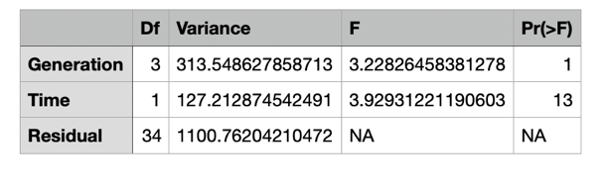
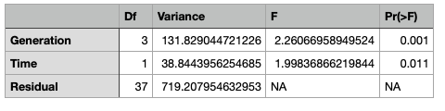
A.
B.
Supplementary Table 2: Statistical data relative to the salinity group at 50 mM NaCl (A) and 75 mM NaCl (B).
An ANOVA-like permutation test with 999 permutations was applied via anova.cca. Data was analyzed using permutational analysis considering size effect and significance exerted by both Generation and Time of growth.

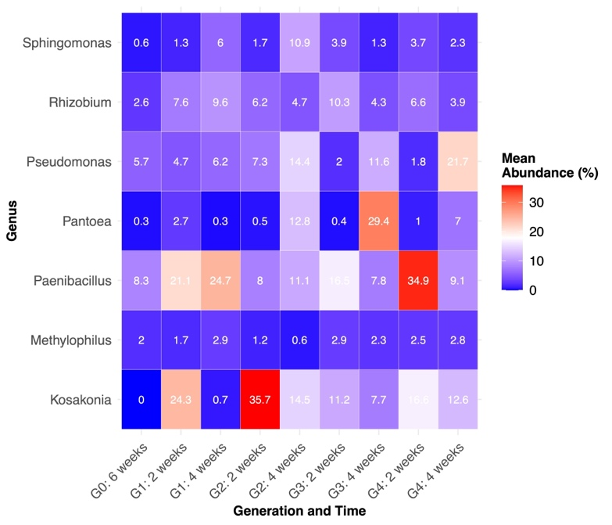

Supplementary Figure 2: Heatmap of genus abundance by Generation and Time under 50mM of NaCl throughout the enrichment procedure.
Percentage of abundance shown is relative only to analyzed strains and is not an absolute value. The average percentage of abundance is across all replicates in the group.

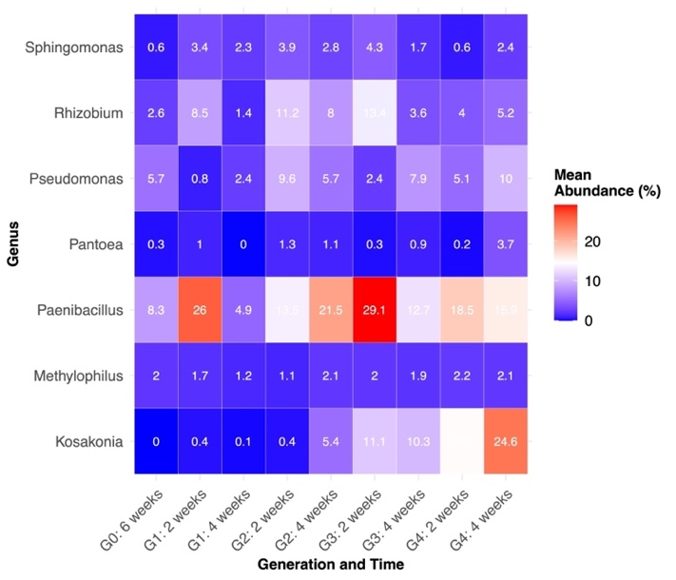
Supplementary Figure 3: Heatmap of genus abundance by Generation and Time under 75mM of NaCl throughout the enrichment procedure.
Percentage of abundance shown is relative only to analyzed strains and is not an absolute value. The average percentage of abundance is across all replicates in the group.

Supplementary Table 3: PGP phenotypes tested in vitro on the 8 strains used in this study.
Each test was performed under increasing percentages of salinity (0, 3 and 5 % of NaCl). Obtained phenotypes derive from 3 biological and technical replicates.
 | EPS production |  |  | P solubilization |  |  | Lipase activity |  |  | Protease activity |  |  | Indole acetic acid production |  |  |  |  |  | Mobility in 0.5% Agar |  |  | Mobility in 0.3% Agar
Salt % added | 0% | 3% | 5% | 0% | 3% | 5% | 0% | 3% | 5% | 0% | 3% | 5% | 0% | 0% + trp | 3% | 3% + trp | 5% | 5% +  trp | 0% | 3% | 5% | 0% | 3% | 5%
E. asburiae Y333 | ✓ | ✓ |  | ✓ | ✓ |  |  |  |  |  |  |  | ✓ |  |  |  |  |  |  |  |  | ✓
M. oleivorans Y323 |  |  |  | ✓ |  |  |  |  |  |  |  |  |  | ✓
P. ananatis R54 | ✓ | ✓ | ✓ | ✓ | ✓ |  |  |  |  |  |  |  |  |  |  |  |  |  |  |  |  | ✓
K. cowanii R316 | ✓ | ✓ |  | ✓ | ✓ |  |  |  |  |  |  |  |  |  |  |  |  |  |  |  |  | ✓
P. hunanensis Y310 | ✓ |  |  | ✓ | ✓ |  | ✓ | ✓ | ✓ | ✓ | ✓ |  |  | ✓ |  | ✓ |  | ✓ |  |  |  | ✓
H. hamiltonii SA63 |  | ✓ |  |  |  |  |  |  |  |  |  |  | ✓ | ✓ | ✓ | ✓ | ✓ | ✓
R. rosettiformans Y35 |  |  |  |  | ✓ |  | ✓ |  |  |  |  |  | ✓ | ✓ | ✓ | ✓ |  |  |  |  |  | ✓
R. marisflavi SA64 |  |  |  | ✓ |  |  |  |  |  | ✓ | ✓ | ✓ | ✓ |  |  |  |  |  |  |  |  | ✓

Supplementary Table 4: PGP phenotypes mining in silico.
gene | Rhizobium rosettiformans Y35 | Pantoea ananatis R54 | Microbacterium oleivorans Y323 | Enterobacter asburiae Y333 | Halomonas hamiltonii SA63 | Rossellomorea marisflavi SA64 | Paenibacillus hunanensis Y310 | Kosakonia cowanii R316 | Gene name, function | Reference
iaaM |  |  |  |  |  |  |  |  | Tryptophan 2-monooxygenase, biosynthesis of auxin
iaaH |  |  |  |  |  |  |  |  | Indoleacetamide hydrolase, biosynthesis of auxin
acdS |  |  | ✓ |  | ✓ |  |  |  | 1-aminocyclopropane-1-carboxylate deaminase, cleavage of the ethylene precursor | [1]
proA | ✓ | ✓ | ✓ | ✓ | ✓ | ✓ | ✓ | ✓ | Gamma-glutamyl phosphate reductase, biosynthesis of proline | [2]
proB | ✓ | ✓ | ✓ | ✓ | ✓ | ✓ | ✓ | ✓ | Glutamate 5-kinase, biosynthesis of proline | [2]
proV | ✓ | ✓ | ✓ | ✓ |  | ✓ | ✓ | ✓ | Glycine betaine/proline transport system ATP-binding protein, glycine betaine/proline transport | [2]
proP |  | ✓ | ✓ | ✓ |  |  |  | ✓ | Proline/betaine transporter, glycine betaine/proline transport | [2]
betA | ✓ | ✓ |  | ✓ | ✓ |  |  | ✓ | Oxygen-dependent choline dehydrogenase, biosynthesis of glycine betaine | [3]
betB | ✓ | ✓ |  | ✓ | ✓ |  |  | ✓ | NAD/NADP-dependent betaine aldehyde dehydrogenase, biosynthesis of glycine betaine | [3]
treS |  |  | ✓ | ✓ |  |  |  |  | Trehalose synthase, conversion of glycogen to trehalose | [4]
exoY |  |  |  |  |  | ✓ |  |  | Glycosyltransferase, exopolysaccharide production | [5]
zwf | ✓ | ✓ | ✓ | ✓ | ✓ | ✓ | ✓ | ✓ | Glucose-1dehydrogenase, biosynthesis of gluconic acid | [6]
gdh |  |  |  |  |  |  |  |  | Glucose-1dehydrogenase, biosynthesis of gluconic acid | [6]
yvcT |  | ✓ |  |  |  |  |  |  | Gluconate-2-dehydrogenase, biosynthesis of 2-ketogluconic acid | [6]
ghrB | ✓ | ✓ |  | ✓ |  | ✓ |  | ✓ | Gluconate-2-dehydrogenase, biosynthesis of 2-ketogluconic acid | [6]
phnC | ✓ | ✓ | ✓ | ✓ | ✓ |  | ✓ |  | ATPase-coupled organic phosphonate transmembrane transporter activity | [7]
phnX |  |  |  |  | ✓ |  |  |  | Phosphonoacetaldehyde hydrolase, cleavage of C-P bond in phosphonoacetaldehyde | [7]
xyl3A |  | ✓ |  | ✓ |  |  |  | ✓ | Xylan 1,4-beta-xylosidase, degradation of plant cell wall polysaccharides | [8]
hcnA |  |  |  |  |  |  |  |  | Hydrogen cyanide subunit A, Metalloenzymes inhibitor and antifungal | [9]
hcnB |  |  |  |  |  |  |  |  | Hydrogen cyanide subunit B, Metalloenzymes inhibitor and antifungal | [9]
hcnC |  |  |  |  |  |  |  |  | Hydrogen cyanide subunit C, Metalloenzymes inhibitor and antifungal | [9]
phzA |  |  |  |  |  |  |  |  | Part of phzABCDEFG cluster, Phenazine-1-Carboxylic Acid biosynthesis | [10]
phzB | ✓ |  |  |  |  |  |  |  | Part of phzABCDEFG cluster, | [10]
phzC |  |  |  |  |  |  |  |  | Part of phzABCDEFG cluster, Probable phospho-2-dehydro-3-deoxyheptonate aldolase | [10]
phzD |  |  |  |  |  |  |  |  | Part of phzABCDEFG cluster, Dihydrophenazinedicarboxylate synthase | [10]
phzE | ✓ |  |  |  |  |  |  |  | Part of phzABCDEFG cluster, Anthranilate synthase, phenazine specific | [10]
phzF | ✓ |  |  |  | ✓ |  |  |  | Part of phzABCDEFG cluster, Trans-2,3-dihydro-3-hydroxyanthranilate isomerase | [10]
phzG |  |  |  |  |  |  |  |  | Part of phzABCDEFG cluster, Dihydrophenazinedicarboxylate synthase Curated | [10]
PhzO |  |  |  |  |  |  |  |  | Part of phzABCDEFG cluster, 2-hydroxy phenazine | [10]
prnA |  |  |  |  |  |  |  |  | Pyrrolnitrin, Tryptophan 7-halogenase PrnA | [11]
prnB |  |  |  |  |  |  |  |  | Pyrrolnitrin, Monodechloroaminopyrrolnitrin synthase PrnB | [11]
prnC |  |  |  |  |  |  |  |  | Pyrrolnitrin, Monodechloroaminopyrrolnitrin halogenase PrnC | [11]
prnD |  |  |  |  |  |  |  |  | Pyrrolnitrin, Aminopyrrolnitrin oxygenase PrnD | [11]
phnC | ✓ | ✓ | ✓ | ✓ | ✓ |  | ✓ |  | 2-hexyl, 5-propyl resorcinol (HRP) | [12]
phnX |  |  |  |  | ✓ |  |  |  | phosphonoacetaldehyde hydrolase | [13]
chiC |  |  |  | ✓ |  |  |  | ✓ | chitinase | [14]
plcN |  |  |  |  |  |  | ✓ |  | Non-hemolytic phospholipase C | [14]
rebB_1 |  |  |  |  |  |  |  |  | rebB cluster, insecticidal | [14]
rebB_2 |  |  |  |  |  |  |  |  | rebB cluster, insecticidal | [14]
rebB_2 |  |  |  |  |  |  |  |  | rebB cluster, insecticidal | [14]
pvdA |  |  |  |  |  |  |  |  | Pyoverdine biosynthesis genes, L-ornithine N(5)-monooxygenase, pyoverdin biosynthesis | [15]
pvdE |  |  |  |  |  |  |  |  | Pyoverdine biosynthesis protein PvdE | [15]
pvdG |  |  |  |  |  |  |  |  | Pyoverdine biosynthesis thioesterase PvdG | [15]
pvdQ |  |  |  |  |  | ✓ |  |  | Pyoverdine biosynthesis genes, Acyl-homoserine lactone (AHL) acylase PvdQ | [15]
pgaA |  |  |  |  |  |  |  |  | Poly-beta-1,6-N-acetyl-D-glucosamine export protein, biofilm adhesin | [15]
pgaB |  |  |  | ✓ |  |  | ✓ |  | poly-beta-1,6-N-acetyl-D-glucosamine N-deacetylase, biofilm adhesin | [16]
pgaC |  |  | ✓ |  |  |  |  |  | Poly-beta-1,6-N-acetyl-D-glucosamine synthase, biofilm adhesin | [16]
pgaD |  |  |  | ✓ |  |  |  |  | Biofilm PGA synthesis protein PgaD | [16]
flgF | ✓ | ✓ |  | ✓ | ✓ | ✓ | ✓ | ✓ | motility of flagella | [16]
flgG | ✓ | ✓ | ✓ | ✓ | ✓ | ✓ | ✓ | ✓ | motility of flagella | [17]
flgH |  |  |  |  |  |  |  |  | motility of flagella | [17]
flgI | ✓ | ✓ |  | ✓ | ✓ |  |  | ✓ | motility of flagella | [18]
flgK |  | ✓ |  | ✓ | ✓ | ✓ |  | ✓ | Flagellar hook-associated protein 1 | [18]
flgL | ✓ | ✓ |  |  |  | ✓ | ✓ | ✓ | Flagellar hook-associated protein 3 | [18]
cheA | ✓ | ✓ |  | ✓ | ✓ | ✓ | ✓ | ✓ | Chemotaxis protein | [18]
cheB | ✓ | ✓ |  | ✓ | ✓ | ✓ | ✓ | ✓ | Protein-glutamate methylesterase/protein-glutamine glutaminase | [19]
cheY | ✓ | ✓ |  | ✓ | ✓ | ✓ | ✓ | ✓ | Chemotaxis protein | [19]
cheR | ✓ | ✓ |  | ✓ | ✓ | ✓ | ✓ | ✓ | Chemotaxis protein methyltransferase, chemotaxis protein | [19]
cheW | ✓ | ✓ |  | ✓ | ✓ | ✓ | ✓ | ✓ | Chemotaxis protein CheW, chemotaxis protein | [19]
cheZ |  | ✓ |  | ✓ | ✓ |  |  | ✓ | Protein phosphatase CheZ, chemotaxis protein | [19]
wspA | ✓ | ✓ |  | ✓ | ✓ | ✓ | ✓ | ✓ | Methyl-accepting chemotaxis protein WspA, chemotaxis protein | [19]
wspB | ✓ | ✓ |  | ✓ | ✓ | ✓ | ✓ | ✓ | Chemotaxis protein wspB | [20]
wspC |  |  |  |  |  |  |  |  | Probable biofilm formation methyltransferase WspC | [20]
wspD | ✓ | ✓ |  | ✓ | ✓ | ✓ | ✓ | ✓ | CheW domain protein WspD | [20]
wspE | ✓ | ✓ | ✓ | ✓ | ✓ | ✓ | ✓ | ✓ | Histidine kinase | [20]
wspF | ✓ | ✓ |  | ✓ | ✓ | ✓ | ✓ | ✓ | Protein-glutamate methylesterase/protein-glutamine glutaminase | [20]
wspR |  |  |  |  | ✓ |  | ✓ |  | diguanylate cyclase | [20]

Supplementary Table 5: Complete raw and Bonferroni-adjusted p-values of 𝛼- diversity measure using Shannon.
Condition | Metric | Reference group | Target group | Mean reference | Mean target | Median reference | Median target | SD reference | SD target | Wilcoxon p_value | Bonferroni adjusted p_value
No stress / 0 mM NaCl | Shannon | Control 3_weeks | C1 3_weeks | 3.21354122 | 3.24688109 | 3.22899992 | 3.28244614 | 0.05754157 | 0.15429802 | 0.5308693 | 1
No stress / 0 mM NaCl | Shannon | Control 3_weeks | C2 3_weeks | 3.21354122 | 3.26023791 | 3.22899992 | 3.25759568 | 0.05754157 | 0.09375201 | 0.5308693 | 1
No stress / 0 mM NaCl | Shannon | Control 3_weeks | C3 3_weeks | 3.21354122 | 2.8132128 | 3.22899992 | 2.84047952 | 0.05754157 | 0.17132772 | 0.01218578 | 0.04874312
No stress / 0 mM NaCl | Shannon | Control 3_weeks | C4 3_weeks | 3.21354122 | 3.0269275 | 3.22899992 | 3.03324548 | 0.05754157 | 0.14046479 | 0.03671386 | 0.14685543
No stress / 0 mM NaCl | Shannon | Control 6_weeks | C1 6_weeks | 3.36947277 | 3.21323495 | 3.5662829 | 3.13414036 | 0.33533727 | 0.18186343 | 0.67610331 | 1
No stress / 0 mM NaCl | Shannon | Control 6_weeks | C2 6_weeks | 3.36947277 | 3.58139191 | 3.5662829 | 3.57161592 | 0.33533727 | 0.34165207 | 0.31530245 | 1
No stress / 0 mM NaCl | Shannon | Control 6_weeks | C3 6_weeks | 3.36947277 | 2.99791356 | 3.5662829 | 3.11375668 | 0.33533727 | 0.38397823 | 0.21007504 | 0.84030016
No stress / 0 mM NaCl | Shannon | Control 6_weeks | C4 6_weeks | 3.36947277 | 3.1603596 | 3.5662829 | 3.2206112 | 0.33533727 | 0.78307643 | 1 | 1
No stress / 0 mM NaCl | Observed_ASV_richness | Control 3_weeks | C1 3_weeks | 118.6 | 114.8 | 119 | 117 | 14.0819033 | 11.7770964 | 0.67610331 | 1
No stress / 0 mM NaCl | Observed_ASV_richness | Control 3_weeks | C2 3_weeks | 118.6 | 111.8 | 119 | 118 | 14.0819033 | 17.0352576 | 0.60040185 | 1
No stress / 0 mM NaCl | Observed_ASV_richness | Control 3_weeks | C3 3_weeks | 118.6 | 101.2 | 119 | 111 | 14.0819033 | 19.1885382 | 0.24915264 | 0.99661055
No stress / 0 mM NaCl | Observed_ASV_richness | Control 3_weeks | C4 3_weeks | 118.6 | 106.4 | 119 | 115 | 14.0819033 | 24.3372143 | 0.5308693 | 1
No stress / 0 mM NaCl | Observed_ASV_richness | Control 6_weeks | C1 6_weeks | 96.8 | 69.4 | 106 | 66 | 31.236197 | 15.4045448 | 0.14367208 | 0.57468833
No stress / 0 mM NaCl | Observed_ASV_richness | Control 6_weeks | C2 6_weeks | 96.8 | 108.333333 | 106 | 112.5 | 31.236197 | 31.6143427 | 0.64807687 | 1
No stress / 0 mM NaCl | Observed_ASV_richness | Control 6_weeks | C3 6_weeks | 96.8 | 62.6 | 106 | 56 | 31.236197 | 23.4478144 | 0.09469294 | 0.37877177
No stress / 0 mM NaCl | Observed_ASV_richness | Control 6_weeks | C4 6_weeks | 96.8 | 99 | 106 | 113 | 31.236197 | 30.5941171 | 0.83403523 | 1
50 mM NaCl | Shannon | Control 3_weeks | C1 3_weeks | 2.11760907 | 2.42437592 | 2.10708199 | 2.52415211 | 0.1001351 | 0.28793225 | 0.14367208 | 0.57468833
50 mM NaCl | Shannon | Control 3_weeks | C2 3_weeks | 2.11760907 | 2.82023514 | 2.10708199 | 2.83531426 | 0.1001351 | 0.05809778 | 0.01218578 | 0.04874312
50 mM NaCl | Shannon | Control 3_weeks | C3 3_weeks | 2.11760907 | 3.49161963 | 2.10708199 | 3.38370029 | 0.1001351 | 0.18141733 | 0.01218578 | 0.04874312
50 mM NaCl | Shannon | Control 3_weeks | C4 3_weeks | 2.11760907 | 3.72464084 | 2.10708199 | 3.74214608 | 0.1001351 | 0.07954027 | 0.01218578 | 0.04874312
50 mM NaCl | Shannon | Control 6_weeks | C1 6_weeks | 3.04694471 | 2.58200795 | 3.20508369 | 2.92517278 | 0.62369617 | 0.89243932 | 0.29626987 | 1
50 mM NaCl | Shannon | Control 6_weeks | C2 6_weeks | 3.04694471 | 3.31852503 | 3.20508369 | 3.27789815 | 0.62369617 | 0.31395341 | 0.54029137 | 1
50 mM NaCl | Shannon | Control 6_weeks | C3 6_weeks | 3.04694471 | 3.26223114 | 3.20508369 | 3.71661603 | 0.62369617 | 0.66731403 | 0.5308693 | 1
50 mM NaCl | Shannon | Control 6_weeks | C4 6_weeks | 3.04694471 | 3.44836496 | 3.20508369 | 3.39728093 | 0.62369617 | 0.17354696 | 0.09469294 | 0.37877177
50 mM NaCl | Observed_ASV_richness | Control 3_weeks | C1 3_weeks | 136 | 141.6 | 136 | 139 | 9.40744386 | 33.5678418 | 0.5296193 | 1
50 mM NaCl | Observed_ASV_richness | Control 3_weeks | C2 3_weeks | 136 | 142.6 | 136 | 148 | 9.40744386 | 31.4213303 | 0.40196536 | 1
50 mM NaCl | Observed_ASV_richness | Control 3_weeks | C3 3_weeks | 136 | 130.8 | 136 | 108 | 9.40744386 | 47.9447599 | 0.34426655 | 1
50 mM NaCl | Observed_ASV_richness | Control 3_weeks | C4 3_weeks | 136 | 166 | 136 | 161 | 9.40744386 | 27.8657496 | 0.03614514 | 0.14458057
50 mM NaCl | Observed_ASV_richness | Control 6_weeks | C1 6_weeks | 106.8 | 81.4 | 114 | 74 | 26.3571622 | 25.1753848 | 0.11607394 | 0.46429577
50 mM NaCl | Observed_ASV_richness | Control 6_weeks | C2 6_weeks | 106.8 | 95.5 | 114 | 98 | 26.3571622 | 29.5803989 | 0.71330317 | 1
50 mM NaCl | Observed_ASV_richness | Control 6_weeks | C3 6_weeks | 106.8 | 95.8 | 114 | 114 | 26.3571622 | 34.5065211 | 0.67423588 | 1
50 mM NaCl | Observed_ASV_richness | Control 6_weeks | C4 6_weeks | 106.8 | 96.6 | 114 | 95 | 26.3571622 | 40.8631864 | 0.5308693 | 1

A.
B.
Supplementary Figure 4: Observed ASV richness for 𝛼-diversity relative to the salinity groups at 0 mM NaCl (A) and 50 mM NaCl (B) with the different consortia applied.

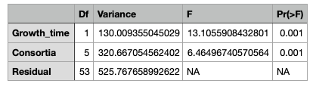
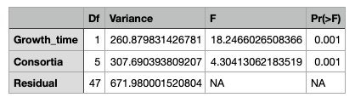
A.
B.
Supplementary Table 6: Statistical data relative to treated plants under no stress conditions (A) and with 50 mM NaCl added to soil (B).
An ANOVA-like permutation test with 999 permutations was applied via anova.cca. Data was analyzed using permutational analysis considering size effect and significance exerted by both Consortia and Time of growth.
Supplementary Figure 5: Comparison of abundance of the 8 applied strains in different consortia at 6 weeks of growth in salt stressed conditions (50 mM NaCl applied to soil).
BarCharts show the Log2 Transformed Mean Abundance of the strains based on consortia and compared to the untreated control.

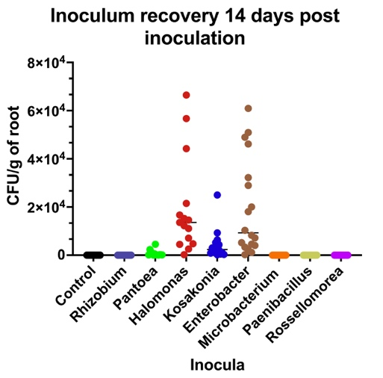
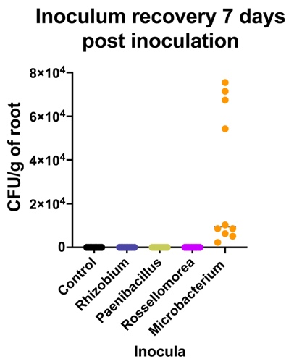
Supplementary Figure 6: In planta colonization and recovery by 8 single strains inocula.
Colonization was evaluated by CFU/g of root in rice plants at 14 dpi. Two biological replicates were performed in different times including 20 plants per inoculum. For rice plants inoculated with R. rosettiformans, R. marisflavi, P. hunanensis, and M. oleivorans, the assay was repeated a third time with endophytic recovery at 7 and 14 dpi handling 10 plants per inoculum each time.

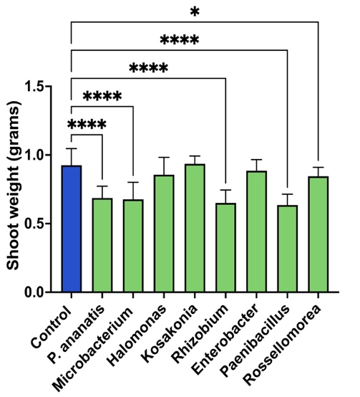
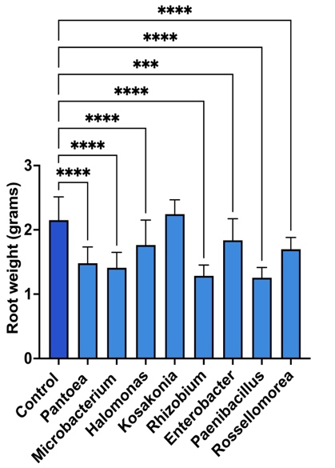
Supplementary Figure 7: Roots weight measurements following inoculation with 8 single strains 2 wpi in Hoagland.
BarCharts show variations of weight in mg of roots (* indicate degree of significance). Statistical analysis was performed using ordinary one-way ANOVA on Prism. 20 plants were weighted per treatment.

Supplementary Table 7: Complete statistics for the comparison of abundance of the applied strains in C1 and C5 at 7 dpi.
Statistical comparisons were performed using per-sample log2-transformed abundance values. For each species/strain, Control and inoculated groups were compared using two-sided Wilcoxon rank-sum tests, with Bonferroni correction across all plotted comparisons. No comparison remained significant after correction.

Strain | Comparison | Mean Group1 | Mean Group2 | Median Group1 | Median Group2 | SD Group1 | SD Group2 | Raw p_value | Bonferroni adjusted p_value | Significance raw | Significance Bonferroni
Enterobacter asburiae | Control vs C1 | 2.29842536 | 9.91439841 | 0.5 | 9.79051752 | 3.62289506 | 0.62543973 | 0.01306185 | 0.1436803 | * | ns
Halomonas hamiltonii | Control vs C1 | 0 | 0.39624063 | 0 | 0 | 0 | 0.79248125 | 0.30743417 | 1 | ns | ns
Kosakonia cowanii | Control vs C1 | 13.3961463 | 12.2012715 | 13.9114822 | 12.1872475 | 2.28387804 | 1.49108441 | 0.45554509 | 1 | ns | ns
Microbacterium oleivorans | Control vs C1 | 3.05496606 | 0.64624063 | 3.43518236 | 0.5 | 1.31387239 | 0.78349609 | 0.03194908 | 0.35143991 | * | ns
Paenibacillus hunanensis | Control vs C1 | 10.5328444 | 10.4074242 | 10.0874318 | 10.7327952 | 1.82689158 | 1.40864054 | 0.91510603 | 1 | ns | ns
Pantoea ananatis | Control vs C1 | 5.45196673 | 4.49592655 | 5.74467312 | 4.11440935 | 2.12018997 | 1.72122676 | 0.45554509 | 1 | ns | ns
Rhizobium rosettiformans | Control vs C1 | 0.33333333 | 10.6029153 | 0 | 10.4307252 | 0.51639778 | 1.4300332 | 0.01115318 | 0.12268493 | * | ns
Rossellomorea marisflavi | Control vs C1 | 0.88698802 | 9.38848304 | 0.5 | 10.2436114 | 1.28955185 | 1.88629127 | 0.01278067 | 0.14058739 | * | ns
Enterobacter asburiae | Control vs C5 | 2.29842536 | 9.1254819 | 0.5 | 9.11374217 | 3.62289506 | 0.63225703 | 0.02126694 | 0.23393631 | * | ns
Halomonas hamiltonii | Control vs C5 | 0 | 0.66438562 | 0 | 0 | 0 | 1.02277916 | 0.13638022 | 1 | ns | ns
Paenibacillus hunanensis | Control vs C5 | 10.5328444 | 9.52959494 | 10.0874318 | 9.95128471 | 1.82689158 | 1.7682102 | 0.52281665 | 1 | ns | ns

References
1. Govindasamy V, Senthilkumar M, Bose P, Kumar LV, Ramadoss D, Annapurna K. ACC Deaminase Containing PGPR for Potential Exploitation in Agriculture. In: Maheshwari DK, editor. Bacteria in Agrobiology: Plant Nutrient Management. Berlin, Heidelberg: Springer Berlin Heidelberg; 2011. p. 183–208. https://doi.org/10.1007/978-3-642-21061-7_8.
2. Csonka LN, Leisinger T. Biosynthesis of Proline. EcoSal Plus. 2007;2:10.1128/ecosalplus.3.6.1.4. https://doi.org/10.1128/ecosalplus.3.6.1.4.
3. Styrvold OB, Falkenberg P, Landfald B, Eshoo MW, Bjørnsen T, Strøm AR. Selection, mapping, and characterization of osmoregulatory mutants of Escherichia coli blocked in the choline-glycine betaine pathway. J Bacteriol. 1986;165:856–63. https://doi.org/10.1128/jb.165.3.856-863.1986.
4. Sugawara M, Cytryn EJ, Sadowsky MJ. Functional Role of Bradyrhizobium japonicum Trehalose Biosynthesis and Metabolism Genes during Physiological Stress and Nodulation. Appl Environ Microbiol. 2010;76:1071–81. https://doi.org/10.1128/AEM.02483-09.
5. Zhan HJ, Leigh JA. Two genes that regulate exopolysaccharide production in Rhizobium meliloti. J Bacteriol. 1990;172:5254–9. https://doi.org/10.1128/jb.172.9.5254-5259.1990.
6. De Werra P, Péchy-Tarr M, Keel C, Maurhofer M. Role of Gluconic Acid Production in the Regulation of Biocontrol Traits of Pseudomonas fluorescens CHA0. Appl Environ Microbiol. 2009;75:4162–74. https://doi.org/10.1128/AEM.00295-09.
7. Parker GF, Higgins TP, Hawkes T, Robson RL. Rhizobium ( Sinorhizobium ) meliloti phn Genes: Characterization and Identification of Their Protein Products. J Bacteriol. 1999;181:389–95. https://doi.org/10.1128/JB.181.2.389-395.1999.
8. Schomburg D, Salzmann M. Xylan 1, 4-beta-xylosidase. In: Schomburg D, Salzmann M, editors. Enzyme Handbook 4. Berlin, Heidelberg: Springer Berlin Heidelberg; 1991. p. 229–36. https://doi.org/10.1007/978-3-642-84437-9_28.
9. Nandi M, Selin C, Brassinga AKC, Belmonte MF, Fernando WGD, Loewen PC, et al. Pyrrolnitrin and Hydrogen Cyanide Production by Pseudomonas chlororaphis Strain PA23 Exhibits Nematicidal and Repellent Activity against Caenorhabditis elegans. PLOS ONE. 2015;10:e0123184. https://doi.org/10.1371/journal.pone.0123184.
10. Mavrodi DV, Ksenzenko VN, Bonsall RF, Cook RJ, Boronin AM, Thomashow LS. A Seven-Gene Locus for Synthesis of Phenazine-1-Carboxylic Acid by Pseudomonas fluorescens 2-79. J Bacteriol. 1998;180:2541–8. https://doi.org/10.1128/JB.180.9.2541-2548.1998.
11. Kirner S, Hammer PE, Hill DS, Altmann A, Fischer I, Weislo LJ, et al. Functions Encoded by Pyrrolnitrin Biosynthetic Genes from Pseudomonas fluorescens. J Bacteriol. 1998;180:1939–43. https://doi.org/10.1128/JB.180.7.1939-1943.1998.
12. Laurie AD, Lloyd-Jones G. The phn Genes of Burkholderia sp. Strain RP007 Constitute a Divergent Gene Cluster for Polycyclic Aromatic Hydrocarbon Catabolism. J Bacteriol. 1999;181:531–40. https://doi.org/10.1128/JB.181.2.531-540.1999.
13. Villarreal-Chiu JF. The genes and enzymes of phosphonate metabolism by bacteria, and their distribution in the marine environment. Front Microbiol. 2012;3. https://doi.org/10.3389/fmicb.2012.00019.
14. Flury P, Aellen N, Ruffner B, Péchy-Tarr M, Fataar S, Metla Z, et al. Insect pathogenicity in plant-beneficial pseudomonads: phylogenetic distribution and comparative genomics. ISME J. 2016;10:2527–42. https://doi.org/10.1038/ismej.2016.5.
15. Ringel MT, Brüser T. The biosynthesis of pyoverdines. Microb Cell. 2018;5:424–37. https://doi.org/10.15698/mic2018.10.649.
16. Yakandawala N, Gawande PV, LoVetri K, Cardona ST, Romeo T, Nitz M, et al. Characterization of the Poly-β-1,6- N -Acetylglucosamine Polysaccharide Component of Burkholderia Biofilms. Appl Environ Microbiol. 2011;77:8303–9. https://doi.org/10.1128/AEM.05814-11.
17. Saijo-Hamano Y, Uchida N, Namba K, Oosawa K. In Vitro Characterization of FlgB, FlgC, FlgF, FlgG, and FliE, Flagellar Basal Body Proteins of Salmonella. J Mol Biol. 2004;339:423–35. https://doi.org/10.1016/j.jmb.2004.03.070.
18. Hirano T, Mizuno S, Aizawa S-I, Hughes KT. Mutations in Flk, FlgG, FlhA, and FlhE That Affect the Flagellar Type III Secretion Specificity Switch in Salmonella enterica. J Bacteriol. 2009;191:3938–49. https://doi.org/10.1128/JB.01811-08.
19. Hamer R, Chen P-Y, Armitage JP, Reinert G, Deane CM. Deciphering chemotaxis pathways using cross species comparisons. BMC Syst Biol. 2010;4:3. https://doi.org/10.1186/1752-0509-4-3.
20. O’Connor JR, Kuwada NJ, Huangyutitham V, Wiggins PA, Harwood CS. Surface sensing and lateral subcellular localization of WspA , the receptor in a chemosensory‐like system leading to c‐di‐ GMP production. Mol Microbiol. 2012;86:720–9. https://doi.org/10.1111/mmi.12013.

