Additional file 1. Supplementary tables and figures

Supplementary tables
Table S1. Detailed regional composition of categorical variables.
Variable | Category | EC | SC | CC | NC | NEC | NWC | SWC | Overall regional test
Education level | Illiterate/semi-illiterate | 2202 (31.7%); E=1965.8; R=7.4 | 543 (19.9%); E=770.8; R=-10.2 | 996 (27.7%); E=1015.7; R=-0.8 | 610 (19.5%); E=886.7; R=-11.7 | 257 (11.8%); E=613.5; R=-17.8 | 1210 (38.4%); E=890.1; R=13.5 | 1411 (36.7%); E=1086.4; R=12.6 | χ²=1207.149; df=24; P=<0.001; Cramer's V=0.109
Education level | Primary school | 2404 (34.6%); E=2441.4; R=-1.1 | 998 (36.6%); E=957.2; R=1.7 | 1258 (35.0%); E=1261.4; R=-0.1 | 1029 (32.8%); E=1101.3; R=-2.9 | 815 (37.6%); E=761.9; R=2.5 | 974 (31.0%); E=1105.5; R=-5.2 | 1500 (39.1%); E=1349.3; R=5.5 | χ²=1207.149; df=24; P=<0.001; Cramer's V=0.109
Education level | Junior secondary | 1440 (20.7%); E=1563.9; R=-4.2 | 661 (24.3%); E=613.2; R=2.3 | 876 (24.4%); E=808.0; R=2.9 | 856 (27.3%); E=705.4; R=6.9 | 670 (30.9%); E=488.1; R=9.8 | 615 (19.5%); E=708.1; R=-4.2 | 633 (16.5%); E=864.3; R=-9.7 | χ²=1207.149; df=24; P=<0.001; Cramer's V=0.109
Education level | Senior secondary/vocational | 700 (10.1%); E=764.7; R=-2.9 | 429 (15.7%); E=299.8; R=8.4 | 396 (11.0%); E=395.1; R=0.1 | 468 (14.9%); E=344.9; R=7.5 | 322 (14.8%); E=238.6; R=6.0 | 280 (8.9%); E=346.2; R=-4.0 | 217 (5.6%); E=422.6; R=-11.5 | χ²=1207.149; df=24; P=<0.001; Cramer's V=0.109
Education level | College or above | 204 (2.9%); E=214.3; R=-0.8 | 94 (3.4%); E=84.0; R=1.2 | 65 (1.8%); E=110.7; R=-4.8 | 172 (5.5%); E=96.7; R=8.3 | 105 (4.8%); E=66.9; R=5.0 | 68 (2.2%); E=97.0; R=-3.2 | 80 (2.1%); E=118.4; R=-3.9 | χ²=1207.149; df=24; P=<0.001; Cramer's V=0.109
Marital status | Without spouse | 1653 (23.8%); E=1775.7; R=-4.0 | 738 (27.1%); E=696.2; R=1.9 | 880 (24.5%); E=917.5; R=-1.5 | 727 (23.2%); E=801.0; R=-3.2 | 470 (21.7%); E=554.2; R=-4.3 | 908 (28.9%); E=804.1; R=4.5 | 1154 (30.0%); E=981.4; R=6.9 | χ²=102.006; df=6; P=<0.001; Cramer's V=0.063
Marital status | With spouse | 5297 (76.2%); E=5174.3; R=4.0 | 1987 (72.9%); E=2028.8; R=-1.9 | 2711 (75.5%); E=2673.5; R=1.5 | 2408 (76.8%); E=2334.0; R=3.2 | 1699 (78.3%); E=1614.8; R=4.3 | 2239 (71.1%); E=2342.9; R=-4.5 | 2687 (70.0%); E=2859.6; R=-6.9 | χ²=102.006; df=6; P=<0.001; Cramer's V=0.063
Chronic disease count | 0 conditions | 1445 (20.8%); E=1347.1; R=3.5 | 685 (25.1%); E=528.2; R=8.0 | 668 (18.6%); E=696.1; R=-1.3 | 553 (17.6%); E=607.7; R=-2.6 | 405 (18.7%); E=420.4; R=-0.9 | 472 (15.0%); E=610.0; R=-6.6 | 726 (18.9%); E=744.5; R=-0.8 | χ²=259.525; df=12; P=<0.001; Cramer's V=0.071
Chronic disease count | 1-2 conditions | 2995 (43.1%); E=2834.1; R=4.6 | 1201 (44.1%); E=1111.2; R=3.7 | 1473 (41.0%); E=1464.3; R=0.3 | 1228 (39.2%); E=1278.4; R=-2.0 | 811 (37.4%); E=884.5; R=-3.4 | 1218 (38.7%); E=1283.3; R=-2.5 | 1496 (38.9%); E=1566.3; R=-2.5 | χ²=259.525; df=12; P=<0.001; Cramer's V=0.071
Chronic disease count | 3+ conditions | 2510 (36.1%); E=2768.8; R=-7.4 | 839 (30.8%); E=1085.6; R=-10.2 | 1450 (40.4%); E=1430.6; R=0.7 | 1354 (43.2%); E=1248.9; R=4.1 | 953 (43.9%); E=864.1; R=4.1 | 1457 (46.3%); E=1253.7; R=7.9 | 1619 (42.2%); E=1530.2; R=3.2 | χ²=259.525; df=12; P=<0.001; Cramer's V=0.071
Number of children | No children | 141 (2.0%); E=154.7; R=-1.3 | 79 (2.9%); E=60.7; R=2.5 | 70 (1.9%); E=79.9; R=-1.2 | 80 (2.6%); E=69.8; R=1.3 | 42 (1.9%); E=48.3; R=-1.0 | 46 (1.5%); E=70.1; R=-3.1 | 111 (2.9%); E=85.5; R=3.0 | χ²=1344.299; df=18; P=<0.001; Cramer's V=0.132
Number of children | 1 child | 1480 (21.3%); E=1216.9; R=9.7 | 288 (10.6%); E=477.1; R=-10.1 | 449 (12.5%); E=628.8; R=-8.5 | 579 (18.5%); E=548.9; R=1.5 | 677 (31.2%); E=379.8; R=17.6 | 303 (9.6%); E=551.0; R=-12.4 | 699 (18.2%); E=672.5; R=1.2 | χ²=1344.299; df=18; P=<0.001; Cramer's V=0.132
Number of children | 2 children | 2487 (35.8%); E=2304.3; R=5.5 | 618 (22.7%); E=903.5; R=-12.3 | 1158 (32.2%); E=1190.6; R=-1.2 | 1265 (40.4%); E=1039.4; R=9.1 | 837 (38.6%); E=719.2; R=5.6 | 881 (28.0%); E=1043.4; R=-6.6 | 1228 (32.0%); E=1273.5; R=-1.7 | χ²=1344.299; df=18; P=<0.001; Cramer's V=0.132
Number of children | 3+ children | 2842 (40.9%); E=3274.0; R=-12.2 | 1740 (63.9%); E=1283.7; R=18.5 | 1914 (53.3%); E=1691.7; R=8.0 | 1211 (38.6%); E=1476.9; R=-10.2 | 613 (28.3%); E=1021.8; R=-18.4 | 1917 (60.9%); E=1482.5; R=16.6 | 1803 (46.9%); E=1809.4; R=-0.2 | χ²=1344.299; df=18; P=<0.001; Cramer's V=0.132
Living arrangement | Living alone | 1118 (16.1%); E=959.4; R=6.5 | 314 (11.5%); E=376.2; R=-3.7 | 526 (14.6%); E=495.7; R=1.6 | 394 (12.6%); E=432.8; R=-2.1 | 271 (12.5%); E=299.4; R=-1.8 | 387 (12.3%); E=434.4; R=-2.6 | 518 (13.5%); E=530.2; R=-0.6 | χ²=1275.351; df=12; P=<0.001; Cramer's V=0.158
Living arrangement | With non-spouse relatives | 2273 (32.7%); E=2875.7; R=-17.2 | 1668 (61.2%); E=1127.5; R=22.2 | 1537 (42.8%); E=1485.8; R=1.9 | 1024 (32.7%); E=1297.2; R=-10.6 | 582 (26.8%); E=897.5; R=-14.4 | 1533 (48.7%); E=1302.1; R=8.9 | 1958 (51.0%); E=1589.3; R=13.1 | χ²=1275.351; df=12; P=<0.001; Cramer's V=0.158
Living arrangement | With spouse only | 3559 (51.2%); E=3115.0; R=12.6 | 743 (27.3%); E=1221.3; R=-19.5 | 1528 (42.6%); E=1609.5; R=-2.9 | 1717 (54.8%); E=1405.1; R=12.0 | 1316 (60.7%); E=972.1; R=15.5 | 1227 (39.0%); E=1410.5; R=-7.0 | 1365 (35.5%); E=1721.5; R=-12.5 | χ²=1275.351; df=12; P=<0.001; Cramer's V=0.158
Annual income level | <6000 CNY | 4098 (59.0%); E=4761.2; R=-20.1 | 1950 (71.6%); E=1866.8; R=3.6 | 2639 (73.5%); E=2460.1; R=6.9 | 2167 (69.1%); E=2147.7; R=0.8 | 1475 (68.0%); E=1485.9; R=-0.5 | 2276 (72.3%); E=2155.9; R=4.9 | 2904 (75.6%); E=2631.4; R=10.3 | χ²=540.757; df=12; P=<0.001; Cramer's V=0.103
Annual income level | 6000-12000 CNY | 1520 (21.9%); E=1243.5; R=10.1 | 372 (13.7%); E=487.6; R=-6.1 | 586 (16.3%); E=642.5; R=-2.7 | 547 (17.4%); E=560.9; R=-0.7 | 462 (21.3%); E=388.1; R=4.3 | 513 (16.3%); E=563.1; R=-2.5 | 573 (14.9%); E=687.3; R=-5.2 | χ²=540.757; df=12; P=<0.001; Cramer's V=0.103
Annual income level | >12000 CNY | 1332 (19.2%); E=945.2; R=15.9 | 403 (14.8%); E=370.6; R=1.9 | 366 (10.2%); E=488.4; R=-6.4 | 421 (13.4%); E=426.4; R=-0.3 | 232 (10.7%); E=295.0; R=-4.1 | 358 (11.4%); E=428.0; R=-3.9 | 364 (9.5%); E=522.4; R=-8.1 | χ²=540.757; df=12; P=<0.001; Cramer's V=0.103
Main income source | Security income | 1360 (19.6%); E=1755.0; R=-12.8 | 666 (24.4%); E=688.1; R=-1.0 | 697 (19.4%); E=906.8; R=-8.7 | 1009 (32.2%); E=791.7; R=9.5 | 880 (40.6%); E=547.7; R=17.2 | 935 (29.7%); E=794.7; R=6.1 | 907 (23.6%); E=969.9; R=-2.5 | χ²=815.161; df=18; P=<0.001; Cramer's V=0.103
Main income source | Labour income | 1304 (18.8%); E=1094.8; R=8.1 | 336 (12.3%); E=429.3; R=-5.2 | 696 (19.4%); E=565.7; R=6.4 | 392 (12.5%); E=493.8; R=-5.3 | 231 (10.7%); E=341.7; R=-6.8 | 459 (14.6%); E=495.7; R=-1.9 | 608 (15.8%); E=605.0; R=0.1 | χ²=815.161; df=18; P=<0.001; Cramer's V=0.103
Main income source | Children support | 906 (13.0%); E=1112.2; R=-7.9 | 591 (21.7%); E=436.1; R=8.6 | 711 (19.8%); E=574.7; R=6.7 | 495 (15.8%); E=501.7; R=-0.3 | 295 (13.6%); E=347.1; R=-3.2 | 486 (15.4%); E=503.6; R=-0.9 | 606 (15.8%); E=614.7; R=-0.4 | χ²=815.161; df=18; P=<0.001; Cramer's V=0.103
Main income source | Other | 3380 (48.6%); E=2988.0; R=11.1 | 1132 (41.5%); E=1171.5; R=-1.6 | 1487 (41.4%); E=1543.9; R=-2.1 | 1239 (39.5%); E=1347.8; R=-4.2 | 763 (35.2%); E=932.5; R=-7.7 | 1267 (40.3%); E=1353.0; R=-3.3 | 1720 (44.8%); E=1651.3; R=2.4 | χ²=815.161; df=18; P=<0.001; Cramer's V=0.103
Exercise frequency | Often | 2408 (34.6%); E=2131.7; R=8.4 | 798 (29.3%); E=835.8; R=-1.7 | 1141 (31.8%); E=1101.4; R=1.5 | 950 (30.3%); E=961.5; R=-0.5 | 585 (27.0%); E=665.3; R=-3.9 | 785 (24.9%); E=965.2; R=-7.4 | 1172 (30.5%); E=1178.1; R=-0.2 | χ²=209.837; df=12; P=<0.001; Cramer's V=0.064
Exercise frequency | Sometimes | 2018 (29.0%); E=2082.4; R=-2.0 | 966 (35.4%); E=816.5; R=6.6 | 1077 (30.0%); E=1076.0; R=0.0 | 888 (28.3%); E=939.3; R=-2.1 | 629 (29.0%); E=649.9; R=-1.0 | 888 (28.2%); E=942.9; R=-2.3 | 1192 (31.0%); E=1150.9; R=1.6 | χ²=209.837; df=12; P=<0.001; Cramer's V=0.064
Exercise frequency | Never | 2524 (36.3%); E=2735.9; R=-6.1 | 961 (35.3%); E=1072.7; R=-4.6 | 1373 (38.2%); E=1413.6; R=-1.5 | 1297 (41.4%); E=1234.1; R=2.5 | 955 (44.0%); E=853.8; R=4.6 | 1474 (46.8%); E=1238.8; R=9.2 | 1477 (38.5%); E=1512.0; R=-1.3 | χ²=209.837; df=12; P=<0.001; Cramer's V=0.064
Sleep quality | Very good | 1735 (25.0%); E=1561.7; R=5.8 | 431 (15.8%); E=612.3; R=-8.8 | 700 (19.5%); E=806.9; R=-4.6 | 760 (24.2%); E=704.4; R=2.5 | 464 (21.4%); E=487.4; R=-1.3 | 786 (25.0%); E=707.1; R=3.6 | 867 (22.6%); E=863.1; R=0.2 | χ²=285.859; df=24; P=<0.001; Cramer's V=0.053
Sleep quality | Good | 1892 (27.2%); E=1819.5; R=2.3 | 661 (24.3%); E=713.4; R=-2.4 | 971 (27.0%); E=940.1; R=1.3 | 836 (26.7%); E=820.7; R=0.7 | 554 (25.5%); E=567.8; R=-0.7 | 857 (27.2%); E=823.9; R=1.4 | 920 (24.0%); E=1005.6; R=-3.4 | χ²=285.859; df=24; P=<0.001; Cramer's V=0.053
Sleep quality | Fair | 2063 (29.7%); E=2165.1; R=-3.1 | 1088 (39.9%); E=848.9; R=10.5 | 1152 (32.1%); E=1118.7; R=1.3 | 885 (28.2%); E=976.6; R=-3.8 | 722 (33.3%); E=675.7; R=2.2 | 867 (27.6%); E=980.4; R=-4.7 | 1185 (30.9%); E=1196.6; R=-0.4 | χ²=285.859; df=24; P=<0.001; Cramer's V=0.053
Sleep quality | Poor | 1065 (15.3%); E=1139.9; R=-2.8 | 459 (16.8%); E=447.0; R=0.7 | 631 (17.6%); E=589.0; R=2.0 | 503 (16.0%); E=514.2; R=-0.6 | 312 (14.4%); E=355.8; R=-2.7 | 514 (16.3%); E=516.2; R=-0.1 | 708 (18.4%); E=630.0; R=3.7 | χ²=285.859; df=24; P=<0.001; Cramer's V=0.053
Sleep quality | Very poor | 195 (2.8%); E=263.8; R=-5.1 | 86 (3.2%); E=103.4; R=-1.8 | 137 (3.8%); E=136.3; R=0.1 | 151 (4.8%); E=119.0; R=3.2 | 117 (5.4%); E=82.3; R=4.1 | 123 (3.9%); E=119.4; R=0.4 | 161 (4.2%); E=145.8; R=1.4 | χ²=285.859; df=24; P=<0.001; Cramer's V=0.053
Age group | 60-69 years | 3746 (53.9%); E=3906.3; R=-4.5 | 1584 (58.1%); E=1531.6; R=2.1 | 2045 (56.9%); E=2018.3; R=1.0 | 1882 (60.0%); E=1762.0; R=4.6 | 1392 (64.2%); E=1219.1; R=7.8 | 1725 (54.8%); E=1768.8; R=-1.7 | 1991 (51.8%); E=2158.9; R=-5.9 | χ²=164.386; df=12; P=<0.001; Cramer's V=0.057
Age group | 70-79 years | 2371 (34.1%); E=2275.2; R=2.9 | 791 (29.0%); E=892.1; R=-4.4 | 1160 (32.3%); E=1175.6; R=-0.6 | 956 (30.5%); E=1026.3; R=-2.9 | 633 (29.2%); E=710.1; R=-3.7 | 1087 (34.5%); E=1030.2; R=2.3 | 1369 (35.6%); E=1257.4; R=4.2 | χ²=164.386; df=12; P=<0.001; Cramer's V=0.057
Age group | 80+ years | 833 (12.0%); E=768.5; R=2.9 | 350 (12.8%); E=301.3; R=3.1 | 386 (10.7%); E=397.1; R=-0.6 | 297 (9.5%); E=346.6; R=-3.0 | 144 (6.6%); E=239.8; R=-6.9 | 335 (10.6%); E=348.0; R=-0.8 | 481 (12.5%); E=424.7; R=3.1 | χ²=164.386; df=12; P=<0.001; Cramer's V=0.057
Loneliness | Often | 310 (4.5%); E=368.5; R=-3.7 | 143 (5.2%); E=144.5; R=-0.1 | 190 (5.3%); E=190.4; R=0.0 | 148 (4.7%); E=166.2; R=-1.5 | 138 (6.4%); E=115.0; R=2.3 | 250 (7.9%); E=166.8; R=7.1 | 176 (4.6%); E=203.6; R=-2.2 | χ²=137.789; df=12; P=<0.001; Cramer's V=0.052
Loneliness | Sometimes | 1264 (18.2%); E=1370.8; R=-3.8 | 593 (21.8%); E=537.5; R=2.8 | 701 (19.5%); E=708.3; R=-0.3 | 532 (17.0%); E=618.3; R=-4.1 | 408 (18.8%); E=427.8; R=-1.1 | 727 (23.1%); E=620.7; R=5.1 | 816 (21.2%); E=757.6; R=2.6 | χ²=137.789; df=12; P=<0.001; Cramer's V=0.052
Loneliness | Never | 5376 (77.4%); E=5210.7; R=5.4 | 1989 (73.0%); E=2043.1; R=-2.5 | 2700 (75.2%); E=2692.3; R=0.3 | 2455 (78.3%); E=2350.5; R=4.6 | 1623 (74.8%); E=1626.2; R=-0.2 | 2170 (69.0%); E=2359.4; R=-8.3 | 2849 (74.2%); E=2879.8; R=-1.2 | χ²=137.789; df=12; P=<0.001; Cramer's V=0.052
Social organisation participation | No | 5031 (72.4%); E=5020.7; R=0.3 | 1783 (65.4%); E=1968.5; R=-8.4 | 2631 (73.3%); E=2594.1; R=1.5 | 2405 (76.7%); E=2264.7; R=6.0 | 1773 (81.7%); E=1566.9; R=10.3 | 2040 (64.8%); E=2273.4; R=-9.9 | 2800 (72.9%); E=2774.7; R=1.0 | χ²=281.068; df=6; P=<0.001; Cramer's V=0.105
Social organisation participation | Yes | 1919 (27.6%); E=1929.3; R=-0.3 | 942 (34.6%); E=756.5; R=8.4 | 960 (26.7%); E=996.9; R=-1.5 | 730 (23.3%); E=870.3; R=-6.0 | 396 (18.3%); E=602.1; R=-10.3 | 1107 (35.2%); E=873.6; R=9.9 | 1041 (27.1%); E=1066.3; R=-1.0 | χ²=281.068; df=6; P=<0.001; Cramer's V=0.105
Social activity participation | No | 3150 (45.3%); E=3016.0; R=3.8 | 1095 (40.2%); E=1182.5; R=-3.6 | 1456 (40.5%); E=1558.3; R=-3.7 | 1491 (47.6%); E=1360.4; R=5.0 | 1184 (54.6%); E=941.2; R=11.0 | 1194 (37.9%); E=1365.7; R=-6.6 | 1521 (39.6%); E=1666.8; R=-5.1 | χ²=227.228; df=6; P=<0.001; Cramer's V=0.094
Social activity participation | Yes | 3800 (54.7%); E=3934.0; R=-3.8 | 1630 (59.8%); E=1542.5; R=3.6 | 2135 (59.5%); E=2032.7; R=3.7 | 1644 (52.4%); E=1774.6; R=-5.0 | 985 (45.4%); E=1227.8; R=-11.0 | 1953 (62.1%); E=1781.3; R=6.6 | 2320 (60.4%); E=2174.2; R=5.1 | χ²=227.228; df=6; P=<0.001; Cramer's V=0.094
Note. Cells show n (within-region %); E = expected count; R = adjusted standardised residual. EC = East China; SC = South China; CC = Central China; NC = North China; NEC = Northeast China; NWC = Northwest China; SWC = Southwest China.

Table S2. Pairwise regional comparison results for quality-of-life components and social network indicators.
Outcome | Method | Contrast | Estimate/statistic | SE | Test statistic | P value | Adjusted P value | 95% CI lower | 95% CI upper
Perceived economic situation | Kruskal-Wallis pairwise comparison (Bonferroni-adjusted) | NEC vs SC | 614.647 | 186.942 | 3.288 | 0.001 | 0.021
Perceived economic situation | Kruskal-Wallis pairwise comparison (Bonferroni-adjusted) | NEC vs NC | 874.662 | 181.443 | 4.821 | <0.001 | <0.001
Perceived economic situation | Kruskal-Wallis pairwise comparison (Bonferroni-adjusted) | NEC vs CC | 964.824 | 176.670 | 5.461 | <0.001 | <0.001
Perceived economic situation | Kruskal-Wallis pairwise comparison (Bonferroni-adjusted) | NEC vs SWC | -1032.725 | 174.491 | -5.918 | <0.001 | <0.001
Perceived economic situation | Kruskal-Wallis pairwise comparison (Bonferroni-adjusted) | NEC vs NWC | -1119.017 | 181.302 | -6.172 | <0.001 | <0.001
Perceived economic situation | Kruskal-Wallis pairwise comparison (Bonferroni-adjusted) | NEC vs EC | 2314.254 | 159.786 | 14.483 | <0.001 | <0.001
Perceived economic situation | Kruskal-Wallis pairwise comparison (Bonferroni-adjusted) | SC vs NC | -260.014 | 170.151 | -1.528 | 0.126 | 1.000
Perceived economic situation | Kruskal-Wallis pairwise comparison (Bonferroni-adjusted) | SC vs CC | -350.177 | 165.051 | -2.122 | 0.034 | 0.711
Perceived economic situation | Kruskal-Wallis pairwise comparison (Bonferroni-adjusted) | SC vs SWC | -418.078 | 162.717 | -2.569 | 0.010 | 0.214
Perceived economic situation | Kruskal-Wallis pairwise comparison (Bonferroni-adjusted) | SC vs NWC | -504.369 | 170.000 | -2.967 | 0.003 | 0.063
Perceived economic situation | Kruskal-Wallis pairwise comparison (Bonferroni-adjusted) | SC vs EC | 1699.607 | 146.838 | 11.575 | <0.001 | <0.001
Perceived economic situation | Kruskal-Wallis pairwise comparison (Bonferroni-adjusted) | NC vs CC | 90.162 | 158.796 | 0.568 | 0.570 | 1.000
Perceived economic situation | Kruskal-Wallis pairwise comparison (Bonferroni-adjusted) | NC vs SWC | -158.064 | 156.369 | -1.011 | 0.312 | 1.000
Perceived economic situation | Kruskal-Wallis pairwise comparison (Bonferroni-adjusted) | NC vs NWC | -244.355 | 163.934 | -1.491 | 0.136 | 1.000
Perceived economic situation | Kruskal-Wallis pairwise comparison (Bonferroni-adjusted) | NC vs EC | 1439.592 | 139.770 | 10.300 | <0.001 | <0.001
Perceived economic situation | Kruskal-Wallis pairwise comparison (Bonferroni-adjusted) | CC vs SWC | -67.902 | 150.803 | -0.450 | 0.653 | 1.000
Perceived economic situation | Kruskal-Wallis pairwise comparison (Bonferroni-adjusted) | CC vs NWC | -154.193 | 158.634 | -0.972 | 0.331 | 1.000
Perceived economic situation | Kruskal-Wallis pairwise comparison (Bonferroni-adjusted) | CC vs EC | 1349.430 | 133.515 | 10.107 | <0.001 | <0.001
Perceived economic situation | Kruskal-Wallis pairwise comparison (Bonferroni-adjusted) | SWC vs NWC | 86.291 | 156.205 | 0.552 | 0.581 | 1.000
Perceived economic situation | Kruskal-Wallis pairwise comparison (Bonferroni-adjusted) | SWC vs EC | 1281.529 | 130.618 | 9.811 | <0.001 | <0.001
Perceived economic situation | Kruskal-Wallis pairwise comparison (Bonferroni-adjusted) | NWC vs EC | 1195.237 | 139.587 | 8.563 | <0.001 | <0.001
Self-rated health | Kruskal-Wallis pairwise comparison (Bonferroni-adjusted) | EC vs NC | -731.221 | 151.064 | -4.840 | <0.001 | <0.001
Self-rated health | Kruskal-Wallis pairwise comparison (Bonferroni-adjusted) | EC vs SWC | -987.417 | 141.172 | -6.994 | <0.001 | <0.001
Self-rated health | Kruskal-Wallis pairwise comparison (Bonferroni-adjusted) | EC vs NWC | -1001.823 | 150.865 | -6.641 | <0.001 | <0.001
Self-rated health | Kruskal-Wallis pairwise comparison (Bonferroni-adjusted) | EC vs CC | -1005.088 | 144.302 | -6.965 | <0.001 | <0.001
Self-rated health | Kruskal-Wallis pairwise comparison (Bonferroni-adjusted) | EC vs SC | -1094.159 | 158.702 | -6.894 | <0.001 | <0.001
Self-rated health | Kruskal-Wallis pairwise comparison (Bonferroni-adjusted) | EC vs NEC | -1648.218 | 172.697 | -9.544 | <0.001 | <0.001
Self-rated health | Kruskal-Wallis pairwise comparison (Bonferroni-adjusted) | NC vs SWC | -256.196 | 169.003 | -1.516 | 0.130 | 1.000
Self-rated health | Kruskal-Wallis pairwise comparison (Bonferroni-adjusted) | NC vs NWC | -270.602 | 177.180 | -1.527 | 0.127 | 1.000
Self-rated health | Kruskal-Wallis pairwise comparison (Bonferroni-adjusted) | NC vs CC | 273.868 | 171.627 | 1.596 | 0.111 | 1.000
Self-rated health | Kruskal-Wallis pairwise comparison (Bonferroni-adjusted) | NC vs SC | 362.938 | 183.899 | 1.974 | 0.048 | 1.000
Self-rated health | Kruskal-Wallis pairwise comparison (Bonferroni-adjusted) | NC vs NEC | -916.997 | 196.104 | -4.676 | <0.001 | <0.001
Self-rated health | Kruskal-Wallis pairwise comparison (Bonferroni-adjusted) | SWC vs NWC | 14.406 | 168.826 | 0.085 | 0.932 | 1.000
Self-rated health | Kruskal-Wallis pairwise comparison (Bonferroni-adjusted) | SWC vs CC | 17.672 | 162.988 | 0.108 | 0.914 | 1.000
Self-rated health | Kruskal-Wallis pairwise comparison (Bonferroni-adjusted) | SWC vs SC | 106.742 | 175.864 | 0.607 | 0.544 | 1.000
Self-rated health | Kruskal-Wallis pairwise comparison (Bonferroni-adjusted) | SWC vs NEC | 660.801 | 188.590 | 3.504 | <0.001 | 0.010
Self-rated health | Kruskal-Wallis pairwise comparison (Bonferroni-adjusted) | NWC vs CC | 3.265 | 171.452 | 0.019 | 0.985 | 1.000
Self-rated health | Kruskal-Wallis pairwise comparison (Bonferroni-adjusted) | NWC vs SC | 92.336 | 183.736 | 0.503 | 0.615 | 1.000
Self-rated health | Kruskal-Wallis pairwise comparison (Bonferroni-adjusted) | NWC vs NEC | 646.395 | 195.951 | 3.299 | 0.001 | 0.020
Self-rated health | Kruskal-Wallis pairwise comparison (Bonferroni-adjusted) | CC vs SC | 89.071 | 178.387 | 0.499 | 0.618 | 1.000
Self-rated health | Kruskal-Wallis pairwise comparison (Bonferroni-adjusted) | CC vs NEC | -643.130 | 190.944 | -3.368 | 0.001 | 0.016
Self-rated health | Kruskal-Wallis pairwise comparison (Bonferroni-adjusted) | SC vs NEC | -554.059 | 202.047 | -2.742 | 0.006 | 0.128
Happiness | Kruskal-Wallis pairwise comparison (Bonferroni-adjusted) | NWC vs NC | 153.352 | 169.723 | 0.904 | 0.366 | 1.000
Happiness | Kruskal-Wallis pairwise comparison (Bonferroni-adjusted) | NWC vs NEC | 453.478 | 187.704 | 2.416 | 0.016 | 0.330
Happiness | Kruskal-Wallis pairwise comparison (Bonferroni-adjusted) | NWC vs EC | 593.510 | 144.515 | 4.107 | <0.001 | 0.001
Happiness | Kruskal-Wallis pairwise comparison (Bonferroni-adjusted) | NWC vs SWC | -747.066 | 161.720 | -4.620 | <0.001 | <0.001
Happiness | Kruskal-Wallis pairwise comparison (Bonferroni-adjusted) | NWC vs CC | 1418.582 | 164.236 | 8.637 | <0.001 | <0.001
Happiness | Kruskal-Wallis pairwise comparison (Bonferroni-adjusted) | NWC vs SC | 2939.156 | 176.003 | 16.699 | <0.001 | <0.001
Happiness | Kruskal-Wallis pairwise comparison (Bonferroni-adjusted) | NC vs NEC | -300.126 | 187.850 | -1.598 | 0.110 | 1.000
Happiness | Kruskal-Wallis pairwise comparison (Bonferroni-adjusted) | NC vs EC | 440.157 | 144.705 | 3.042 | 0.002 | 0.049
Happiness | Kruskal-Wallis pairwise comparison (Bonferroni-adjusted) | NC vs SWC | -593.714 | 161.890 | -3.667 | <0.001 | 0.005
Happiness | Kruskal-Wallis pairwise comparison (Bonferroni-adjusted) | NC vs CC | 1265.230 | 164.403 | 7.696 | <0.001 | <0.001
Happiness | Kruskal-Wallis pairwise comparison (Bonferroni-adjusted) | NC vs SC | 2785.804 | 176.159 | 15.814 | <0.001 | <0.001
Happiness | Kruskal-Wallis pairwise comparison (Bonferroni-adjusted) | NEC vs EC | 140.032 | 165.428 | 0.846 | 0.397 | 1.000
Happiness | Kruskal-Wallis pairwise comparison (Bonferroni-adjusted) | NEC vs SWC | -293.589 | 180.652 | -1.625 | 0.104 | 1.000
Happiness | Kruskal-Wallis pairwise comparison (Bonferroni-adjusted) | NEC vs CC | 965.104 | 182.908 | 5.276 | <0.001 | <0.001
Happiness | Kruskal-Wallis pairwise comparison (Bonferroni-adjusted) | NEC vs SC | 2485.678 | 193.543 | 12.843 | <0.001 | <0.001
Happiness | Kruskal-Wallis pairwise comparison (Bonferroni-adjusted) | EC vs SWC | -153.557 | 135.230 | -1.136 | 0.256 | 1.000
Happiness | Kruskal-Wallis pairwise comparison (Bonferroni-adjusted) | EC vs CC | -825.072 | 138.229 | -5.969 | <0.001 | <0.001
Happiness | Kruskal-Wallis pairwise comparison (Bonferroni-adjusted) | EC vs SC | -2345.647 | 152.023 | -15.430 | <0.001 | <0.001
Happiness | Kruskal-Wallis pairwise comparison (Bonferroni-adjusted) | SWC vs CC | 671.515 | 156.128 | 4.301 | <0.001 | <0.001
Happiness | Kruskal-Wallis pairwise comparison (Bonferroni-adjusted) | SWC vs SC | 2192.090 | 168.463 | 13.012 | <0.001 | <0.001
Happiness | Kruskal-Wallis pairwise comparison (Bonferroni-adjusted) | CC vs SC | 1520.574 | 170.879 | 8.899 | <0.001 | <0.001
Overall quality of life | Kruskal-Wallis test | Not performed | H=6.259 |  |  | 0.395 | Not applicable
Functional status total score | Tamhane T2 post-hoc comparison | EC vs SC | -0.273 | 0.113 |  | 0.280 | 0.280 | -0.61 | 0.07
Functional status total score | Tamhane T2 post-hoc comparison | EC vs CC | 0.074 | 0.105 |  | 1.000 | 1.000 | -0.24 | 0.39
Functional status total score | Tamhane T2 post-hoc comparison | EC vs NC | 0.954 | 0.126 |  | <0.001 | <0.001 | 0.57 | 1.34
Functional status total score | Tamhane T2 post-hoc comparison | EC vs NEC | 0.654 | 0.143 |  | <0.001 | <0.001 | 0.22 | 1.09
Functional status total score | Tamhane T2 post-hoc comparison | EC vs NWC | 1.474 | 0.127 |  | <0.001 | <0.001 | 1.09 | 1.86
Functional status total score | Tamhane T2 post-hoc comparison | EC vs SWC | 0.483 | 0.108 |  | <0.001 | <0.001 | 0.16 | 0.81
Functional status total score | Tamhane T2 post-hoc comparison | SC vs CC | 0.347 | 0.125 |  | 0.111 | 0.111 | -0.03 | 0.73
Functional status total score | Tamhane T2 post-hoc comparison | SC vs NC | 1.227 | 0.143 |  | <0.001 | <0.001 | 0.79 | 1.66
Functional status total score | Tamhane T2 post-hoc comparison | SC vs NEC | 0.927 | 0.159 |  | <0.001 | <0.001 | 0.44 | 1.41
Functional status total score | Tamhane T2 post-hoc comparison | SC vs NWC | 1.747 | 0.145 |  | <0.001 | <0.001 | 1.31 | 2.19
Functional status total score | Tamhane T2 post-hoc comparison | SC vs SWC | 0.756 | 0.128 |  | <0.001 | <0.001 | 0.37 | 1.14
Functional status total score | Tamhane T2 post-hoc comparison | CC vs NC | 0.880 | 0.137 |  | <0.001 | <0.001 | 0.46 | 1.30
Functional status total score | Tamhane T2 post-hoc comparison | CC vs NEC | 0.580 | 0.153 |  | 0.003 | 0.003 | 0.11 | 1.05
Functional status total score | Tamhane T2 post-hoc comparison | CC vs NWC | 1.400 | 0.139 |  | <0.001 | <0.001 | 0.98 | 1.82
Functional status total score | Tamhane T2 post-hoc comparison | CC vs SWC | 0.409 | 0.121 |  | 0.015 | 0.015 | 0.04 | 0.78
Functional status total score | Tamhane T2 post-hoc comparison | NC vs NEC | -0.300 | 0.169 |  | 0.807 | 0.807 | -0.81 | 0.21
Functional status total score | Tamhane T2 post-hoc comparison | NC vs NWC | 0.520 | 0.155 |  | 0.017 | 0.017 | 0.05 | 0.99
Functional status total score | Tamhane T2 post-hoc comparison | NC vs SWC | -0.470 | 0.140 |  | 0.016 | 0.016 | -0.89 | -0.05
Functional status total score | Tamhane T2 post-hoc comparison | NEC vs NWC | 0.820 | 0.170 |  | <0.001 | <0.001 | 0.31 | 1.33
Functional status total score | Tamhane T2 post-hoc comparison | NEC vs SWC | -0.171 | 0.156 |  | 0.999 | 0.999 | -0.64 | 0.30
Functional status total score | Tamhane T2 post-hoc comparison | NWC vs SWC | -0.991 | 0.141 |  | <0.001 | <0.001 | -1.42 | -0.56
Kin support total score | Tamhane T2 post-hoc comparison | EC vs SC | -0.139 | 0.085 |  | 0.893 | 0.893 | -0.40 | 0.12
Kin support total score | Tamhane T2 post-hoc comparison | EC vs CC | 0.165 | 0.075 |  | 0.458 | 0.458 | -0.06 | 0.39
Kin support total score | Tamhane T2 post-hoc comparison | EC vs NC | 0.161 | 0.076 |  | 0.512 | 0.512 | -0.07 | 0.39
Kin support total score | Tamhane T2 post-hoc comparison | EC vs NEC | 1.097 | 0.088 |  | <0.001 | <0.001 | 0.83 | 1.37
Kin support total score | Tamhane T2 post-hoc comparison | EC vs NWC | 0.612 | 0.077 |  | <0.001 | <0.001 | 0.38 | 0.84
Kin support total score | Tamhane T2 post-hoc comparison | EC vs SWC | 0.188 | 0.076 |  | 0.240 | 0.240 | -0.04 | 0.42
Kin support total score | Tamhane T2 post-hoc comparison | SC vs CC | 0.304 | 0.095 |  | 0.028 | 0.028 | 0.02 | 0.59
Kin support total score | Tamhane T2 post-hoc comparison | SC vs NC | 0.301 | 0.095 |  | 0.034 | 0.034 | 0.01 | 0.59
Kin support total score | Tamhane T2 post-hoc comparison | SC vs NEC | 1.237 | 0.106 |  | <0.001 | <0.001 | 0.92 | 1.56
Kin support total score | Tamhane T2 post-hoc comparison | SC vs NWC | 0.751 | 0.096 |  | <0.001 | <0.001 | 0.46 | 1.04
Kin support total score | Tamhane T2 post-hoc comparison | SC vs SWC | 0.327 | 0.095 |  | 0.012 | 0.012 | 0.04 | 0.62
Kin support total score | Tamhane T2 post-hoc comparison | CC vs NC | -0.004 | 0.087 |  | 1.000 | 1.000 | -0.27 | 0.26
Kin support total score | Tamhane T2 post-hoc comparison | CC vs NEC | 0.933 | 0.098 |  | <0.001 | <0.001 | 0.64 | 1.23
Kin support total score | Tamhane T2 post-hoc comparison | CC vs NWC | 0.447 | 0.088 |  | <0.001 | <0.001 | 0.18 | 0.71
Kin support total score | Tamhane T2 post-hoc comparison | CC vs SWC | 0.023 | 0.087 |  | 1.000 | 1.000 | -0.24 | 0.29
Kin support total score | Tamhane T2 post-hoc comparison | NC vs NEC | 0.936 | 0.098 |  | <0.001 | <0.001 | 0.64 | 1.23
Kin support total score | Tamhane T2 post-hoc comparison | NC vs NWC | 0.451 | 0.088 |  | <0.001 | <0.001 | 0.18 | 0.72
Kin support total score | Tamhane T2 post-hoc comparison | NC vs SWC | 0.027 | 0.087 |  | 1.000 | 1.000 | -0.24 | 0.29
Kin support total score | Tamhane T2 post-hoc comparison | NEC vs NWC | -0.486 | 0.099 |  | <0.001 | <0.001 | -0.79 | -0.19
Kin support total score | Tamhane T2 post-hoc comparison | NEC vs SWC | -0.910 | 0.098 |  | <0.001 | <0.001 | -1.21 | -0.61
Kin support total score | Tamhane T2 post-hoc comparison | NWC vs SWC | -0.424 | 0.088 |  | <0.001 | <0.001 | -0.69 | -0.16
Friend support total score | Tamhane T2 post-hoc comparison | EC vs SC | -0.67090 | 0.10205 |  | <0.001 | <0.001 | -0.9804 | -0.3614
Friend support total score | Tamhane T2 post-hoc comparison | EC vs CC | 0.16848 | 0.09198 |  | 0.767 | 0.767 | -0.1104 | 0.4473
Friend support total score | Tamhane T2 post-hoc comparison | EC vs NC | -0.04144 | 0.09721 |  | 1.000 | 1.000 | -0.3362 | 0.2533
Friend support total score | Tamhane T2 post-hoc comparison | EC vs NEC | 0.20172 | 0.10755 |  | 0.732 | 0.732 | -0.1244 | 0.5279
Friend support total score | Tamhane T2 post-hoc comparison | EC vs NWC | 0.32465 | 0.09273 |  | 0.010 | 0.010 | 0.0435 | 0.6058
Friend support total score | Tamhane T2 post-hoc comparison | EC vs SWC | -0.45798 | 0.09052 |  | <0.001 | <0.001 | -0.7324 | -0.1835
Friend support total score | Tamhane T2 post-hoc comparison | SC vs CC | 0.83937 | 0.11434 |  | <0.001 | <0.001 | 0.4927 | 1.1861
Friend support total score | Tamhane T2 post-hoc comparison | SC vs NC | 0.62946 | 0.11859 |  | <0.001 | <0.001 | 0.2699 | 0.9890
Friend support total score | Tamhane T2 post-hoc comparison | SC vs NEC | 0.87261 | 0.12720 |  | <0.001 | <0.001 | 0.4869 | 1.2583
Friend support total score | Tamhane T2 post-hoc comparison | SC vs NWC | 0.99555 | 0.11495 |  | <0.001 | <0.001 | 0.6470 | 1.3441
Friend support total score | Tamhane T2 post-hoc comparison | SC vs SWC | 0.21292 | 0.11317 |  | 0.727 | 0.727 | -0.1302 | 0.5561
Friend support total score | Tamhane T2 post-hoc comparison | CC vs NC | -0.20992 | 0.11004 |  | 0.705 | 0.705 | -0.5435 | 0.1237
Friend support total score | Tamhane T2 post-hoc comparison | CC vs NEC | 0.03324 | 0.11927 |  | 1.000 | 1.000 | -0.3284 | 0.3949
Friend support total score | Tamhane T2 post-hoc comparison | CC vs NWC | 0.15618 | 0.10611 |  | 0.959 | 0.959 | -0.1655 | 0.4779
Friend support total score | Tamhane T2 post-hoc comparison | CC vs SWC | -0.62646 | 0.10418 |  | <0.001 | <0.001 | -0.9423 | -0.3106
Friend support total score | Tamhane T2 post-hoc comparison | NC vs NEC | 0.24316 | 0.12335 |  | 0.650 | 0.650 | -0.1309 | 0.6172
Friend support total score | Tamhane T2 post-hoc comparison | NC vs NWC | 0.36609 | 0.11067 |  | 0.020 | 0.020 | 0.0306 | 0.7016
Friend support total score | Tamhane T2 post-hoc comparison | NC vs SWC | -0.41654 | 0.10883 |  | 0.003 | 0.003 | -0.7465 | -0.0866
Friend support total score | Tamhane T2 post-hoc comparison | NEC vs NWC | 0.12294 | 0.11985 |  | 1.000 | 1.000 | -0.2405 | 0.4864
Friend support total score | Tamhane T2 post-hoc comparison | NEC vs SWC | -0.65970 | 0.11815 |  | <0.001 | <0.001 | -1.0180 | -0.3014
Friend support total score | Tamhane T2 post-hoc comparison | NWC vs SWC | -0.78263 | 0.10485 |  | <0.001 | <0.001 | -1.1005 | -0.4648
Note. For Kruskal-Wallis pairwise comparisons, adjusted P values are Bonferroni-corrected. For continuous score variables, post-hoc comparisons are based on Tamhane T2. Overall quality of life was not subjected to pairwise comparison because the overall Kruskal-Wallis test was not significant.
Table S3. Construction, internal consistency and supplementary construct check of core composite indicators
Indicator/item | Source items | No. of items | Cronbach’s α | PCA component | Main rotated loading(s) | Analytic role
Functional status total score | D1D101–D1D115 | 15 | 0.921 | Component 3 | 0.535 | Quality-of-life component
Kin support total score | B9B901–B9B903 | 3 | 0.791 | Component 2 | 0.747–0.813 | Main exposure
Friend support total score | B9B904–B9B906 | 3 | 0.888 | Component 1 | 0.849–0.882 | Main exposure
Kin support item 1 | B9B901 | — | — | Component 2 | 0.813 | Kin support item
Kin support item 2 | B9B902 | — | — | Component 2 | 0.805 | Kin support item
Kin support item 3 | B9B903 | — | — | Component 2 | 0.747 | Kin support item
Friend support item 1 | B9B904 | — | — | Component 1 | 0.857 | Friend support item
Friend support item 2 | B9B905 | — | — | Component 1 | 0.882 | Friend support item
Friend support item 3 | B9B906 | — | — | Component 1 | 0.849 | Friend support item
Loneliness | I6 | — | — | Component 3 | 0.61 | Psychosocial covariate
Happiness | I8 | — | — | Component 3 | -0.636 | Quality-of-life component
Functional status | D1 total | — | — | Component 3 | 0.535 | Quality-of-life component
Self-rated health | C12 | — | — | Component 3 | 0.75 | Quality-of-life component
Note. Cronbach’s alpha was calculated for multi-item indicators. Principal component analysis was conducted as a supplementary construct check for core social network and wellbeing-related indicators. Extraction method: principal component analysis. Rotation method: varimax with Kaiser normalization. Loadings below 0.50 were suppressed. KMO = 0.792; Bartlett’s test of sphericity: χ² = 85381.57, df = 45, P < 0.001. Three components with eigenvalues greater than 1 were extracted and explained 62.87% of the total variance. Component 1 mainly represented friend support, Component 2 represented kin support and Component 3 represented wellbeing-related indicators. The sign of the happiness loading reflects the original coding direction.
Table S4. Component-specific secondary model overview.
Outcome/component | Role in construct | Model type | Displayed in | Reporting purpose
Self-rated health | Quality-of-life component | Multinomial logistic regression | Fig. S4; detailed model in Fig. S5 | Component-specific secondary analysis
Functional status total score | Quality-of-life component | Linear regression | Fig. S4 | Continuous functional component model
Happiness | Quality-of-life component | Multinomial logistic regression | Fig. S4 | Component-specific secondary analysis
Perceived economic situation | Quality-of-life component | Multinomial logistic regression | Fig. S4; detailed model in Fig. S6 | Component-specific secondary analysis
Note. The overall quality-of-life composite was the primary outcome. Component-specific analyses were used to examine whether the main findings were consistent across self-rated health, functional status, happiness and perceived economic situation.
Table S5. Full coefficients from the fully adjusted linear regression model for overall quality of life.
Domain | Predictor | B | SE | β | t | P | 95% CI | Tolerance | VIF
Intercept | Constant | 1.588 | 0.026 | — | 60.958 | <0.001 | 1.537, 1.639 | — | —
Demographic | Sex | −0.039 | 0.006 | −0.044 | −6.724 | <0.001 | −0.051, −0.028 | 0.636 | 1.572
Demographic | Age | 0.056 | 0.004 | 0.088 | 15.320 | <0.001 | 0.049, 0.064 | 0.849 | 1.178
Demographic | Marital status | −0.001 | 0.006 | −0.001 | −0.101 | 0.920 | −0.012, 0.011 | 0.814 | 1.229
Demographic | Education level | −0.010 | 0.003 | −0.024 | −3.852 | <0.001 | −0.015, −0.005 | 0.706 | 1.416
Macro−region | South China vs East China | 0.090 | 0.008 | 0.063 | 10.572 | <0.001 | 0.073, 0.106 | 0.784 | 1.276
Macro−region | Central China vs East China | 0.029 | 0.008 | 0.023 | 3.708 | <0.001 | 0.013, 0.044 | 0.753 | 1.329
Macro−region | North China vs East China | 0.032 | 0.008 | 0.024 | 3.934 | <0.001 | 0.016, 0.048 | 0.764 | 1.309
Macro−region | Northeast China vs East China | 0.054 | 0.009 | 0.034 | 5.788 | <0.001 | 0.036, 0.072 | 0.798 | 1.253
Macro−region | Northwest China vs East China | 0.037 | 0.008 | 0.027 | 4.499 | <0.001 | 0.021, 0.052 | 0.756 | 1.323
Macro−region | Southwest China vs East China | 0.023 | 0.008 | 0.018 | 2.990 | 0.003 | 0.008, 0.037 | 0.738 | 1.355
Health | Sleep quality | 0.103 | 0.002 | 0.262 | 46.033 | <0.001 | 0.098, 0.107 | 0.860 | 1.163
Health | Smoking | −0.006 | 0.003 | −0.011 | −1.722 | 0.085 | −0.013, 0.001 | 0.729 | 1.372
Health | Alcohol use | 0.034 | 0.004 | 0.052 | 8.810 | <0.001 | 0.026, 0.041 | 0.806 | 1.240
Health | Exercise frequency | −0.091 | 0.003 | −0.173 | −30.925 | <0.001 | −0.097, −0.086 | 0.888 | 1.126
Health | Chronic disease count | 0.151 | 0.003 | 0.255 | 45.756 | <0.001 | 0.144, 0.157 | 0.899 | 1.112
Socioeconomic / psychosocial | Annual income | −0.037 | 0.004 | −0.060 | −10.206 | <0.001 | −0.044, −0.030 | 0.795 | 1.258
Socioeconomic / psychosocial | Social organization participation | −0.033 | 0.006 | −0.034 | −5.853 | <0.001 | −0.044, −0.022 | 0.833 | 1.201
Socioeconomic / psychosocial | Social activity participation | −0.084 | 0.005 | −0.094 | −16.120 | <0.001 | −0.094, −0.074 | 0.811 | 1.234
Socioeconomic / psychosocial | Loneliness | 0.108 | 0.004 | 0.138 | 24.357 | <0.001 | 0.099, 0.116 | 0.866 | 1.155
Socioeconomic / psychosocial | Main income source | 0.011 | 0.002 | 0.030 | 5.238 | <0.001 | 0.007, 0.014 | 0.863 | 1.158
Social network | Kin support total score | −0.005 | 0.001 | −0.040 | −6.423 | <0.001 | −0.006, −0.003 | 0.736 | 1.359
Social network | Friend support total score | −0.006 | 0.001 | −0.061 | −9.704 | <0.001 | −0.007, −0.005 | 0.695 | 1.438
Note. Dependent variable: overall quality-of-life composite score. B = unstandardised regression coefficient; β = standardised coefficient; CI = confidence interval; VIF = variance inflation factor. Macro-region was entered as six dummy variables with East China as the reference category.

Table S6. Regional modification and region-stratified coefficients for social network indicators.
Panel | Indicator | Region/contrast | B | 95% CI | P value | Interpretation
A. Region-by-social-network interaction terms | Kin support total score | EC reference | Reference | Reference | Reference | Reference
A. Region-by-social-network interaction terms | Kin support total score | SC vs EC | 0.007 | 0.002, 0.012 | 0.007 | Significant
A. Region-by-social-network interaction terms | Kin support total score | CC vs EC | 0.005 | 0.000, 0.010 | 0.039 | Significant
A. Region-by-social-network interaction terms | Kin support total score | NC vs EC | 0.008 | 0.003, 0.013 | 0.001 | Significant
A. Region-by-social-network interaction terms | Kin support total score | NEC vs EC | 0.005 | -0.001, 0.010 | 0.113 | Not significant
A. Region-by-social-network interaction terms | Kin support total score | NWC vs EC | 0.006 | 0.001, 0.011 | 0.019 | Significant
A. Region-by-social-network interaction terms | Kin support total score | SWC vs EC | 0.007 | 0.002, 0.011 | 0.004 | Significant
A. Region-by-social-network interaction terms | Friend support total score | EC reference | Reference | Reference | Reference | Reference
A. Region-by-social-network interaction terms | Friend support total score | SC vs EC | -0.002 | -0.006, 0.002 | 0.417 | Not significant
A. Region-by-social-network interaction terms | Friend support total score | CC vs EC | -0.001 | -0.005, 0.003 | 0.654 | Not significant
A. Region-by-social-network interaction terms | Friend support total score | NC vs EC | -0.009 | -0.012, -0.005 | <0.001 | Significant
A. Region-by-social-network interaction terms | Friend support total score | NEC vs EC | -0.005 | -0.009, 0.000 | 0.052 | Borderline
A. Region-by-social-network interaction terms | Friend support total score | NWC vs EC | -0.008 | -0.012, -0.004 | <0.001 | Significant
A. Region-by-social-network interaction terms | Friend support total score | SWC vs EC | -0.003 | -0.006, 0.001 | 0.164 | Not significant
B. Region-stratified fully adjusted slopes | Kin support total score | EC | -0.009 | -0.011, -0.006 | <0.001 | Significant
B. Region-stratified fully adjusted slopes | Kin support total score | SC | -0.003 | -0.007, 0.001 | 0.161 | Not significant
B. Region-stratified fully adjusted slopes | Kin support total score | CC | -0.005 | -0.009, -0.001 | 0.007 | Significant
B. Region-stratified fully adjusted slopes | Kin support total score | NC | -0.002 | -0.006, 0.003 | 0.435 | Not significant
B. Region-stratified fully adjusted slopes | Kin support total score | NEC | -0.003 | -0.009, 0.002 | 0.226 | Not significant
B. Region-stratified fully adjusted slopes | Kin support total score | NWC | -0.004 | -0.009, 0.000 | 0.064 | Not significant
B. Region-stratified fully adjusted slopes | Kin support total score | SWC | -0.003 | -0.006, 0.001 | 0.183 | Not significant
B. Region-stratified fully adjusted slopes | Friend support total score | EC | -0.003 | -0.006, -0.001 | 0.003 | Significant
B. Region-stratified fully adjusted slopes | Friend support total score | SC | -0.007 | -0.011, -0.003 | <0.001 | Significant
B. Region-stratified fully adjusted slopes | Friend support total score | CC | -0.004 | -0.007, -0.001 | 0.018 | Significant
B. Region-stratified fully adjusted slopes | Friend support total score | NC | -0.011 | -0.014, -0.007 | <0.001 | Significant
B. Region-stratified fully adjusted slopes | Friend support total score | NEC | -0.005 | -0.010, 0.000 | 0.036 | Significant
B. Region-stratified fully adjusted slopes | Friend support total score | NWC | -0.011 | -0.015, -0.007 | <0.001 | Significant
B. Region-stratified fully adjusted slopes | Friend support total score | SWC | -0.005 | -0.008, -0.002 | 0.001 | Significant
Note. Panel A reports interaction coefficients from the full-sample interaction model, with East China as the reference region. Panel B reports region-stratified fully adjusted slopes for kin support and friend support. B = unstandardised regression coefficient; CI = confidence interval.

Supplementary figure captions
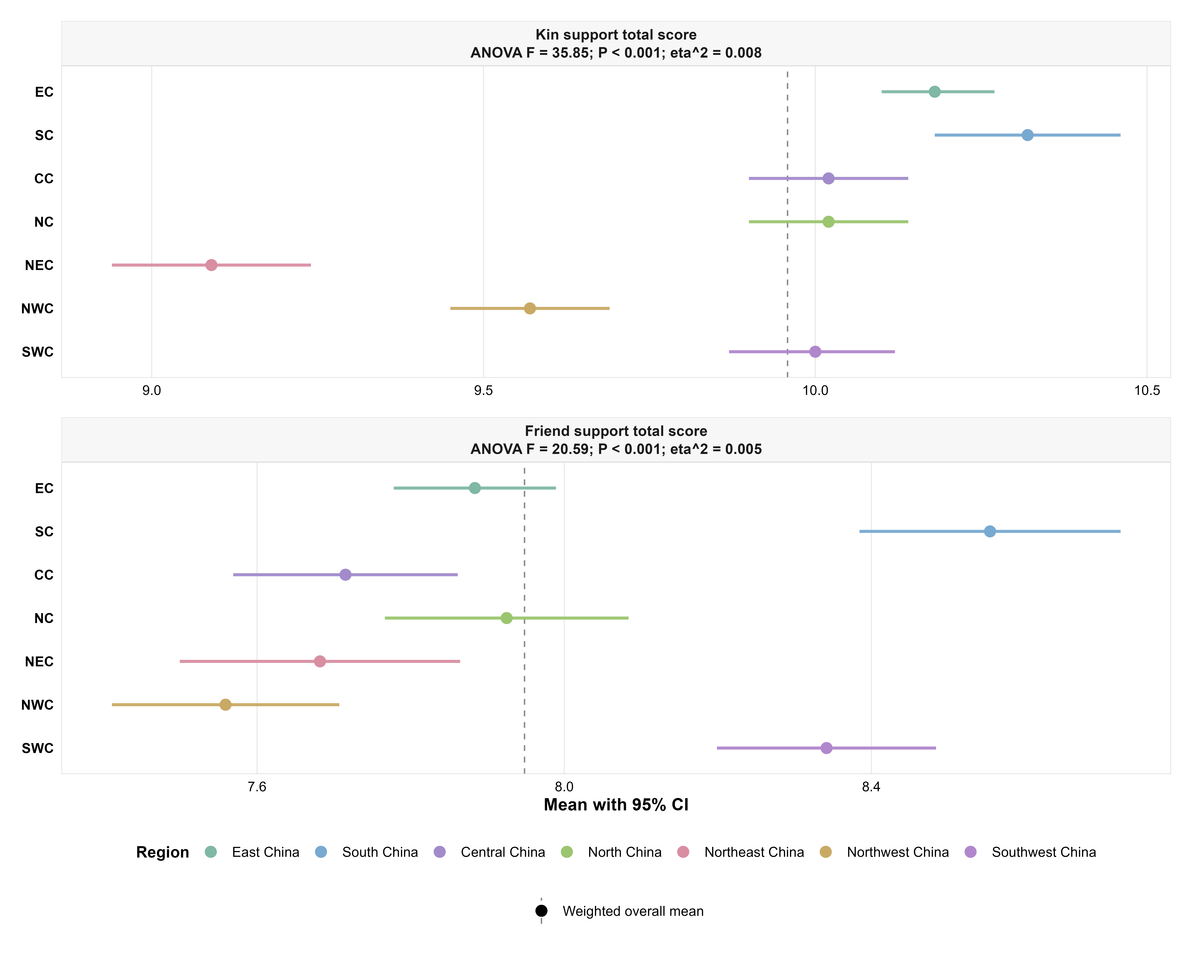
Supplementary Fig. S1. Regional distribution of kin support and friend support.
Note. Point-range plots show regional means and 95% confidence intervals for kin support total score and friend support total score. Dashed vertical lines indicate the overall mean values.

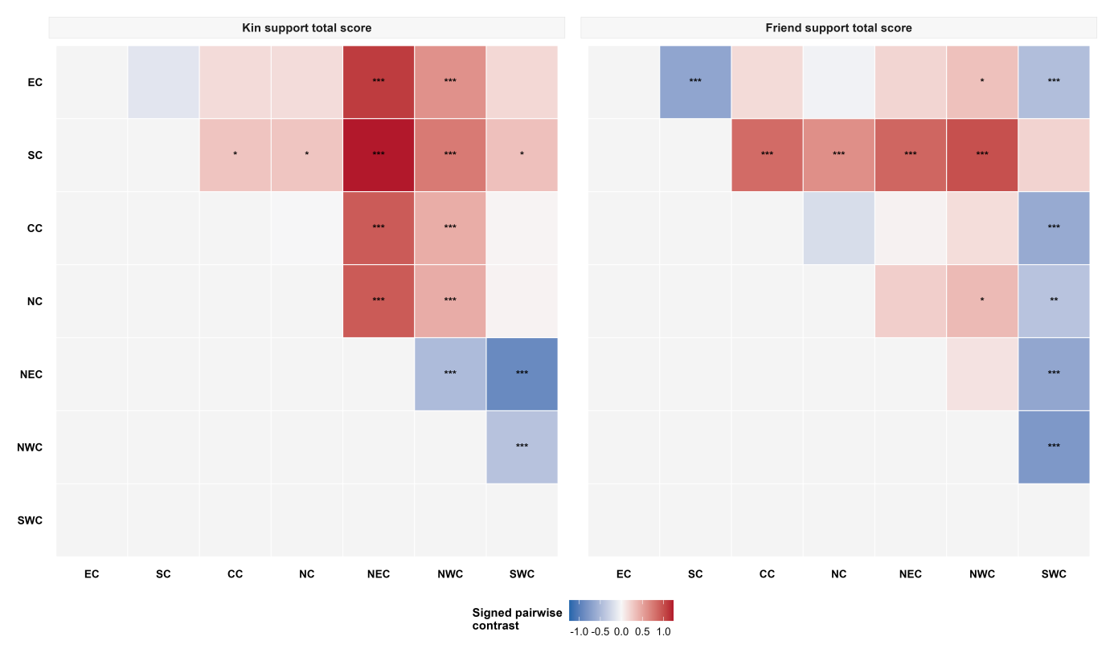
Supplementary Fig. S2. Pairwise regional contrasts for kin support and friend support.
Note. Heatmaps show signed pairwise contrasts for kin support total score and friend support total score. Significance markers indicate adjusted pairwise comparison results. EC = East China; SC = South China; CC = Central China; NC = North China; NEC = Northeast China; NWC = Northwest China; SWC = Southwest China.

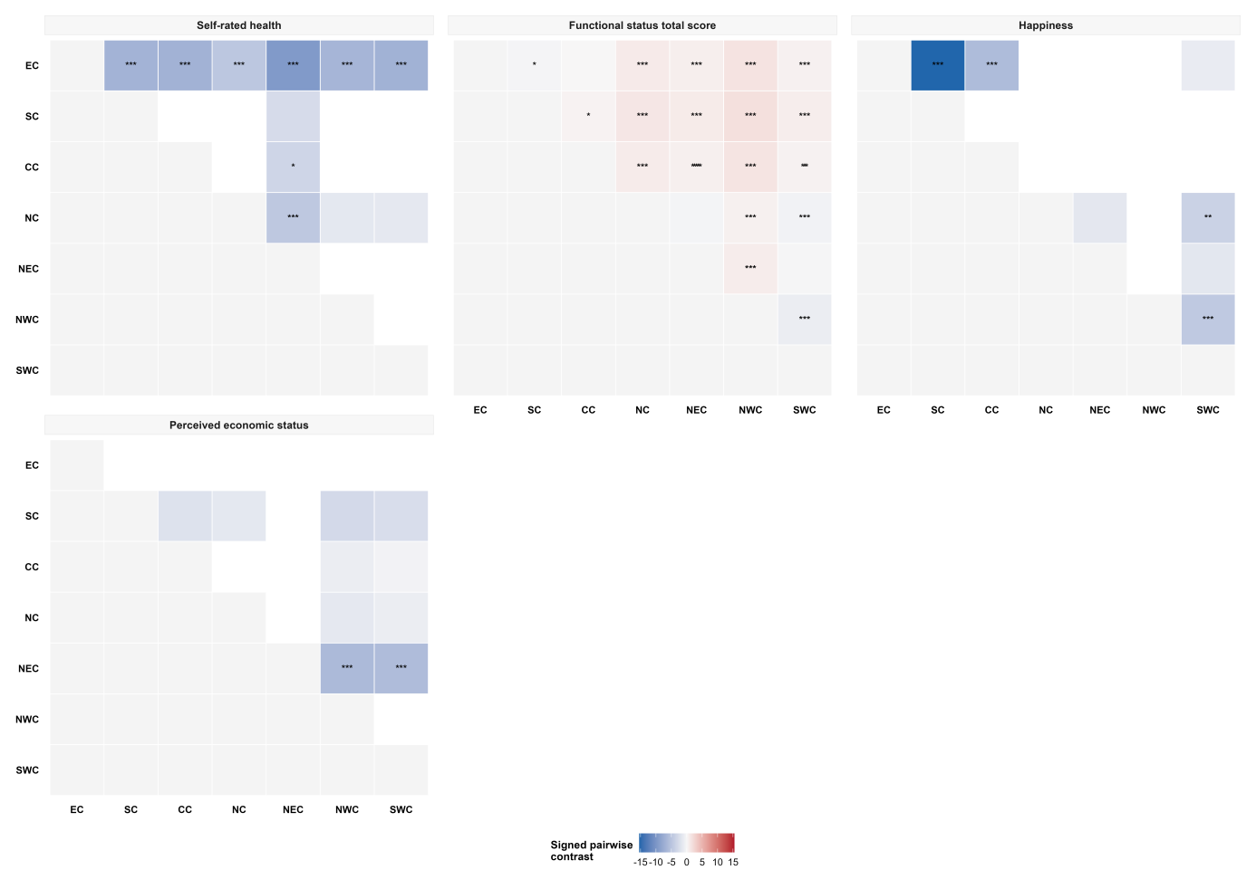
Supplementary Fig. S3. Pairwise regional contrasts for quality-of-life component indicators.
Note. Heatmaps show signed pairwise regional contrasts for self-rated health, functional status total score, happiness and perceived economic situation. Significance markers indicate Bonferroni-adjusted pairwise comparisons where applicable.

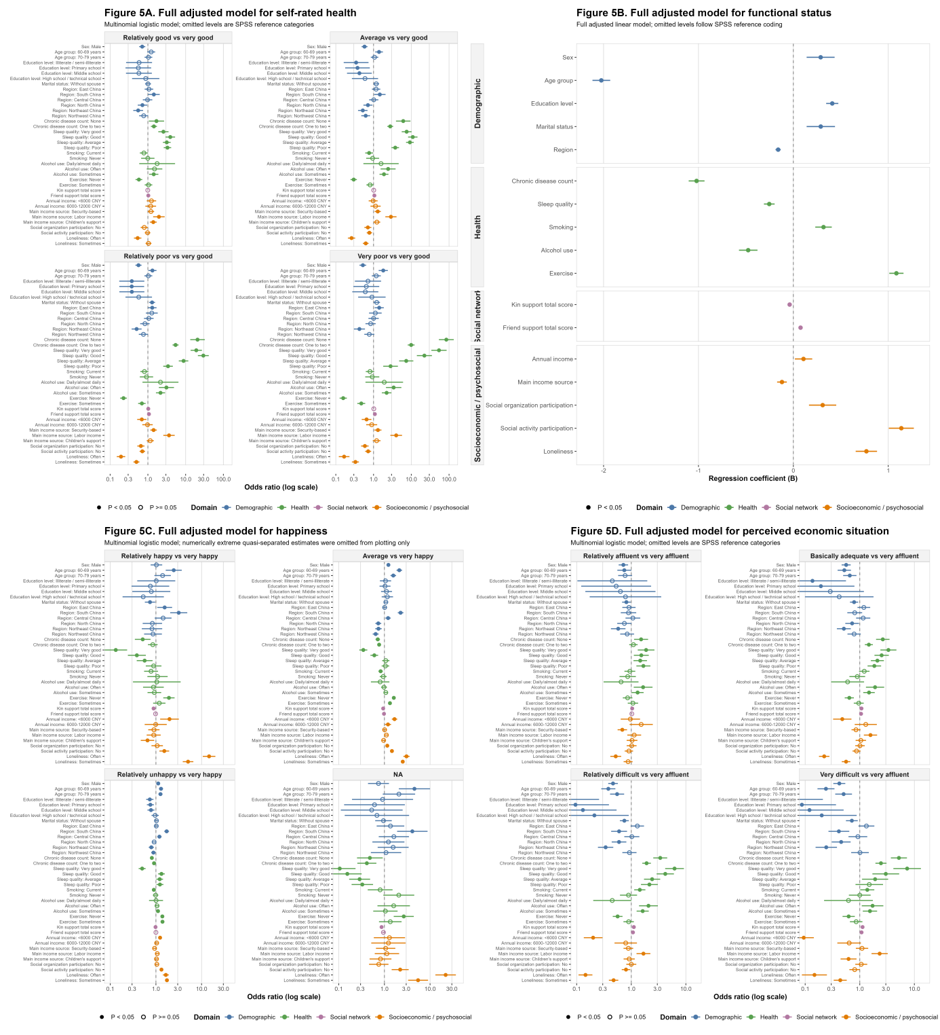
Supplementary Fig. S4. Component-specific secondary analyses for the quality-of-life construct.
Note. The figure presents fully adjusted models for self-rated health, functional status, happiness and perceived economic situation. Self-rated health, happiness and perceived economic situation were analysed using multinomial logistic regression, whereas functional status total score was analysed using linear regression.

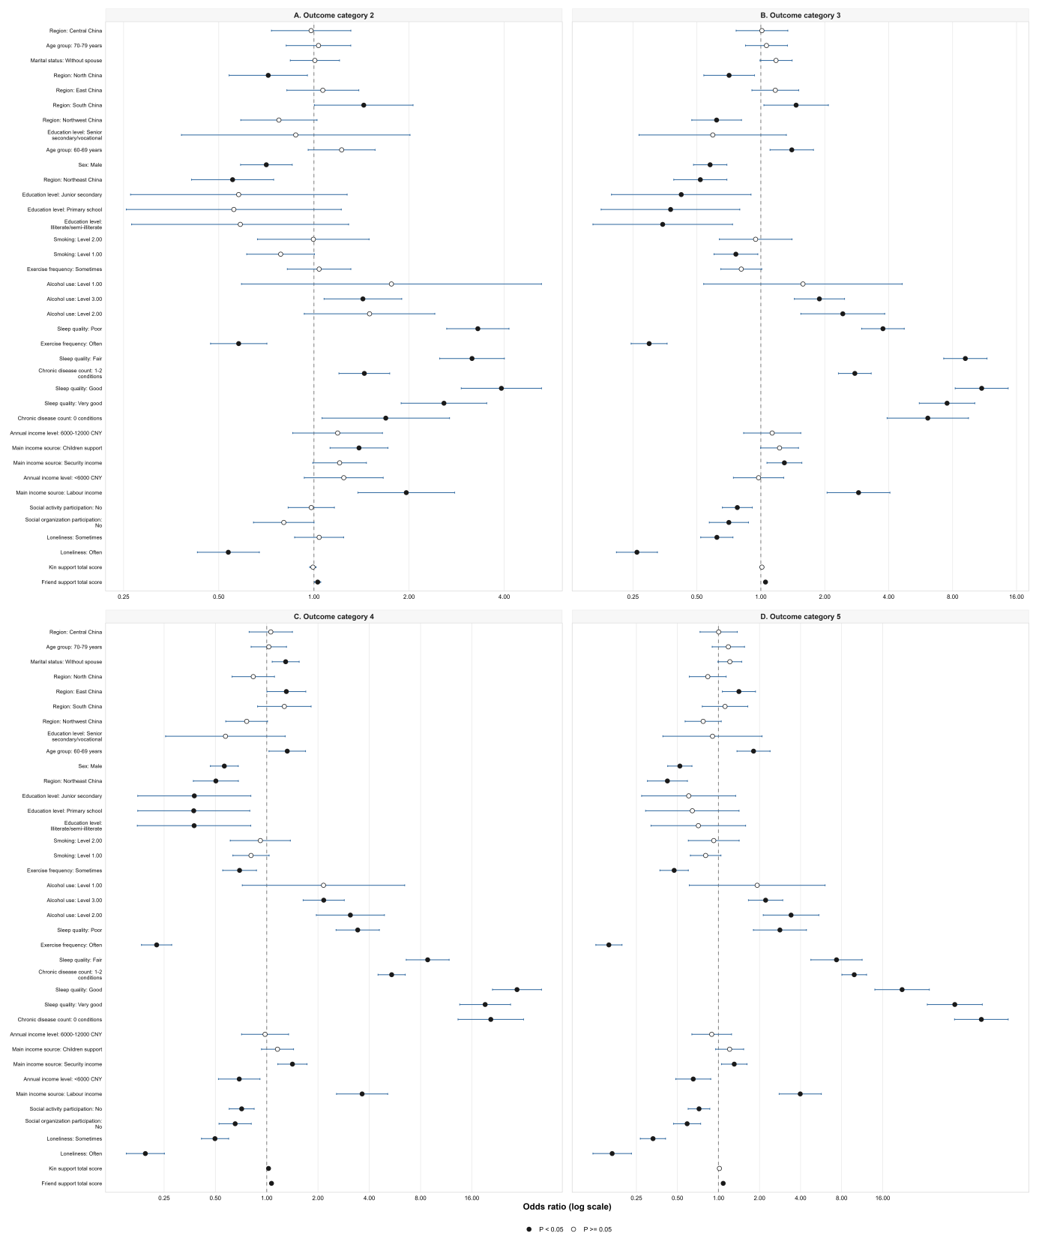
Supplementary Fig. S5. Detailed multinomial model for self-rated health.
Note. The figure presents odds ratios and 95% confidence intervals from the fully adjusted multinomial logistic model for self-rated health. Reference categories follow SPSS reference coding.

Supplementary Fig. S6. Detailed multinomial model for perceived economic situation.
Note. The figure presents odds ratios and 95% confidence intervals from the fully adjusted multinomial logistic model for perceived economic situation. Reference categories follow SPSS reference coding.

