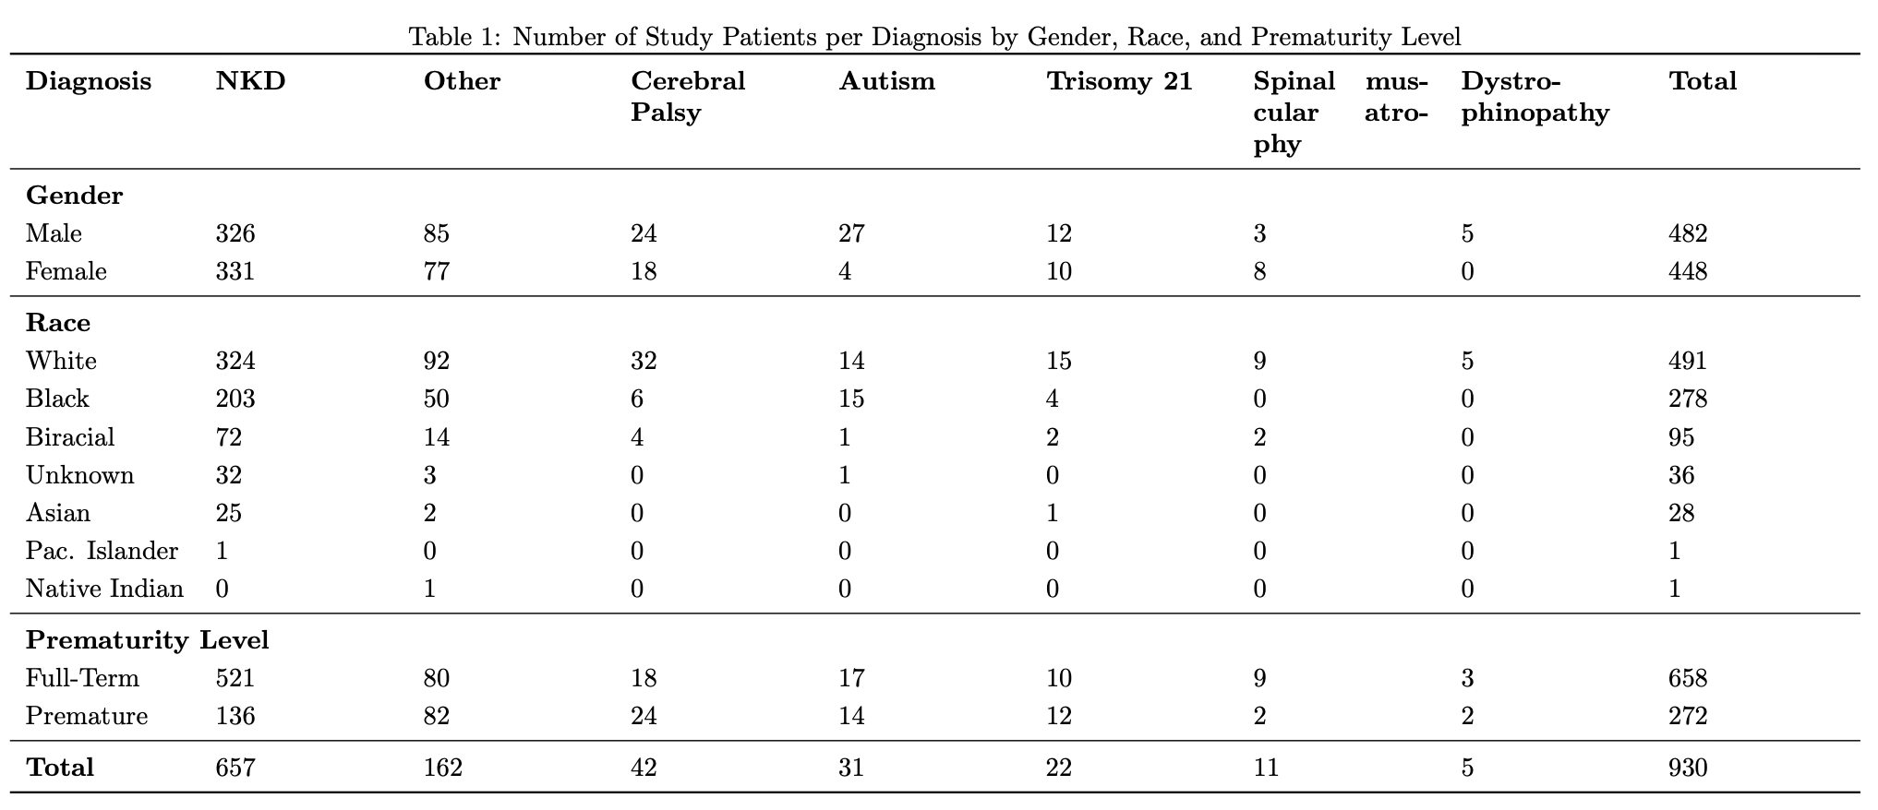
Table 2: Label Definitions for feature sets
Label | Time Series Description
rotation_angle | The rotation angle required to vertically align the shoulders above the hips.
positional, no_asym | Processed positional data corresponding to x- and y-values for the 12 joints considered in this study.
positional, asym | The asymmetry (or difference) between left and right joint counterparts based on positional data.
single_joint_framewise, no_asym | The distances between a joint’s current location and its location in the previous frame.
single_joint_framewise, asym | The asymmetry between left and right counterparts based on single joint framewise distances.
single_joint_centroid, no_asym | The distances between a joint’s current location and its centroid location for the entire video (excursion).
single_joint_centroid, asym | The asymmetry between left and right counterparts based on single joint centroid distances.
Features with Distances Between:
joint_to_joint (ipsilateral), no_asym | Distances between two joints on the same side of the body (e.g., left wrist to left shoulder).
joint_to_joint (ipsilateral), asym | The asymmetry between left and right counterparts based on ipsilateral joint-to-joint distances.
joint_to_joint (contralateral) | Distances between two joints on differing sides of the body (e.g., left wrist to right wrist). No asymmetry was calculated as these distances are inherently contralateral.
angular, no_asym | The angles between three joints located at the shoulder, elbow, hip, and knee joints.
angular, asym | The asymmetry between left and right counterparts based on angular measurements.

Table 3: Label Definitions for encompassing feature sets
Label | Time Series Included
positional | “positional, no_asym”, “positional, asym”
single_joint_framewise | “single_joint_framewise, no_asym”, “single_joint_framewise, asym”
single_joint_centroid | “single_joint_centroid, no_asym”, “single_joint_centroid, asym”
joint_to_joint | “joint_to_joint (ipsilateral), no_asym”, “joint_to_joint (ipsilateral), asym”, “joint_to_joint (contralateral), no_asym”
angular | “angular, no_asym”, “angular, asym”
asym | All asymmetry-related time series data
all | All time series data

