Supplementary Figures:
Supplementary Figure 1: Overview of the study design for metaproteome (with red arrows) (ALF; n=40), and metabolome (with green arrows) (ALF; n=40) (ALF; n=230) done in training cohort and test cohort (plasma and one drop blood)
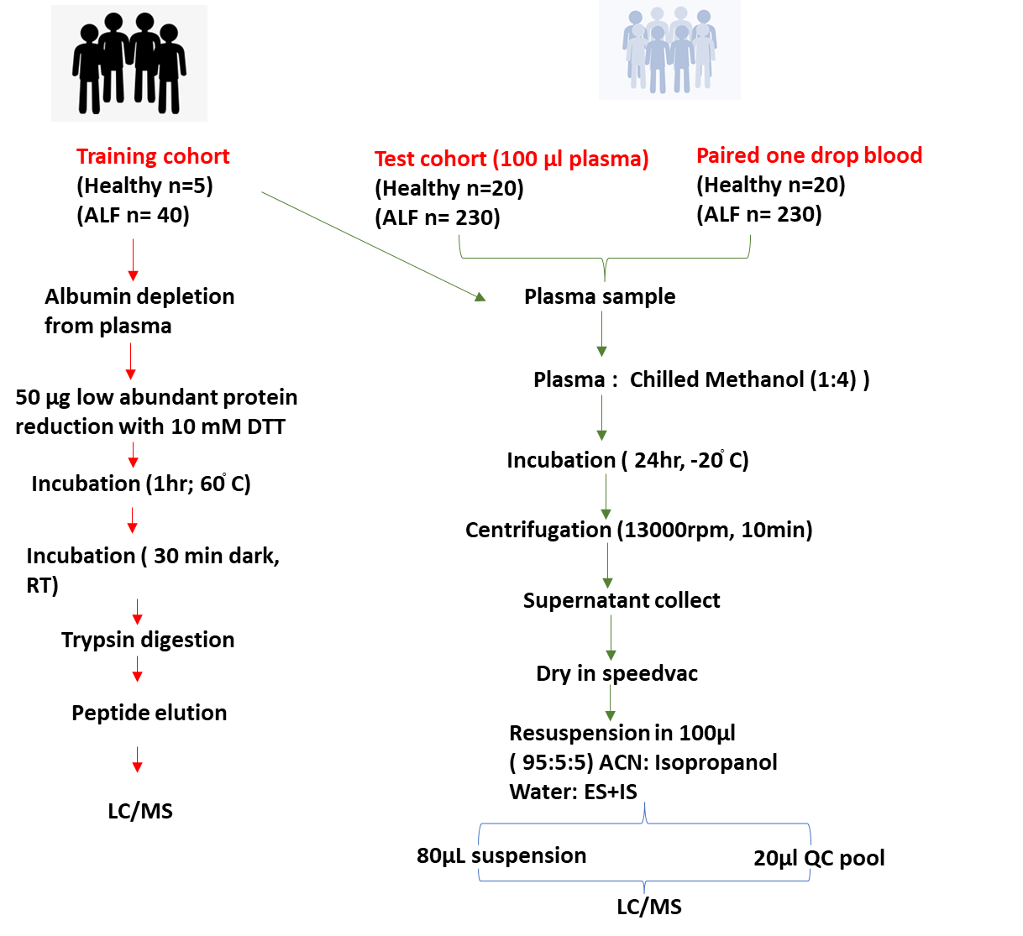

Supplementary Figure 2: Flow chart of statistical analysis performed for Integrated Analysis of Plasma Metabolome and Meta-Proteome in Baseline Plasma and also to elucidate key Metabolome Indicators of Poor outcomes in Acute Liver Failure Patients.
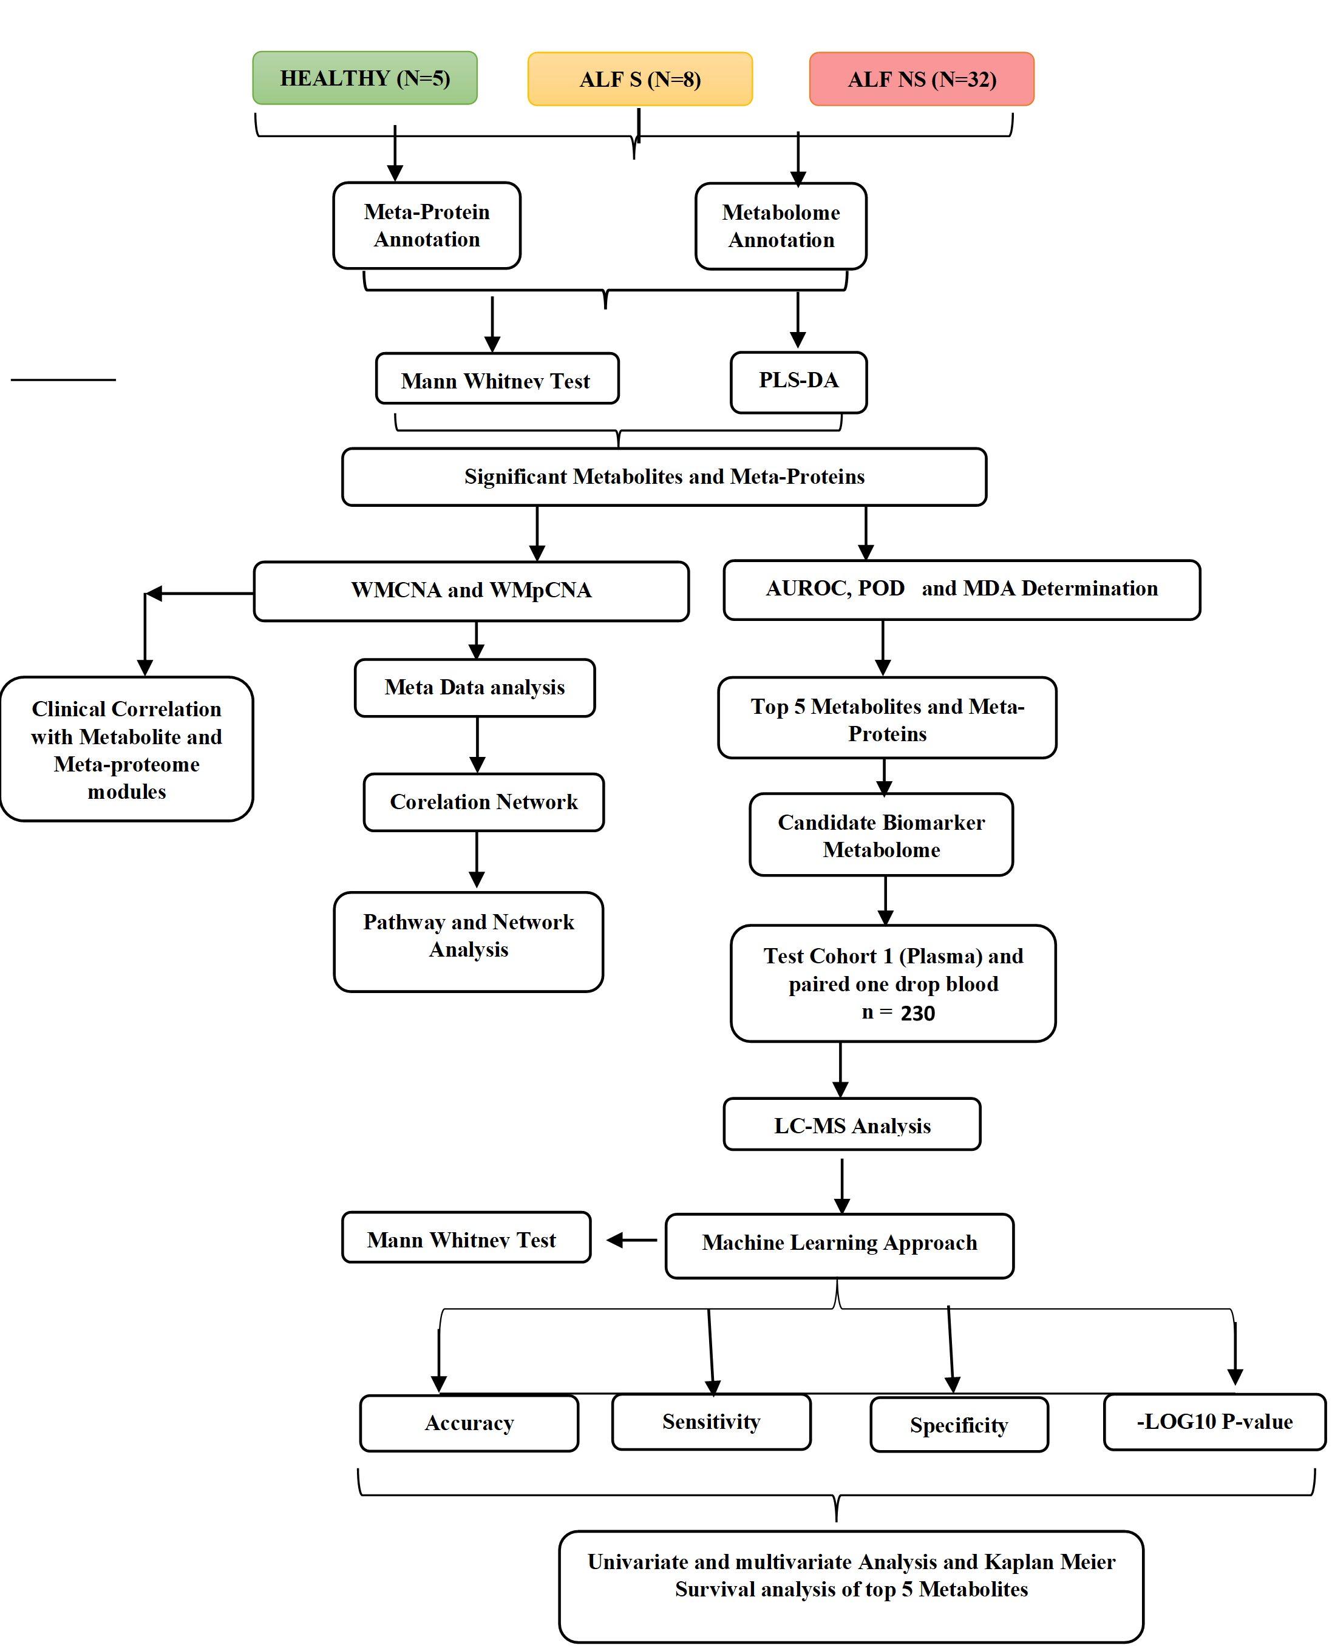

Supplementary Figure 3: Metabolome profile could help to stratify non-survivors of ALF and healthy control detailed in Panel-1
Panel 1- Metabolomics profile of different study groups
- Metabolomics profile of ALF VS Healthy
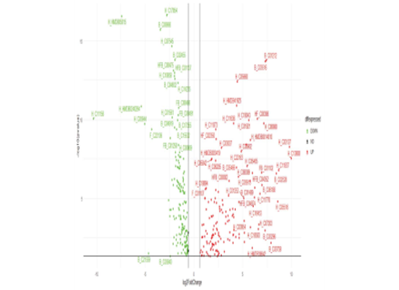
- Volcano plot of ALF vs. Healthy baseline plasma samples in training cohort. green dot; downregulated and red dot; upregulated (FC>1.5, p < 0.05; Mann-Whitney-U-test, FDR<0.01; Benjamini-Hochberg-correction).
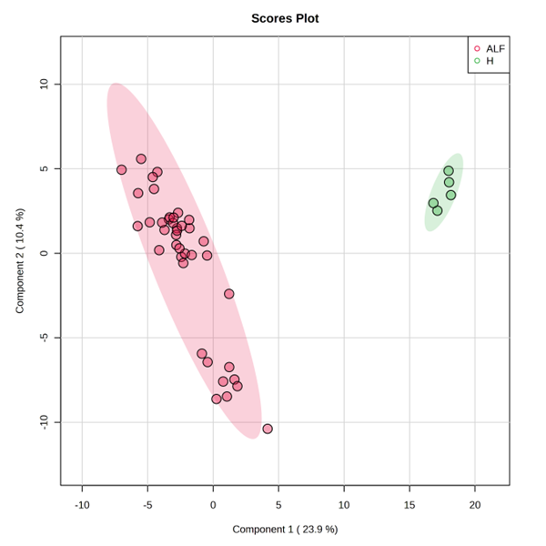
B) Partial Least Squares - Discriminant Analysis (PLS-DA) Plot showing clear separation of protein species in Acute liver failure and healthy control samples with ALF; HC revealing component variance
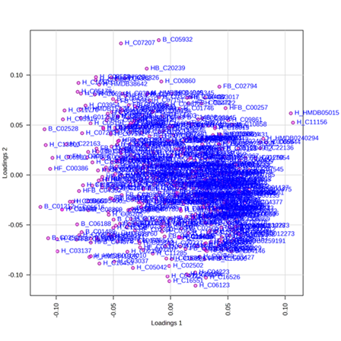
C) Loading plot between the ALF and healthy samples.
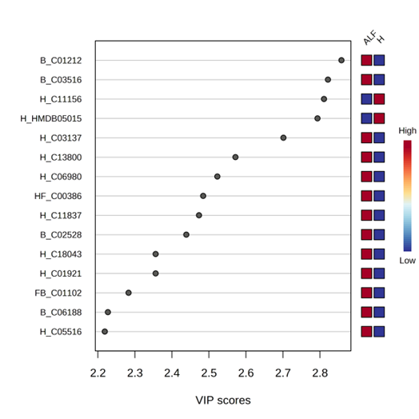
D) VIP scores of important features identified by PLS-DA in ALF and healthy samples.
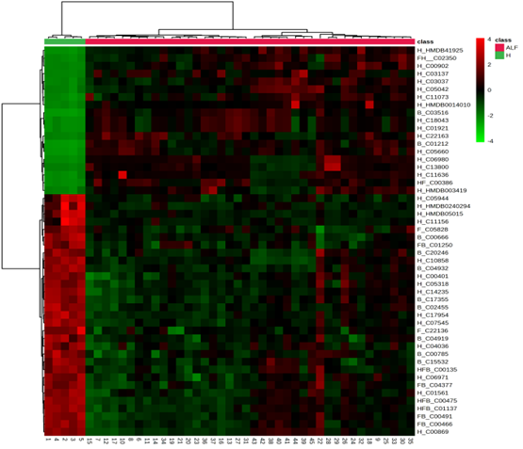

E) Heat map showing hierarchical clustering of 50 different metabolite species from ALF vs Healthy (distance measure using Euclidean, and clustering algorithm using ward D.
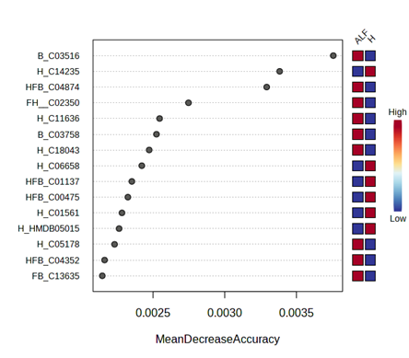
F) 15 different metabolite features identified by Random Forest and ranked by the mean decrease in classification accuracy from ALF VS H.

Supplementary Figure 4: Metabolite profile could stratify non-survivors of Acute liver failure
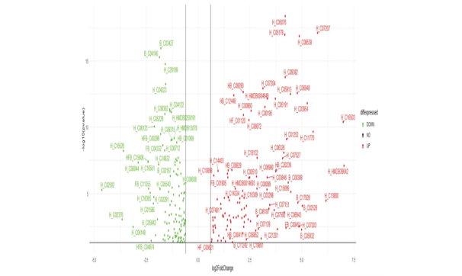
Panel 3- A) Volcano plot of NS vs. S baseline plasma samples in training cohort. green dot; downregulated and red dot; upregulated (FC>1.5, p < 0.05; Mann-Whitney-U-test, FDR<0.01; Benjamini-Hochberg-correction).
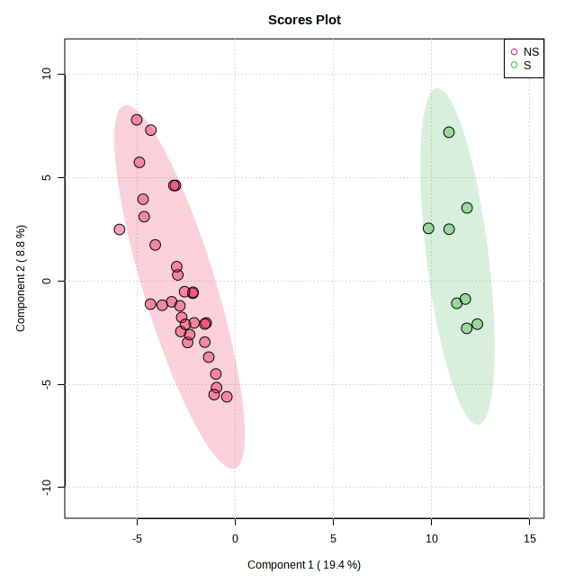
B) Partial Least Squares - Discriminant Analysis (PLS-DA) Plot showing clear separation of metabolite species in with NS vs. S

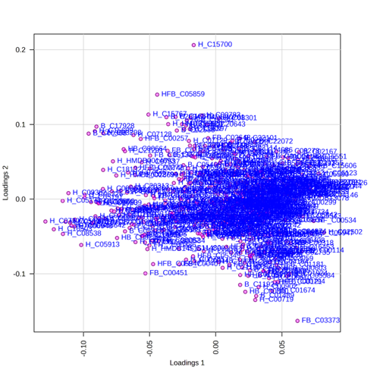
C) Loading plot between the selected components with NS vs. S
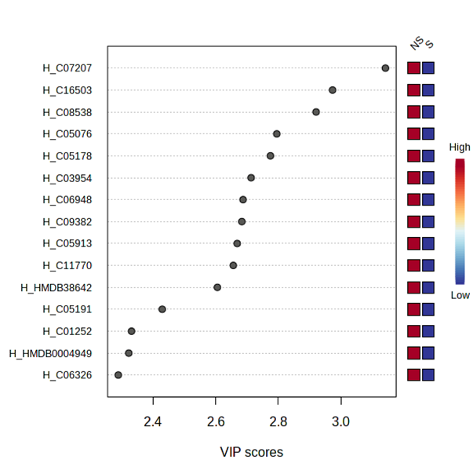

D) VIP scores of important features identified by PLS-DA with NS vs. S

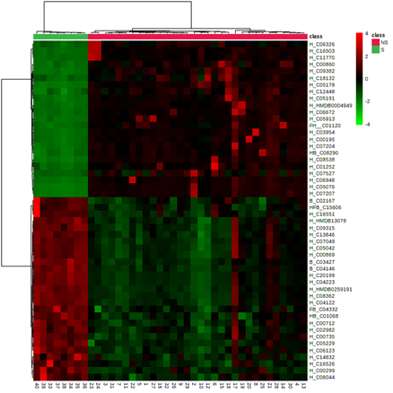
E) Heat map showing hierarchical clustering of 50 different metabolite species from NS VS S (distance measure using Euclidean, and clustering algorithm using ward D.
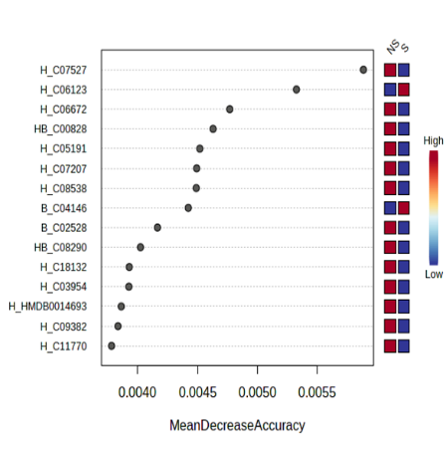
F) 15 different metabolite features identified by Random Forest and ranked by the mean decrease in classification accuracy from NS vs. S

Supplementary Figure 5: Heat map showing hierarchical clustering of 50 different metabolome from ALF vs Healthy and NS VS S (distance measure using Euclidean, and clustering algorithm using ward D and 15 different metabolite features identified by Random Forest and ranked by the mean decrease in classification accuracy from ALF vs Healthy and NS VS S

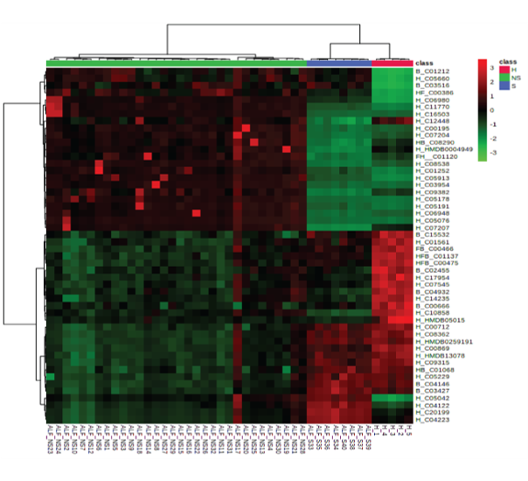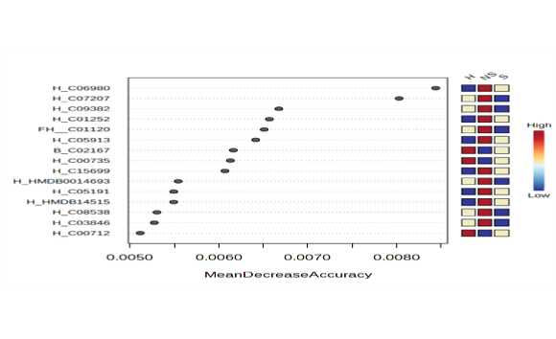

Supplementary figure 6: Meta-proteomics profile of different study groups
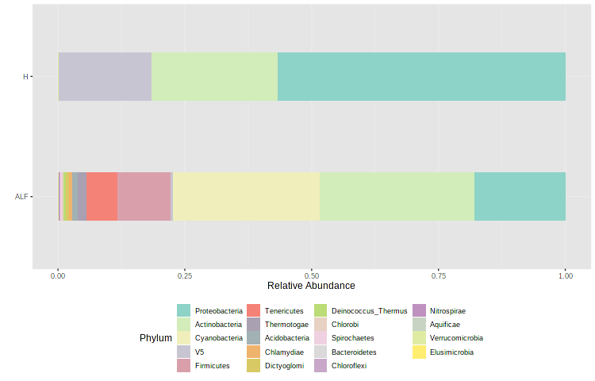

- Metaproteome abundance in the study group ALF VS H at the phylum level (p<0.05).

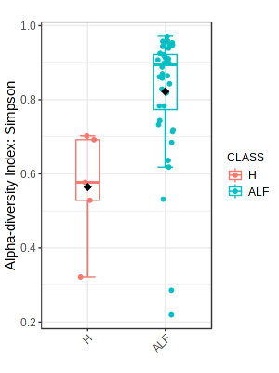
B) Alpha diversity indices (Shannon/Simpson index) in metaproteome of ALF VS Healthy.

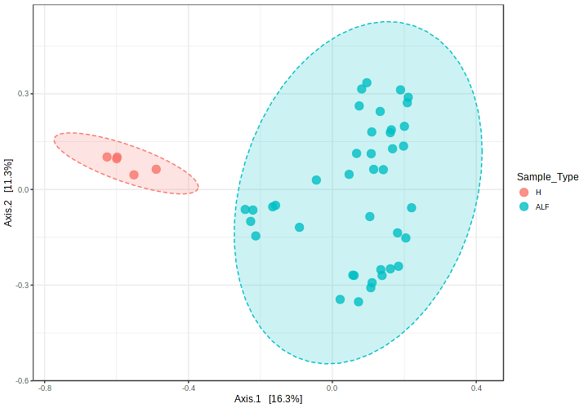
C) Beta Diveristy plot plot showing clear separation of metaproteome in ALF VS H.

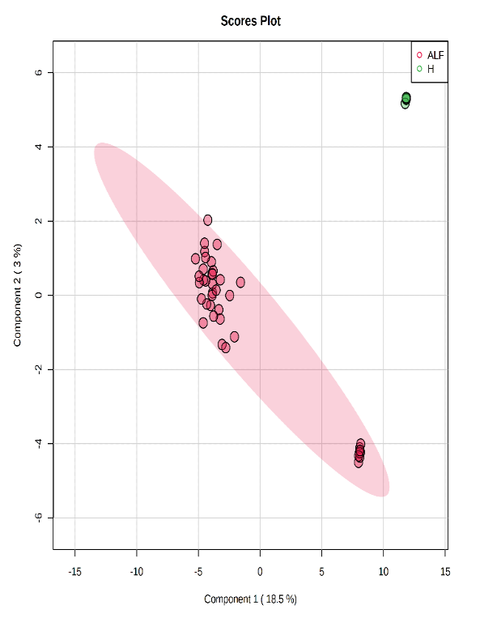
D) Partial Least Squares - Discriminant Analysis (PLS-DA) Plot showing clear separation of metabolite species in with ALF Vs H

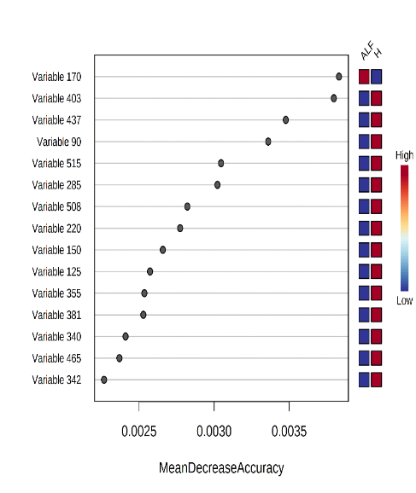
E) 15 different Bacterial features identified by Random Forest and ranked by the mean decrease in classification accuracy from ALF Vs H

Supplementary Figure 7: Meta-proteomics profile of different study groups
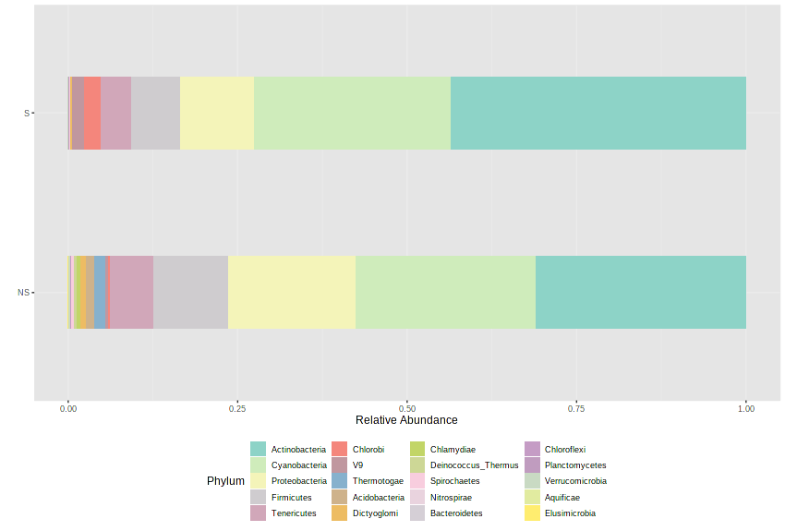
- Metaproteome abundance in the study group NS VS S at the phylum level (p<0.05).

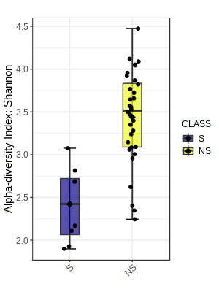
- Alpha diversity indices (Shannon/Simpson index) in metaproteome of NS VS S.
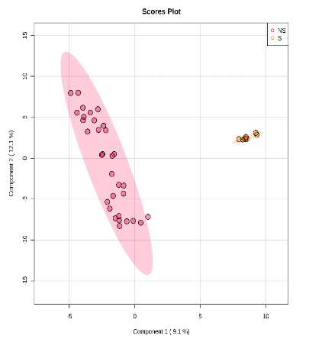
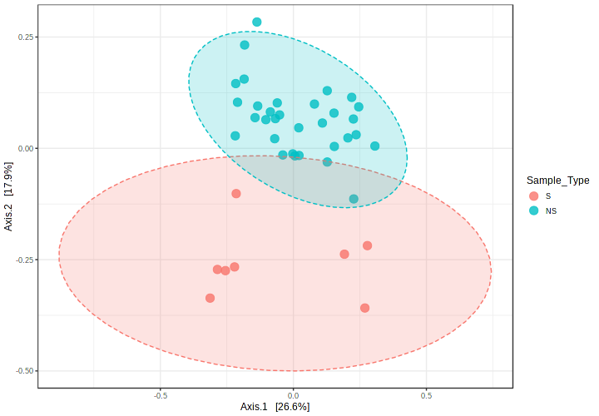
C) Partial Least Squares - Discriminant Analysis (PLS-DA) Plot showing clear separation of metabolite species in with NS VS S

D) Beta Diveristy plot plot showing clear separation of metaproteome in NS VS S.

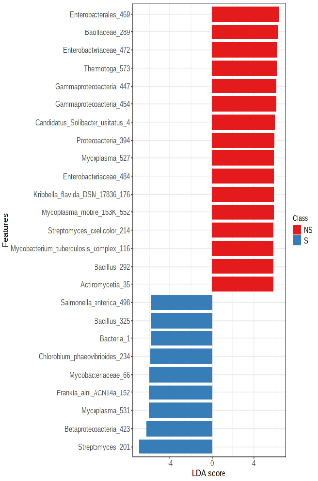
E) LDA scores for bacterial peptides in NS VS S
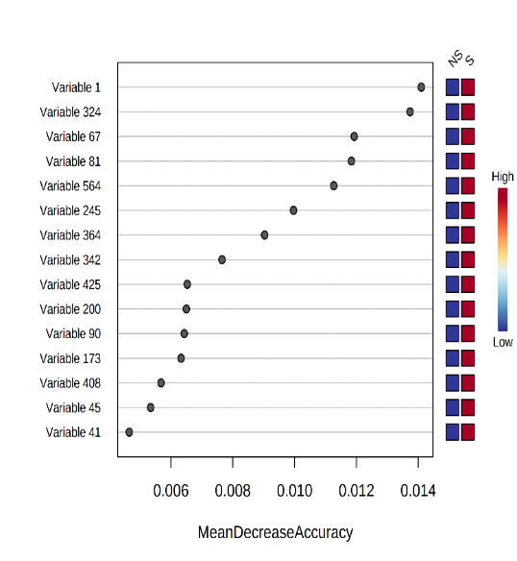

F) 15 different Bacterial features identified by Random Forest and ranked by the mean decrease in classification accuracy from NS VS S

Supplementary Figure 8:
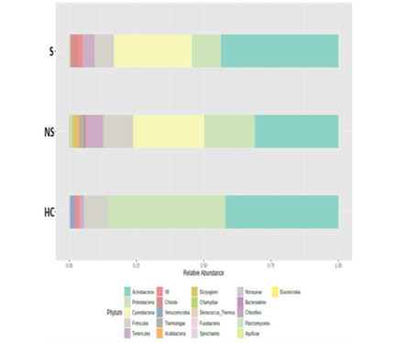
- Relative metaproteome abundance (ALF-Survivor; ALF-Non-Survivor, Healthy-control) at phylum and genus levels (p < 0.05)
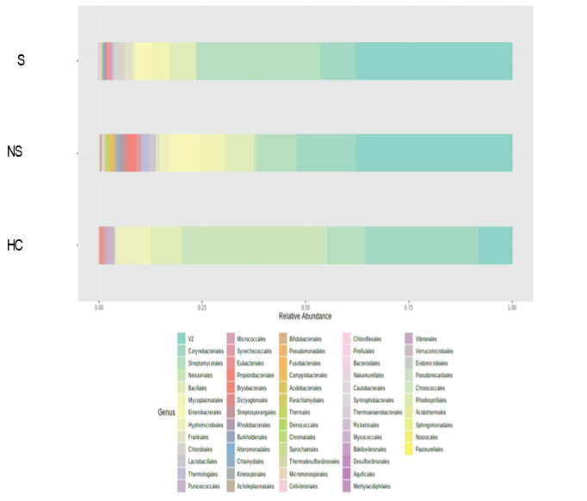

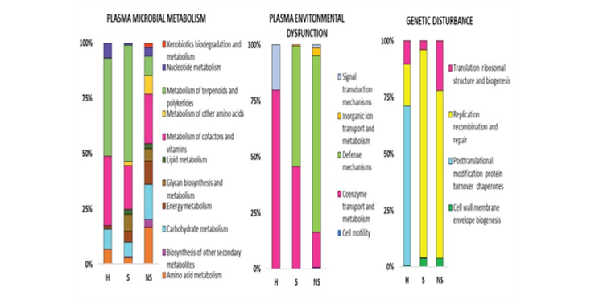
(B) Cluster of Orthologous Groups function analysis of bacterial peptides in study groups HC, ALF-S, and ALF-NS.

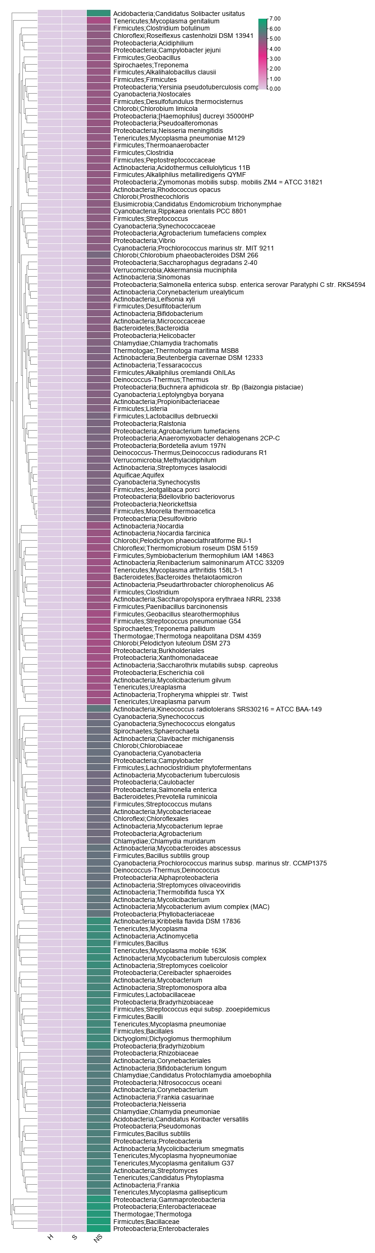
Supplementary figure 9: Bacterial features associated with different WMpCNA module
Turquoise
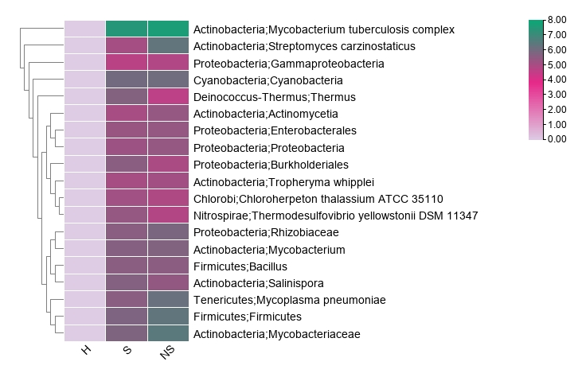
Yellow

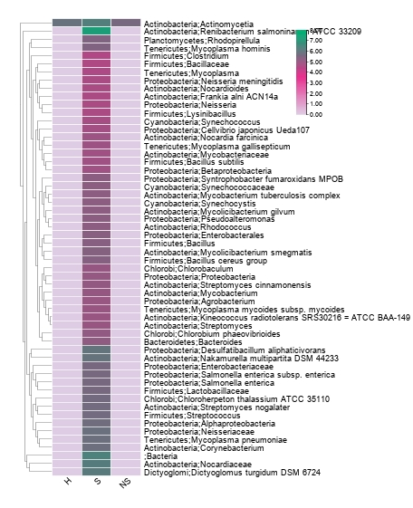
Blue
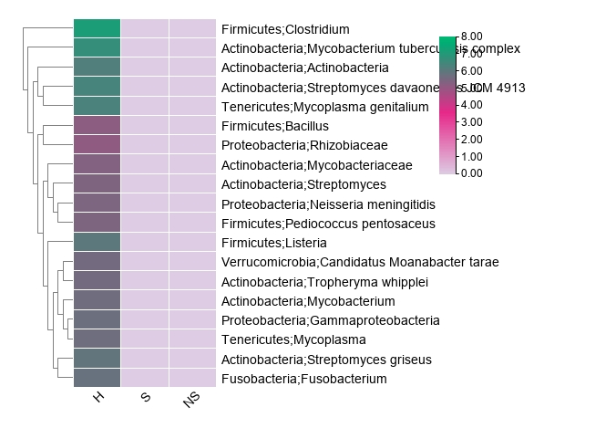
Brown
Supplementary Figure 10: Correlation plot of functions annotated from directly correlating Mp functionality and metabolome modules
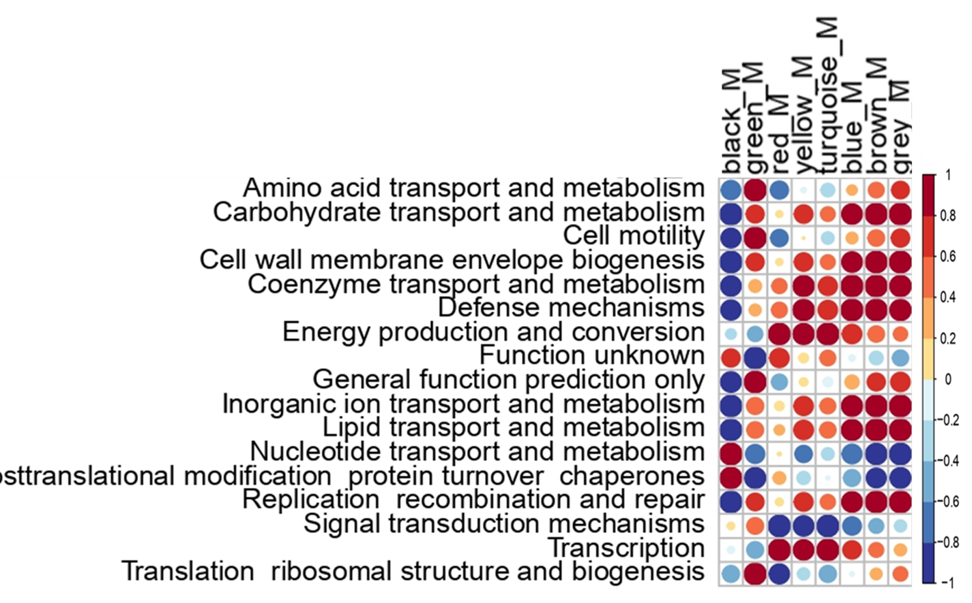

Supplementary Figure 11: Correlation plot of bacteria directly correlate with metabolic pathway (R2>0.5;P<0.05)

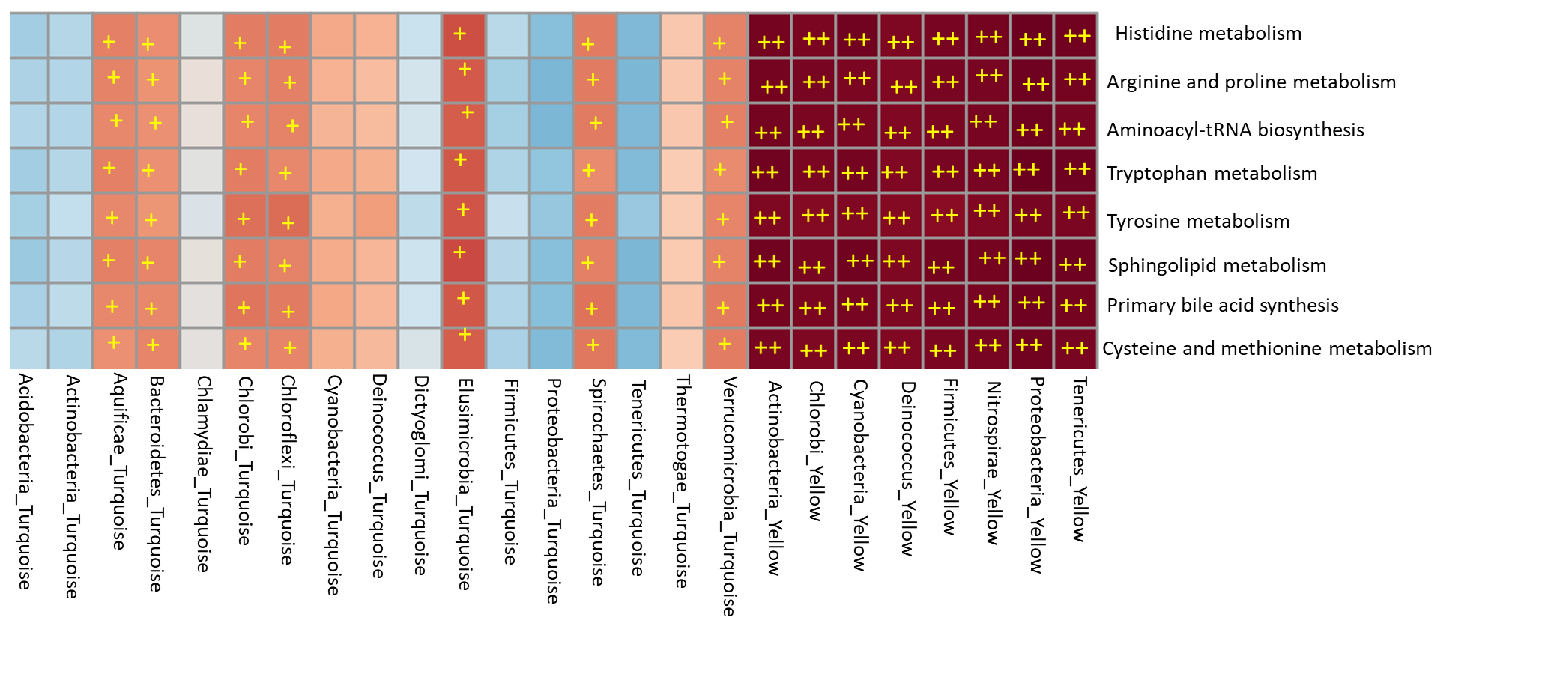

Supplementary Figure 12: Linear regression of the meta-protein’s turquoise module with the clinical complication of ALF
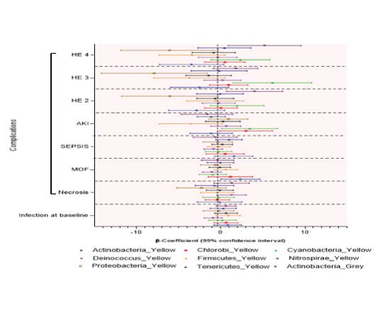
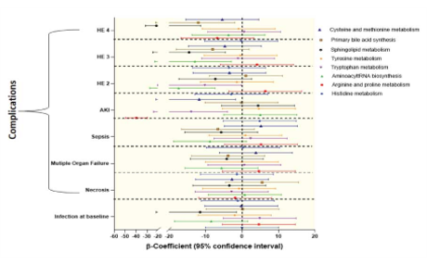

Supplementary Figure 13: Meta-proteomic analysis on the basis of etiology (HEV, DILI, HAV and Others)
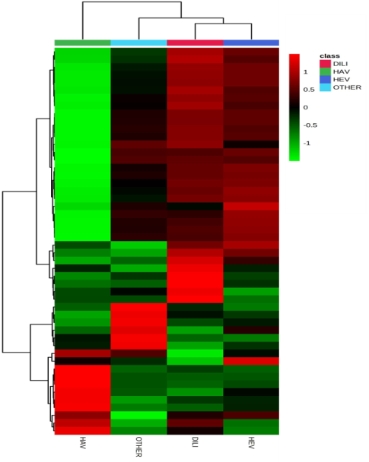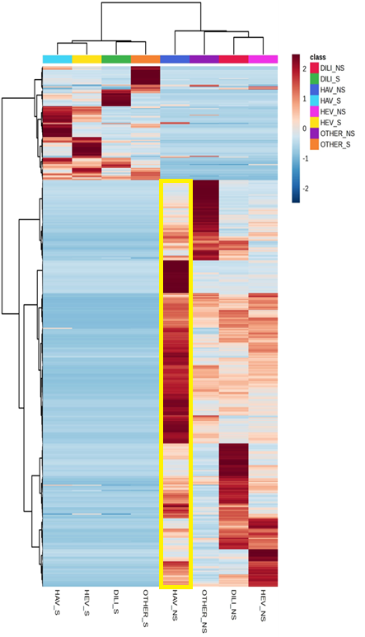
Figure 1A- Unsupervised hierarchical clustering with different etiology showing meta-proteomic phylum LCA signatures is capable to segregate ALF-Non-Survivor. The expression is given as Red; upregulated, Green; downregulated, and Black; unregulated (p<0.05; Kruskal-Wallis-test)
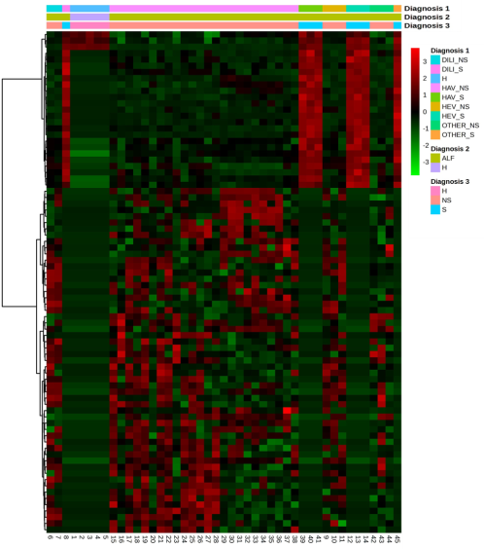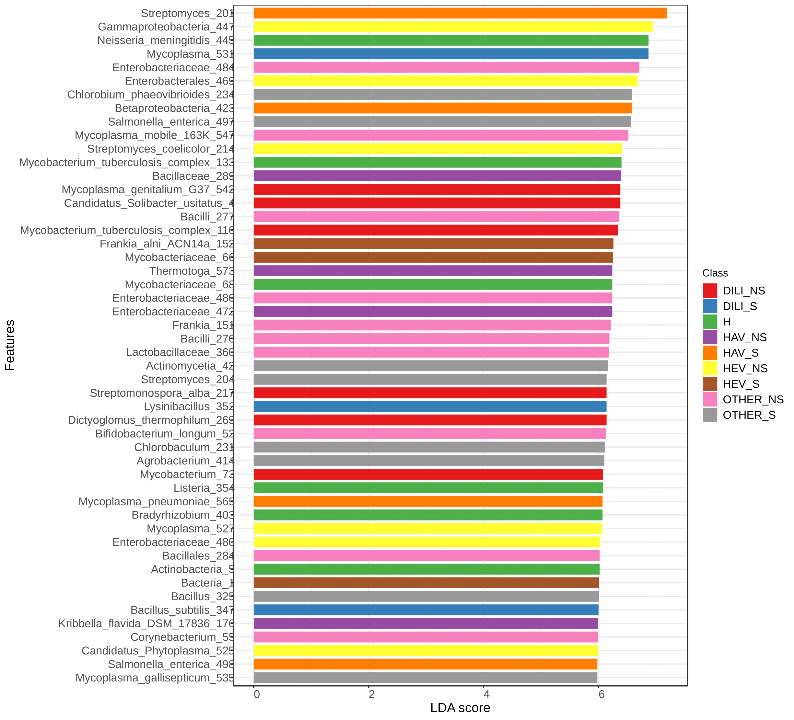
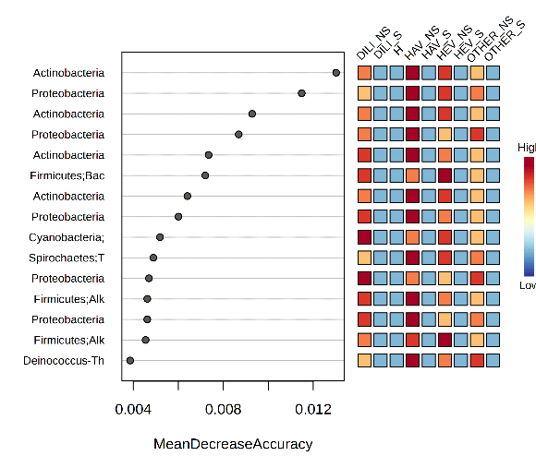
Figure 1B- Linear Discriminating Analysis (LDA) of bacterial peptides in different etiology study group, ALF-survivor, ALF-non-survivor (p < 0.05; Kruskal-Wallis-test) Figure 1C-Mean Decrease in Accuracy showing top 15 bacterial peptides along (Red; upregulated and blue; downregulated)

Supplementary Figure14 - Heat map and mean decrease accuracy according to the etiology of the samples.
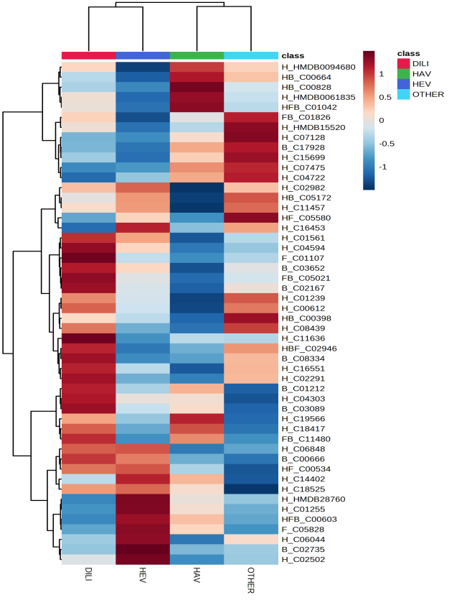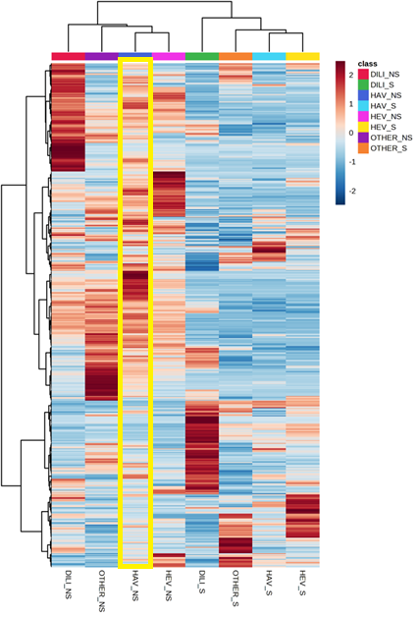
Figure A- Unsupervised hierarchical clustering with different etiology showing metabolome signatures is capable to segregate ALF-Non-Survivor. The expression is given as Red; upregulated, Green; downregulated, and Black; unregulated (p<0.05; Kruskal-Wallis-test)
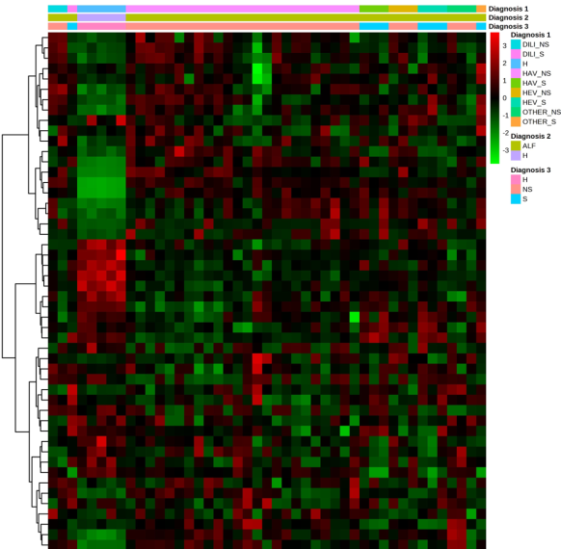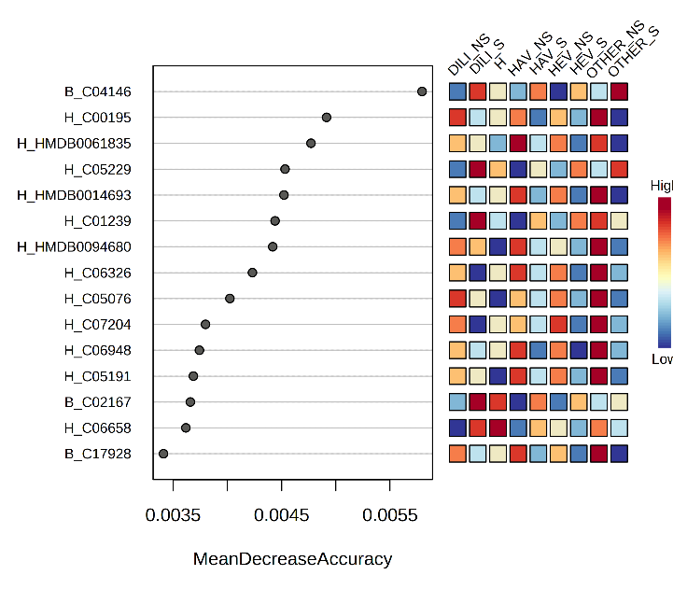
Figure B- Mean Decrease in Accuracy of different etiologies showing top metabolome (Red; upregulated and blue; downregulated). Mean Decrease in Accuracy Others etiologies (Wilson disease, autoimmune and etc) showing top metabolome (Red; upregulated and blue; downregulated).

Supplementary Figure 15: Top 5 metabolites correlation with the variability in the etiology of ALF (a) DILI (Drug Induced Liver Injury) (b) HAV (Hepatitis A Virus) (c) HEV (Hepatitis E virus) (d) Other etiologies (Wilson disease, autoimmune and etc) (GREEN-ALF-S;PURPLE ALF-NS)
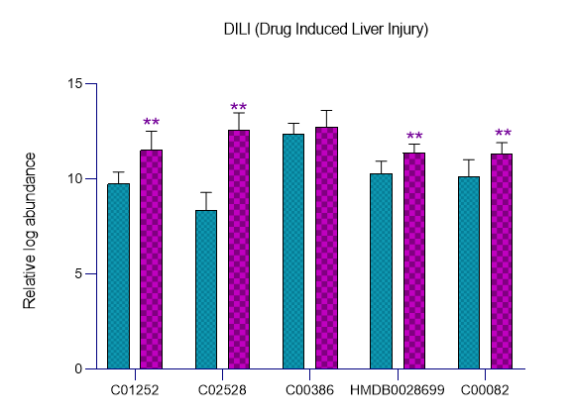
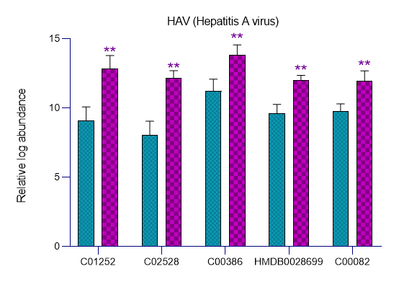
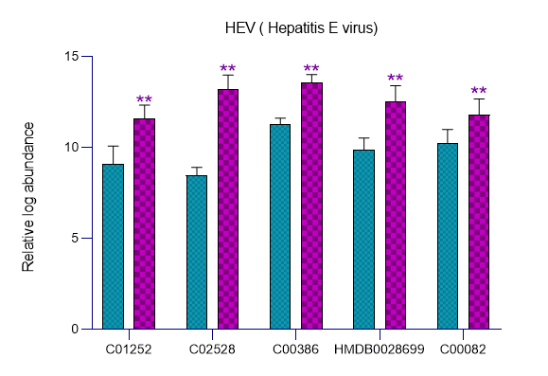
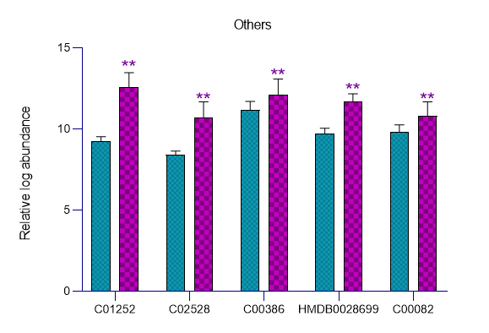

Supplementary Figure 16: Quantitative Assessment of top 5 metabolite in Test-Cohort 2-Disease control (Baseline Plasma-Severe Alcoholic Hepatitis-SAH; n=70) with ALF training-Cohort (p<0.05; Mann-Whitney-U-test)

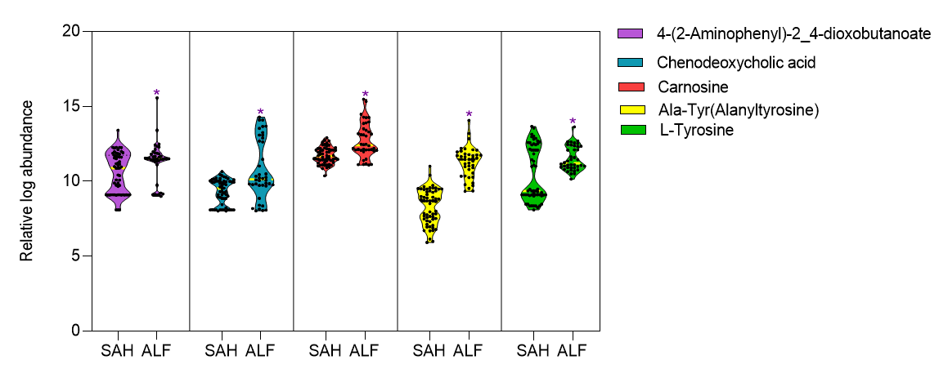

Supplementary Figure 17: Accuracy and kappa value of the different ML models for indicator identification in study group and Accuracy, specificity, sensitivity, and p value of five different metabolome species individually and altogether in test cohort plasma (100µl) and one drop blood along with confusion matrix for different ML models.

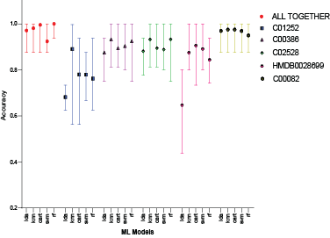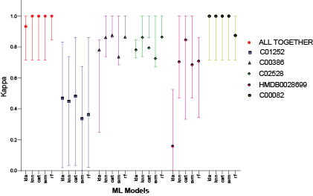
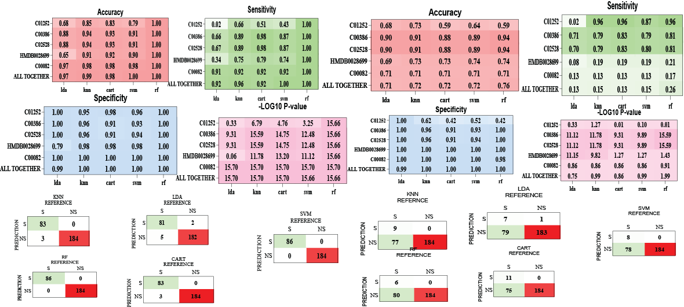

Supplementary Figure 18: Positive predictive value (PPV), Negative predictive value (NPV) and balanced accuracy for their respective models of top 5 metabolites and all together.

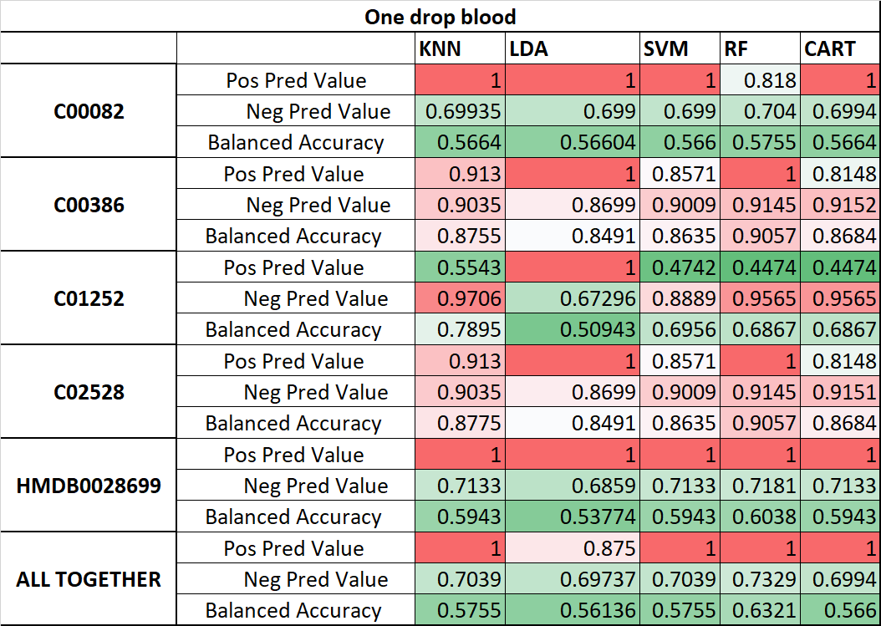
Supplementary Figure 19: Univariate and multivariate cox regression analysis and Kaplan-Meier’s survival analysis of (7 day and 15 day); chenodeoxycholic acid level in ALF-S, ALF-NS and ALF-transplant
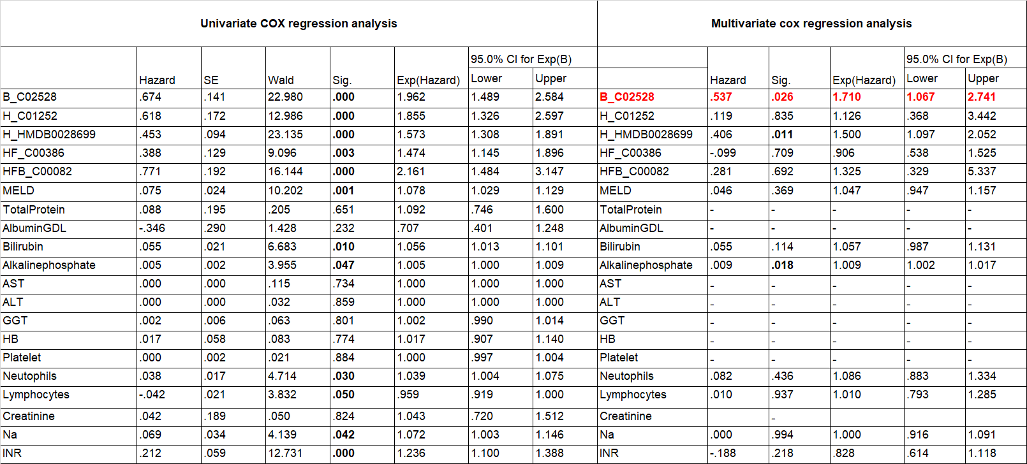

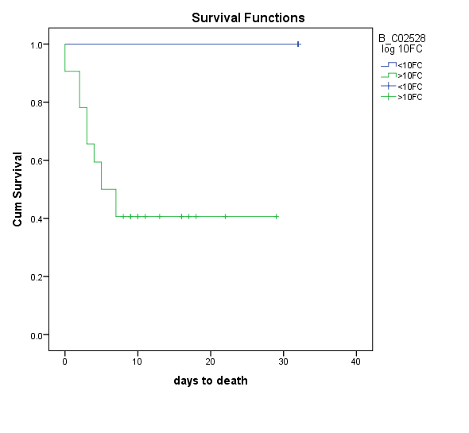
7 day
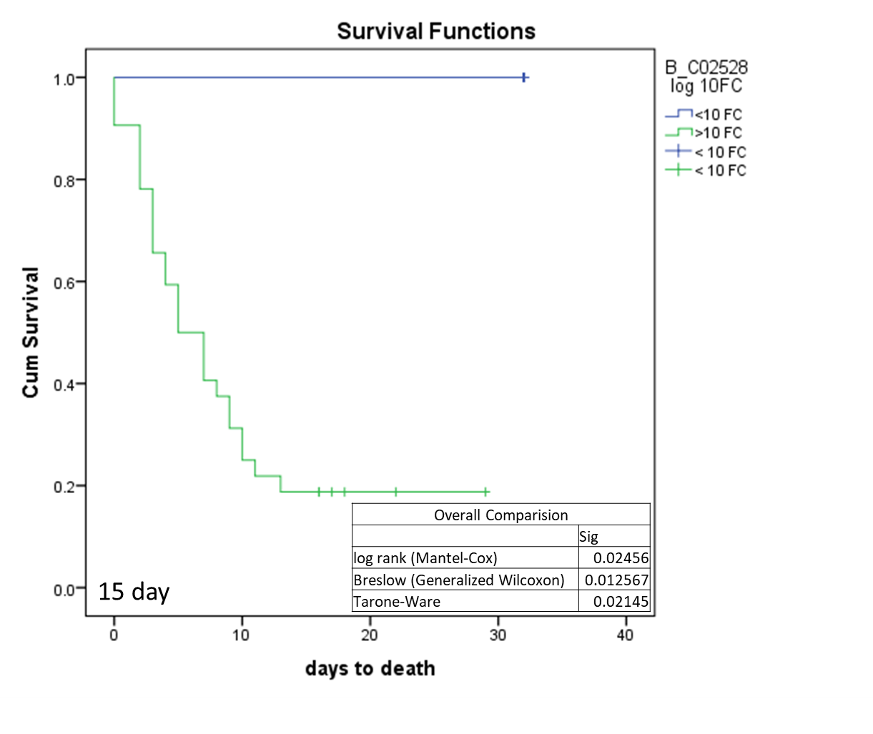
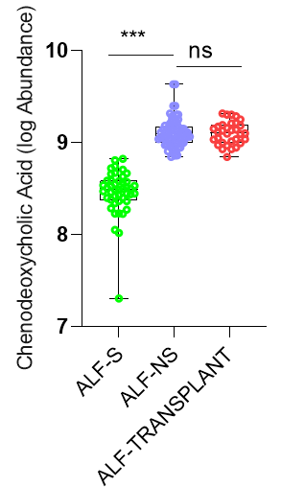

Supplementary Figure 20: Flow diagram for bacterial culture methodology
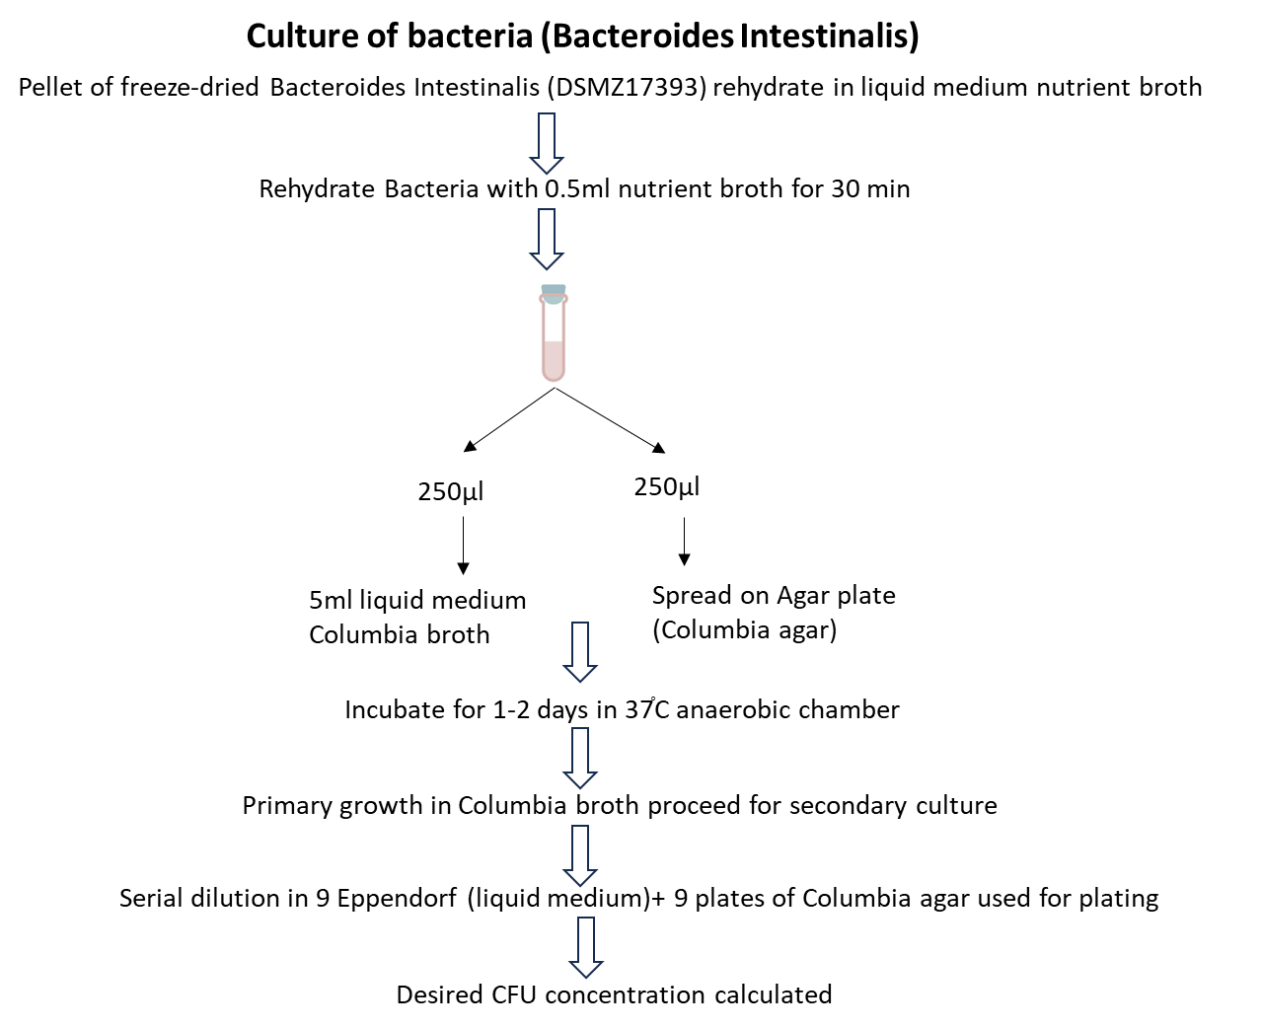

Supplementary Figure 21: Number of animals per group in animal model
No. of animal | Treatment group
10 | Control
6 | APAP_250_24
6 | APAP_250_72
6 | APAP_500_24
6 | APAP_500_72
6 | BI+APAP_250_24
6 | BI+APAP_250_72
6 | BI+APAP_500_24
6 | BI+APAP_500_72
6 | APAP+BI_250_24
6 | APAP+BI_250_72
6 | APAP+BI_500_24
6 | APAP+BI_500_72

Supplementary Figure 22- Liver function test parameter in different groups
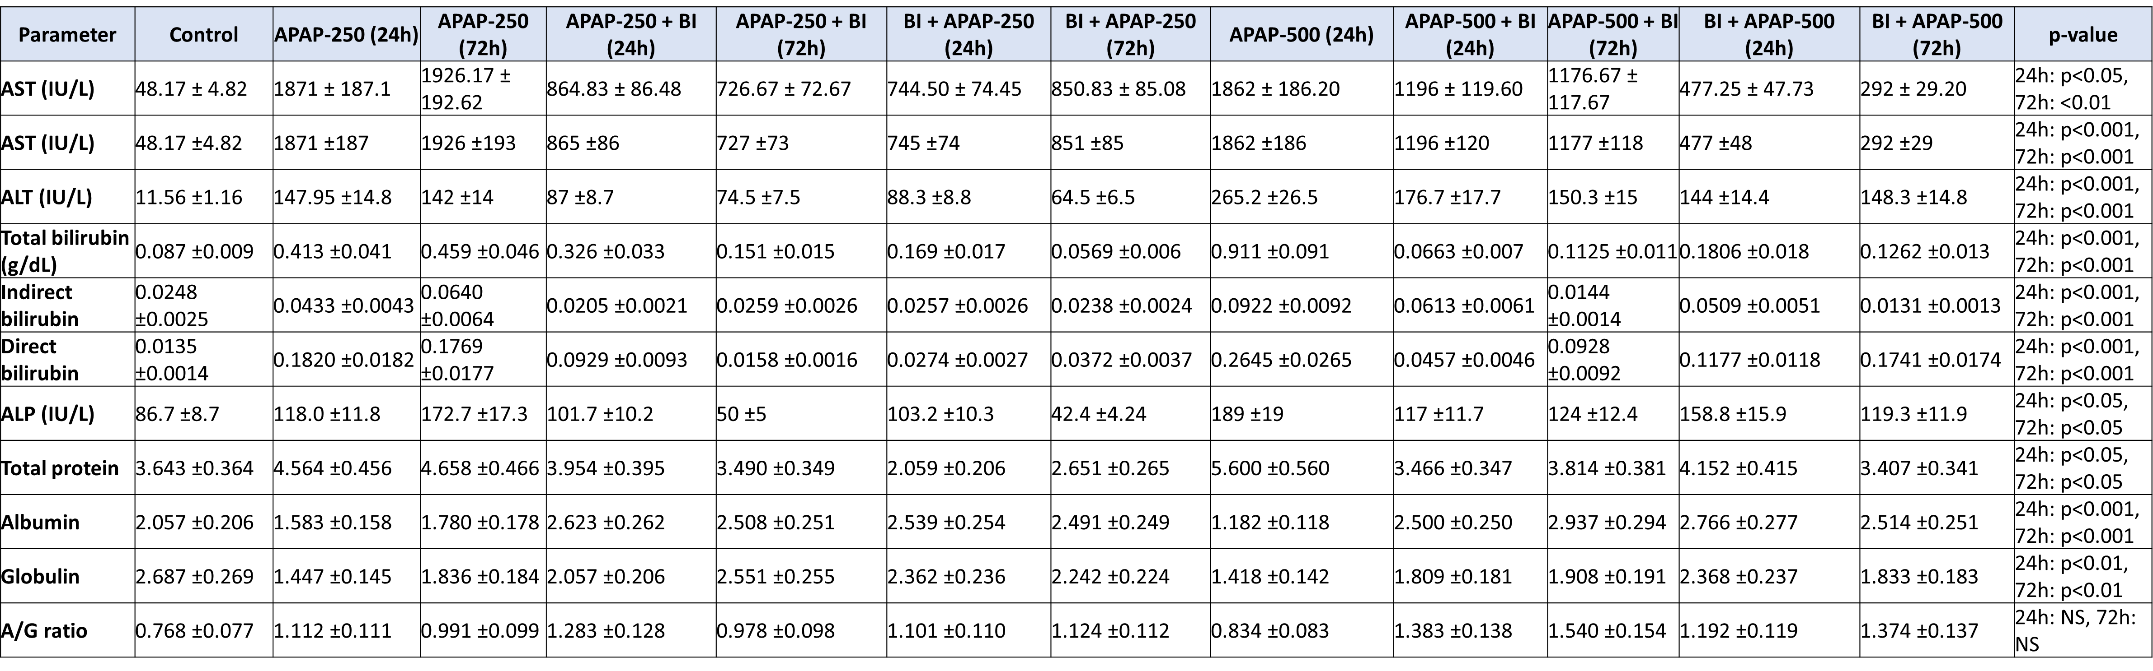

Supplementary Figure 23: MRNA Expression of different bile transported gene in different study groups in liver and intestine.
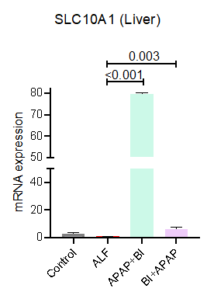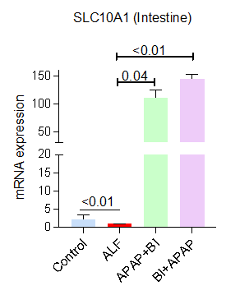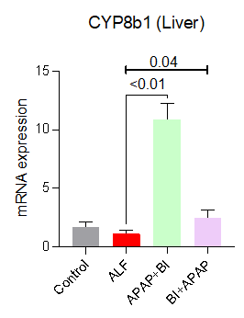
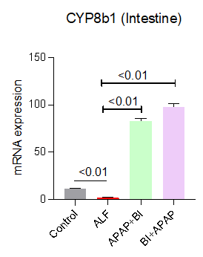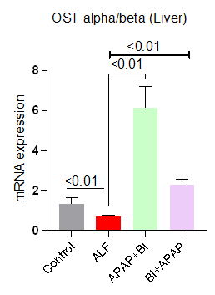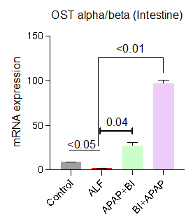

Supplementary Figure 24: Unsupervised hierarchical clustering with different group showing metabolome pathway of plasma is capable to segregate Treatment and ALF (250_72hrs) and control group in mice model
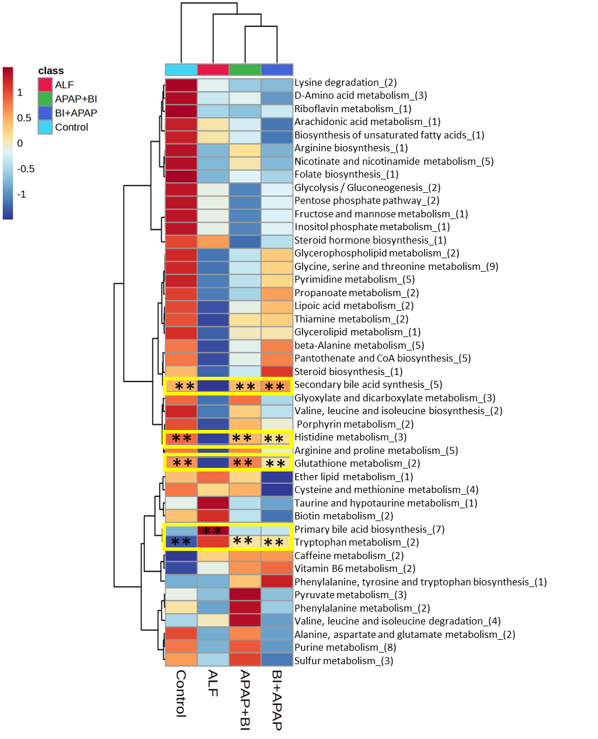

Supplementary Figure 25: Unsupervised hierarchical clustering with different group showing metabolome pathway of plasma is capable to segregate Treatment and ALF (500_24hrs) and control group in mice model

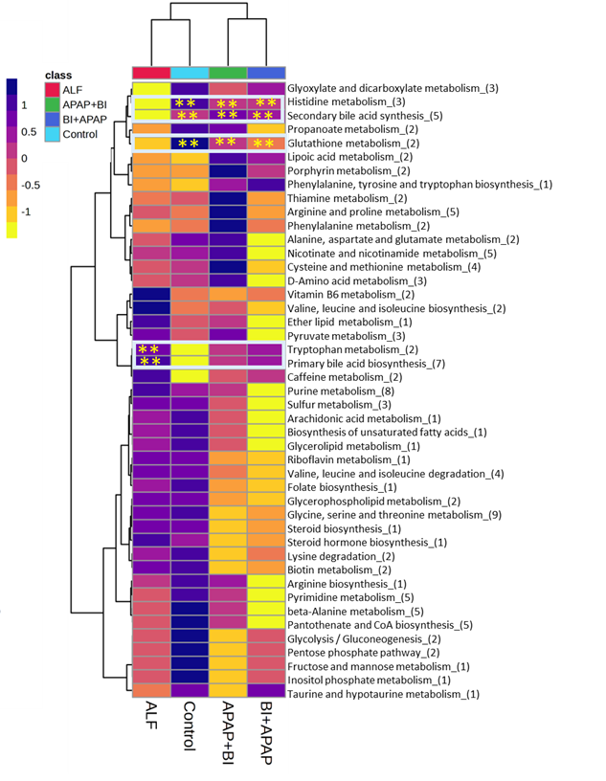

Supplementary Figure 26: Unsupervised hierarchical clustering with different group showing metabolome pathway of plasma is capable to segregate Treatment and ALF (500_72hrs) and control group in mice model

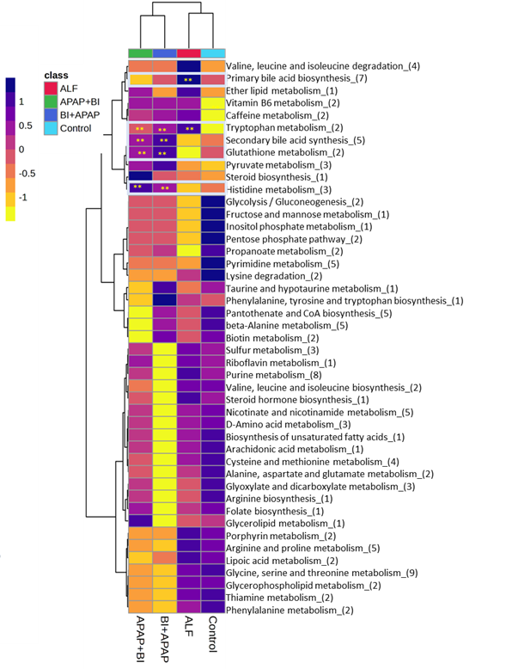

Supplementary figure 27: Unsupervised hierarchical clustering with different group showing metabolome pathway of liver is capable to segregate Treatment and ALF (250_72hrs) and control group in mice model

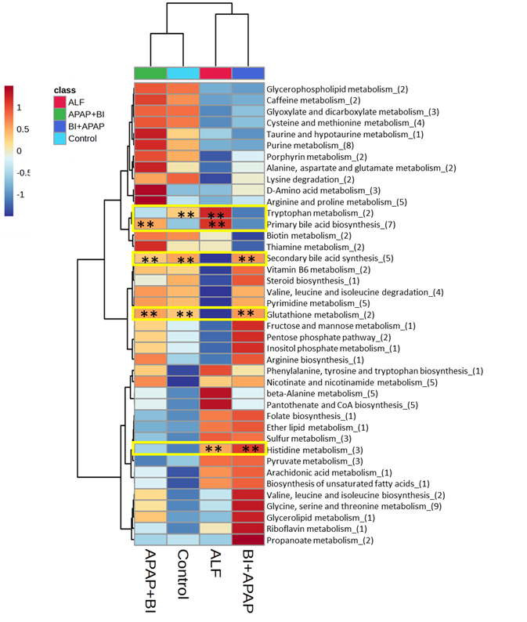

Supplementary Figure 28: Unsupervised hierarchical clustering with different group showing metabolome pathway of liver is capable to segregate Treatment and ALF (500_24hrs) and control group in mice model

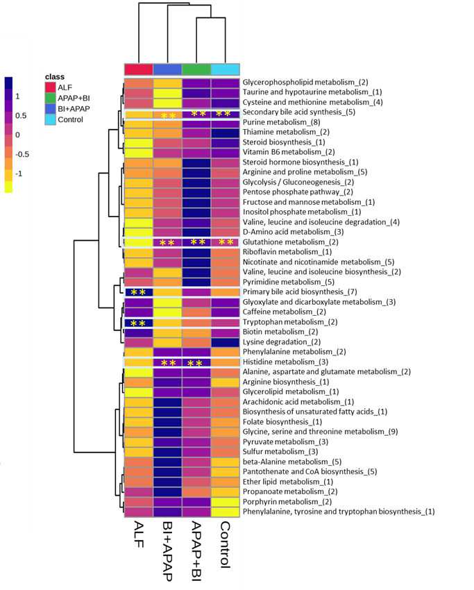

Supplementary Figure 29: Unsupervised hierarchical clustering with different group showing metabolome pathway of liver is capable to segregate Treatment and ALF (500_72hrs) and control group in mice model

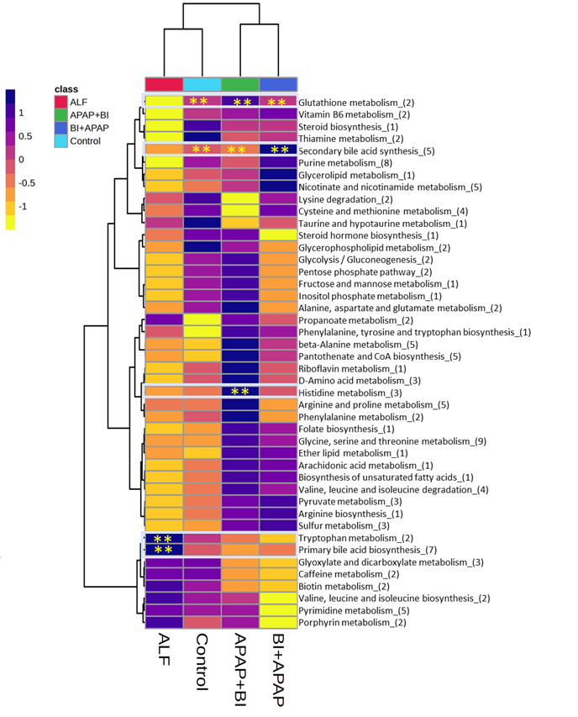

Supplementary Figure 30: Unsupervised hierarchical clustering with different group showing proteomics pathway of liver is capable to segregate Treatment and ALF (250_24hrs) and control group in mice model

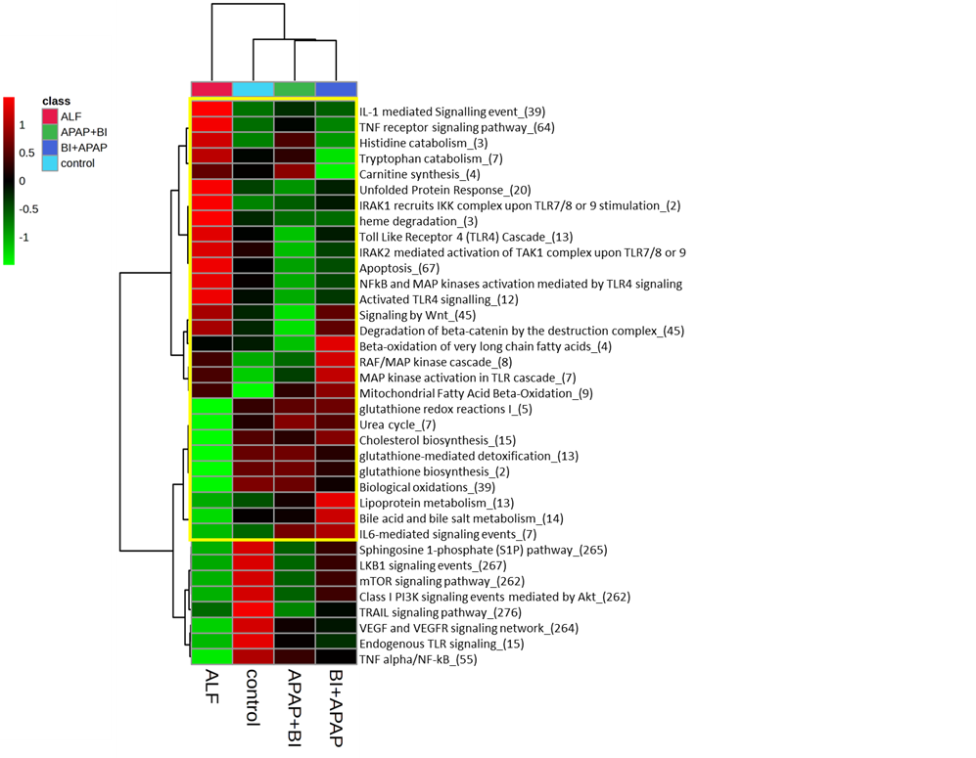

Supplementary Figure 31: Unsupervised hierarchical clustering with different group showing proteomics pathway of liver is capable to segregate Treatment and ALF (500_24hrs) and control group in mice model

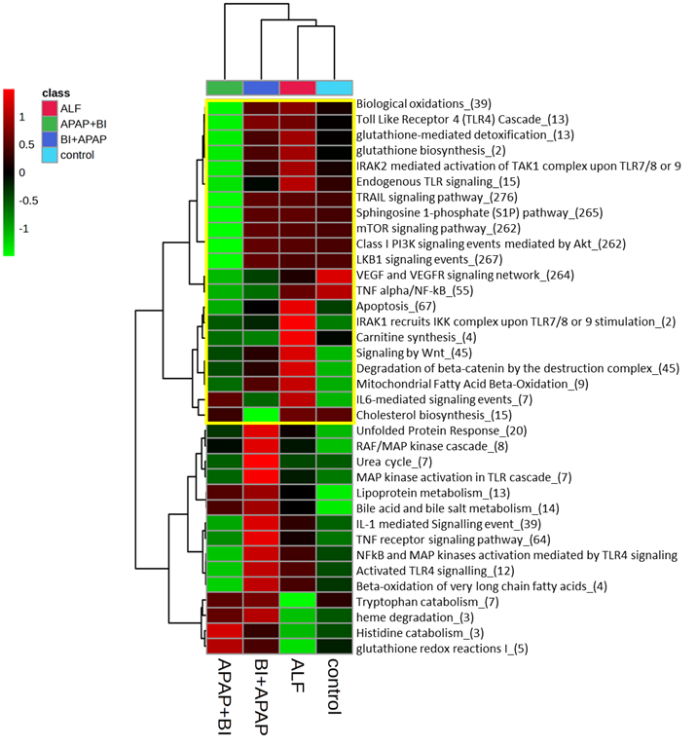

Supplementary Figure 32: Unsupervised hierarchical clustering with different group showing proteomics pathway of liver is capable to segregate Treatment and ALF (250_72hrs) and control group in mice model

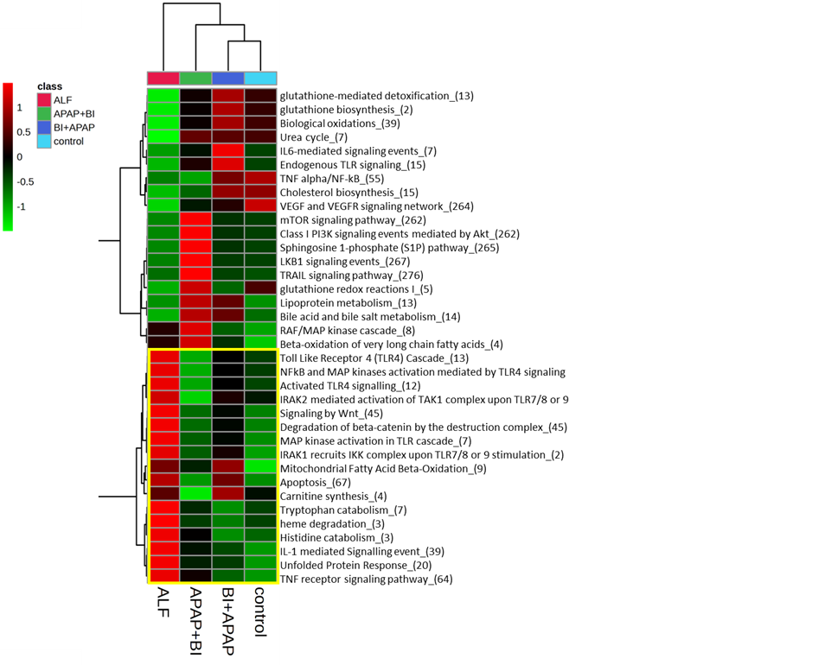

Supplementary Figure 33: List of enzyme, metabolite and protein involved in reducing apoptosis (FC>1.5;P<0.05- UPREGULATED), (FC<1.5;p<0.05-DOWNREGULATED)
Glutathione producing enzyme
Name | FC | p value | FC | p value
 | APAP+BI/ALF |  | BI+APAP/ALF
L-histidine amino-lygase(4.3.1.3) | 2.246 | <0.005 | 1.972 | <0.005
Urocanate hydratase(4.2.1.49) | 2.5878 | <0.005 | 2.6547 | <0.005
imidazolonepropionase(3.5.2.7) | 3.546 | <0.005 | 4.687 | <0.005
Gluatamte cysteine ligase(6.3.2.2) | 1.86 | <0.005 | 2.584 | <0.005
GSH Synthetase(6.3.2.3) | 5.64 | <0.005 | 7.84 | <0.005
Metabolite
Histidine | 5.49 | <0.005 | 5.89 | <0.005
Urocanoic acid | 9.04 | <0.005 | 8.8 | <0.005
4-Imidazolone-5-phopshtae | 2.32 | <0.005 | 31.97 | <0.005
Glutamate | 1.56 | <0.005 | 1.89 | <0.005
Cysteine | 65.7 | <0.005 | 47.8 | <0.005
gamma-glutamylcysteine | 7.82 | <0.005 | 13.93 | <0.005
Glutathione | 19.3 | <0.005 | 3.92 | <0.005
Mitochondrial GSH Transporter
SLC25A39 | 3.61 | <0.005 | 5.17 | <0.005
SLC25A40 | 4.15 | <0.005 | 6.76 | <0.005
Mitochondrial Function gene
Complex 1
NDUFS1 | 16.25 | <0.005 | 8.93 | <0.005
NDUFS2 | 36.19 | <0.005 | 30.72 | <0.005
NDUFS8 | 16.26 | <0.005 | 12.27 | <0.005
NDUFS3 | 11.9 | <0.005 | 12.88 | <0.005
NDUFS7 | 4.94 | <0.005 | 18.28 | <0.005
ComplexII
SDHA | 11.09 | <0.005 | 9.17 | <0.005
SDHB | 7.43 | <0.005 | 5.43 | <0.005
SDHC | 5.4 | <0.005 | 3.82 | <0.005
SDHD | 12.11 | <0.005 | 16.41 | <0.005
ComplexIII
UQCRFS1 | 107.19 | <0.005 | 88.76 | <0.005
UQCRC2 | 4.93 | <0.005 | 6.95 | <0.005
UQCRC1 | 2.83 | <0.005 | 7.21 | <0.005
ComplexIV
COX4I1 | 24.83 | <0.005 | 13.23 | <0.005
COX5A | 6.83 | <0.005 | 6.44 | <0.005
COX6A1 | 6.17 | <0.005 | 6.15 | <0.005
ComplexV
ATP5F1A | 6.68 | <0.005 | 9.811 | <0.005
ATP5F1B | 8.4 | <0.005 | 9.72 | <0.005
ATP5F1C | 10.84 | <0.005 | 13.23 | <0.005
Apoptosis
CYCS | 0.36 | <0.005 | 0.2 | <0.005
BAX | 0.06 | <0.005 | 0.055 | <0.005
CASP3 | 0.82 | <0.005 | 0.39 | <0.005
CSP6 | 0.58 | <0.005 | 0.33 | <0.005

