Figure S1. Fragmentation time series for all wetlands with mapped barriers. Multi-panel time-series plots using the same visual style as Fig. 3, with sensor background colours and barrier-length observations shown at image-pair midpoint dates.
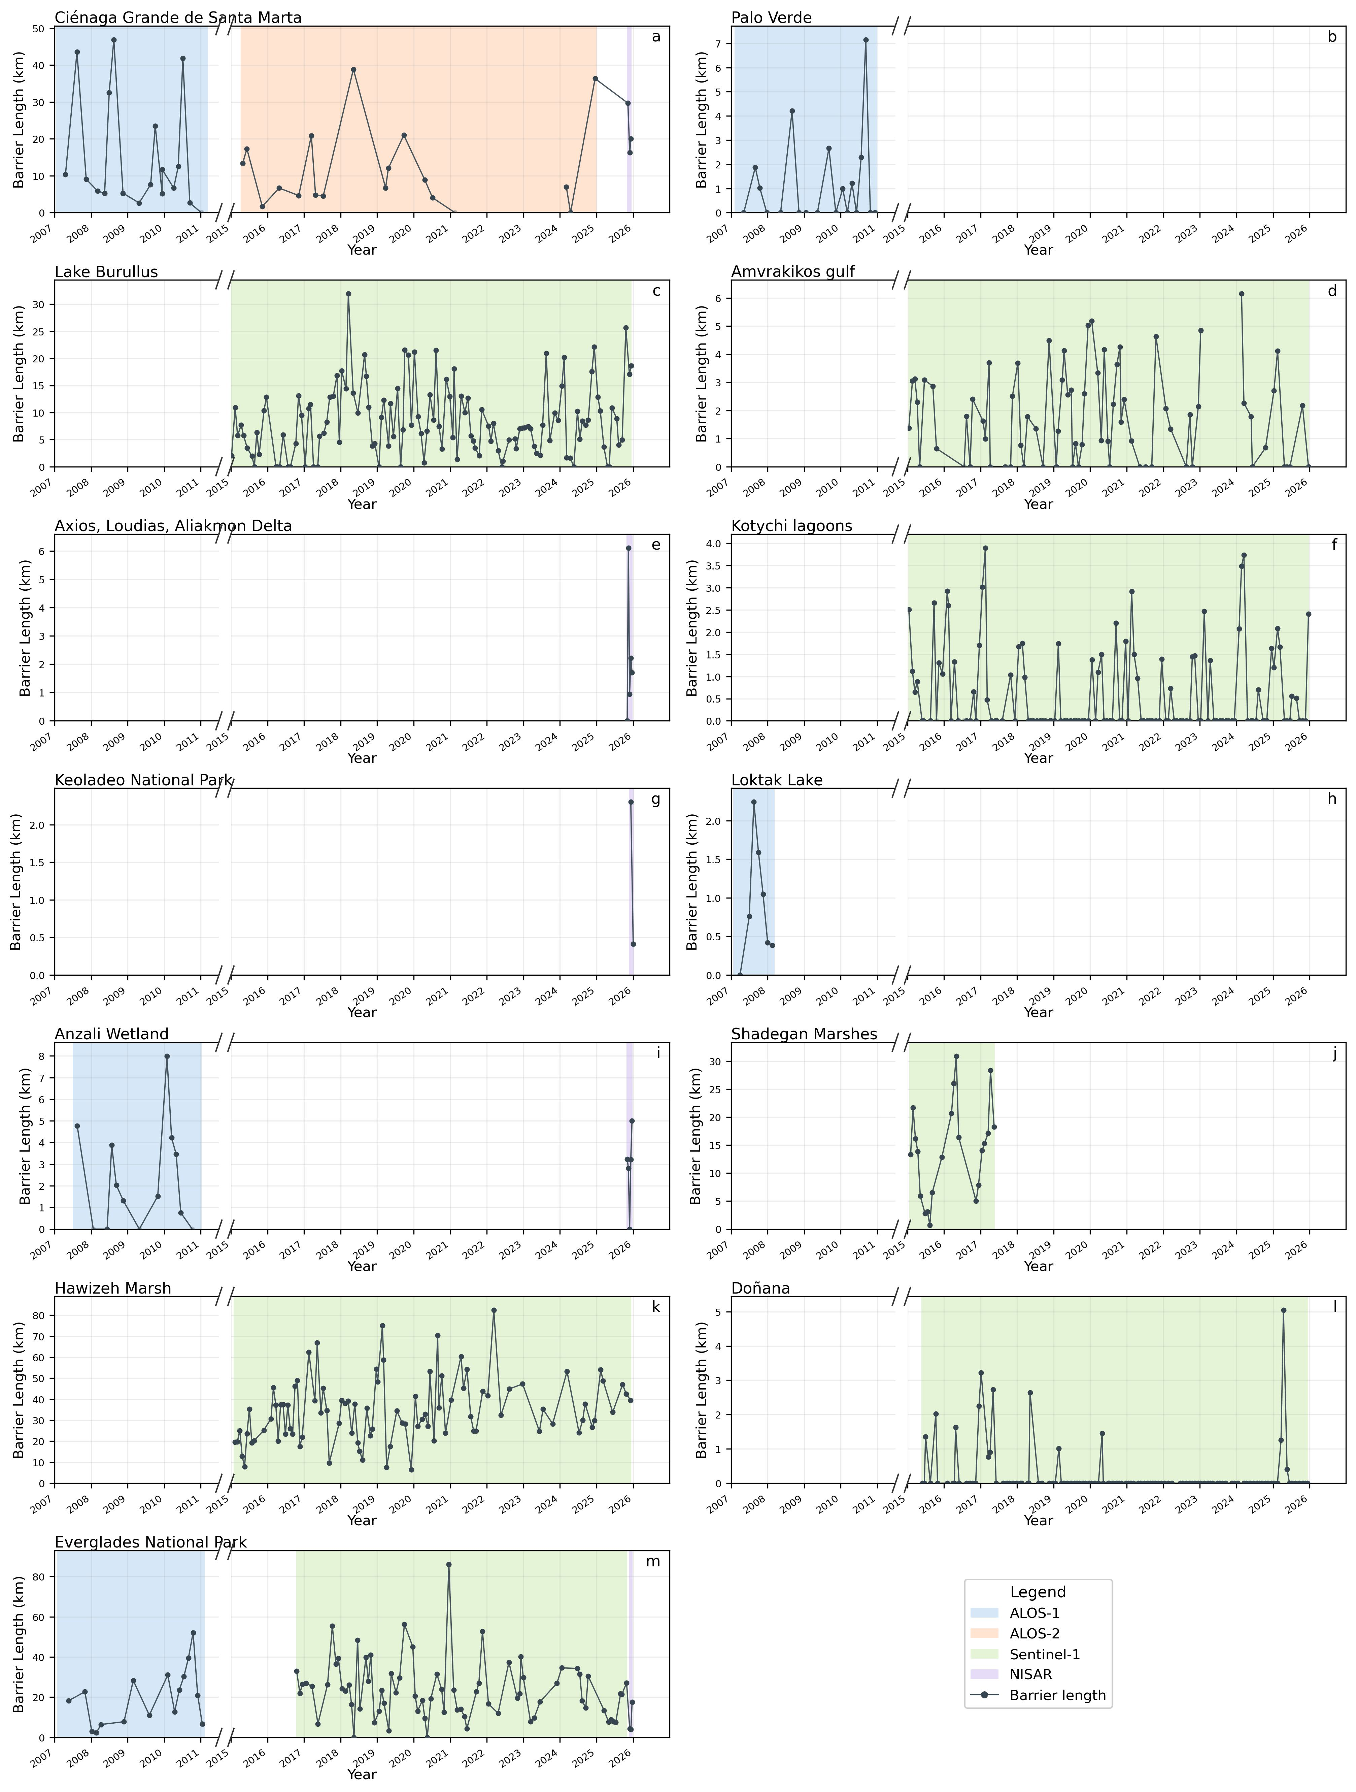

Figure S2. Barrier occurrence maps for all wetlands with mapped barriers. Warmer colours indicate locations where barriers were repeatedly detected across image pairs.
