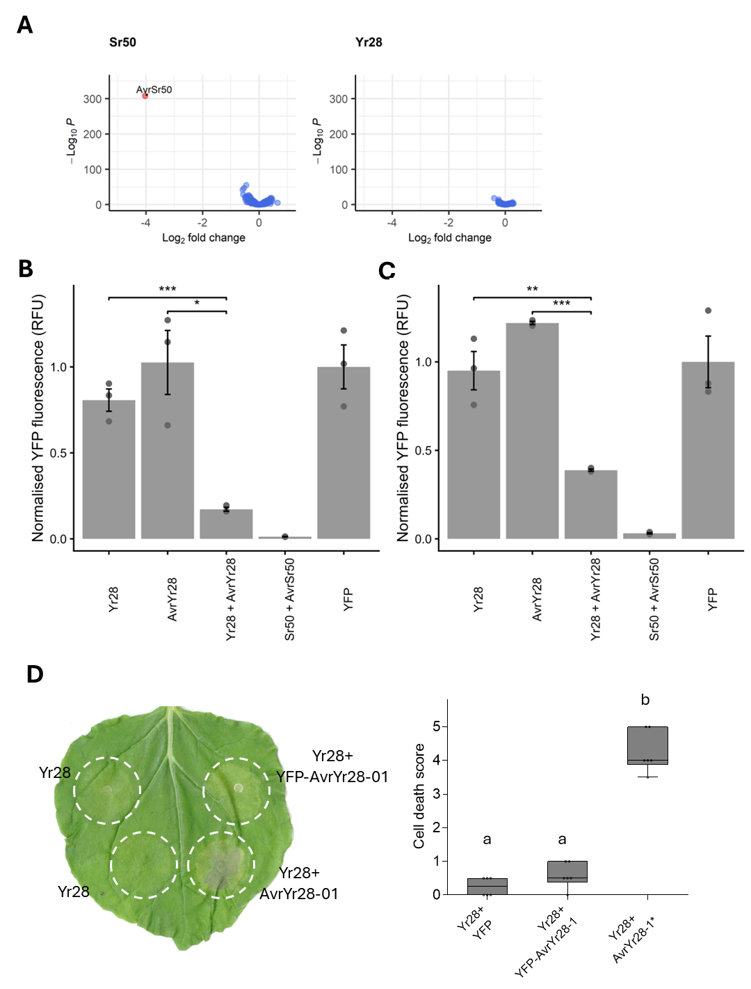
Supplementary Figure S1. AvrYr28 identification. (A) A library of 694 Pst effector candidates (<143 aa) and Pgt AvrSr50 was screened against the stem rust resistance gene Sr50 (left) and stripe rust resistance gene Yr28 (right). Graphs show differential gene expression (x-axis) versus adjusted P-value (y-axis) for each effector construct (blue dots). (B) Yr28 and AvrYr28 genes were expressed singly or in combination in wheat protoplasts (cv Avocet) and fluorescence of a co-transformed YFP reporter gene measured (y-axis). Sr50 and AvrSr50 were included as a positive control. * indicates P<0.05; ** indicates P<0.01; *** indicates P<0.001 (t-test). (C) As in (B) except that protoplasts of oat cultivar Swan were used for transformation. (D) Yr28 was expressed alone or in combination with AvrYr28-01 either with an N-terminal YFP tag (YFP-AvrYr28-01) or with no tag in N. benthamiana leaves by Agro-infiltration. Images were recorded after 3 days (left panel). Right panel shows box plot of cell death scores from six infiltration sites per treatment. Different letters on columns represent statistically significant differences (ANOVA, Tukey’s test, P < 0.05).

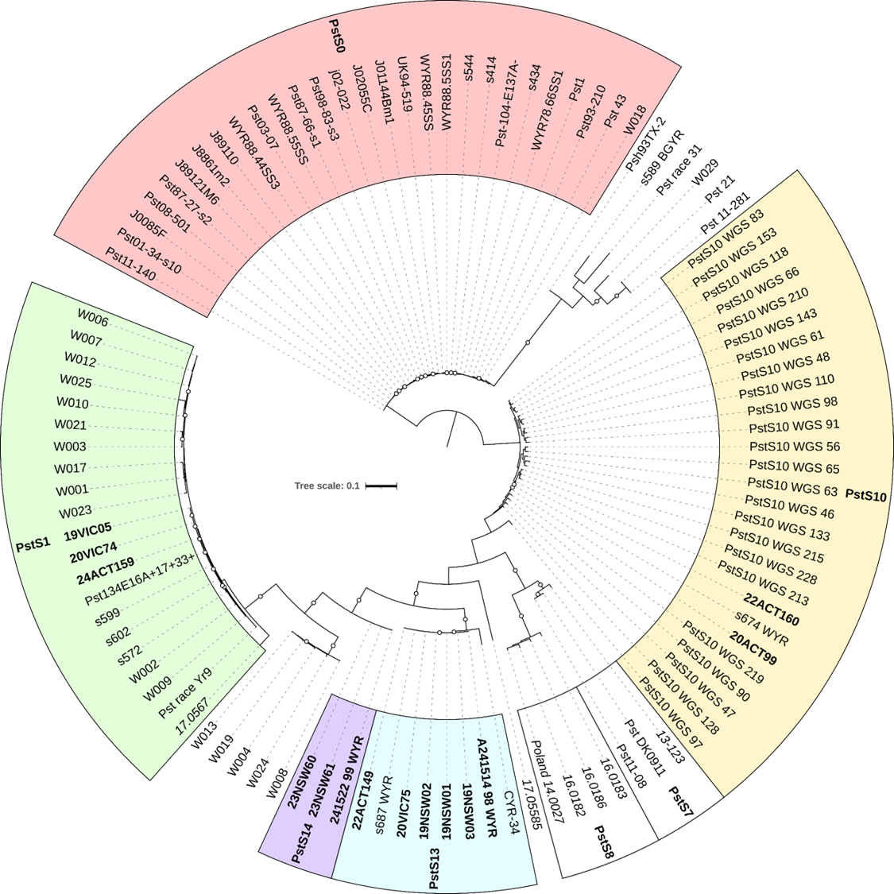

Supplementary Figure S2. Maximum Likelihood (ML) tree of Pst isolates based on whole genome SNPs (147,683) called from Illumina sequence data from 106 isolates against the Pst104 chromosomes. Branches with bootstrap support (500 cycles) ≥ 80% are indicated by white circles at branch midpoints. Isolates belonging to named clonal lineages PstS0, PstS1 etc are labelled in coloured boxes. Isolates sequenced in this study are labelled with bold text and RNAseq samples are labelled with italicized text. The tree is midpoint rooted and scale is nucleotide substitutions per site.

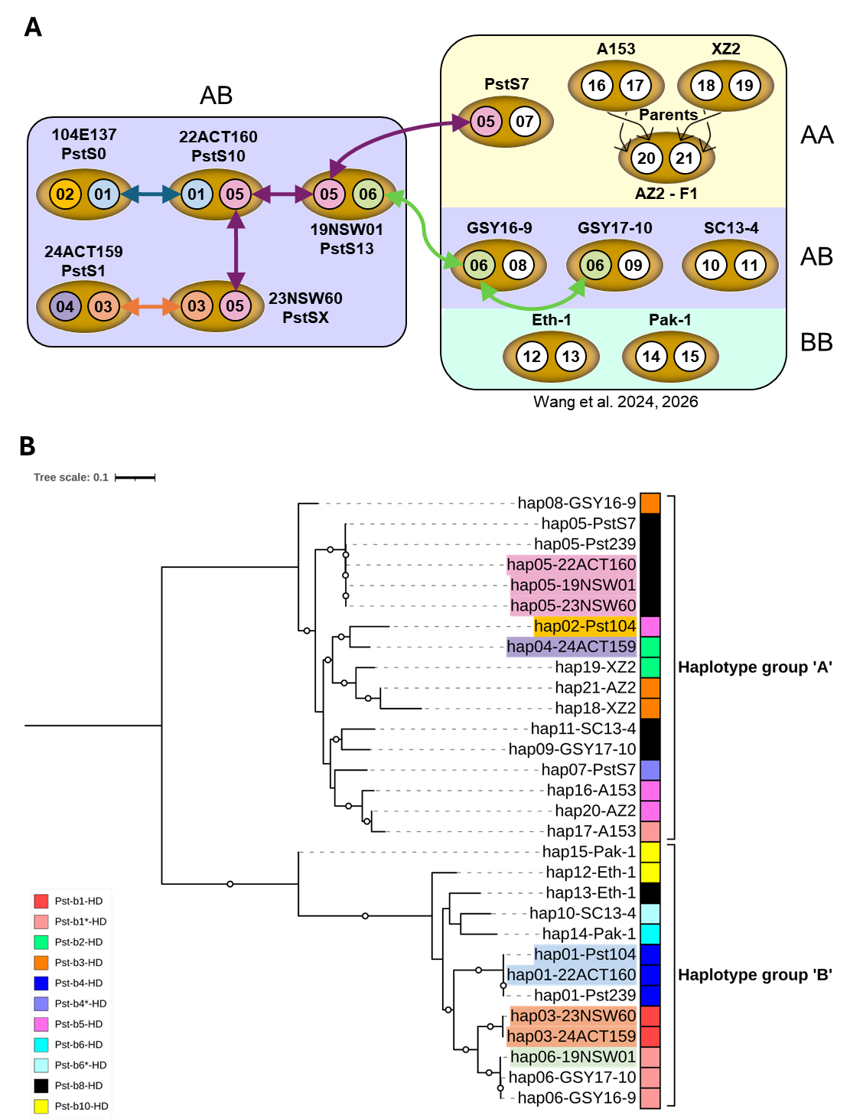
Supplementary Figure S3. Genomic relationships between Pst strains. A. Schematic showing nuclear genome content of fourteen Pst isolates representing different lineages. Individual haploid nuclei in each strain are numbered (01 to 21) and colour coded according to identity. B. Maximum Likelihood (ML) phylogenetic tree based on whole genome alignment of haplotypes hap01 to hap21 from fourteen Pst isolates generated by RAxML. The tree is midpoint-rooted and the scale represents mean substitutions per site. Branches with bootstrap support (500 cycles) ≥ 80% are indicated by white circles at branch midpoints. Coloured squares indicate b-locus mating type alleles (b1 to b10) present in each haplotype according to the key at left.
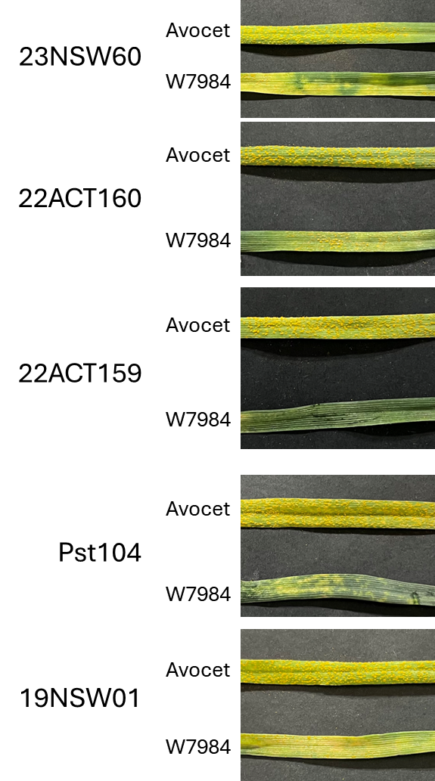
Supplementary Figure S4. Infection phenotypes of five Australian Pst isolates on the rust susceptible line Avocet and the synthetic hexaploid line W7984 containing Yr28. Seedlings were infected at ten days old and photographs taken after fourteen days.

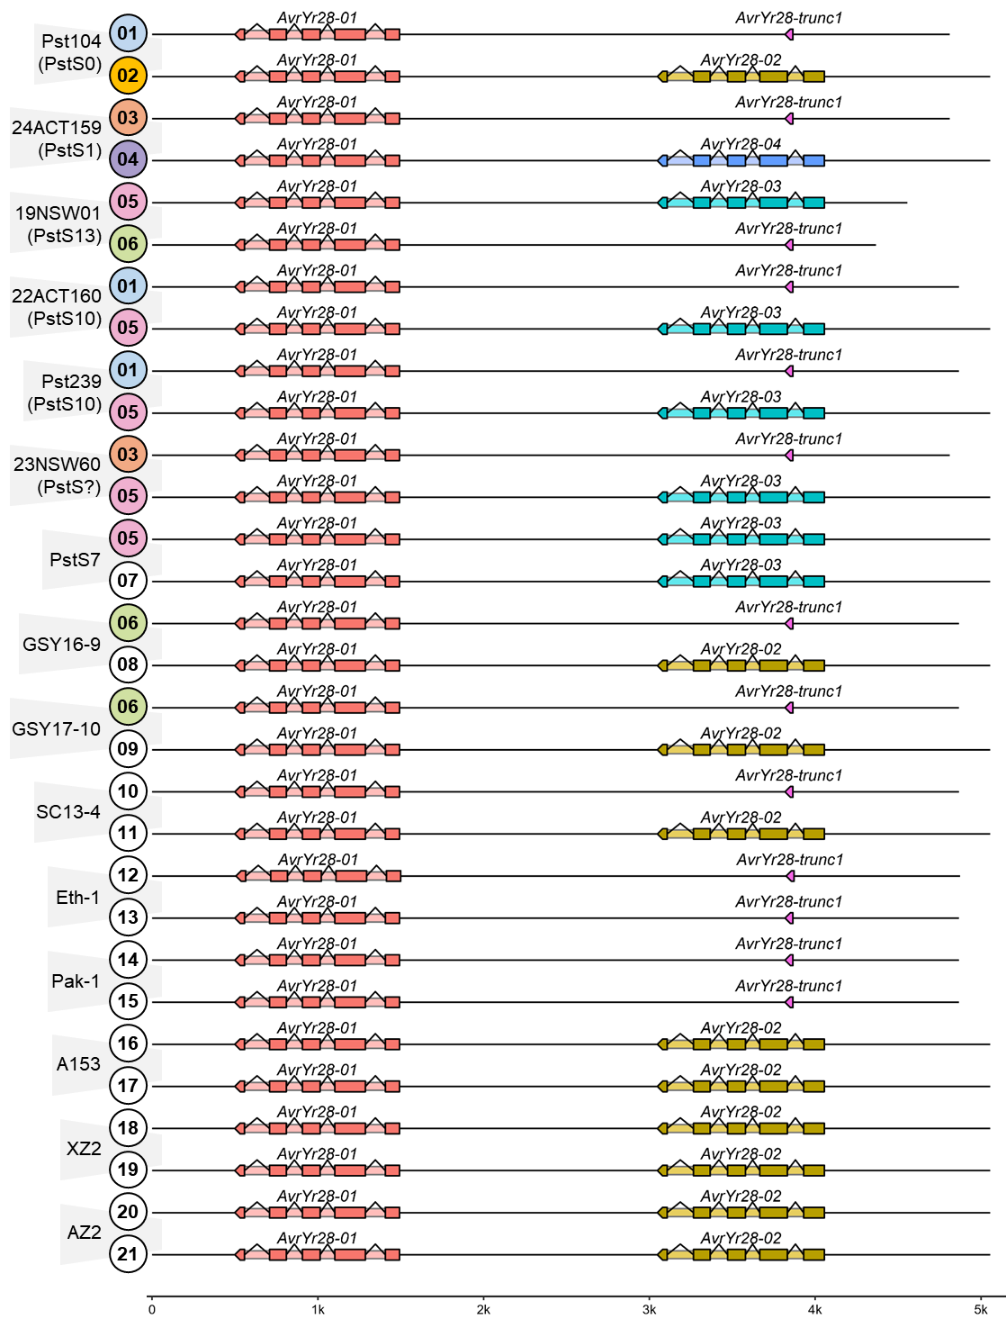
Supplementary Figure S5. AvrYr28 locus genotypes in haplotypes (01 to 21) from all nuclear-phased reference assemblies of Pst isolates. Gene colors represent alleles with dark shaded boxes representing coding sequences and light shading introns. X-axis shows the scale in kbp.

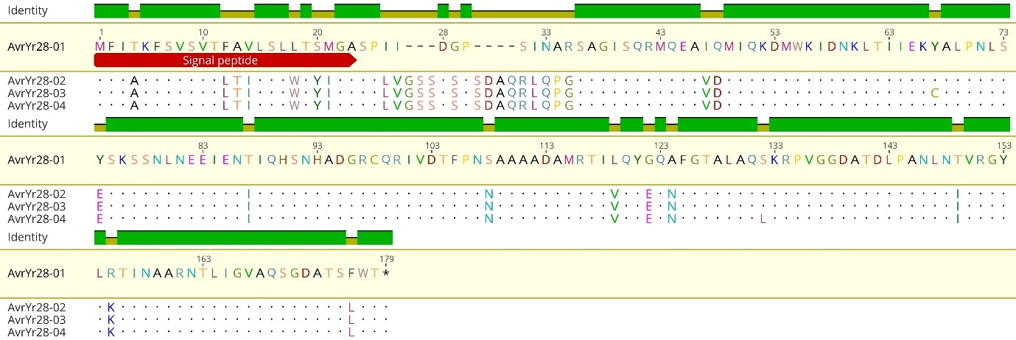
Supplementary Figure S6. Alignment of AvrYr28 protein variants. AvrYr28-01 sequence shown in full on top line. Residues in AvrYr28-02, -03 and -04 that differ from AvrYr28-01 are highlighted.

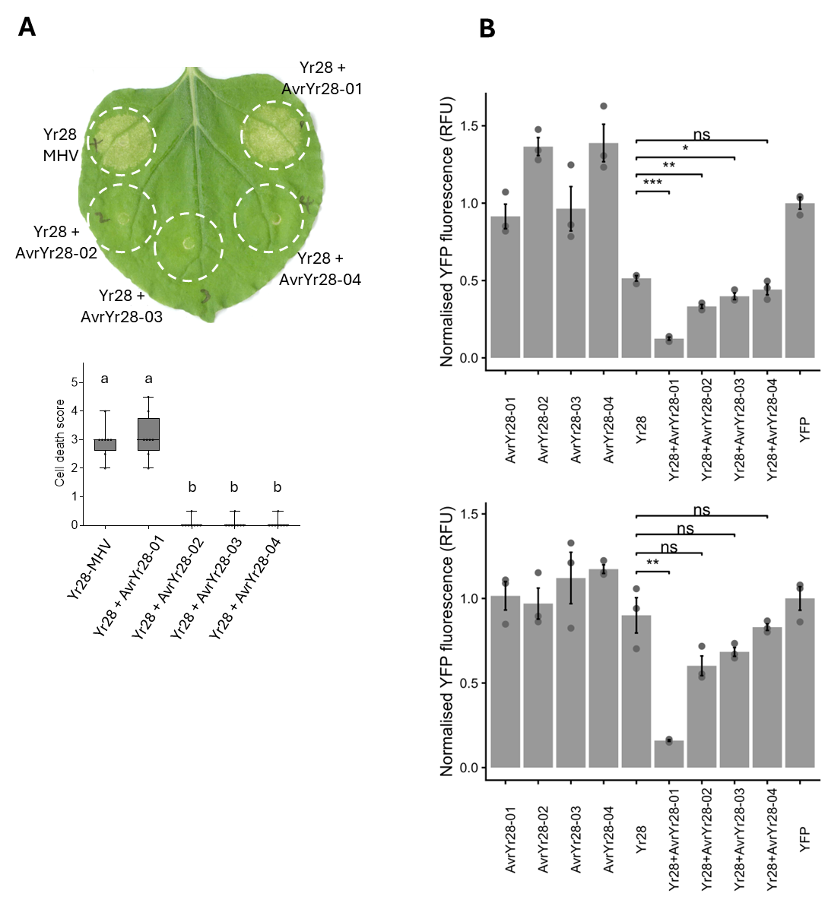
Supplementary Figure S7. Recognition of AvrYr28 variants. (A) Yr28 was co-expressed with AvrYr28-01, -02, -03 or -04 in N. benthamiana leaves by Agro-infiltration. A mutant version of Yr28 (Yr28-MHV) containing the autoactivating D to V substitution in the conserved MHD motif (Yr28-MHV) was included as a positive control. Leaf images were recorded after 3 days (upper panel). Lower panel shows box plot of cell death scores from eight infiltration sites per treatment. Different letters represent statistically significant differences (ANOVA, Tukey’s test, P < 0.05). (B) Yr28 and AvrYr28-01, -02, -03 or -04 genes were expressed singly or in combination in wheat protoplasts of cv Fielder (top) or Avocet (bottom) and fluorescence of a co-transformed YFP reporter gene measured (y-axis). * indicates P<0.05; ** indicates P<0.01; *** indicates P<0.001; ns not significant (t-test).

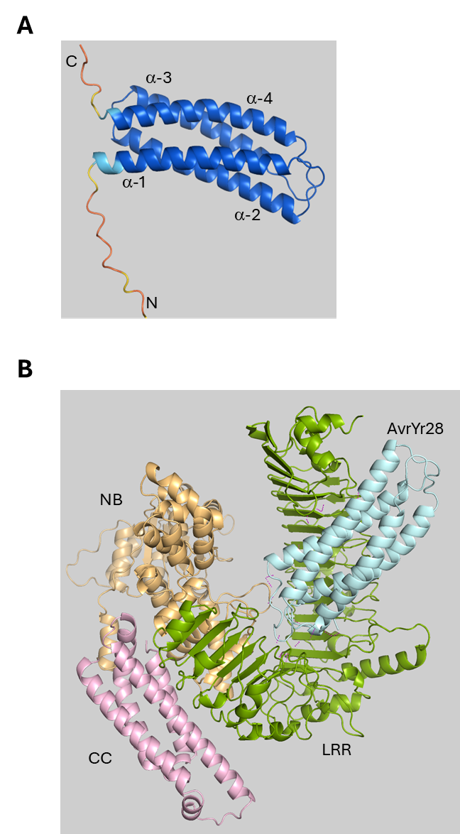
Supplementary Figure S8. (A) Structural model AvrYr28-01 predicted by Alphafold 3. Structure is represented in cartoon format with the four a-helices and N-and C- terminal extensions labelled and colour-coded by per-residue prediction confidence values: dark blue indicates very high confidence (pLDDT >0.90), light blue - high confidence (0.7 to 0.9), yellow - moderate confidence (0.5 to 0.7) and orange - low confidence (<0.5). (B) Structural model of Yr28-AvrYr28-01 interaction complex predicted by Alphafold 3 and colour-coded to indicate the coiled-coil (CC), nucleotide-binding (NB) and leucine-rich repeat (LRR) domains of Yr28 and the AvrYr28-01 protein. (cyan).

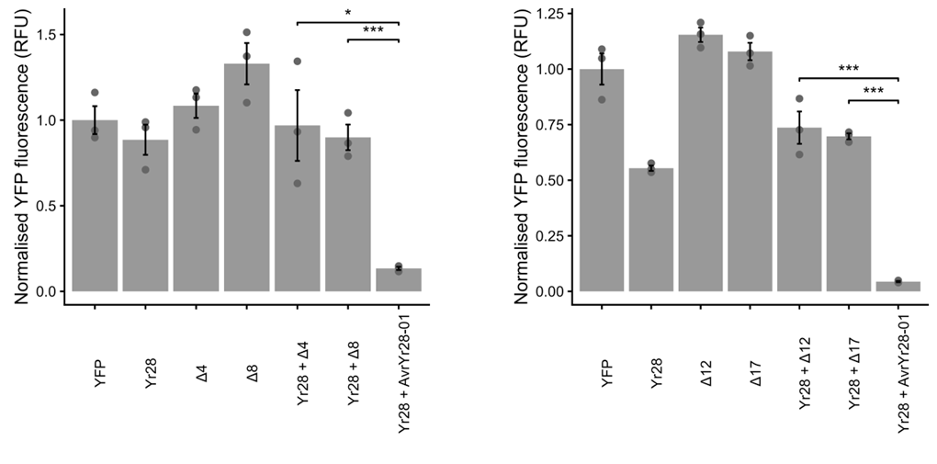
Supplementary Figure S9. N-terminal truncations of AvrYr28-01co-expressed with Yr28. Yr28, AvrYr28-01 and N-terminal truncation constructs of AvrYr28-01 ∆4 and ∆8 (left) and ∆12 and ∆17 (right) were expressed singly or in combination in wheat protoplasts of cv Avocet and fluorescence of a co-transformed YFP reporter gene measured (y-axis). The number used in the truncation construct name corresponds to the number of sequential deleted amino acids from the N-terminus of the resulting protein. * indicates P<0.05; ** indicates P<0.01; *** indicates P<0.001; ns not significant (t-test).

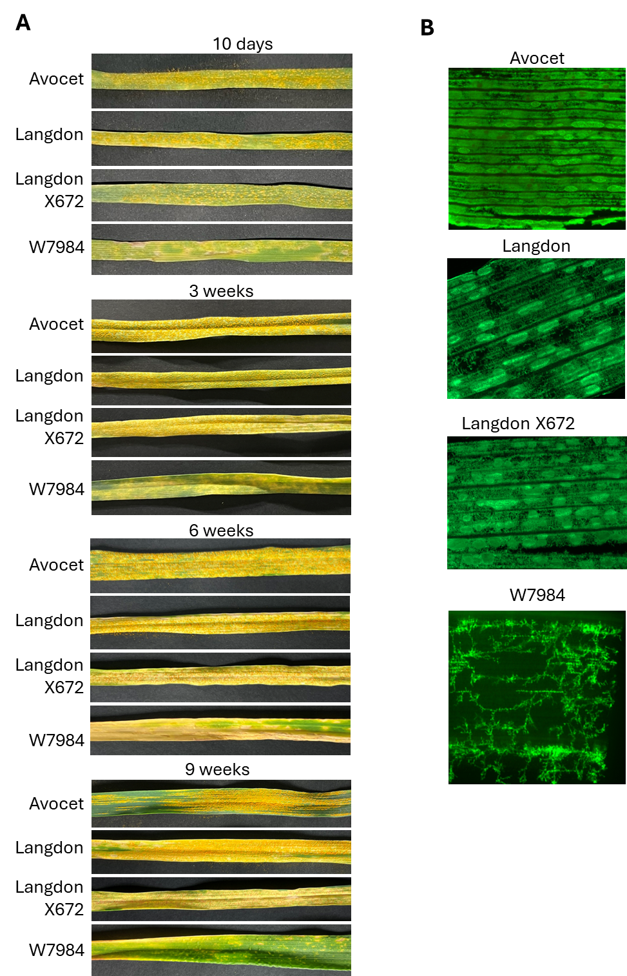
Supplementary Figure S10. (A) Infection phenotypes of Pst isolate 24ACT159 on the rust susceptible lines Avocet and Langdon and the synthetic hexaploid lines LangdonX672 and W7984 containing Yr28. Plants were infected were infected at ten days, three weeks, six weeks old and photographs taken after fourteen days. (B) Fluorescence microscopy of Pst infection sites using alexa 488-labelled wheat germ agglutinin (WGA) inoculated at 42 days.

