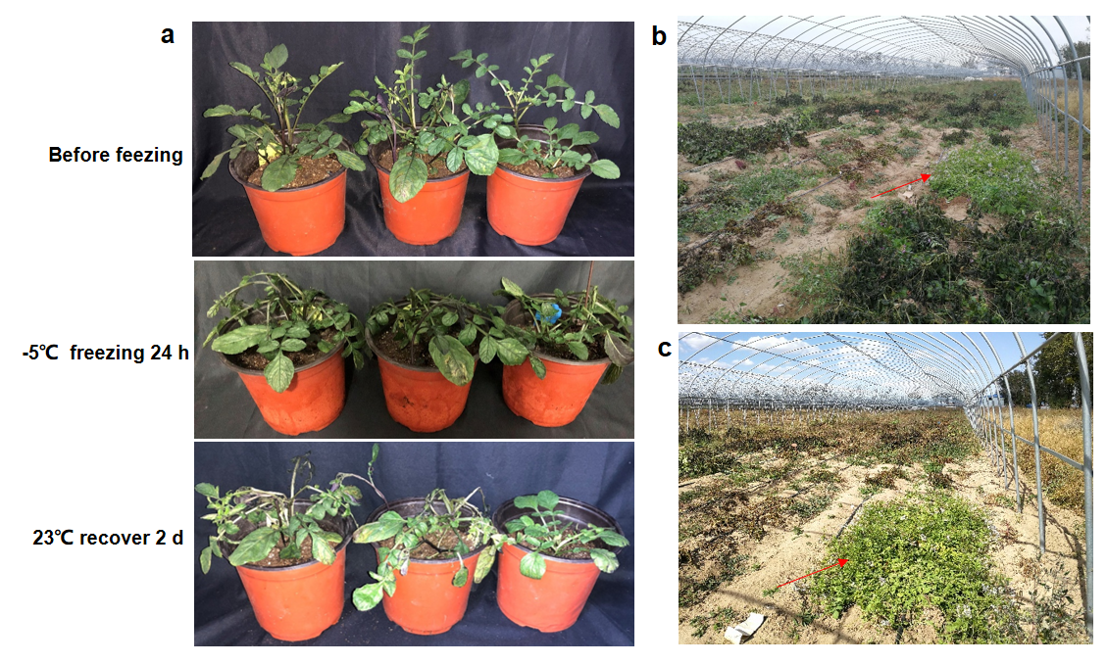
Fig. S1 Identification of cold tolerance of S. commersonii (W3). a Seedlings before freeing, after 24 h at -5°C, and after recovery for 2 d at 23°C. b-c The cold-resistant phenotype of W3 in the field with natural frost (minimum temperature -5℃)

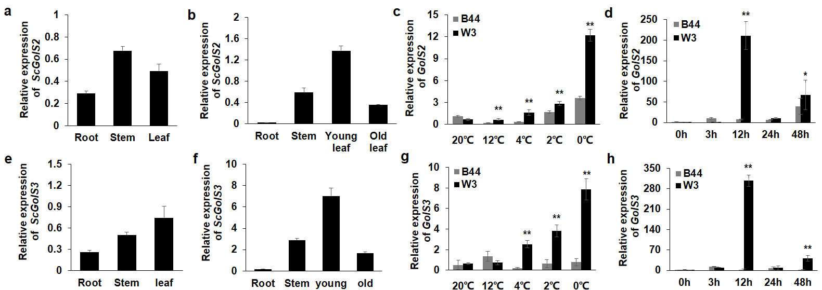
Fig. S2 Expression analysis of GolS2 and GolS3 gene. a-b Expression analysis of ScGolS2 gene in roots, stems and leaves of W3 tissue cultured seedlings and Potted seedlings. c Relative expression levels of GolS2 gene in B44 (S. tuberosum) and W3 (S. commersonii) under freezing stress at 20℃, 12℃, 4℃, 2℃ and 0℃ for 24 h. d Relative expression levels of GolS2 gene in B44 (S. tuberosum) and W3 (S. commersonii) under freezing stress at -1℃ for 0 h, 3 h, 12 h, 24h h and 24 h. e-f. Expression analysis of ScGolS3 gene in roots, stems and leaves of W3 tissue cultured seedlings and Potted seedlings. g Relative expression levels of GolS3 gene in B44 (S. tuberosum) and W3 (S. commersonii) under freezing stress at 20℃, 12℃, 4℃, 2℃ and 0℃ for 24 h. h Relative expression levels of GolS3 gene in B44 (S. tuberosum) and W3 (S. commersonii) under freezing stress at -1℃ for 0 h, 3 h, 12 h, 24h h and 24 h
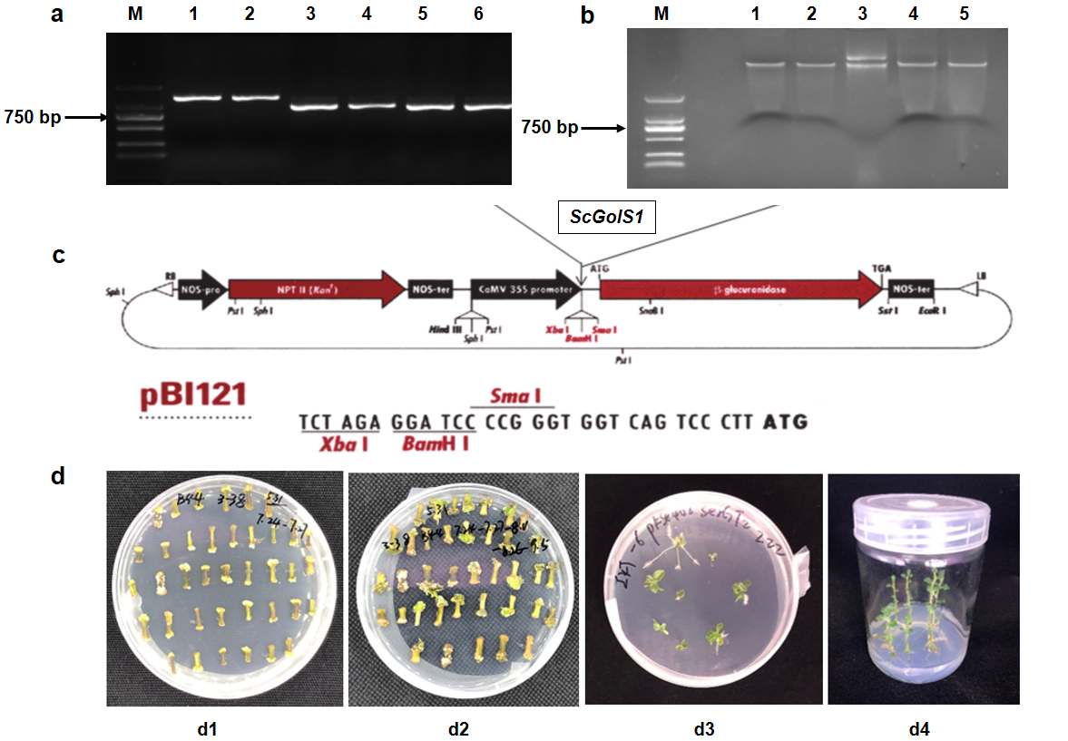
Fig. S3 Genetic transformation of ScGolS1 in potato. a PCR amplification of ScGolS1 gene, 1 and 2, genomic DNA; 3, 4, 5, and 6, cDNA, M, DNA molecular marker. b Linearization of pBI121 expression vector. 1 and 2, BamH I single digestion; 3, pBI121 plasmid; 4 and 5, Xba I and Xma I double digestion. c Schematic diagram of the insertion position of ScGolS1 gene in pBI121 vector. d. Obtaining of potato regeneration plantlets through genetic transformation, D1, callus; D2, callus swelling; D3, callus budding; D4, callus buds taking root and forming

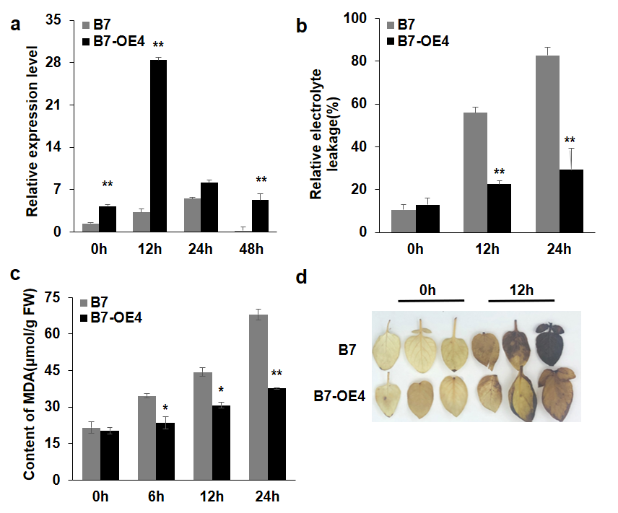
Fig. S4 Relative expression and physiological and biochemical analysis of B7 transgenic lines. a Relative expression levels of ScGolS1 in WT (B7) and transgenic lines (B7-OE4) at 0, 12, 24, and 48 h after exposure to -1℃ freezing stress. b Relative electrolyte leakage in WT (B7) and transgenic lines ( B7-OE4) after freezing stress at -1℃ for 0, 12 and 24 h. c MDA contents after freezing stress at -1℃ for 0, 6, 12, and 24 h in WT (B7) and transgenic lines ( B7-OE4). d DAB staining of leaves exposed to -1℃ freezing stress for 12h in WT (B7) and transgenic lines ( B7-OE4). Values represent means of three biological replicates with error bars indicating standard error of the mean. ** indicates a significant difference compared with the control at p < 0.01 determined by Student's t-test

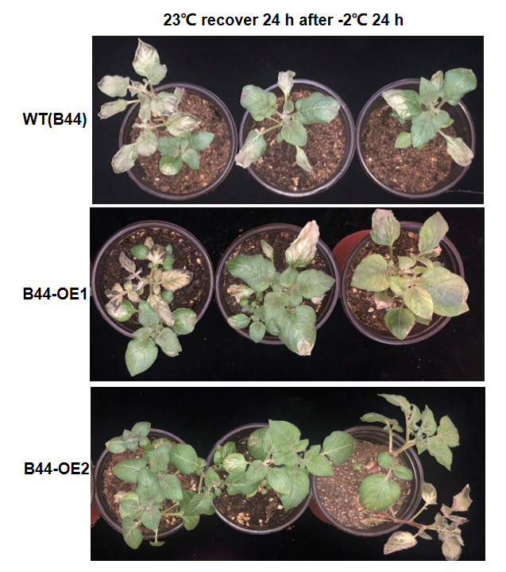
Fig. S5 Identification of freezing-tolerant phenotype of overexpression strains that were recovered at 23°C for 24 h after treatment at -2°C 24 h

