Supplementary data

Diagnosis | Group | Sex | Age | Braak | PMD (min) | SnRNA-seq | MS
Alzheimer dis. with congophilic angiopathy | capCAA | f | 87 | 6 | 480 | N | Y
Alzheimer. dis. with congophilic angiopathy | capCAA | m | 70 |  | 265 | Y | Y
Alzheimer. dis. with congophilic angiopathy | capCAA | m | 71 | 6 | 240 | N | Y
Alzheimer. dis. with congophilic angiopathy | capCAA | f | 94 | 3 | 375 | Y | Y
Alzheimer. dis. with congophilic angiopathy | capCAA | f | 84 | 5 | 285 | Y | Y
Alzheimer. dis. with congophilic angiopathy | capCAA | m | 88 | 5 | 235 | Y | Y
Alzheimer. dis. with congophilic angiopathy | capCAA | f | 80 | 5 | 325 | Y | Y
Alzheimer. dis. with congophilic angiopathy | capCAA | m | 87 | 4 | 225 | Y | Y
Alzheimer. dis. with congophilic angiopathy | capCAA | f | 82 | 6 | 190 | Y | N
Fronto-temporal dementia TDP type A | FTD-GRN | m | 60 | 3 | 470 | N | Y
Fronto-temporal dementia TDP type A | FTD-GRN | f | 66 |  | 319 | N | Y
Fronto-temporal dementia TDP type A | FTD-GRN | f | 61 | 1 | 650 | N | Y
Fronto-temporal dementia TDP type A | FTD-GRN | m | 69 | 0 | 345 | N | Y
Fronto-temporal dementia TDP type A | FTD-GRN | m | 69 | 2 | 300 | N | Y
Fronto-temporal dementia TDP type A | FTD-GRN | f | 94 | 4 | 310 | N | Y
Fronto-temporal dementia TDP type A | FTD-GRN | f | 76 |  | 270 | N | Y
Non-demented control | NDC | f | 88 | 2 | 340 | Y | N
Non-demented control | NDC | m | 86 | 3 | 405 | Y | Y
Non-demented control | NDC | f | 95 | 3 | 260 | Y | Y
Non-demented control | NDC | m | 77 | 2 | 525 | Y | Y
Non-demented control | NDC | f | 84 | 3 | 470 | Y | Y
Non-demented control | NDC | f | 81 | 2 | 460 | N | Y
Non-demented control | NDC | f | 79 | 3 | 360 | Y | Y
Non-demented control | NDC | m | 92 | 3 | 445 | Y | Y
Non-demented control | NDC | m | 77 | 1 | 445 | N | Y

Supplementary Table 1: Cohort overview. Pmd = Post mortem delay (in minutes); SnRNA-seq = used in single-nucleus RNA-sequencing; MS = used in Mass spectrometry; N = No; Y = Yes.

Parameter | NDC | CapCAA | FTD-GRN | Test | P-value | Pairwise Comparison
Sample size | 8 | 8 | 7 | NA | NA | NA
Mean age in years (SD) | 83.9 (6.8) | 82.6  (8.5) | 70.7  (11.6) | Kruskal-Wallis rank sum test | 0.03041 | Pairwise comparisons using Wilcoxon rank sum test with continuity correction  NDC/CAA 1.000  NDC/FTD 0.052  FTD/CAA 0.055  P value adjustment method: BH
Sex (m/f) | 4/4 | 4/4 | 3/4 | Pearson's Chi-squared test | 0.9514 | NA
Mean PMD in min (SD) | 421  (80.9) | 304  (87.4) | 381  (135) | Kruskal-Wallis rank sum test | 0.08075 | Pairwise comparisons using Wilcoxon rank sum exact test  NDC/CAA 0.12  NDC/FTD 0.35  FTD/CAA 0.28  P value adjustment method: BH

Supplementary Table 2: Mass spectrometry cohort characteristics. PMD = Post mortem delay (in minutes). NA = Not applicable.

Parameter | NDC | CapCAA | Test | P-value | Pairwise Comparison
Sample size | 7 | 7 | NA | NA | NA
Mean age in years (SD) | 85.9  (6.5) | 83.6  (7.5) | Kruskal-Wallis rank sum test | 0.654 | NA
Sex (m/f) | 3/4 | 3/4 | Pearson's Chi-squared test | 1.000 | NA
Mean PMD in min (SD) | 401  (88.9) | 271  (63.2) | Kruskal-Wallis rank sum test | 0.01809 | NA

Supplementary Table 3: Single-nucleus RNA-sequencing cohort characteristics. PMD = Post mortem delay (in minutes). NA = Not applicable.

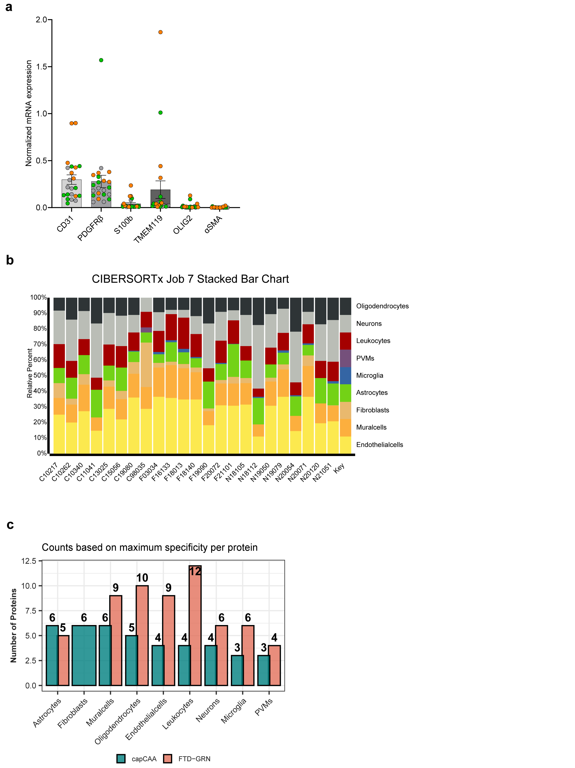
Supplementary Figure 1: Cell type specific analysis.
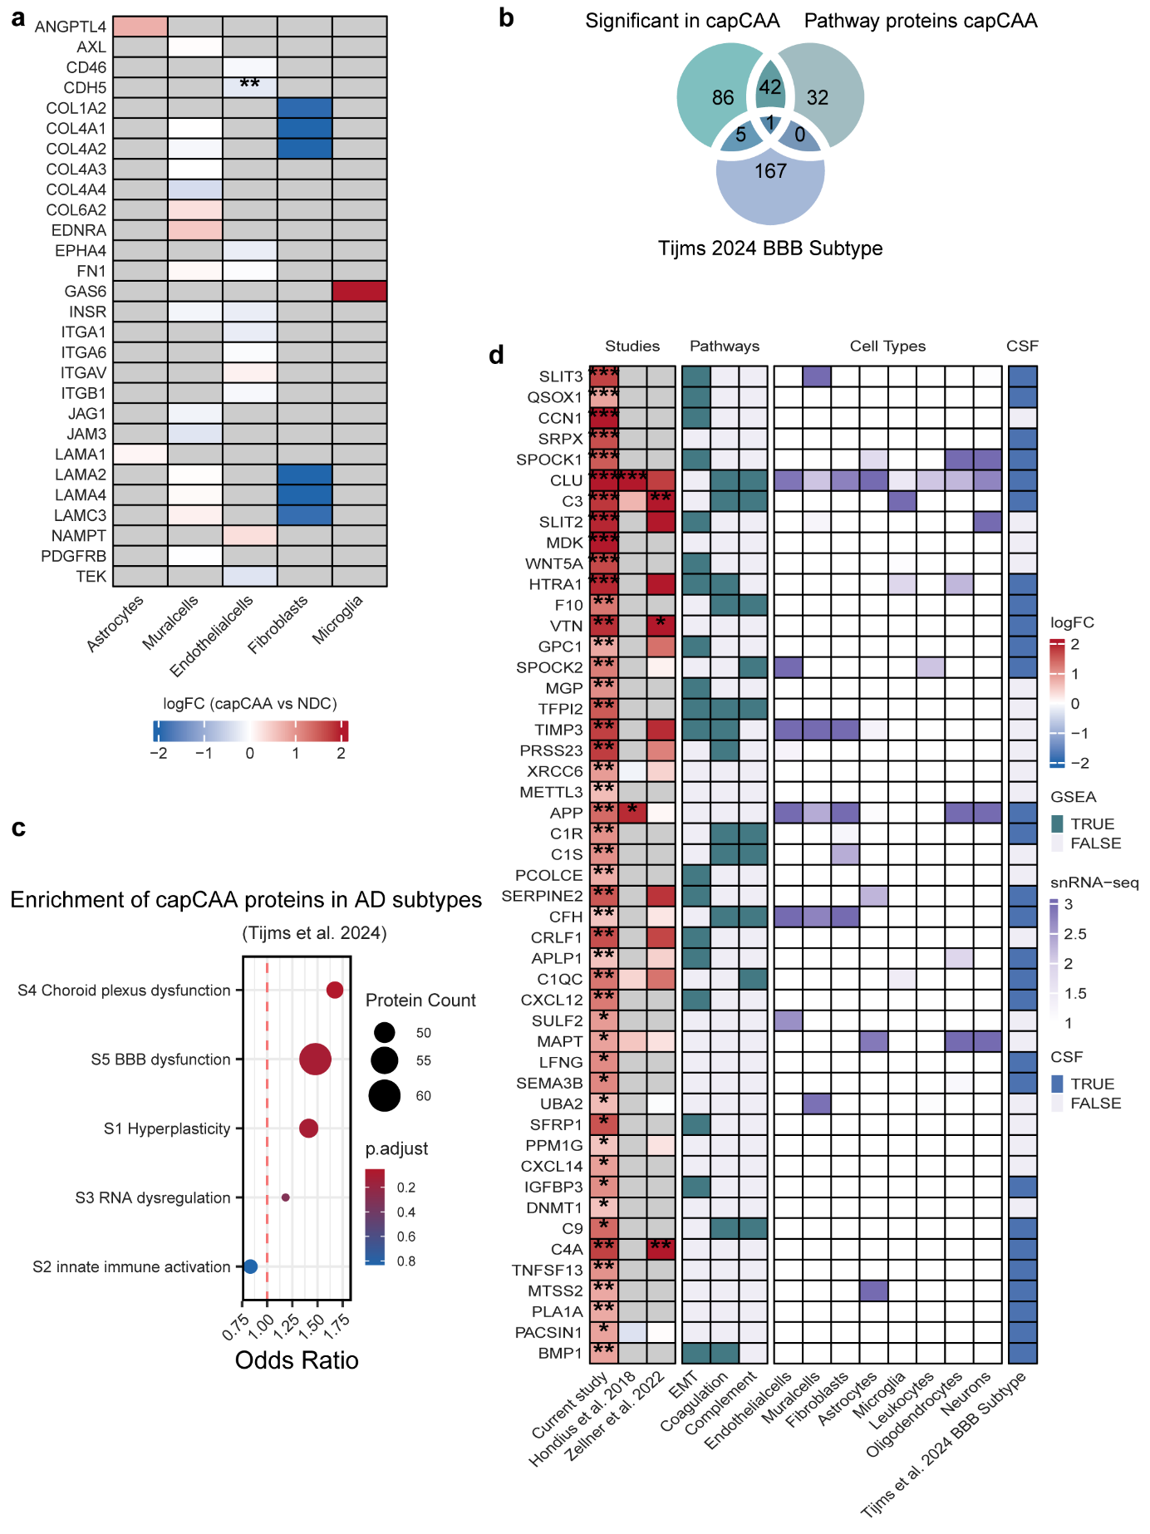
Supplementary Figure 2: Additional analysis capCAA vs NDC.
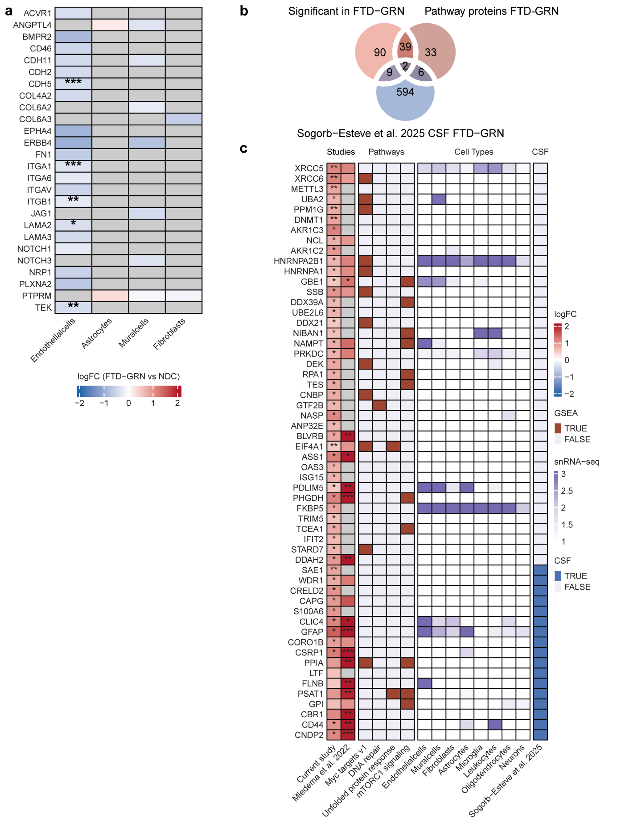
Supplementary Figure 3: Additional analysis FTD-GRN vs NDC.
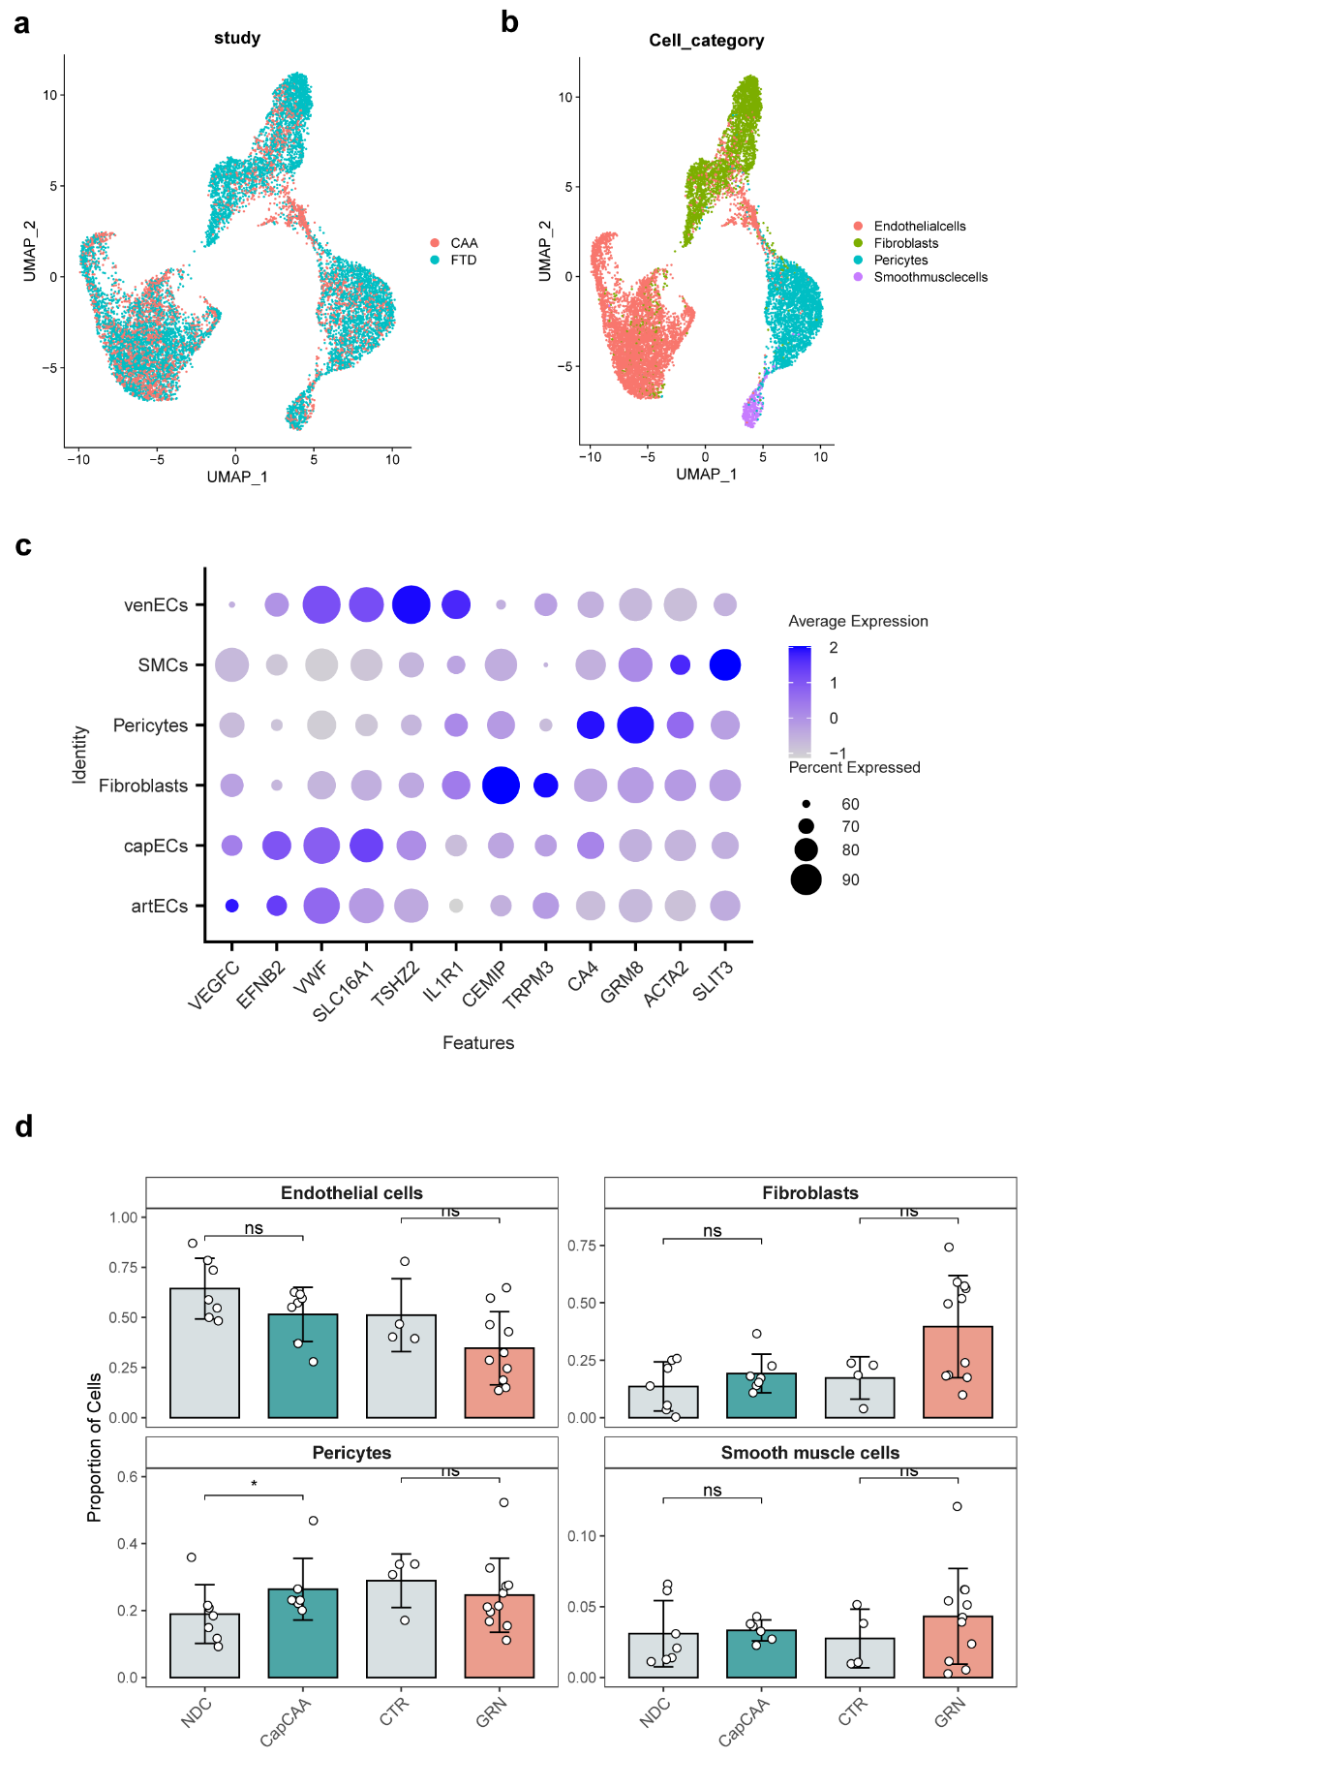
Supplementary Figure 4: Additional analysis snRNA-seq.
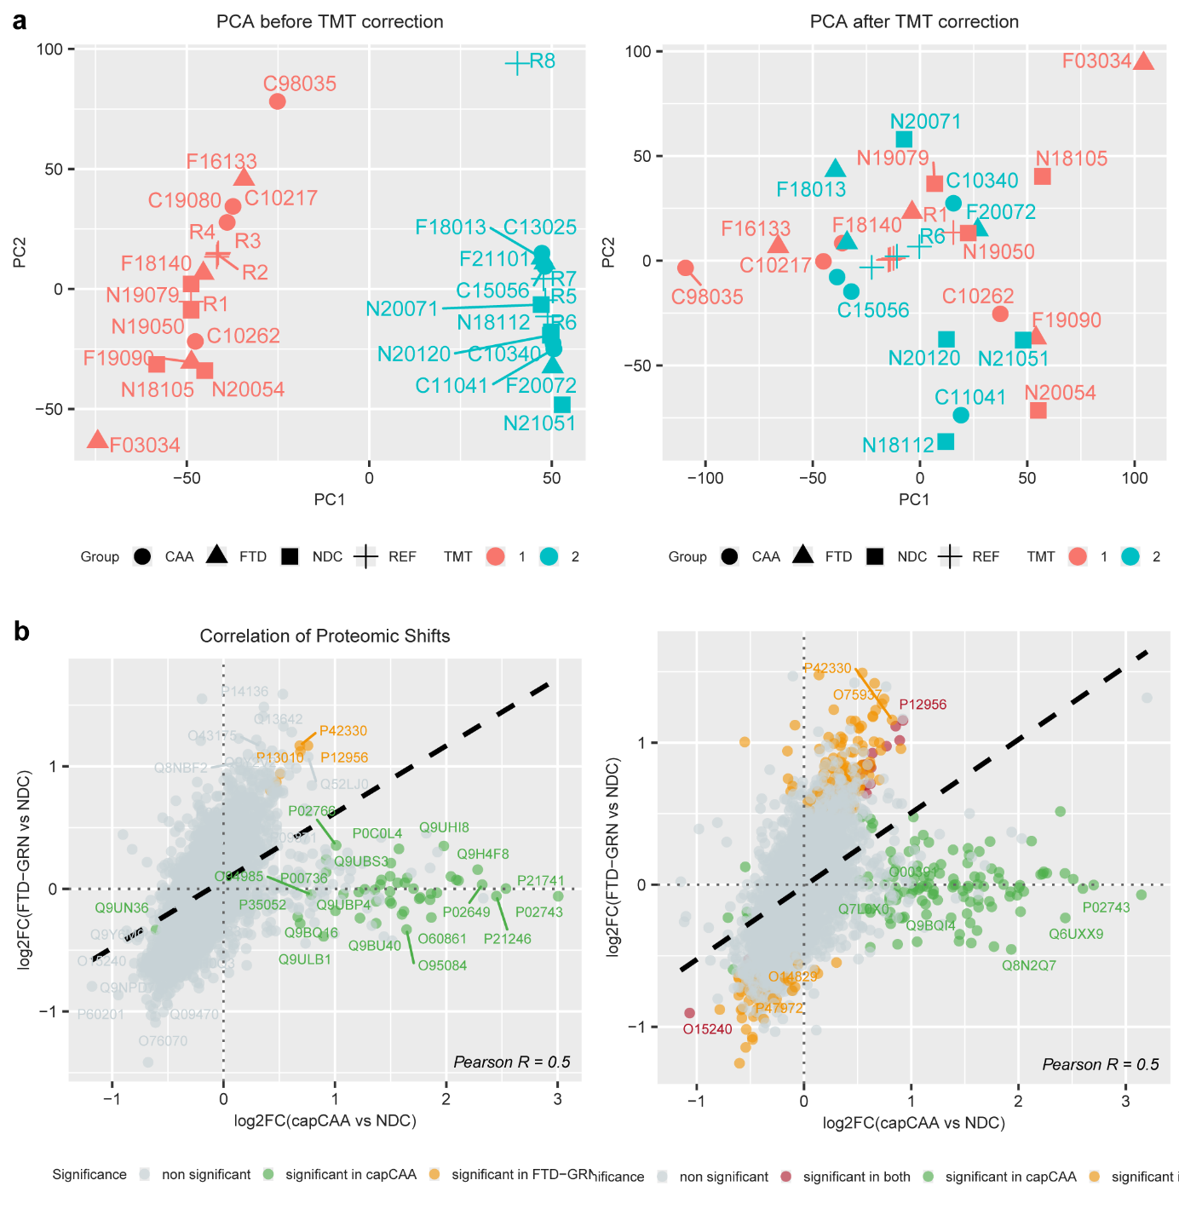
Supplementary Figure 5: TMT correction and protein abundance correction.
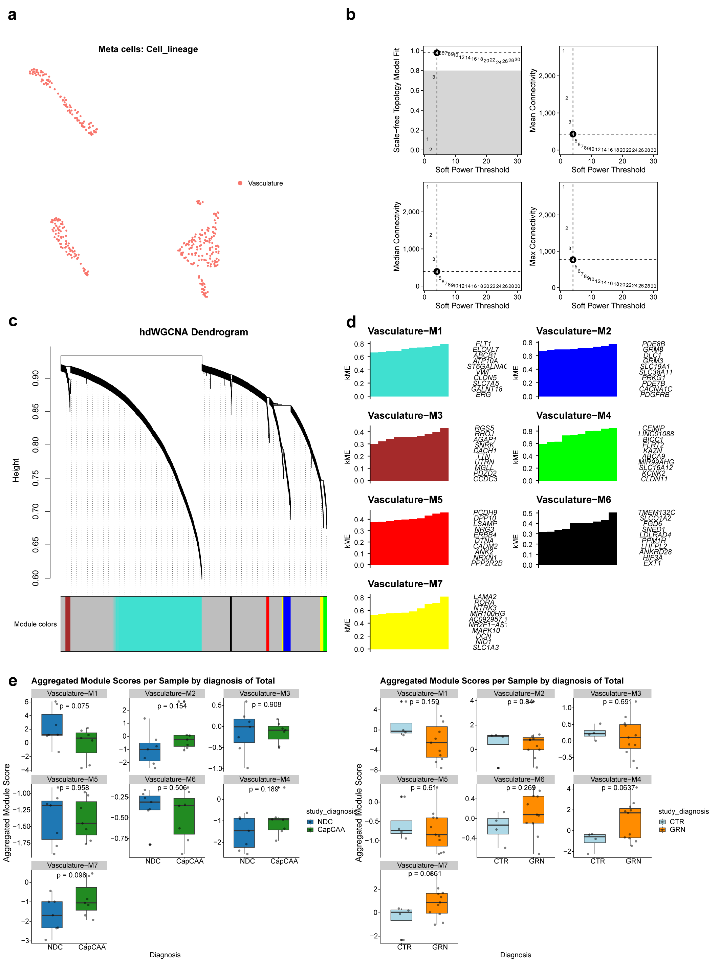

Supplementary Figure 6: Additional analysis hdWGCNA vasculature.

