Supplementary Information for “Time-varying errors in the atmospheric CO₂ growth rate”
Sudhanshu Pandey¹, Christopher O’Dell², Thomas E. Taylor², Christian Rödenbeck³, Naveen Chandra⁴, Liang Feng⁵, Paul I. Palmer⁵, and Junjie Liu¹,⁶
¹NASA Jet Propulsion Laboratory, California Institute of Technology, Pasadena, CA, USA ²Cooperative Institute for Research in the Atmosphere (CIRA), Colorado State University, Fort Collins, CO, USA ³Max Planck Institute for Biogeochemistry, Hans-Knöll-Str. 10, 07745 Jena, Germany ⁴Research Institute for Global Change, Japan Agency for Marine-Earth Science and Technology (JAMSTEC), Yokohama, Japan ⁵National Centre for Earth Observation and School of Geosciences, University of Edinburgh, Edinburgh, UK ⁶Division of Geological and Planetary Sciences, California Institute of Technology, Pasadena, CA, USA
Copyright: © 2026. All rights reserved.

Supplementary Discussion

Supplementary Discussion 1: Multi-year-mean accuracy and 1/n scaling of the MBL discrepancy
At multi-year averaging scales, the NOAA MBL growth-rate discrepancy is strongly suppressed because an n-year mean of annual growth rates depends only on the two endpoint annual concentrations. Computed against the in situ inversion median over 1991–2024, the climatological-mean NOAA MBL discrepancy is nearly zero (NOAA minus inversion median = −0.002 ppm yr⁻¹), and the typical absolute discrepancy of rolling five-year means is only 0.03 ppm yr⁻¹, about five times smaller than the annual RMS discrepancy of 0.15 ppm yr⁻¹. Across 1991–2024, the standard deviation of the n-year rolling-mean discrepancy against the in situ inversion median scales as 1/n rather than the 1/√n expected for independent errors (best-fit log–log slope −0.97; Supplementary Fig. S9). This follows because the n-year mean of annual growth rates reduces algebraically to $\left(C_{n+1}−C_{1}\right)/n$: only the two endpoint annual concentrations contribute, and interior-year sampling errors do not enter the average. Equivalently, the endpoint formulation produces a variance reduction proportional to $1/n^{2}$, rather than the $1/n$ reduction expected from averaging independent annual growth-rate errors. This accounts for the multi-year-mean accuracy of the MBL record despite its annual-scale representativeness bias. Long-term Earth-system applications of the MBL record are well supported by these results, consistent with the observing-system-simulation analysis of Pandey et al.¹, who used atmospheric chemistry-transport-model (CTM) simulations to estimate the whole-atmosphere truth versus MBL sampling discrepancy at ~0.03 ppm yr⁻¹ for five-year-mean growth rates.

Supplementary Discussion 2: Annual-scale bias mechanism and the variable conversion factor
The MBL annual growth-rate bias does not arise from a single defect but from multiple representativeness gaps between an MBL network and the whole atmosphere. Prior work has already pointed to sampling limitations and to year-to-year variation in the mapping from MBL growth to whole-atmosphere carbon mass, including effects of vertical structure and stratosphere–troposphere exchange^{1,2}. Our results show that time-varying network representativeness is an additional, independently important driver of this discrepancy. Its effect is modest in near-mean years but amplifies when atmospheric growth departs strongly from its long-term mean, consistent with the predictive role of the seven-year anomaly term. Recent work by Friedlingstein et al.³ reached a related conclusion from a different direction, showing that the conversion from the MBL growth rate to whole-atmosphere carbon mass is not constant from year to year. That inversion-derived variable conversion factor is a useful diagnostic of interannual variability in the MBL-to-mass mapping. Our analysis suggests a mechanistic contribution to that variability: time-varying representativeness of the MBL observing network, arising from both network geometry and atmospheric state. Because the variable conversion factor is itself inferred from inversions, it remains an inversion-informed correction to the MBL record, whereas the GRESO whole-atmosphere estimates provide an alternative atmospheric term over the satellite era without using the flux-inversion machinery.

Supplementary Discussion 3: Practical considerations for community adoption
Several caveats follow for community-wide adoption of the data-driven satellite growth rates. Time-varying biases in satellite retrievals must continue to be quantified, and cross-validation against the Total Carbon Column Observing Network (TCCON) remains essential^{1,4,5}. The whole-atmosphere growth-rate methodology depends on regular, fixed-time-of-day sampling, which OCO-2 and GOSAT both provide; it should be testable for upcoming missions with similar sun-synchronous sampling, including MicroCarb⁶, GOSAT-GW⁷, and CO₂M⁸, provided mission-specific retrieval biases, sampling patterns, and cross-calibration are explicitly evaluated. The whole-atmosphere satellite growth-rate record now spans 2010–2024 when GOSAT and OCO-2 are considered together, but continuity across missions will require careful cross-calibration and, ultimately, uncertainty-weighted multi-satellite fusion rather than the simple arithmetic mean used here^{9,10}. Reliance on a single satellite is also a structural risk: the multi-instrument ground network has built-in redundancy, so individual instrument or platform losses do not collapse the record, whereas a single-satellite gap can interrupt the whole-atmosphere series. In situ data, including the individual MBL flask measurements from NOAA used in this study, therefore remain indispensable as an independent benchmark and as a bridge from atmospheric growth to flux attribution.
Lower atmospheric-term discrepancy may also improve the sensitivity of the global carbon budget to large but transient emissions perturbations. For reference, the COVID-19 emissions anomaly in 2020 was about 0.5 PgC yr⁻¹¹¹; a perturbation of that scale may be easier to isolate in a climatically quieter year, when variability in the land and ocean terms is smaller than during events such as the 2023–2024 anomaly.

Supplementary Figures
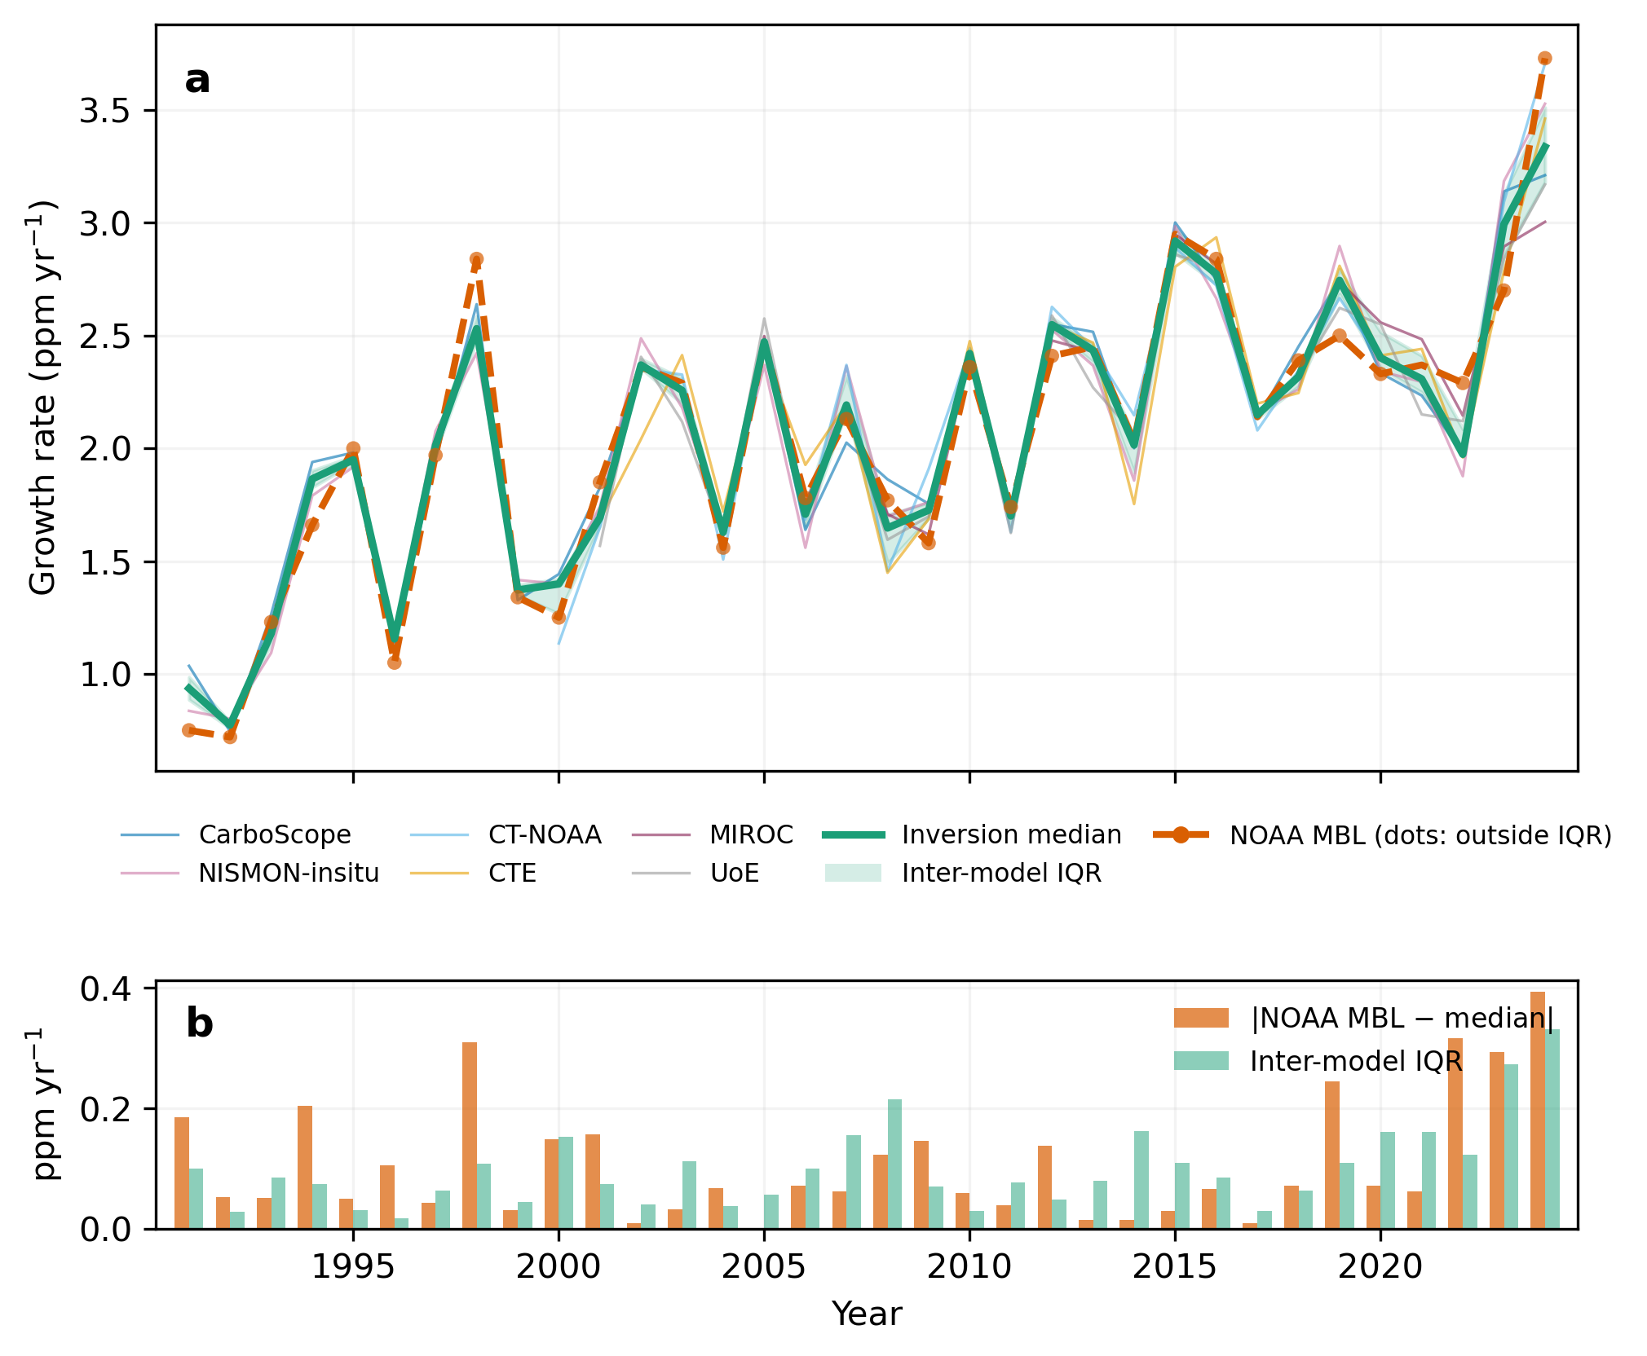
Supplementary Fig. S1 | Inter-model spread of GCB 2025 in situ inversions and NOAA MBL growth rate, 1991–2024. (a) Annual atmospheric CO₂ growth rates (ppm yr⁻¹) from six in situ atmospheric inversions (colored lines, one per inversion; see panel-a legend), their per-year median (green) and interquartile range (IQR; green shading), and the NOAA MBL growth rate (orange dashed). Orange dots mark years in which the NOAA value falls outside the inversion IQR. (b) Absolute NOAA MBL discrepancy from the inversion median (ppm yr⁻¹; orange) compared with the inter-model IQR (green) for each year.
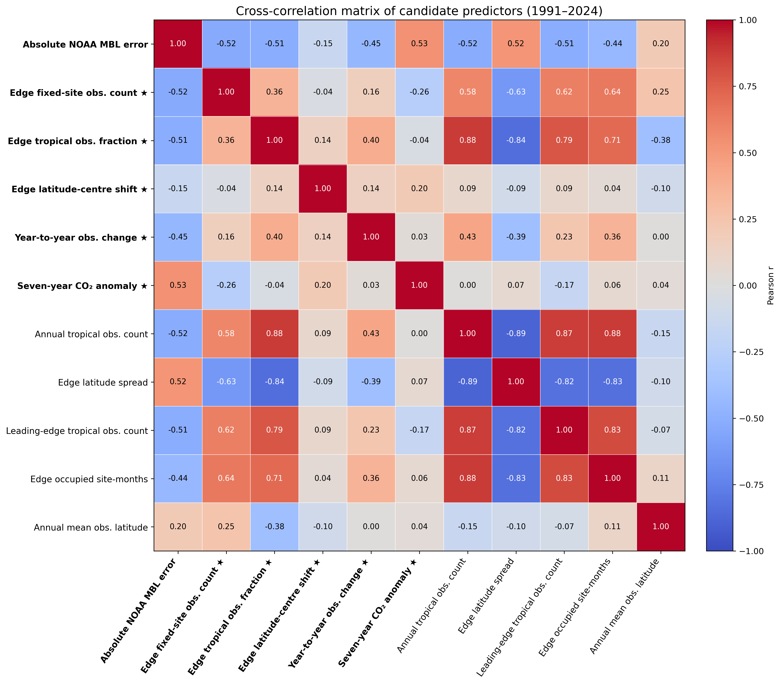
Supplementary Fig. S2 | Cross-correlation matrix of candidate predictors and the NOAA–inversion discrepancy. Pearson correlations for the ten candidate predictors and the absolute NOAA–inversion growth-rate discrepancy, 1991–2024. Warm/cool colors denote positive/negative correlations; values annotated in each cell. ★ marks the five predictors retained in the selected regression model (see Supplementary Table S1).
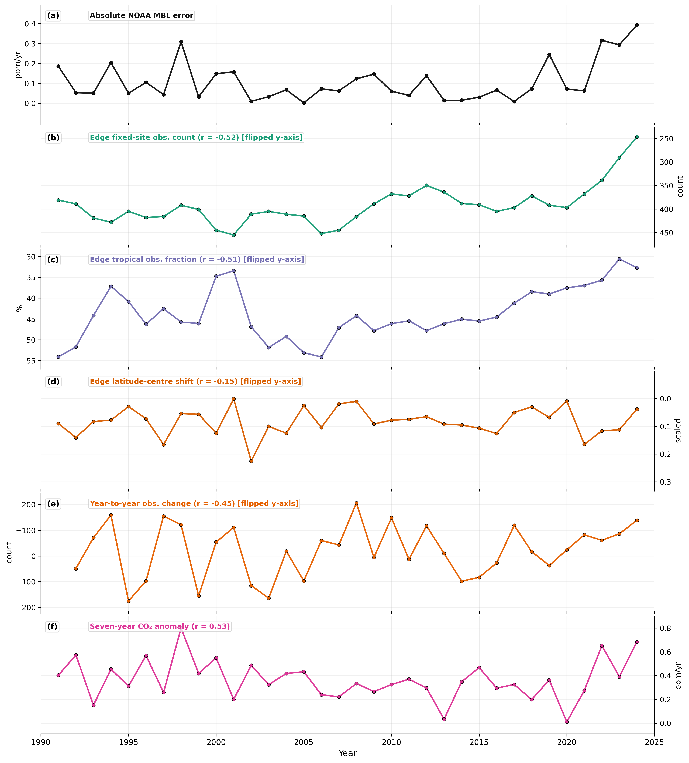
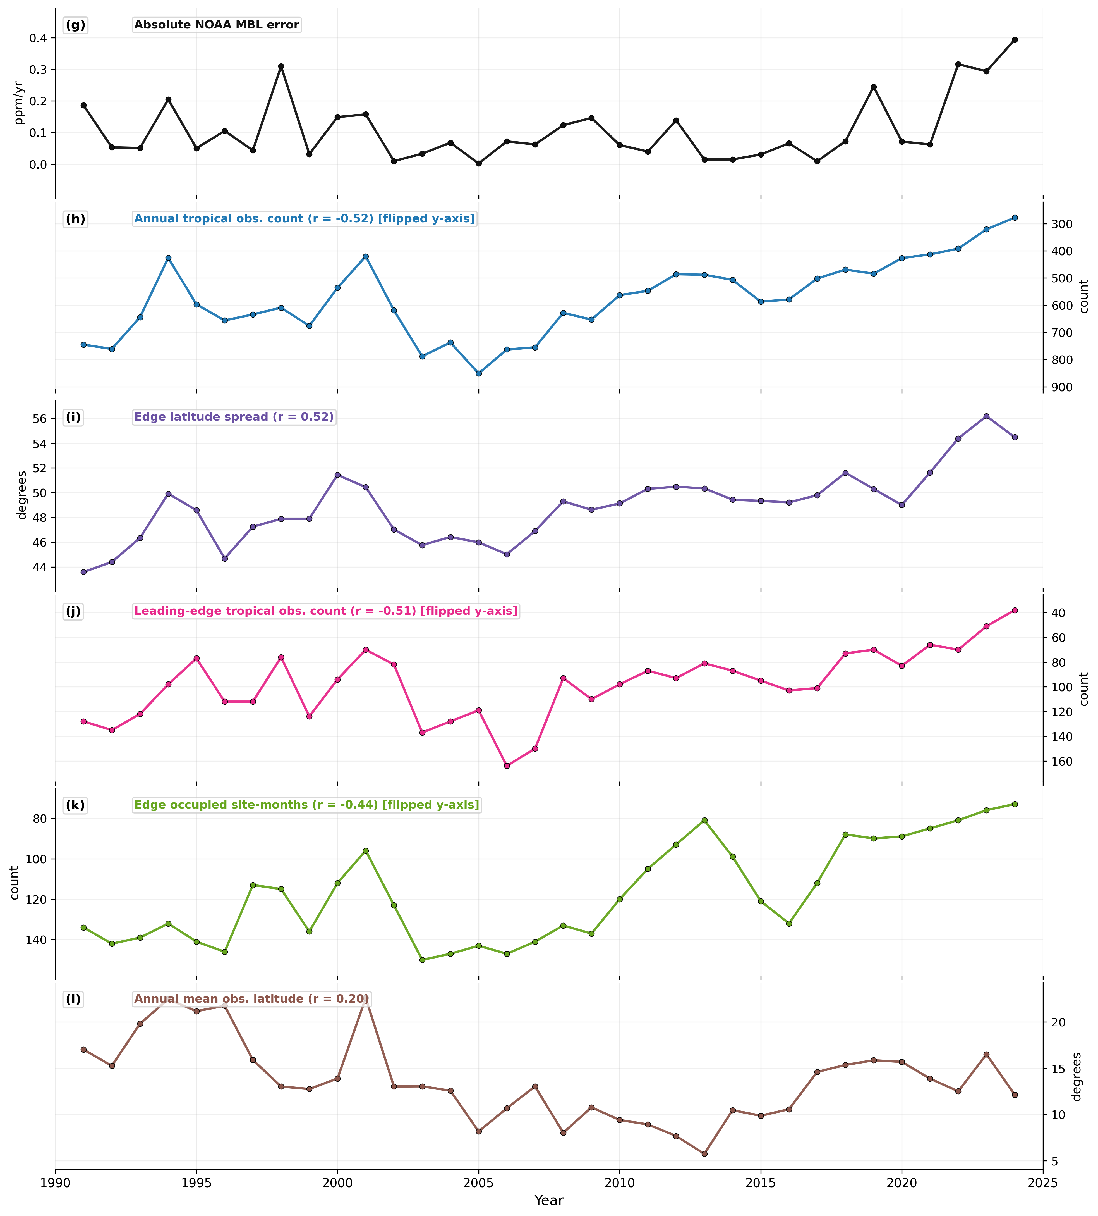
Supplementary Fig. S3 | Diagnostic time series for predictors of the absolute NOAA–inversion growth-rate discrepancy, 1991–2024. The figure is shown in two parts for readability: panels (a–f) show the target variable and the five selected predictors; panels (g–l) show the five unselected candidate predictors. The target variable (absolute NOAA–inversion discrepancy) is repeated in panel (g) for visual reference. (a, g) Absolute NOAA–inversion discrepancy. (b) Edge fixed-site observation count. (c) Edge tropical observation fraction. (d) Edge latitude-center shift. (e) Year-to-year observation change. (f) Seven-year CO₂ anomaly. (h) Annual tropical observation count. (i) Edge latitude spread. (j) Leading-edge tropical observation count. (k) Edge occupied site-months. (l) Annual mean observation latitude. Predictors with negative Pearson correlations are plotted with a flipped y-axis so that visually higher values correspond to larger expected discrepancy magnitude. See Supplementary Table S1 for predictor definitions and univariate correlations.
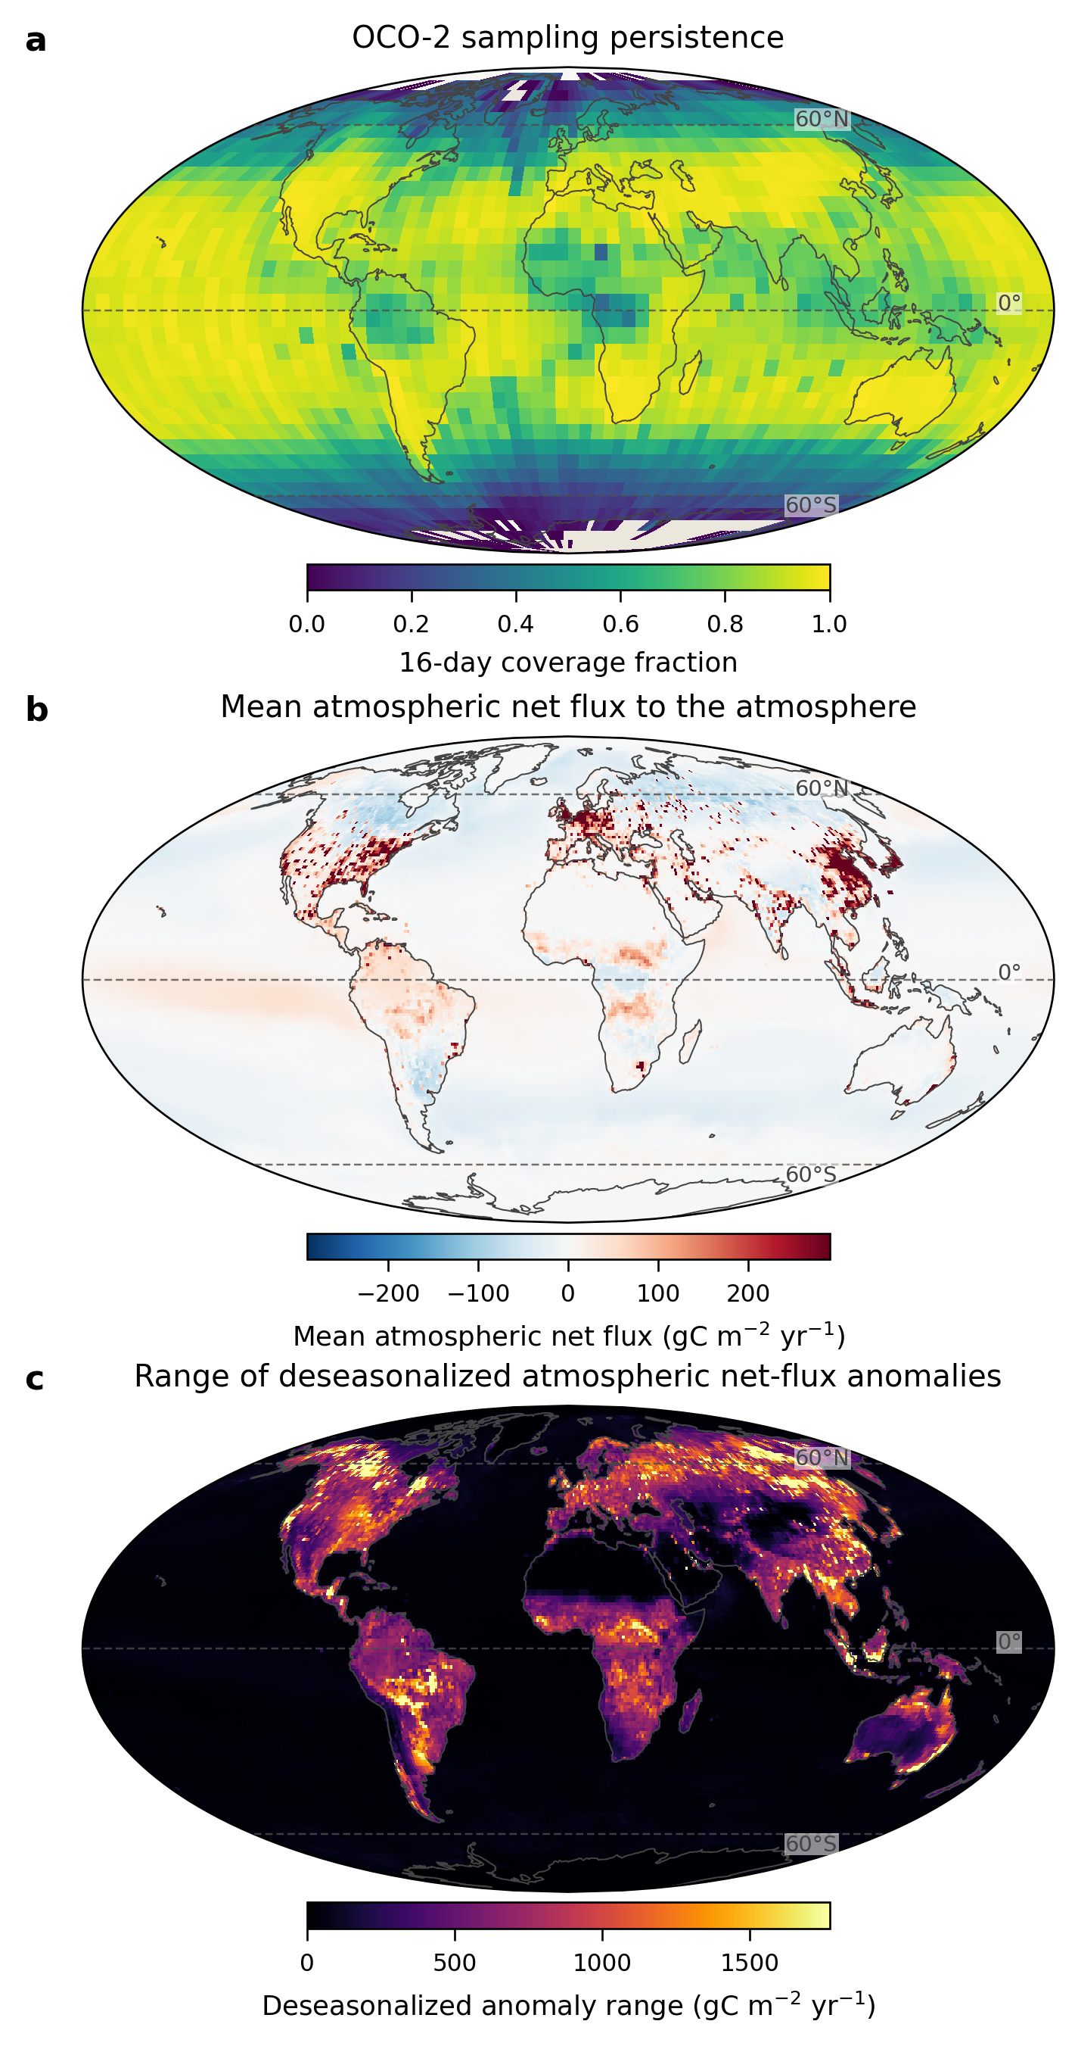
Supplementary Fig. S4 | OCO-2 sampling and GCB 2025 inversion flux fields. (a) OCO-2 sampling persistence: fraction of 16-day windows with at least one observation per 5° × 5° cell. (b) Time-mean atmospheric net flux, 1991–2024, from the GCB in situ inversion-median total field (fossil-cement-adjusted land flux + unadjusted ocean flux + gridded fossil emissions) on a 1° grid. Positive: net source; negative: net uptake. (c) Range (maximum minus minimum over 1991–2024) of the deseasonalized monthly flux anomalies in each grid cell, from the same field as (b). Larger values indicate grid cells with greater interannual flux variability that can contribute to atmospheric CO₂ growth-rate variations.
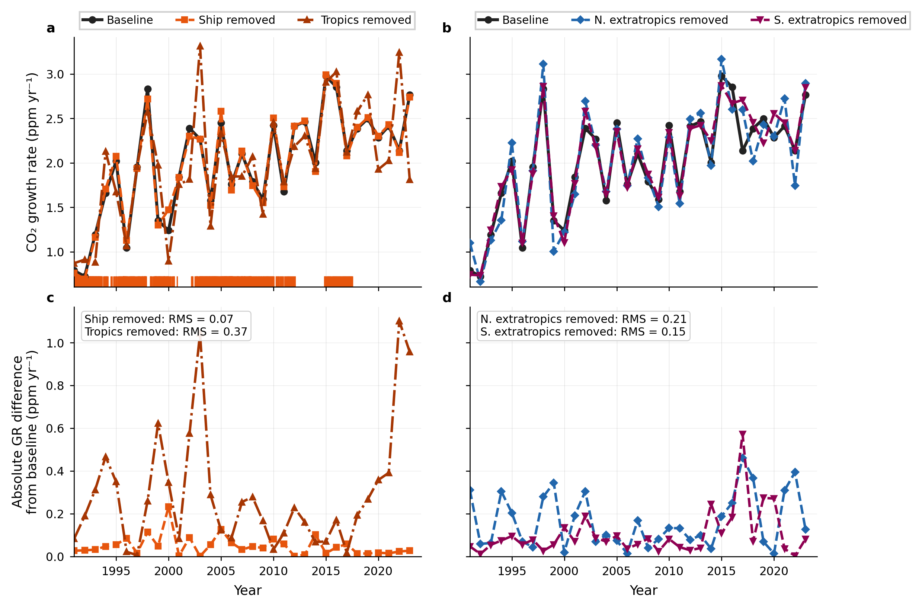
Supplementary Fig. S5 | Sensitivity of the NOAA MBL growth rate to regional site removal. (a) Annual NOAA MBL CO₂ growth rates (ppm yr⁻¹) after removing ship sites (14 POC bins, |latitude| ≤ 35°) or all tropical sites (23 sites, |latitude| ≤ 30°). (b) Same for NH extratropical (12 sites, latitude > 30°N) and SH extratropical (8 sites, latitude < −30°S) removal. (c,d) Absolute departures (ppm yr⁻¹) from the baseline NOAA MBL growth rate computed using the full 43-site network.
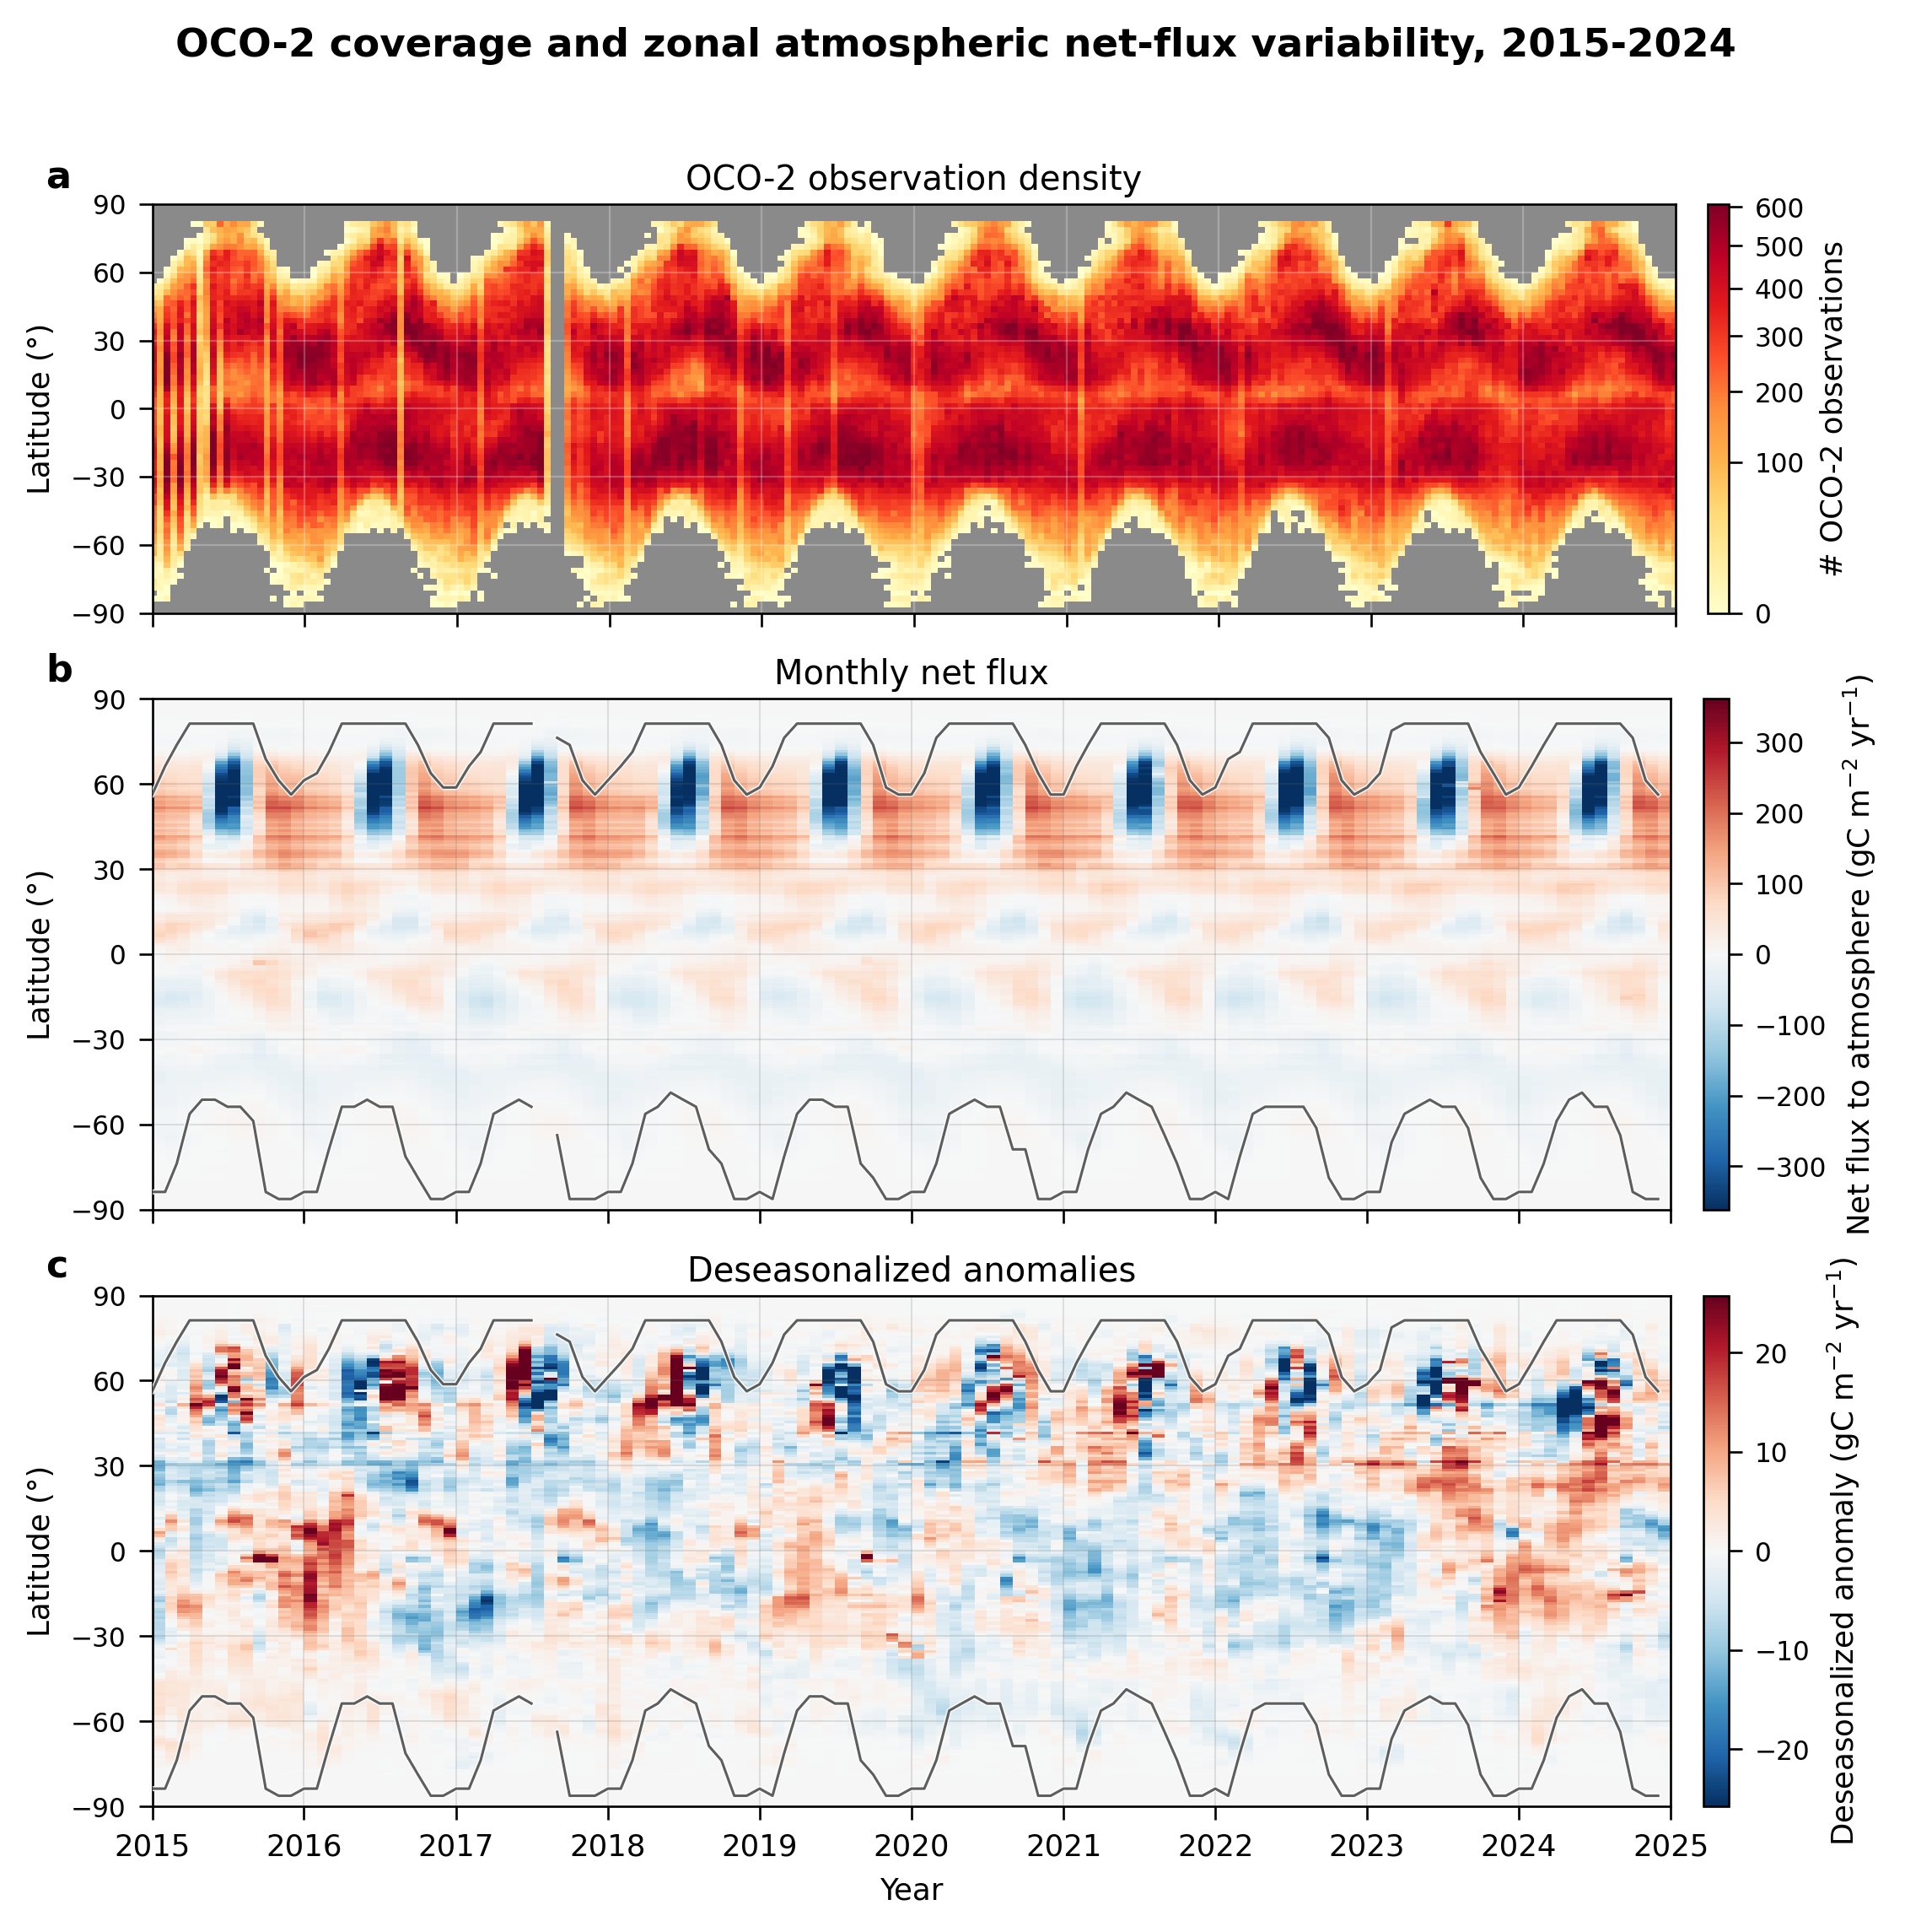
Supplementary Fig. S6 | OCO-2 coverage and zonal flux anomalies, 2015–2024. (a) OCO-2 observation density (16-day × 2.5° bins). (b) Zonal-mean monthly atmospheric net flux (same inversion-median field as Fig. S4b). (c) Zonal-mean deseasonalized flux anomalies. In (b,c), black envelopes mark the monthly OCO-2 latitude limits from the same record as (a) and Fig. S4a. For latitudes north of 30°N, anomaly magnitudes are 2.3× larger in May–September than November–February, peaking at 60–64°N when OCO-2 coverage is widest.
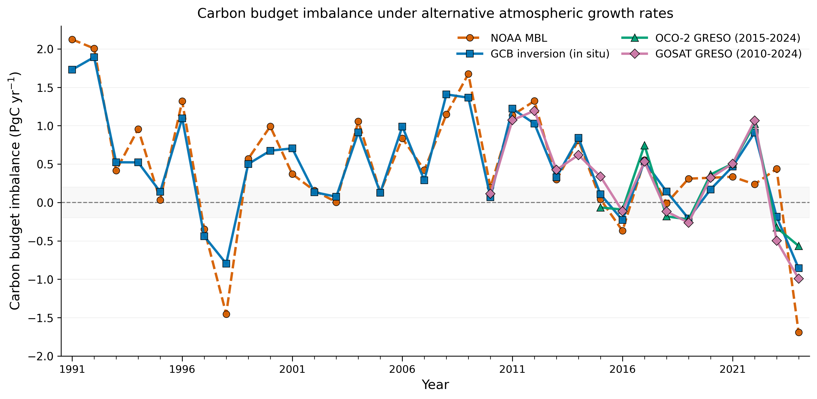
Supplementary Fig. S7 | Full-record carbon budget imbalance (BIM), 1991–2024. Annual budget imbalance for NOAA MBL (orange), GCB in situ inversions (blue), OCO-2 GRESO (green, 2015–2024 only), and GOSAT GRESO (mauve, 2010–2024). Dashed line: zero; gray band: ±0.2 PgC yr⁻¹. Full-record BIM RMS: NOAA MBL 0.92, GCB in situ inversions 0.80 PgC yr⁻¹. Over 2015–2024, BIM RMS is 0.62 for NOAA MBL, 0.47 for GCB in situ inversions, 0.50 for OCO-2 GRESO, and 0.55 for GOSAT GRESO.
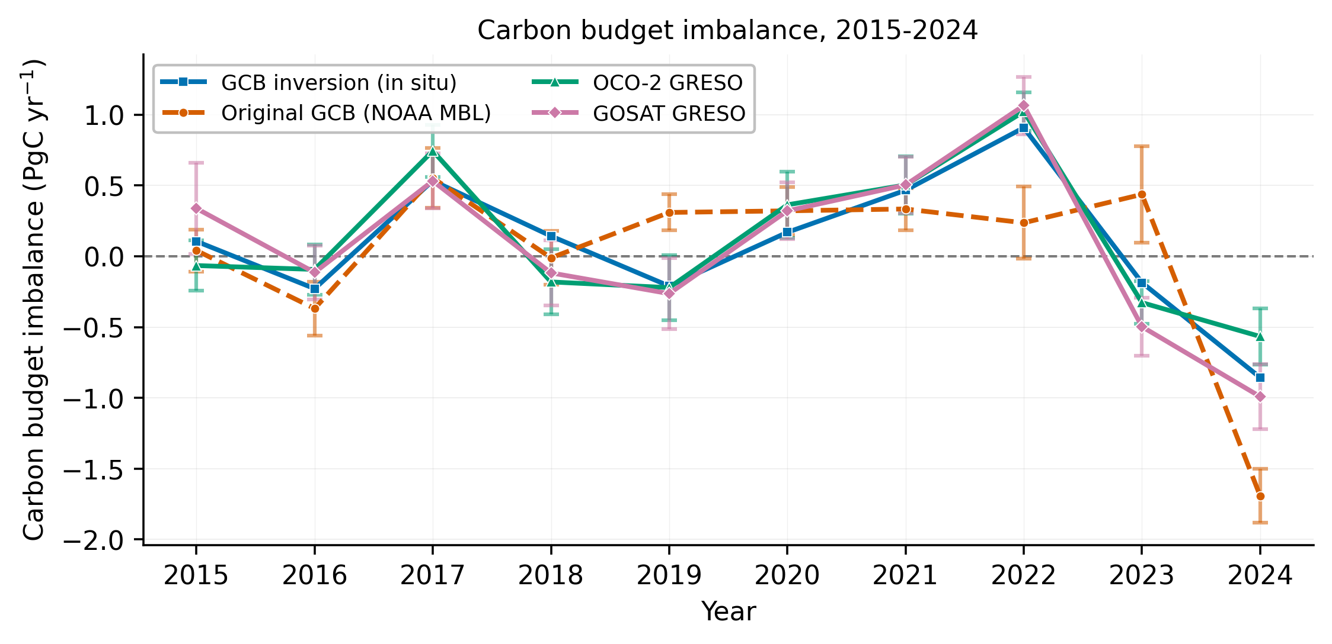
Supplementary Fig. S8 | Individual-satellite carbon budget imbalance (BIM), 2015–2024. Annual budget imbalance using each satellite product separately as the atmospheric term: NOAA MBL (orange dashed), GCB in situ inversions (blue), OCO-2 GRESO (green), and GOSAT GRESO (mauve). Error bars/ranges show the reported atmospheric-term uncertainty for each product: 1σ bootstrap uncertainty for NOAA MBL (bootstrap), OCO-2 and GOSAT (40-member parametric bootstraps), and the inter-model IQR for the GCB in situ inversion ensemble. These are propagated into the budget imbalance. BIM RMS over 2015–2024: MBL 0.62, GCB in situ inversions 0.47, OCO-2 0.50, GOSAT 0.55 PgC yr⁻¹.
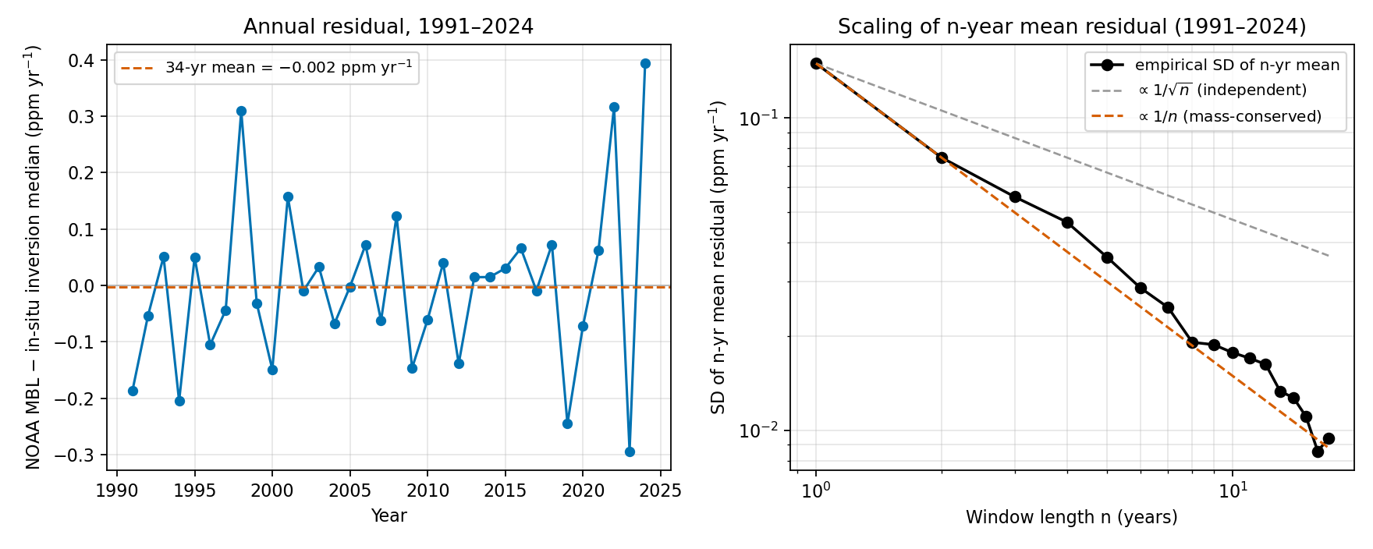
Supplementary Fig. S9 | Mass-conservation scaling of multi-year-mean NOAA–inversion discrepancies, 1991–2024. (a) Annual discrepancy of the NOAA MBL growth rate relative to the GCB in situ inversion median, 1991–2024. Dashed line: 34-year mean (−0.002 ppm yr⁻¹). (b) Standard deviation of n-year rolling means of the discrepancies shown in (a), as a function of window length n. The empirical scaling tracks the 1/n reference (orange dashed) rather than the 1/√n reference (gray dashed), with best-fit log–log slope −0.97. Let $C_{i}$ denote the annual mean NOAA MBL CO₂ concentration in year i and $G_{i}=C_{i+1}−C_{i}$ the annual growth rate. The arithmetic mean of n consecutive annual growth rates simplifies to $⟨G⟩_{n}=\left(C_{n+1}−C_{1}\right)/n$, so only the two endpoint annual concentrations enter the average and interior-year sampling errors do not contribute. If each annual mean has sampling-error variance $σ_{C}^{2}$, then $Var\left(⟨G⟩_{n}\right)=2σ_{C}^{2}/n^{2}$ and $SD\left(⟨G⟩_{n}\right)∝1/n$. The 1/n scaling is therefore a property of the n-year-mean operator collapsing to a function of two endpoint values, not random-error cancellation in the usual sense.

Supplementary Table S1
Supplementary Table S1 | Candidate predictor definitions and univariate correlations for the 1991–2024 regression.
The target variable is the absolute NOAA–in situ-inversion growth-rate discrepancy, |NOAA MBL AGR − inversion median|, in ppm yr⁻¹. Negative $r$ means larger predictor values tend to coincide with smaller absolute discrepancy; positive $r$ means larger predictor values tend to coincide with larger absolute discrepancy.
Predictor name | Selected | Group | Explanation | Pearson r
Edge fixed-site observation count | Yes | Edge | Total number of fixed-site observations in the year-edge window (Dec(y−1)+Jan(y)+Dec(y)+Jan(y+1)). An edge-sampling intensity metric: larger values mean denser fixed-network sampling at the calendar-year boundaries that define the growth rate. | −0.524
Edge tropical observation fraction | Yes | Edge | Fraction of all edge-window observations from tropical sites (30°S–30°N). Measures how strongly boundary sampling is weighted toward the tropics, which are dynamically important for global CO₂ variability. | −0.514
Edge latitude-center shift | Yes | Edge | Absolute shift in observation-weighted mean latitude between the leading and trailing edge windows, scaled by the edge latitude spread. Larger values indicate greater movement of the network’s effective centre between the start and end of the growth-rate year. | −0.148
Year-to-year observation change | Yes | Annual | Change in the annual total observation count relative to the previous year. A network-stability term: positive values mean the network gained observation volume; negative values mean it lost volume. | −0.449
Seven-year CO₂ anomaly | Yes | Climate state | Absolute departure of the in situ inversion-median growth rate from its centered seven-year running mean. An anomaly-strength term: larger values identify years when the growth-rate signal is unusually far from the local background, making coverage weaknesses more visible. | +0.532
Annual tropical observation count | No | Annual | Total tropical observations in the full calendar year. The simplest annual tropical-sampling metric: more tropical observations generally mean stronger constraint on global growth-rate variability. | −0.522
Edge latitude spread | No | Edge | Observation-weighted standard deviation of latitude in the edge window. Measures how broadly edge observations span latitude bands; larger values mean wider latitudinal distribution rather than concentration in one zone. | +0.519
Leading-edge tropical observation count | No | Edge | Tropical observations in the leading boundary window only (Dec(y−1)+Jan(y)). Isolates how well the network samples the start of the growth-rate year in the tropics. | −0.509
Edge occupied site-months | No | Edge | Number of distinct site-month bins occupied in the edge window. A coverage-completeness metric that increases when more site-month combinations are present, even if total observation count does not rise proportionally. | −0.438
Annual mean observation latitude | No | Annual | Observation-weighted mean latitude for the full annual network. A large-scale geometry metric: higher values mean the network is centered farther north on average. | +0.198

Supplementary Table S2
Supplementary Table S2 | Robustness diagnostics for the five-predictor OLS regression of the absolute NOAA–inversion growth-rate discrepancy. All statistics in this table are computed on the 33-year subsample 1992–2024 (1991 excluded entirely); this subsample is used as a robustness check against the main-text regression, which includes 1991 via 1990 site-count data for the lagged predictor. Methodological details are given in the footnotes.
(a) Coefficient estimates — baseline five-predictor model. β denotes the unstandardized OLS regression coefficient.
Predictor | β | 95% CI¹
Intercept | +0.483 | [+0.239, +0.728]
Edge fixed-site observation count⁷ | −0.0005 | [−0.0011, 0.0000]
Edge tropical observation fraction | −0.572 | [−0.977, −0.166]
Edge latitude-center shift | −0.353 | [−0.782, +0.077]
Year-to-year observation change⁷ | −0.0003 | [−0.0005, 0.0000]
Seven-year CO₂ anomaly | +0.293 | [+0.165, +0.421]
(b) Permutation test of overall model significance²
Statistic | Value
Observed R² | 0.728
p-value (10,000 permutations) | < 0.0001
(c) Influential-observation screening³
Statistic | Value
Maximum Cook’s D (year) | 0.141 (2006)
Years with Cook’s D > 4/n (0.121) | 2006 only
(d) Sensitivity experiments
Experiment | R | R² | LOO R² | RMSE (ppm yr⁻¹)
Baseline (five predictors, 1992–2024)⁶ | 0.853 | 0.728 | 0.588 | 0.052
Coverage-only (drop anomaly predictor)⁴ | 0.712 | 0.507 | 0.355 | 0.070
Excluding 2024 (five predictors, 1992–2023)⁵ | 0.797 | 0.634 | 0.478 | 0.053
Footnotes. ¹Confidence intervals are derived from the OLS residual variance and the ${\left(X^{⊤}X\right)}^{−1}$ covariance matrix; the critical value is $t_{0.975, 27}$. ²The permutation test randomly shuffles the target variable 10,000 times and refits the model each time to obtain a null $R^{2}$ distribution; the reported $p$-value is the fraction of null $R^{2}$ values exceeding the observed $R^{2}$. ³Cook’s distance threshold of $4/n$ (= 0.121 for $n$ = 33) identifies observations with disproportionate leverage on the fitted coefficients. ⁴The “coverage-only” experiment removes the seven-year CO₂ anomaly predictor, retaining only the four network-coverage terms; the resulting drop in LOO $R^{2}$ (0.588 to 0.355) confirms that the anomaly predictor contributes independent explanatory power. ⁵The “excluding 2024” experiment drops the most recent (and most anomalous) year to test whether a single influential endpoint drives the fit. ⁶The main text reports LOO $R^{2}$ = 0.635 for the full 34-year sample (1991–2024); the baseline value of 0.588 in this table reflects the 33-year subsample (1992–2024) after excluding 1991 for the lagged predictor requirement. ⁷Upper 95% CI bounds shown as “0.0000” for the “Edge fixed-site observation count” and “Year-to-year observation change” coefficients result from rounding to four decimal places; the unrounded magnitudes are below $5×{10}^{−5}$ ppm yr⁻¹ per unit predictor, and the sign of the upper bound is not resolved at this precision.

Supplementary Table S3
Supplementary Table S3 | OCO-2, GOSAT, and satellite-mean growth-rate and carbon-budget comparison, 2015–2024.
(a) Annual atmospheric CO₂ growth rates (ppm yr⁻¹). Uncertainties are 1σ except for the inversion column, which reports the median with the interquartile range [Q1, Q3] across the six in situ inversions (CarboScope, NISMON-insitu, CT-NOAA, CTE, MIROC, UoE). The OCO-2/GOSAT mean is the arithmetic mean of the two satellite growth-rate estimates; its 1σ uncertainty is propagated from the individual product 1σ uncertainties assuming independent product-level errors.
Year | Inversion (median [Q1, Q3]) | NOAA | OCO-2 | GOSAT | OCO-2/GOSAT mean
2015 | 2.92 [2.87, 2.98] | 2.95 ± 0.07 | 3.00 ± 0.08 | 2.81 ± 0.10 | 2.91 ± 0.06
2016 | 2.77 [2.73, 2.81] | 2.84 ± 0.09 | 2.71 ± 0.08 | 2.72 ± 0.08 | 2.71 ± 0.06
2017 | 2.15 [2.13, 2.16] | 2.14 ± 0.10 | 2.05 ± 0.09 | 2.18 ± 0.08 | 2.12 ± 0.06
2018 | 2.32 [2.28, 2.34] | 2.39 ± 0.09 | 2.47 ± 0.11 | 2.44 ± 0.10 | 2.46 ± 0.07
2019 | 2.74 [2.68, 2.79] | 2.50 ± 0.06 | 2.75 ± 0.11 | 2.76 ± 0.10 | 2.75 ± 0.07
2020 | 2.40 [2.35, 2.52] | 2.33 ± 0.08 | 2.31 ± 0.11 | 2.33 ± 0.08 | 2.32 ± 0.07
2021 | 2.31 [2.25, 2.41] | 2.37 ± 0.07 | 2.29 ± 0.10 | 2.29 ± 0.09 | 2.29 ± 0.07
2022 | 1.97 [1.96, 2.09] | 2.29 ± 0.12 | 1.92 ± 0.06 | 1.89 ± 0.09 | 1.90 ± 0.05
2023 | 2.99 [2.85, 3.13] | 2.70 ± 0.16 | 3.06 ± 0.07 | 3.13 ± 0.08 | 3.09 ± 0.05
2024 | 3.34 [3.18, 3.51] | 3.73 ± 0.09 | 3.20 ± 0.09 | 3.36 ± 0.09 | 3.28 ± 0.07
(b) Adjusted carbon budget imbalance (PgC yr⁻¹).
Year | NOAA MBL | GCB in situ inversion median | OCO-2 GRESO | GOSAT GRESO | OCO-2/GOSAT GRESO mean
2015 | 0.04 | 0.11 | −0.07 | 0.34 | 0.14
2016 | −0.37 | −0.23 | −0.09 | −0.11 | −0.10
2017 | 0.55 | 0.53 | 0.74 | 0.47 | 0.61
2018 | −0.01 | 0.14 | −0.18 | −0.12 | −0.15
2019 | 0.31 | −0.21 | −0.22 | −0.24 | −0.23
2020 | 0.32 | 0.17 | 0.36 | 0.32 | 0.34
2021 | 0.33 | 0.47 | 0.50 | 0.50 | 0.50
2022 | 0.24 | 0.91 | 1.02 | 1.09 | 1.05
2023 | 0.44 | −0.19 | −0.33 | −0.48 | −0.40
2024 | −1.69 | −0.86 | −0.57 | −0.91 | −0.74
(c) Summary metrics over 2015–2024.
Product | r vs inversion | Growth-rate RMSE (ppm yr⁻¹) | BIM RMS (PgC yr⁻¹)
NOAA MBL | 0.889 | 0.205 | 0.622
GCB in situ inversion median | n/a | n/a | 0.475
OCO-2 GRESO | 0.978 | 0.089 | 0.501
GOSAT GRESO | 0.983 | 0.079 | 0.548
OCO-2/GOSAT mean | 0.986 | 0.070 | 0.516

References
1. Pandey, S. et al. Toward Low‐Latency Estimation of Atmospheric CO $​_{2}$ Growth Rates Using Satellite Observations: Evaluating Sampling Errors of Satellite and In Situ Observing Approaches. AGU Advances 5, (2024).
2. Pandey, S. et al. Reduction in Earth’s carbon budget imbalance. Nature Communications 16, (2025).
3. Friedlingstein, P. et al. Emerging climate impact on carbon sinks in a consolidated carbon budget. Nature 649, 98–103 (2025).
4. Taylor, T. E. et al. Evaluating the consistency between OCO-2 and OCO-3 XCO₂ estimates derived from the NASA ACOS version 10 retrieval algorithm. Atmospheric Measurement Techniques 16, 3173–3209 (2023).
5. Wunch, D. et al. Comparisons of the Orbiting Carbon Observatory-2 (OCO-2) XCO$​_{2}$ measurements with TCCON. Atmospheric Measurement Techniques 10, 2209–2238 (2017).
6. Bertaux, J.-L. et al. The use of the 1.27 m O$​_{2}$ absorption band for greenhouse gas monitoring from space and application to MicroCarb. Atmospheric Measurement Techniques 13, 3329–3374 (2020).
7. Imasu, R. et al. Greenhouse gases Observing SATellite 2 (GOSAT-2): mission overview. Progress in Earth and Planetary Science 10, (2023).
8. Sierk, B. et al. The Copernicus CO$​_{2}$ Monitoring (CO2M) mission for monitoring anthropogenic carbon dioxide emissions from space. Proceedings of SPIE 11852, (2021).
9. Kuze, A., Suto, H., Nakajima, M. & Hamazaki, T. Thermal and near infrared sensor for carbon observation Fourier-transform spectrometer on the Greenhouse Gases Observing Satellite for greenhouse gases monitoring. Applied Optics 48, 6716–6733 (2009).
10. Buchwitz, M. et al. Computation and analysis of atmospheric carbon dioxide annual mean growth rates from satellite observations during 2003–2016. Atmospheric Measurement Techniques 11, 5765–5782 (2018).
11. Le Quéré, C. et al. Temporary reduction in daily global CO2 emissions during the COVID-19 forced confinement. Nature Climate Change 10, 647–653 (2020).

