Supplementary Materials

Supplementary Figures

Supplementary Figure S1. Encoder validation: seizure detection on HUP dataset

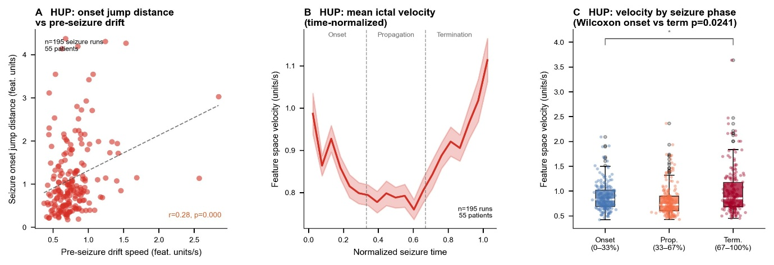

Supplementary Figure S1. Validation of the pre-trained encoder on the HUP dataset (n=195 seizure runs, 55 patients), demonstrating clinically meaningful signal structure. (A) Onset jump distance vs. pre-seizure drift speed (Spearman r=0.28, p<0.001). (B) Time-normalised mean ictal velocity profile confirming acceleration into termination. (C) Velocity by seizure phase; termination exceeds onset (Wilcoxon p=0.0241).

Supplementary Figure S2. Seizure reversibility in the AI feature space

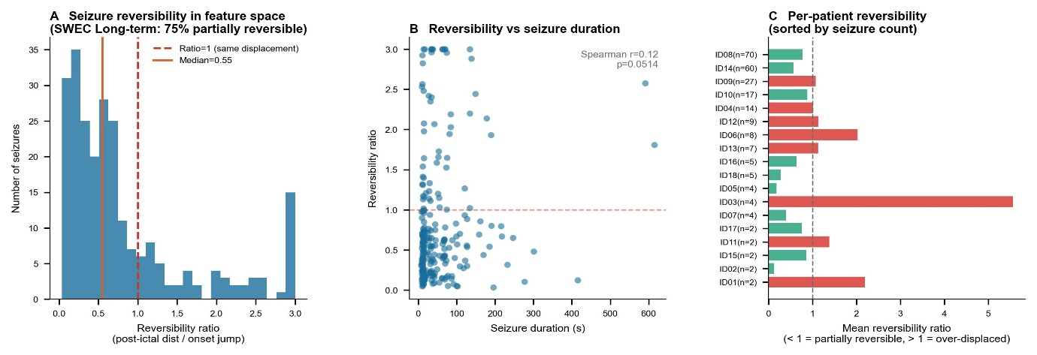

Supplementary Figure S2. Reversibility analysis (SWEC-ETHZ long-term; 244 seizures, 18 patients). (A) 75% of seizures are partially reversible (ratio<1.0; median=0.55). (B) Reversibility vs. seizure duration (r=0.12, p=0.051). (C) Per-patient mean reversibility sorted by seizure count; ID03 (n=4) shows extreme irreversibility; ID08 (n=70) and ID14 (n=60) near-complete reversibility.

Supplementary Figure S3. Cross-patient seizure trajectory similarity

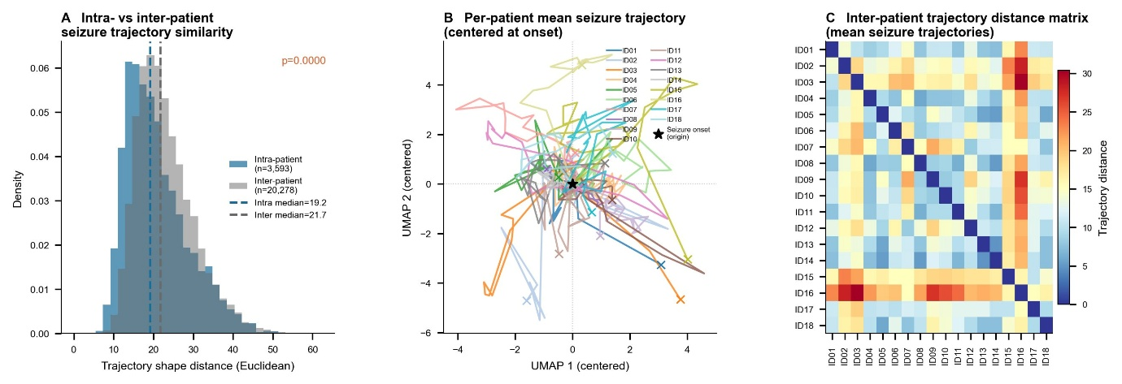

Supplementary Figure S3. Within-patient vs. between-patient trajectory similarity (SWEC-ETHZ long-term). (A) Trajectory shape distances: within-patient pairs (blue; n=3,593; median=19.2) vs. between-patient pairs (grey; n=20,278; median=21.7); Mann-Whitney p<0.0001. (B) Per-patient mean seizure trajectories centred at onset. (C) 18×18 inter-patient trajectory distance matrix.

Supplementary Figure S4. Clinical determinants of seizure electrophysiological fingerprints

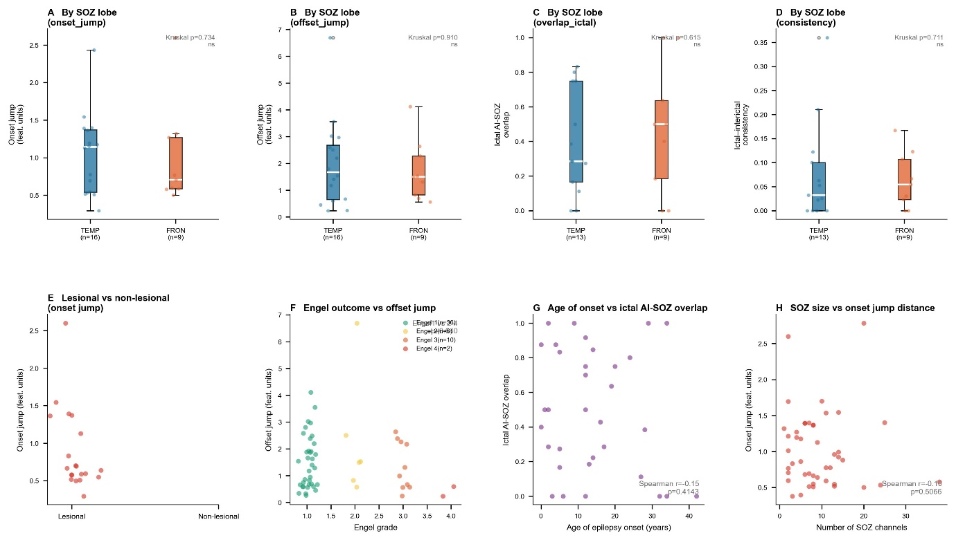

Supplementary Figure S4. Association between clinical variables and AI-derived fingerprint metrics (HUP). (A-D) SOZ lobe (TEMPORAL n=16, FRONTAL n=9): no significant differences for onset jump (Kruskal p=0.734), offset jump (p=0.910), ictal AI-SOZ overlap (p=0.615), or consistency (p=0.711) - consistent with the Network Disruption Theory prediction that functional network identity, not anatomical lobe, determines the fingerprint. (E) Lesional vs. non-lesional onset jump: not significant. (F) Engel grade vs. offset jump: not significant (p=0.640). (G) Age of onset vs. ictal AI-SOZ overlap (r=−0.15, p=0.414; not significant). (H) Age of onset vs. ictal-interictal consistency (r=0.48, p=0.005): the sole significant clinical predictor.

Supplementary Figure S5. Spatial SOZ characteristics and fingerprint metrics

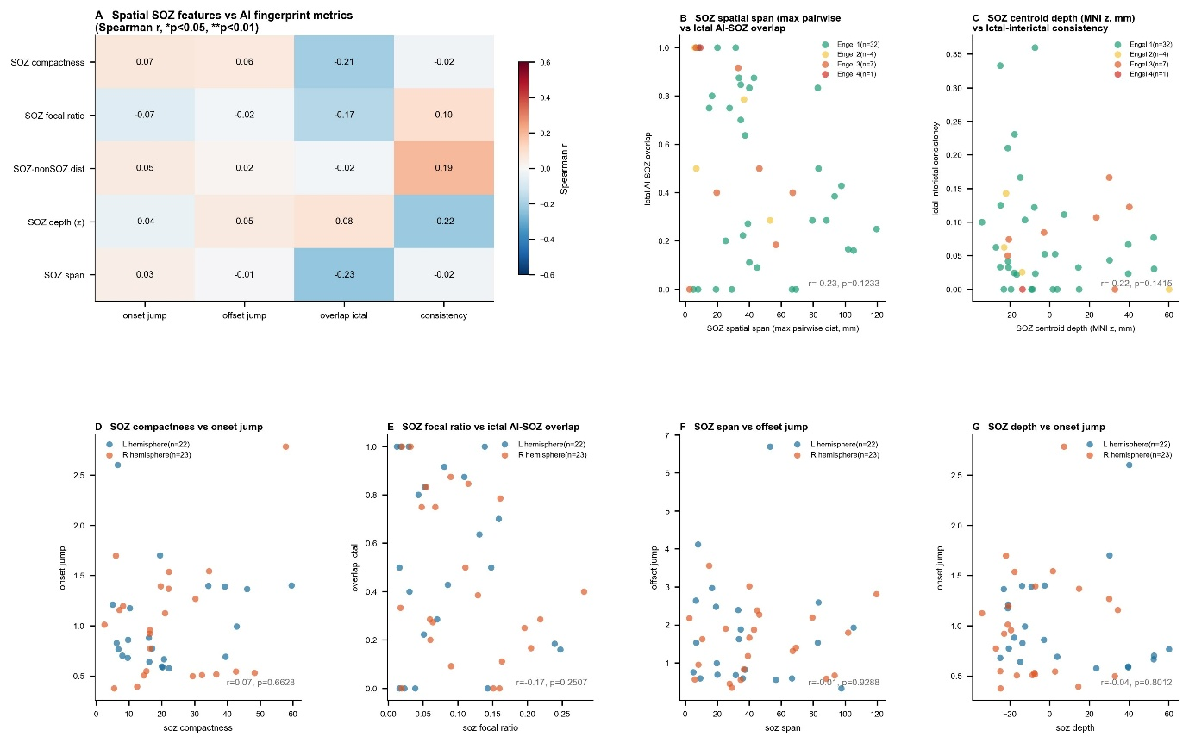

Supplementary Figure S5. Spearman correlation between five SOZ spatial features and four fingerprint metrics (HUP; n=45-52 patients). (A) Heatmap: all correlations small and non-significant (max |r|=0.23, p=0.12). Under the Network Disruption Theory, this null result is expected: functional network identity rather than anatomical geometry governs the fingerprint. (B-G) Representative scatter plots coloured by hemisphere; no hemisphere-dependent effects (all p>0.05).

Supplementary Figure S6. Yeo-7 functional network affiliation of SOZ channels

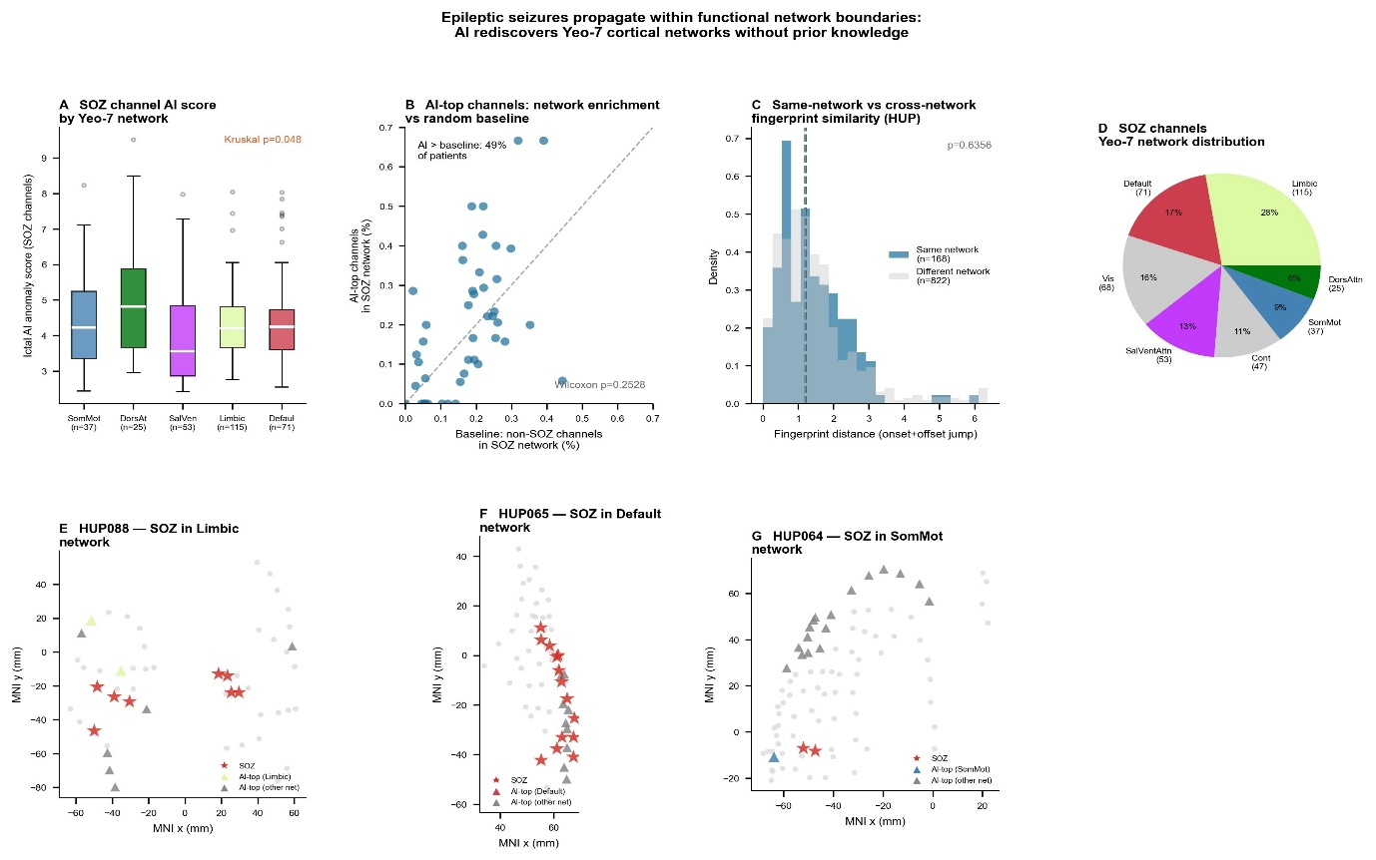

Supplementary Figure S6. Functional network analysis at 7-network granularity. (A) Ictal AI anomaly score of SOZ channels by Yeo-7 network (Kruskal p=0.048); Limbic network SOZ channels show the highest scores. (B) AI-top channel network enrichment vs. baseline (49% above baseline; Wilcoxon p=0.253; not significant at 7-network granularity). (C) Same-network vs. different-network fingerprint distance (p=0.636). (D) SOZ channel Yeo-7 distribution: Limbic 28% (n=115), Default 17% (n=71), SalVentAttn 13% (n=53), Cont 11% (n=47), SomMot 9% (n=37), Vis 16% (n=68), DorsAttn 6% (n=25). (E-G) Representative brain maps for SOZ in Limbic (HUP088), Default (HUP065), and Somatomotor (HUP064) networks.

Supplementary Figure S7. CNN surgical outcome prediction (Schaefer 400-region)

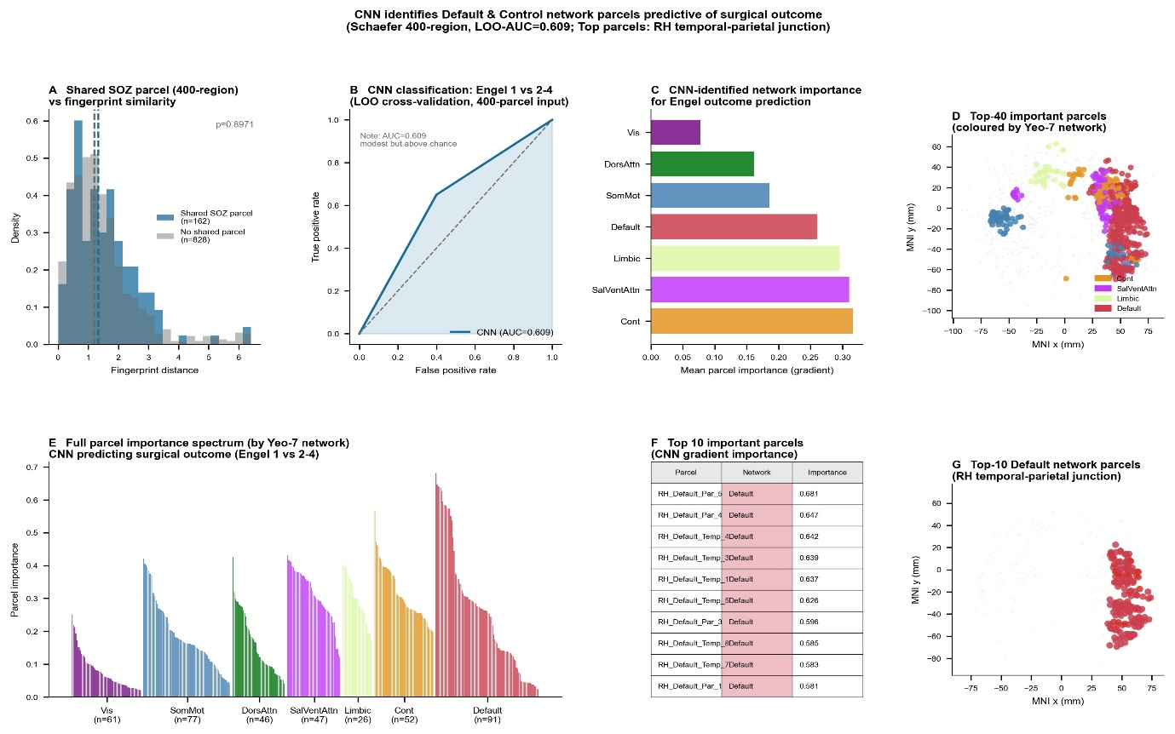

Supplementary Figure S7. CNN classification of surgical outcome (Engel I vs. II-IV; HUP n=46; LOO-AUC=0.609). (A) Shared SOZ parcel vs. fingerprint distance (p=0.897). (B) ROC curve (AUC=0.609). (C) Network importance: Frontoparietal Control and Salience/Ventral Attention ranked highest. (D) Top-40 important parcels in MNI space. (E) Full parcel importance spectrum. (F) Top-10 parcels (all in right-hemisphere Default Mode Network; RH_Default_Par_5: 0.681; RH_Default_Par_4: 0.647; RH_Default_Temp_4: 0.642; RH_Default_Temp_3: 0.639; RH_Default_Temp_1: 0.637; RH_Default_Temp_5: 0.626; RH_Default_Par_3: 0.596; RH_Default_Temp_8: 0.585; RH_Default_Temp_7: 0.583; RH_Default_Par_1: 0.581). (G) MNI axial distribution of top-10 Default network parcels (right temporoparietal junction).

Supplementary Figure S8. Transformer surgical outcome prediction (reference analysis)

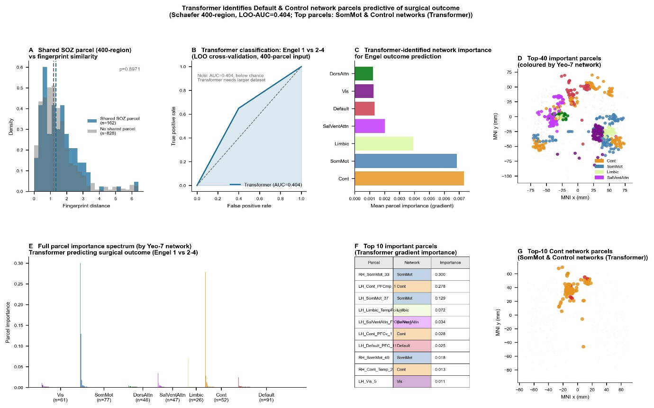

Supplementary Figure S8. Transformer-based classification using the same 400-region feature vectors (LOO-AUC=0.404; n=46). The below-chance performance reflects the data requirements of self-attention at this sample size (45 training samples/fold). Top gradient parcels (RH_SomMot_33: 0.300; LH_Cont_PFCmp_1: 0.278; LH_SomMot_37: 0.129) differ from the CNN result and are not interpretable given the underfitted model. This confirms that the CNN AUC=0.609 reflects genuine biological signal.

Supplementary Methods

Encoder architecture details

Six TransformerBlock layers, each with multi-head self-attention (4 heads, dropout 0.1) and position-wise feedforward (dimension 512, GELU). Pre-norm architecture. Input: 256 samples divided into 16 patches of 16 samples, linearly projected to 128 dimensions, with sinusoidal positional encodings for positions 0–16. For MAE: 75% patch masking with learnable mask token; 2-layer Transformer decoder (64 dimensions) reconstructs original patches. Contrastive: NT-Xent loss (temperature 0.1).

Schaefer atlas parcellation procedure

Electrode MNI coordinates mapped to Schaefer 2018 400-parcel atlas at 1-mm resolution via nilearn. For atlas-value-0 electrodes, nearest non-zero voxel within 3-mm radius used. Electrodes without assignment within 3 mm labelled "Unknown" and excluded (219/4,950; 4.4%).

Within-network synchrony ratio computation

Activation time = first time point during seizure at which channel anomaly score exceeded interictal mean + 2 SD; channels never reaching threshold assigned the maximum observed activation time. Only networks with ≥2 channels per patient included. SR = mean(within-network SD) / SD(all channels). SR=1.0 expected under random propagation; SR<1.0 indicates within-network synchrony.

