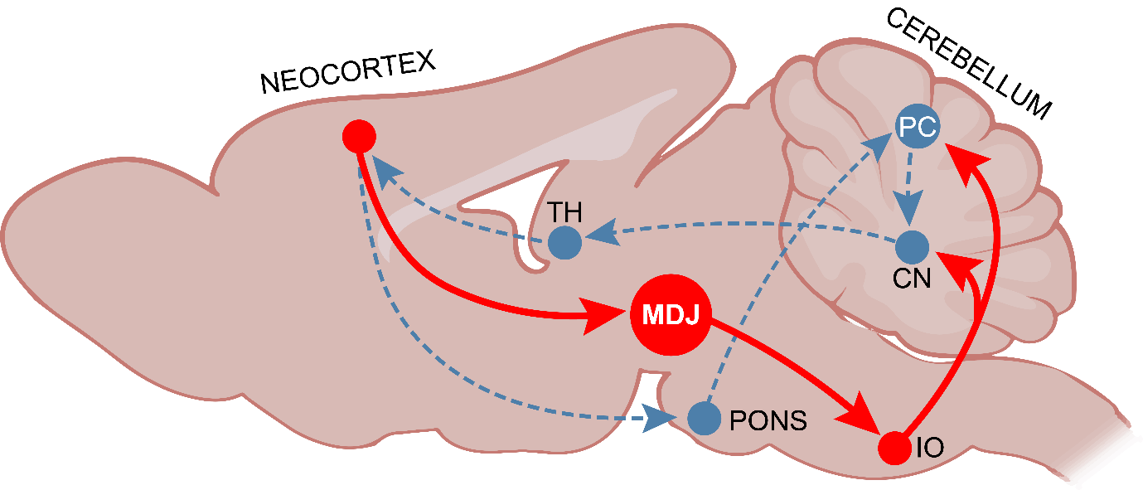Extended Data Figure 1. Anatomical organisation of the MDJ-IO cerebro-cerebellar pathway.
Schematic representation of the cerebro-cerebellar loop highlighting the pathway from the neocortex through the MDJ to the IO and Purkinje cells (PC). CN = cerebellar nuclei, PC Purkinje cell, TH = thalamus. This MDJ-IO pathway mediating the climbing fibre signals from neocortex to the cerebellum runs in parallel to that of the mossy fibre system, which is relayed via the pons.

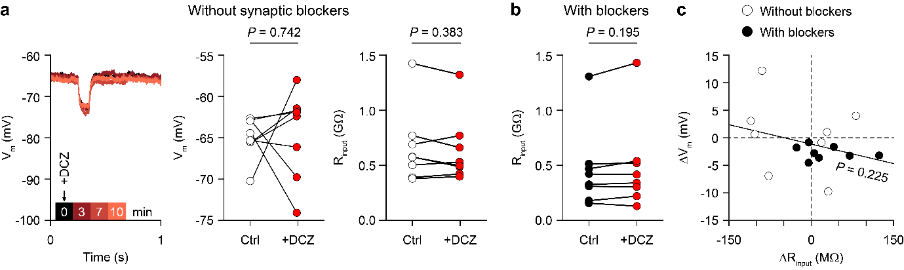
Extended Data Figure 2. In vitro whole-cell recordings of MDJ neurons expressing hM4Di with and without the addition of synaptic blockers.
a, In the absence of synaptic blockers, we measured the impact of bath application of 1000 µM of DCZ on the membrane potential of a representative neuron of the MDJ during current-clamp whole-cell recording in an acutely prepared brain slice (left panel; at 0, 3, 7 and 10 minutes after DCZ application). Overview of all recorded neurons (middle panel; n = 8, P = 0.742, Wilcoxon test). The input resistance (R_{input}) was not affected by DCZ application (right panel, P = 0.383, Wilcoxon test). b, Comparison of the input resistance of MDJ neurons before and 10 minutes after the addition of DCZ in the presence of synaptic blockers (same 8 neurons as in Fig. 1c; P = 0.195, Wilcoxon test). Blockers used were: 10 µM NBQX, 50 µM DL-AP5 and 100 µM picrotoxin. c, Grouping all neurons, whether recorded in the presence or absence of synaptic blockers, did not show a statistically significant correlation between the change in membrane voltage and the change in input resistance 10 minutes after the addition of DCZ (R = -0.322, P = 0.225, Pearson correlation).

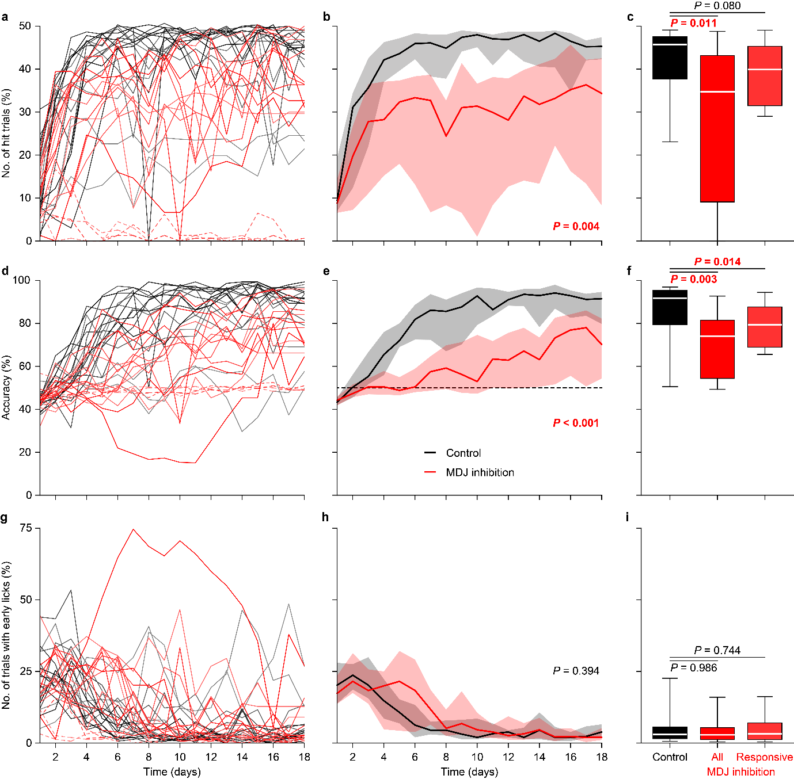

Extended Data Figure 3. Impact of chemogenetic inhibition of the MDJ-IO pathways on various parameters of learning.
Behavioural performance in mice trained in combination with (red) or without (black) chemogenetic inhibition of the MDJ-IO pathway (see Fig. 1a). Presented here is a further analysis of the mice presented in Fig. 1e-f. Hit trials of individual mice (a) and per experimental group (b) as well as averaged over the last three days of training (c). Note that 4 experimental mice showed very low rates of licking (dashed lines). The right columns of panels c, f and i represent analyses after excluding these 4 mice. For all box plots, the center line indicates the median, box limits indicate the upper and lower quartiles, and whiskers represent the 10th and 90th percentiles. The same analysis for the accuracy (d-f) and the trials with licks during the no-lick interval (the 300 ms period after onset of the sound cue; g–i). Panels b, e and h show medians and IQR and P values represent the outcomes of repeated measures ANOVA. b, effect of experimental treatment: F = 9.863, P = 0.004; interaction effect: F = 3.531, P = 0.006 (after Greenhouse-Geisser correction); e, effect of experimental treatment: F = 15.987, P < 0.001; interaction effect: F = 5.680, P < 0.001 (after Greenhouse-Geisser correction); and h, effect of experimental treatment: F = 0.746, P = 0.394; interaction effect: F = 2.034, P = 0.104 (after Greenhouse-Geisser correction).

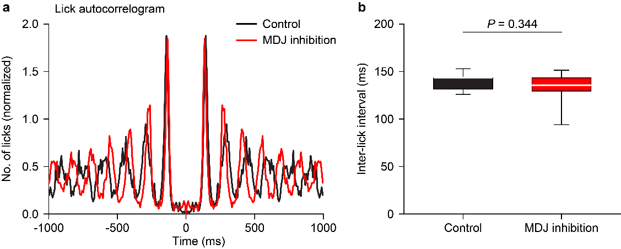

Extended Data Figure 4. No acute effect of chemogenetic inhibition of the IO-MDJ pathway on licking.
a, Autocorrelogram of inter-lick intervals in mice with and without chemogenetic inhibition of the MDJ-IO pathway on the final day of habituation. Data from two representative mice during 15 minute periods. b, Comparison of inter-lick intervals between control and inhibited mice on the final day of habituation (P = 0.344, t test; n = 17 control and n = 16 experimental mice). For all box plots, the center line indicates the median, box limits indicate the upper and lower quartiles, and whiskers represent 10th and 90th percentiles.

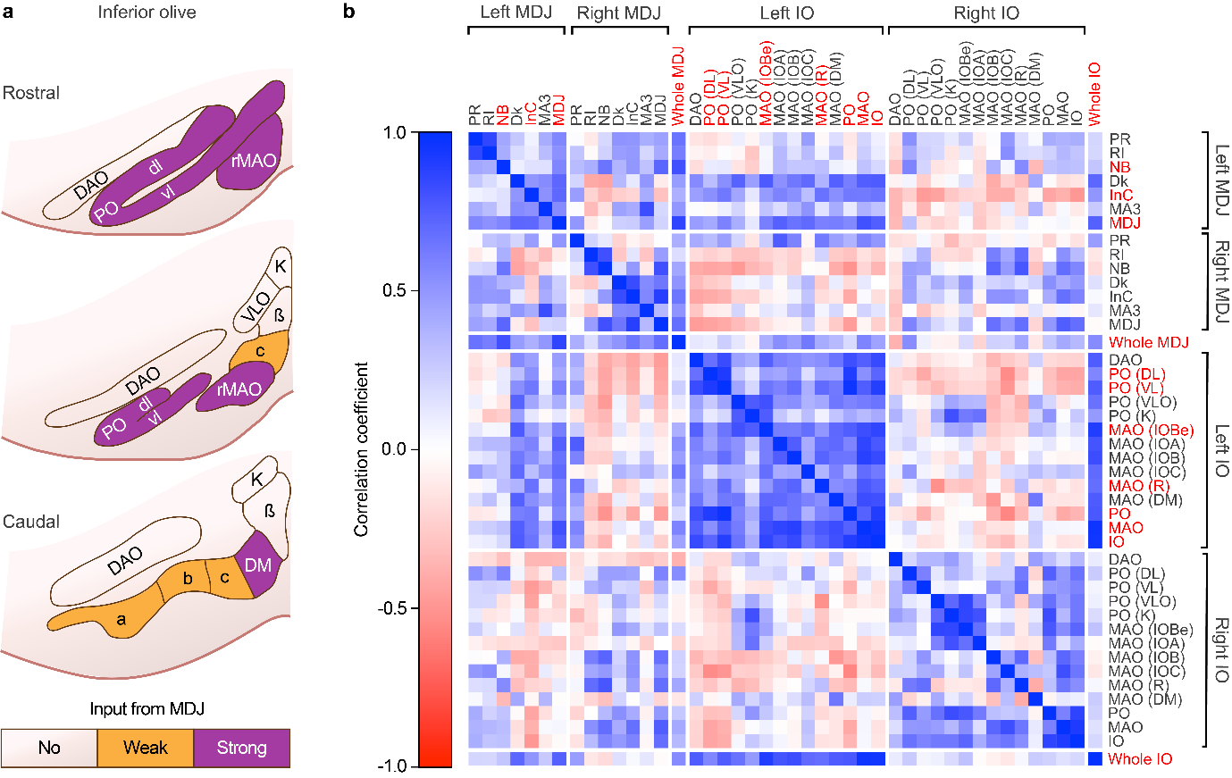

Extended Data Figure 5. Anatomical correlation of viral labelling within the MDJ-IO network.
a, Schematic drawing of coronal sections through the mouse IO at different rostro-caudal levels, indicating whether specific subunits receive no, weak or strong inputs from the MDJ. Connectivity data based on⁷¹. b, Successful viral injections and transfections in both the MDJ and ipsilateral IO induced optimal expression of mCherry. Correlation matrix of the degree of mCherry labelling (in % of the area of each subnucleus) between different subnuclei of the MDJ and IO (n = 16 mice, Pearson correlation). DAO = dorsal accessory olive, Dk = nucleus of Darkschewitz, DL = dorsal leaf of the PO, DM = dorsomedial cell column, InC = interstitial nucleus of Cajal, IOa = subnucleus a, IOBe = beta nucleus, IOb = subnucleus b, IOc = subnucleus c, K = dorsal cap of Kooij, MA3 = medial accessory oculomotor nucleus, MAO = medial accessory nucleus, NB = nucleus of Bechterew, PO = principal olive, PR = prerubral field, rMAO = rostral part of the MAO, RI = rostral interstitial nucleus of the medial longitudinal fasciculus, VL = ventral leaf of the PO, VLO = ventrolateral outgrowth.

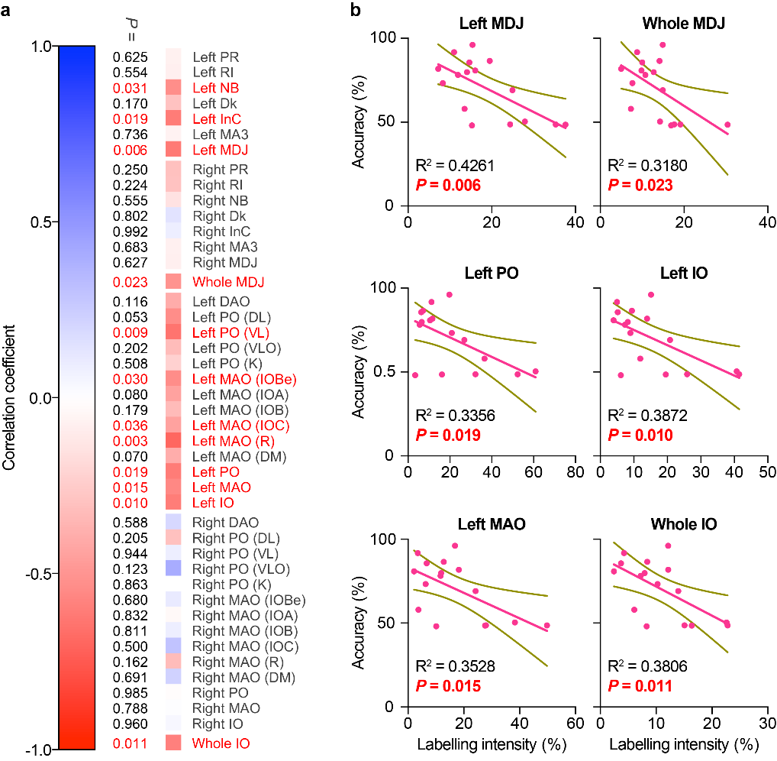

Extended Data Figure 6. Behavioural performance accuracy correlates with viral labelling in specific MDJ and IO subnuclei.
a, Correlation between the labelled areas in the subnuclei of the MDJ and IO and mouse performance (averaged accuracy over the final three days of training). Illustrated for selected subnuclei in b. n = 16 mice, Pearson correlation tests. DAO = dorsal accessory olive, Dk = nucleus of Darkschewitz, DL = dorsal leaf of the PO, DM = dorsomedial cell column, InC = interstitial nucleus of Cajal, IOa = subnucleus a, IOBe = beta nucleus, IOb = subnucleus b, IOc = subnucleus c, K = dorsal cap of Kooij, MA3 = medial accessory oculomotor nucleus, MAO = medial accessory nucleus, NB = nucleus of Bechterew, PO = principal olive, PR = prerubral field, rMAO = rostral part of the MAO, RI = rostral interstitial nucleus of the medial longitudinal fasciculus, VL = ventral leaf of the PO, VLO = ventrolateral outgrowth.

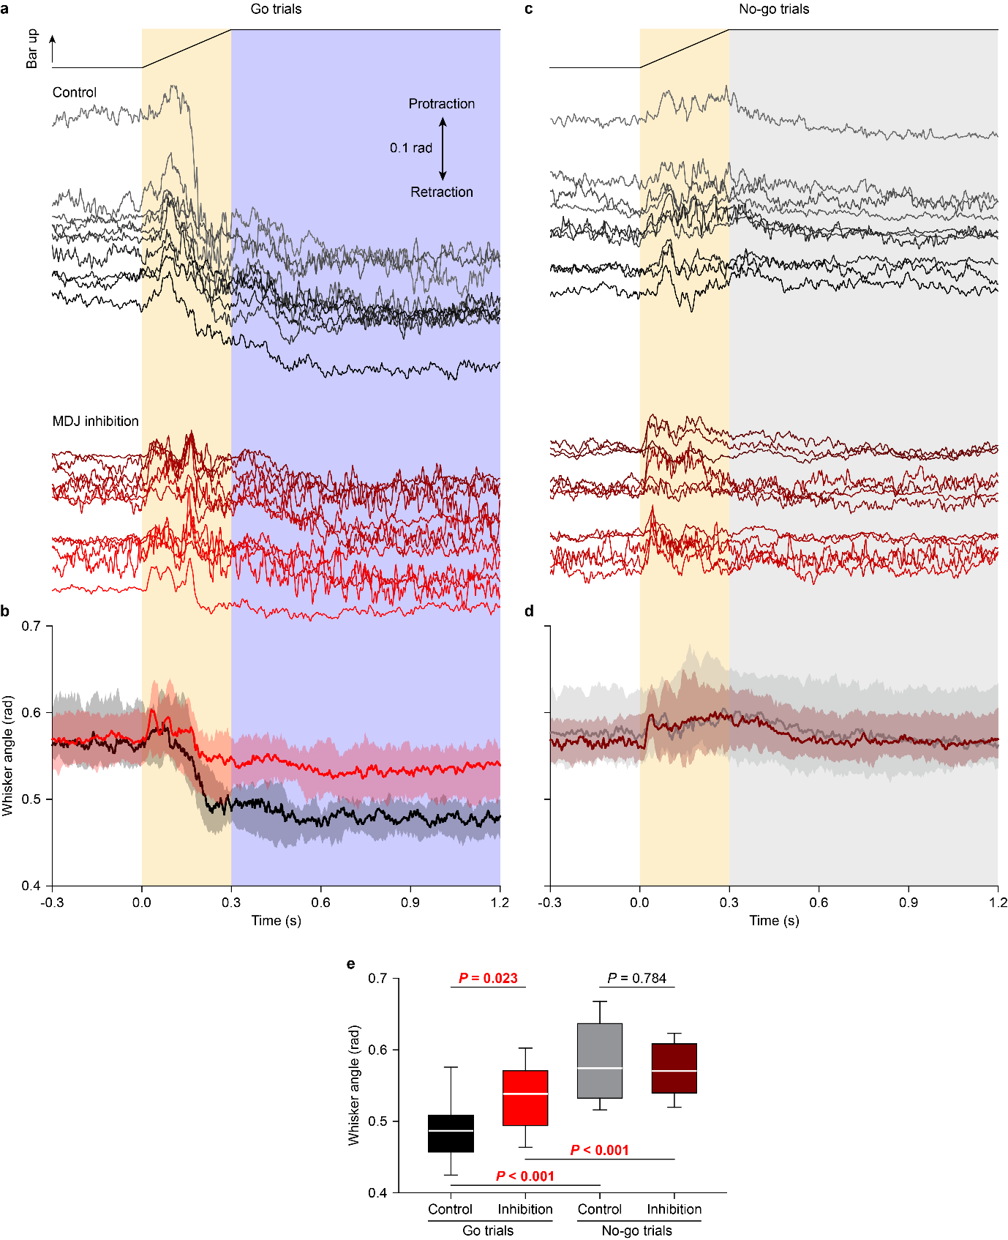
Extended Data Figure 7. Whisker movements in mice trained for 18 days in the presence or absence of chemogenetic inhibition of the MDJ-IO pathway.
a, The dynamics of whisker movements during a single go trial for an example control and a MDJ-IO inhibited mouse on the last day (day 18) of training. b, The dynamics of whisker movements during go trials across all control (black; n = 15 mice) and experimental mice (red; n = 16 mice) on day 18. c and d, The same as a and b but for no-go trials. e, Comparison of whisker angles at 300 ms after trial start between control and experimental mice in go and no-go trials. P values reflect t tests; bold in red, if significant after Benjamini-Hochberg correction for multiple comparisons. For all box plots, the center line indicates the median, box limits indicate the upper and lower quartiles, and whiskers represent 10th and 90th percentiles.

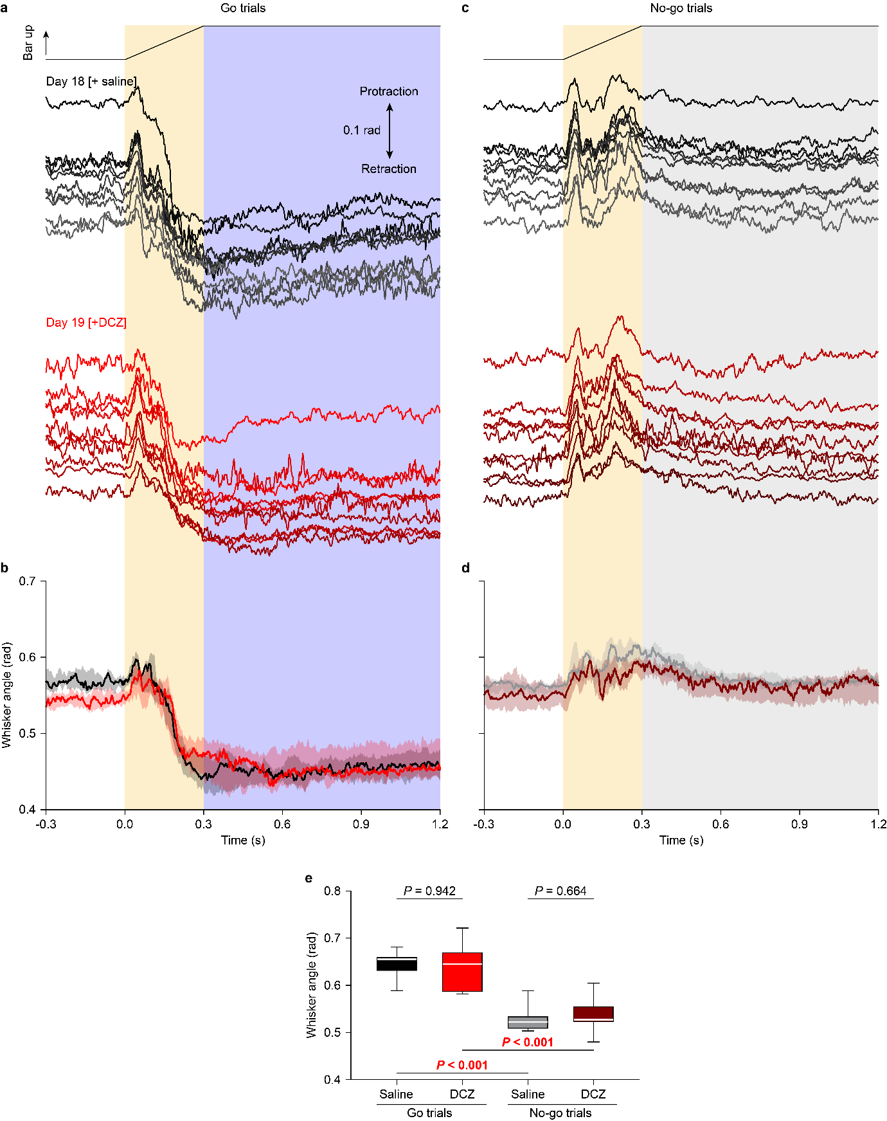

Extended Data Figure 8. Whisker movements in expert mice in the presence or absence of chemogenetic inhibition of the MDJ-IO pathway.
a, The dynamics of whisker movements during a single go trial for an example expert mouse after injection of saline (day 18) or DCZ (day 19). b, The dynamics of whisker movements during go trials across all mice in the absence of chemogenetic inhibition (day 18; black; n = 7 mice) and in the presence thereof (day 19, red). c and d, The same as a and b, but for no-go trials. e, Comparison of whisker angles at 300 ms after trial start between control and experimental mice in go and no-go trials. P values reflect t tests; bold and red, if significant after Benjamini-Hochberg correction for multiple comparisons. For all box plots, the center line indicates the median, box limits indicate the upper and lower quartiles, and whiskers represent 10th and 90th percentiles.

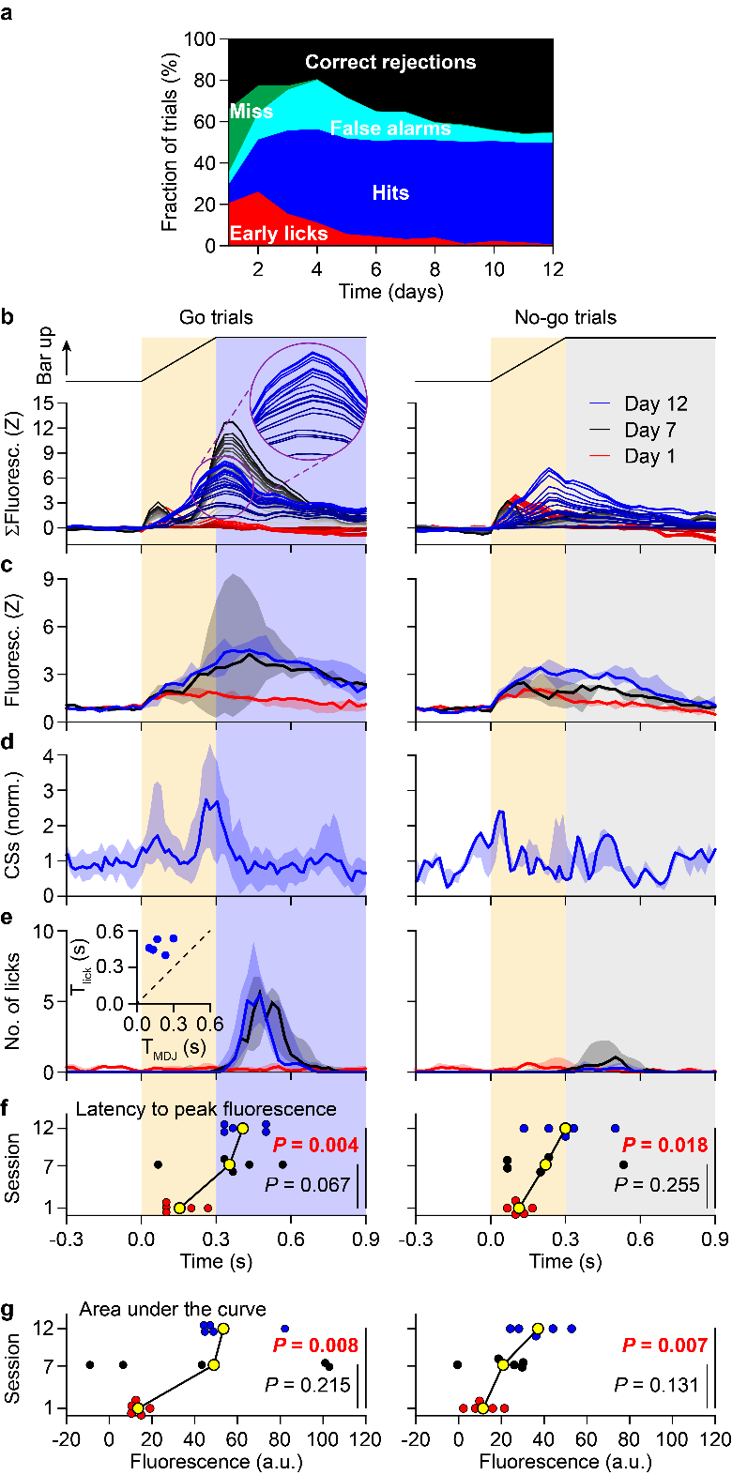
Extended Data Figure 9. MDJ activity changes during learning.
a, Daily evolution of trial outcomes, showing the fraction of trial types. Training was discontinued at day 12, since all mice reached expert levels. b, Left column: Normalised summed line plots of the fluorescence intensity of MDJ activity across 20 consecutive go trials on the first (red), seventh (black) and 12th (blue) day of training from the same mouse as shown in Fig. 3c. Each line indicates the contribution of one trial, normalised so that the top (darkest) line indicates the average fluorescence over the 20 trials of each day. Inset shows enlarged traces, highlighting the inter-trial variation in fluorescent signals. Right column: no-go trials. c, MDJ neuronal fluorescence intensity in go (left) and no-go (right) trials from all mice on days 1, 7 and 12 (n = 5 mice). Data in c-e are represented as medians and IQR. d, Complex spikes firing rates from Purkinje cells from well-trained mice (n = 20 responsive cells). e, Licking frequency. f, Comparison of latencies from the trial start to the MDJ fluorescence peak. g, Comparison of fluorescence intensity (area under the curve between 0 and 600 ms). P values calculated with t tests. Values indicated in bold red are statistically significant after Benjamini-Hochberg correction for multiple comparisons.

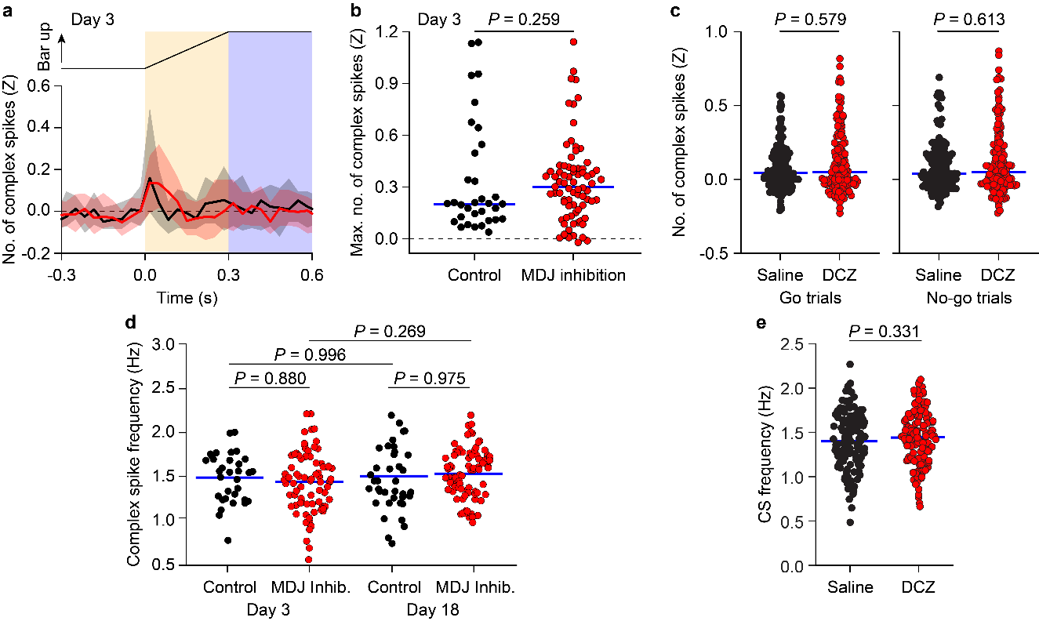

Extended Data Figure 10. Chemogenetic inhibition of the MDJ-IO pathway and its effect on Purkinje cell complex spike activity.
PSTHs (a) and maxima (b) of complex spike firing following the sound cue of go trials at the third day of training in control and MDJ-inhibited mice. c, Comparison of the Z-scored peaks in complex spike firing in go trials (left) (P = 0.579; Mann-Whitney U test) and no-go trials (right, P = 0.613) following application of saline [day 18; black] or DCZ [day 19; red]. n = 140 dendrites at day 18, n = 139 dendrites at day 19, from n = 5 mice. d, Comparison of the baseline complex spike firing rate at days 3 and 18 of training. e, Comparison of the baseline complex spike (CS) firing frequency between saline and DCZ conditions (P = 0.331).

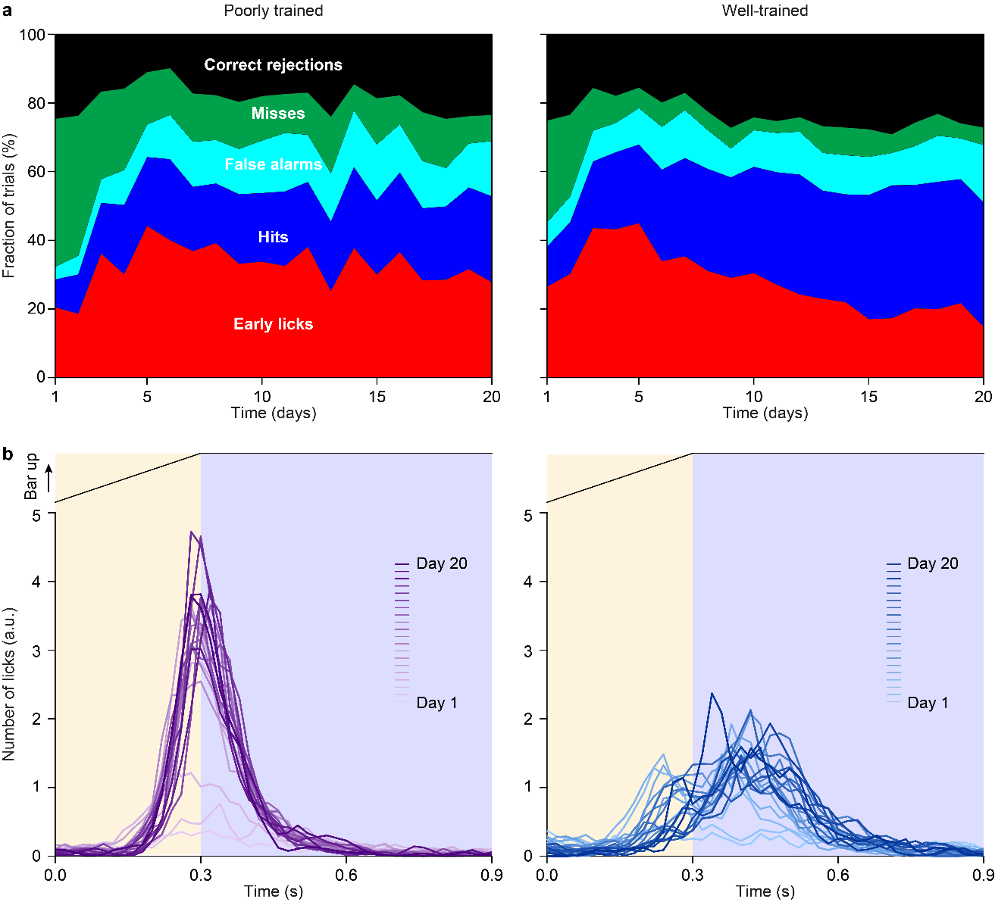

Extended Data Figure 11. Behavioural trajectories of the well-trained and poorly trained mice that were used for the optogenetic experiments.
a, Daily evolution of trial outcomes. Stacked plots show the fraction of trial types across 20 days of training for poorly trained (left) and well-trained (right) mice. b, Reaction time dynamic across training. Data are presented as number of licks in arbitrary units, for poorly trained and well-trained mice (n = 9 and n = 10, respectively). Colour shades represent the training days. Note that there is a gradual shift of the onset of licking towards the occurrence of the go cue in the well-trained, but not poorly trained, mice.

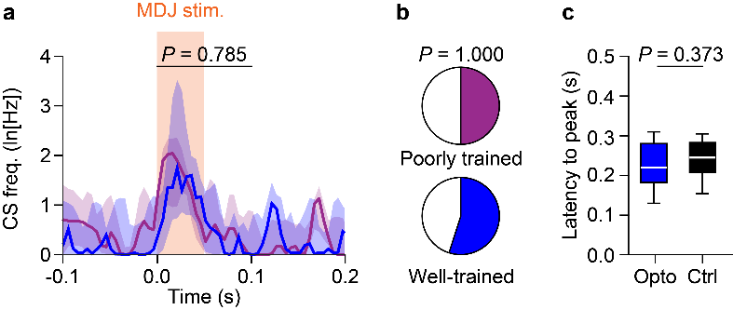

Extended Data Figure 12. Optogenetic stimulation of MDJ-IO pathway triggers complex spike firing in well-trained and poorly trained mice
a, PSTH of in vivo recorded Purkinje cells with a significant complex spike modulation. Purple and blue lines represent the median log transformed firing rate (ln(1+frequency[complex spikes])) of poorly trained and well-trained mice, respectively (P = 0.785, Wilcoxon signed-rank test). Shading indicates interquartile range (IQR). b, Pie charts showing the proportion of Purkinje cells with significant complex spike modulation in well-trained (blue; n = 13 out of 24 Purkinje cells, n = 10 mice) and poorly trained mice (purple; n = 4 out of 8 Purkinje cells, n = 8 mice), (P = 1.000, Fisher’s exact test). c, The latency from the optogenetic stimulus that triggered the complex spikes and the subsequent peak in licks was conserved: there was no statistical difference between the latency from the optogenetic stimulation to the evoked lick peak and the latency from the natural touch go cue (at 300 ms) to the lick peak in control trials (P = 0.373, Wilcoxon signed-rank test). Thus, given that the natural touch cue elicited the complex spike peak during go trials in controls, the latency between these complex spikes and the lick peak in these animals was in the same range.

Extended Data Video 1. Animated cartoon depicting the habituation phase.
Extended Data Video 2. Animated cartoon depicting the training phase.
Extended Data Video 3. Mouse performing correct go and no-go trials.

