Supplementary Table 1
Accession numbers of Yeasts sequences deposited in the NCBI-GenBank.
Strain  Code | Organism | NCBI  Accession number
SC-6 | Candida sorboxylosa | OQ919166
SC-9 | Candida quercitrusa | OQ913702
SC-1 | Yarrowia lipolytica | OQ913576
FSC | Hanseniaspora opuntiae | OQ913574
SS-A | Candida viswanathii | OQ913732

Supplementary Table 2
Optimized media composition for the growth of C. sorboxylosa and Y. lipolytica

Components (g/L) | C. sorboxylosa | Y. lipolytica
Dextrose  Glycerol | 15  - | -  20
Yeast extract | 15 | 15
KH₂ PO₄ | 1.4 | 1.4
MgSO₄7H₂O | 0.2 | 0.2
NaCl | 2 | 2
(NH₄)₂SO₄ | 1.5 | 1.5
FeSO₄ | 0.01 | 0.01
Final pH adjusted to 6.5

Supplementary Table 3
Media ingredients in Biotransformation media
Components | g/L
Dextrose | 10
Glycerol | 10
L- Phe | 6
MgSO₄7H₂O | 0.4
Yeast extract | 1

Supplementary Table 4
The precise medium formulation for the validation run (Run 41).

Components | g/L
Dextrose | 20
Glycerol | 20
L-phe | 9
MgSo4 | 0.6
Yeast extract | 2

Supplementary Table 5
The average OD and standard deviation of three copies.
Run | OD 1 | OD 2 | OD 3 | Mean | SD
1 | 18.2 | 17.6 | 17 | 17.6 | 0.60
2 | 15.55 | 15.65 | 15.75 | 15.65 | 0.10
3 | 15.7 | 16.1 | 16.23 | 16.01 | 0.28
4 | 15.5 | 16.3 | 16.5 | 16.1 | 0.53
5 | 14.65 | 14.85 | 15.26 | 14.92 | 0.31
6 | 15.68 | 15.98 | 16.28 | 15.98 | 0.30
7 | 17.35 | 17.55 | 17.9 | 17.6 | 0.28
8 | 14.95 | 15.03 | 15.05 | 15.01 | 0.05
9 | 16.05 | 16.15 | 16.16 | 16.12 | 0.06
10 | 17.61 | 17.71 | 17.81 | 17.71 | 0.10
11 | 14.46 | 14.56 | 14.66 | 14.56 | 0.10
12 | 16.01 | 16.31 | 16.61 | 16.31 | 0.30
13 | 15.95 | 16.08 | 16.15 | 16.06 | 0.10
14 | 14.96 | 15.04 | 15.06 | 15.02 | 0.05
15 | 15.05 | 15.24 | 15.55 | 15.28 | 0.25
16 | 12.9 | 13.1 | 13.3 | 13.1 | 0.20
17 | 15.82 | 15.96 | 16.25 | 16.01 | 0.22
18 | 16.4 | 17.1 | 17.26 | 16.92 | 0.46
19 | 15.12 | 15.06 | 14.85 | 15.01 | 0.14
20 | 15.7 | 16.1 | 16.26 | 16.02 | 0.29
21 | 14.7 | 15.15 | 15.18 | 15.01 | 0.27
22 | 16.8 | 15.75 | 16.2 | 16.25 | 0.53
23 | 14.85 | 15.63 | 15.15 | 15.21 | 0.39
24 | 13.12 | 13.08 | 12.95 | 13.05 | 0.09
25 | 17.48 | 17.05 | 17.25 | 17.26 | 0.22
26 | 16.01 | 15.91 | 16.11 | 16.01 | 0.10
27 | 13.1 | 13.15 | 13.05 | 13.1 | 0.05
28 | 16.45 | 17.2 | 16.15 | 16.6 | 0.54
29 | 16.25 | 15.75 | 16.18 | 16.06 | 0.27
30 | 16.32 | 15.92 | 15.85 | 16.03 | 0.25
31 | 15.91 | 16.01 | 16.11 | 16.01 | 0.10
32 | 15.2 | 15.39 | 15.1 | 15.23 | 0.15
33 | 16.45 | 16.55 | 16.35 | 16.45 | 0.10
34 | 15.13 | 14.8 | 15.1 | 15.01 | 0.18
35 | 18.28 | 17.65 | 17.92 | 17.95 | 0.32
36 | 15.56 | 15.75 | 15.91 | 15.74 | 0.18
37 | 13.91 | 14.25 | 13.75 | 13.97 | 0.26
38 | 17.85 | 17.6 | 16.9 | 17.45 | 0.49
39 | 20.12 | 19.81 | 19.65 | 19.86 | 0.24
40 | 16.6 | 16.95 | 16.1 | 16.55 | 0.43
41 | 18.8 | 19.2 | 19.3 | 19.1 | 0.26
42 | 15.75 | 15.96 | 16.23 | 15.98 | 0.24
43 | 14.82 | 14.65 | 14.96 | 14.81 | 0.16
44 | 14.55 | 14.62 | 14.87 | 14.68 | 0.17
45 | 15.42 | 15.22 | 15.32 | 15.32 | 0.10
46 | 16.1 | 16.24 | 15.6 | 15.98 | 0.34

Supplementary Table 6
The average yield (2-PE production) and standard deviation of three copies.
Run | Trial 1 | Trial 2 | Trial 3 | Mean | S. D
1 | 0.98 | 0.99 | 1.03 | 1.00 | 0.03
2 | 0.79 | 0.89 | 0.69 | 0.79 | 0.10
3 | 1.08 | 1.04 | 0.88 | 1.00 | 0.11
4 | 1.04 | 0.85 | 1.14 | 1.01 | 0.15
5 | 1.25 | 1.42 | 1.53 | 1.40 | 0.14
6 | 1.21 | 1.12 | 1.18 | 1.17 | 0.05
7 | 1.39 | 1.19 | 1.29 | 1.29 | 0.10
8 | 0.75 | 1.03 | 1.10 | 0.96 | 0.19
9 | 0.83 | 0.95 | 0.92 | 0.90 | 0.06
10 | 1.36 | 1.10 | 1.20 | 1.22 | 0.13
11 | 0.81 | 0.72 | 0.78 | 0.77 | 0.05
12 | 0.98 | 1.05 | 0.94 | 0.99 | 0.06
13 | 0.90 | 1.00 | 0.80 | 0.90 | 0.10
14 | 0.98 | 0.94 | 1.05 | 0.99 | 0.06
15 | 0.91 | 1.01 | 0.81 | 0.91 | 0.10
16 | 0.84 | 0.64 | 0.74 | 0.74 | 0.10
17 | 0.96 | 0.91 | 0.98 | 0.95 | 0.04
18 | 1.08 | 1.11 | 1.17 | 1.12 | 0.05
19 | 0.78 | 0.88 | 0.68 | 0.78 | 0.10
20 | 0.85 | 0.82 | 0.76 | 0.81 | 0.05
21 | 0.95 | 1.00 | 1.02 | 0.99 | 0.04
22 | 0.69 | 0.79 | 0.89 | 0.79 | 0.10
23 | 1.17 | 1.15 | 1.10 | 1.14 | 0.04
24 | 0.67 | 0.77 | 0.57 | 0.67 | 0.10
25 | 1.06 | 0.96 | 0.86 | 0.96 | 0.10
26 | 1.01 | 0.81 | 0.91 | 0.91 | 0.10
27 | 0.55 | 0.57 | 0.54 | 0.56 | 0.02
28 | 0.82 | 0.97 | 0.91 | 0.90 | 0.08
29 | 1.07 | 0.91 | 0.98 | 0.99 | 0.08
30 | 0.91 | 0.74 | 1.11 | 0.92 | 0.19
31 | 0.61 | 0.73 | 0.85 | 0.73 | 0.12
32 | 0.96 | 1.22 | 0.82 | 1.00 | 0.20
33 | 1.13 | 1.02 | 1.06 | 1.07 | 0.06
34 | 0.88 | 0.94 | 0.95 | 0.92 | 0.04
35 | 0.84 | 0.74 | 0.71 | 0.76 | 0.07
36 | 0.82 | 0.91 | 0.93 | 0.89 | 0.06
37 | 0.38 | 0.41 | 0.41 | 0.40 | 0.02
38 | 1.09 | 0.98 | 0.91 | 1.00 | 0.09
39 | 1.14 | 1.22 | 1.27 | 1.21 | 0.07
40 | 0.85 | 1.30 | 1.45 | 1.20 | 0.31
41 | 1.44 | 1.72 | 1.22 | 1.46 | 0.25
42 | 0.93 | 0.93 | 0.84 | 0.90 | 0.05
43 | 0.84 | 0.92 | 0.97 | 0.91 | 0.06
44 | 0.82 | 0.88 | 0.97 | 0.89 | 0.08
45 | 1.08 | 0.75 | 0.80 | 0.88 | 0.18
46 | 0.90 | 0.79 | 0.75 | 0.81 | 0.08

Supplementary Table 7
Comparison of the predicted and experimental values- OD
Run Order | Actual Value | Predicted Value | Residual | Leverage | Internally Studentized Residuals | Externally Studentized Residuals | Cook's Distance | Influence on Fitted Value DFFITS | Standard  Order
1 | 17.60 | 17.56 | 0.0400 | 0.397 | 0.168 | 0.165 | 0.001 | 0.134 | 40
2 | 15.65 | 15.45 | 0.2000 | 0.397 | 0.840 | 0.835 | 0.029 | 0.677 | 25
3 | 16.01 | 15.91 | 0.1043 | 0.022 | 0.344 | 0.339 | 0.000 | 0.051 | 45
4 | 16.10 | 16.05 | 0.0481 | 0.397 | 0.202 | 0.199 | 0.002 | 0.161 | 16
5 | 14.92 | 14.87 | 0.0500 | 0.397 | 0.210 | 0.206 | 0.002 | 0.167 | 34
6 | 15.98 | 15.57 | 0.4131 | 0.397 | 1.734 | 1.798 | 0.124 | 1.458 | 17
7 | 17.60 | 17.87 | -0.2663 | 0.397 | -1.118 | -1.123 | 0.051 | -0.910 | 9
8 | 15.01 | 15.23 | -0.2163 | 0.397 | -0.908 | -0.905 | 0.034 | -0.734 | 38
9 | 16.12 | 16.29 | -0.1650 | 0.397 | -0.693 | -0.687 | 0.020 | -0.557 | 31
10 | 17.71 | 17.53 | 0.1831 | 0.397 | 0.769 | 0.763 | 0.024 | 0.619 | 1
11 | 14.56 | 14.80 | -0.2444 | 0.397 | -1.026 | -1.027 | 0.043 | -0.833 | 13
12 | 16.31 | 16.62 | -0.3082 | 0.397 | -1.294 | -1.309 | 0.069 | -1.062 | 22
13 | 16.06 | 16.17 | -0.1082 | 0.397 | -0.454 | -0.448 | 0.008 | -0.363 | 24
14 | 15.02 | 15.40 | -0.3763 | 0.397 | -1.580 | -1.622 | 0.103 | -1.315 | 37
15 | 15.28 | 15.91 | -0.6257 | 0.022 | -2.063 | -2.189 | 0.006 | -0.326 | 41
16 | 13.10 | 13.21 | -0.1113 | 0.397 | -0.467 | -0.461 | 0.009 | -0.374 | 10
17 | 16.01 | 15.91 | 0.1043 | 0.022 | 0.344 | 0.339 | 0.000 | 0.051 | 42
18 | 16.92 | 16.83 | 0.0950 | 0.397 | 0.399 | 0.393 | 0.007 | 0.319 | 7
19 | 15.01 | 15.06 | -0.0457 | 0.397 | -0.192 | -0.189 | 0.002 | -0.153 | 19
20 | 16.02 | 16.33 | -0.3094 | 0.397 | -1.299 | -1.315 | 0.069 | -1.066 | 15
21 | 15.01 | 14.96 | 0.0537 | 0.397 | 0.226 | 0.222 | 0.002 | 0.180 | 29
22 | 16.25 | 16.18 | 0.0750 | 0.397 | 0.315 | 0.310 | 0.004 | 0.251 | 8
23 | 15.21 | 15.17 | 0.0375 | 0.397 | 0.157 | 0.155 | 0.001 | 0.125 | 26
24 | 13.05 | 13.31 | -0.2594 | 0.397 | -1.089 | -1.093 | 0.049 | -0.886 | 2
25 | 17.26 | 17.49 | -0.2294 | 0.397 | -0.963 | -0.962 | 0.038 | -0.780 | 20
26 | 16.01 | 15.91 | 0.1043 | 0.022 | 0.344 | 0.339 | 0.000 | 0.051 | 43
27 | 13.10 | 12.97 | 0.1300 | 0.397 | 0.546 | 0.539 | 0.012 | 0.437 | 11
28 | 16.60 | 16.21 | 0.3868 | 0.397 | 1.624 | 1.672 | 0.108 | 1.356 | 23
29 | 16.06 | 16.12 | -0.0613 | 0.397 | -0.257 | -0.253 | 0.003 | -0.205 | 30
30 | 16.03 | 15.91 | 0.1243 | 0.022 | 0.410 | 0.404 | 0.000 | 0.060 | 44
31 | 16.01 | 16.21 | -0.1975 | 0.397 | -0.829 | -0.825 | 0.028 | -0.669 | 33
32 | 15.23 | 15.91 | -0.6757 | 0.022 | -2.227 | -2.397 | 0.007 | -0.357 | 46
33 | 16.45 | 16.21 | 0.2437 | 0.397 | 1.023 | 1.024 | 0.043 | 0.830 | 6
34 | 15.01 | 14.93 | 0.0837 | 0.397 | 0.351 | 0.346 | 0.005 | 0.281 | 35
35 | 17.95 | 17.62 | 0.3312 | 0.397 | 1.391 | 1.413 | 0.079 | 1.146 | 36
36 | 15.74 | 15.51 | 0.2293 | 0.397 | 0.963 | 0.962 | 0.038 | 0.780 | 18
37 | 13.97 | 13.61 | 0.3631 | 0.397 | 1.524 | 1.560 | 0.096 | 1.265 | 3
38 | 17.45 | 17.32 | 0.1337 | 0.397 | 0.561 | 0.555 | 0.013 | 0.450 | 28
39 | 19.86 | 19.58 | 0.2850 | 0.397 | 1.196 | 1.205 | 0.059 | 0.977 | 12
40 | 16.55 | 16.44 | 0.1131 | 0.397 | 0.475 | 0.469 | 0.009 | 0.380 | 14
41 | 19.10 | 19.18 | -0.0794 | 0.397 | -0.333 | -0.328 | 0.005 | -0.266 | 4
42 | 15.98 | 15.68 | 0.2962 | 0.397 | 1.244 | 1.255 | 0.064 | 1.018 | 27
43 | 14.81 | 14.62 | 0.1868 | 0.397 | 0.784 | 0.779 | 0.025 | 0.632 | 21
44 | 14.68 | 14.42 | 0.2637 | 0.397 | 1.107 | 1.111 | 0.050 | 0.901 | 5
45 | 15.32 | 15.44 | -0.1200 | 0.397 | -0.504 | -0.498 | 0.010 | -0.403 | 39
46 | 15.98 | 16.26 | -0.2800 | 0.397 | -1.176 | -1.183 | 0.057 | -0.960 | 32

Best Lambda | 0.7000
95% CI Low | -0.2800
95% CI High | 1.67

Supplementary Table 8
Comparison of the predicted and experimental values- 2-PE production (g/L)
Run Order | Actual Value | Predicted Value | Residual | Leverage | Internally Studentized Residuals | Externally Studentized Residuals | Cook's Distance | Influence on Fitted Value DFFITS | Standard  Order
1 | 1.0000 | 0.9843 | 0.0157 | 0.397 | 0.617 | 0.611 | 0.016 | 0.495 | 40
2 | 0.7900 | 0.7682 | 0.0218 | 0.397 | 0.857 | 0.853 | 0.030 | 0.692 | 25
3 | 1.00 | 0.9465 | 0.0555 | 0.022 | 1.714 | 1.774 | 0.004 | 0.264 | 45
4 | 1.01 | 0.9897 | 0.0203 | 0.397 | 0.800 | 0.795 | 0.026 | 0.645 | 16
5 | 1.40 | 1.37 | 0.0337 | 0.397 | 1.327 | 1.344 | 0.072 | 1.090 | 34
6 | 1.17 | 1.16 | 0.0123 | 0.397 | 0.485 | 0.478 | 0.010 | 0.388 | 17
7 | 1.29 | 1.31 | -0.0232 | 0.397 | -0.911 | -0.909 | 0.034 | -0.737 | 9
8 | 0.9600 | 0.9400 | 0.0200 | 0.397 | 0.785 | 0.780 | 0.025 | 0.633 | 38
9 | 0.8950 | 0.9175 | -0.0225 | 0.397 | -0.884 | -0.881 | 0.032 | -0.714 | 31
10 | 1.22 | 1.20 | 0.0169 | 0.397 | 0.663 | 0.657 | 0.018 | 0.533 | 1
11 | 0.7650 | 0.7879 | -0.0229 | 0.397 | -0.900 | -0.897 | 0.033 | -0.728 | 13
12 | 0.9900 | 1.01 | -0.0232 | 0.397 | -0.913 | -0.911 | 0.034 | -0.739 | 22
13 | 0.8950 | 0.9111 | -0.0161 | 0.397 | -0.634 | -0.628 | 0.017 | -0.509 | 24
14 | 0.9900 | 0.9862 | 0.0038 | 0.397 | 0.148 | 0.146 | 0.001 | 0.118 | 37
15 | 0.9132 | 0.9465 | -0.0333 | 0.022 | -1.029 | -1.030 | 0.001 | -0.154 | 41
16 | 0.7402 | 0.7416 | -0.0014 | 0.397 | -0.054 | -0.053 | 0.000 | -0.043 | 10
17 | 0.9500 | 0.9465 | 0.0035 | 0.022 | 0.107 | 0.106 | 0.000 | 0.016 | 42
18 | 1.12 | 1.09 | 0.0326 | 0.397 | 1.282 | 1.296 | 0.068 | 1.051 | 7
19 | 0.7821 | 0.7686 | 0.0135 | 0.397 | 0.531 | 0.525 | 0.012 | 0.426 | 19
20 | 0.8050 | 0.8428 | -0.0378 | 0.397 | -1.486 | -1.518 | 0.091 | -1.231 | 15
21 | 0.9850 | 1.04 | -0.0512 | 0.397 | -2.013 | -2.128 | 0.166 | -1.725 | 29
22 | 0.7912 | 0.7724 | 0.0188 | 0.397 | 0.739 | 0.733 | 0.022 | 0.595 | 8
23 | 1.14 | 1.16 | -0.0181 | 0.397 | -0.711 | -0.705 | 0.021 | -0.571 | 26
24 | 0.6650 | 0.6586 | 0.0064 | 0.397 | 0.252 | 0.248 | 0.003 | 0.201 | 2
25 | 0.9550 | 0.9628 | -0.0078 | 0.397 | -0.305 | -0.301 | 0.004 | -0.244 | 20
26 | 0.9123 | 0.9465 | -0.0342 | 0.022 | -1.057 | -1.059 | 0.002 | -0.158 | 43
27 | 0.5550 | 0.5486 | 0.0064 | 0.397 | 0.253 | 0.249 | 0.003 | 0.202 | 11
28 | 0.9000 | 0.9213 | -0.0213 | 0.397 | -0.839 | -0.834 | 0.029 | -0.677 | 23
29 | 0.9890 | 1.02 | -0.0296 | 0.397 | -1.163 | -1.170 | 0.056 | -0.949 | 30
30 | 0.9200 | 0.9465 | -0.0265 | 0.022 | -0.819 | -0.815 | 0.001 | -0.121 | 44
31 | 0.7300 | 0.6885 | 0.0415 | 0.397 | 1.634 | 1.683 | 0.110 | 1.365 | 33
32 | 1.00 | 0.9465 | 0.0575 | 0.022 | 1.775 | 1.845 | 0.004 | 0.275 | 46
33 | 1.07 | 1.06 | 0.0100 | 0.397 | 0.392 | 0.386 | 0.006 | 0.313 | 6
34 | 0.9243 | 0.9422 | -0.0179 | 0.397 | -0.705 | -0.699 | 0.020 | -0.567 | 35
35 | 0.7634 | 0.7891 | -0.0257 | 0.397 | -1.012 | -1.013 | 0.042 | -0.821 | 36
36 | 0.8881 | 0.8971 | -0.0090 | 0.397 | -0.352 | -0.347 | 0.005 | -0.281 | 18
37 | 0.4012 | 0.4275 | -0.0263 | 0.397 | -1.036 | -1.037 | 0.044 | -0.841 | 3
38 | 0.9960 | 0.9973 | -0.0013 | 0.397 | -0.053 | -0.052 | 0.000 | -0.042 | 28
39 | 1.21 | 1.18 | 0.0282 | 0.397 | 1.110 | 1.115 | 0.051 | 0.904 | 12
40 | 1.20 | 1.17 | 0.0352 | 0.397 | 1.386 | 1.409 | 0.079 | 1.143 | 14
41 | 1.46 | 1.50 | -0.0368 | 0.397 | -1.448 | -1.476 | 0.086 | -1.197 | 4
42 | 0.9010 | 0.8625 | 0.0385 | 0.397 | 1.515 | 1.550 | 0.094 | 1.257 | 27
43 | 0.9120 | 0.9404 | -0.0284 | 0.397 | -1.118 | -1.123 | 0.051 | -0.911 | 21
44 | 0.8900 | 0.8662 | 0.0238 | 0.397 | 0.935 | 0.933 | 0.036 | 0.756 | 5
45 | 0.8750 | 0.8755 | -0.0005 | 0.397 | -0.020 | -0.020 | 0.000 | -0.016 | 39
46 | 0.8130 | 0.8139 | -0.0009 | 0.397 | -0.035 | -0.034 | 0.000 | -0.028 | 32

Best Lambda | 1.04
95% CI Low | 0.7800
95% CI High | 1.30

Supplementary Table 9
9a. ANOVA for 2FI model
Response 1: Optical density
Source | Sum of Squares | df | Mean Square | F-value | p-value
Model | 82.03 | 15 | 5.47 | 58.14 | < 0.0001 | significant
A-Dextrose | 1.84 | 1 | 1.84 | 19.52 | 0.0001
B-Glycerol | 3.8 | 1 | 3.8 | 40.43 | < 0.0001
C-L-phenylalanine | 1.3 | 1 | 1.3 | 13.82 | 0.0008
D-MgSO4.7H20 | 5.65 | 1 | 5.65 | 60.1 | < 0.0001
E-Yeast Extract | 2.15 | 1 | 2.15 | 22.9 | < 0.0001
AB | 23.96 | 1 | 23.96 | 254.75 | < 0.0001
AC | 0.912 | 1 | 0.912 | 9.7 | 0.004
AD | 0.912 | 1 | 0.912 | 9.7 | 0.004
AE | 4.06 | 1 | 4.06 | 43.17 | < 0.0001
BC | 1.04 | 1 | 1.04 | 11.06 | 0.0023
BD | 1.31 | 1 | 1.31 | 13.94 | 0.0008
BE | 31.7 | 1 | 31.7 | 337 | < 0.0001
CD | 1.49 | 1 | 1.49 | 15.82 | 0.0004
CE | 0.354 | 1 | 0.354 | 3.76 | 0.0618
DE | 1.55 | 1 | 1.55 | 16.48 | 0.0003
Residual | 2.82 | 30 | 0.0941
Lack of Fit | 2.05 | 25 | 0.082 | 0.5313 | 0.8666 | not significant
Pure Error | 0.7717 | 5 | 0.1543
Cor Total | 84.85 | 45

9b. Response 1: Optical density: Fit Summary
Source | Sequential p-Value | Lack of fit p-value | Adjusted R² | Predicted R²
Linear | 0.1611 | 0.0048 | 0.0705 | -0.1314
2F1 | ˂0.0001 | 0.8666 | 0.9501 | 0.9266 | Suggested
Quadratic | 0.7982 | 0.8207 | 0.9452 | 0.9016
Cubic | 0.6432 | 0.7707 | 0.9388 | 0.6988 | Aliased

9c. Response 1: Optical density: ANOVA: Fit Statistics
Std. Dev. | 0.3067 | R² | 0.9667
Mean | 15.91 | Adjusted R² | 0.9501
C.V. % | 1.93 | Predicted R² | 0.9266
 |  | Adeq Precision | 36.5174

Supplementary Table 10
10a. ANOVA for 2FI model
Response 2: 2-PE (g/L)
Source | Sum of Squares | df | Mean Square | F-value | p-value
Model | 1.75 | 15 | 0.1164 | 108.62 | < 0.0001 | significant
A-Dextrose | 0.2753 | 1 | 0.2753 | 256.97 | < 0.0001
B-Glycerol | 0.0039 | 1 | 0.0039 | 3.66 | 0.0654
C-L-phenylalanine | 0.0147 | 1 | 0.0147 | 13.71 | 0.0009
D-MgSO4.7H20 | 0.0044 | 1 | 0.0044 | 4.12 | 0.0513
E-Yeast Extract | 0.1046 | 1 | 0.1046 | 97.6 | < 0.0001
AB | 0.6511 | 1 | 0.6511 | 607.67 | < 0.0001
AC | 0.0133 | 1 | 0.0133 | 12.45 | 0.0014
AD | 0.0163 | 1 | 0.0163 | 15.17 | 0.0005
AE | 0.1726 | 1 | 0.1726 | 161.09 | < 0.0001
BC | 0.0017 | 1 | 0.0017 | 1.61 | 0.2146
BD | 0.006 | 1 | 0.006 | 5.61 | 0.0245
BE | 0.3635 | 1 | 0.3635 | 339.25 | < 0.0001
CD | 0.0647 | 1 | 0.0647 | 60.4 | < 0.0001
CE | 0.0018 | 1 | 0.0018 | 1.73 | 0.1989
DE | 0.0517 | 1 | 0.0517 | 48.26 | < 0.0001
Residual | 0.0321 | 30 | 0.0011
Lack of Fit | 0.0228 | 25 | 0.0009 | 0.4916 | 0.8917 | not significant
Pure Error | 0.0093 | 5 | 0.0019
Cor Total | 1.78 | 45

10b. Response 1: 2-PE (g/L): Fit Summary
Source | Sequential p-value | Lack of Fit p-value | Adjusted R² | Predicted R²
Linear | 0.0587 | 0.0015 | 0.13 | -0.0605
2FI | < 0.0001 | 0.8917 | 0.9729 | 0.9593 | Suggested
Quadratic | 0.5529 | 0.8813 | 0.972 | 0.9512
Cubic | 0.6917 | 0.8395 | 0.9674 | 0.8629 | Aliased

10c. Response 1: 2-PE (g/L): ANOVA: Fit Statistics
Std. Dev. | 0.0327 | R² | 0.9819
Mean | 0.9465 | Adjusted R² | 0.9729
C.V. % | 3.46 | Predicted R² | 0.9593
 |  | Adeq Precision | 55.3881

Supplementary Table 11
Fundamental genes involved in shikimate pathway and Ehrlich pathway of C. sorboxylosa.
Gene name | Candida sorboxylosa Gene | Log 2FC | Regulation | P -Vlaue | Adjusted  p-values | Organism
GAP1 | DN110935  DN3688  DN87205  DN87205 | 5.8412  5.1171  1.0151812  5.275054 | Up  Up  Up  Up | NA  NA  0.495241245  NA | NA  NA  NA  NA | S. cerevisiae  C. albicans  Candida glabrata  Candida glabrata
BCAA Permease | DN53444 | 5.9263 | Up | NA | NA | B.bassiana
ATP-dependent permease MDL1 | DN95919 | 5.2464 | Up | NA | NA | S. cerevisiae
ATPbinding/permease protein CydD | DN92873 | 4.7270 | Up | 0.094504463 | NA | S. cerevisiae
ARO1 | DN86206  DN53580  DN88374  DN101798 | -0.4458  -0.9491  -1.1847  -3.0590 | Down  Down  Down  Down | NA  0.72574793  0.664996793  0.282039237 | NA  NA  NA  NA | K. lactis  C.usitaniae  L.thermotolerance  L.bicolor
ARO2 | DN86988 | 0.49176 | Down | 0.816964677 | NA | S. cerevisiae
ARO3 | DN81648 | 0.2247 | Down | 0.685547413 | 0.97683043 | C. albicans
ARO4 | DN85620 | -2.7925 | Down | 0.308090916 | NA | S. cerevisiae
ARO7 | DN81664 | -3.6567 | Down | 0.147533034 | NA | S. cerevisiae
PHA2 | DN3326 | -3.7782 | Down | NA | NA | B. bassiana
ARO8 | DN86933 | 6.49184 | Up | NA | NA | S. cerevisiae
ARO8 | DN47851 | 2.2791 | Up | 2.58E-07 | 6.70E-05 | S. cerevisiae
ARO9 | DN86628 | 6.7256 | Up | 0.009985022 | NA | R.oryzae
ARO9 | DN45691 | 4.6785 | Up | NA | NA | P.kernoviae
ARO10 | DN85655 | 3.1958 | Up | 2.22E-14 | 2.88E-11 | S. cerevisiae
ADH1 | DN3502  DN84966 | 5.0781  2.30642 | Up  Up | 0.064307289 | NA | S.stipitis
 |  |  |  | 0.390335323 | 0.91384216 | Kluyveromyces marxianus
ADH3 | DN100294 | 4.973306 | Up | NA | NA | Emericella nidulans
ADH4 | DN60431  DN58191 | 4.9293  4.4160 | Up  Up | NA  0.120455857 | NA  NA | S.pombe  S.pombe
ADH6 | DN85705 | 4.5972 | Up | NA | NA | S. cerevisiae
ADH | DN74426  DN76692  DN79455 | 5.803  5.3661  5.1539 | Up  Up  Up | NA  NA  NA | NA  NA  NA | NA  NA  NA
ADH | DN1227  DN75204  DN83477  DN41726  DN605  DN72811  DN86558  DN90329  DN86558 | 5.1108  4.5647  3.52766  6.2582377  6.2117462  6.1779637  4.8968325  5.6869808  2.1123739 | Up  Up  Up  Up  Up  Up  Up  Up  Up | NA  NA  NA  NA  NA  NA  NA  NA  6.44E-05 | NA  NA  NA  NA  NA  NA  NA  NA  0.006966272 | R.microsporous  B.bassiana  Morganella  Morganella  Phaeoacremonium minimum  Pseudogymnoascus sp.  Saccharomyces cerevisiae  Ustilago maydis  Saccharomyces cerevisiae

Supplementary Table 12
BLASTp-based identification of putative 2-phenylethanol biosynthesis genes in C. sorboxylosa using Saccharomyces cerevisiae as reference.
Gene_ID | Uniprot_ID | Accession | Identity | E-value | Score
GAP-1
DN110935_c0_g1_i1 | sp|P19145|GAP1_YEAST | P19145 | 52.6 | 4.20E-17 | 84.7
ADH
DN86558_c1_g1_i1 | sp|P25377|ADH7_YEAST | P25377 | 46.2 | 8.00E-83 | 305.4
DN86558_c1_g1_i3 | sp|P25377|ADH7_YEAST | P25377 | 46.4 | 3.10E-43 | 173.3
ARO8
DN86933_c1_g1_i1 | sp|P53090|ARO8_YEAST | P53090 | 48.4 | 2.50E-24 | 109.4
DN86933_c1_g1_i2 | sp|P53090|ARO8_YEAST | P53090 | 48.4 | 2.60E-24 | 109.4
DN86933_c1_g2_i1 | sp|P53090|ARO8_YEAST | P53090 | 52.6 | 5.20E-12 | 67.8
DN86933_c1_g2_i2 | sp|P53090|ARO8_YEAST | P53090 | 51.5 | 5.00E-15 | 77.8
DN47851_c0_g1_i1 | sp|P53090|ARO8_YEAST | P53090 | 51.1 | 5.80E-77 | 285.8
ARO10
DN85655_c2_g1_i1 | sp|Q06408|ARO10_YEAST | Q06408 | 40.7 | 2.30E-31 | 133.3
DN85655_c3_g2_i1 | sp|Q06408|ARO10_YEAST | Q06408 | 32.7 | 2.30E-48 | 191

Supplementary Table 13
COG classification of differentially expressed genes showing the number of upregulated and downregulated genes in each functional category, with emphasis on categories related to amino acid metabolism and secondary metabolite biosynthesis relevant to 2-PE production via the Ehrlich pathway.
Code | Description | Gene Number  (Up) | Gene Number  (Down)
E | Amino acid transport and metabolism | 6 | 2
Q | Secondary metabolites biosynthesis, transport and catabolism | 1 | 0

Supplementary Table 14
Gene Ontology (GO) enrichment analysis of differentially expressed genes. Terms associated with amino acid catabolism and enzymatic activities relevant to 2-PE production via the Ehrlich pathway are highlighted.
Category | Term | Ontology | Over_represented_pvalue | Over_represented_FDR | GeneNumber (Up) | GeneNumber (Down)
GO:0000949 | aromatic amino acid family catabolic process to alcohol via Ehrlich pathway | BP | 0.032119 | 1 | 1 | 0
GO:0000950 | branched-chain amino acid catabolic process to alcohol via Ehrlich pathway | BP | 0.032119 | 1 | 1 | 0
GO:0050177 | phenylpyruvate decarboxylase activity | MF | 0.032119 | 1 | 1 | 0
GO:0050546 | 4-hydroxyphenylpyruvate decarboxylase activity | MF | 0.032119 | 1 | 1 | 0
GO:0006559 | L-phenylalanine catabolic process | BP | 0.038589 | 1 | 1 | 0

Supplementary Table 15
KEGG pathway enrichment analysis of differentially expressed, showing significantly enriched metabolic pathways and the distribution of upregulated and downregulated genes, with emphasis on pathways relevant to the Ehrlich pathway.
Pathway | Level1 | Level2 | DEGs with Pathway annotation (31) | All genes with Pathway annotation (5491) | P-value | Q-value | Gene  Number (Up) | Gene  Number (Down)
Pyruvate metabolism | Metabolism | Carbohydrate metabolism | 6(19.35%) | 265(4.83%) | 0.000545 | 0.006545 | 1 | 5

Supplementary Figures
Supplementary Figure-1
Experimental versus predicted OD values generated by the selected 2FI model. The plot demonstrates the agreement between observed and model- predicted biomass responses under the tested conditions. The predicted optimum OD was 19.17, with a 95% prediction interval of 18.43-19.9.

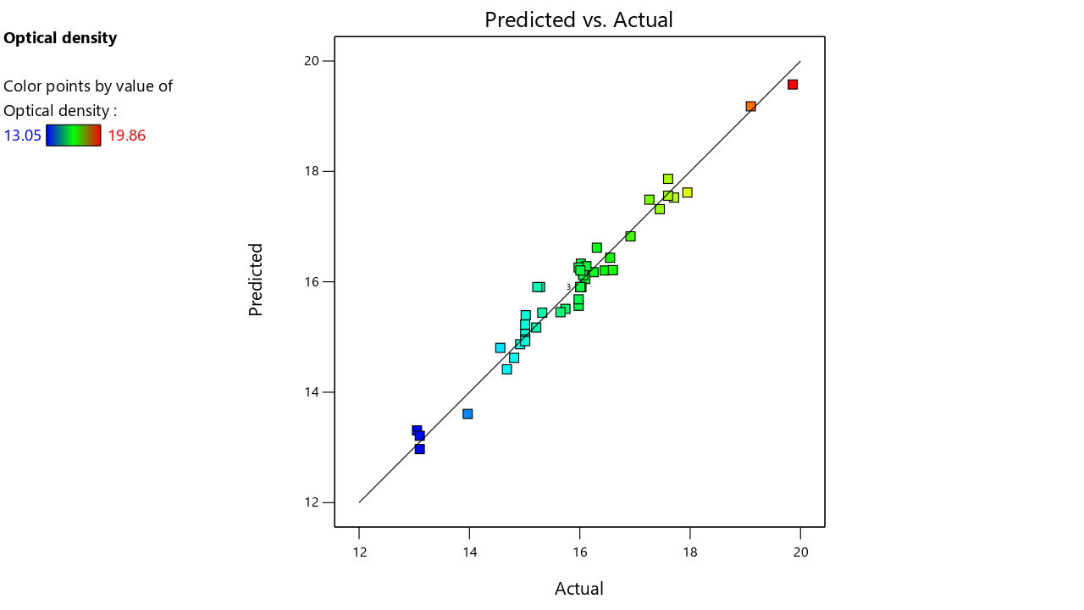

Supplementary Figure -2
Experimental versus predicted 2-PE yield (g/L) values generated by the selected 2FI model. The plot demonstrates the agreement between observed and model-predicted 2-PE production under the tested conditions. The predicted optimum 2-PE yield was 1.49 g/L, with a 95% prediction interval of 1.41-1.57 g/L.
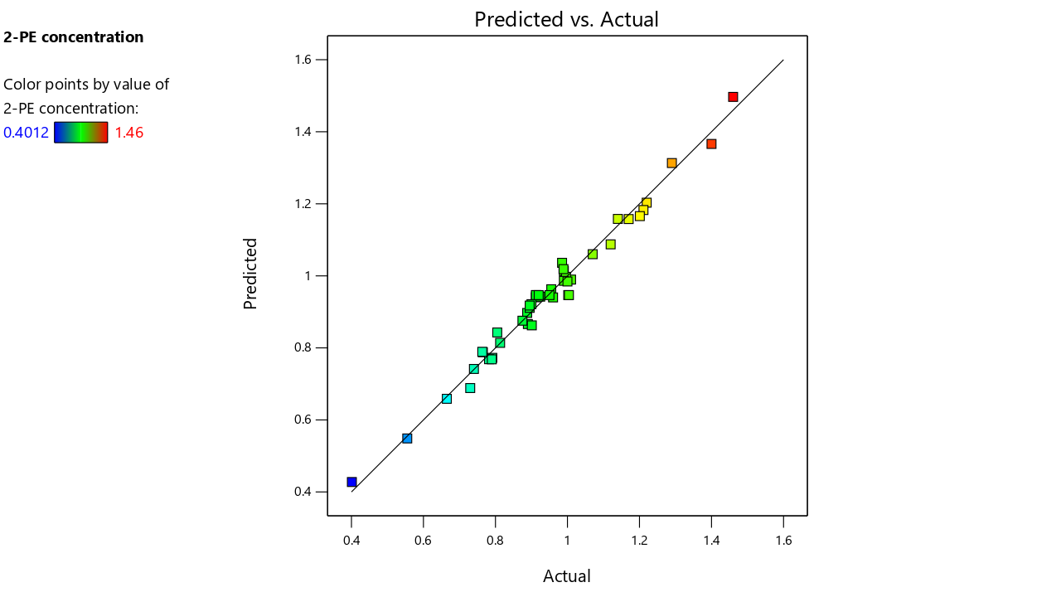

Supplementary Figure-3
Calibration curve of 2-PE Analysis

Supplementary Figure-4
Gas chromatography-flame ionization detection (GC-FID) analysis of 2-phenylethanol from C. sorboxylosa fermentation. The chromatogram represents the selected retention window around the target analyte peak, the peak corresponding to 2-phenylethanol at retention time 7.176 min with a peak area of 348.544.
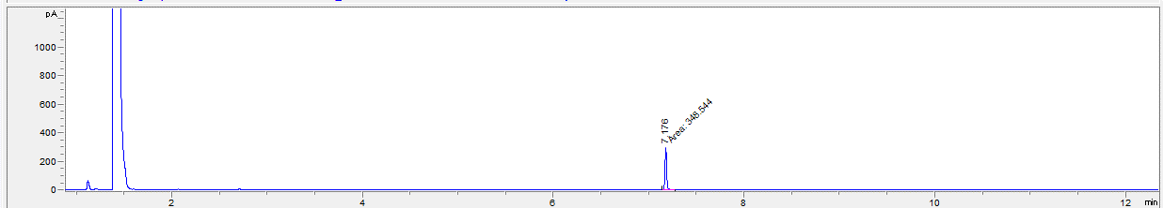
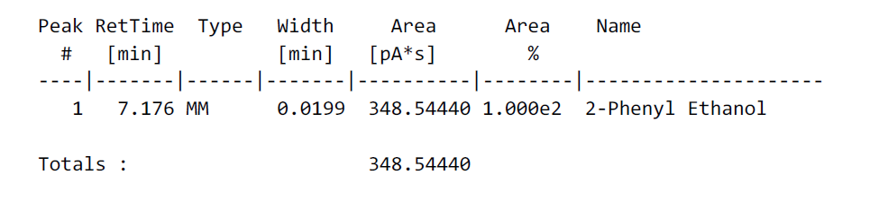
Concentration, ppm

Supplementary Figure-5
Differential gene expression clustering heatmap.
Red indicates high expression, while blue indicates low expression, with the color gradient from blue to red representing increasing gene expression levels. C1, C2, and C3 represent control groups without L-Phe, whereas T1, T2, and T3 represent test groups supplemented with L-Phe.

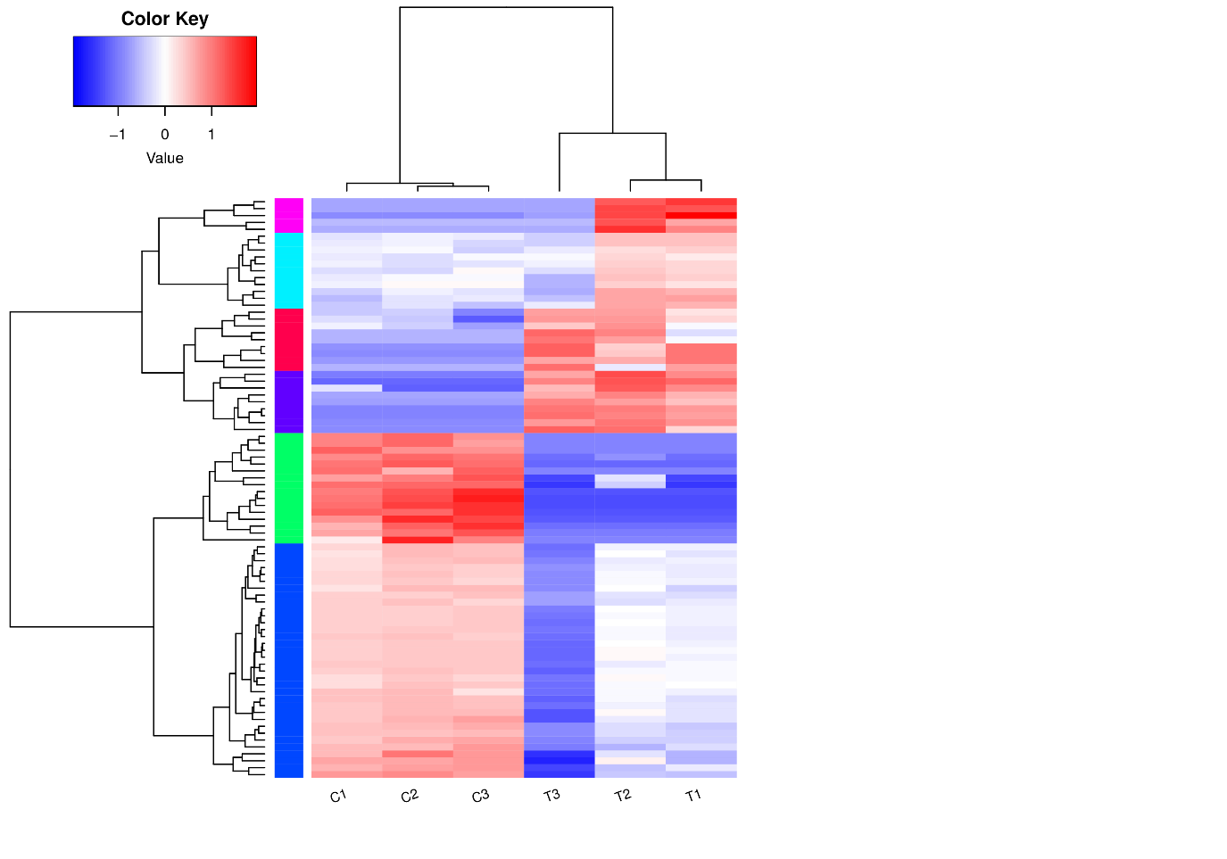

Supplementary Figure-6
Kinetic profile of biomass growth and 2-PE production by C. sorboxylosa under optimized conditions. The profile shows a concomitant increase in biomass and 2-PE production during the early phase (24-72 h), followed by only marginal improvement in 2-PE concentration despite continued biomass growth, indicating partially growth-associated production

