Supplementary materials for
Defect-tolerant anti-fatigue titanium alloy via multi-scale heterogeneous interface engineering
Xiaoyuan Teng^{a, b}, Jianchao Pang^{a, b*}, Chenglu. Zou^{a, b}, Zhefeng Zhang^{a, b**}
ª Shenyang National Laboratory for Materials Science, Institute of Metal Research, Chinese Academy of Sciences, Shenyang, 110016, PR China
^{b} School of Materials Science and Engineering, University of Science and Technology of China, Shenyang, 110016, PR China
* Corresponding author: Tel.: +86 24 83978779. E-mail: jcpang@imr.ac.cn (J. C. Pang)
** Corresponding author: Tel.: +86 24 23971043. E-mail: zhfzhang@imr.ac.cn (Z. F. Zhang)

This file includes:
Section 1: Determination of alloy β-transus temperature
Section 2: Exploration of multi-scale heterogeneous interface network process
Section 3 Tensile fracture analysis
Section 4 Fatigue fracture analysis and statistics
Section 5 The source of data in Fig. 2 and Fig. 3
Supplementary References

Section 1: Determination of alloy β-transus temperature
To establish the β-transus temperature range of the alloy, a series of heat treatments were conducted between 990 °C and 1050 °C, followed by water quenching to provide a consistent baseline for microstructural analysis. The resulting microstructures are shown in Fig. S1. Between 1000 °C and 1010 °C, a distinct transformation occurs: prior-β grains remain confined within the outline of the melt pool, their boundaries traced by remnant α laths, while the original α phase begins to dissolve and its lath structure gradually disappears. Upon further heating, nearly all α laths dissolve completely, and β grains grow beyond the initial melt-pool boundaries. Based on these observations, the β-transus temperature of Ti-6.5Al-3.5Mo-1.5Zr-0.3Si is inferred to be approximately 1005 °C.

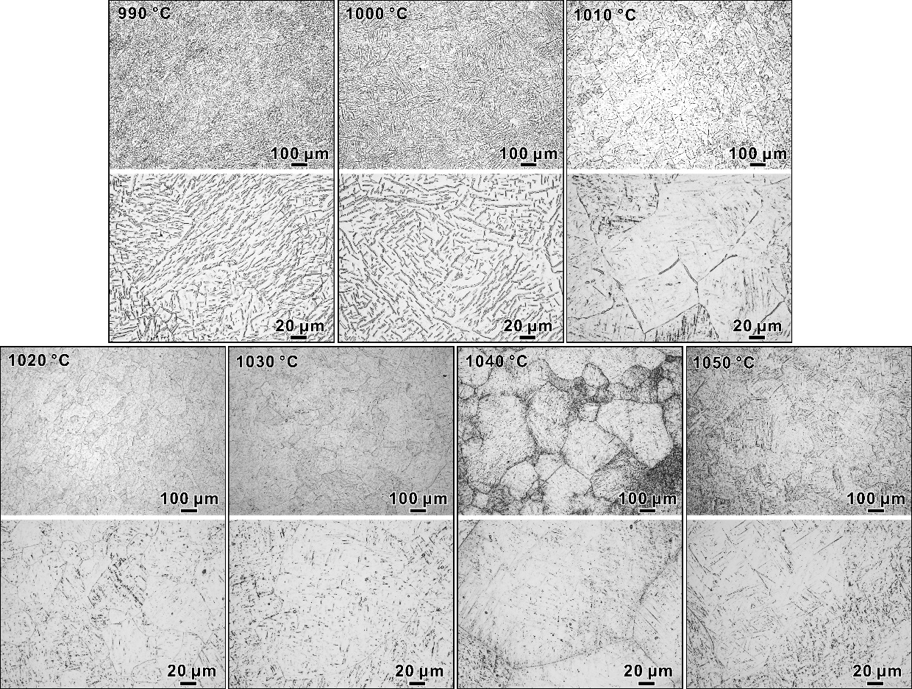
Fig. S1 Microstructure information of Ti-6.5Al-3.5Mo-1.5Zr-0.3Si alloy at various processing temperatures.

Section 2: Exploration of multi-scale microstructure strengthening process
To investigate microstructural evolution under rapid thermal processing (RTP), temperatures of 1010 °C and 1020 °C were selected. Given the stringent control required for reproducible rapid heating and cooling cycles, a custom-built RTP device was employed (Fig. S2). At 1010 °C (Fig. S3a), a 20-minute hold left α laths at β grain boundaries incompletely transformed. Extending the hold to 30 min achieved full dissolution but also triggered β grain boundary migration and coarsening. In contrast, at 1020 °C, a near-complete dissolution of the α laths was achieved in as little as 5 min (Fig. S3b). Given this result, a hold time of 5 min at this temperature was selected as a viable solution treatment parameter for refining the α phase. Extending the hold time at this temperature to 8 min further promoted epitaxial recrystallization via grain boundary migration, which actively refined the grain structure. Beyond this point, a 10 min hold induced rapid boundary migration and significant β-grain coarsening. Based on this enhanced microstructure, the 8 min treatment was ultimately chosen as the final RTP parameter set.
In summary, a heat treatment process was developed to produce an ultrafine acicular α' martensite structure while restricting β grain growth, that is, solution treatment at 1020 °C for 8 min, followed by water quenching. The quantitative information of microstructure and microvoids in the AM-RTP alloy are presented in Fig. S4.
Fig. S2 Schematic diagram of RTP process equipment: (a) Preparation stage: During the initial furnace heating stage, the sample is fixed on the fixture and then exposed to the ambient temperature outside the furnace. (b) Heating stage: using an automated manipulator, the sample is inserted into the 1020 °C zone and maintained there for 8 min. (c) Quenching process: After heating is completed, the sample was rapidly quenched by automated manipulator lowering it into the circulating water bath beneath the furnace.

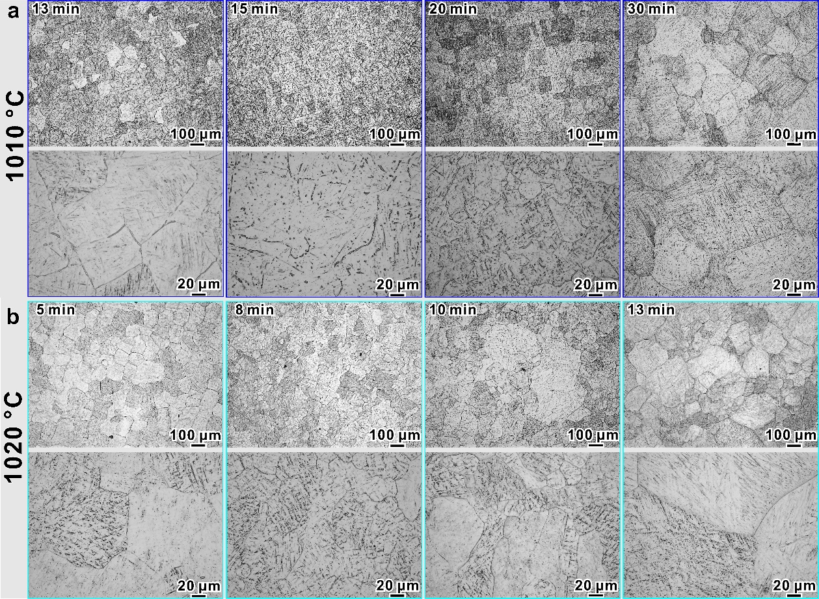
Fig. S3 Microstructure evolution of Ti-6.5Al-3.5Mo-1.5Zr-0.3Si alloy under different holding times at (a) 1010 °C and (b) 1020 °C

Fig. S4 Quantitative characteristics of the microstructure after AM-RTP: (a) prior β grain size, (b) α lamella length, (c) α lamella thickness, (d) microvoid size.

Section 3 Tensile fracture analysis
The tensile fracture surfaces are presented in Fig. S5. At ambient temperature, macroscopic failure occurs primarily through brittle intergranular fracture (Fig. S5a1). While higher-magnification imaging reveals fine dimples within the grains (Fig. S5a2), the overall fracture mode remains macroscopically brittle. This morphology aligns with, and directly accounts for, the very limited failure elongation measured during room-temperature tensile testing. The fracture mechanism transforms fundamentally at 500 °C, where thermal activation promotes a dimpled fracture surface with notably coarser features (Figs. S5 b1 and b2). This microstructural shift corresponds to a marked increase in fracture elongation, reflecting the alloy’s enhanced ductility at elevated temperature. In both temperature regimes, fracture surfaces exhibit intergranular characteristics. Longitudinal sections along the loading axis (Figs. S5a3 and S5b3) further confirm that grain boundaries serve as the predominant sites for crack nucleation.

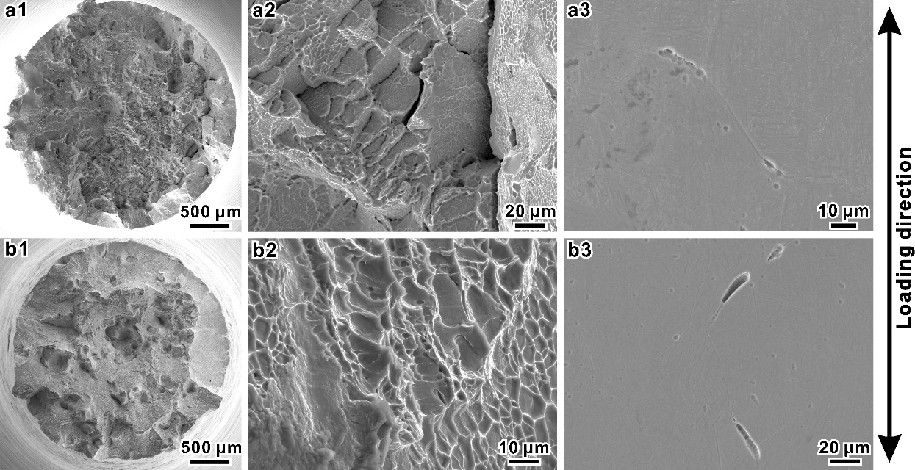
Fig. S5 Typical surface morphology of tensile failure at (a) 25 ℃ and (b) 500 ℃, (1) macroscopic morphology, (2) high-magnification morphology, (3) nucleation characteristics of grain boundary cracks along the loading direction in the longitudinal section.

Section 4 Fatigue fracture analysis and statistics
Fatigue cracks at ambient temperature consistently originated from AM-induced microvoids, as illustrated in Fig. S6a. Statistical analysis confirmed that all fatigue cracks in specimens tested at room temperature initiated at these microvoids (Table S1). The fracture surfaces exhibited distinct shear lips, suggesting rapid and unstable crack propagation. This indicates that while microvoids shortened the crack initiation stage, this phase still dominated the overall fatigue life, with crack progression occurring over a relatively brief period. At elevated temperatures, even as shear lip features become less pronounced, fatigue cracks predominantly nucleate at micropores (Fig. S6b), which remains a key factor limiting high-temperature fatigue resistance. In some specimens, surface oxidation led to interfacial strain incompatibility, resulting in stress concentration and direct crack initiation from the surface (Table S1). Notably, these cracks showed no connection to subsurface micropores, representing a distinct high-temperature failure mechanism.

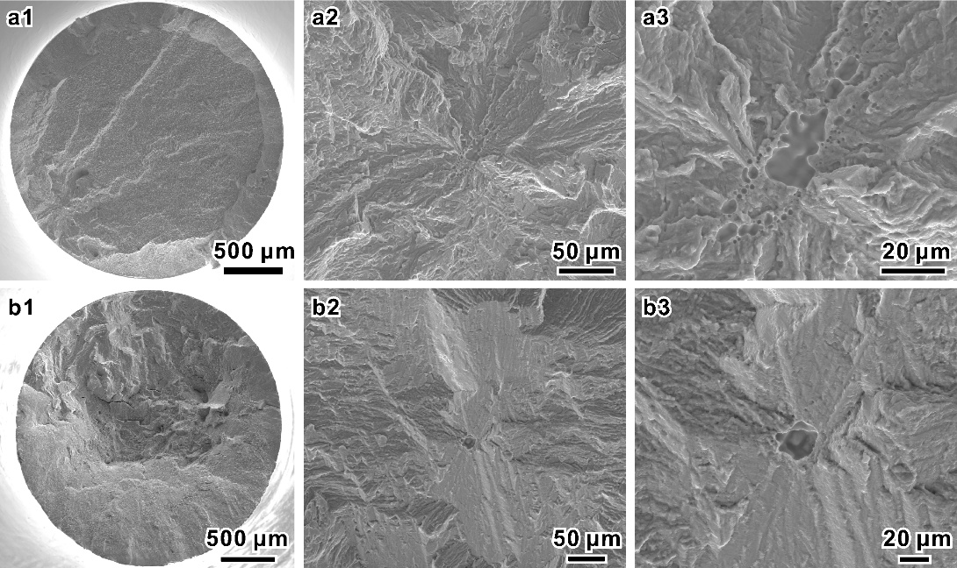
Fig. S6 Typical surface morphology of fatigue failure at (a) 25℃ and (b) 500℃.
Samples exhibiting short fatigue lives at ambient temperature, specifically those fractured at 950 MPa, 1050 MPa, and 1100 MPa, consistently revealed crack initiation from surface microvoids, as shown in Fig. S7. Although the crack initiation stage typically occupies the majority of fatigue life, microvoids located at the specimen edge act as potent initiation sites that significantly accelerate this process, leading to failure after a reduced number of cycles.
Table S1 Statistics of fatigue failure fracture surface characteristics σ_{f0.1}: Maximum stress, N_{f}: The number of cycles for loading failed samples, Tem.: Test temperature, S: Distance from the crack initiation site to the specimen edge, XFe-max: Maximum Feret diameter of the microviods, area: Microvoids area.
σ_{f0.1}, MPa | N_{f}, cycles | Tem. ℃ | S, μm | XFe-max, μm | area, µm²
1100 | 1,019,700 | 25 | 417.71 | 18.32 | 129.61
950 | 20,500 | 25 | 0 | 20.32 | 151.7
1000 | 6,280,200 | 25 | 100.34 | 9.88 | 52.25
1000 | 3,515,900 | 25 | 474.62 | 10.59 | 80.98
1100 | 1,369,300 | 25 | 282.70 | 12 | 116.76
950 | 529,600 | 25 | 31.18 | 4.55 | 8.86
1100 | 19,200 | 25 | 0 | 83 | 3329.38
1000 | 832,500 | 25 | 272.30 | 23.9 | 214.10
1050 | 3,284,800 | 25 | 405.91 | 13.37 | 124.78
1000 | 1,766,600 | 25 | 271.69 | 27.98 | 190.81
1050 | 17,900 | 25 | 0 | 23.51 | 193.79
1050 | 24,700 | 25 | 0 | 33.22 | 384.14
1050 | 1,259,100 | 25 | 315.76 | 22.83 | 294.54
800 | 62,700 | 500 | 36.47 | 48.43 | 805.28
700 | 9,342,300 | 500 | 278.27 | 13.47 | 129.89
800 | 99,200 | 500 | 291.65 | 14.95 | 125.69
775 | 100,400 | 500 | 0 | - | -
725 | 1,169,800 | 500 | 368.97 | 35.92 | 366.97
725 | 1,105,300 | 500 | 0 | - | -
750 | 1,170,500 | 500 | 0 | - | -
750 | 3,645,700 | 500 | 996.11 | 19.94 | 185.70

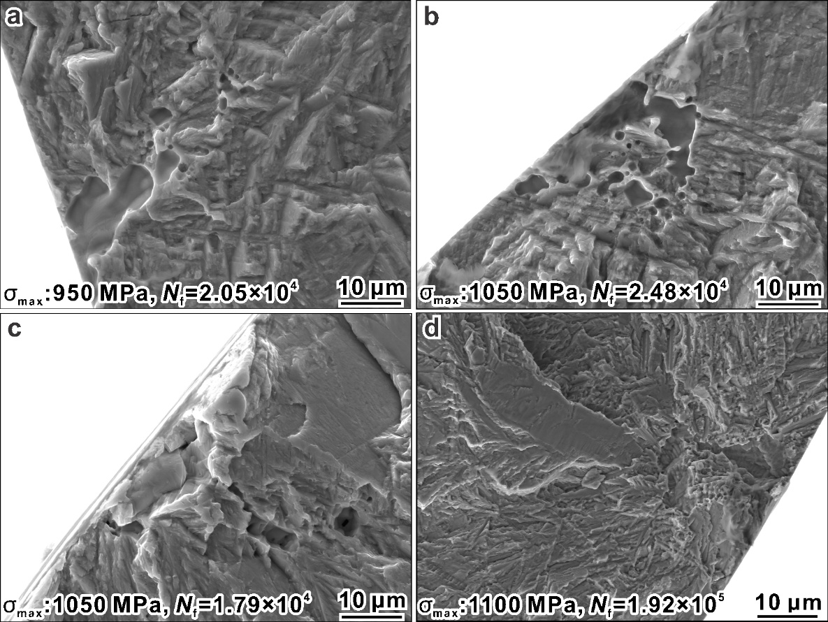
Fig. S7 Fracture morphology at the fatigue crack initiation position of the short-life test sample at ambient temperature.

Section 5 The source of data in Fig. 2 and Fig. 3
Table S2 Reference fatigue life data of Ti-6.5Al-3.5Mo-1.5Zr-0.3Si at 500 ℃ for Fig. 2c
Process | N_{f}, cycles | σ_{f0.1}, MPa | Ref. | Process | N_{f}, cycles | σ_{f0.1}, MPa | Ref.
AM | 103860 | 500 | [1] | AM | 569689 | 350 | [1]
AM | 182597 | 500 | [1] | AM | 442741 | 300 | [1]
AM | 144006 | 450 | [1] | AM | 641498 | 300 | [1]
AM | 267052 | 450 | [1] | AM | 877668 | 250 | [1]
AM | 195191 | 400 | [1] | AM | 994912 | 250 | [1]
AM | 307200 | 400 | [1] | AM | 1199186 | 200 | [1]
AM | 281312 | 350 | [1] | AM | 1281892 | 200 | [1]
Forging | 16982 | 600 | [2] | Forging | 1077187 | 505 | [2]
Forging | 21577 | 600 | [2] | Forging | 1544237 | 505 | [2]
Forging | 28829 | 600 | [2] | Forging | 1703139 | 505 | [2]
Forging | 135787 | 565 | [2] | Forging | 2993473 | 505 | [2]
Forging | 194970 | 565 | [2] | Forging | 4003238 | 475 | [2]
Forging | 292146 | 565 | [2] | Forging | 5595737 | 475 | [2]
Forging | 351456 | 565 | [2] | Forging | 6914966 | 455 | [2]
Forging | 351456 | 535 | [2] | Forging | 7674858 | 455 | [2]
Forging | 555686 | 535 | [2] | Forging | 10000000 | 445 | [2]
Forging | 651812 | 535 | [2]
Forging | 20266 | 700 | [3] | Forging | 544588 | 475 | [3]
Forging | 259590 | 675 | [3] | Forging | 6792399 | 450 | [3]
Forging | 2687131 | 650 | [3] | Forging | 10000000 | 450 | [3]
Forging | 10000000 | 625 | [3] | Forging | 7808532 | 425 | [3]
Forging | 10172 | 650 | [3] | Forging | 10000000 | 425 | [3]
Forging | 13915 | 625 | [3] | Forging | 10000000 | 400 | [3]
Forging | 1982949 | 600 | [3] | Forging | 51147 | 525 | [3]
Forging | 2202375 | 575 | [3] | Forging | 93337 | 500 | [3]
Forging | 10000000 | 550 | [3] | Forging | 314257 | 475 | [3]
Forging | 17935 | 625 | [3] | Forging | 1173310 | 450 | [3]
Forging | 18886 | 625 | [3] | Forging | 481954 | 425 | [3]
Forging | 20618 | 500 | [3] | Forging | 4238913 | 425 | [3]
Forging | 20813 | 575 | [3] | Forging | 1338313 | 400 | [3]
Forging | 142028 | 575 | [3] | Forging | 3346031 | 400 | [3]
Forging | 408220 | 550 | [3] | Forging | 7735486 | 375 | [3]
Forging | 10000000 | 540 | [3] | Forging | 10000000 | 375 | [3]
Forging | 62994 | 525 | [3] | Forging | 10000000 | 350 | [3]
Forging | 194283 | 500 | [3]

Table S3 Reference fatigue life data of various titanium alloys at 500 ℃ for Fig. 2d
Material | N_{f}, cycles | σ_{f0.1}, MPa | Ref. | Material | N_{f}, cycles | σ_{f0.1}, MPa | Ref.
TA12A | 21706 | 550 | [4] | TA12A | 1955041 | 430 | [4]
TA12A | 28263 | 550 | [4] | TA12A | 2414715 | 430 | [4]
TA12A | 36731 | 550 | [4] | TA12A | 4778433 | 430 | [4]
TA12A | 21502 | 490 | [4] | TA12A | 5835558 | 430 | [4]
TA12A | 36731 | 490 | [4] | TA12A | 8178140 | 430 | [4]
TA12A | 40822 | 490 | [4] | TA12A | 54267 | 410 | [4]
TA12A | 917913 | 490 | [4] | TA12A | 1271922 | 410 | [4]
TA12A | 3010717 | 490 | [4] | TA12A | 8524502 | 410 | [4]
TA12A | 39163 | 470 | [4] | TA12A | 2197475 | 390 | [4]
TA12A | 514538 | 470 | [4] | TA12A | 2739858 | 390 | [4]
TA12A | 1085621 | 470 | [4] | TA12A | 7670330 | 370 | [4]
TA12A | 4040256 | 470 | [4] | TA12A | 8178140 | 350 | [4]
TA12A | 4778433 | 470 | [4] | TA12A | 8902301 | 350 | [4]
TA15 | 1147688 | 600 | [4] | TA15 | 6893276 | 530 | [4]
TA15 | 1577398 | 600 | [4] | TA15 | 7909212 | 530 | [4]
TA15 | 1844899 | 600 | [4] | TA15 | 9383316 | 540 | [4]
TA15 | 2021336 | 600 | [4] | TA15 | 9844329 | 530 | [4]
TA15 | 3307620 | 600 | [4] | TA15 | 10000000 | 520 | [4]
TA15 | 3606424 | 600 | [4] | TA15 | 2305912 | 500 | [4]
TA15 | 83374 | 580 | [4] | TA15 | 8481210 | 500 | [4]
TA15 | 846038 | 580 | [4] | TA15 | 10000000 | 500 | [4]
TA15 | 5766356 | 580 | [4] | TA15 | 3259242 | 480 | [4]
TA15 | 1719686 | 560 | [4] | TA15 | 4275178 | 480 | [4]
TA15 | 3005969 | 560 | [4] | TA15 | 3131182 | 460 | [4]
TA15 | 4417466 | 560 | [4] | TA15 | 5114677 | 460 | [4]
TA15 | 4528450 | 560 | [4] | TA15 | 6227369 | 460 | [4]
TA15 | 5496008 | 560 | [4] | TA15 | 5686674 | 440 | [4]
TA15 | 3401530 | 550 | [4] | TA15 | 6307050 | 440 | [4]
TA15 | 1719686 | 530 | [4] | TA15 | 8273469 | 440 | [4]
TA15 | 2704319 | 530 | [4] | TA15 | 4545525 | 420 | [4]
Ti60 | 24255 | 600 | [4] | Ti60 | 289174 | 290 | [4]
Ti60 | 28719 | 600 | [4] | Ti60 | 3387606 | 290 | [4]
Ti60 | 35557 | 600 | [4] | Ti60 | 8456817 | 290 | [4]
Ti60 | 22397 | 575 | [4] | Ti60 | 10000000 | 290 | [4]
Ti60 | 30561 | 575 | [4] | Ti60 | 10000000 | 280 | [4]
Ti60 | 38507 | 575 | [4] | Ti60 | 25046 | 500 | [4]
Ti60 | 558511 | 550 | [4] | Ti60 | 46381 | 400 | [4]
Ti60 | 673003 | 550 | [4] | Ti60 | 48150 | 400 | [4]
Ti60 | 951090 | 550 | [4] | Ti60 | 55551 | 400 | [4]
Ti60 | 1756761 | 500 | [4] | Ti60 | 61629 | 400 | [4]
Ti60 | 401559 | 480 | [4] | Ti60 | 77419 | 350 | [4]
Ti60 | 262383 | 460 | [4] | Ti60 | 85161 | 350 | [4]
Ti60 | 76294 | 420 | [4] | Ti60 | 806789 | 350 | [4]
Ti60 | 6896159 | 400 | [4] | Ti60 | 667892 | 300 | [4]
Ti60 | 604840 | 380 | [4] | Ti60 | 3975702 | 300 | [4]
Ti60 | 4011109 | 380 | [4] | Ti60 | 125541 | 290 | [4]
Ti60 | 5005854 | 380 | [4] | Ti60 | 134158 | 290 | [4]
Ti60 | 3941399 | 360 | [4] | Ti60 | 198107 | 290 | [4]
Ti60 | 9500281 | 360 | [4] | Ti60 | 2992012 | 290 | [4]
Ti60 | 10000000 | 360 | [4] | Ti60 | 10000000 | 290 | [4]
Ti60 | 1591465 | 340 | [4] | Ti60 | 81198 | 280 | [4]
Ti60 | 10000000 | 340 | [4] | Ti60 | 1691698 | 280 | [4]
Ti60 | 10000000 | 320 | [4] | Ti60 | 10000000 | 280 | [4]
Ti60 | 3703866 | 300 | [4] | Ti60 | 8029964 | 270 | [4]
Ti60 | 10000000 | 300 | [4] | Ti60 | 10000000 | 270 | [4]
 |  |  | [4] | Ti60 | 10000000 | 260 | [4]
ZTA15 | 8747 | 600 | [4] | ZTA15 | 679552 | 430 | [4]
ZTA15 | 9735 | 570 | [4] | ZTA15 | 2133964 | 430 | [4]
ZTA15 | 15685 | 550 | [4] | ZTA15 | 10000000 | 430 | [4]
ZTA15 | 23853 | 550 | [4] | ZTA15 | 79529 | 415 | [4]
ZTA15 | 32877 | 550 | [4] | ZTA15 | 249743 | 415 | [4]
ZTA15 | 53655 | 550 | [4] | ZTA15 | 1548286 | 415 | [4]
ZTA15 | 162474 | 550 | [4] | ZTA15 | 2909903 | 415 | [4]
ZTA15 | 302111 | 550 | [4] | ZTA15 | 295086 | 400 | [4]
ZTA15 | 26207 | 500 | [4] | ZTA15 | 2189445 | 400 | [4]
ZTA15 | 40284 | 490 | [4] | ZTA15 | 4579378 | 400 | [4]
ZTA15 | 252429 | 490 | [4] | ZTA15 | 5818940 | 400 | [4]
ZTA15 | 374160 | 490 | [4] | ZTA15 | 10000000 | 400 | [4]
ZTA15 | 554596 | 490 | [4] | ZTA15 | 258992 | 385 | [4]
ZTA15 | 648316 | 490 | [4] | ZTA15 | 10000000 | 385 | [4]
ZTA15 | 51079 | 430 | [4] | ZTA15 | 447802 | 370 | [4]
ZTA15 | 158696 | 430 | [4] | ZTA15 | 10000000 | 370 | [4]
ZTA15 | 320757 | 430 | [4] | ZTA15 | 10000000 | 355 | [4]

Table S4 Reference fatigue strength data of titanium alloys at 25 ℃ for Fig. 3a
Material | σ_{UTS}, MPa | σ_{f0.1}, MPa | Ref. | Material | σ_{UTS}, MPa | σ_{f0.1}, MPa | Ref.
Ti-4Al-2.5V-1.5Fe-0.25O | 1010 | 685 | [5] | Ti-6Al-4V | 956 | 475 | [6]
Ti-4Al-2.5V-1.5Fe-0.25O | 1100 | 775 | [5] | Ti-6Al-4V | 1237 | 340 | [6]
Ti-6.5Al-1Mo-1V-2Zr | 1119 | 508 | [7] | Ti-6Al-4V | 1050 | 375 | [6]
Ti-6.5Al-1Mo-1V-2Zr | 875 | 452 | [7] | Ti-6Al-4V | 1186 | 340 | [6]
Ti-6.5Al-1Mo-1V-2Zr | 845 | 344 | [7] | Ti-6Al-4V | 975 | 400 | [6]
Ti-4Al-6Mo-2V-5Cr-2Zr | 1168 | 630 | [8] | Ti-6Al-4V | 1222 | 453 | [6]
Ti-4Al-6Mo-2V-5Cr-2Zr | 1253 | 685 | [8] | Ti-6Al-4V | 974 | 453 | [6]
Ti-5Al-5Mo-5V-1Cr-1Fe | 1241 | 855 | [9] | Ti-6Al-4V | 1145 | 475 | [6]
Ti-5Al-5Mo-5V-1Cr-1Fe | 1172 | 810 | [9] | Ti-6Al-4V | 1228 | 978 | [10]
Ti-5Al-5Mo-5V-1Cr-1Fe | 1155 | 795 | [9] | Ti-6Al-4V | 1179 | 850 | [10]
Ti-5Al-5Mo-5V-1Cr-1Fe | 1126 | 750 | [9] | Ti-6Al-4V | 977 | 675 | [10]
Ti-5Al-5Mo-5V-1Cr-1Fe | 1286 | 880 | [9] | Ti-6Al-4V | 1271 | 475 | [10]
Ti-5Al-5Mo-5V-1Cr-1Fe | 1215 | 880 | [11] | Ti-6Al-4V | 1140 | 179 | [12]
Ti-5Al-5Mo-5V-1Cr-1Fe | 1199 | 780 | [11] | Ti-6Al-4V | 980 | 173 | [12]
Ti-5Al-5Mo-5V-1Cr-1Fe | 1141 | 730 | [11] | Ti-6Al-4V | 940 | 187 | [12]
Ti-5Al-5Mo-5V-1Cr-1Fe | 1133 | 650 | [11] | Ti-6Al-4V | 880 | 172 | [12]
Ti-15V-3Cr-3Al-3Sn | 1275 | 655 | [13] | Ti-6Al-4V | 889 | 216 | [14]
Ti-15V-3Cr-3Al-3Sn | 1613 | 875 | [13] | Ti-6Al-4V | 880 | 154 | [14]
Ti-15V-3Cr-3Al-3Sn | 1317 | 780 | [13] | Ti-6Al-4V | 913 | 187 | [14]
Ti-6.5A1-3.5Mo-1.5Zr-0.3Si | 781 | 166 | [15] | Ti-6Al-4V | 951 | 404 | [16]
Ti-6.5A1-3.5Mo-1.5Zr-0.3Si | 933 | 166 | [15] | Ti-6Al-4V | 959 | 452 | [16]
Ti-6.5A1-3.5Mo-1.5Zr-0.3Si | 935 | 156 | [15] | Ti-6Al-4V | 1086 | 600 | [17]
Ti-6.5A1-3.5Mo-1.5Zr-0.3Si | 1238 | 160 | [18] | Ti-6Al-4V | 1075 | 425 | [17]
Ti-6.5A1-3.5Mo-1.5Zr-0.3Si | 1315 | 260 | [18] | Ti-6Al-4V | 1074 | 420 | [17]
Ti-6.5A1-3.5Mo-1.5Zr-0.3Si | 1056 | 510 | [19] | IMI834 | 1037 | 521 | [20]
Ti-6.5A1-3.5Mo-1.5Zr-0.3Si | 1098 | 500 | [19] | IMI834 | 1055 | 559 | [20]
Ti-6.5A1-3.5Mo-1.5Zr-0.3Si | 1030 | 682 | [21] | TC4/TB8 | 1054 | 450 | [22]
Ti-6.5A1-3.5Mo-1.5Zr-0.3Si | 960 | 601 | [23] | Ti-60 | 1044 | 320 | [24]
Ti-6.5A1-3.5Mo-1.5Zr-0.3Si | 960 | 717 | [23] | Ti-600 | 1000 | 475 | [25]
Ti-6.5A1-3.5Mo-1.5Zr-0.3Si | 1000 | 800 | [26] | TC17 | 1141 | 629 | [27]
Ti-6.5A1-3.5Mo-1.5Zr-0.3Si | 1057 | 781 | [28] | Ti-5553-0.36O | 1779 | 1058 | [29]
Ti-6.5A1-3.5Mo-1.5Zr-0.3Si | 1057 | 796 | [28] | Ti-5553-0.22O | 1704 | 900 | [29]
Ti-6.5A1-3.5Mo-1.5Zr-0.3Si | 1154 | 675 | [30] | Ti-8Al-1Mo-1V | 928 | 400 | [31]
Ti-6.5A1-3.5Mo-1.5Zr-0.3Si | 1154 | 828 | [30] | Ti-5Al-7.5V | 1324 | 720 | [32]
Ti-6.5A1-3.5Mo-1.5Zr-0.3Si | 961 | 167 | [15] | Ti-10V-2Fe-3Al | 1065 | 850 | [33]
Ti-6.5A1-3.5Mo-1.5Zr-0.3Si | 951 | 189 | [15] | Ti-10V-2Fe-3Al | 1085 | 850 | [33]
Ti-6.5A1-3.5Mo-1.5Zr-0.3Si | 898 | 233 | [15] | Ti-10V-2Fe-3Al | 1100 | 850 | [33]
Ti-6.5A1-3.5Mo-1.5Zr-0.3Si | 1128 | 896 | [34] | Ti-10V-2Fe-3Al | 1330 | 790 | [33]
Ti-6.5A1-3.5Mo-1.5Zr-0.3Si | 1179 | 531 | [34] | Ti-10V-2Fe-3Al | 1317 | 905 | [33]
Ti-6.5A1-3.5Mo-1.5Zr-0.3Si | 1430 | 815 | [35] | Ti-10V-2Fe-3Al | 1027 | 825 | [36]
Ti-6.5A1-3.5Mo-1.5Zr-0.3Si | 1320 | 838 | [35] | Ti-6Al-2Zr-1Mo-1V | 967 | 725 | [37]
Ti-6.5A1-3.5Mo-1.5Zr-0.3Si | 1050 | 810 | [35] | Ti-6Al-2Zr-1Mo-1V | 977 | 500 | [37]
Ti-6.5A1-3.5Mo-1.5Zr-0.3Si | 1083 | 450 | [38]
Ti-6.5A1-3.5Mo-1.5Zr-0.3Si | 999 | 395 | [26]
Ti-6.5A1-3.5Mo-1.5Zr-0.3Si | 1132 | 900 | [39]

Table S5 Reference fatigue strength data of various alloys at 500 ℃ for Fig. 3b
Material | σ_{UTS}, MPa | σ_{f0.1}, MPa | Ref. | Material | σ_{UTS}, MPa | σ_{f0.1}, MPa | Ref.
2CrMo | 549 | 338 | [40] | Ti6242s | 722 | 454 | [41]
2CrMo | 568 | 388 | [42] | Ti6242s | 699 | 485 | [41]
304L | 364 | 148 | [43] | QT-500 | 352 | 107 | [44]
RuT-500 | 196 | 141 | [45] | RuT-500 | 252 | 164 | [46]
RuT-500 | 300 | 187 | [45] | RuT-500 | 323 | 205 | [47]
RuT-500 | 366 | 207 | [45] | G42CrMo4 | 633 | 385 | [48]
DD6 | 1026 | 599 | [4] | G42CrMo4 | 793 | 410 | [48]
DD5 | 1142 | 502 | [4] | Ti60 | 768 | 525 | [49]
FGH95 | 1424 | 570 | [4] | 2.25Cr-1Mo | 501 | 357 | [50]
GH909 | 1114 | 608 | [4] | 9Cr-1Mo | 556 | 362 | [51]
K4750 | 763 | 421 | [4] | 18Cr-2Mo | 238 | 207 | [52]
Ti60 | 651 | 372 | [4] | 42CrMo4 | 760 | 483 | [53]
Ti60 | 651 | 367 | [4] | 42CrMo4 | 793 | 481 | [53]
38MnVS6 | 548 | 422 | [54] | GH4169 | 1226 | 635 | [55]
38MnVS6 | 567 | 336 | [54] | Ti-6.5A1-3.5Mo-1.5Zr-0.3Si | 737 | 536 | [56]
38MnVS6 | 552 | 303

Supplementary references
[1] F.P. An, L.J. Zhang, C.H.T. Lee, Influences of grain orientation on high-cycle fatigue performance of laser powder bed fused Ti-6.5Al-3.5Mo-1.5Zr-0.3Si alloy at room temperature and 500degree celsius, Mater. Sci. Eng. A 912 (2024) 146988.
[2] J.N. Wu, D.X. Liu, X.H. Zhang, Y.J. Liu, Z.Q. Yang, J.F. Xiang, Enhancing high-temperature fatigue resistance of TC11 titanium alloy through combined plasma zirconizing and ultrasonic surface rolling, Int. J. Fatigue 198 (2025) 108993.
[3] H.L. Shi, D.X. Liu, T.Y. Jia, X.H. Zhang, W.D. Zhao, Effect of the ultrasonic surface rolling process and plasma electrolytic oxidation on the hot salt corrosion fatigue behavior of TC11 alloy, Int. J. Fatigue 168 (2023) 107443.
[4] B. Su, X.D. Li, S.C. Zhang, W. Xu, Study on service mechanical properties characterization model and performance rule of key materials for advanced aero engine (Part II), Aviation industry press, Beijing, China, 2023.
[5] T.S. Srivatsan, M. Kuruvilla, L. Park, A study at understanding the mechanisms governing the high cycle fatigue and final fracture behavior of the titanium alloy: Ti-4Al-2.5V, Mater. Sci. Eng. A 527(3) (2010) 435-448.
[6] P. Kumar, U. Ramamurty, High cycle fatigue in selective laser melted Ti-6Al-4V, Acta Mater. 194 (2020) 305-320.
[7] V. Nesterenkov, S. Akhonin, I. Klochkov, V. Matviichuk, V. Berezos, S. Motrunich, High cyclic fatigue behavior of 3D-printed titanium alloy TA15, Welding in the World 69(3) (2025) 717-725.
[8] S.Y. Wang, H.Y. Zhang, G. Zhou, X.B. Chen, L.J. Chen, Effects of microstructure on high-cycle fatigue properties of Ti-4Al-6Mo-2V-5Cr-2Zr alloy, Int. J. Fatigue 182 (2024).
[9] X.H. Shi, W.D. Zeng, S.K. Xue, Z.Q. Jia, The crack initiation behavior and the fatigue limit of Ti-5Al-5Mo-5V-1Cr-1Fe titanium alloy with basket-weave microstructure, J. Alloys Compd. 631 (2015) 340-349.
[10] Z. Qu, Z.J. Zhang, R. Liu, L. Xu, Y.N. Zhang, X.T. Li, Z.K. Zhao, Q.Q. Duan, S.G. Wang, S.J. Li, Y.J. Ma, X.H. Shao, R. Yang, J. Eckert, R.O. Ritchie, Z.F. Zhang, High fatigue resistance in a titanium alloy via near-void-free 3D printing, Nature 626(8001) (2024) 999-1004.
[11] G.Q. Wu, C.L. Shi, W. Sha, A.X. Sha, H.R. Jiang, Microstructure and high cycle fatigue fracture surface of a Ti-5Al-5Mo-5V-1Cr-1Fe titanium alloy, Mater. Sci. Eng. A 575 (2013) 111-118.
[12] M.H. Wang, H. Yan, Q.H. Lu, P.L. Zhang, K.W. Liu, Selective Laser Melted Ti-6Al-4V Alloy after Post-Heat Treatments: Microstructure, Mechanical Properties and Fatigue Behavior, J. Mater. Eng. Perform. 34(6) (2025) 5381-5393.
[13] R.R. Boyer, H.J. Rack, V. Venkatesh, The influence of thermomechanical processing on the smooth fatigue properties of Ti-15V-3Cr-3Al-3Sn, Mater. Sci. Eng. A 243(1-2) (1998) 97-102.
[14] J. Long, L.J. Zhang, M.X. Xie, Y.Q. Liu, Dealloying significantly improves the fatigue property of laser-welded joints of TC4 titanium alloy, Eng. Fail. Anal. 171 (2025) 109390.
[15] B. Zhang, Z.M. Song, L.M. Lei, L. Kang, G.P. Zhang, Geometrical scale-sensitive fatigue properties of Ti-6.5Al-3.5Mo-1.5Zr-0.3Si alloys with α/β lamellar microstructures, J. Mater. Sci. Technol. 30(12) (2014) 1284-1288.
[16] Z.C. Pang, L.Q. Cui, W.F. He, X.Q. Liang, Z.Y. Cao, W. Zhao, J.D. Song, S. Hu, S.H. Luo, Superior high-cycle fatigue property through in-situ precipitation of α' martensite in additively repaired titanium alloy, J. Alloys Compd. 996 (2024) 174875.
[17] A.K. Syed, W. Vesga, B. Dutton, T. Berentshaw, X. Zhang, Defect tolerance and fatigue limit prediction for laser powder bed fusion Ti6Al4V, Int. J. Fatigue 184 (2024) 108285.
[18] F.P. An, L.J. Zhang, S.J. Na, Effects of plasma electrolytic polishing on the surface and mechanical properties of Ti-6.5Al-3.5Mo-1.5Zr-0.3Si specimen fabricated by laser powder bed fusion, J. Manuf. Process 131 (2024) 283-296.
[19] J.K. Zhang, X.Y. Kong, S.J. Ma, D. Liu, X.B. Wang, J. Feng, H.M. Wang, Laser additive manufactured high strength-toughness TC11 titanium alloy:Mechanical properties and application in airframe load-bearing structure, Acta Aeronaut. Astronaut. Sin. 42(10) (2021) 525403.
[20] J.F. Hu, P. Qi, W. Wei, B.L. Li, T.B. Wang, J.M. Yin, Z.R. Nie, Structural characteristics, tensile properties and room-temperature high-cycle fatigue properties of heterogeneous structure in near-α titanium alloys, T. Nonferrous Met. Soc. 35(9) (2025) 2918-2934.
[21] X.F. Nie, W.F. He, S.L. Zang, X.D. Wang, J. Zhao, Effect study and application to improve high cycle fatigue resistance of TC11 titanium alloy by laser shock peening with multiple impacts, Surf. Coat. Tech. 253 (2014) 68-75.
[22] T.L. Li, W. Fan, X.F. Li, H.P. Wu, D.Y. An, Q. Hu, J. Chen, High-cycle and low-cycle fatigue characteristics of multilayered dissimilar titanium alloys, Int. J. Plast. 179 (2024) 104033.
[23] X.H. Zhao, G.L. Xue, Y. Liu, Gradient crystalline structure induced by ultrasonic impacting and rolling and its effect on fatigue behavior of TC11 titanium alloy, Result Phys. 7 (2017) 1845-1851.
[24] R.X. He, H.T. Peng, F.L. Liu, M.K. Khan, Y. Chen, C. He, C. Wang, Q.Y. Wang, Y.J. Liu, Crack Initiation Mechanism and Life Prediction of Ti60 Titanium Alloy Considering Stress Ratios Effect in Very High Cycle Fatigue Regime, Materials 15(8) (2022) 2800.
[25] L.Y. Zeng, Y.Q. Zhao, Q.A. Hong, G.J. Yang, High cycle fatigue property of Ti-600 alloy at ambient temperature, J. Alloys Compd. 509(5) (2011) 2081-2086.
[26] C. Li, W. Li, S.H. Yuan, X.L. Li, L. Cai, Y.C. Zhang, T.Y. Hu, Z.L. Mo, M.I. Lashari, U. Hamid, High cycle and very high cycle fatigue properties and microscopic crack growth modeling of Ti-6.5Al-3.5Mo-1.5Zr-0.3Si titanium alloy at elevated temperatures, Fatigue Fract. Eng. Mater. Struct. 45(12) (2022) 3677-3691.
[27] G. Li, C.Q. Sun, High-temperature failure mechanism and defect sensitivity of TC17 titanium alloy in high cycle fatigue, J. Mater. Sci. Technol. 122 (2022) 128-140.
[28] J.L. Song, M.F. Li, P. Tang, J.L. Liu, D.S. Qiu, Z.C. Wang, Fatigue properties of TC11 titanium alloy after electric pulse processing, Chin. J. Rare Met. 42(7) (2018) 691-697.
[29] Y.M. Mao, Q.Y. Zhao, R.Q. Zhang, P. Guo, Y.N. Chen, Y.Q. Zhao, Trifunctional local-range order oxygen structure enhanced strength-ductility and fatigue resistance in large-scale metastable titanium alloy, Nat. Commun. 16(1) (2025) 7168.
[30] Z. Yan, Y. Liang, Z. Zhang, J. Xu, Y. Yi, High cycle fatigue behavior of TC11 titanium alloy by shot peening strengthening, Chin. J. Rare Met. 38(4) (2014) 554-560.
[31] K. Yang, B. Zhong, Q. Huang, C. He, Z.Y. Huang, Q.Y. Wang, Y.J. Liu, Stress ratio effect on notched fatigue behavior of a Ti-8Al-1Mo-1V alloy in the very high cycle fatigue regime, Int. J. Fatigue 116 (2018) 80-89.
[32] Z.H. Wu, H.C. Kou, N.A. Chen, F.M. Qiang, J.K. Fan, B. Tang, J.S. Li, Crack initiation mechanism in a high-strength Ti-5Al-7.5V alloy subjected to high cycle fatigue loading, Eng. Fail. Anal. 148 (2023) 107201.
[33] S.K. Jha, K.S.R. Chandran, An unusual fatigue phenomenon: duality of the S-N fatigue curve in the β-titanium alloy Ti-10V-2Fe-3Al, Scr. Mater. 48(8) (2003) 1207-1212.
[34] Z.L. Zhang, Y.L. Zhang, Z.L. Zhang, G.Y. He, Effect of brittle TiN coating on fatigue performance of TC11 titanium alloy under rotating bending and tension-tension, J. Alloys Compd. 968 (2023) 172163.
[35] Z. Shao, Z.J. Zhang, R. Liu, Z. Qu, Z.K. Zhao, H.Z. Liu, J.C. Pang, Z.F. Zhang, Fatigue strength plateau induced by primary alpha phase size in TC11 alloy, Adv. Eng. Mater. 27(5) (2025) 2402891.
[36] Y. Wu, J.R. Liu, H. Wang, S.X. Guan, R. Yang, H.F. Xiang, Effect of stress ratio on very high cycle fatigue properties of Ti-10V-2Fe-3Al alloy with duplex microstructure, J. Mater. Sci. Technol. 34(7) (2018) 1189-1195.
[37] S.K. Li, B.Q. Xiong, S.X. Hui, W.J. Ye, Y. Yu, Comparison of the fatigue and fracture of Ti-6Al-2Zr-1Mo-1V with lamellar and bimodal microstructures, Mater. Sci. Eng. A 460 (2007) 140-145.
[38] Y.L. Wu, Y. Xiong, W. Liu, Z.G. Chen, X. Zhang, S.B. Wang, W. Cao, Effect of supersonic fine particle bombardment on microstructure and fatigue properties of Ti-6.5Al-3.5Mo-1.5Zr-0.3Si titanium alloy at different temperatures, Surf. Coat. Tech. 421 (2021) 127473.
[39] T. Gao, H.Q. Xue, Z.D. Sun, D. Retraint, Investigation of crack initiation mechanism of a precipitation hardened TC11 titanium alloy under very high cycle fatigue loading, Mater. Sci. Eng. A 776 (2020) 138989.
[40] Q. Gao, B. Hu, Q. Zuo, Effect of temperature on high-cycle fatigue properties of 2CrMo alloy steel for turbine rotor, Mater. Mech. Eng. 46(4) (2022) 37-41.
[41] J.T. Yu, B.B. Li, M.Q. Li, S.K. Wang, X. Guo, J. Wu, G. Chen, New insights into physical origins of dynamic strain aging in Ti-2Al-2.5Zr alloy and influence on LCF and HCF behaviors, Mater. Sci. Eng. A 918 (2024) 147483.
[42] Q. Gao, B. Hu, B. Chen, Y. Zhao, X. Guo, Study on high cycle fatigue properties of alloy steel at room and high temperature, Hot Work. Technol. 46(14) (2017) 93-95.
[43] K. Kobayashi, K. Yamaguchi, M. Hayakawa, M. Kimura, High-temperature fatigue properties of austenitic superalloys 718, A286 and 304L, Int. J. Fatigue 30(10-11) (2008) 1978-1984.
[44] C. Delprete, R. Sesana, Experimental characterization of a Si-Mo-Cr ductile cast iron, Mater. Des. 57 (2014) 528-537.
[45] Y. Chen, J.C. Pang, C.L. Zou, S.X. Li, Z.F. Zhang, High-temperature fatigue damage mechanism and strength prediction of vermicular graphite iron, Int. J. Fatigue 168 (2023) 107477.
[46] Q.Y. Liu, G. Zhu, J.C. Pang, F. Liu, S.X. Li, C.L. Guo, A.L. Jiang, Z.F. Zhang, High-cycle fatigue properties prediction and damage mechanisms of RuT400 compacted graphite iron at different temperatures, Mater. Sci. Eng. A 764 (2019) 138248.
[47] C.L. Zou, J.C. Pang, M.X. Zhang, Y. Qiu, S.X. Li, L.J. Chen, J.P. Li, Z. Yang, Z.F. Zhang, The high cycle fatigue, deformation and fracture of compacted graphite iron: Influence of temperature, Mater. Sci. Eng. A 724 (2018) 606-615.
[48] A. Schmiedel, S. Henkel, T. Kirste, R. Morgenstern, A. Weidner, H. Biermann, Ultrasonic fatigue testing of cast steel G42CrMo4 at elevated temperatures, Fatigue Fract. Eng. Mater. Struct. 43(10) (2020) 2455-2475.
[49] C.L. Chen, D.G. Shang, N.M. Xiao, X.W. Li, A.X. Sha, J. Li, J.X. Li, Z.Q. Tang, Z.Y. Han, Y.E. Guo, D.H. Li, Fatigue life prediction of Ti60 titanium alloy under very high cycle loading at different temperatures, Int. J. Fatigue 176 (2023) 107838.
[50] H. Kobayashi, A. Todoroki, T. Oomura, T. Sano, T. Takehana, Ultra-high-cycle fatigue properties and fracture mechanism of modified 2.25Cr-1Mo steel at elevated temperatures, Int. J. Fatigue 28(11) (2006) 1633-1639.
[51] C.D. Shao, F.G. Lu, X.F. Wang, Y.M. Ding, Z.G. Li, Microstructure characterization and HCF fracture mode transition for modified 9Cr-1Mo dissimilarly welded joint at different elevated temperatures, J. Mater. Sci. Technol. 33(12) (2017) 1610-1620.
[52] Y. Uematsu, M. Akita, M. Nakajima, K. Tokaji, Effect of temperature on high cycle fatigue behaviour in 18Cr-2Mo ferritic stainless steel, Int. J. Fatigue 30(4) (2008) 642-648.
[53] A. Schmiedel, T. Kirste, R. Morgenstern, A. Weidner, H. Biermann, The fatigue life of 42CrMo4 steel in the range of HCF to VHCF at elevated temperatures up to 773 K, Int. J. Fatigue 152 (2021) 106437.
[54] T. Kirste, R. Morgenstern, A. Schmiedel, A. Weidner, H. Biermann, Influence of the local degree of deformation on the temperature dependent fatigue behaviour of a ferritic-pearlitic steel, Fatigue Fract. Eng. Mater. Struct. 43(12) (2020) 2786-2799.
[55] H.C. Ma, J.H. Wang, W. Hua, M.L. Jiang, R. Chen, H.Q. Xue, Y.L. He, Transition in crack initiation mechanism of nickel-based superalloys under very high cycle fatigue at elevated temperatures, J. Alloys Compd. 1044 (2025) 184445.
[56] X.Y. Teng, J.C. Pang, X.H. Peng, H. Zhang, S.X. Li, Z.F. Zhang, High-cycle fatigue properties of near-defect-free titanium alloy treated by additive manufacturing and hot-isostatic pressing at different temperatures, Int. J. Fatigue 203 (2026) 109311.

