Supplementary Materials
Tripartite motif 46 aggravates MASLD progression by suppressing SGPL1- mediated hepatic lipophagy

Li Xiao^{1,#}, Dating Sun^{4,#}, Yaoyao Jin³, Yifan Qin², Ziwei Zhou³, Jialin Zhao², Yuanhan Geng², Sumei Ren², Hui Ding¹, Bingyong Zhang¹, Zhi-Gang She⁵, Yaping Guo^{3,*}, Junyong Wang^{1,2,*}

¹ Department of Gastroenterology, Henan Provincial People’s Hospital & Zhengzhou University People’s Hospital, Zhengzhou University, Zhengzhou, 450003, China.
² State Key Laboratory of Metabolic Dysregulation & Prevention and Treatment of Esophageal Cance, School of Convergence Medicine, Tianjian Laboratory of Advanced Biomedical Sciences, Zhengzhou University, Zhengzhou, 450052, China.
³ Department of Pathophysiology, School of Basic Medical Sciences, Zhengzhou University, Zhengzhou, 450001, China.
⁴ Department of Cardiology, The First Affiliated Hospital of Wenzhou Medical University, Wenzhou, 325000, China.
⁵ Department of Cardiology, Renmin Hospital of Wuhan University, Wuhan 430072, China; State Key Laboratory of New Targets Discovery and Drug Development for Major Diseases, Ganzhou 341000, China; Gannan Innovation and Translational Medicine Research Institute, Gannan Medical University, Ganzhou 341000, China.
# These authors contributed equally: Li Xiao and Dating Sun
*Corresponding authors: Yaping Guo: guoyaping@zzu.edu.cn, Junyong Wang: wangjunyong@zzu.edu.cn
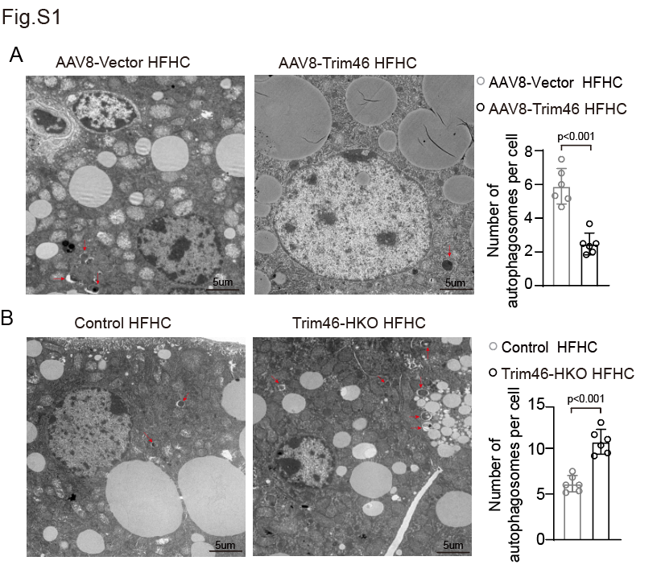
Supplementary Fig. S1. (A-B) Electron microscopy analysis of liver sections from AAV8-Vector/AAV8-Trim46 (A) and Control/ Trim46-HKO (B) mice. Purple arrows indicate autophagosomes. Quantitative analysis of autophagosomes per cell is shown in the right panel. Scale bar, 5um. n = 6 mice per group. All data are shown as the mean ± s.d.

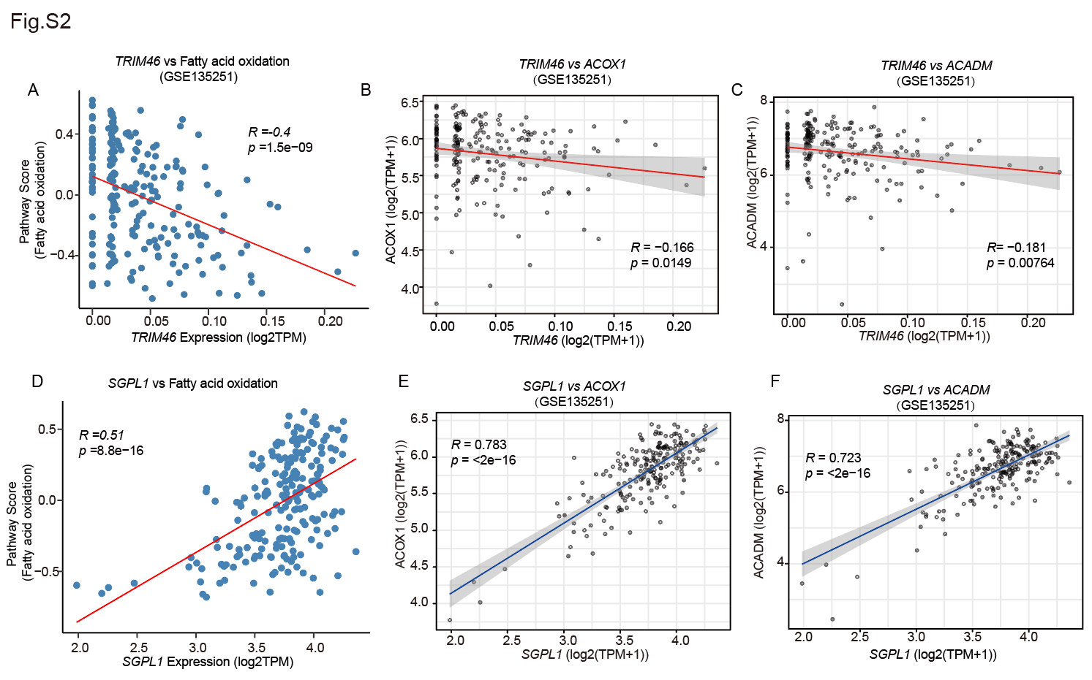
Supplementary Fig.S2. (A-C) The correlation analysis between TRIM46 expression and Fatty acid oxidation pathway (A) or ACOX1/ACADM genes (B-C) in human GEO database (GSE13525). (D-F) the correlation analysis between SGPL1 expression and fatty acid oxidation pathway (D) or ACOX1/ACADM genes (E-F) in human GEO database (GSE13525).
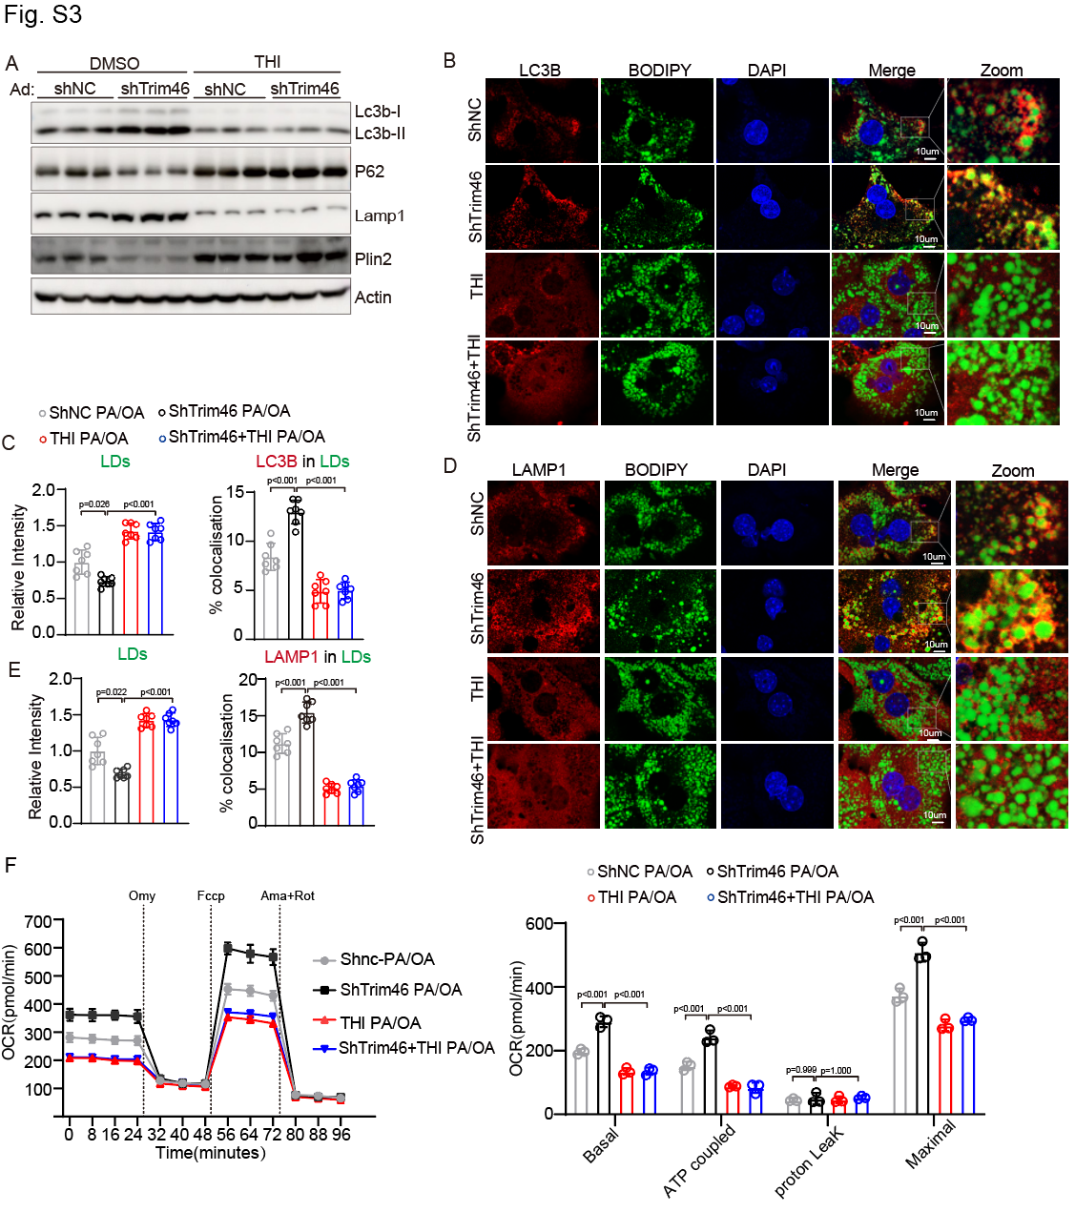
Supplementary Fig. S3 (A) Representative western blot images showing the protein levels of Sgpl1, Lc3b, P62, Lamp1 and Plin2 in mice primary hepatocytes infected with Ad-Shnc/Ad-ShTrim46 followed by treatment with or without THI administration. n = 3 independent experiments. (B-E) Representative confocal microscopy images of LC3B (B) or LAMP1 (D) on Lipid droplets in the indicated groups of cells followed by treatment with PA/OA (0.5/1mM) treatment for 24 hours. Scale bars, 10μm. Quantification of relative fluorescence intensity shown (LC3B (C) or LAMP1 (E)) in the panel represents one independent experiment. (F) Representative and statistical results of respiration in mice primary hepatocytes in the indicated groups by treatment with PA/OA (0.5/1mM) treatment for 12 hours. n = 3 independent experiments. All data are shown as the mean ± s.d.
Table S1. sgRNA target Trim46 for adeno-associated virus8 (AAV8) construction
Prime name | Species | Sequence (5’-3’)
sgTrim46#1 | Mice | GGAGAAGTGGGCTCCGAACT
sgTrim46#2 | Mice | ACATACCCTGGGCGGAAGCG

Table S2. Primers for overexpression and luciferase reporter plasmids construction.
Gene |  | Vector |  | Primer Sequence (5’-3’)
TRIM46-human | pHAGE |  |  |  | F:TCGGGTTTAAACGGATCCGCCACCATGGCAGAGGGTGAGGATA
TRIM46-human |  |  |  |  | R:GGGCCCTCTAGACTCGAGGTCCAGCTTGGCGAAGCCCC
TRIM46(1-263aa)-human | pHAGE |  |  |  | F:TCGGGTTTAAACGGATCCGCCACCATGGCAGAGGGTGAGGATA
TRIM46(1-263aa)-human |  |  |  |  | R:GGGCCCTCTAGACTCGAGCACTGGTGTGATCTTGTGCC
TRIM46(1-400aa)-human | pHAGE |  |  |  | F:TCGGGTTTAAACGGATCCGCCACCATGGCAGAGGGTGAGGATA
TRIM46(1-400aa)-human |  |  |  |  | R:GGGCCCTCTAGACTCGAGCCGGAATGTCTGGAGGGCTT
TRIM46(1-429aa)--human | pHAGE |  |  |  | F:TCGGGTTTAAACGGATCCGCCACCATGGCAGAGGGTGAGGATA
TRIM46(1-429aa)--human |  |  |  |  | R:GGGCCCTCTAGACTCGAGTCAGGCACTACTGGGCACCTTC
TRIM46(1-528aa)--human | pHAGE |  |  |  | F:TCGGGTTTAAACGGATCCGCCACCATGGCAGAGGGTGAGGATA
TRIM46(1-528aa)--human |  |  |  |  | R:GGGCCCTCTAGACTCGAGTGCCGGGGGCGTGTGCAGGT
TRIM46(167-759aa)--human | pHAGE |  |  |  | F:TCGGGTTTAAACGGATCCGCCACCATGGGAGGTGCCATCCTGTGCC
TRIM46(167-759aa)--human |  |  |  |  | R:GGGCCCTCTAGACTCGAGGTCCAGCTTGGCGAAGCCCC
TRIM46(264-759aa)--human | pHAGE |  |  |  | F:TCGGGTTTAAACGGATCCGCCACCATGCTCAGTGCCTACCAGGCC
TRIM46(264-759aa)--human |  |  |  |  | R:GGGCCCTCTAGACTCGAGGTCCAGCTTGGCGAAGCCCC
TRIM46(401-759aa)--human | pHAGE |  |  |  | F:TCGGGTTTAAACGGATCCGCCACCATGCCAGCTGCCAGCTCCTCC
TRIM46(401-759aa)--human |  |  |  |  | R:GGGCCCTCTAGACTCGAGGTCCAGCTTGGCGAAGCCCC
TRIM46(430-759aa)--human |  | pHAGE- |  |  | F:TCGGGTTTAAACGGATCCGCCACCATGCCTGAGGCCCCCGTCATT
 |  |  |  |  | R:GGGCCCTCTAGACTCGAGGTCCAGCTTGGCGAAGCCCC
TRIM46(C33A/C36A)--human |  | pHAGE- |  |  | F:GAGAAGGAACTGCTGGCCCCAGTGGCTCAAGAGATGTACAAG
 |  |  |  |  | R:CTTGTACATCTCTTGAGCCACTGGGGCCAGCAGTTCCTTCTC
TRIM46(C48A/C53A)--human |  | pHAGE- |  |  | F:CCACTGGTGCTGCCCGCTACCCACAACGTGGCCCAGGCCTGTGCCCGA
 |  |  |  |  | R:TCGGGCACAGGCCTGGGCCACGTTGTGGGTAGCGGGCAGCACCAGTGG
SGPL1-human |  | pHAGE |  |  | F:TCGGGTTTAAACGGATCCATGCCTAGCACAGACCTTCT
 |  |  |  |  | R:GGGCCCTCTAGACTCGAGTCAGTGGGGTTTTGGAGAA
SGPL1(Δ1-40aa)-human |  | pHAGE |  |  | F:TCGGGTTTAAACGGATCCCAGCTAATTGCATGGAGTG
 |  |  |  |  | R:GGGCCCTCTAGACTCGAGTCAGTGGGGTTTTGGAGAA
SGPL1(Δ41-61aa)-human |  | pHAGE |  |  | F: CCAAGTATGAGCCCTGGCAGCCAGAGAGTTTATG
 |  |  |  |  | R: CATAAACTCTCTGGCTGCCAGGGCTCATACTTGG
SGPL1(Δ167-452aa)-human |  | pHAGE |  |  | F: CCTTGTGAAGGCTTATGGAGATCTGGGATCCCGT
 |  |  |  |  | R: ACGGGATCCCAGATCTCCATAAGCCTTCACAAGG
SGPL1(K107R)-human |  | pHAGE |  |  | F: CAAGAACATGTCATTCCTGAGAGTGGACAAAGAGTAT
 |  |  |  |  | R: ATACTCTTTGTCCACTCTCAGGAATGACATGTTCTTG
SGPL1(K342R)-human |  | pHAGE |  |  | F: ACCCATTTGATTTCCGGGTGAGAGGTGTAACCAGCAT
 |  |  |  |  | R: ATGCTGGTTACACCTCTCACCCGGAAATCAAATGGGT
CREB3--human |  |  | pHAGE |  |  | F: TCGGGTTTAAACGGATCCATGGAGCTGGAATTGGAT
 |  |  |  |  |  | R: GGGCCCTCTAGACTCGAGCTAGCCTGAGTATCTGTC
HNRNPUL2--human |  |  | pHAGE |  |  | F:TCGGGTTTAAACGGATCCATGGAGGTGAAGCGGCTG
 |  |  |  |  |  | R: GGGCCCTCTAGACTCGAGTCACCGATACCCTTGGTACC
PPIA--human |  |  | pHAGE |  |  | F:TCGGGTTTAAACGGATCCATGGTCAACCCCACCGTGTT
 |  |  |  |  |  | R:GGGCCCTCTAGACTCGAGTTATTCGAGTTGTCCACAGGT
ALG5--human |  |  | pHAGE |  |  | F:TCGGGTTTAAACGGATCCATGGCTCCGCTTCTGTTGC
 |  |  |  |  |  | R:GGGCCCTCTAGACTCGAGCTAATTCATTTTCCGAGTT
ITPR1--human |  |  | pHAGE |  |  | F:TCGGGTTTAAACGGATCCATGTCTGACAAAATGTCTA
 |  |  |  |  |  | R:GGGCCCTCTAGACTCGAGTTATGCTGGTTGTTGTGGG
TRIM46-(promoter)-human |  |  | pGL4.17 |  |  | F:GCCTAACTGGCCGGTACCAAGAGAAAAGATTAAGGGCAA
 |  |  |  |  |  | R:GATCTTGATATCCTCGAGTGTTCCAGGTCCCAGCTTG
TRIM46-promoter(-2100//-1600)-human |  |  | pGL4.17 |  |  | F:GCCTAACTGGCCGGTACCAAGAGAAAAGATTAAGGGCAA
 |  |  |  |  |  | R: GATCTTGATATCCTCGAGAAAGCAAGAAACTTTGGT
TRIM46-promoter(-1600//-1100)-human |  |  | pGL4.17 |  |  | F: GCCTAACTGGCCGGTACCCAAAGGCCTTCTCTTCCA
 |  |  |  |  |  | R: GATCTTGATATCCTCGAGCTCTCCTCCCTCCTGTCC
TRIM46-promoter(-1100//-500)-human |  |  | pGL4.17 |  |  | F:GCCTAACTGGCCGGTACCCGCCAGCGAGGTGCCCGT
 |  |  |  |  |  | R: GATCTTGATATCCTCGAGCAGACGCACCAGGTACGA
TRIM46-promoter(-500//-135)-human |  |  | pGL4.17 |  |  | F: GCCTAACTGGCCGGTACCCTGCCACTCTGTACAAGG
 |  |  |  |  |  | R:GATCTTGATATCCTCGAGTGTTCCAGGTCCCAGCTTG
TRIM46-promoter(mutans)-human |  |  | pGL4.17 |  |  | F:CGCTCCCGGTGGAACCCAAAAAAAAAAAAATCTGTCGGGAGAGGACGA
 |  |  |  |  |  | R:TCGTCCTCTCCCGACAGATTTTTTTTTTTTTGGGTTCCACCGGGAGCG
TRIM46--human |  |  | pGEX-6P- |  |  | F: GGGCCCCTGGGATCCATGGCAGAGGGTGAGGATA
 |  |  |  |  |  | R: ATGCGGCCGCTCGAGTCAGTCCAGCTTGGCGAA
SGPL1--human |  |  | pET-21b |  |  | F: ATGGGTCGGGATCCGATGCCTAGCACAGACCTTCT
 |  |  |  |  |  | R: TGCGGCCGCAAGCTTGTGGGGTTTTGGAGAACCAT
Trim46--mice |  |  | pENTR |  |  | F:GGCTAGCGATATCGGATCCGCCACCATGGCTGAGGGTGAGGATAT
 |  |  |  |  |  | R:CGTCCTTGTAATCACTAGTGTCCAGTTTGGCAAAGCCCC
Sgpl1--mice |  |  | pENTR |  |  | F:GGCTAGCGATATCGGATCCGCCACCATGCCCGGAACCGACCTCC
 |  |  |  |  |  | R:CGTCCTTGTAATCACTAGTGCGGGGCTTTGGAGAACCGT

Table S3. The target sequences for the shRNAs in RNAi Vectors
Prime name | Species | Sequence (5’-3’)
ShTRIM46 | Human | GCTGACAAAGAGCCTGACATT
ShCREB3 | Human | CGGAGGAAGATTCGAAATAAA
ShTrim46#1 | Mice | CTAGTCCGCATCAGTACAATT
ShTrim46#2 | Mice | GCCAAACAGCTGCATAACATT
ShSgpl1#1 | Mice | TCAGGAAGATGCCATTTATTG
ShSgpl1#2 | Mice | GTTGGCTGTCAGATATAAATT

Table S4. The primers for CHIP-qPCR
Gene | Species | Primer Sequence (5’-3’)
TRIM46-promoter(-1100//-950) | Human | F:CGCCAGCGAGGTGCCCGTAC
TRIM46-promoter(-1100//-950) | Human | R:GCTGCAGTCCCGGGAGTTCT
TRIM46- promoter (-950//-800) | Human | F:CACACGCCCCAACTCCCCAC
TRIM46- promoter (-950//-800) | Human | R:GGGTGGACAAGCTTTCCTCG
TRIM46- promoter (-800//-650) | Human | F:ACCCAAACCCCGACCCCCT
TRIM46- promoter (-800//-650) | Human | R:GGTAAGCGCTGACGCATGCG
TRIM46- promoter (-650//-500) | Human | F:CGCGGACTTGCTACTCCTCGC
TRIM46- promoter (-650//-500) | Human | R:CAGACGCACCAGGTACGAGG

Table S5. The primers for qPCR
Gene | Species | Primer Sequence (5’-3’)
TRIM46 | Human | F: GATTGCCCGAGCCACTGAA
TRIM46 | Human | R: AGGCACTCGCAGGAAGTTAAG
Trim46 | Mice | F:TTCCGGGCTTTTCCGAAACC
Trim46 | Mice | R: TGGTGGCCTCTAGTGGTGG
Cd36 | Mice | F: AGATGACGTGGCAAAGAACAG
Cd36 | Mice | R: CCTTGGCTAGATAACGAACTCTG
Fatp5 | Mice | F: TTTCTGGGGTTGGCCAAGTT
Fatp5 | Mice | R: CTCCTGGAGGTCTGGATCCA
Srebp1c | Mice | F: GACCCTACGAAGTGCACACA
Srebp1c | Mice | R: TGTCGGGCTCAGAGTCACTA
Acc1 | Mice | F: AATGAACGTGCAATCCGATTTG
Acc1 | Mice | R: ACTCCACATTTGCGTAATTGTTG
Fasn | Mice | F: AAGTTGCCCGAGTCAGAGAA
Fasn | Mice | R: CGTCGAACTTGGAGAGATCC
Scd1 | Mice | F: CAAACACCCGGCTGTCAAAG
Scd1 | Mice | R: TGAAGCACATCAGCAGGAGG
Gpat1 | Mice | F: ATGAAACGCACACAAGGCAC
Gpat1 | Mice | R: TTGCCTCTTGGACTCTGCTG
Dgat2 | Mice | F: GCGCTACTTCCGAGACTACTT
Dgat2 | Mice | R: GGGCCTTATGCCAGGAAACT
Pparα | Mice | F: AACCTGAGGAAGCCGTTCTG
Pparα | Mice | R: TCTGCAGGTGGAGCTTAAGC
Cpt1a | Mice | F: ACAATTCCCCTCTGCTCTGC
Cpt1a | Mice | R: TACACGACAATGTGCCTGCT
Acox1 | Mice | F: TAACTTCCTCACTCGAAGCCA
Acox1 | Mice | R: AGTTCCATGACCCATCTCTGTC
Ucp2 | Mice | F: CAGCGCCAGATGAGCTTTG
Ucp2 | Mice | R: GGAAGCGGACCTTTACCACA
Acadam | Mice | F: GGGGATGTCTCACAATGCCA
Acadam | Mice | R: CAGACTCTGGGTTCAGCTGG
Tnfa | Mice | F: GGTGATCGGTCCCCAAAGGGATGA
Tnfa | Mice | R: TGGTTTGCTACGACGTGGGCT
Il6 | Mice | F: TCTGCAAGAGACTTCCATCCAGTTGC
Il6 | Mice | R: AGCCTCCGACTTGTGAAGTGGT
Il1b | Mice | F: CGGACCCCAAAAGATGAAGGGCTG
Il1b | Mice | R: AGCTGCCACAGCTTCTCCACA
Cxcl10 | Mice | F: ATCATCCCTGCGAGCCTATCCT
Cxcl10 | Mice | R: GACCTTTTTTGGCTAAACGCTTTC
Tgfb1 | Mice | F: CTTCAATACGTCAGACATTCGGG
Tgfb1 | Mice | R: GTAACGCCAGGAATTGTTGCTA
Col1a1 | Mice | F: CTGGCGGTTCAGGTCCAAT
Col1a1 | Mice | R: TTCCAGGCAATCCACGAGC
Timp1 | Mice | F: TACACCCCAGTCATGGAAAGC
Timp1 | Mice | R: CGGCCCGTGATGAGAAACT
Ctgf | Mice | F: GGGCCTCTTCTGCGATTTC
Ctgf | Mice | R: ATCCAGGCAAGTGCATTGGTA
β-Actin | Mice | F: TACTGCTCTGGCTCCTAGCA
β-Actin | Mice | R: CGGACTCATCGTACTCCTGC

Table S6. Antibodies used in the research.
Antibodies name | Source |  | Cat No.
Anti-TRIM46 | Proteintech |  | 21026-1-AP
Anti-p-IKKα/β (Ser176/180) | Cell Signaling Technology |  | 2697S
Anti-IKKα/β | Zenbio |  | R381216
Anti-p-P65(Ser536) | Zenbio |  | 310013
Anti-P65 | Zenbio |  | 380172
Anti-CTGF | Zenbio |  | R24001
Anti-α-SMA | Zenbio |  | R380653
Anti-LC3B | Proteintech |  | 14600-1-AP
Anti- SQSTM1/p62 | Abclonal |  | A19700
Anti-LAMP1 | Abclonal |  | A21194
Anti-HA | Medical Biological Laboratories |  | M180-3
Anti-Flag | Medical Biological Laboratories |  | M185
Anti-His | Abclonal |  | AE003
Anti-GST | Proteintech |  | 10000-0-AP
Anti-SGPL1 | Abclonal |  | A26855
Anti-SGPL1 | Thermofisher |  | H00008879-B01P
Anti-CREB3 | Proteintech |  | 11275-1-AP
Anti-β-Actin | Abclonal |  | AC026
Anti-F4/80 | Boster |  | 29414-1-AP
HRP-conjugated Affinipure Goat Anti-Mouse IgG(H+L) |  | Abclonal | SA00001-1
HRP-conjugated Affinipure Goat Anti-Rabbit IgG(H+L) |  | Abclonal | SA00001-2
Multi-rAb™ CoraLite® Plus 488-Goat Anti-Rabbit Recombinant Secondary Antibody (H+L) |  | Proteintech | RGAR002
Multi-rAb™ CoraLite® Plus 488-Goat Anti-Mouse Recombinant Secondary Antibody (H+L) |  | Proteintech | RGAM002
Multi-rAb™ CoraLite® Plus 594-Goat Anti-Rabbit Recombinant Secondary Antibody (H+L) |  | Proteintech | RGAR004
Multi-rAb™ CoraLite® Plus 594-Goat Anti-Mouse Recombinant Secondary Antibody (H+L) |  | Proteintech | RGAM004

