Supplementary Materials — Bayesian and frequentist meta-analysis of GCB-classification heterogeneity in TP53-reporting DLBCL cohorts at small k
This file accompanies the main manuscript and contains the supplementary figures (S-Figures 1–5), supplementary tables (S-Tables 1–3), and the Stan model code referenced in the main text.

Section S1. Supplementary Figures

S-Figure 1. Bootstrap-I² histogram with empirical convergence rate.
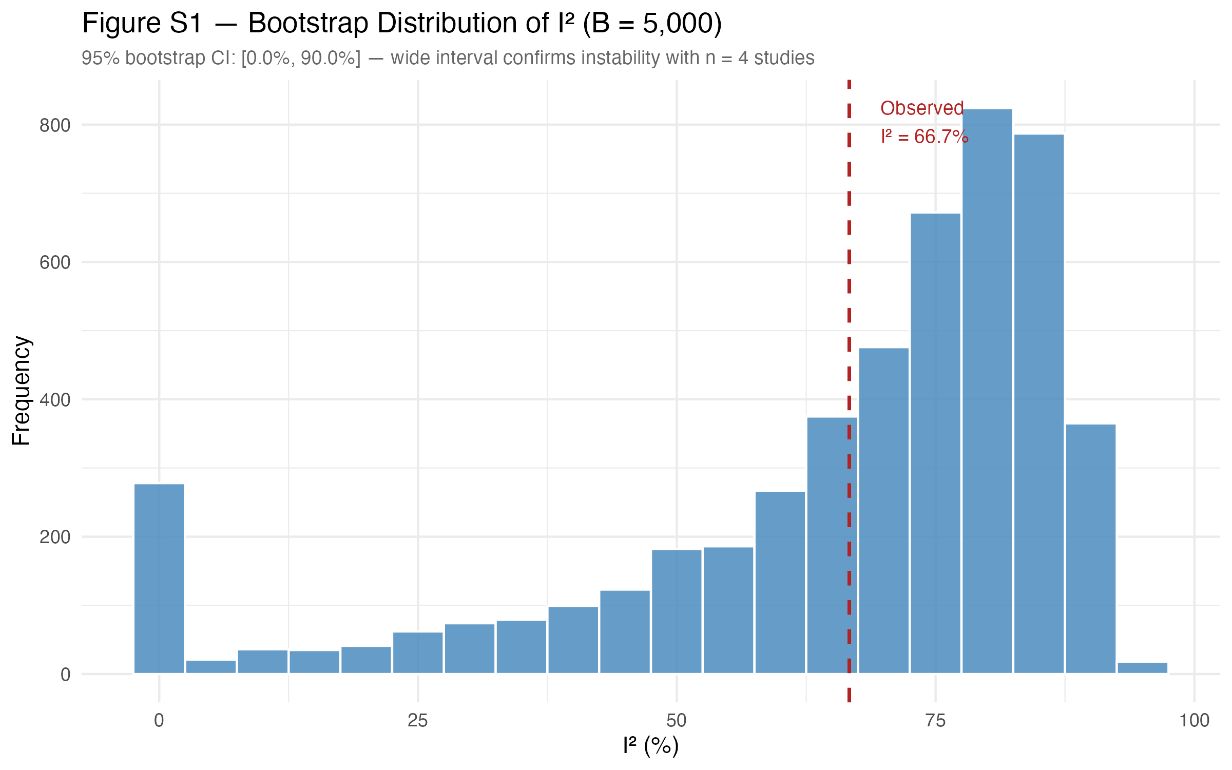
Distribution of I² values across 1,000 non-parametric bootstrap resamples of the k = 5 cohorts. Only the proportion of resamples for which I² is estimable is reported in the main text; the histogram is shown here for completeness.

S-Figure 2. Bootstrap pooled-proportion histogram.
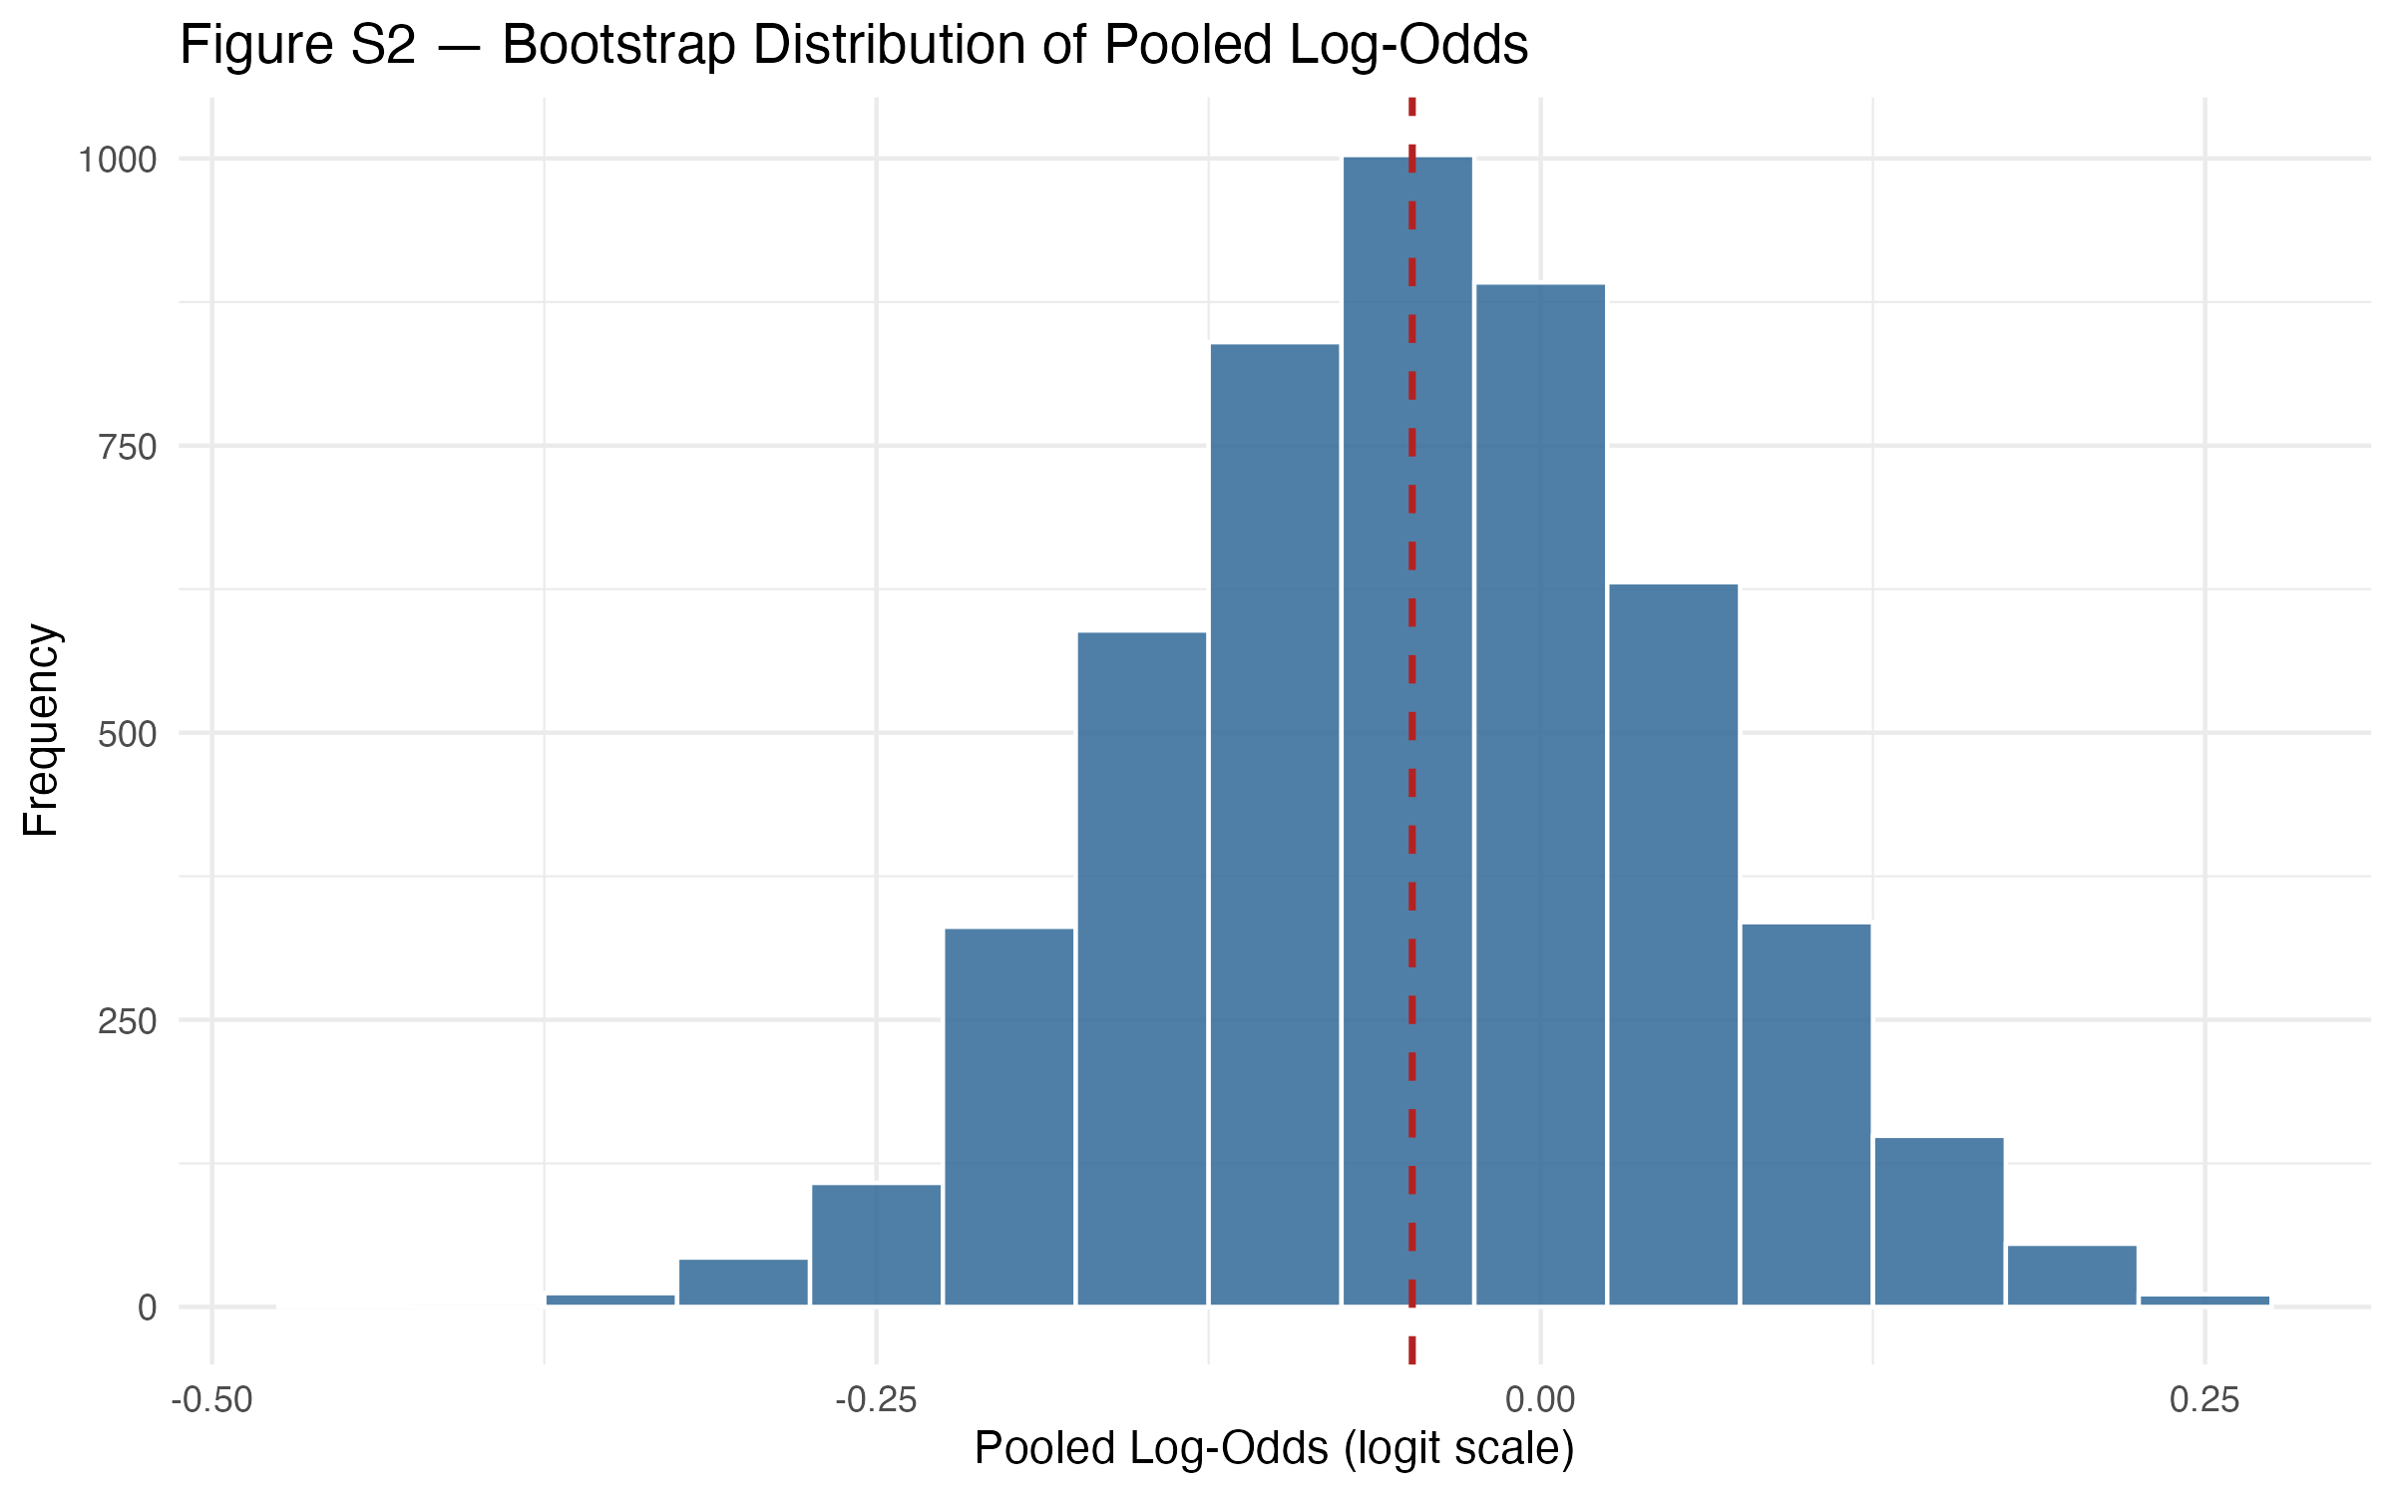
Distribution of the pooled GCB proportion across the same 1,000 bootstrap resamples.

S-Figure 3. LOO sensitivity of I² by detection method.
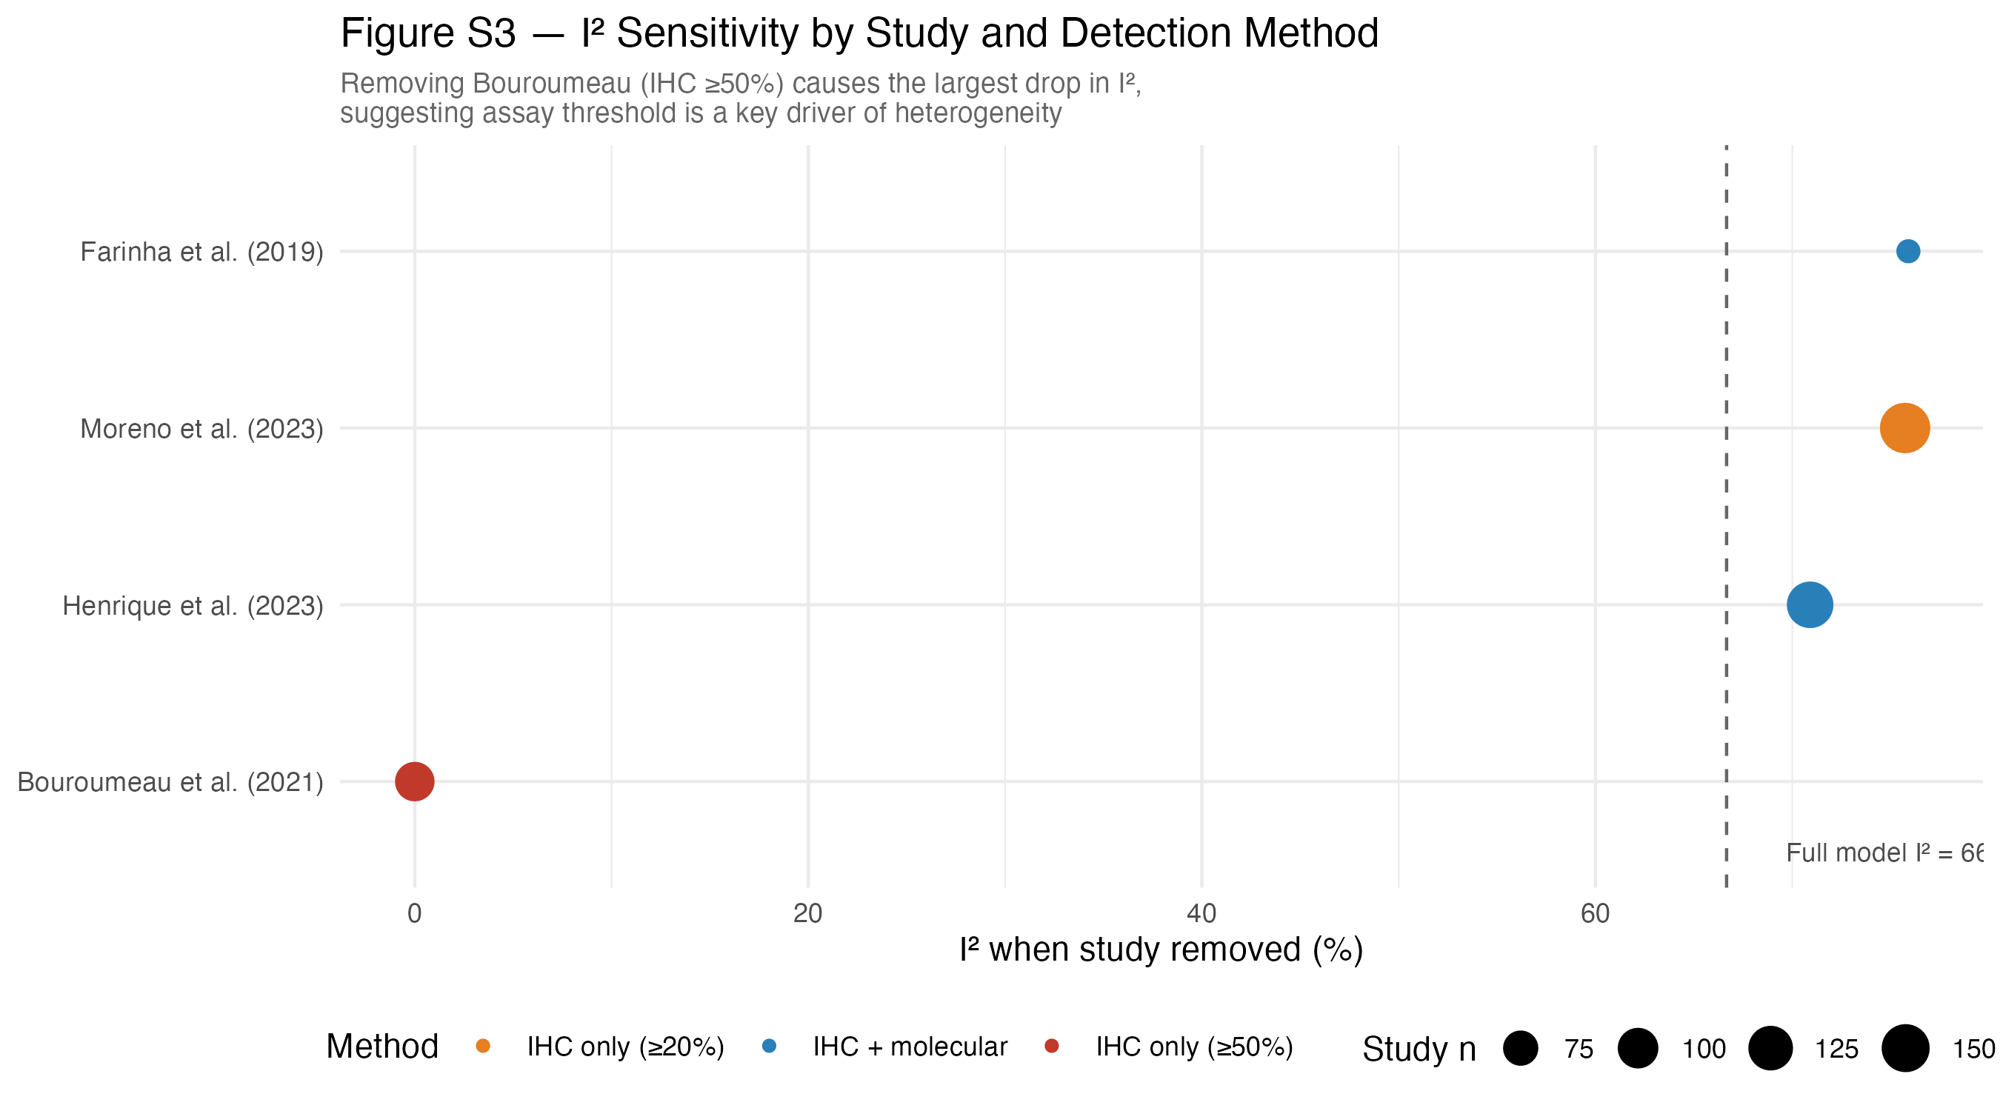
Leave-one-out (LOO) plot of I² when each cohort is removed in turn, stratified by TP53 detection method (IHC vs. sequencing).

S-Figure 4. IHC-threshold comparison.
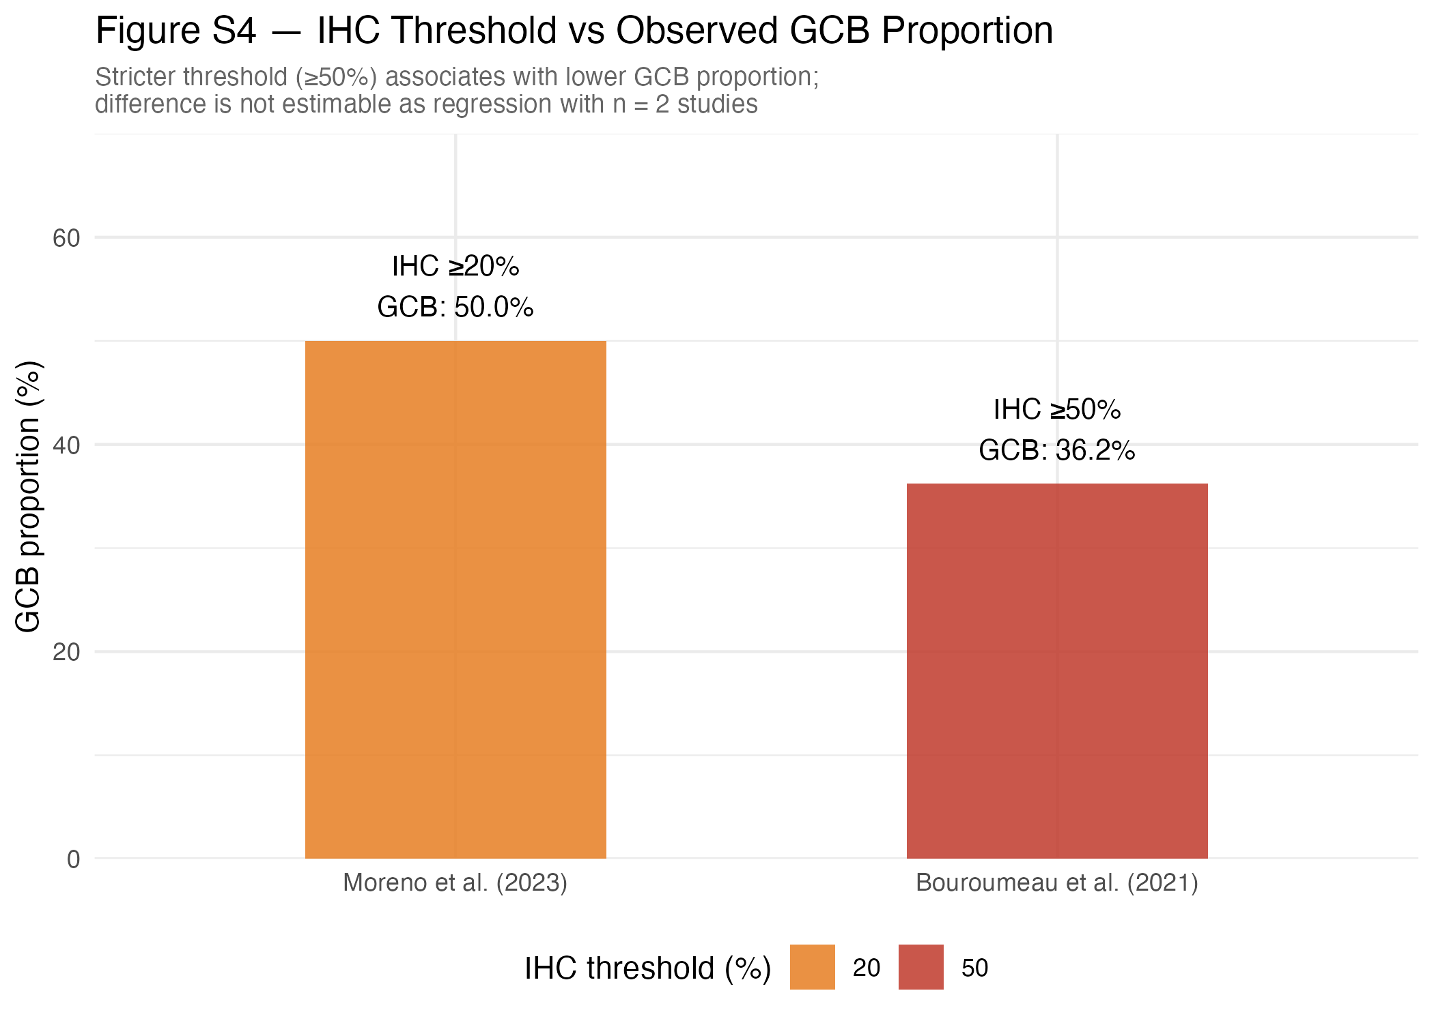
Observed GCB proportions per cohort plotted against the cohort's nominal TP53 IHC positivity threshold (≥10%, ≥20%, ≥50%).

S-Figure 5. Odds-ratio forest plot for the three full-2×2 cohorts (Henrique, Moreno, Jing).
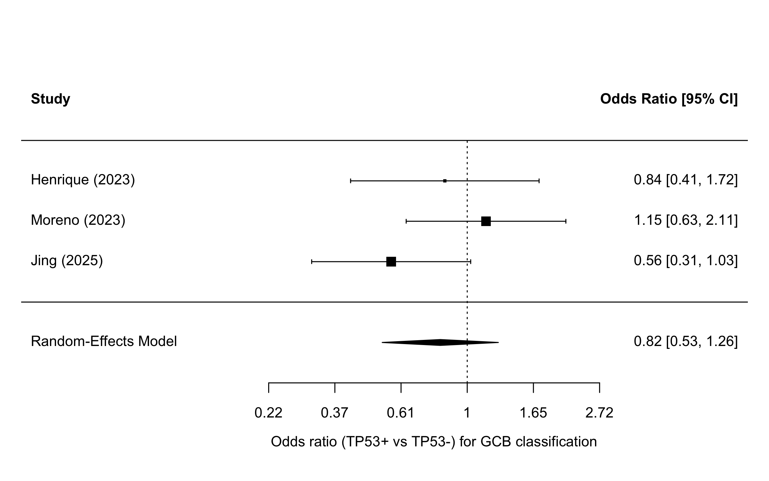
Random-effects pooled log-odds-ratio for the association between TP53 positivity and GCB classification (k = 3 cohorts for which the full 2×2 cross-tabulation is reported in the source paper).

Section S2. Supplementary Tables

S-Table 1. Full posterior-summary tables per prior on τ.
Posterior mean, SD, 2.5 / 50 / 97.5 percentiles, effective sample size (n_eff), and rank-normalized R̂ for each of the seven Bayesian parameters (μ, τ, p_overall, and the five study-specific p_i), across all four prior specifications on τ.
Prior_tau | Parameter | Mean | SD | Q2.5 | Q50 | Q97.5 | n_eff | Rhat
HalfCauchy_05 | mu | 0.009 | 0.166 | -0.346 | 0.013 | 0.339 | 1854 | 1.001
HalfCauchy_05 | tau | 0.272 | 0.195 | 0.023 | 0.236 | 0.737 | 1396 | 1.002
HalfCauchy_05 | p_overall | 0.502 | 0.041 | 0.414 | 0.503 | 0.584 | 1868 | 1.001
HalfCauchy_05 | p[1] | 0.43 | 0.055 | 0.317 | 0.432 | 0.525 | 2805 | 1.001
HalfCauchy_05 | p[2] | 0.535 | 0.035 | 0.472 | 0.534 | 0.607 | 6023 | 1
HalfCauchy_05 | p[3] | 0.525 | 0.035 | 0.458 | 0.523 | 0.599 | 7141 | 1
HalfCauchy_05 | p[4] | 0.502 | 0.032 | 0.437 | 0.503 | 0.565 | 8417 | 1.001
HalfCauchy_05 | p[5] | 0.524 | 0.033 | 0.463 | 0.522 | 0.592 | 7819 | 1
HalfCauchy_10 | mu | 0.005 | 0.18 | -0.379 | 0.012 | 0.359 | 1933 | 1.002
HalfCauchy_10 | tau | 0.322 | 0.231 | 0.024 | 0.278 | 0.908 | 1264 | 1.003
HalfCauchy_10 | p_overall | 0.501 | 0.044 | 0.406 | 0.503 | 0.589 | 1938 | 1.002
HalfCauchy_10 | p[1] | 0.422 | 0.056 | 0.314 | 0.422 | 0.524 | 2174 | 1.001
HalfCauchy_10 | p[2] | 0.538 | 0.036 | 0.471 | 0.536 | 0.611 | 5888 | 1
HalfCauchy_10 | p[3] | 0.527 | 0.036 | 0.46 | 0.526 | 0.599 | 6892 | 1
HalfCauchy_10 | p[4] | 0.502 | 0.033 | 0.436 | 0.502 | 0.565 | 9361 | 1
HalfCauchy_10 | p[5] | 0.525 | 0.034 | 0.461 | 0.524 | 0.594 | 6955 | 1
HalfNormal_1 | mu | 0.003 | 0.189 | -0.4 | 0.016 | 0.358 | 1122 | 1
HalfNormal_1 | tau | 0.317 | 0.226 | 0.021 | 0.274 | 0.913 | 1214 | 1.002
HalfNormal_1 | p_overall | 0.501 | 0.046 | 0.401 | 0.504 | 0.589 | 1145 | 1
HalfNormal_1 | p[1] | 0.422 | 0.057 | 0.312 | 0.422 | 0.525 | 2145 | 1
HalfNormal_1 | p[2] | 0.537 | 0.036 | 0.472 | 0.534 | 0.612 | 5918 | 1
HalfNormal_1 | p[3] | 0.527 | 0.036 | 0.459 | 0.525 | 0.602 | 6898 | 1
HalfNormal_1 | p[4] | 0.502 | 0.033 | 0.433 | 0.502 | 0.567 | 8646 | 1
HalfNormal_1 | p[5] | 0.524 | 0.033 | 0.461 | 0.523 | 0.591 | 7610 | 1
Exponential_1 | mu | 0.011 | 0.169 | -0.355 | 0.017 | 0.331 | 1883 | 1.004
Exponential_1 | tau | 0.29 | 0.212 | 0.018 | 0.25 | 0.802 | 1376 | 1.001
Exponential_1 | p_overall | 0.503 | 0.042 | 0.412 | 0.504 | 0.582 | 1888 | 1.004
Exponential_1 | p[1] | 0.426 | 0.057 | 0.315 | 0.428 | 0.527 | 2751 | 1
Exponential_1 | p[2] | 0.536 | 0.036 | 0.469 | 0.535 | 0.608 | 6277 | 1
Exponential_1 | p[3] | 0.526 | 0.036 | 0.458 | 0.525 | 0.601 | 7448 | 1
Exponential_1 | p[4] | 0.502 | 0.033 | 0.435 | 0.503 | 0.567 | 8998 | 1
Exponential_1 | p[5] | 0.524 | 0.033 | 0.463 | 0.523 | 0.592 | 6846 | 1.001

S-Table 2. JBI Prevalence Studies (k = 5 prevalence analysis) and QUIPS (k = 3 OR sub-analysis) risk-of-bias assessment.
Each NOS item from the main-manuscript risk-of-bias table is mapped to the corresponding item on the JBI Prevalence Studies Checklist (J1–J9) for the k = 5 prevalence analysis and to the six QUIPS domains (D1–D6) for the k = 3 odds-ratio sub-analysis. Cohorts that lost the NOS Follow-up star are scored Unclear (U) on JBI item 9 (response rate / non-response handling); all five cohorts meet items 1–8 by construction (peer-reviewed DLBCL cohorts reporting both TP53 status and GCB / non-GCB counts). JBI items: J1 sample frame; J2 sampling; J3 sample size; J4 subject/setting description; J5 coverage; J6 valid identification of condition; J7 standard measurement; J8 appropriate statistical analysis; J9 response rate.
JBI Prevalence Studies Checklist (k = 5):
Study | J1 | J2 | J3 | J4 | J5 | J6 | J7 | J8 | J9 | Yes-count | Overall
Bouroumeau (2021) | Y | Y | Y | Y | Y | Y | Y | Y | U | 8 | Low risk
Hu (2019) | Y | Y | Y | Y | Y | Y | Y | Y | Y | 9 | Low risk
Henrique (2023) | Y | Y | Y | Y | Y | Y | Y | Y | U | 8 | Low risk
Moreno (2023) | Y | Y | Y | Y | Y | Y | Y | Y | Y | 9 | Low risk
Jing (2025) | Y | Y | Y | Y | Y | Y | Y | Y | Y | 9 | Low risk
QUIPS domains: D1 study participation; D2 study attrition; D3 prognostic-factor measurement (TP53 IHC / sequencing); D4 outcome measurement (COO via Hans algorithm); D5 study confounding; D6 statistical analysis and reporting.
QUIPS risk-of-bias (k = 3 OR sub-analysis):
Study | D1 Participation | D2 Attrition | D3 Prognostic factor (TP53) | D4 Outcome (COO) | D5 Confounding | D6 Stats/Reporting | Overall
Henrique (2023) | Low | Moderate | Low | Low | Moderate | Low | Low–Moderate
Moreno (2023) | Low | Low | Low | Low | Moderate | Low | Low
Jing (2025) | Low | Low | Low | Low | Moderate | Low | Low

S-Table 3. PRISMA-2020 excluded-studies-with-reasons list.
Records considered at title/abstract or full-text stage of the PRISMA-2020 screening flow that were excluded, together with the documented reason for exclusion. The list includes, at minimum, the records named in the main text.
Excluded study | Year | Stage of exclusion | Reason for exclusion
Xu-Monette et al. | 2012 | Full-text | Out-of-window (pre-2018 cutoff).
Landsburg et al. | 2023 | Full-text | Cohort lacked GCB / non-GCB classification (DLBCL not stratified by cell-of-origin).
Sang et al. | 2021 | Title/abstract | ASH conference abstract; full TP53 × COO joint table not reported in any associated publication.
Li et al. | 2023 | Full-text | TP53 status not reported (cohort characterized by MYC/BCL2 only).
Qin et al. | 2022 | Full-text | No GCB / non-GCB subgroup tabulation; pooled DLBCL only.
Song et al. | 2021 | Full-text | TP53 ↔ COO joint table not reported; only marginal frequencies shown.
Farinha et al. | 2019 | Full-text | ASH conference abstract; full joint TP53 × COO table not available in any peer-reviewed publication (excluded from the present revision; previously included in v1).

Section S3. Stan model code (all four prior variants)
Two reference Stan source files are provided. The four prior variants on τ reported in the main text — Half-Cauchy(0, 0.5) [primary], Half-Cauchy(0, 1.0), Half-Normal(0, 1), and Exponential(1) — are obtained from the same canonical binomial-logit hierarchical template by changing only the τ prior line; the remaining model code (likelihood, non-centered parameterization, generated quantities for posterior predictive replicates) is identical across variants.
PD-L1.stan — canonical hierarchical model with weakly informative Half-Cauchy(0, 0.5) prior on the between-study heterogeneity scale (the primary specification in the main text):
data {
int<lower=1> N; // number of studies
int<lower=0> y[N]; // number of GCB cases
int<lower=0> n[N]; // total cases
}

parameters {
real<lower=0, upper=1> pi; // true underlying prevalence
real mu_logit; // logit of mean detection rate
real<lower=0> phi; // precision (heterogeneity)
vector[N] z; // standard normal for non-centered DR
}

transformed parameters {
real<lower=0, upper=1> mu;
vector<lower=0, upper=1>[N] DR; // study-specific detection rates
vector<lower=0, upper=1>[N] p; // observed prevalence

mu = inv_logit(mu_logit);

for (i in 1:N) {
real alpha = mu * phi;
real beta = (1 - mu) * phi;
real mean = alpha / (alpha + beta);
real beta_var = (alpha * beta) / ((alpha + beta)^2 * (alpha + beta + 1));

// non-centered reparameterization of beta distribution
real sd = sqrt(beta_var);
real raw = mean + sd * z[i];
DR[i] = fmin(fmax(raw, 1e-6), 1 - 1e-6); // constrain to (0,1)
p[i] = pi * DR[i];
}
}

model {
// Priors
pi ~ beta(2, 2);
mu_logit ~ normal(0, 1);
phi ~ normal(2, 1); // weakly informative, positive-only

z ~ normal(0, 1); // non-centered

// Likelihood
y ~ binomial(n, p);
}

generated quantities {
int y_rep[N];
for (i in 1:N) {
y_rep[i] = binomial_rng(n[i], p[i]);
}
}
PD-L1-uniform.stan — alternative parameterization with a Uniform(0, 1) prior on the underlying prevalence π and the same non-centered binomial-logit likelihood. Used in conjunction with the Half-Normal(0, 1) and Exponential(1) τ priors as a sensitivity check on the marginal prior on the pooled rate.
data {
int<lower=1> N; // number of studies
int<lower=0> y[N]; // number of GCB cases
int<lower=0> n[N]; // total cases
}

parameters {
real<lower=0, upper=1> pi; // true underlying prevalence
real mu_logit; // logit of mean detection rate
real<lower=0> phi; // precision (heterogeneity)
vector[N] z; // standard normal for non-centered DR
}

transformed parameters {
real<lower=0, upper=1> mu;
vector<lower=0, upper=1>[N] DR; // study-specific detection rates
vector<lower=0, upper=1>[N] p; // observed prevalence

mu = inv_logit(mu_logit);

for (i in 1:N) {
real alpha = mu * phi;
real beta = (1 - mu) * phi;
real beta_mean = alpha / (alpha + beta);
real beta_var = (alpha * beta) / ((alpha + beta)^2 * (alpha + beta + 1));

// non-centered reparameterization
real sd = sqrt(beta_var);
real raw = beta_mean + sd * z[i];
DR[i] = fmin(fmax(raw, 1e-6), 1 - 1e-6); // keep in (0,1)
p[i] = pi * DR[i];
}
}

model {
// PRIOR: Uniform for pi
pi ~ beta(1, 1); // Uniform(0,1)

mu_logit ~ normal(0, 1); // Prior for detection mean (logit scale)
phi ~ normal(2, 1); // Prior for detection precision

z ~ normal(0, 1); // Non-centered standard normal

// Likelihood
y ~ binomial(n, p);
}

generated quantities {
int y_rep[N];
for (i in 1:N)
y_rep[i] = binomial_rng(n[i], p[i]);
}

