Selectively Demarcating and Modifying Defects
in Two-Dimensional Semiconductors in a 300 mm Fab
Supplementary Information
Figure | Description
S1 | Schematic and SEM image of as-grown polycrystalline (PC) MoS2
S2 | Photograph of 12” carrier wafer used to process 2” sapphire substrates with deposited MoS2
S3 | SEMs of MoS₂ after annealing in Ar and Ar/H₂
S4 | Additional thermodynamic calculations for the reaction of MoS₂ with Cl2 or H2
S5 | SEMs of single-crystalline (SC) MoS₂ annealed with Cl2 at different temperatures
S6 | SEMs of SC MoS₂ annealed with Cl2 at 500°C at different times and Cl2 doses
S7 | SEMs of PC MoS₂ anneal with Cl2 at different temperatures
S8 | Etch fraction for SC and PC monolayer and bilayer islands (BI) as a function of temperature
S9 | Time dependence of SC monolayer and BI etch
S10 | Schematic of proposed reaction mechanism for BI etching
S11 | Schematic of proposed reaction mechanism for SC monolayer etching
S12 | Schematic of proposed reaction mechanism for PC monolayer etching
S13 | Correlations between A₁' and E' FWHM with local strain and charge doping
S14 | Cryo-PL spectra of as-grown and Ar-annealed MoS₂
S15 | XPS spectra and analysis for MoS₂ after different Cl₂ treatments
S16 | A⁻ PL peak position and width as a function of treatment temperature
S17 | Cyro-PL spectra and analysis for MoS₂ treated at different times and Cl₂ doses
S18 | Additional thermodynamic calculations for the reaction between Cl₂ with MoS₂, H₂ or H₂S
S19 | SEMs of SC-MoS₂ treated at 500°C with differing H₂/Cl₂ ratios
S20 | SEMs of SC-MoS₂ treated at 500°C with differing H₂S/Cl₂ ratios
S21 | SEMs of SC-MoS₂ treated H₂S/Cl₂=1.25 at different temperatures
S22 | Additional Raman analysis for MoS2 treated with H₂S/Cl₂
S23 | Trion-binding energies and A⁰ and A⁻ peak widths for H₂S/Cl₂-treated MoS2
S24 | Schematic of transistor device structure
S25 | Transport characteristics for SC-MoS2 treated with Cl₂ and H₂S/Cl₂
S26 | Resistor schematic to describe changes in transport properties after Cl₂ and H₂S/Cl₂ treatment

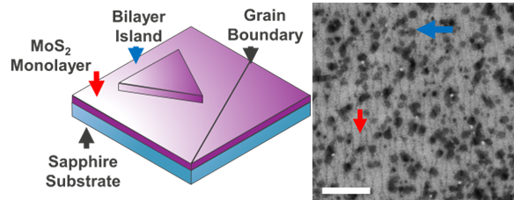
Sup. Fig. S1: Schematic and SEM micrograph of as-grown polycrystalline (PC) MoS₂ with monolayer and bilayer islands (BI) indicated by red and blue arrows, respectively. Scale bar: 1 μm
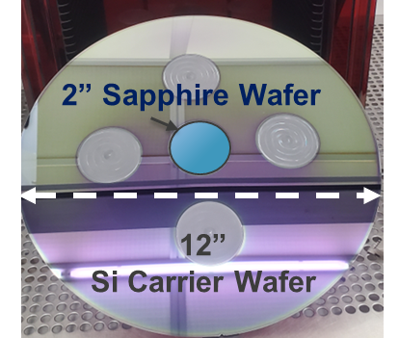
Sup. Fig. S2: Photograph of 12” Si/SiO2 carrier wafer used to process 2” sapphire wafers with deposited MoS₂.

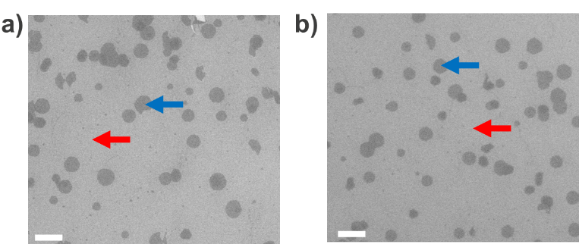
Sup. Fig. S3: Representative SEM micrographs of MoS₂ annealed for 10 minutes at 500°C under a) Ar only and b) 0.24% H₂ in Ar show no notice etching of BIs. Scale bar: 1 μm
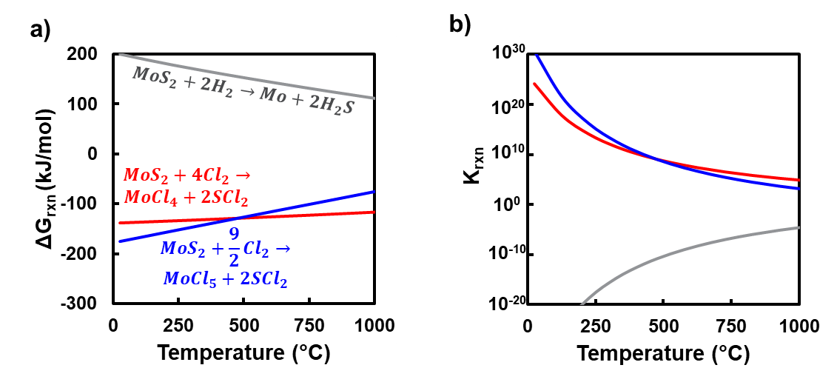
Sup. Fig. S4: Thermodynamic calculation of the ${∆G}_{rxn}$ and $K_{rxn}$ for different reactions of MoS₂ with Cl₂ and H₂ show that the reaction with Cl₂ is favorable while the reaction with H₂ is not.

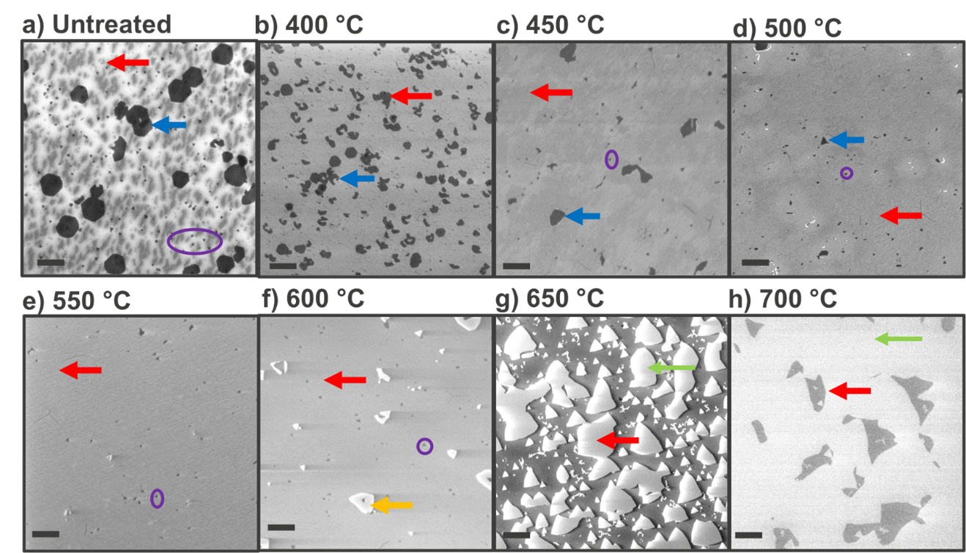
Sup. Fig. S5: Representative SEM micrographs of single-crystalline (SC) MoS₂ a) prior to treated and b-h) after treated in in 0.08% Cl₂ for 10 minutes at 400-700°C. The BI are selectively etched at 550°C and below (b-e), while the monolayer displays visible signs of etching when treated above 600°C (f-h). Red, blue, green and orange arrows indicate monolayer, bilayer islands, exposed sapphire, and etching residue (likely MoCl_{x}), respectively, while embedded bilayers located between the monolayer and the sapphire are highlighted in orange. Scale bar: 1 μm
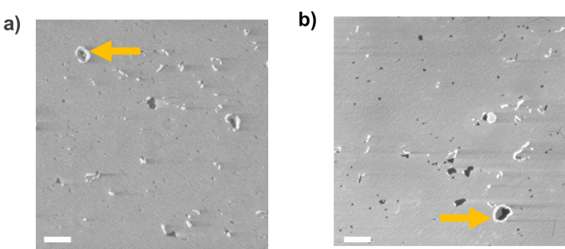
Sup. Fig. S6: Representative SEM micrographs of SC-MoS₂ after treatment at 500°C for a) 30 minutes with 0.08% Cl₂ and b) 10 minutes with 0.24% Cl₂ show no noticeable signs of etching but do display residues (again likely MoCl_{x}). Scale bar: 1 μm
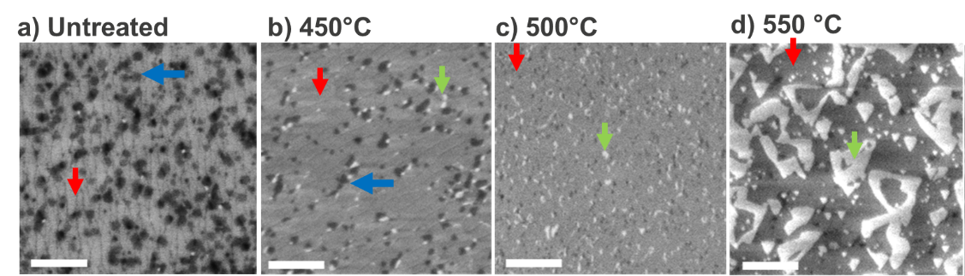
Sup. Fig. S7: Representative SEM micrographs of PC-MoS₂ a) prior to treated and b-h) after treated in 0.08% Cl₂ for 10 minutes at 450-550°C (b-d). While all treated PC samples show etch pits, samples treated above 500°C contain linear etch pits that demarcate grain boundaries. Scale bar: 500 nm.

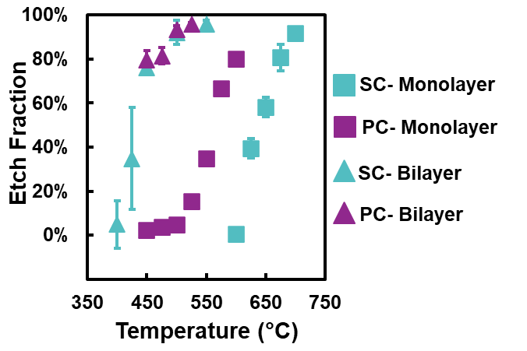
Sup. Fig. S8: Etching of SC monolayers (cyan square) sharply increases above 600°C, while PC monolayers display slight etching above 450°C and significant etching above 500°C as GBs are attacked. In contrast, the temperature dependence of both SC and PC BI (cyan and purple triangles) is identical.

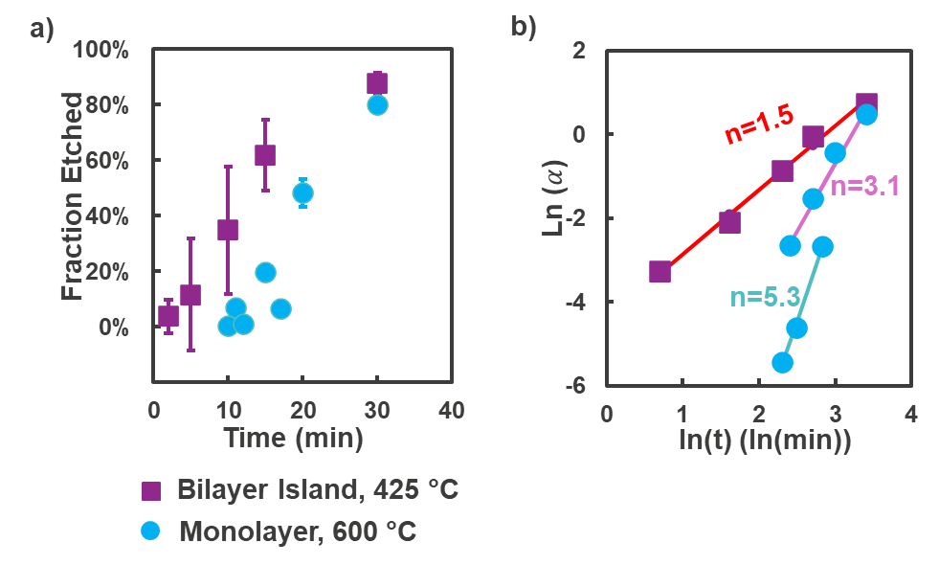
Sup. Fig. S9: Time splits were conducted at 425°C and 600°C to observe the evolution of the bilayer island and monolayer etch, respectively. The etched fraction of bilayer island steadily increases with time (a, purple). In contrast, the monolayer etch fraction (a, blue) is non-monotonic with time when treated at 600°C, which suggests that some other factor is involved. Importantly, since etch pits can only form in unetched MoS₂, the instantaneous etch rate will decline with time. This effect can be accounted for, by analogy to the extended volume used in transformation reaction kinetics ^{1–3}, by defining an extended etch fraction $α$ which, at time t and temperature T is equal to (Eqn S1):
$$\begin{aligned}α\left(t,T\right)=-\ln\left(Y_{R}\left(t,T\right)\right)=-\ln\left(1-Y_{E}\left(t,T\right)\right) \#\left(S1\right)\end{aligned}$$
where Y_{r} is the fraction remaining, Y_{e} is the fraction etched. In the Avrami model^{1–3} (Eqn S2), the extended volume $α$ follows a power-law-based time-dependence
$$\begin{aligned}α=kt^{n} \#\left(S2\right)\end{aligned}$$
where n is the dimensionality and k(T) is the rate constant at temperature T. This model can be linearized (Eqn S3)
$$\begin{aligned}\ln\left(-\ln\left(Y_{R}\left(t,T\right)\right)\right)=\ln\left(α\right)=\ln\left(k\left(T\right)\right)+n\ln\left(t\right)\#\left(S3\right)\end{aligned}$$
to enable Avrami plots of the transformation (b). The bilayer island etching reaction fits well with a dimensionality of n=1.5 (R²=0.99). In contrast, the ML etch appears to follow two distinct trends, with the top pink data having n = 3.2 (R²=0.97) and the bottom cyan trend having n=5.3 (R²=1.0). Apart from 1 data point, the two trends correspond to two separate experimental runs conducted with two distinct batches of MoS₂ grown during two separate time periods with tool maintenance occurring in the interim. This further supports the hypothesis that the monolayer etch rate at 600°C is impacted by some material property, such as defect density.
If the rate constant is assumed to follow an Arrhenius relation (Eqn S4):
$$\begin{aligned}k=k_{0}e^{\frac{-E_{A}}{RT}} \#\left(S4\right)\end{aligned}$$
where E_{A} is the activation energy, R is the gas constant, and k₀ is the pre-exponential factor, the fraction etched at a given temperature and time has the following temperature dependence (Eqn S5):
$$\begin{aligned}\ln\left(α\left(t,T\right)\right)=-\frac{E_{A}}{R}\frac{1}{T}+n\ln\left(t\right)+\ln\left(k_{0}\right)\#\left(S5\right)\end{aligned}$$
If time is held constant, this simplifies to (Eqn S6):
$$\begin{aligned}\ln\left(α\left(t,T\right)\right)=-\frac{E_{A}}{R}\frac{1}{T}+b \#\left(S6\right)\end{aligned}$$
Where the fitting constant b is defined as (Eqn S7):
$$\begin{aligned}b=n\ln\left(t\right)+\ln\left(k_{0}\right)\#\left(S7\right)\end{aligned}$$
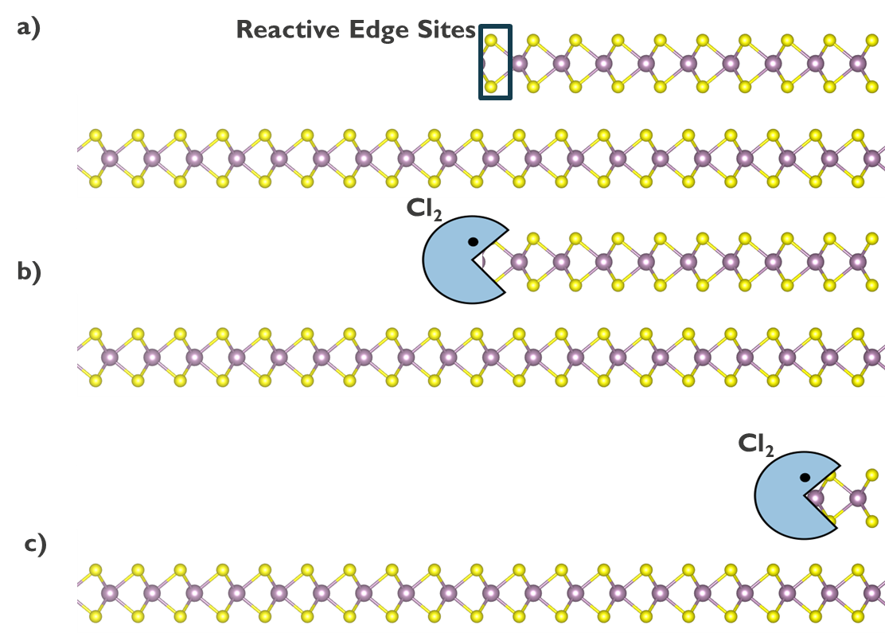
Sup. Fig. S10: Proposed mechanism for etching of a) bi-layer islands with exposed edges that b) Cl₂ can attack, resulting in c) lateral etching into the bilayer island
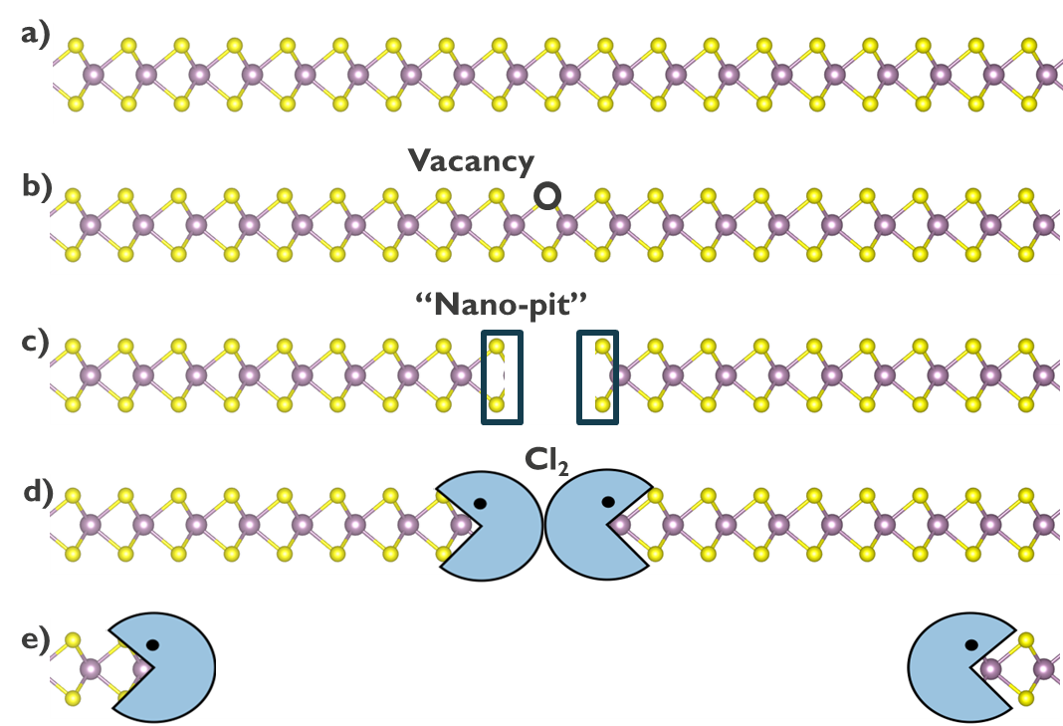
Sup. Fig. S11: Proposed mechanism for etching of a) single-crystalline monolayers via the formation of b) vacancies and c) “nano-pits” with exposed edges that facilitates the lateral in-plane etch by Cl₂ (d,e)
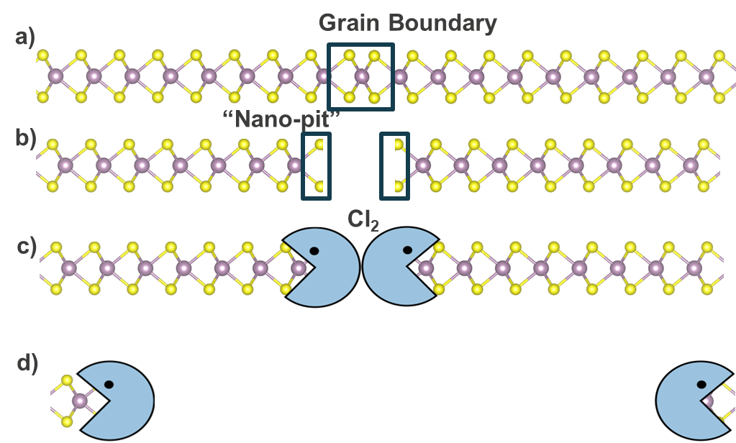
Sup. Fig. S12: Proposed mechanism for etching of a) polycrystalline monolayer with grain boundaries where the formation of b) “nano-pits” with exposed edges enables the lateral etch (c, d)
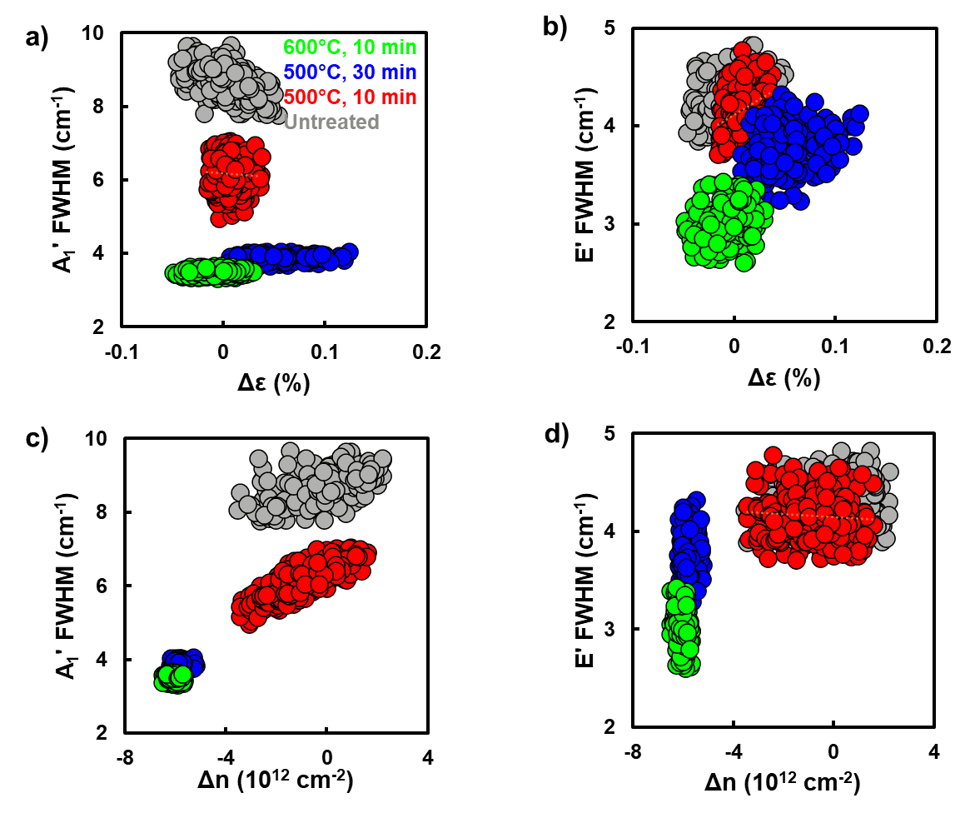
Sup. Fig. S13: The FWHM of neither the a) A₁' or b) E' mode displayed a significant correlation with the local strain. However, the A₁' FWHM is strongly correlated with decreased n-type doping (c) for the three smoothened films (red, blue, and green). As the FWHM of the A₁' mode increases with defect concentration^{4,5}, this correlation is strong evidence that PDs are being healed/passivated during the treatment. Furthermore, for the 500°C, 10 minute sample (red), the FWHM and doping concentration are linearly correlated with a slope of 0.33 cm⁻¹ / (10¹³ e⁻ cm⁻²) (R²=0.67). In contrast, the ~2.5 cm⁻¹ reduction in the A₁' FWHM observed between the untreated (grey) and 500°C, 10 min (red) sample is not correlated with any significant change in doping. However, the untreated film had ~13% bilayer coverage, which likely serves as scattering sites for the phonons.
The phonon peak width can be (to first approximation) modelled with Matthiessen’s rule⁵ where, at some temperature T and defect density n, the total FWHM $Γ_{tot}$ is equal to the sum over all scattering effects, namely:
$$\begin{aligned}Γ_{tot}\left(T,n\right)= Γ_{in}\left(T\right)+Γ_{e-p}\left(T,n\right)+Γ_{d-p}\left(T,n\right)+Γ_{BI}\left(T,n\right) \#\left(4.15\right)\end{aligned}$$
Where $Γ_{in}(T)$ is the intrinsic FWHM of a perfect crystal, $Γ_{e-p}$ is the contribution due to electron-phonon scattering, $Γ_{d-p}$ the contribution due to direct defect-phonon scattering and $Γ_{BI}$ is the bilayer scattering contribution. (In principle, there should also be a strain-contribution. However, as seen in a and b, the total FWHM for neither mode is correlated with strain, and thus the strain contribution can be ignored.) As these maps were taken at a constant room temperature, $Γ_{in}(T)$ is constant for all spectra and samples. Thus, any difference in the total FWHM (whether it be between two different samples or two points on a single sample) is equal to the sum of the change in the electron-phonon, defect-phonon, and bilayer island contributions:
$$\begin{aligned}ΔΓ_{tot}= ΔΓ_{e-p}+ΔΓ_{d-p}+ΔΓ_{BI} \#\left(4.16\right)\end{aligned}$$
When comparing the untreated and 500°C, 10 minute sample (grey and red), the doping does not significantly change and thus ${ΔΓ}_{e-p}$ and $ΔΓ_{d-p}$are likely negligible. However, the untreated sample has ~13-15% bilayer island coverage, which the smoothed sample lacks. As a result, the change in FWHM can be thus attributed to ${ΔΓ}_{BI}$ can be estimated to be ~2.5 cm⁻¹ based on the sample averages.
For the standard smoothened film, variations in the defect density can cause variations in FWHM via direct scattering between defects and phonons ($ΔΓ_{d-p})$ or indirectly by modulating the carrier concentration and thus the scattering between electrons and phonons ($ΔΓ_{e-p}$). Previously, Chakraborty et al⁶ observed that, in gate-dependent measurements, the A₁’ FWHM increased from 6 to 12 cm⁻¹ when the carrier concentration was increased by 1.8x10¹³ cm⁻², a change of 0.33 cm⁻¹/ 10¹² cm⁻². As these devices do not modify the defect concentration, such changes can only be attributable to $ΔΓ_{e-p}$. This slope matches the observed slope for the standard smoothened sample. For this to occur, any variation in $Γ$ with the sample must be primarily attributable to $ΔΓ_{e-p}$. Importantly, as the matrix method derived by Chae et al⁷ is calibrated based on the measurements from Chakraborty et al⁶, this analysis is valid even if the extracted carrier concentrations are incorrect. Extrapolating this linear trend accounts for ~1.6 cm⁻¹ of the decrease in FWHM when the time or temperature is increased to 30 min or 600°C, respectively. The remaining decrease in the FWHM for the extended time and temperature samples is thus mostly likely attributable to direct phonon-defect interactions $ΔΓ_{d-p}$. Thus, for the ~ 5 cm⁻¹ decrease in the A₁' FWHM observed, removal of bilayer constitutes approximately half of the reduction, while the difference within smoothened films is mostly attributable to the removal of charge carriers.

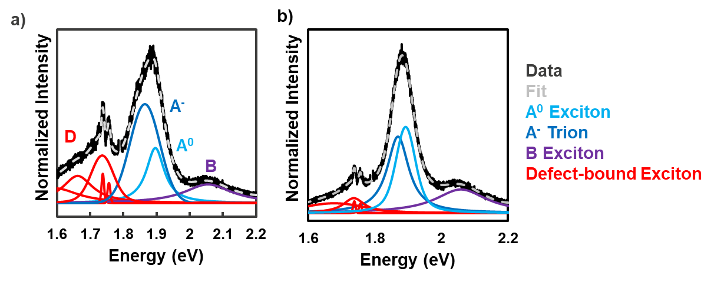
Sup. Fig. 14: Representative cryogenic photoluminescence (PL) spectra for SC-MoS₂ a) without treatment and b) after annealing for 10 min at 500°C under Ar only. Importantly, neither samples displays the peak at ~1.8 eV that is strongly present in the Cl2 samples. As such, that peak is likely a Cl₂-assisted defect peak.

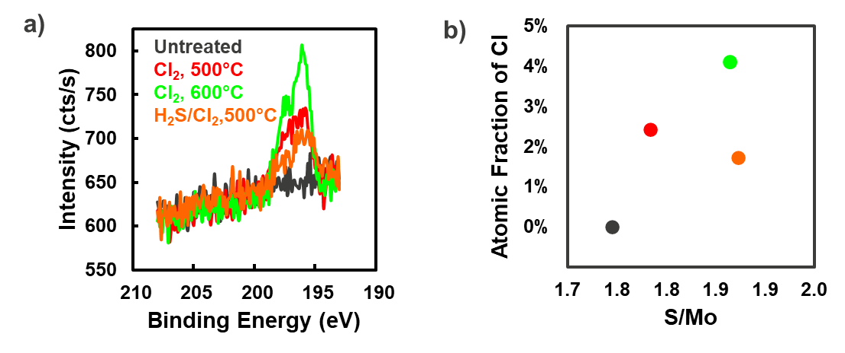
Sup. Fig. S15: The Cl 2p X-ray photoelectron peak a) is not present in untreated MoS₂ but is present in the samples treated for 10 minutes. Moreover, the atomic fraction of Cl b) increases with treatment temperature and decreases with co-injection of H₂S, matching the trends in the D_{Cl}/A_{tot} ratio from the PL spectra.
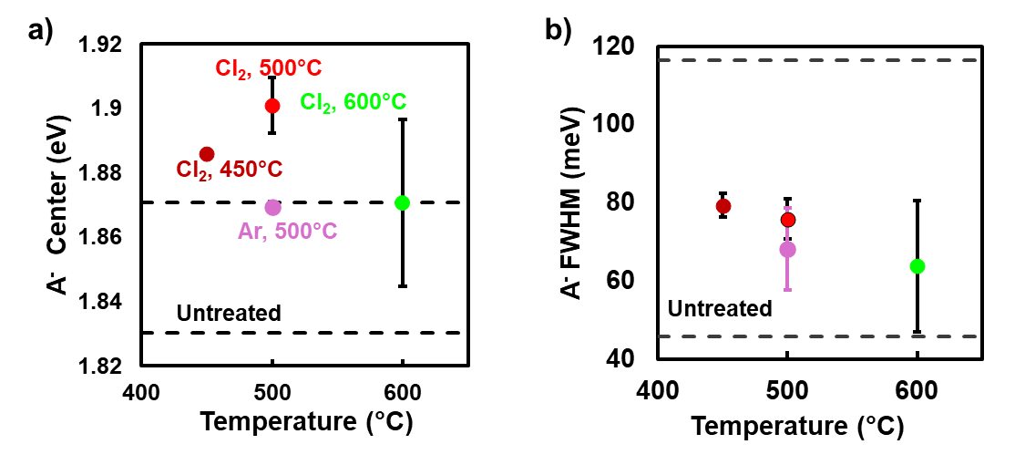
Sup. Fig. S16: After treating Cl₂, the A⁻ peak blueshifts (a) but has limited impact on the FWHM (b)
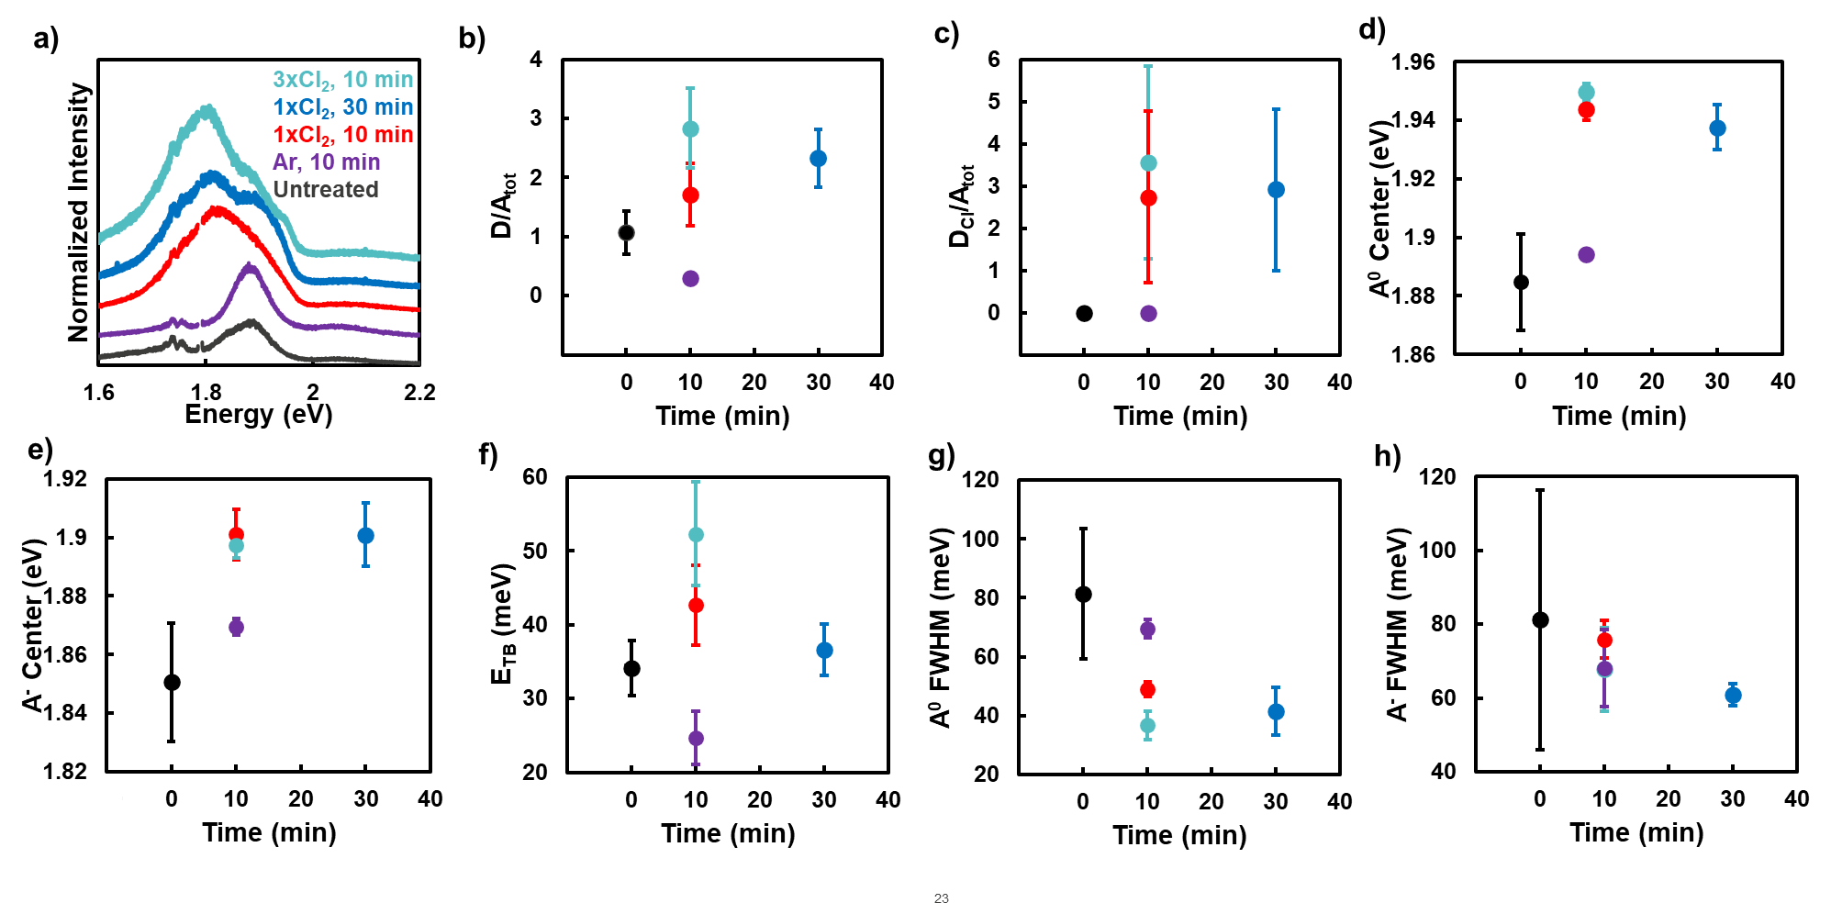
Sup. Fig. S17: According the a) Cryo-PL spectra of SC-MoS2 treated at 500°C for different time and Cl2 doses, the b) D/A_{tot} increases with time and Cl₂ dose, while the c) D_{Cl}/A_{tot} ratio remains relatively constant, indicating increased defectivity but minimal changes in Cl incorporation. Furthermore, both the A⁰ and A⁻ peaks blueshift (d,e), and E_{TB} increases (f). Finally, the A⁰ and A⁻ FWHM generally decrease with increased time or Cl₂ dose (g,h).

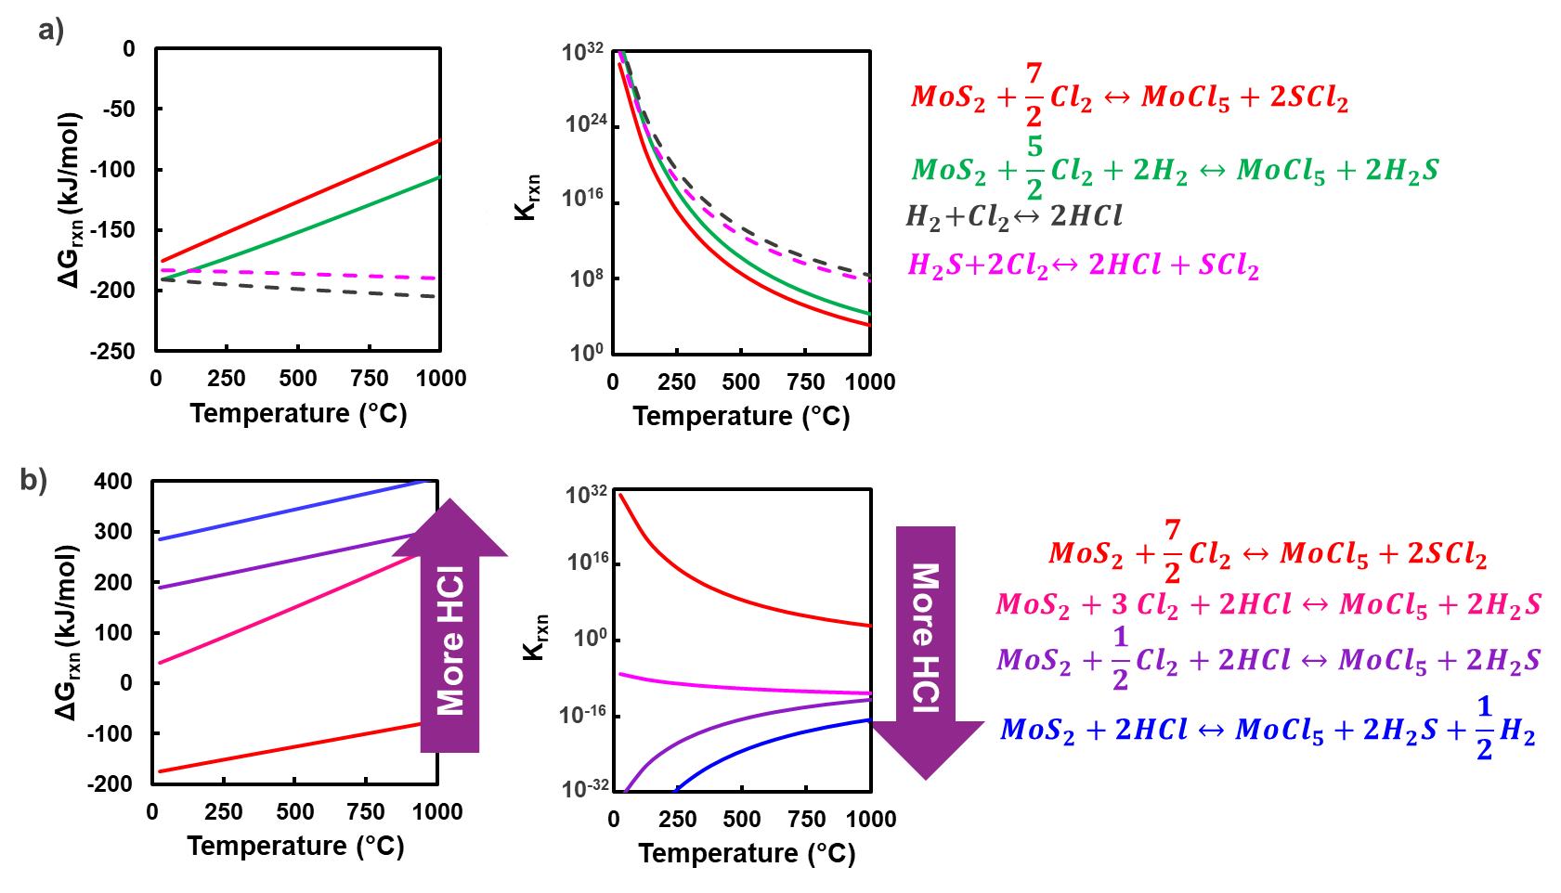
Sup. Fig. 18: a) Thermodynamic calculations of the change in Gibbs free energy (ΔG_{rxn}) and equilibrium constant (K_{rxn}) show that the gas phase reactions (dashed lines) between H₂ and Cl₂ and between H₂S and Cl₂ are more favored than the etching reactions for MoS2 (solid lines). Furthermore, as the HCl content increases (b, increasing blue) the favorability of the MoS₂ etching reaction decreases.
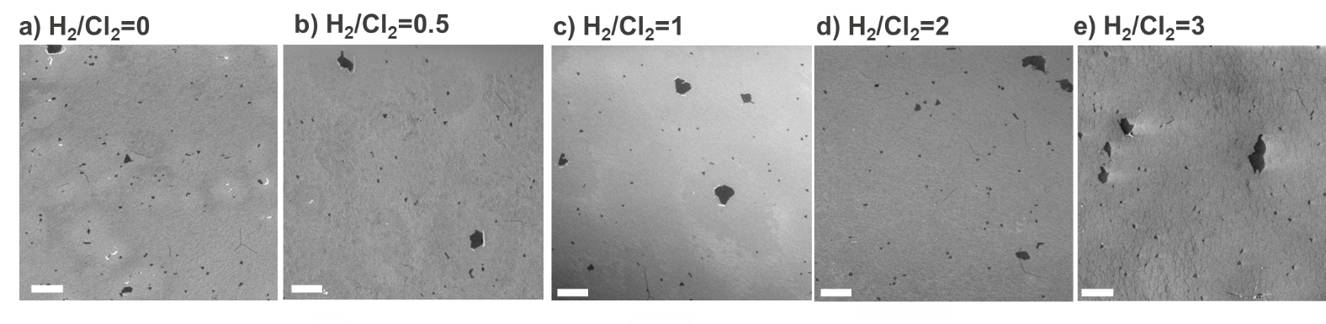
Sup. Fig. 19: Representative SEM micrographs of SC-MoS₂ treated at 500°C for 10 minutes in 0.08% Cl₂ with differing H₂/Cl₂ ratios show slight suppression of the BI etch as the H2/Cl2 ratio is increased. Scale bar: 1 μm
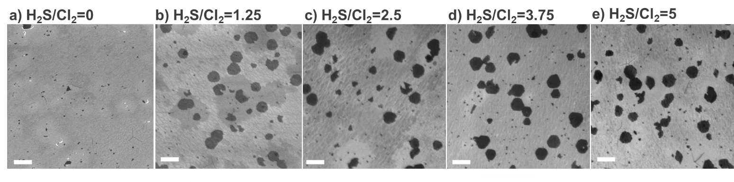
Sup. Fig. 20: Representative SEM micrographs of SC-MoS₂ treated at 500°C for 10 minutes in 0.08% Cl2 with differing H₂S/Cl₂ ratios show significant suppression of the BI etch as the H2S/Cl2 ratio is increased. Scale bar: 1 μm
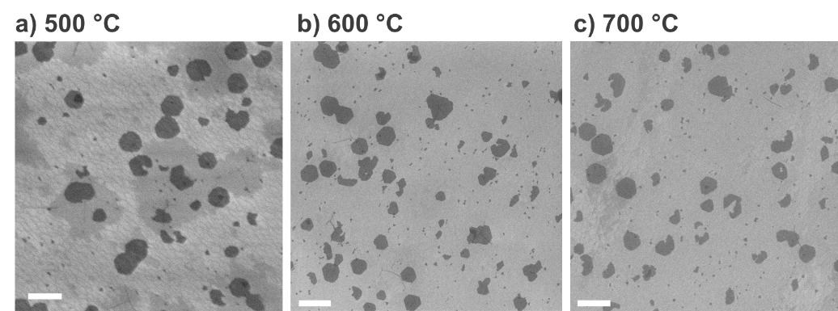
Sup. Fig. 21: Representative SEM micrographs of SC-MoS₂ treated at 500-700°C for 10 minutes in 0.08% Cl₂ with H₂S/Cl₂=1.25 show BI etch suppression, even at conditions that significantly etch the monolayer when no H2S is co-injected (Sup. Fig. 4h). Scale bar: 1 μm

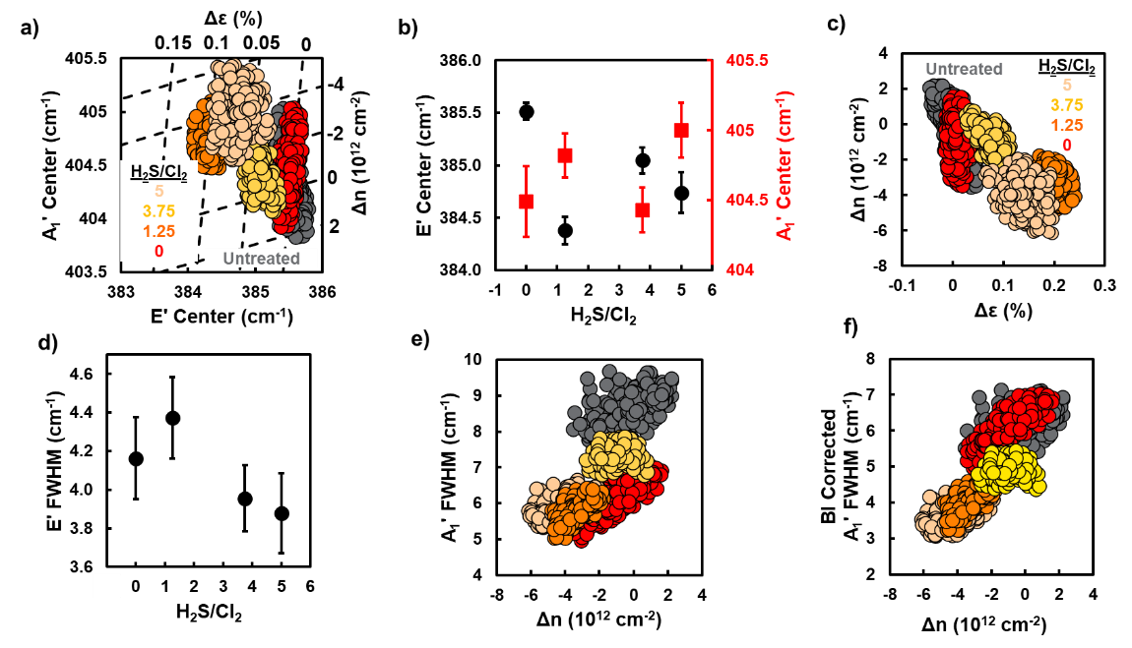
E'
A₁'
BI corrected A₁'
Sup. Fig. 22: According to the Raman maps (a), the E' (b, black) mode generally redshifts with co-injection of H2S while the A₁' (b, red) modes generally blueshifts. This corresponds to a generally increased tensile strain and reduced n-type doping that are correlated (d) with a slope of -1.9x10¹³ cm⁻²/% (R²=0.63). Furthermore, the E' FWHM (e, black) is relatively independent of co-injection. Finally, the A₁' FWHM generally decreases with decreasing n-type doping (e). However, as shown in Fig. 3d and Sup. Fig. 11a and c, the presence of BIs increase the A₁'FWHM by ~2.5 cm⁻¹. Given that co-injection suppresses BI etching, this effect should be accounted for. To correct for this, the FWHM without bilayers will be crudely approximated as
$$Γ_{A}^{*}=Γ_{A, measured}-f_{BI,rem}ΔΓ_{BI}$$
Where $Γ_{A, measured}$ is the measured FWHM, and $f_{BI,rem}$ is the fraction of remaining bilayers. Once this correction is applied, the A₁' FWHM is correlated with the change in n-type doping (f) with a slope of ~0.5 cm⁻¹/(10¹² cm⁻²) (R²=0.71). This is slightly higher than the ~0.33 cm⁻¹/(10¹² cm⁻²) trend measured on gate-dependent measurements⁶, which, as discussed for Sup. Fig. S13, strongly indicates that both direct defect-phonon scattering and electron-phonon scattering are being modified.
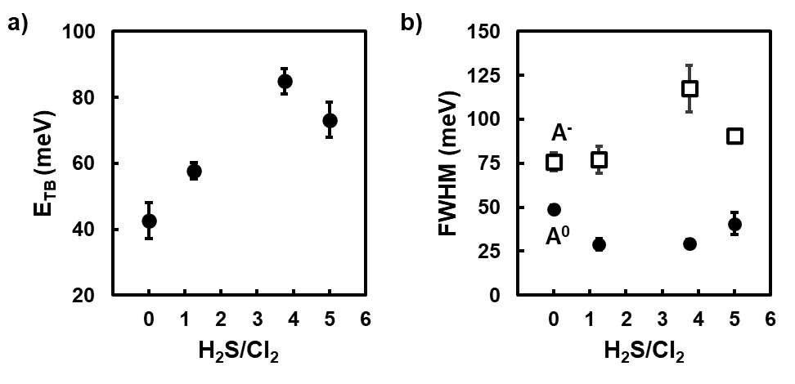
Sup. Fig S23: As the H₂S/Cl₂ ratio increases, the trion-binding energy (E_{TB}, a) generally increases. Additionally, the A⁰ FWHM (b, black circles) generally decreases with H₂S co-injection, while the A⁻ FWHM (b, hallow squares) increases.
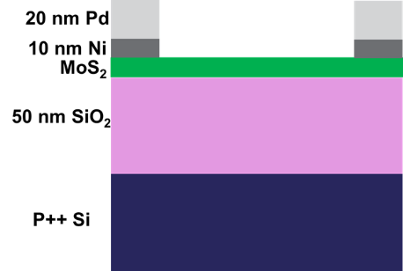
Sup. Fig S24: Schematic of the device structure used to measure transport properties
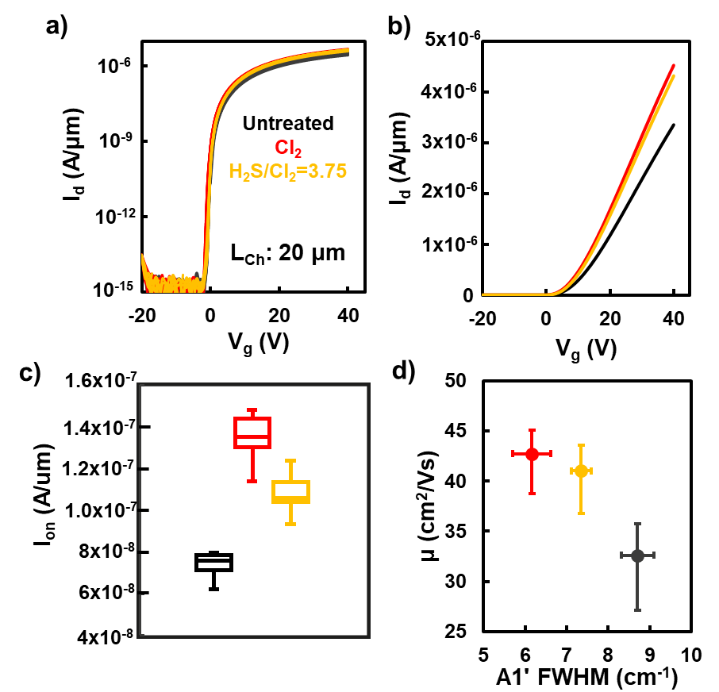
Fig S25a) Transfer characteristics for long channel (20 μm) devices from untreated (black), Cl₂-treated (red) and H₂S/Cl₂-treated (orange) MoS₂. b) Median I_{d}-V_{g} (linear scale) for all 3 types of MoS₂ showing superior performance for the treated MoS₂. c) Normalized I_{on} at a fixed carrier concentration of 1e13/cm³. d) Both Cl₂ and H₂S/Cl₂ treatment improves the median carrier mobility.

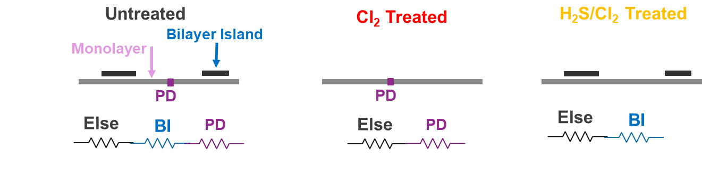
Sup. Fig. 26: The trends in mobility for SC MoS₂ after different treatments can be understood via a simple 4-resistor model. Untreated SC MoS₂ has resistances associated with both bilayer islands (BIs) and point defects (PDs) along with all other miscellaneous sources of resistance (ex: contacts, phonon scattering, etc). As a first approximation, treating SC with Cl₂ removes the BI resistance, while treating with H₂S/Cl₂ likely reduces the PD resistance. As a result, both treatments can improve the mobility of SC MoS_{2.}
References
1. Avrami, M. Kinetics of phase change. I General theory. J. Chem. Phys. 7, 1103–1112 (1939).
2. Avrami, M. Kinetics of phase change. II transformation‐time relations for random distribution of nuclei. J. Chem. Phys. 8, 212–224 (1940).
3. Fanfoni, M. & Tomellini, M. The johnson-mehl-avrami-kohnogorov model: a brief review. Il Nuovo Cimento D 20, 1171–1182 (1998).
4. Mignuzzi, S. et al. Effect of disorder on Raman scattering of single-layer Mo S 2. Phys. Rev. B 91, 195411 (2015).
5. Wang, Y., Dai, H., Liu, Z. & Liu, D. Phonon scattering in monolayer molybdenum disulfide under different defect concentrations based on temperature-dependent Raman spectra. The Journal of Physical Chemistry C 127, 1109–1116 (2023).
6. Chakraborty, B. et al. Symmetry-dependent phonon renormalization in monolayer MoS 2 transistor. Phys. Rev. B 85, 161403 (2012).
7. Chae, W. H., Cain, J. D., Hanson, E. D., Murthy, A. A. & Dravid, V. P. Substrate-induced strain and charge doping in CVD-grown monolayer MoS2. Appl. Phys. Lett. 111, 143106 (2017).

