Table 1. Patient Demographics
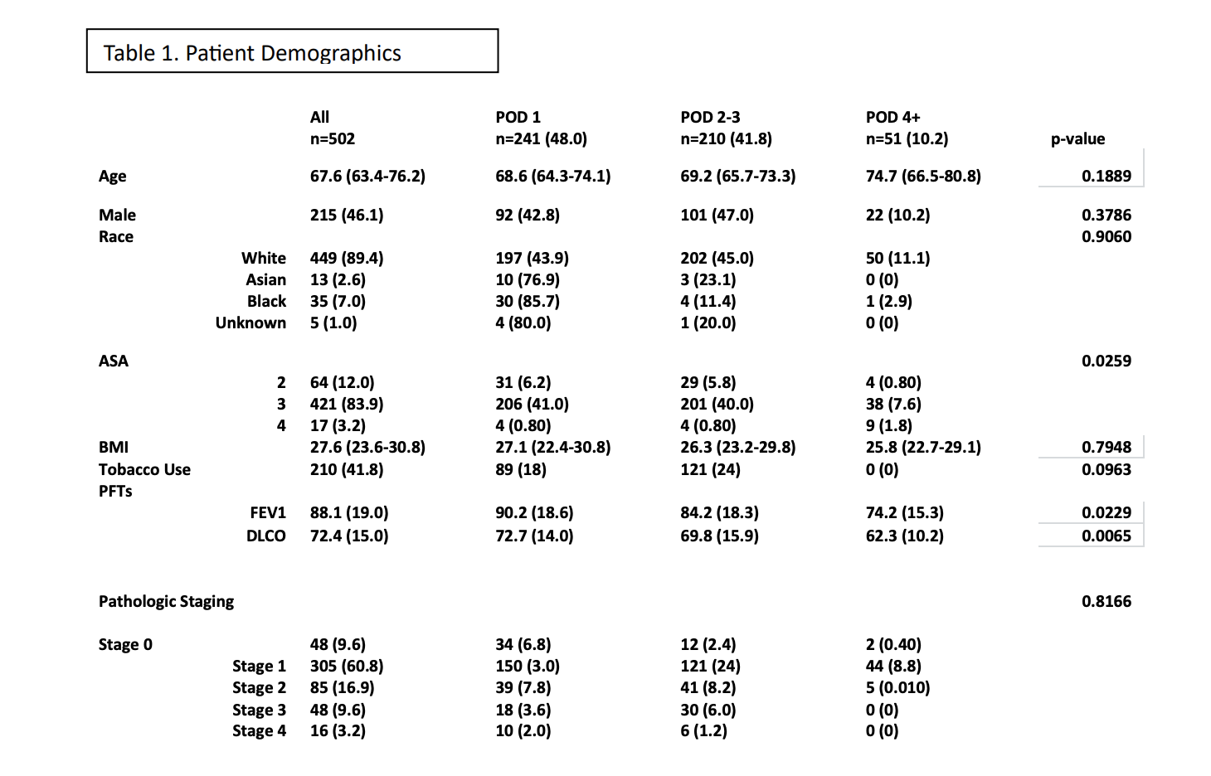

Table 2. Perioperative ERAS Outcomes
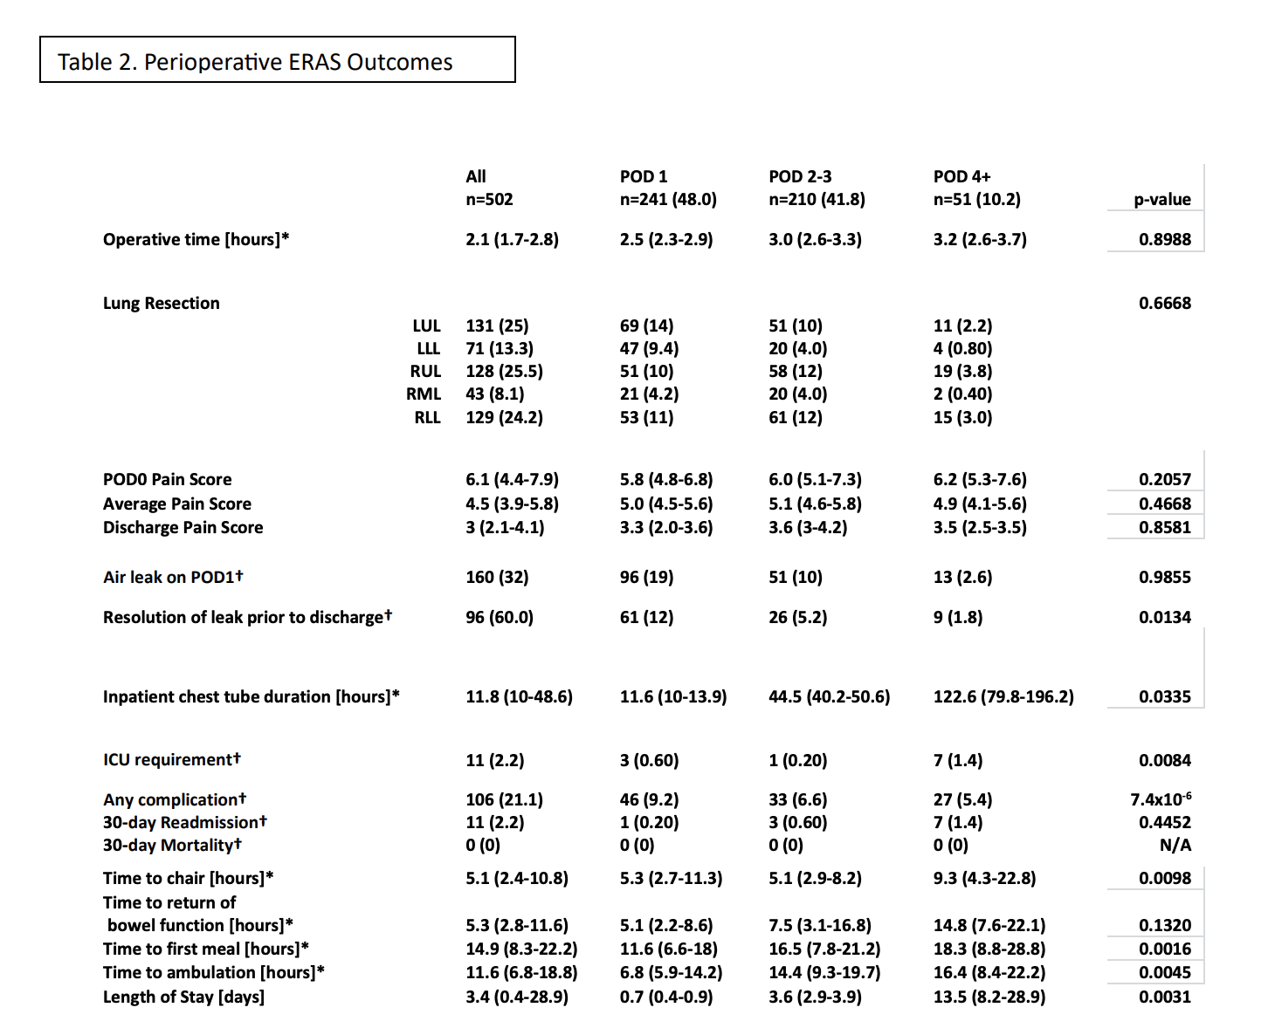

Table 3. Last Chest X-ray Results and Reinterventions
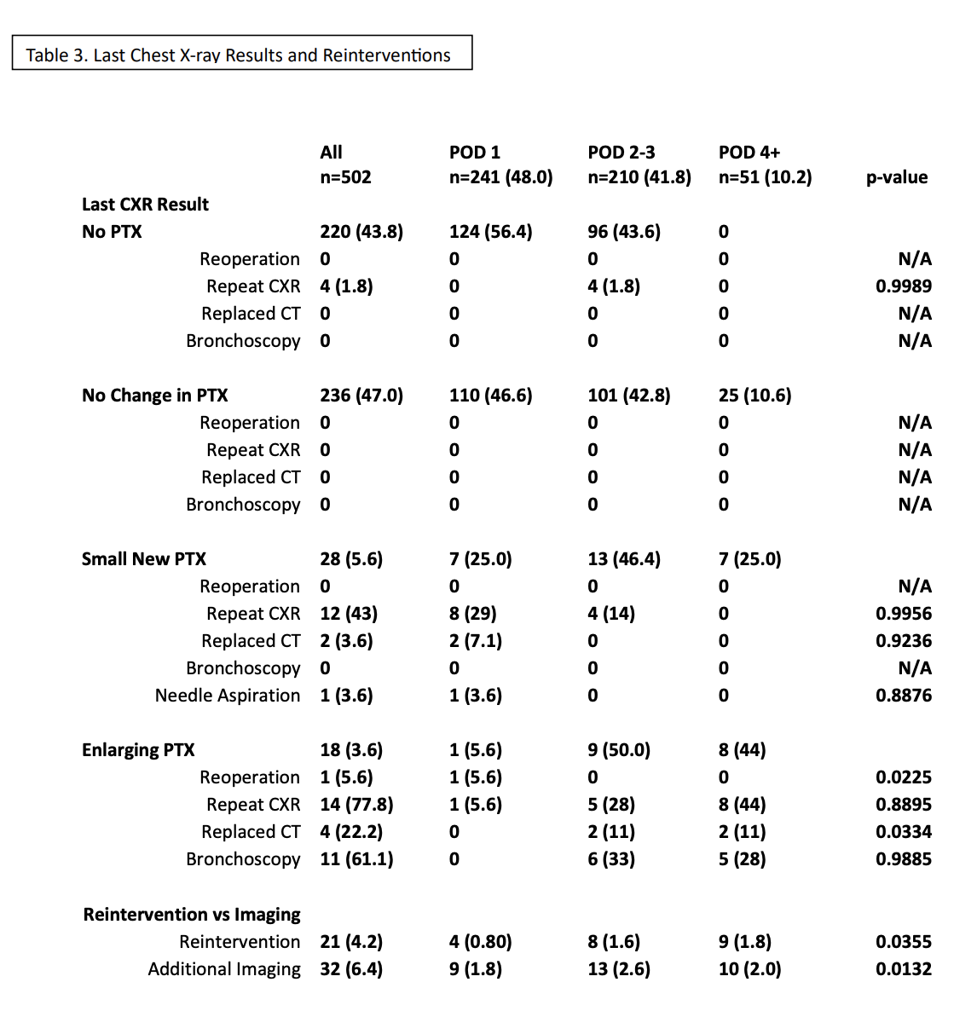

Table 4. Outcomes of Last CXR by Type of Resection

Table 4. Outcomes of Last CXR by Type of Resection
 | All | POD1 | POD 2-3 | POD 4+ | p-value
 | n = 502 | 241 (48.0) | 210 (41.8) | 51 (10.2)
Lobectomy | 297 (59.2) | 133 (44.8) | 137 (46.1) | 27 (9.1) | 0.6541
Reintervention | 12 (4.0) | 3 (1.0) | 2 (0.70) | 7 (2.4) | 0.3355
Additional Imaging | 20 (6.7) | 4 (1.3) | 9 (3.0) | 7 (2.4) | 0.0132
Segmentectomy | 102 (20.3) | 40 (39.2) | 50 (49.0) | 12 (11.8) | 0.9845
Reintervention | 6 (3.0) | 1 (1.0) | 3 (2.9) | 2 (2.0) | 0.0355
Additional Imaging | 7 (5.8) | 5 (4.9) | 1 (1.0) | 1 (1.0) | 0.6132
Wedge Resection | 103 (20.5) | 60 (66.0) | 23 (22.3) | 12 (11.6) | 0.5598
Reintervention | 3 (2.9) | 0 (0) | 3 (2.9) | 0 (0) | 0.0355
Additional Imaging | 5 (5.8) | 0 (0) | 3 (2.9) | 2 (1.9) | 0.011

