Table S1 Samples used for transcripts and metabolic profiling
Maize (Zea mays) Inbred lines | Tissues | Developmental stages | Abbreviation
Huangchang b | Stem cross sections | The tenth leaf stage(V10) | Hcb_V10
Huangchang b | Stem cross sections | Days to silking (DTS) | Hcb_DTS
Huangchang b | Stem cross sections | 10 days after silking (AS10) | Hcb_AS10
Huangchang b | Stem cross sections | 20 days after silking (AS20) | Hcb_AS20
Ji63 | Stem cross sections | The tenth leaf stage(V10) | Ji_V10
Ji63 | Stem cross sections | Days to silking (DTS) | Ji_DTS
Ji63 | Stem cross sections | 10 days after silking (AS10) | Ji_AS10
Ji63 | Stem cross sections | 20 days after silking (AS20) | Ji_AS20

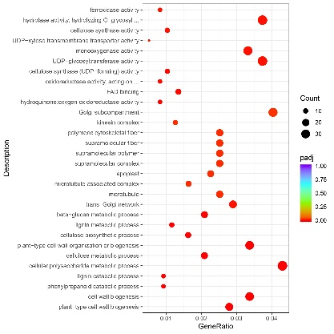
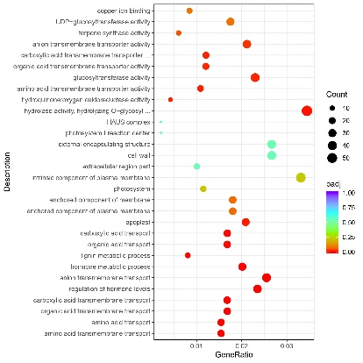
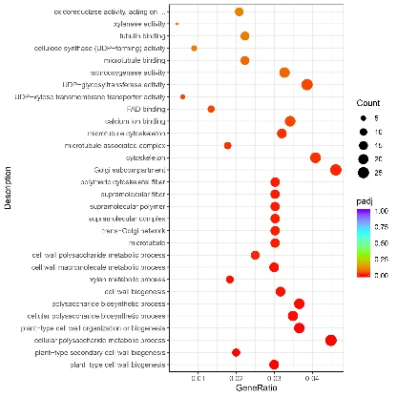
A
B
C
Fig. S1. Enriched GO terms for common DEGs. GO terms for DEGs at Hcb (A) and Ji 63(B). GO terms for unique DEGs at Hcb compared with Ji 63(C). The color scale indicates the padj in the treatments relative to V10.

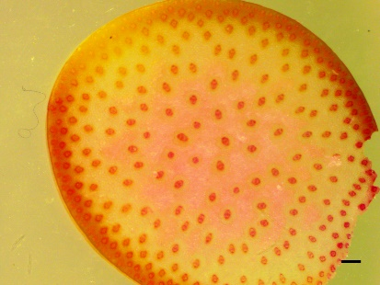
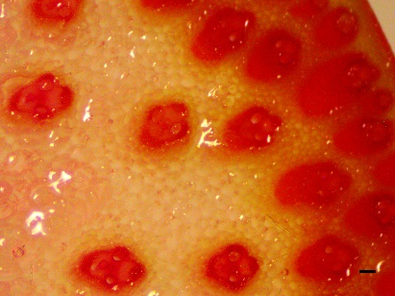
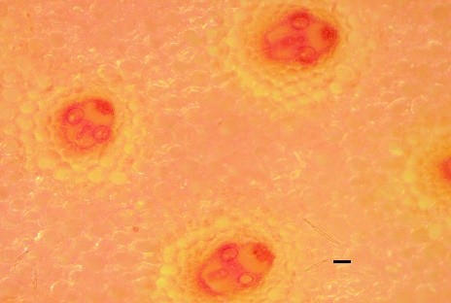
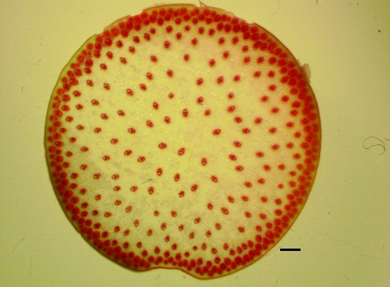
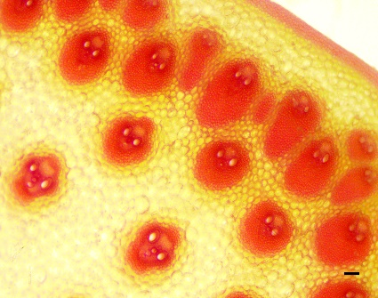
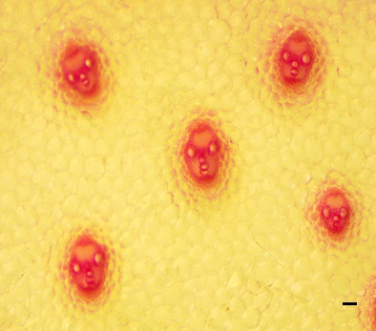
A
WT
B
WT
C
WT
D
Zmacs7
E
Zmacs7
F
Zmacs7

Fig. S2. Mutation of ZmACS7 with a transposon insertion affects cell wall composition. Phenotypic comparison of cross-sections stained with phloroglucinol between the wild type (WT) control and the Zmacs7 mutant at the 3rd internode (A, D), Scale bar, 1 mm. Cross-section phenotypic in details (B, C, E, F). Scale bar, 100um.

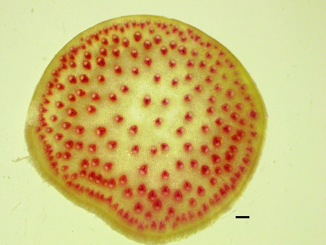
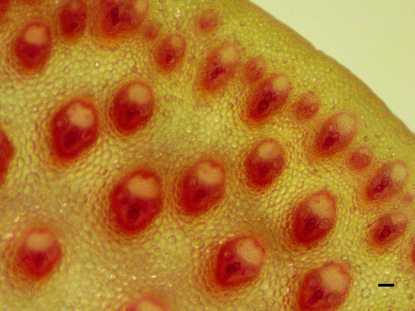
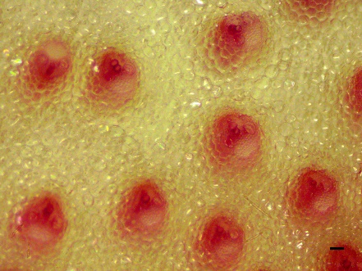
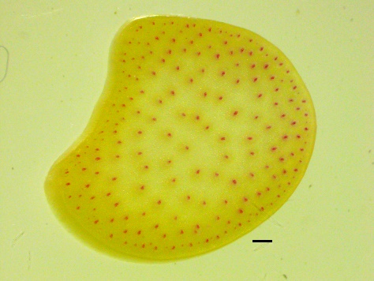
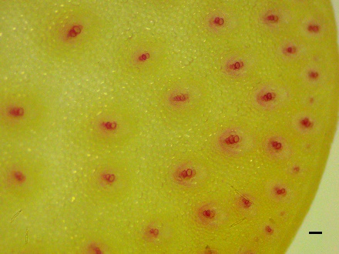
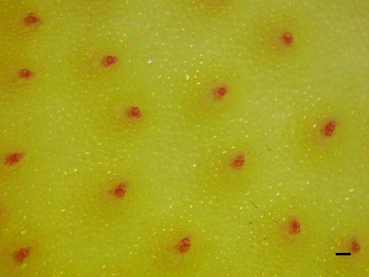
A
WT
B
WT
C
WT
D
Zmacs7
E
Zmacs7
F
Zmacs7

Fig.S3. A mutated ZmACS7, which is a transposon insertion in the candidate gene ZmACS7, affects several cell wall components. Cross-section phenotypic comparison between the homozygous ZmACS7 wild type (WT) control and the Zmacs7 mutant in the peduncle (A, D), Scale bar, 1 mm. Cross-section phenotypic in details (B, C, E, F). Scale bar, 100um.
FF

