Table 1. Culture media in different phases of NK generation
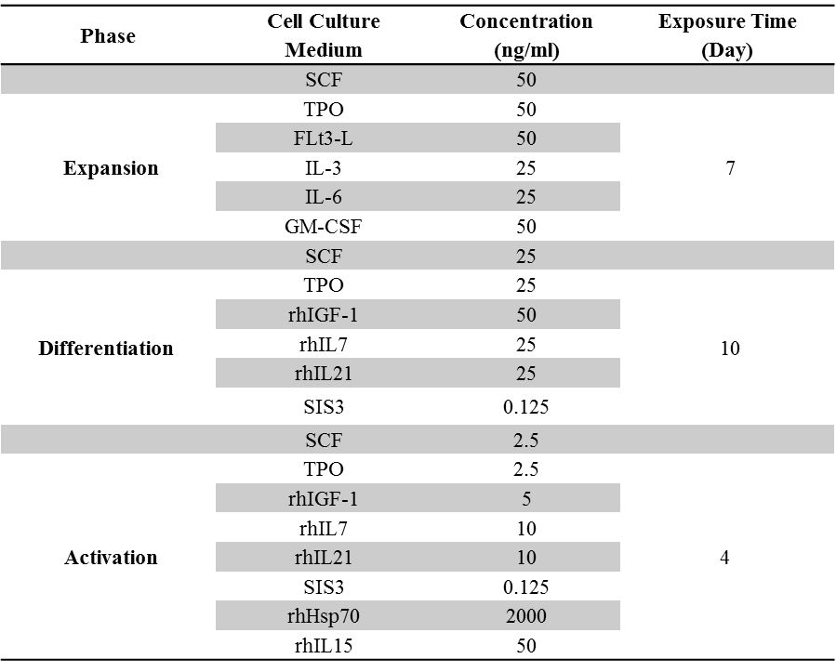
- SFT (SCF/ FLt3-L/TPO), SFT36G (SCF/ FLt3-L/TPO/IL-3/IL-6/GM-CSF)
- I7 (IGF-1/IL-7), I21 (IGF-1/IL-21), I721 (IGF-1/IL-7/IL-21), IS721 (IGF-1/SIS3/ IL-7/IL-21)

