Supplementary material
Clinical outcomes and opportunities for improvement across modified trauma quality improvement cohorts: a registry-based cohort study
Jonatan Attergrim^{1,2}, Lovisa Strömmer^{1,3}, Olof Brattström⁴, Martin Jacobsson⁵, Josef Al-Khalili¹, Elin Sun Cao¹, Kelvin Szolnoky⁶, Johanna Berg^{1,7}, Martin Gerdin Wärnberg^{1,2}
¹ Department of Global Public Health, Karolinska Institutet, Stockholm, Sweden
² Perioperative Medicine and Intensive Care, Karolinska University Hospital, Solna, Stockholm, Sweden
³ Department of Clinical Science, Intervention and Technology, Division of Surgery, Karolinska Institutet, Karolinska University Hospital Huddinge, Stockholm, Sweden
⁴ Department of Anesthesiology, Mora Hospital, Mora, Sweden
⁵ Department of Biomedical Engineering and Health Systems, KTH Royal Institute of Technology, Huddinge, Sweden
⁶ Department of Medical Epidemiology and Biostatistics, Karolinska Institutet, Stockholm, Sweden
⁷ Department of Internal and Emergency Medicine, Skånes universitetssjukhus Malmö, Malmö, Sweden
Corresponding author: Jonatan Attergrim, Department of Global Public Health, Karolinska Institutet, 171 77 Stockholm, Sweden. Email: jonatan.attergrim@ki.se
Contents
Additional file 1: OFI categories with definitions and subcategory frequencies
Additional file 2: Full logistic regression results: 30-day mortality
Additional file 3: Full logistic regression results: Unfavourable GOS
Additional file 4: Full logistic regression results: Opportunities for improvement
Additional file 5: Unadjusted and fully adjusted odds ratios by cohort
Additional file 6: Cause of death by TQIP cohort (multinomial logistic regression)
Additional file 7: Individual GOS levels by TQIP cohort (multinomial logistic regression)
Additional file 8: MICE convergence diagnostics
Additional file 9: OR trajectories across sequential models

Additional files

Additional file 1: OFI categories with definitions and subcategory frequencies
Category (n) | Opportunities for Improvement, N = 493
Potentially preventable deaths (42)  Deaths judged by peer review as potentially avoidable given optimal care at the study hospital. | • Potentially preventable death: 38  e.g., death where alternative management may have altered the outcome  • Preventable death: 4  e.g., death from surgically accessible haemorrhage where timely intervention was feasible
Missed diagnosis (70)  Failure to identify an injury or condition despite sufficient information and resources. | • Missed injury: 67  e.g., injury not identified on imaging or failure to perform indicated radiology  • Communication + missed injury: 1  • Level of care + missed injury: 1  • Tertiary survey: 1  e.g., omitted tertiary survey
Delay in treatment (72)  Inappropriate delay from assessment to treatment or imaging, not attributable to resource constraints. | • Delay to surgery: 47  e.g., prolonged time to intervention not attributable to incorrect management or lacking resources  • Delay to CT: 25  e.g., delayed CT in a patient with reduced consciousness and later confirmed intracranial injury
Clinical judgement error (174)  Incorrect management strategy despite sufficient information and resources. | • Triage in the ED: 63  e.g., highest trauma level deprioritized despite clinical signs of instability  • Patient management: 48  e.g., no epidural analgesia for multiple rib fractures, or CT performed before surgery when immediate intervention was indicated  • Level of care: 47  e.g., intermediate care when ICU indicated, including inter-hospital transfers  • Communication: 16  e.g., failed handover between teams
Inadequate protocols (24)  Absent or insufficient protocols or guidelines. | • Trauma criteria/guidelines: 22  e.g., protocol undertriage of patient  • Inadequate routine: 2  e.g., absent or unclear local clinical guidelines for managing a specific injury pattern
Inadequate resources (111)  Lack of personnel, material, or infrastructure. | • Resources: 73  e.g., no operating room available  • Logistics/technical: 36  e.g., IT system or equipment failure  • Competence: 2  e.g., required specialist unavailable

Additional file 2: Full logistic regression results: 30-day mortality
Term | Unadjusted OR (95% CI) | Unadj. p | Patient char. OR (95% CI) | Patient char. p | Physiological OR (95% CI) | Physiological p | Care-process OR (95% CI) | Care-process p
Cohort: blunt multisystem with TBI | 9.50 (7.65–11.79) | <0.001 | 10.42 (8.26–13.15) | <0.001 | 7.49 (5.72–9.82) | <0.001 | 5.28 (3.89–7.17) | <0.001
Cohort: blunt multisystem without TBI | 4.45 (3.34–5.93) | <0.001 | 4.58 (3.39–6.20) | <0.001 | 2.40 (1.66–3.48) | <0.001 | 1.69 (1.13–2.52) | 0.011
Cohort: Isolated severe TBI | 26.34 (19.94–34.79) | <0.001 | 25.66 (18.90–34.83) | <0.001 | 38.16 (26.30–55.38) | <0.001 | 21.54 (14.16–32.78) | <0.001
Cohort: severe penetrating | 6.35 (4.88–8.26) | <0.001 | 13.72 (10.21–18.44) | <0.001 | 5.05 (3.37–7.56) | <0.001 | 2.83 (1.77–4.52) | <0.001
Age (years) |  |  | 1.04 (1.03–1.04) | <0.001 | 1.05 (1.04–1.06) | <0.001 | 1.06 (1.05–1.06) | <0.001
ASA: .L |  |  | 3.53 (2.42–5.16) | <0.001 | 3.90 (2.59–5.88) | <0.001 | 4.39 (2.89–6.66) | <0.001
ASA: .Q |  |  | 2.39 (1.78–3.19) | <0.001 | 2.20 (1.60–3.02) | <0.001 | 2.48 (1.79–3.42) | <0.001
ASA: .C |  |  | 0.81 (0.67–1.00) | 0.045 | 0.83 (0.66–1.03) | 0.091 | 0.85 (0.68–1.07) | 0.166
Female sex |  |  | 0.96 (0.79–1.17) | 0.699 | 0.97 (0.78–1.21) | 0.802 | 1.06 (0.84–1.33) | 0.624
SBP (mmHg) |  |  |  |  | 0.97 (0.97–0.98) | <0.001 | 0.98 (0.98–0.98) | <0.001
Respiratory rate |  |  |  |  | 0.93 (0.90–0.97) | 0.002 | 0.94 (0.90–0.98) | 0.002
Intubated in ED |  |  |  |  |  |  | 1.36 (1.00–1.84) | 0.050
Emergency procedure |  |  |  |  |  |  | 927.21 (16.57–51895.77) | <0.001
Care level: .L |  |  |  |  |  |  | 1.30 (0.94–1.79) | 0.117
Care level: .Q |  |  |  |  |  |  | 2.61 (1.93–3.52) | <0.001
Care level: .C |  |  |  |  |  |  | 1.03 (0.72–1.49) | 0.854
Care level: ^4 |  |  |  |  |  |  | 1.09 (0.77–1.56) | 0.620
Time to procedure: .L |  |  |  |  |  |  | 0.01 (0.00–0.08) | <0.001
Time to procedure: .Q |  |  |  |  |  |  | 23.80 (2.19–258.61) | 0.009
Time to procedure: .C |  |  |  |  |  |  | 0.16 (0.04–0.59) | 0.006
Time to procedure: ^4 |  |  |  |  |  |  | NA (NA–NA)
Time to CT: .L |  |  |  |  |  |  | 0.44 (0.32–0.60) | <0.001
Time to CT: .Q |  |  |  |  |  |  | 2.14 (1.61–2.84) | <0.001
Time to CT: .C |  |  |  |  |  |  | 0.97 (0.71–1.31) | 0.828
Time to CT: ^4 |  |  |  |  |  |  | 1.60 (1.19–2.16) | 0.002
Time to CT: ^5 |  |  |  |  |  |  | 0.99 (0.77–1.26) | 0.917

Additional file 3: Full logistic regression results: Unfavourable GOS
Term | Unadjusted OR (95% CI) | Unadj. p | Patient char. OR (95% CI) | Patient char. p | Physiological OR (95% CI) | Physiological p | Care-process OR (95% CI) | Care-process p
Cohort: blunt multisystem with TBI | 15.06 (11.99–18.90) | <0.001 | 19.83 (15.57–25.26) | <0.001 | 16.85 (13.16–21.58) | <0.001 | 7.80 (6.00–10.16) | <0.001
Cohort: blunt multisystem without TBI | 8.80 (7.02–11.05) | <0.001 | 10.62 (8.33–13.54) | <0.001 | 8.71 (6.79–11.18) | <0.001 | 4.05 (3.09–5.31) | <0.001
Cohort: Isolated severe TBI | 29.23 (18.80–45.44) | <0.001 | 30.29 (19.11–47.99) | <0.001 | 32.29 (20.26–51.48) | <0.001 | 10.86 (6.68–17.66) | <0.001
Cohort: severe penetrating | 1.54 (1.26–1.90) | <0.001 | 3.07 (2.45–3.84) | <0.001 | 1.92 (1.50–2.45) | <0.001 | 0.87 (0.65–1.17) | 0.345
Age (years) |  |  | 1.04 (1.03–1.04) | <0.001 | 1.04 (1.04–1.05) | <0.001 | 1.05 (1.04–1.05) | <0.001
ASA: .L |  |  | 2.20 (1.54–3.15) | <0.001 | 2.08 (1.44–2.99) | <0.001 | 2.09 (1.40–3.10) | <0.001
ASA: .Q |  |  | 1.10 (0.84–1.45) | 0.471 | 1.03 (0.78–1.36) | 0.820 | 1.25 (0.93–1.69) | 0.137
ASA: .C |  |  | 0.97 (0.83–1.14) | 0.727 | 1.00 (0.85–1.17) | 0.981 | 1.11 (0.93–1.32) | 0.257
Female sex |  |  | 1.00 (0.89–1.12) | 0.960 | 0.96 (0.85–1.09) | 0.555 | 1.21 (1.06–1.38) | 0.006
SBP (mmHg) |  |  |  |  | 0.99 (0.98–0.99) | <0.001 | 0.99 (0.99–0.99) | <0.001
Respiratory rate |  |  |  |  | 1.00 (0.98–1.02) | 0.713 | 0.98 (0.96–1.00) | 0.026
Intubated in ED |  |  |  |  |  |  | 0.79 (0.62–1.01) | 0.058
Emergency procedure |  |  |  |  |  |  | 4.32 (0.37–50.35) | 0.243
Care level: .L |  |  |  |  |  |  | 9.13 (7.49–11.13) | <0.001
Care level: .Q |  |  |  |  |  |  | 0.91 (0.77–1.08) | 0.286
Care level: .C |  |  |  |  |  |  | 0.93 (0.77–1.12) | 0.436
Care level: ^4 |  |  |  |  |  |  | 1.38 (1.17–1.62) | <0.001
Time to procedure: .L |  |  |  |  |  |  | 0.51 (0.11–2.50) | 0.410
Time to procedure: .Q |  |  |  |  |  |  | 2.87 (0.69–11.93) | 0.146
Time to procedure: .C |  |  |  |  |  |  | 0.81 (0.37–1.77) | 0.599
Time to procedure: ^4 |  |  |  |  |  |  | NA (NA–NA)
Time to CT: .L |  |  |  |  |  |  | 0.79 (0.66–0.94) | 0.009
Time to CT: .Q |  |  |  |  |  |  | 2.37 (2.00–2.80) | <0.001
Time to CT: .C |  |  |  |  |  |  | 0.81 (0.69–0.96) | 0.015
Time to CT: ^4 |  |  |  |  |  |  | 1.49 (1.28–1.75) | <0.001
Time to CT: ^5 |  |  |  |  |  |  | 1.09 (0.95–1.25) | 0.227

Additional file 4: Full logistic regression results: Opportunities for improvement
Term | Unadjusted OR (95% CI) | Unadj. p | Patient char. OR (95% CI) | Patient char. p | Physiological OR (95% CI) | Physiological p | Care-process OR (95% CI) | Care-process p
Cohort: blunt multisystem with TBI | 2.39 (1.80–3.19) | <0.001 | 2.31 (1.73–3.08) | <0.001 | 2.37 (1.77–3.17) | <0.001 | 1.78 (1.29–2.46) | <0.001
Cohort: blunt multisystem without TBI | 4.11 (3.11–5.43) | <0.001 | 3.96 (3.00–5.24) | <0.001 | 4.03 (3.03–5.36) | <0.001 | 2.82 (2.07–3.83) | <0.001
Cohort: Isolated severe TBI | 1.60 (0.98–2.62) | 0.062 | 1.45 (0.88–2.39) | 0.141 | 1.49 (0.91–2.46) | 0.115 | 1.08 (0.63–1.87) | 0.777
Cohort: severe penetrating | 1.55 (1.05–2.28) | 0.028 | 1.64 (1.10–2.44) | 0.014 | 1.71 (1.14–2.56) | 0.009 | 1.40 (0.90–2.17) | 0.133
Age (years) |  |  | 1.01 (1.00–1.01) | 0.037 | 1.01 (1.00–1.01) | 0.051 | 1.01 (1.00–1.01) | 0.049
ASA: .L |  |  | 0.87 (0.43–1.77) | 0.704 | 0.86 (0.43–1.74) | 0.676 | 0.79 (0.39–1.60) | 0.504
ASA: .Q |  |  | 0.79 (0.47–1.34) | 0.382 | 0.79 (0.47–1.34) | 0.380 | 0.83 (0.48–1.41) | 0.480
ASA: .C |  |  | 0.89 (0.67–1.19) | 0.441 | 0.88 (0.66–1.18) | 0.406 | 0.86 (0.64–1.16) | 0.329
Female sex |  |  | 0.85 (0.69–1.04) | 0.114 | 0.85 (0.69–1.05) | 0.135 | 0.90 (0.72–1.11) | 0.317
SBP (mmHg) |  |  |  |  | 1.00 (1.00–1.00) | 0.451 | 1.00 (1.00–1.00) | 0.602
Respiratory rate |  |  |  |  | 1.02 (1.00–1.04) | 0.019 | 1.01 (0.99–1.03) | 0.456
Intubated in ED |  |  |  |  |  |  | 1.29 (0.94–1.77) | 0.111
Emergency procedure |  |  |  |  |  |  | 1.99 (0.04–102.57) | 0.731
Care level: .L |  |  |  |  |  |  | 2.91 (2.01–4.21) | <0.001
Care level: .Q |  |  |  |  |  |  | 0.41 (0.30–0.55) | <0.001
Care level: .C |  |  |  |  |  |  | 0.89 (0.67–1.17) | 0.407
Care level: ^4 |  |  |  |  |  |  | 0.75 (0.59–0.95) | 0.019
Time to procedure: .L |  |  |  |  |  |  | 1.52 (0.12–19.06) | 0.744
Time to procedure: .Q |  |  |  |  |  |  | 2.17 (0.21–22.26) | 0.513
Time to procedure: .C |  |  |  |  |  |  | 0.70 (0.20–2.40) | 0.571
Time to procedure: ^4 |  |  |  |  |  |  | NA (NA–NA)
Time to CT: .L |  |  |  |  |  |  | 2.04 (1.53–2.73) | <0.001
Time to CT: .Q |  |  |  |  |  |  | 0.91 (0.69–1.20) | 0.495
Time to CT: .C |  |  |  |  |  |  | 0.67 (0.52–0.87) | 0.002
Time to CT: ^4 |  |  |  |  |  |  | 0.76 (0.60–0.96) | 0.023
Time to CT: ^5 |  |  |  |  |  |  | 1.17 (0.95–1.44) | 0.146

Additional file 5: Unadjusted and fully adjusted odds ratios by cohort
 | 30-day mortality |  | Unfavourable GOS |  | OFI
Cohort | Mortality Unadj. | Mortality Adjusted | Unfav. GOS Unadj. | Unfav. GOS Adjusted | OFI Unadj. | OFI Adjusted
Isolated TBI | 26.34 (19.94–34.79) | 21.54 (14.16–32.78) | 29.23 (18.80–45.44) | 10.86 (6.68–17.66) | 1.60 (0.98–2.62) | 1.08 (0.63–1.87)
BM with TBI | 9.50 (7.65–11.79) | 5.28 (3.89–7.17) | 15.06 (11.99–18.90) | 7.80 (6.00–10.16) | 2.39 (1.80–3.19) | 1.78 (1.29–2.46)
Penetrating truncal injury | 6.35 (4.88–8.26) | 2.83 (1.77–4.52) | 1.54 (1.26–1.90) | 0.87 (0.65–1.17) | 1.55 (1.05–2.28) | 1.40 (0.90–2.17)
BM without TBI | 4.45 (3.34–5.93) | 1.69 (1.13–2.52) | 8.80 (7.02–11.05) | 4.05 (3.09–5.31) | 4.11 (3.11–5.43) | 2.82 (2.07–3.83)

Additional file 6: Cause of death by TQIP cohort (multinomial logistic regression)
Cohort | Cause of death | Frequency | OR | 95% CI | p-value
Blunt multisystem without TBI (n=427) | Alive | 359 / 7,568 (4.7%) | —
Blunt multisystem without TBI (n=427) | TBI | 6 / 329 (1.8%) | 1.29 | 0.56, 2.98 | 0.547
Blunt multisystem without TBI (n=427) | Bleeding | 28 / 131 (21.4%) | 44.98 | 22.21, 91.06 | <0.001
Blunt multisystem without TBI (n=427) | Multi-organ failure | 12 / 36 (33.3%) | 10.60 | 5.14, 21.85 | <0.001
Blunt multisystem without TBI (n=427) | Other | 22 / 183 (12.0%) | 3.21 | 2.02, 5.12 | <0.001
Blunt multisystem with TBI (n=587) | Alive | 417 / 7,568 (5.5%) | —
Blunt multisystem with TBI (n=587) | TBI | 109 / 329 (33.1%) | 20.23 | 14.94, 27.39 | <0.001
Blunt multisystem with TBI (n=587) | Bleeding | 21 / 131 (16.0%) | 29.04 | 13.91, 60.63 | <0.001
Blunt multisystem with TBI (n=587) | Multi-organ failure | 3 / 36 (8.3%) | 2.28 | 0.68, 7.71 | 0.184
Blunt multisystem with TBI (n=587) | Other | 28 / 183 (15.3%) | 3.52 | 2.31, 5.37 | <0.001
Isolated severe TBI (n=246) | Alive | 115 / 7,568 (1.5%) | —
Isolated severe TBI (n=246) | TBI | 119 / 329 (36.2%) | 80.08 | 57.20, 112.10 | <0.001
Isolated severe TBI (n=246) | Bleeding | 0 | 0.00 | 0.00, 0.00 | <0.001
Isolated severe TBI (n=246) | Multi-organ failure | 0 | 0.00 | 0.00, 0.00 | <0.001
Isolated severe TBI (n=246) | Other | 7 / 183 (3.8%) | 3.19 | 1.46, 6.98 | 0.004
Penetrating truncal injury (n=423) | Alive | 333 / 7,568 (4.4%) | —
Penetrating truncal injury (n=423) | TBI | 13 / 329 (4.0%) | 3.02 | 1.67, 5.48 | <0.001
Penetrating truncal injury (n=423) | Bleeding | 71 / 131 (54.2%) | 122.97 | 64.55, 234.27 | <0.001
Penetrating truncal injury (n=423) | Multi-organ failure | 1 / 36 (2.8%) | 0.95 | 0.13, 7.12 | 0.962
Penetrating truncal injury (n=423) | Other | 5 / 183 (2.7%) | 0.79 | 0.32, 1.94 | 0.602
Reference: Alive in the Non TQIP-cohort. Frequency: n / N (%), where N is the total count of that cause of death across all cohorts. Multinomial logistic regression. Deaths classified as Unknown excluded.

Additional file 7: Individual GOS levels by TQIP cohort (multinomial logistic regression)
Cohort | GOS level | Frequency | OR | 95% CI | p-value
Blunt multisystem without TBI (n=427) | Good recovery | 4 / 2,629 (0.2%) | —
Blunt multisystem without TBI (n=427) | Moderate disability | 101 / 2,773 (3.6%) | 27.55 | 10.14, 74.88 | <0.001
Blunt multisystem without TBI (n=427) | Severe disability | 253 / 2,225 (11.4%) | 107.90 | 40.14, 290.06 | <0.001
Blunt multisystem without TBI (n=427) | Dead/Vegetative | 69 / 671 (10.3%) | 210.05 | 75.98, 580.70 | <0.001
Blunt multisystem with TBI (n=587) | Good recovery | 1 / 2,629 (0.0%) | —
Blunt multisystem with TBI (n=587) | Moderate disability | 93 / 2,773 (3.4%) | 101.74 | 14.16, 731.13 | <0.001
Blunt multisystem with TBI (n=587) | Severe disability | 325 / 2,225 (14.6%) | 555.95 | 77.93, 3966.10 | <0.001
Blunt multisystem with TBI (n=587) | Dead/Vegetative | 168 / 671 (25.0%) | 2051.16 | 285.57, 14732.71 | <0.001
Isolated severe TBI (n=246) | Good recovery | 3 / 2,629 (0.1%) | —
Isolated severe TBI (n=246) | Moderate disability | 19 / 2,773 (0.7%) | 6.91 | 2.04, 23.37 | 0.002
Isolated severe TBI (n=246) | Severe disability | 91 / 2,225 (4.1%) | 51.78 | 16.38, 163.73 | <0.001
Isolated severe TBI (n=246) | Dead/Vegetative | 133 / 671 (19.8%) | 540.16 | 170.66, 1709.70 | <0.001
Penetrating truncal injury (n=423) | Good recovery | 59 / 2,629 (2.2%) | —
Penetrating truncal injury (n=423) | Moderate disability | 216 / 2,773 (7.8%) | 4.00 | 2.98, 5.37 | <0.001
Penetrating truncal injury (n=423) | Severe disability | 57 / 2,225 (2.6%) | 1.65 | 1.14, 2.39 | 0.008
Penetrating truncal injury (n=423) | Dead/Vegetative | 91 / 671 (13.6%) | 18.81 | 13.17, 26.87 | <0.001
Reference: Good recovery in the Non TQIP-cohort. Frequency: n / N (%), where N is the total count of that GOS level across all cohorts. Multinomial logistic regression.

Additional file 8: MICE convergence diagnostics
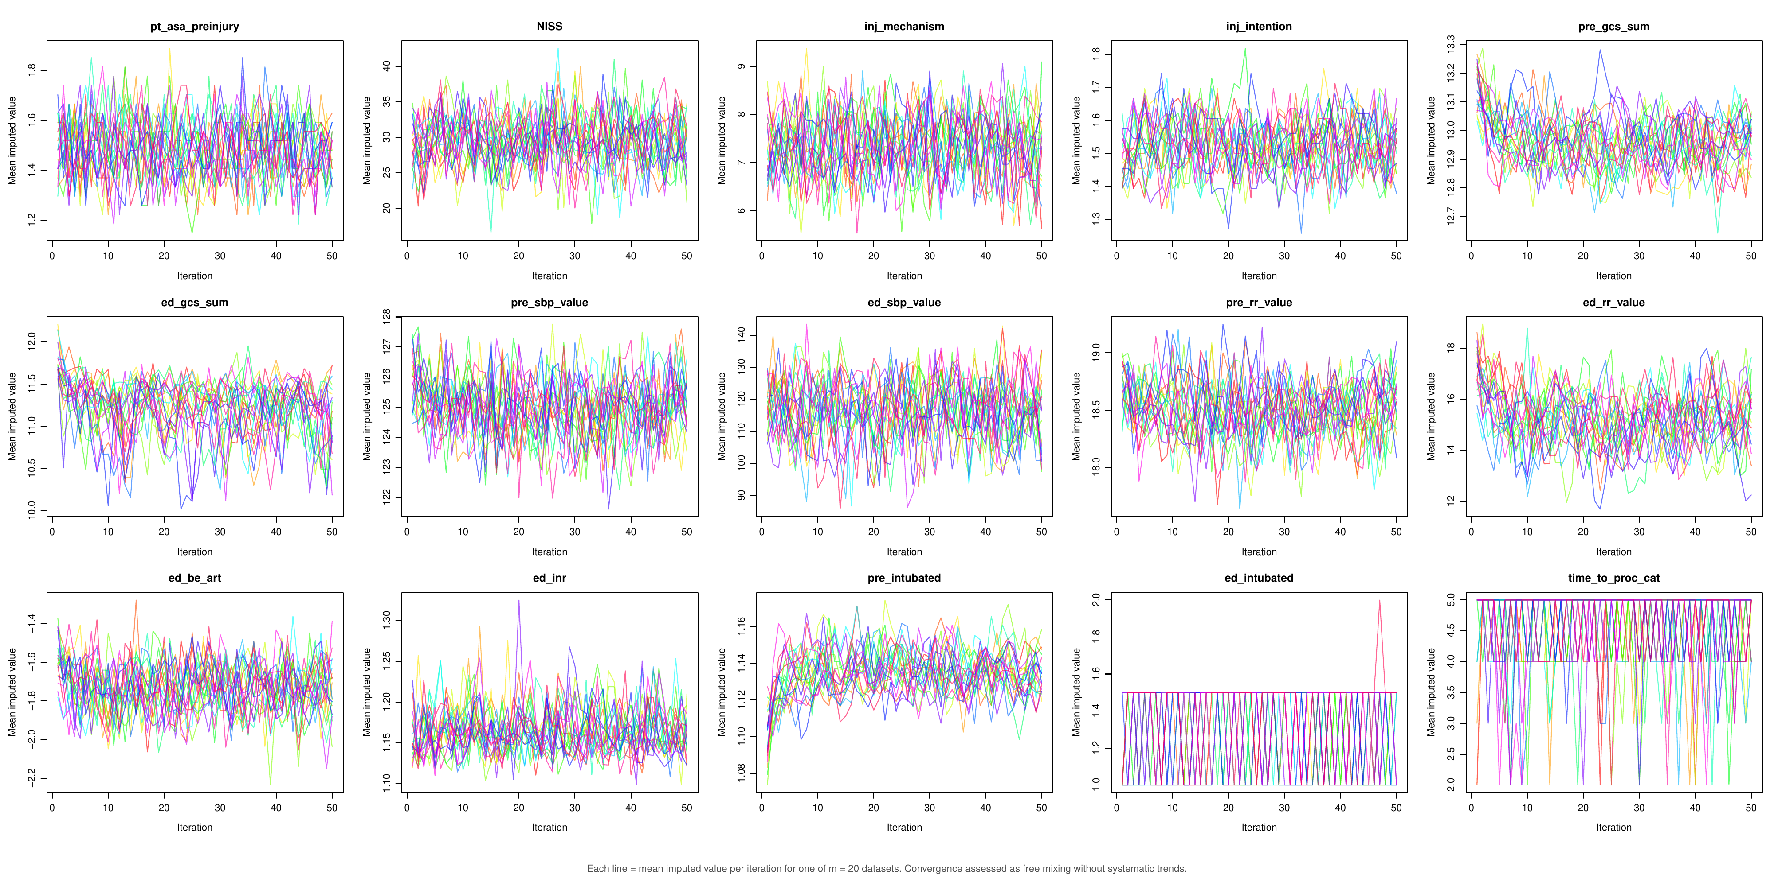
MICE convergence trace plots across 20 imputed datasets and 50 iterations. Each line represents the mean imputed value per iteration for one imputed dataset. Outcomes (survival, GOS, OFI) were included as predictors in the imputation model. Variables with very few missing values (marked with *) exhibit oscillating trace plots, which is expected; convergence for these was confirmed quantitatively (R-hat < 1.05).

Additional file 9: OR trajectories across sequential models
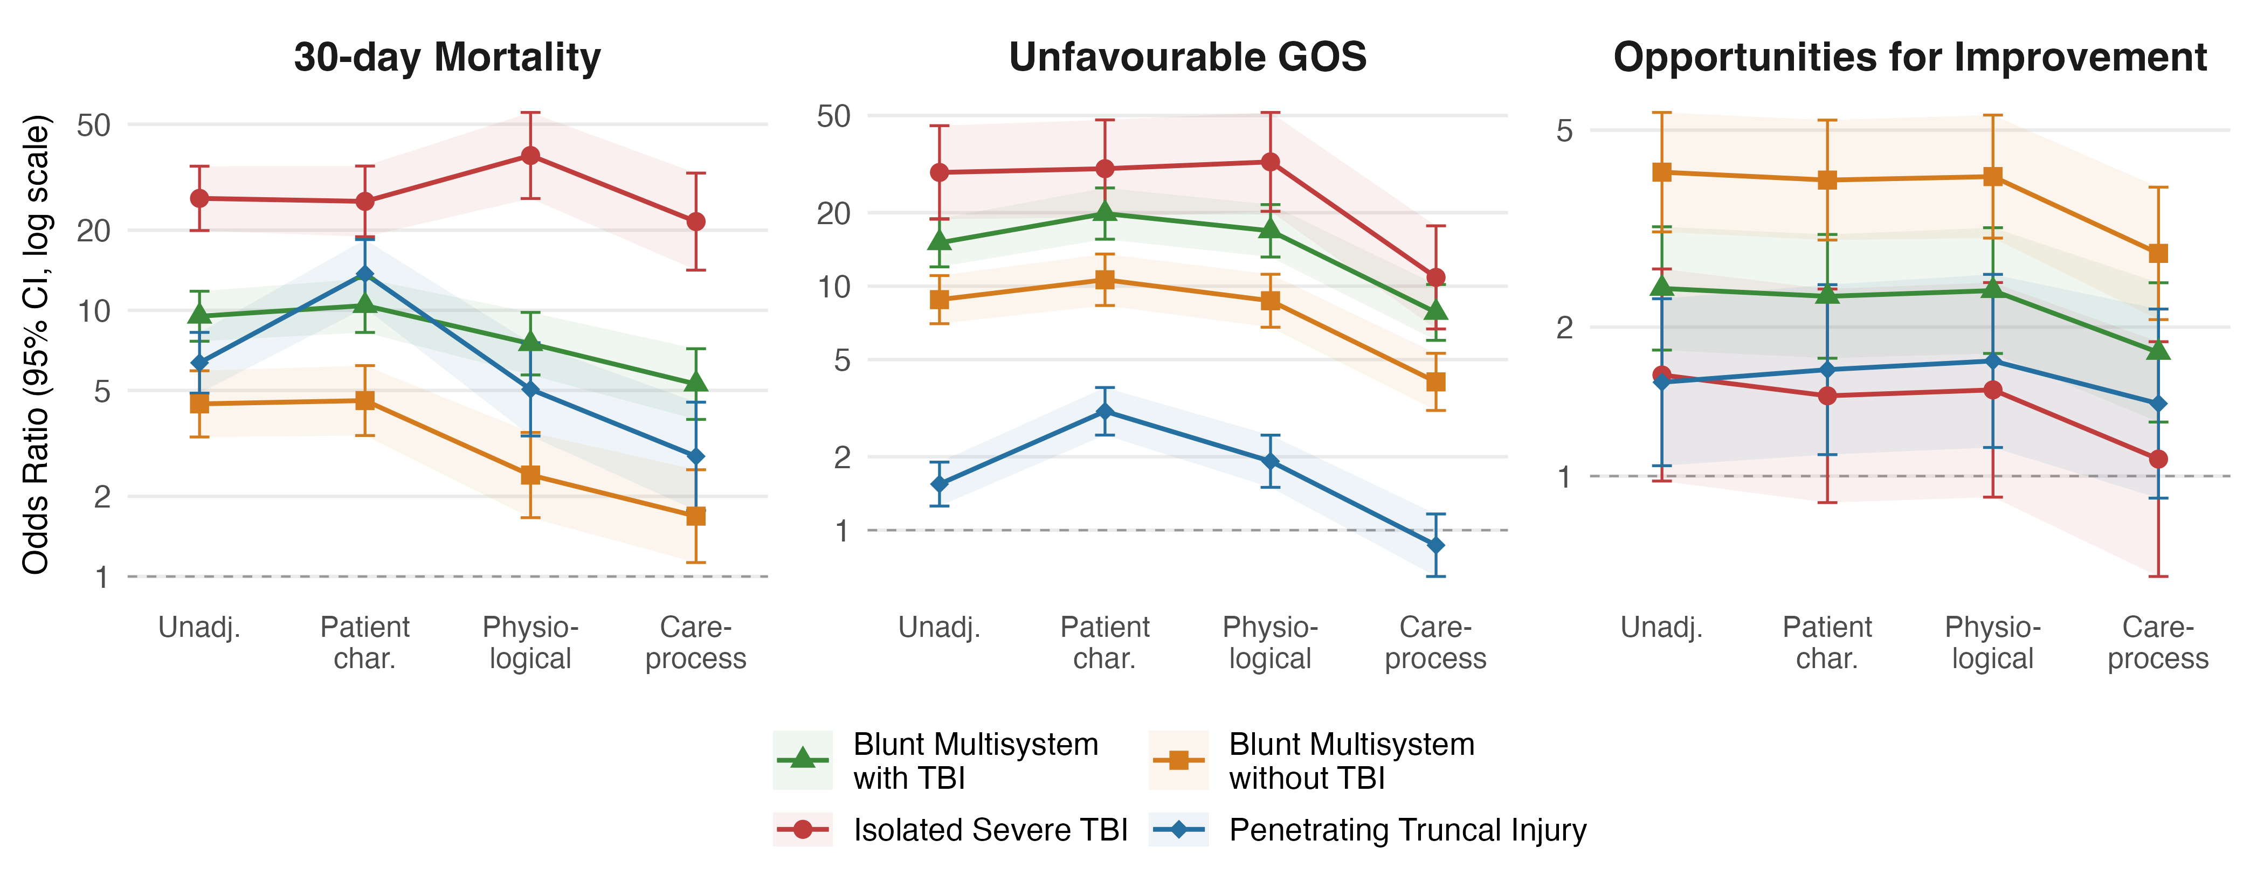
Odds ratio trajectories across sequential regression models. Trajectories shown for 30-day mortality, unfavourable GOS, and OFI by TQIP cohort.
Points represent odds ratios with 95% confidence intervals. Dashed line indicates OR = 1 (reference). Patient characteristics: age, ASA, sex. Physiological: + SBP, respiratory rate. Care-process: + intubation, emergency procedure, care level, time to procedure, time to CT.

