An integrated Augmented Reality (AR) and embedded electronics-based toolkit for improved visualization and understanding of network graphs.
Table S1. Twenty-eight probability distribution transformations with their respective cases, source and target distributions, and convergence conditions. D is for discrete and C is for continuous.
Case | Source Distribution | Target Distribution | Convergence Condition
Taking the limit | Hypergeometric (D) | Binomial (D) | X ~ Hypergeometric (n, m, N)  p = m/N  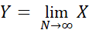  ~ Binomial (n, p)
Taking the limit | Binomial  (D) | Poisson  (D) | X ~ Binomial (n, p)  λ = n*p  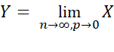  ~ Poisson (λ)
Taking the limit | Poisson  (D) | Gaussian  (C) | X ~ Poisson (λ)  µ = λ, σ² = λ  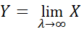  ~ Gaussian (µ, σ²)
Taking the limit | Binomial  (D) | Gaussian  (C) | X ~ Binomial (n, p)  µ = n*p, σ² = n*p*(1-p)  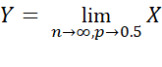  ~ Gaussian (µ, σ²)
Taking the limit | Geometric  (D) | Exponential  (C) | X ~ Geometric (p)  λ = n*p  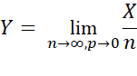  ~ Exponential (λ)
Taking the limit | Negative Binomial (D) | Gamma  (C) | X ~ Negative Binomial (r, p)  α = r, λ = (1-p)/p  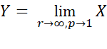  ~ Gamma (α, λ)
Variable transformation | Uniform  (C) | Exponential  (C) | X ~ Uniform (a, b)  a=0, b=1  Y = -ln(1-X)~ Exponential (λ)
Variable transformation | Gamma  (C) | Beta  (C) | X₁ ~ Gamma (α, λ)  X₂ ~ Gamma (β, λ)  Y = X₁/(X₁+X₂)~ Beta (α, β)
Variable transformation | Chi-squared  (C) | Beta  (C) | X₁ ~ Chi-squared (υ₁)  X₂ ~ Chi-squared (υ₂)  α=υ₁/2, β=υ₂/2  Y = X₁/(X₁+X₂)~ Beta (α, β)
Variable transformation | Gaussian  (C) | Chi-squared  (C) | X ~ Gaussian (µ, σ²)  Y = X²~ Chi-squared (υ=1)
Conditioning | Poisson  (D) | Binomial  (D) | X₁ ~ Poisson (λ₁)  X₂ ~ Poisson (λ₂)  p=λ₁/(λ₁+λ₂)  Y = X₁ | X₁+X₂=n ~ Binomial (n, p)
Conditioning | Binomial  (D) | Hypergeometric  (D) | X₁ ~ Binomial (n₁, p)  X₂ ~ Binomial (n₂, p)  N = n₁+n₂, m = n₁  Y = X₁ | X₁+X₂=n ~ Hypergeometric (n, m, N)
Convolution | Geometric  (D) | Negative Binomial (D) | X ~ Geometric (p)  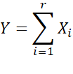  ~ Negative Binomial (r, p)
Convolution | Negative Binomial (D) | Negative Binomial (D) | X ~ Negative Binomial (r, p)  ~ Negative Binomial (r², p)
Convolution | Bernoulli  (D) | Binomial  (D) | X ~ Bernoulli (p)  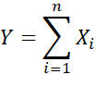  ~ Binomial (n, p)
Convolution | Binomial  (D) | Binomial  (D) | X ~ Binomial (n, p)  ~ Binomial (n², p)
Convolution | Exponential  (C) | Gamma  (C) | X ~ Exponential (λ)  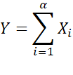  ~ Gamma (α, λ)
Convolution | Gamma  (C) | Gamma  (C) | X ~ Gamma (α, λ)  ~ Gamma (α², λ)
Convolution | Gaussian  (C) | Gaussian  (C) | X ~ Gaussian (µ, σ²)  ~ Gaussian (n*µ, n*σ²)
Convolution | Chi-squared  (C) | Chi-squared  (C) | X ~ Chi-squared (υ)  ~ Chi-squared (n*υ)
Convolution | Poisson  (D) | Poisson  (D) | X ~ Poisson (λ)  ~ Poisson (n*λ)
Central Limit Theorem | Geometric  (D) | Gaussian  (C) | X ~ Geometric (p)  µ=(1-p)/p, σ²=(1-p)/(n*p²)  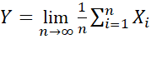  ~ Gaussian (µ, σ²)
Central Limit Theorem | Uniform  (C) | Gaussian  (C) | X ~ Uniform (a, b)  µ=(a+b)/2, σ²=(b-a)²/(12*n)  ~ Gaussian (µ, σ²)
Special Cases | Hypergeometric (D) | Bernoulli  (D) | Sample size n = 1
Special Cases | Negative Binomial (D) | Geometric  (D) | r = 1
Special Cases | Binomial (D) | Bernoulli (D) | n = 1
Special Cases | Gamma (C) | Exponential (C) | α = 1
Special Cases | Uniform (C) | Beta (C) | a = 0, b = 1
Table S1 Glossary: n = # trials (for binomial), n = #draws without replacement (for hypergeometric), m = # successes in the population, N = finite population size, p = probability of success, λ = occurrence rate, µ = mean, σ² = variance, r = r^{th} success, a = start of interval, b = stop of interval, α = shape 1, β = shape 2, υ = degrees of freedom. Another term for Gaussian is “Normal”.

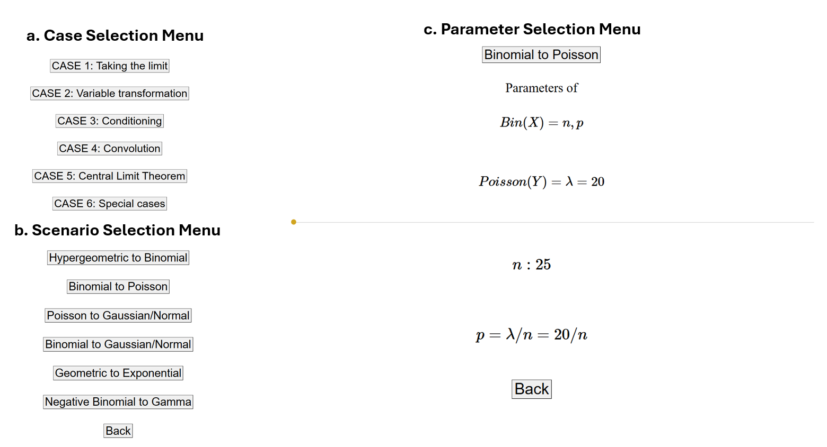

Figure S1. (a) Case selection menu. (b) Scenario selection menu for Case 1: Taking the limit. (c) Parameter selection menu for the binomial to Poisson scenario. The p value for binomial is defined as λ/n because p represents the probability of success, which is equivalent to the average number of successes λ divided by the number of trials n. λ is held constant at 20 to demonstrate what occurs as n grows large.
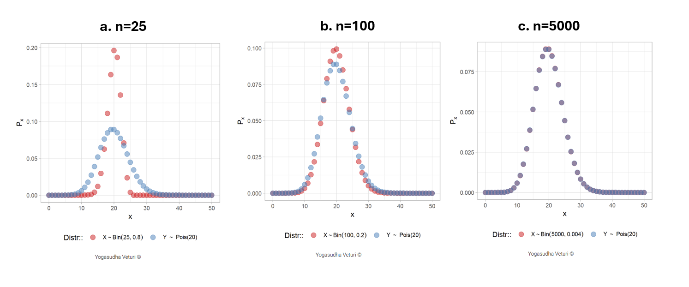
Figure S2. A plot of the source binomial distribution (in red) converging to the target Poisson distribution (in blue) due to taking the limit of the sample size n to infinity. (a) n=25. (b) n=100. (c) n=5000.

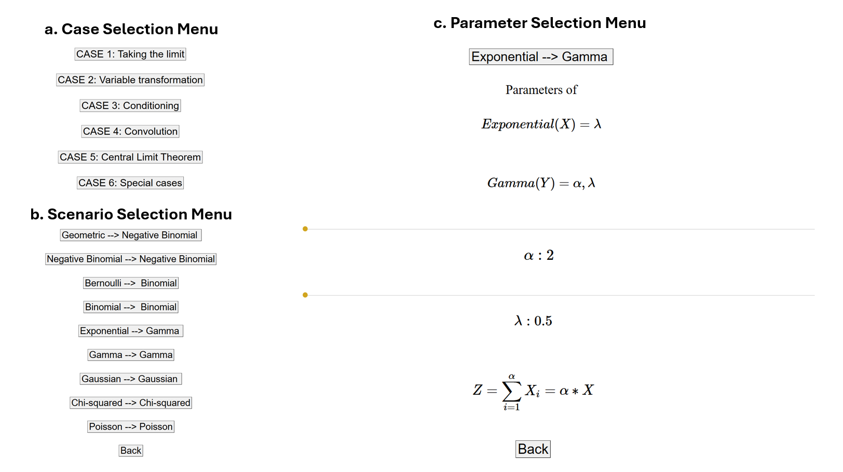 Figure S3. (a) Case selection menu. (b) Scenario selection menu for Case 4: Convolution. (c) Parameter selection menu for the exponential to gamma scenario. The Z random variable is defined as the sum of α independent and identically distributed exponential random variables. The λ parameter remains the same for all exponential random variables because they are independent and identically distributed, and as such is identical to the λ parameter for gamma.

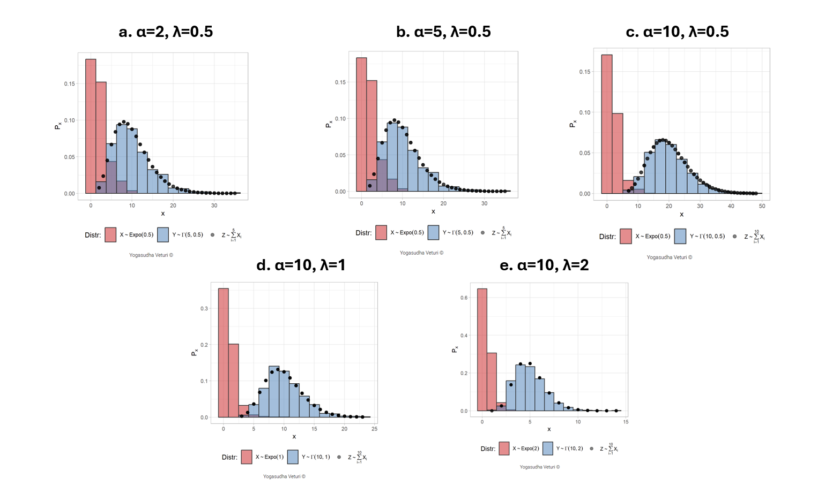
Figure S4. A plot of the source exponential distribution (in red) and the sum of α exponential random variables (in black) converging to the target gamma distribution (in blue) due to convolution, regardless of the value of α or λ. (a) α=2, λ=0.5. (b) α=5, λ=0.5. (c) α=10, λ=0.5. (d) α=10, λ=1. (e) α=10, λ=2.

Table S2. Eighteen questions asked to students of STAT 414 during finals week in Spring 2024 with the correct answer italicized and bolded. The questions were asked in the following order (note that iid = independent and identically distributed and d.f. = degrees of freedom):
Question | Multiple Choice Answers
1. Can we go from Hypergeometric distribution to Binomial distribution? (Q7) | - No  - Yes. As the sample size n->infinity  - Yes. As the population size N-->infinity  - Yes. As the probability of success p-->1  - B, C, D  - B, C  - By conditioning: X|X+Y=n where X and Y are both independent hypergeometric
2. Can we go from Binomial distribution to Hypergeometric distribution? (Q9) | - No  - Yes. As the sample size n->infinity  - Yes. As the population size N-->infinity  - Yes. As the probability of success p-->1  - B, C, D  - B, C  - By conditioning: X|X+Y=n where X and Y are both independent binomial
3. Can we go from Binomial distribution to Poisson distribution (with a fixed occurrence rate lambda)? (Q12) | - No  - Yes. As the sample size n->infinity  - Yes. As the probability of success p-->0  - Yes. As the probability of success p-->1  - B, C  - By conditioning: X|X+Y=n where X and Y are both independent binomial
4. Can we go from Poisson distribution to Binomial distribution? (Q6) | - No  - Yes. As the occurrence rate lambda ->infinity  - Yes. As the occurrence rate lambda ->0  - Yes. As the occurrence rate lambda ->1  - By conditioning: X|X+Y=n where X and Y are both independent Poisson
5. Can we go from Negative Binomial distribution to Gamma distribution? (Q16) | - No  - Yes. As the required number of successes r-> infinity  - Yes. As the probability of success p-->0  - Yes. As the probability of success p-->0.5  - B, C  - By conditioning: X|X+Y=n where X and Y are both independent negative binomial
6. Can we go from Poisson distribution to Normal distribution? (Q17) | - No  - Yes. As the occurrence rate lambda->infinity  - Yes. As the occurrence rate lambda-->0  - Yes. As the occurrence rate lambda-->1  - Yes. By applying CLT, the sample mean converges to normal as n-->infinity  - B, E
7. Can we go from Binomial distribution to Normal distribution? (Q15) | - No  - Yes. As the sample size n->infinity  - Yes. As the probability of success p-->0  - Yes. As the probability of success p->0.5  - Yes. By applying CLT, the sample mean converges to normal as n-->infinity  - B, E  - B, D, E  - B, C, E
8. Can we go from Exponential distribution to Chi-squared distribution? (Q13) | - No  - Yes. When the rate parameter lambda-->1/2 we get chi-squared with 2 d.f.  - Yes. When the rate parameter lambda-->1 we get chi-squared with 2 d.f.  - Yes. When the rate parameter lambda-->1/2 we get chi-squared with 1 d.f.  - Yes. When the rate parameter lambda-->2 we get chi-squared with 2 d.f.  - Yes. When the rate parameter lambda-->2 we get chi-squared with 1 d.f.
9. Can we go from Uniform distribution to Exponential distribution? (Q8) | - No  - Yes. When we make the transformation -ln(1-U) on U~U (0,1)  - Yes. As the upper limit b-->infinity  - Yes. When we make the transformation -ln(1-U) on U~U (1,1)  - B and C  - C and D
10. Can we go from Geometric distribution to Negative binomial? (Q11) | - No  - Yes. When we sum n iid geometric (p) random variables we get negative binomial (n,p)  - Yes. When we sum n independent geometric (p_i) random variables we get negative binomial (n,p_i); i= 1,2,...n  - Yes. As the probability of success (p) --> 0.5  - B and C  - C and D
11. Can we go from Normal distribution to Chi-squared distribution? (Q18) | - No  - Yes. When we sum iid N (0,1) random variables, we get chi-squared with 1 d.f.  - Yes. When we square a N (0,1) random variable, we get a chi-squared with 1 d.f.  - Yes. When we sum squares of n N (0,1) random variables, we get chi-squared with n d.f.  - B and D  - Yes. When we square a N (0,1) random variable, we get chi-squared with n d.f.
12. Can we go from Exponential distribution to Gamma distribution? (Q14) | - No  - Yes. When we sum n iid exponential (lambda) random variables, we get gamma (n, lambda) distribution  - Yes. When we sum n independent exponential (lambda_i) random variables, we get gamma (n,lambda_i) distribution; i= 1,2,...n  - Yes. As the occurrence rate lambda-->infinity  - Yes. If we go from distribution of inter-arrival times to distribution of arrival times in a Poisson Process  - B and E
13. Can we go from Geometric distribution to Normal distribution? (Q2) | - No  - Yes. When we sum n iid exp(lambda) random variables, we get N (0, lambda) distribution  - Yes. A sample size --> infinity, sampling distribution of the sample mean converges to Normal according to Central Limit Theorem  - Yes. As the probability of success p-->0  - Yes. When we subtract the mean and divide by the SD of any geometric random variable, we get N (0,1)  - C and E
14. Can we go from Uniform distribution to Normal distribution? (Q3) | - No  - Yes. When we sum n iid U (0,1) random variables, we get N (0, 1) distribution  - Yes. As sample size --> infinity, sampling distribution of the sample mean converges to Normal according to Central Limit Theorem  - Yes. Square of U (0,1) random variable follows N (0, 1) distribution  - Yes. When we subtract the mean and divide by the SD of any Uniform random variable, we get N (0,1)  - C and E
15. Can we go from Hypergeometric distribution to Bernoulli distribution? (Q5) | - No  - Yes. When the sample size n=1  - Yes. As the sample size n-->infinity  - Yes. Only when both population size N=1 and sample size n=1
16. Can we go from Gamma distribution to Exponential distribution? (Q1) | - No  - Yes. Sum of iid gamma random variables follows exponential  - Yes. When shape parameter alpha=1  - Yes. When rate parameter lambda=1  - C and D
17. Can we go from Negative binomial distribution to Geometric distribution? (Q4) | - No  - Yes. Sum of iid negative binomial random variables follows geometric  - Yes. When number of successes r=1  - Yes. When the probability of success p=1  - C and D
18. Can we go from Uniform distribution to Beta distribution? (Q10) | - No  - Yes. U (0,1) follows Beta (0,1)  - Yes. U (0,1) follows Beta (1,1)  - Yes. U (0,n) follows Beta (0,n)

Table S3. Year of Study vs Major. 25 individuals answered pre- and post-surveys. All but 1 individuals were in the 18-25 age range.
 | Actuarial Science | Biological Sciences | Data Science | Engineering | Mathematics | Physics | Statistics | Other | Total
1 | 1 | 1 | 0 | 0 | 0 | 0 | 0 | 1 | 3
2 | 1 | 0 | 9 | 2 | 2 | 0 | 2 | 1 | 17
3 | 1 | 0 | 2 | 0 | 0 | 1 | 0 | 0 | 4
4+ | 0 | 0 | 0 | 0 | 0 | 1 | 0 | 0 | 1
Total | 3 | 1 | 11 | 2 | 2 | 2 | 2 | 2 | 25

Table S4. Year of Study vs Confidence Level. 25 individuals answered pre- and post-surveys. All but 1 individuals were in the 18-25 age range.
 | I don’t feel confident at all | I have low-level confidence | I feel moderately confident | Total
1 | 0 | 1 | 2 | 3
2 | 1 | 9 | 7 | 17
3 | 0 | 3 | 1 | 4
4+ | 0 | 1 | 0 | 1
Total | 1 | 14 | 10 | 25

Table S5. Major vs Confidence Level. 25 individuals answered pre- and post-surveys. All but 1 individuals were in the 18-25 age range.
 | I don’t feel confident at all | I have low-level confidence | I feel moderately confident | Total
Actuarial Science | 0 | 3 | 0 | 3
Biological Sciences | 0 | 0 | 1 | 1
Data Science | 1 | 4 | 6 | 11
Engineering | 0 | 1 | 1 | 2
Mathematics | 0 | 2 | 0 | 2
Physics | 0 | 0 | 2 | 2
Statistics | 0 | 2 | 0 | 2
Other | 0 | 2 | 0 | 2
Total | 1 | 14 | 10 | 25

Table S6. Confidence level before vs “confidence level improved after presentation. 25 individuals answered pre- and post-surveys. All but 1 individuals were in the 18-25 age range.
 | Agree | Disagree | Neutral | Strongly Agree | Total
I don’t feel confident at all | 0 | 0 | 1 | 0 | 1
I have low-level confidence | 6 | 1 | 6 | 1 | 14
I feel moderately confident | 8 | 0 | 1 | 1 | 10
Total | 14 | 1 | 8 | 2 | 25

Table S7. Confidence level before vs “I found the presentation useful”. 25 individuals answered pre- and post-surveys. All but 1 individuals were in the 18-25 age range.
 | Agree | Neutral | Strongly Agree | Total
I don’t feel confident at all | 1 | 0 | 0 | 1
I have low-level confidence | 7 | 5 | 2 | 14
I feel moderately confident | 8 | 1 | 1 | 10
Total | 16 | 6 | 3 | 25

Table S8. Confidence level before vs “I found the presentation engaging”. 25 individuals answered pre- and post-surveys. All but 1 individuals were in the 18-25 age range.
 | Agree | Disagree | Neutral | Strongly Agree | Total
I don’t feel confident at all | 0 | 0 | 0 | 1 | 1
I have low-level confidence | 6 | 0 | 2 | 6 | 14
I feel moderately confident | 6 | 1 | 1 | 2 | 10
Total | 12 | 1 | 3 | 9 | 25

Table S9. Wearing Hololens (yes/no) vs “confidence level improved after presentation”. 25 individuals answered pre- and post-surveys. All but 1 individuals were in the 18-25 age range.
 | Agree | Disagree | Neutral | Strongly Agree | Total
Yes | 5 | 1 | 3 | 2 | 11
No | 9 | 0 | 5 | 0 | 14
Total | 14 | 1 | 8 | 2 | 25

Table S10. Wearing Hololens (yes/no) vs “I found the presentation engaging. 25 individuals answered pre- and post-surveys. All but 1 individuals were in the 18-25 age range.
 | Agree | Disagree | Neutral | Strongly Agree | Total
Yes | 4 | 0 | 2 | 5 | 11
No | 8 | 1 | 1 | 4 | 14
Total | 12 | 1 | 3 | 9 | 25

