Supplementary information

Imaging the Alternatively Spliced D Domain of Tenascin C in Preclinical Models of Inflammatory Bowel Disease

¹AbbVie Bioresearch Center, Worcester, MA 01605

Table of Contents

1. Reagent characterization
2. Mouse colitis
3. Primate colitis

1. Reagent characterization
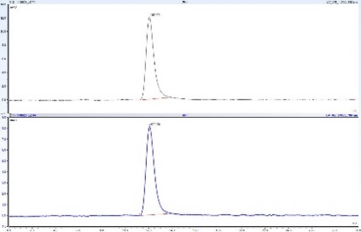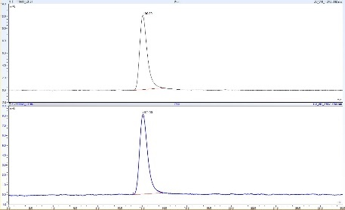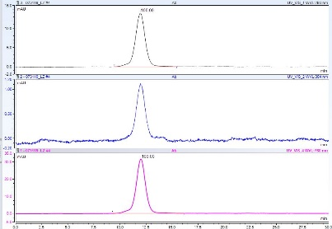
Figure S1. (Left) TNC D IgG-800CW; (Middle) ABBV022-800CW; (Right) non-targeted scFv. Size exclusion chromatograms for various NIR labeled reagents. For each analyte, both 280 nm (top) and 770 nm (bottom) absorption are measured. The data suggest high monomer purity and minimal unreacted fluorophore.

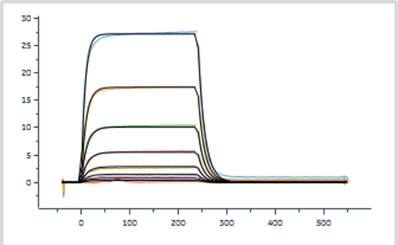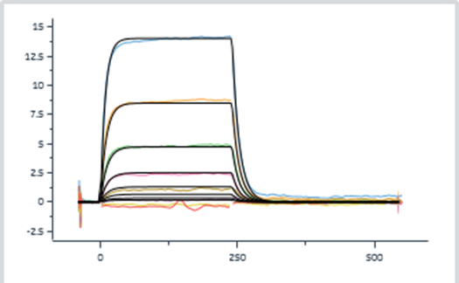
Figure S2. Surface plasmon resonance (SPR) data for unlabeled (left) and 800CW labeled (right) ABBV022 scFv fusion protein. The data suggest minimal impact of binding to TNC D post-fluorophore conjugation.

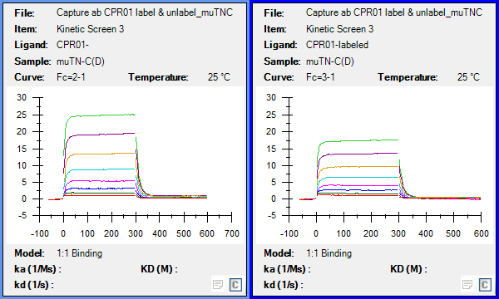
Figure S3. Surface plasmon resonance (SPR) data for unlabeled (left) and 800CW labeled (right) TNC D IgG. The data suggest minimal impact of binding to TNC D post-fluorophore conjugation.
2. Mouse colitis

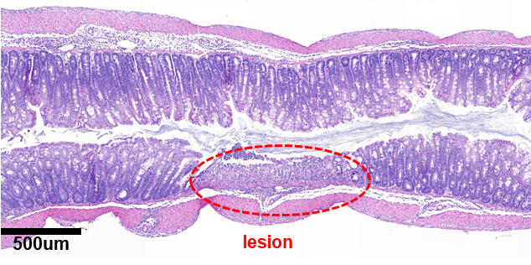

Figure S4. Mouse colon (H&E, left). A colonic lesion is circled (red). From the H&E and macroscopic NIR image (right), lesions appear to be ellipsoid in shape with minor and major axes averaging 100 µm and 300 µm, respectively. On average, we observe between 20-30 lesions per colon with an estimated average volume of 4 x 10⁻⁵ cm³.
Using the lower affinity scFv fusion construct, colon digest data estimated the absolute diabody amount at 24 h post IV to be ~ 2.2 pmol. Non-targeting controls and blocking controls from digests estimated non-specific uptake to be ~1 pmol. Assuming the difference (1.2 pmol) is subsaturating, a conservative lesional concentration for the TNC targeting scFv fusion is calculated to be > 100nM given the lesion volume estimates.

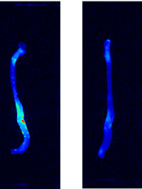
Figure S5. Macroscopic NIR images of resected DSS mouse colon. Animals received either 0.7 nmol ABBV022-800CW (left) or 0.7 nmol ABBV022-800CW + 20 nmol unlabeled TNC D IgG (right). A reduction in punctate lesion signal is observed with the blocking dose.

Due to higher %ID/g in the kidney and liver for the diabody compared to the IgG, we wanted to confirm if this was a result of the NIR label. Tyrosine iodination for the ABBV022 scFv fusion was performed with lactoperoxidase (Perkin Elmer, Waltham, MA). [¹²⁵I]ABBV022 was obtained with an A_{s} of 0.470 GBq/mg in 95% radiochemical purity as determined by ITLC.
Seven-day acute murine colitis was induced in wild-type C57BL/6 mice with 3% DSS in the drinking water. On day 7, animals were intravenously co-dosed with 0.074 MBq of [¹²⁵I]ABBV022 and 1 nmol of ABBV022-800CW via tail vein injection. Whole blood was collected to determine the systemic clearance via gamma detection and NIR fluorescence (Fig. S9). After 24 h, one cohort of animals (n=3) were euthanized and the colons were imaged using a near infrared scanner. Afterwards, samples were placed onto a phosphoimaging screen, placed into a cassette, and exposed for 72 h before being scanned using a GE phosphor imager FLA 7000. The autoradiographic results were compared to the NIR images (Fig. S6). %ID/g were determined for each colon using gamma counting and NIR homogenization (Fig. S7).

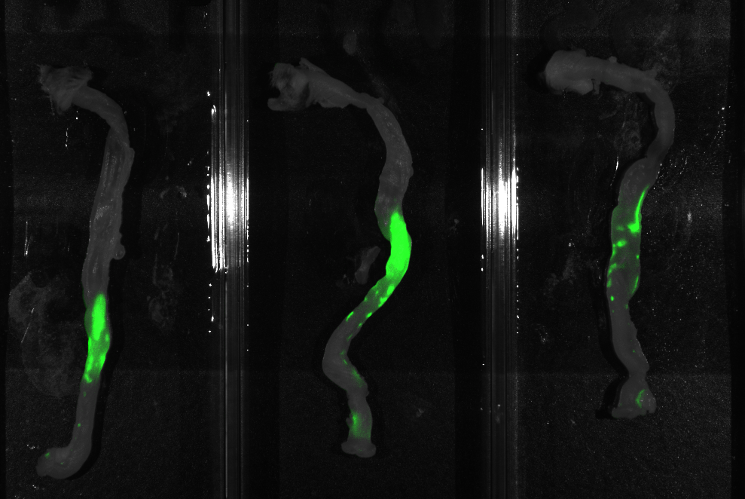
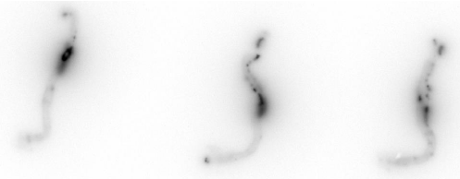
Figure S6. 24 h macroscopic NIR scans (top) and phosphorimages (bottom) of resected colon from mice treated with DSS. Top and bottom scans represent the same colon and show agreement in lesion accumulation independent of imaging modality and label chemistry.

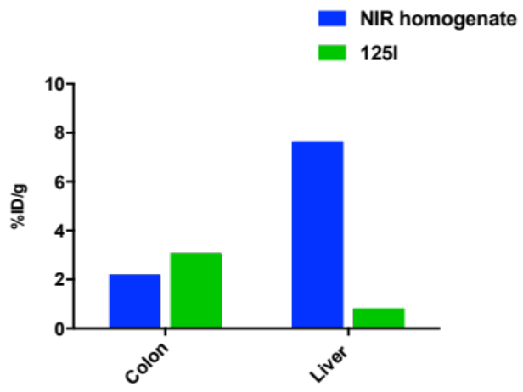
Figure S7. Normalized uptake values using gamma count and NIR homogenate for DSS colon. Values are measured in triplicate. Data suggest minimal differences in normalized colon uptake between labeling chemistries. Liver normalize uptake is significantly higher for the NIR approach, likely due to residualization of the fluorescent label.

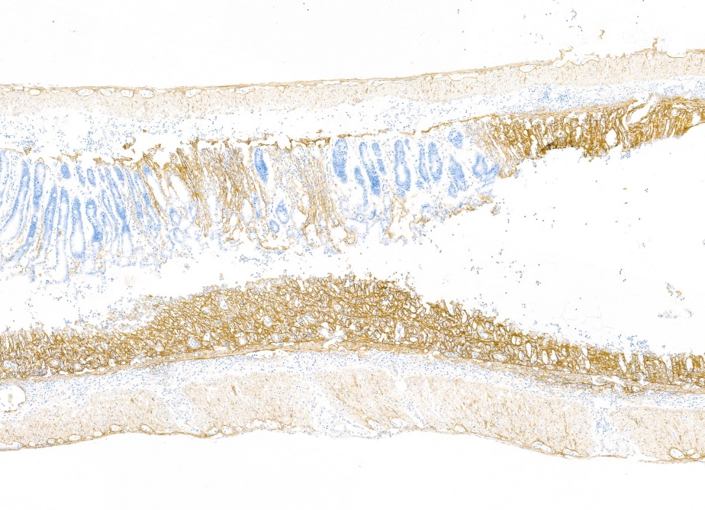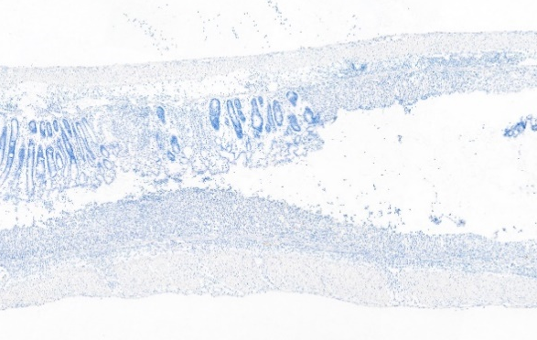
Figure S8. Anti-human IHC (left) and isotype control (right) for serial mouse DSS colon sections. The anti-human staining is in agreement with the NIR signal in Fig. 4C.

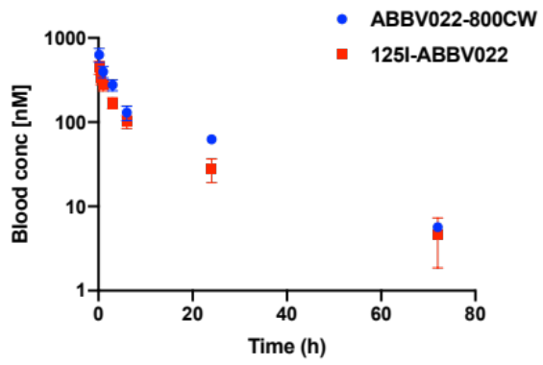
Figure S9. Systemic clearance for IV dosed scFv fusions labeled with either 800CW or ¹²⁵I from the same animal. Fluorescent concentrations are obtained by using a standard curve of known concentrations. Concentrations for iodinated reagents are converted assuming linear pharmacokinetics and using the specific activity of the reagents. The data suggest minimal differences in systemic clearance between the fluorescent and iodinated reagents.

3. Primate colitis
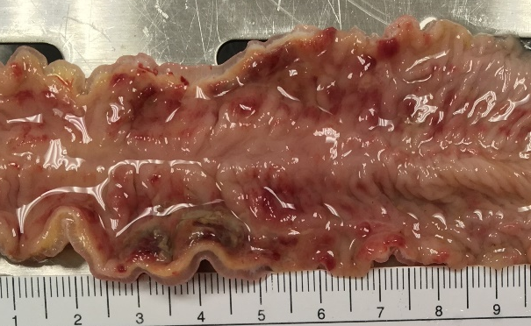
Figure S10. TNBS induces ulceration, hemorrhaging, and bowel wall thickening in distal colon of cynomolgus macaque. Note thickened bowel between 2-5 cm position on ruler, where lesions are transmural. Red, hemorrhagic areas are present on mucosa surface throughout the section. An ulcer with a pseudomembrane is seen between 3-5 cm.

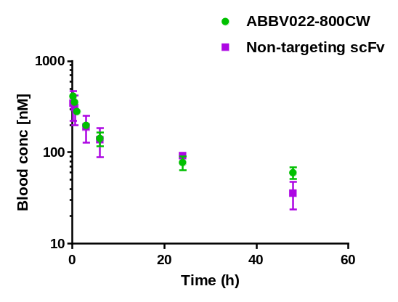
Figure S11. Systemic clearance for IV dosed scFv fusion proteins labeled with IRDye 800CW. The non-targeting scFv was used to estimate non-specific signal in the diseased colon.

Figure S12. Near infrared images of inflamed (left) and healthy (right) colons sections from the same primate. There is increased diffuse fluorescent signal in the diseased segment, likely due to a combination of specific and non-specific uptake.
Biopsies samples were removed at 24 h to estimate colon concentration of dosed scFv fusion proteins. Following resection, the biopsies were digested using a mixture of collagenase type IV and RIPA buffer, followed by trypsin and sonication. The fluorescent signal was measured using a NIR Odyssey CLx scanner and converted to ng/g using fluorescent standards of known digested amounts of dosed protein. While the inflamed biopsy had 2-fold higher concentration of ABBV022-800CW compared to healthy tissue, a similar trend was observed for the non-targeting scFv protein. This suggests non-specific signal on the organ level and microscopy was used to confirm cellular-level TNC D specificity.

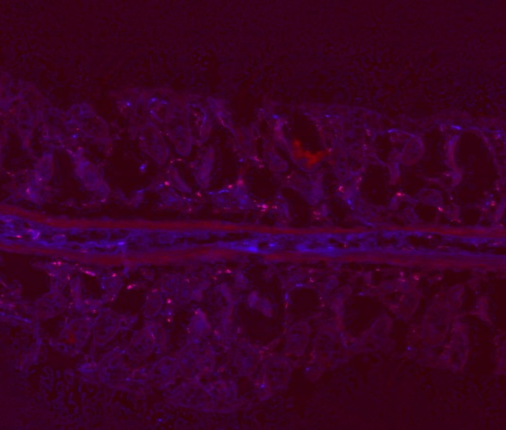
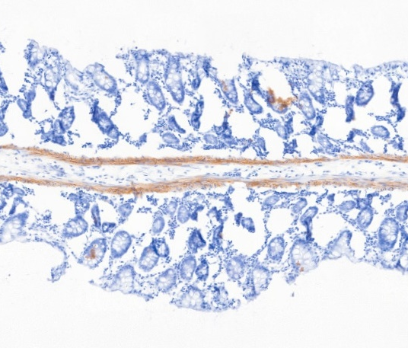
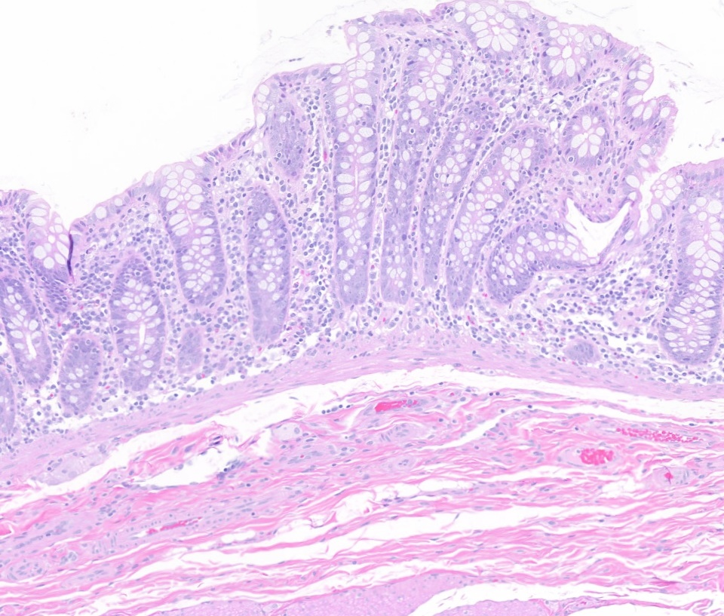

Figure S13. Hematoxylin and eosin stain (left); TNC D IHC (middle); NIR image (right) for healthy primate colon. There is a lack of inflammatory cell infiltrate and faint TNC D signal is reserved to the muscularis in both the IHC and NIR images.

