Supplemental Material
Supplemental Figure 1. Predictive performance on each internal validation dataset across model architectures.
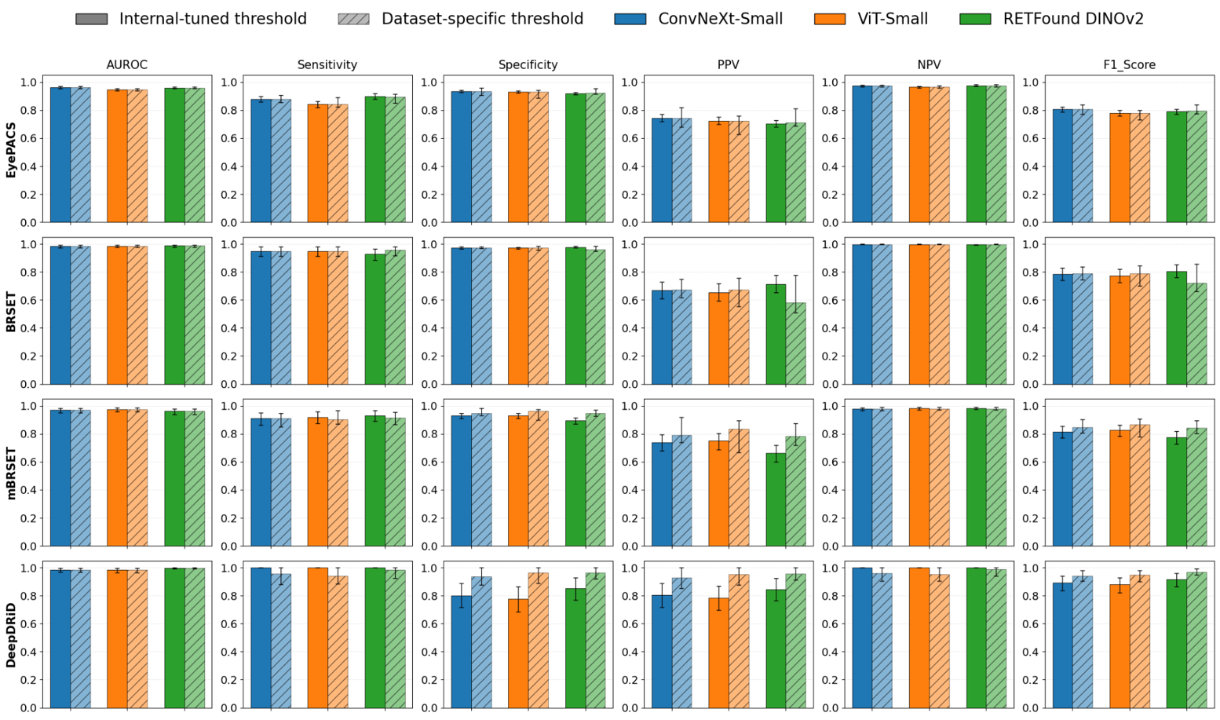
Bar charts summarise six performance metrics—AUROC, sensitivity, specificity, PPV, NPV, and F1 score—for three model architectures (ConvNeXt-Small, ViT-Small, and RETFound DINOv2) across four internal validation datasets, evaluated under two threshold strategies (internally tuned and each dataset-specific). Solid bars denote the internally tuned threshold, whereas hatched bars denote the dataset-specific threshold.

Abbreviations: AUROC, area under the receiver operating characteristic curve; NPV, negative predictive value; PPV, positive predictive value.

Supplemental Figure 2. Predictive performance on each external validation dataset across model architectures.
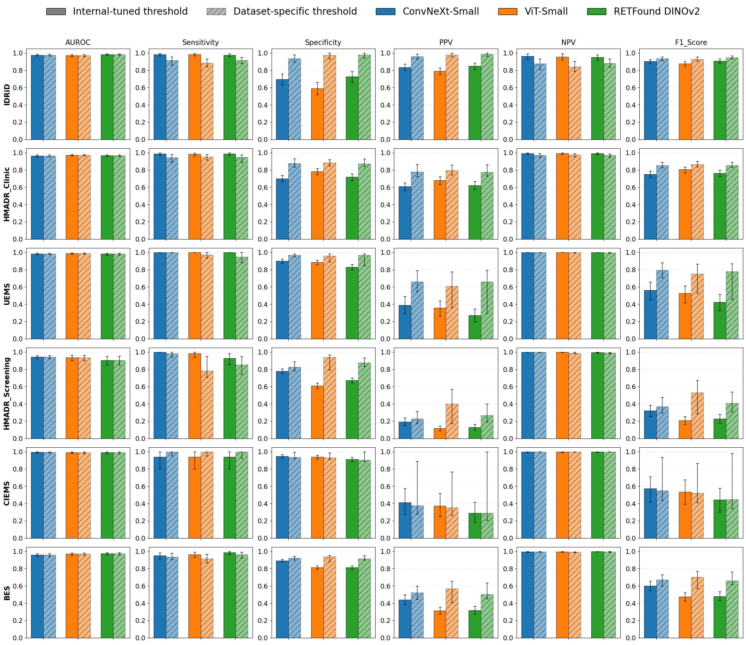
Bar charts summarise six performance metrics—AUROC, sensitivity, specificity, PPV, NPV, and F1 score—for three model architectures (ConvNeXt-Small, ViT-Small, and RETFound DINOv2) across six external validation datasets, evaluated using two threshold strategies (internally tuned and each dataset-specific). Solid bars denote the internally tuned threshold, whereas hatched bars denote the dataset-specific threshold.

Abbreviations: AUROC, area under the receiver operating characteristic curve; NPV, negative predictive value; PPV, positive predictive value. BES, Beijing Eye Study; CIEMS, Central India Eye and Medical Study; UEMS, Ural Eye and Medical Study.

Supplemental Figure 3. Calibration plots and calibration metrics for each external validation dataset.
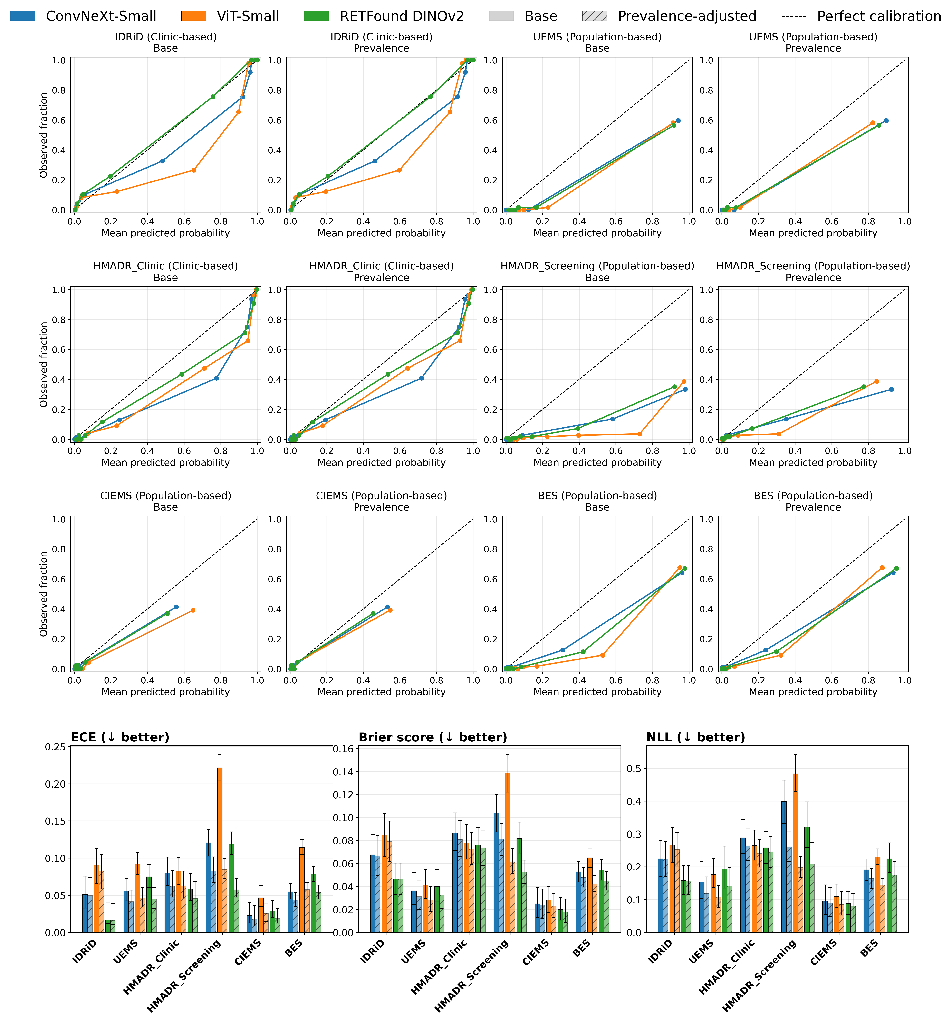
Reliability diagrams plot mean predicted probability against observed event frequency across 10 equal-frequency bins for each of the six external validation datasets (IDRiD, HMADR_Clinic, UEMS, HMADR_Screening, CIEMS, and BES). For all dataset, results are presented separately for the base predicted probabilities and for predictions after prevalence-based odds adjustment. The diagonal dashed line indicates perfect calibration. The bottom panels summarise the corresponding calibration metrics—ECE (left), Brier score (middle), and negative log-likelihood (right) with their 95% confidence intervals—comparing base predictions with prevalence-adjusted predictions across all six external datasets.

Abbreviations: BES, Beijing Eye Study; CIEMS, Central India Eye and Medical Study; ECE, expected calibration error; NLL, negative log-likelihood; UEMS, Ural Eye and Medical Study.

Supplemental Figure 4. Alignment between model-derived and clinician-derived uncertainty across three model architectures and the HMADR datasets, with model uncertainty quantified by Deep ensembles.
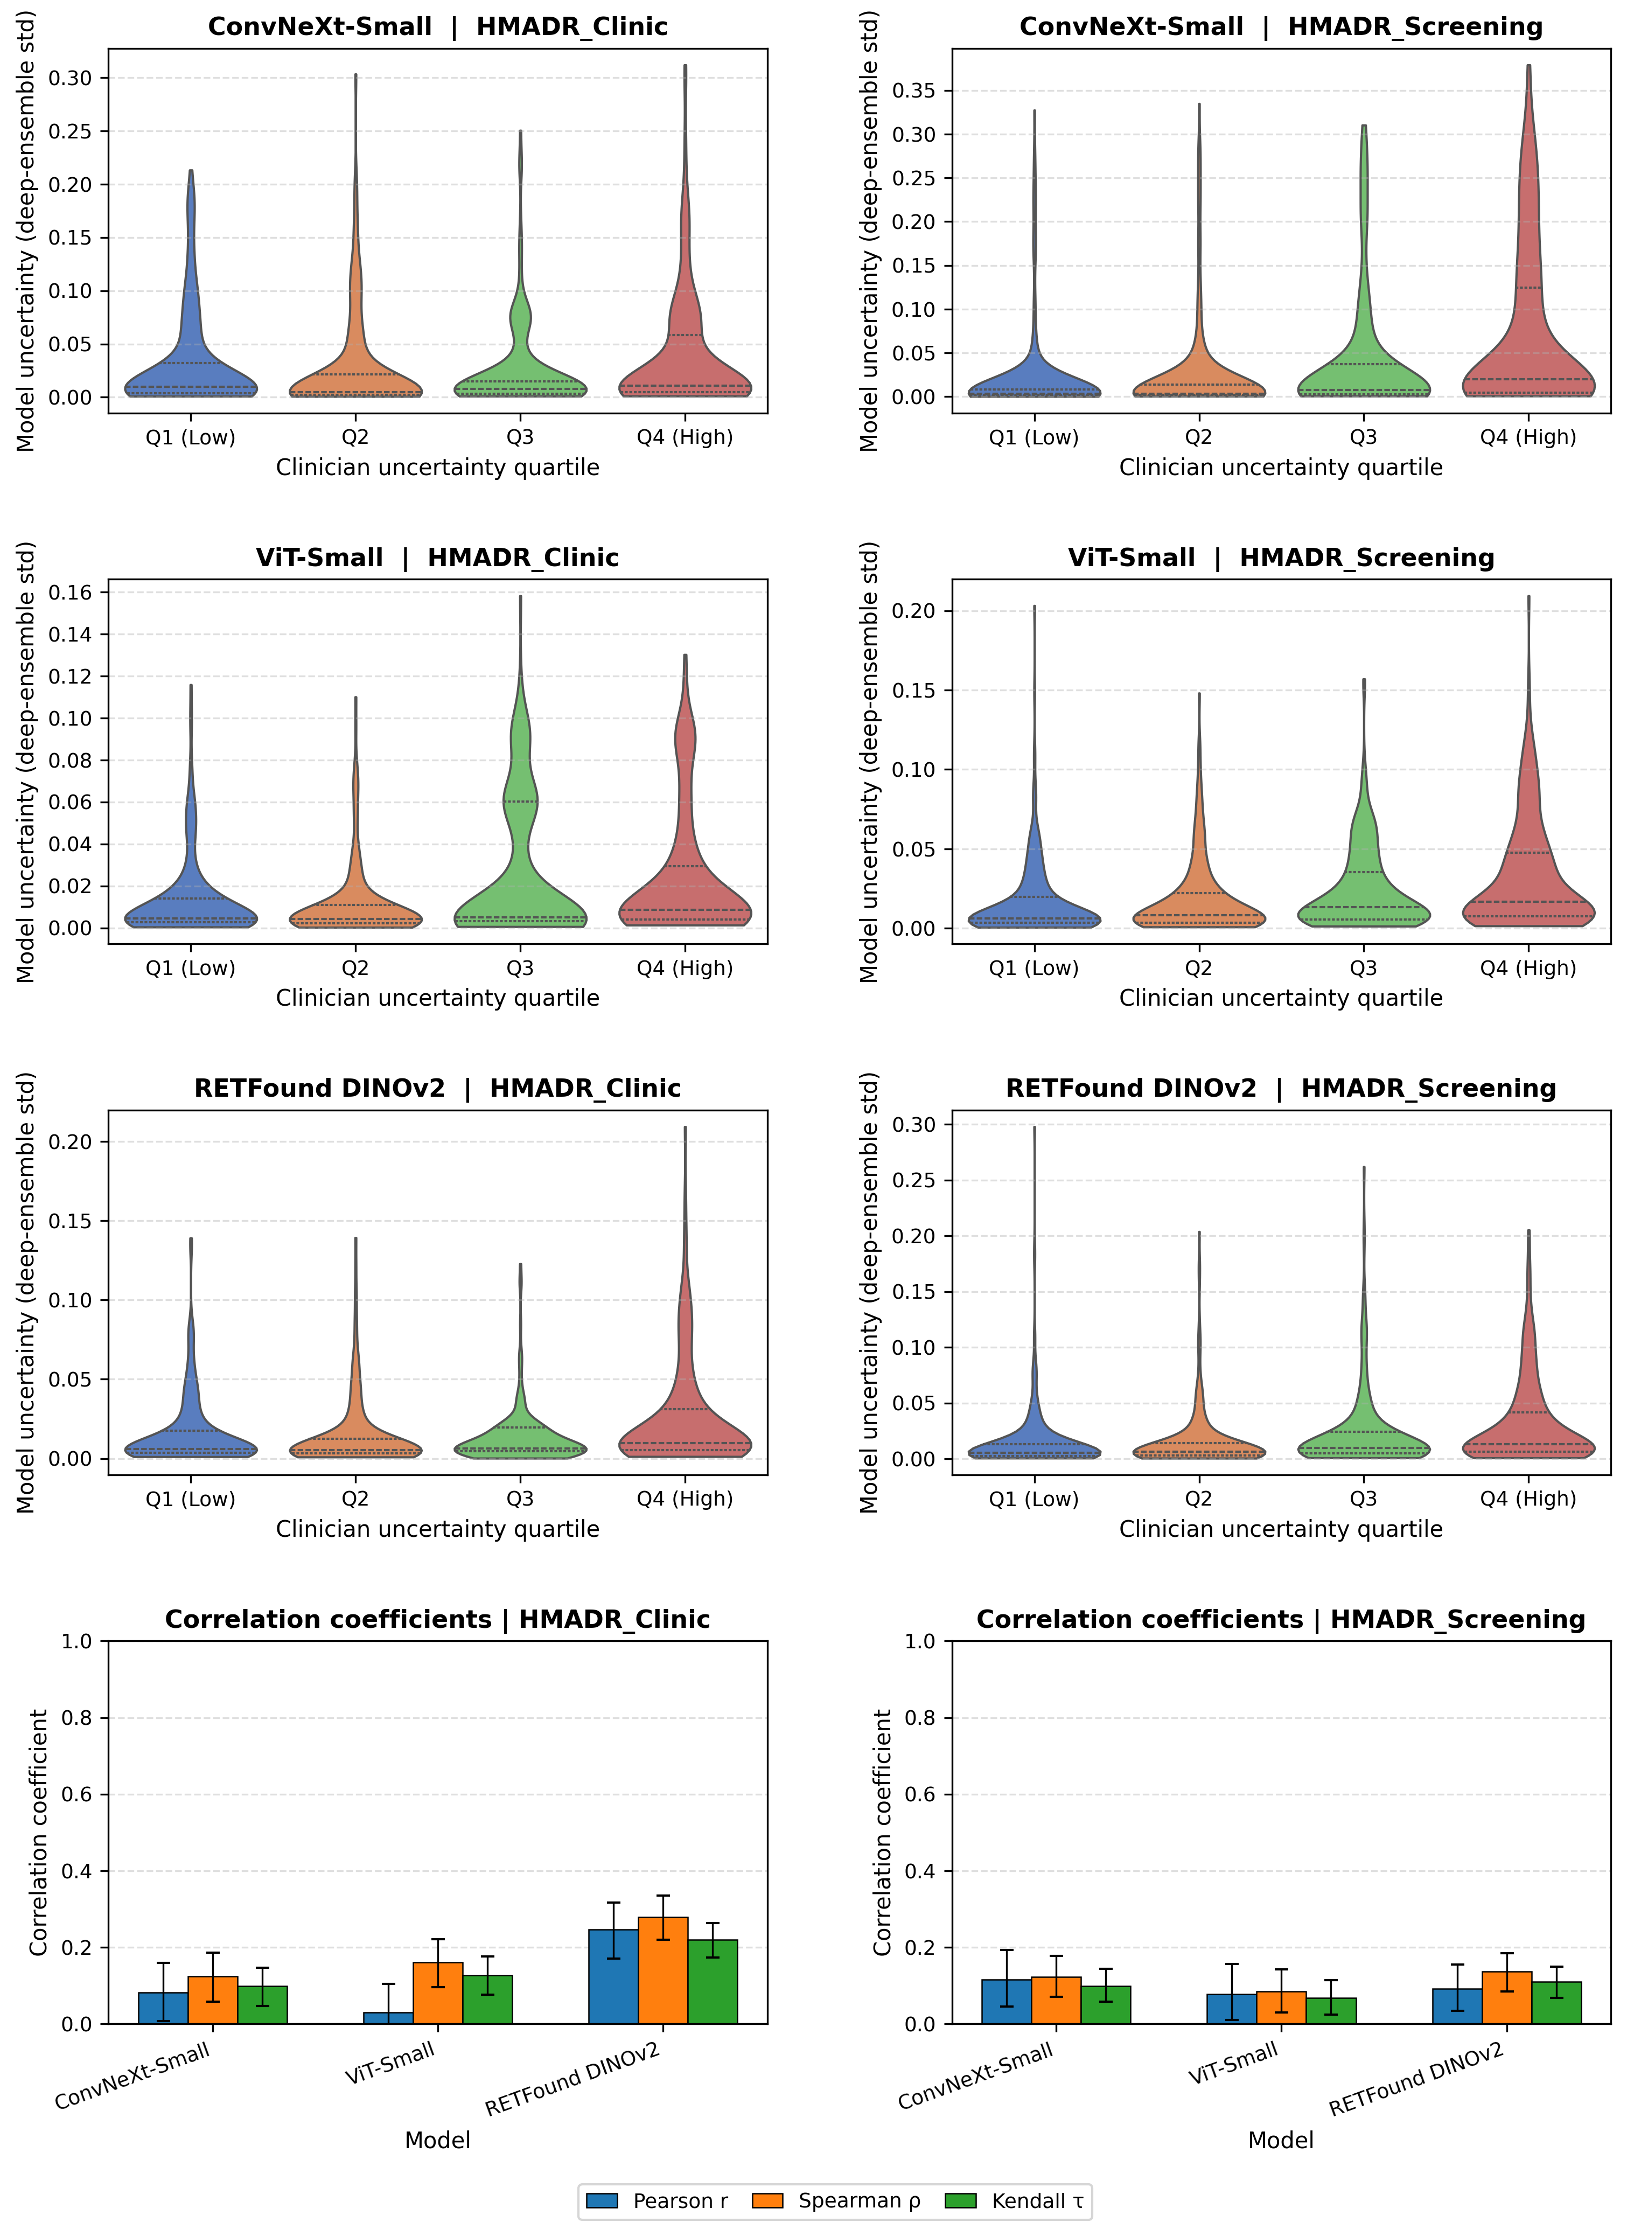
Each row in the upper panels corresponds to one model architecture (ConvNeXt-Small, ViT-Small, and RETFound DINOv2), and each pair of columns corresponds to one dataset (HMADR_Clinic and HMADR_Screening). The violin plots show the distribution of model uncertainty, defined as the predictive standard deviation estimated via Deep Ensemble, stratified by clinician uncertainty quartiles (Q1–Q4). Clinician uncertainty was defined as the standard deviation of the binary labels from five ophthalmologists for each image. The bottom row summarises the Pearson, Spearman’s rank, and Kendall's tau correlation coefficients between clinician and model uncertainty for each model and dataset. Error bars indicate bootstrap 95% confidence intervals.

Supplemental Figure 5. Sensitivity analysis of borderline cases for robustness to noise and cross-device variation in the AI-READI dataset.
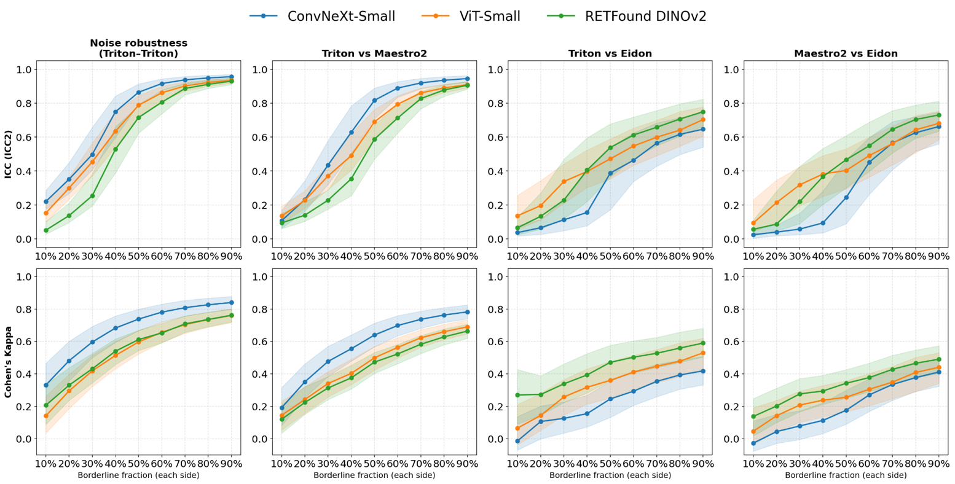
Line plots show how inter-prediction agreement varies as a function of the borderline fraction—defined as the proportion of predicted probabilities closest to the decision threshold on each side—swept from 10% to 90% in 10% increments. Results are shown for three model architectures (ConvNeXt-Small, ViT-Small, and RETFound DINOv2) across four comparison conditions: an intra-device pair for noise robustness (repeated Triton acquisitions from the AI-READI dataset) and three cross-device pairs (Triton vs Maestro2, Triton vs Eidon, and Maestro2 vs Eidon). The upper row shows the intraclass correlation coefficient (ICC) and the lower row shows Cohen's kappa, with shaded bands indicating 95% confidence intervals derived from bootstrap resampling.

Supplemental Figure 6. Inter-version agreement and decision-threshold stability across seven model updates of three model architectures, evaluated on each of six external validation datasets.
Bar charts and line plots summarise discriminative performance (AUROC), inter-update agreement, and the stability of the Youden-optimal threshold across seven model versions (v1–v7) for three model architectures (ConvNeXt-Small, ViT-Small, and RETFound DINOv2), evaluated on each six external validation datasets (IDRiD, HMADR_Clinic, UEMS, HMADR_Screening, CIEMS, and BES). The top row shows AUROC across model versions with 95% bootstrap confidence intervals, plotted as separate lines for each architecture and each dataset. The second and third rows show the average ICC and Cohen's kappa, respectively, between consecutive model versions (v1→v2 through v6→v7); solid bars represent the overall dataset, while hatched bars represent the borderline subset (cases within the upper or lower 10% of the decision threshold). The bottom row shows the group-specific Youden-optimal threshold plotted across model versions, with separate lines for each architecture.

Abbreviations: AUROC, area under the receiver operating characteristic curve; BES, Beijing Eye Study; CIEMS, Central India Eye and Medical Study; ICC, intraclass correlation coefficient; UEMS, Ural Eye and Medical Study.

Supplemental Figure 7. Sensitivity Analysis of Borderline Cases Across Model Update Scenarios
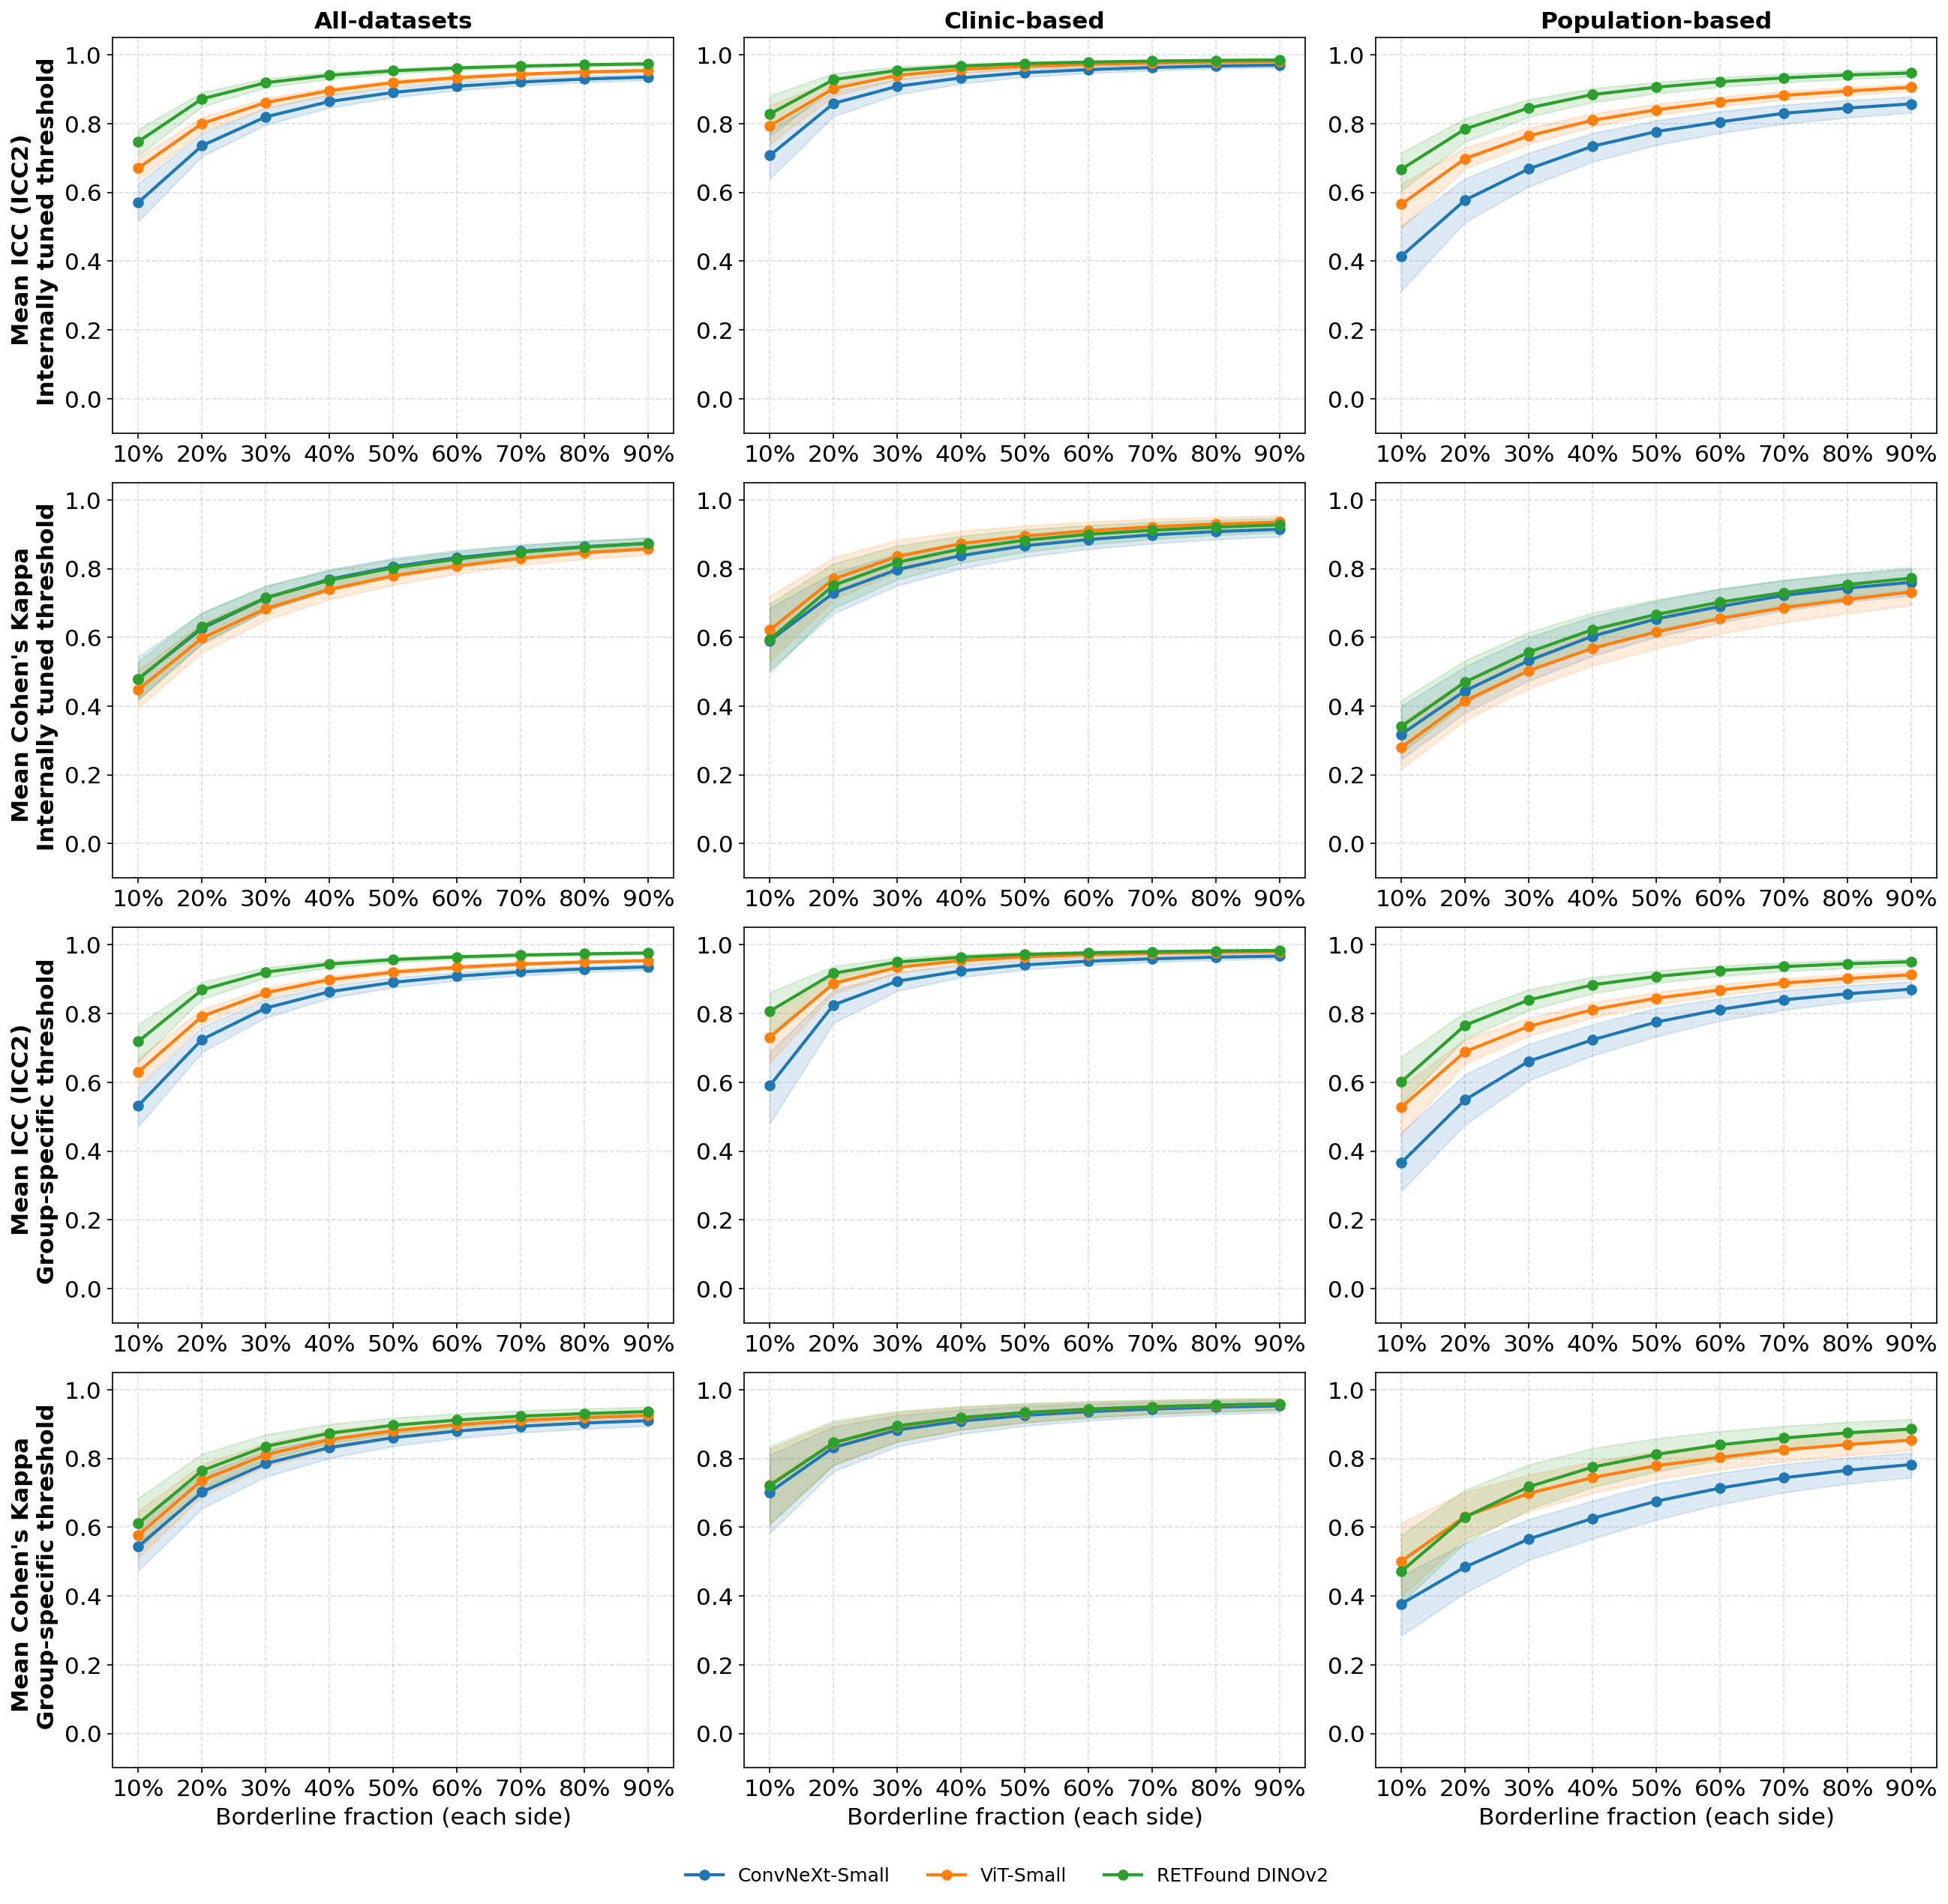
Line plots show how inter-version agreement varies as a function of the borderline fraction — defined as the proportion of predicted probabilities closest to the decision threshold on each side — swept from 10% to 90% in 10% increments. Each panel represents the mean agreement across six consecutive model-version pairs (v1→v2 through v6→v7), evaluated on three external dataset groupings: all-datasets (left column), clinic-based (middle column), and population-based (right column). Results are shown for three model architectures (ConvNeXt-Small, ViT-Small, and RETFound DINOv2), with shaded bands indicating 95% confidence intervals derived from 1,000 bootstrap resamples. The upper two rows use the internally tuned decision threshold, while the lower two rows use a group-specific threshold. Within each threshold strategy, the intraclass correlation coefficient (ICC; first and third rows) and Cohen's kappa (second and fourth rows) are reported.

Abbreviations: ICC, intraclass correlation coefficient.

Supplemental Figure 8. Inter-update agreement across randomised dataset update orderings.
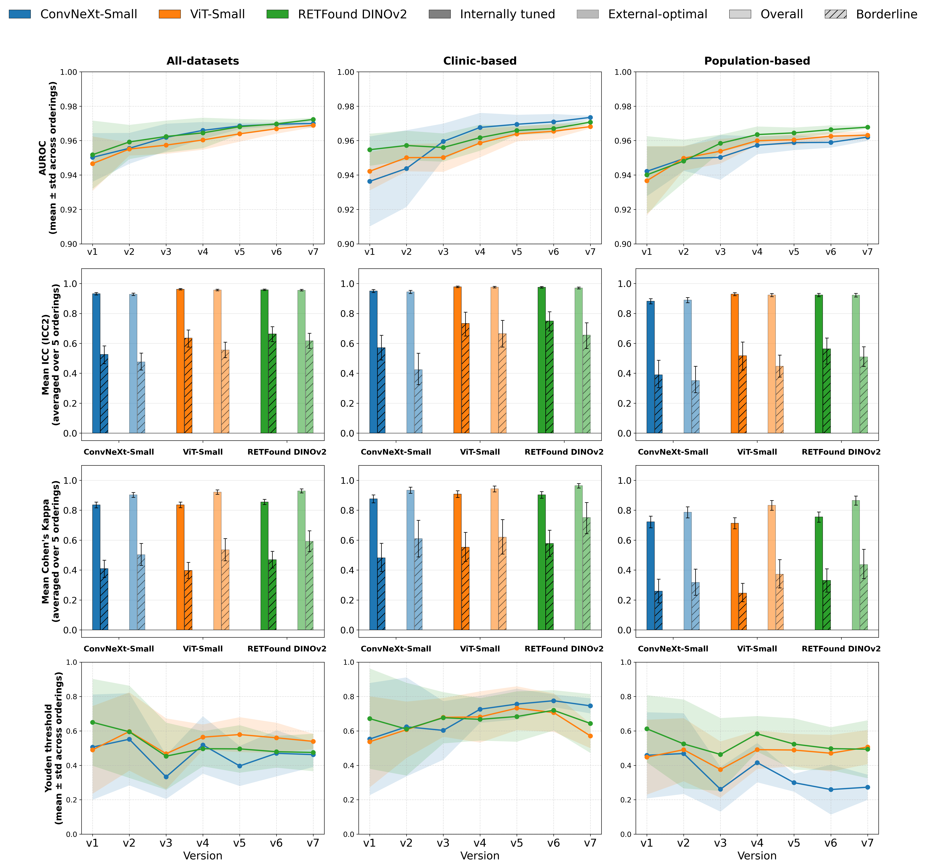
To confirm the robustness of the main findings, models were retrained with five random orderings of dataset updates. Bar charts summarise inter-update agreement (Cohen's kappa and ICC, with 95% confidence intervals) for three model architectures (ConvNeXt-Small, ViT-Small, and RETFound DINOv2) across three external dataset groupings (all-datasets, clinic-based, and population-based). All other details are identical to those of Figure 6.

Abbreviations: ICC, intraclass correlation coefficient.

Supplemental Table 1. Predictive performance of three model architectures for referable DR detection across external validation groups, under two threshold strategies.
Threshold strategy | Group | Model | AUROC | Sensitivity | Specificity | PPV | NPV | F1 score
Internal-tuned | All-datasets | ConvNeXt-Small | 0.966 (0.960–0.971) | 0.980 (0.970–0.989) | 0.841 (0.830–0.852) | 0.527 (0.503–0.552) | 0.996 (0.994–0.998) | 0.685 (0.664–0.706)
 |  | ViT-Small | 0.971 (0.965–0.976) | 0.980 (0.970–0.989) | 0.775 (0.762–0.786) | 0.439 (0.416–0.461) | 0.995 (0.993–0.997) | 0.607 (0.585–0.627)
 |  | RETFound DINOv2 | 0.972 (0.966–0.977) | 0.979 (0.969–0.988) | 0.777 (0.765–0.790) | 0.442 (0.420–0.464) | 0.995 (0.993–0.997) | 0.609 (0.588–0.630)
 | Clinic-based | ConvNeXt-Small | 0.971 (0.963–0.978) | 0.985 (0.974–0.995) | 0.699 (0.665–0.732) | 0.715 (0.684–0.748) | 0.984 (0.972–0.994) | 0.829 (0.807–0.850)
 |  | ViT-Small | 0.971 (0.963–0.979) | 0.983 (0.972–0.993) | 0.731 (0.698–0.766) | 0.737 (0.705–0.770) | 0.983 (0.971–0.993) | 0.843 (0.821–0.866)
 |  | RETFound DINOv2 | 0.974 (0.966–0.981) | 0.982 (0.970–0.992) | 0.720 (0.689–0.752) | 0.729 (0.696–0.758) | 0.981 (0.969–0.992) | 0.837 (0.814–0.857)
 | Population-based | ConvNeXt-Small | 0.960 (0.947–0.969) | 0.968 (0.944–0.988) | 0.869 (0.858–0.879) | 0.333 (0.300–0.367) | 0.998 (0.996–0.999) | 0.495 (0.456–0.533)
 |  | ViT-Small | 0.965 (0.954–0.974) | 0.972 (0.950–0.991) | 0.783 (0.769–0.796) | 0.233 (0.206–0.260) | 0.998 (0.996–0.999) | 0.375 (0.340–0.411)
 |  | RETFound DINOv2 | 0.964 (0.948–0.975) | 0.972 (0.950–0.989) | 0.788 (0.774–0.802) | 0.237 (0.211–0.264) | 0.998 (0.996–0.999) | 0.381 (0.346–0.415)
Group-specific | All-datasets | ConvNeXt-Small | 0.966 (0.960–0.971) | 0.954 (0.938–0.978) | 0.905 (0.883–0.921) | 0.644 (0.594–0.687) | 0.991 (0.988–0.996) | 0.769 (0.737–0.795)
 |  | ViT-Small | 0.971 (0.965–0.976) | 0.922 (0.906–0.953) | 0.922 (0.894–0.934) | 0.680 (0.614–0.716) | 0.985 (0.982–0.991) | 0.783 (0.742–0.807)
 |  | RETFound DINOv2 | 0.972 (0.966–0.977) | 0.943 (0.917–0.958) | 0.910 (0.902–0.936) | 0.655 (0.632–0.720) | 0.989 (0.984–0.992) | 0.773 (0.755–0.811)
 | Clinic-based | ConvNeXt-Small | 0.971 (0.963–0.978) | 0.908 (0.869–0.959) | 0.913 (0.863–0.950) | 0.889 (0.839–0.932) | 0.928 (0.903–0.965) | 0.898 (0.884–0.919)
 |  | ViT-Small | 0.971 (0.963–0.979) | 0.923 (0.869–0.956) | 0.900 (0.865–0.953) | 0.876 (0.843–0.936) | 0.938 (0.903–0.963) | 0.899 (0.883–0.919)
 |  | RETFound DINOv2 | 0.974 (0.966–0.981) | 0.899 (0.884–0.959) | 0.935 (0.878–0.953) | 0.914 (0.854–0.937) | 0.924 (0.913–0.966) | 0.907 (0.891–0.925)
 | Population-based | ConvNeXt-Small | 0.960 (0.947–0.969) | 0.948 (0.930–0.982) | 0.910 (0.886–0.923) | 0.418 (0.352–0.463) | 0.996 (0.995–0.999) | 0.580 (0.515–0.622)
 |  | ViT-Small | 0.965 (0.954–0.974) | 0.900 (0.871–0.941) | 0.928 (0.899–0.940) | 0.459 (0.365–0.509) | 0.993 (0.990–0.996) | 0.608 (0.520–0.652)
 |  | RETFound DINOv2 | 0.964 (0.948–0.975) | 0.932 (0.891–0.961) | 0.917 (0.909–0.952) | 0.433 (0.396–0.562) | 0.995 (0.992–0.997) | 0.592 (0.554–0.693)
Values are point estimates with 95% bootstrap confidence intervals (1,000 resamples).

Abbreviations: AUROC, area under the receiver operating characteristic curve; NPV, negative predictive value; PPV, positive predictive value; DR, diabetic retinopathy.

Supplemental Table 2. Annotation results of HMADR_Clinic and HMADR_Screening, including inter-annotator variability.
Dataset | Class | A1 | A2 | A3 | A4 | A5 | Adjudicated
HMADR_Clinic | Non-referral | 602 | 589 | 573 | 523 | 499 | 521
HMADR_Clinic | Referral | 164 | 177 | 193 | 243 | 267 | 245
HMADR_Clinic | Cohen’s kappa | 0.734 | 0.773 | 0.797 | 0.910 | 0.918 | —
HMADR_Clinic | Gwet's AC1 | 0.826 | 0.848 | 0.859 | 0.931 | 0.934 | —
HMADR_Screening | Non-referral | 1064 | 1072 | 1051 | 1045 | 1031 | 1055
HMADR_Screening | Referral | 46 | 38 | 59 | 65 | 79 | 55
HMADR_Screening | Cohen’s kappa | 0.762 | 0.742 | 0.778 | 0.859 | 0.794 | —
HMADR_Screening | Gwet's AC1 | 0.977 | 0.977 | 0.976 | 0.984 | 0.974 | —
Counts of non-referral and referral cases annotated by each of five ophthalmologists (A1–A5) and the corresponding Adjudicated label are shown for the HMADR_Clinic and HMADR_Screening datasets. For each annotator, agreement with the adjudicated label is summarised using Cohen’s kappa and Gwet's AC1 coefficient.

