Supplementary Data:
Methods:
Proximity Ligation Assay:
The following section provides a detailed description of the experimental procedures and computational analysis pipeline used for the Proximity Ligation Assay (PLA), including antibody incubation, signal amplification, image acquisition, and quantitative image analysis at the single-cell level. Cells were rehydrated, permeabilized (0.1% Triton X and 1% SDS (Carl Roth, Karlsruhe, Germany)) and blocked using Duolink Blocking Solution (Sigma-Aldrich, St. Louis, MO, USA). Primary antibodies were diluted in antibody diluent (Sigma-Aldrich, St. Louis, MO, USA) and applied to the slides for overnight incubation at 4 °C. Primary antibodies, including clones, dilutions, and catalog numbers, are provided in Supplementary Table 2. The following antibody pairs were used: ERK with phospho, TFAM with TFB2M. In addition, GLUT1 was used as a single primary antibody to assess GLUT1 expression. After washing the following day, slides were incubated with the Duolink proximity probes (Mouse Plus and Rabbit Minus (Sigma-Aldrich, St. Louis, MO, USA)) according to the manufacturer’s instructions. Ligation and amplification steps were performed as previously described ⁹. Slides were mounted using SlowFade Gold antifade reagent (Thermo Fisher Scientific, Waltham, MA, USA), nuclei were counterstained with DAPI, and images were acquired using a wide-field microscope (IX51, Olympus, Tokyo, Japan). Image analysis was done, following a pipeline of FIJI ¹⁰ , Python (version 3.10) and CellProfiler ¹¹. Maximal Intensity Projections of z-stacked images were generated in FIJI. Automatic detection of nuclei was performed using Python’s Cellpose library (v4.0.4) utilizing a custom trained ML model. PLA spot detection was done using the spotiflow library (v0.5.4) within Python. Nuclear as well as PLA signal masks were exported in binary images. Visualization and manual quality control of images were performed using Napari (v0.6.1). The binary images of nuclear masks and PLA signal masks were then imported into CellProfiler (v4.2). Detected PLA signals were assigned to individual nuclei, and the number of PLA signals per cell was calculated. Resulting data were exported as CSV files and used for downstream statistical analysis. PLA assays targeting ERK/pospho-ERK and TFAM/TFB2M interactions were performed as previously established and published^{12,13}. The establishment and validation of the GLUT1 PLA assay were conducted within this study and are described in detail in the Supplementary Data (Supplementary Figure 1).

Target | Conjugate | Clone | Manufacturer | RRID | Dilution
CD16 | APC-Fire750 | 3G8 | BioLegend, USA | AB_2616707 | 1:100
CD56 | AF647 | 5.1H11 | BioLegend, USA | AB_2564087 | 1:200
CD4 | A700 | OKT4 | BioLegend, USA | AB_571943 | 1:200
CD19 | BV605 | HIB19 | BioLegend, USA | AB_2562015 | 1:200
CD45RA | BV650 | HI100 | BioLegend, USA | AB_2563653 | 1:200
CD3 | BV785 | OKT3 | BioLegend, USA | AB_2563507 | 1:200
CCR7 | PE-Dazzle594 | G043H7 | BioLegend, USA | AB_2563641 | 1:200
CD8 | PE-Cy7 | SK1 | BioLegend, USA | AB_2044006 | 1:100
CD45 | AF488 | 2D1 | BioLegend, USA | AB_2721364 | 1:800
HLA-DR | PE | L243 | BD Biosciences, USA | AB_2916858 | 1:200
CD14 | PerCP-Cy5.5 | MφP9 | BD Biosciences, USA | AB_2737726 | 1:200

Supplementary Table 1: Overview of applied fluorochrome-conjugated monoclonal antibodies for immunephenotyping. All reagents were purchased from BioLegend (San Diego, CA, USA) unless otherwise specified: CD16 (clone 3G8, APC-Fire750, RRID: AB_2616707, 1:100), CD56 (clone 5.1H11, AF647, RRID: AB_2564087, 1:200), CD4 (clone OKT4, A700, RRID: AB_571943, 1:200), CD19 (clone HIB19, BV605, RRID: AB_2562015, 1:200), CD45RA (clone HI100, BV650, RRID: AB_2563653, 1:200), CD3 (clone OKT3, BV785, RRID: AB_2563507, 1:200), CCR7 (clone G043H7, PeDaz, RRID: AB_2563641, 1:200), CD8 (clone SK1, PeCy7, RRID: AB_2044006, 1:100), CD45 (clone 2D1, A488, RRID: AB_2721364, 1:800), HLA-DR (clone L243, PE, BD Biosciences, RRID: AB_2916858, 1:200), and CD14 (clone MφP9, PerCP-Cy5.5, BD Biosciences, RRID: AB_2737726, 1:200).

Target | Host species | Clone | Manufacturer | Catalog number | Dilution
ERK | Mouse | #4696 | Cell Signaling Technology | 4696 | 1:50
Phospho-ERK | Rabbit | #4370 | Cell Signaling Technology | 4370 | 1:50
TFAM | Mouse | sc-376672 | Santa Cruz | sc-376672 | 1:50
TFB2M | Goat | #46-481 | ProSci | 46-481 | 1:100
GLUT1 | Rabbit | 73015 | Cell Signaling Technology | 73015 | 1:50

Supplementary Table 2: Primary antibodies used for proximity ligation assays (PLA). Detailed information on all primary antibodies, including target, host species, clone, manufacturer, catalog number, and dilution, used for detection of protein expression and interactions (ERK/phospho-ERK, TFAM/TFB2M, and GLUT1) in PLA experiments.

Type of Transplantation, n (%) | n=43
Kidney | 29 (67.4)
Kidney and Pancreas | 13 (30.2)
Liver | 1 (2.3)
Primary SOT | 35 (81.4)
Re-SOT | 8 (18.6)
Baseline immunosuppressive regimen before ICU-admission, n (%) | n=38
Steroids | 37 (97.4)
Anticalcineurin | 34 (89.5)
Tacrolimus | 26 (70.3)
Ciclosporin | 8 (21.6)
Inosine monophosphate dehydrogenase inhibitors | 28 (73.7)
Mycophenolate mofetil | 21 (55.3)
Myfortic | 7 (18.9)
mTOR-Inhibitor | 2 (5.3)
Everolimus | 1 (2.7)
Rapamycin | 1 (2.7)
Azathioprine | 1 (2.7)
Belatacept | 2 (5.4)
Immunosuppressive therapy on first day of sepsis, n (%) | n=30
Steroids | 29 (96.7)
Anticalcineurin | 4 (13.3)
Tacrolimus | 3 (10)
Ciclosporin | 1 (3.3)
Inosine monophosphate dehydrogenase inhibitors | 1 (3.3)
Mycophenolate mofetil | 1 (3.3)
Myfortic | 0 (0)
mTOR-Inhibitor | 0 (0)
Everolimus | 0 (0)
Rapamycin | 0 (0)
Azathioprine | 0 (0)
Belatacept | 0 (0)

Supplementary Table 3: Transplant characteristics and immunosuppressive therapy in patients with solid organ transplantation (SOT). Data are shown for patients with available information at the respective time point. Data are presented as n (%). The number of observations (n) varies between variables due to missing data. Abbreviations: SOT = solid organ transplantation; ICU = intensive care unit; mTOR = mechanistic target of rapamycin.

 | Non-SOT | SOT | p-value
 | n=322 | n=41
Penicillin (+ beta-lactamase inhibitor)
Piperacillin/Tazobactam i.v., n (%) | 176 (54.7) | 16 (39) | 0.068
Ampicillin/Sulbactam i.v., n (%) | 30 (9.3) | 1 (2.4) | 0.230
Ampicillin i.v., n (%) | 6 (1.9) | 0 (0) | 1
Carbapenem
Meropenem i.v., n (%) | 106 (32.9) | 19 (46.3) | 0.115
Imipenem/Cilastatin i.v., n (%) | 7 (2.2) | 3 (7.3) | 0.091
Ertapenem i.v., n (%) | 0 (0) | 1 (2.4) | 0.113
Cephalosporin
Ceftriaxone i.v., n (%) | 14 (4.3) | 0 (0) | 0.383
Cefazolin i.v., n (%) | 5 (1.6) | 0 (0) | 1
Fluoroquinolone
Moxifloxacin i.v., n (%) | 17 (5.3) | 12 (29.3) | <0.001
Ciprofloxacin i.v., n (%) | 17 (5.3) | 1 (2.4) | 0.706
Levofloxacin i.v., n (%) | 2 (0.6) | 1 (2.4) | 0.303
Glycopeptide
Vancomycin i.v., n (%) | 50 (15.5) | 2 (4.9) | 0.094
Vancomycin p.o., n (%) | 6 (1.9) | 1 (2.4) | 0.571
Vancomycin rectal, n (%) | 1 (0.3) | 1 (2.4) | 0.213
Oxazolidinone
Linezolid i.v., n (%) | 20 (6.2) | 4 (9.8) | 0.332
Anti-staphylococcal penicillin
Flucloxacillin i.v., n (%) | 28 (8.7) | 4 (9.8) | 0.771
Nitroimidazole
Metronidazole i.v., n (%) | 22 (6.8) | 1 (2.4) | 0.494

Supplementary Table 4: Antibiotic therapy in non-SOT and SOT patients. Antibiotic treatments administered in patients without (non-SOT) and with prior solid organ transplantation (SOT) are shown. Data are shown for patients with available information. Data are presented as n (%). Comparisons were performed using the chi-square or Fisher’s exact test, as appropriate. Abbreviations: SOT = solid organ transplantation, i.v. = intravenous, p.o. = per os.

Protein | Gene | Protein Description
P00746 | CFD | Complement factor D
P61769 | B2M | Beta-2-microglobulin
P02753 | RBP4 | Retinol-binding protein 4
Q12805 | EFEMP1 | EGF-containing fibulin-like extracellular matrix protein 1
P06396 | GSN | Gelsolin
P01034 | CST3 | Cystatin-C
P61626 | LYZ | Lysozyme C
P05090 | APOD | Apolipoprotein D
P41222 | PTGDS | Prostaglandin-H2 D-isomerase
P02656 | APOC3 | Apolipoprotein C-III
P06727 | APOA4 | Apolipoprotein A-IV
P02749 | APOH | Beta-2-glycoprotein 1
P02760 | AMBP | Protein AMBP
P18065 | IGFBP2 | Insulin-like growth factor-binding protein 2
P25311 | AZGP1 | Zinc-alpha-2-glycoprotein
P02652 | APOA2 | Apolipoprotein A-II
P03952 | KLKB1 | Plasma kallikrein
P01023 | A2M | Alpha-2-macroglobulin
O95445 | APOM | Apolipoprotein M
O75636 | FCN3 | Ficolin-3
P00751 | CFB | Complement factor B
Q9UK55 | SERPINA10 | Protein Z-dependent protease inhibitor
P01009 | SERPINA1 | Alpha-1-antitrypsin
A0A0C4DH68 | IGKV2-24 | Immunoglobulin kappa variable 2-24
Q15582 | TGFBI | Transforming growth factor-beta-induced protein ig-h3
Q08380 | LGALS3BP | Galectin-3-binding protein

Supplementary Table 5: Differentially abundant plasma proteins comparing SOT versus non-SOT sepsis patients. Proteins shown represent significantly altered candidates (FDR-adjusted). Protein identifiers correspond to UniProt IDs, and gene symbols and protein descriptions are provided for functional interpretation.

Baseline characteristics | n=10
Age, years (IQR) | 49.50 [46.00 - 56.00]
BMI, kg/m² (IQR) | 26.95 [23.14 - 31.76]
Female sex, n (%) | 4 (40.0)
Transplantation type, n (%) | n=10
Previous transplants | 1 (10.0)
Deceased donation | 9 (90.0)
Living donation | 1 (10.0)
Immunosuppressive treatments, n (%) | n=8
Steroids | 8 (100.0)
Anticalcineurin | 8 (100.0)
Inosine monophosphate dehydrogenase inhibitors | 8 (100.0)
Azathioprine | 0

Supplementary Table 6: Baseline characteristics external kidney transplantation cohort without sepsis. Continuous variables are presented as median (IQR: q25-q75) and categorical variables as n (%). Abbreviations: BMI = Body mass index.

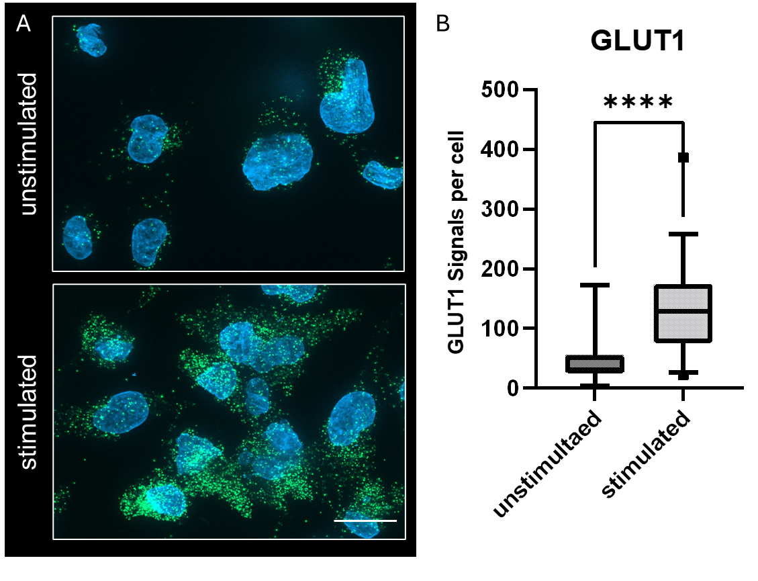
Supplementary Fig. 1: Establishment of GLUT1 expression analysis in THP-1-derived macrophages following CoCl2 stimulation. (A) Representative fluorescence microscopy images showing GLUT1 expression assessed by proximity ligation assay (PLA) in unstimulated and CoCl2-stimulated (24 h, 100µM) cells. Nuclei are stained with DAPI (blue), and PLA signals are shown as green dots (ATTO488). (B) Quantification of GLUT1 PLA signals per cell. Data are presented as boxplots with individual data points. CoCl2 stimulation resulted in a significant increase in GLUT1 expression (****p < 0.0001).

Supplementary Fig. 2: Non-significant different serum cytokine concentrations at day 1 and day 4 in SOT and non-SOT patients with sepsis. Cytokines were measured using the LEGENDplex™ Human Inflammation Panel 1. Data are presented as boxplots with individual data points. No statistically significant differences were observed between groups across all analyzed cytokines. Data are shown as boxplots with individual data points.

Supplementary Fig. 3: T-cell subset in SOT and non-SOT patients with sepsis. Quantification (cells/µl) and Lineage (%) of immune cell subsets (T-cells). Data are shown as boxplots with individual data points; statistical significance is indicated (*p < 0.05, **p < 0.01, ***p < 0.001).

