Supplementary Materials

Establishment and Comparative Secondary Metabolite Production of Callus and Cambial Meristematic Cells of Coffea arabica and Coffea canephora

Janik Haffelder¹(0009-0003-9933-9257), Torben Simon¹, Judith Stiefelmaier¹(0000-0002-5628-1927), Ahmed Zayed² (0000-0001-5747-6972), Roland Ulber¹(0000-0002-7674-0967)
¹Institute of Bioprocess Engineering, RPTU Kaiserslautern Landau, Gottlieb-Daimler-Straße 49, 67663 Kaiserslautern, Germany
²Department of Pharmacognosy, College of Pharmacy, Tanta University, Elguish street, 31527, Tanta, Egypt

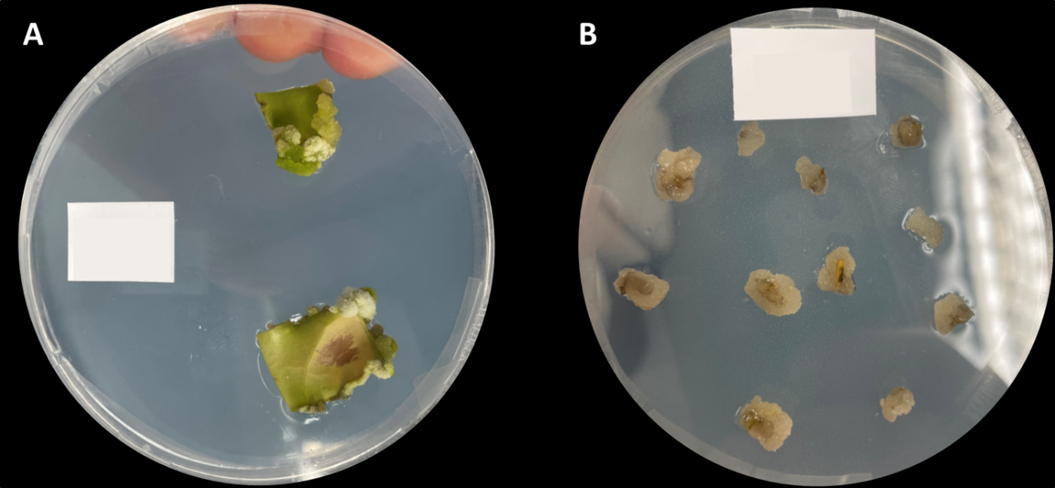
Figure S1: Visual differentiation in freshly induced Coffea arabica cell cultures. (A) Dedifferentiated cells (DDCs) adhere to the leaf explant; (B) Cambial meristematic cells (CMCs) cover entirely the shoots.
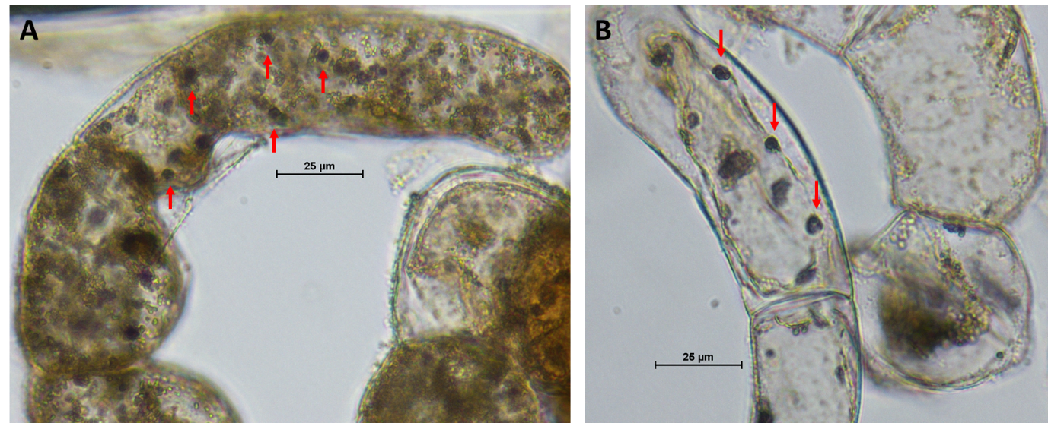
Figure S2: Amyloplast visualization in Coffea arabica callus cells. Light microscopy of C. arabica callus cells stained with 2% Lugol's iodine solution. Red arrows indicate starch-containing amyloplasts, which appear dark blue to black due to iodine–starch complex formation. Scale bar = 25 µm.

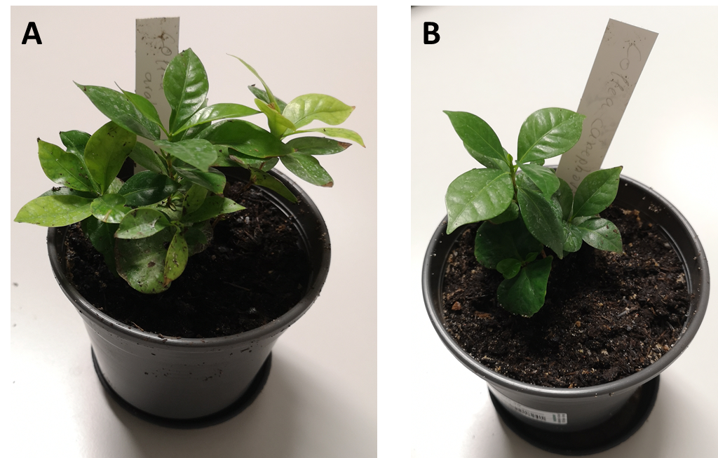
Figure S3: Donor plants used for explant isolation. Representative Coffea arabica (A) and Coffea canephora (B) plants serving as explant sources for DDC and CMC induction and subsequent suspension culture establishment. Plants were cultivated under controlled greenhouse conditions prior to explant harvest.

Table S1: Cell culture media.
Composition | Concentration [mg·l⁻¹]
Composition | DDC Media | CMC Media
Sucrose | 30,0 | 30,0
MES-Buffer | 1,0 | 1,0
LS-salts with vitamins¹ | 4,4 | 4,4
2,4 D | 0,001 | 0,001
Kinetin | 0,001 | -
pH | 5,7 | 5,7
Plant agar (for solid media) | 5,55 | 5,55

¹Linsmaier, E. M., & Skoog, F. (1965). Organic growth factor requirements of tobacco tissue cultures. Physiologia plantarum, 18(1).

