Network-based analyses identify GFAP as a cross-domain hub linking synaptic, neuronal, and inflammatory markers in Alzheimer’s disease

Chiara Trasciatti^{1-4 §} and Andrea Pilotto^{1-5 §}*, Chiara Tolassi¹⁻³, Flavio Ragni⁶, Elena Marcello⁷, Monica Moroni⁶, Stefano Bovo⁶, Caterina Martinuzzo¹, Silvia Pelucchi⁷, Salvatore Caratozzolo², Irene Girotto¹⁻³, Laura D’Andrea⁷, Ramona Stringhi⁷, Andrea L. Benedet⁸, Ilaria Pola⁸, Henrik Zetterberg⁸⁻¹⁴, Nicholas J. Ashton^{8,15-16}, Giuseppe Jurman^{6,17}, Monica di Luca^{7 #} and Alessandro Padovani^{1-4, 18 #}

¹ Department of continuity of care and frailty, Neurology Unit, ASST Spedali Civili of Brescia, Brescia, Italy
² Neurobiorepository and Laboratory of advanced biological markers, University of Brescia and ASST Spedali Civili Hospital, Brescia, Italy
³ Laboratory of digital Neurology and biosensors, University of Brescia, Italy
⁴ Neurology Unit, Department of Clinical and Experimental Sciences, University of Brescia, Italy
⁵ Center for Alzheimer Research, Division of Clinical Geriatrics, Department of Neurobiology, Care Sciences and Society (NVS), Karolinska Institute, Sweden
⁶ Data Science for Health, Fondazione Bruno Kessler, Trento, Italy
⁷ Department of Pharmacological and Biomolecular Sciences, “Rodolfo Paoletti”, University of Milan, Milan, Italy
⁸ Department of Psychiatry and Neurochemistry, Institute of Neuroscience & Physiology, the Sahlgrenska Academy at the University of Gothenburg, Mölndal, Sweden
⁹ Clinical Neurochemistry Laboratory, Sahlgrenska University Hospital, Mölndal, Sweden
¹⁰ Department of Pathology and Laboratory Medicine, University of Wisconsin School of Medicine and Public Health, Madison, WI, USA
¹¹ Wisconsin Alzheimer’s Disease Research Center, University of Wisconsin School of Medicine and Public Health, University of Wisconsin-Madison, Madison, WI, USA
¹² Department of Neurodegenerative Disease, UCL Institute of Neurology, Queen Square, London, UK
¹³ UK Dementia Research Institute at UCL, London, UK
¹⁴ Centre for Brain Research, Indian Institute of Science, Bangalore, India
¹⁵ Banner Alzheimer's Institute and University of Arizona, Phoenix, AZ, USA
¹⁶ Banner Sun Health Research Institute, Sun City, AZ 85351, USA
¹⁷ Department of Biomedical Sciences, Humanitas University, Milan, Italy
¹⁸ Brain Health Center, University of Brescia, Brescia, Italy

Supplementary Figure 1. Comparison of pairwise Spearman correlations between biomarkers in the AD and HC cohorts after adjustment for age and sex. The heatmap displays Z-scores representing the difference between group-specific correlation coefficients. Only statistically significant differences (p < 0.05, two-tailed) are shown. Positive values indicate stronger correlations in the AD group relative to HC (blue), and negative values indicate stronger correlations in HC (red).
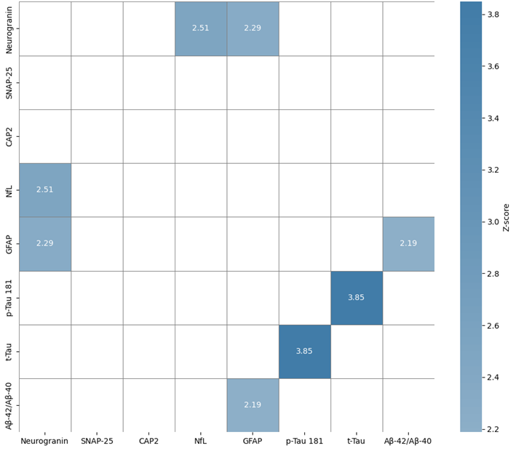
Abbreviations: neurogranin; SNAP-25, synaptosomal-associated protein 25 kDa; CAP2, cyclase-associated protein 2; NfL, neurofilament light chain; GFAP, glial fibrillary acidic protein; p-Tau 181, phosphorylated tau (Thr181); t-Tau, total tau; Aβ-40, amyloid-β 1–40; Aβ-42, amyloid-β 1–42.

