Additional file 3. Kaplan-Meier Survival Analysis:
comparison of patient groups (ARB and ACEI users vs. non-RASI users)

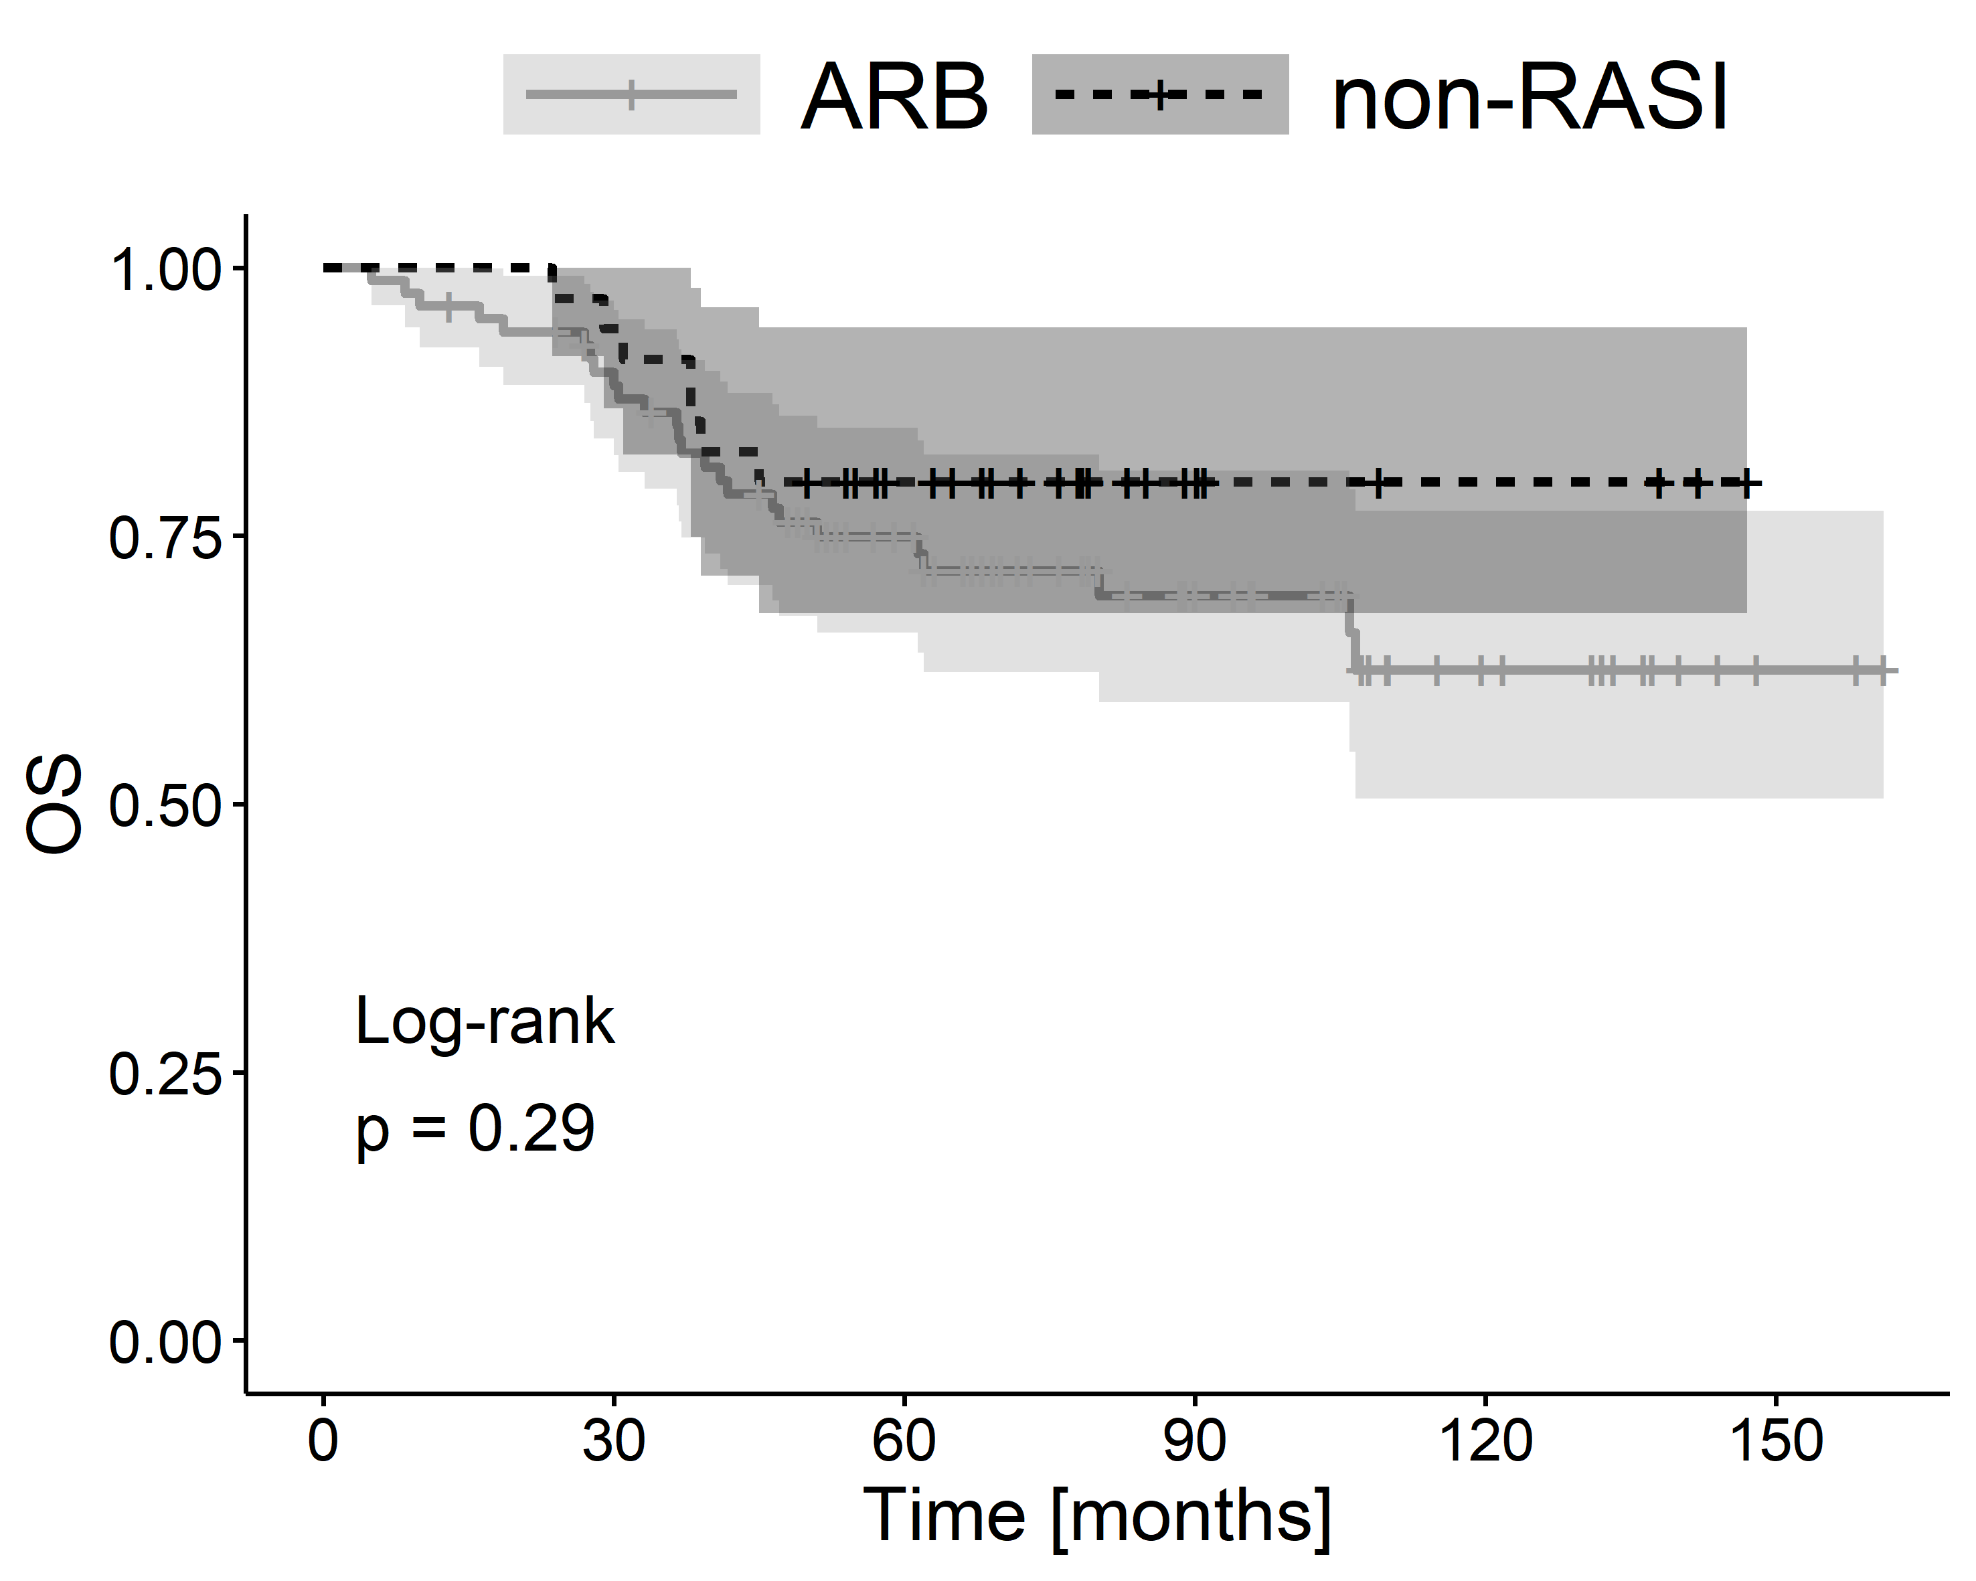
Additional file 3A. The Kaplan–Meier plots of overall survival (OS) for the comparison of patient groups (ARB users vs. non-RASI users).

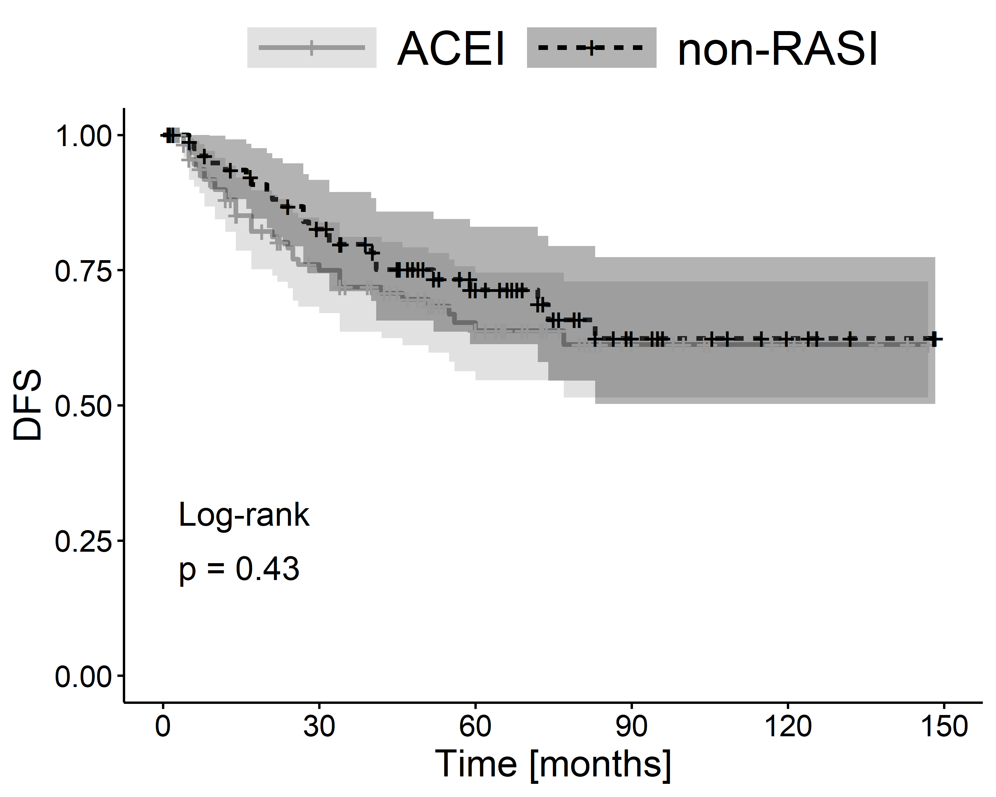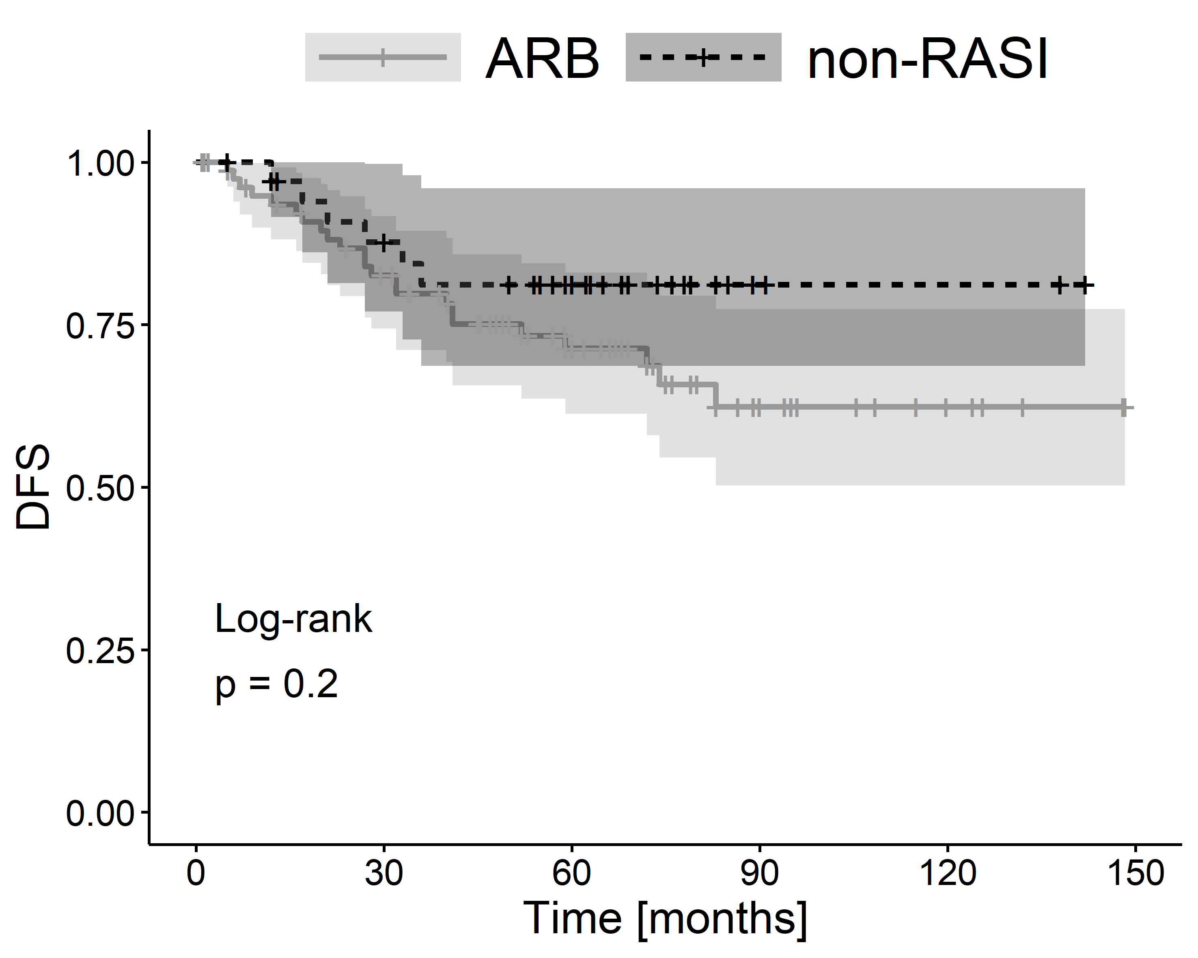

Additional file 3B. The Kaplan–Meier plots of disease-free survival (DFS) for the comparison of patient groups (ACEI users vs. non-RASI users and ARB users vs. non-RASI users).

