Table S1. Questionnaire

QUESTIONNAIRE
This questionnaire concerns your indoor climate at the workplace and possible symptoms you may be experiencing. The information filled in is for statistical analysis only.
INDOOR CLIMATE | Work environment | ENGLISH VERSION | Date:  year ___ month ___ day ___ | Hospital: ______________  Campus: ______________
Nature of Unit:  ☐ Primary ☐ Secondary ☐ Tertiary ☐ Other | Do you engage in cleaning and disinfection  work?  ☐ Yes ☐ No

SECTION 1: BACKGROUND FACTORS
1. Age: ___ years | Height: ___ cm | Weight: ___ kg
2. How long have you been at your present place of work? ___ years | Average daily working hours: ___ hours
3. Sex: ☐ Male ☐ Female
4. Education:
☐ Junior high or below ☐ High school/Vocational ☐ College/Associate degree ☐ Bachelor or above
5. Position:
☐ Technical cooperation ☐ Cleaning & disinfection ☐ Nursing management ☐ Other
6. Professional Title:
☐ Junior ☐ Intermediate ☐ Senior ☐ Other
7. Do you smoke?
☐ No ☐ <5 cig/day ☐ 5-20 cig/day ☐ >20 cig/day
8. Do you drink alcohol?
☐ No ☐ <50g/day ☐ Other
9. Do you exercise?
☐ No ☐ <0.5 h/day ☐ 0.5-1 h/day ☐ >1 h/day
10. Night sleep duration:
☐ <4h ☐ 4-6h ☐ 6-8h ☐ >8h
11. Sleep quality:
☐ Good ☐ Fair ☐ Poor
12. Do you regularly ventilate your residence by opening windows??
☐ Never/Seldom ☐ Sometimes ☐ Often ☐ Always
13. Do you suffer from any of the following diseases? (Multiple choice):
☐ None ☐ Hypertension ☐ Hyperlipidemia ☐ Diabetes ☐ Peptic ulcer ☐ Asthma ☐ Neurasthenia ☐ Frequent insomnia ☐ Depression ☐ Other

SECTION 2: WORK ENVIRONMENT & CONDITIONS
1. What kind of ventilation measure is used in your workplace?
☐ Natural ventilation ☐ Exhaust fan mechanical ventilation ☐ Negative pressure mechanical ventilation (full supply and exhaust) ☐ Air conditioning ventilation system ☐ Cleaning/disinfection tank ventilation ☐ Other
2. Does the ventilation system have the following functions? (Multiple choice)
☐ None ☐ Sound insulation ☐ Air filtration ☐ Temperature/humidity control ☐ Ventilation volume control
3. What kind of disinfectant is used in your workplace? (Multiple choice)
☐ Peracetic acid ☐ Glutaraldehyde ☐ Ortho-phthalaldehyde (OPA) ☐ Hydrogen peroxide ☐ Acidic electrolyzed water ☐ Other
4. Are you satisfied with the room temperature?
☐ Satisfied, suitable ☐ Dissatisfied, too low ☐ Dissatisfied, too high ☐ Dissatisfied, varying/unstable
5. Are you satisfied with the room humidity?
☐ Satisfied, suitable ☐ Dissatisfied, too dry ☐ Dissatisfied, too high ☐ Dissatisfied, varying/unstable
6. Are you satisfied with the fresh air volume?
☐ Satisfied, enough fresh air ☐ Dissatisfied, not enough fresh air
7. Unpleasant odour in the workplace?
☐ Yes, obvious ☐ Yes, slight ☐ No (Specify: _________)
8. How do you rate the air quality?
☐ Clean ☐ Mildly polluted ☐ Moderately polluted ☐ Heavily polluted
9. Causes of air pollution (Multiple choice):
☐ Poor ventilation ☐ Volatilization of disinfectants ☐ Cleaning/disinfection of endoscopes and accessories ☐Transfer of endoscopes ☐ Severe ambient pollution ☐ Caused by medical procedures ☐ Other
10. Is there noise at the workplace?
☐ No ☐ Mild noise ☐ Moderate noise ☐ Severe noise
WORK CONDITIONS:
1. Do you regard your work as satisfying? ☐ Satisfied ☐ Fair ☐ Dissatisfied
2. Do you feel you have too much work pressure? ☐ High pressure ☐ Fair ☐ Relaxed

SECTION 3: PRESENT SYMPTOMS (During the last two weeks)
Symptoms | 1  No, never | 2  Once per 2 weeks | 3  Twice | 4  3 times or more
1. Unpleasant oral odour | ☐ | ☐ | ☐ | ☐
2. Tearing / watery eyes | ☐ | ☐ | ☐ | ☐
3. Eye pain | ☐ | ☐ | ☐ | ☐
4. Itching eyes | ☐ | ☐ | ☐ | ☐
5. Dry eyes | ☐ | ☐ | ☐ | ☐
6. Bloodshot eyes (Conjunctival congestion) | ☐ | ☐ | ☐ | ☐
7. Cough | ☐ | ☐ | ☐ | ☐
8. Dry throat | ☐ | ☐ | ☐ | ☐
9. Wheezing | ☐ | ☐ | ☐ | ☐
10. Runny nose | ☐ | ☐ | ☐ | ☐
11. Sneezing | ☐ | ☐ | ☐ | ☐
12. Chest pain | ☐ | ☐ | ☐ | ☐
13. Dizziness | ☐ | ☐ | ☐ | ☐
14. Headache | ☐ | ☐ | ☐ | ☐
15. Fatigue | ☐ | ☐ | ☐ | ☐
16. Insomnia | ☐ | ☐ | ☐ | ☐
17. Lethargy | ☐ | ☐ | ☐ | ☐
18. Memory decline (Difficulties concentrating) | ☐ | ☐ | ☐ | ☐
19. Itching skin | ☐ | ☐ | ☐ | ☐
20. Rough skin | ☐ | ☐ | ☐ | ☐
21. Scaling skin | ☐ | ☐ | ☐ | ☐
22. Cracked skin | ☐ | ☐ | ☐ | ☐
23. Rash | ☐ | ☐ | ☐ | ☐
24. Dermatitis | ☐ | ☐ | ☐ | ☐
25. Flushed or swollen skin | ☐ | ☐ | ☐ | ☐
26. Irritability (Easily angered) | ☐ | ☐ | ☐ | ☐
27. Nausea | ☐ | ☐ | ☐ | ☐
28. Vomiting | ☐ | ☐ | ☐ | ☐
- Loss of appetite | ☐ | ☐ | ☐ | ☐

SECTION 4: FOLLOW-UP
1. Did the above symptoms alleviate or disappear after leaving the workplace? ☐ Yes ☐ No
2. Did your fellow workers have similar symptoms? ☐ Yes ☐ No
3. Have you seen a doctor at a hospital for the above symptoms since joining your current workplace? ☐ Yes ☐ No
4. (If Yes) Which department did you visit? (Multiple choice)
☐ Respiratory ☐ Gastroenterology ☐ Endocrinology ☐ Neurology ☐ ENT ☐ Gynecology/Reproductive ☐Cardiovascular ☐ Dermatology ☐ Other
THANK YOU!

Table S2. Construction of the 29 Symptom Items Based on the Sick Building Syndrome (SBS) Symptom Spectrum
Symptom | Frequency (within two weeks) | Score
Oral odor | ① 0 | 0
Oral odor | ② Once on average | 1
Oral odor | ③ Twice | 2
Oral odor | ④ Three times or more | 3
Tearing | ① 0 | 0
Tearing | ② Once on average | 1
Tearing | ③ Twice | 2
Tearing | ④ Three times or more | 3
Eye pain | ① 0 | 0
Eye pain | ② Once on average | 1
Eye pain | ③ Twice | 2
Eye pain | ④ Three times or more | 3
Eye itching | ① 0 | 0
Eye itching | ② Once on average | 1
Eye itching | ③ Twice | 2
Eye itching | ④ Three times or more | 3
Dry eye | ① 0 | 0
Dry eye | ② Once on average | 1
Dry eye | ③ Twice | 2
Dry eye | ④ Three times or more | 3
Conjunctival congestion | ① 0 | 0
Conjunctival congestion | ② Once on average | 1
Conjunctival congestion | ③ Twice | 2
Conjunctival congestion | ④ Three times or more | 3
Cough | ① 0 | 0
Cough | ② Once on average | 1
Cough | ③ Twice | 2
Cough | ④ Three times or more | 3
Dry throat | ① 0 | 0
Dry throat | ② Once on average | 1
Dry throat | ③ Twice | 2
Dry throat | ④ Three times or more | 3
Wheezing | ① 0 | 0
Wheezing | ② Once on average | 1
Wheezing | ③ Twice | 2
Wheezing | ④ Three times or more | 3
Rhinorrhea | ① 0 | 0
Rhinorrhea | ② Once on average | 1
Rhinorrhea | ③ Twice | 2
Rhinorrhea | ④ Three times or more | 3
Sneezing | ① 0 | 0
Sneezing | ② Once on average | 1
Sneezing | ③ Twice | 2
Sneezing | ④ Three times or more | 3
Chest pain | ① 0 | 0
Chest pain | ② Once on average | 1
Chest pain | ③ Twice | 2
Chest pain | ④ Three times or more | 3
Dizziness | ① 0 | 0
Dizziness | ② Once on average | 1
Dizziness | ③ Twice | 2
Dizziness | ④ Three times or more | 3
Headache | ① 0 | 0
Headache | ② Once on average | 1
Headache | ③ Twice | 2
Headache | ④ Three times or more | 3
Fatigue | ① 0 | 0
Fatigue | ② Once on average | 1
Fatigue | ③ Twice | 2
Fatigue | ④ Three times or more | 3
Insomnia | ① 0 | 0
Insomnia | ② Once on average | 1
Insomnia | ③ Twice | 2
Insomnia | ④ Three times or more | 3
Somnolence | ① 0 | 0
Somnolence | ② Once on average | 1
Somnolence | ③ Twice | 2
Somnolence | ④ Three times or more | 3
Memory loss | ① 0 | 0
Memory loss | ② Once on average | 1
Memory loss | ③ Twice | 2
Memory loss | ④ Three times or more | 3
Skin itching | ① 0 | 0
Skin itching | ② Once on average | 1
Skin itching | ③ Twice | 2
Skin itching | ④ Three times or more | 3
Rough skin | ① 0 | 0
Rough skin | ② Once on average | 1
Rough skin | ③ Twice | 2
Rough skin | ④ Three times or more | 3
Desquamation | ① 0 | 0
Desquamation | ② Once on average | 1
Desquamation | ③ Twice | 2
Desquamation | ④ Three times or more | 3
Skin fissure | ① 0 | 0
Skin fissure | ② Once on average | 1
Skin fissure | ③ Twice | 2
Skin fissure | ④ Three times or more | 3
Rash | ① 0 | 0
Rash | ② Once on average | 1
Rash | ③ Twice | 2
Rash | ④ Three times or more | 3
Dermatitis | ① 0 | 0
Dermatitis | ② Once on average | 1
Dermatitis | ③ Twice | 2
Dermatitis | ④ Three times or more | 3
Skin redness | ① 0 | 0
Skin redness | ② Once on average | 1
Skin redness | ③ Twice | 2
Skin redness | ④ Three times or more | 3
Irritability | ① 0 | 0
Irritability | ② Once on average | 1
Irritability | ③ Twice | 2
Irritability | ④ Three times or more | 3
Nausea | ① 0 | 0
Nausea | ② Once on average | 1
Nausea | ③ Twice | 2
Nausea | ④ Three times or more | 3
Vomiting | ① 0 | 0
Vomiting | ② Once on average | 1
Vomiting | ③ Twice | 2
Vomiting | ④ Three times or more | 3
Loss of appetite | ① 0 | 0
Loss of appetite | ② Once on average | 1
Loss of appetite | ③ Twice | 2
Loss of appetite | ④ Three times or more | 3

Table S3. Correspondence Between Study Variables and Questionnaire Items
Items | Questionnaire
age, Median [Q1 Q3] | Age (years)
height centimeters, Median [Q1 Q3] | Height (cm)
weight kilograms, Median [Q1 Q3] | Weight (kg)
tenure years, Median [Q1 Q3] | How long have you been at your present place of work(years)?
work hours, Median [Q1 Q3] | Average daily working hours (h)
temperature satisfaction, N (percentage): | Are you satisfied with the room temperature in your workplace?
humidity satisfaction, N (percentage): | Are you satisfied with the room humidity in your workplace?
fresh air satisfaction, N (percentage): | Are you satisfied with the fresh air volume of the ventilation measure in your workplace?
job satisfaction, N (percentage): | Do you regard your present work as satisfying?
job stress, N (percentage): | Do you feel you have too much work pressure?
organization type, N (percentage): | Nature of Unit
gender, N (percentage): | Sex
position, N (percentage): | Position
title, N (percentage): | Professional Title
education, N (percentage): | Education
smoking status, N (percentage): | Your smoking status
drinking status, N (percentage): | Your drinking status
sleep quality, N (percentage): | Your sleep quality
home ventilation, N (percentage): | Do you regularly ventilate your residence by opening windows?
workplace ventilation type, Median [Q1 Q3] | What kind of ventilation measure is used in your workplace?
odor present, N (%): | Is there any unpleasant odour in your workplace? (Specify:
air quality, N (%): | How do you rate the air quality in your workplace?
noise present, N (%): | Is there noise in your workplace?
symptom relief after work, N (%): | Did the above symptoms alleviate or disappear after leaving the workplace?
coworker similar symptoms, N (%): | Did your fellow workers have similar symptoms?
visit hospital, N (%): | Have you seen a doctor at a hospital for the above symptoms since joining your current workplace?
abnormal symptoms of nine major systems, N (%): | Do you suffer from any of the following diseases? (Multiple choice)
exercise frequency, N (%): | Your exercise status
sleep hours, N (%): | Your nighttime sleep duration

Table S4.Hyperparameter settings for candidate models in the model-comparison stage
Model | Key hyperparameters
XGBoost | objective=binary:logistic; colsample_bytree=default; learning_rate=default; max_depth=default; min_child_weight=default; n_estimators=default; reg_lambda=default; subsample=default
Logistic regression | C=1.0; penalty=l2; solver=lbfgs; max_iter=100; tol=0.0001; l1_ratio=NA
LightGBM | boosting_type=gbdt; learning_rate=0.1; n_estimators=100; num_leaves=31; max_depth=-1; min_child_samples=20; colsample_bytree=1.0; subsample=1.0; reg_alpha=0.0; reg_lambda=0.0
RandomForest | n_estimators=20; criterion=gini; max_features=sqrt; max_depth=default; min_samples_split=2; min_samples_leaf=1; min_impurity_decrease=0.0
AdaBoost | n_estimators=50; learning_rate=1.0
KNN | n_neighbors=5; weights=uniform; algorithm=auto; leaf_size=30; p=2
SVM | kernel=rbf; C=1.0; gamma=scale; probability=True; tol=0.001; max_iter=-1
DecisionTree | criterion=gini; max_depth=default; min_samples_split=2; min_samples_leaf=1
GBDT | loss=log_loss; learning_rate=0.1; n_estimators=100; max_depth=3; subsample=1.0; max_features=default; min_samples_split=2; min_samples_leaf=1
Table S5 Validation-fold performance of candidate classifiers.
Model | AUC (SD) | Cutoff (SD) | Accuracy (SD) | Sensitivity (SD) |  | Specificity (SD) | PPV (SD) | NPV (SD) | F1 Score  (SD) | Kappa  (SD)
XGBoost | 0.782(0.054) | 0.387  (0.091) | 0.749  (0.061) | 0.575  (0.092) | 0.807  (0.068) |  | 0.510  (0.094) | 0.850  (0.033) | 0.537  (0.086) | 0.367  (0.126)
logistic | 0.848(0.031) | 0.264  (0.018) | 0.790  (0.034) | 0.750  (0.056) | 0.803  (0.043) |  | 0.565  (0.054) | 0.906  (0.020) | 0.643  (0.046) | 0.499  (0.069)
LightGBM | 0.823(0.043) | 0.294  (0.056) | 0.758  (0.040) | 0.638  (0.100) | 0.799  (0.045) |  | 0.518  (0.057) | 0.869  (0.034) | 0.569  (0.063) | 0.404  (0.088)
RandomForest | 0.832(0.027) | 0.406  (0.027) | 0.790  (0.025) | 0.613  (0.155) | 0.849  (0.047) |  | 0.579  (0.048) | 0.871  (0.045) | 0.586  (0.075) | 0.447  (0.085)
AdaBoost | 0.839(0.040) | 0.494  (0.001) | 0.780  (0.029) | 0.763  (0.061) | 0.787  (0.043) |  | 0.549  (0.046) | 0.909  (0.020) | 0.636  (0.035) | 0.485  (0.054)
KNN | 0.799(0.049) | 0.360  (0.080) | 0.768  (0.058) | 0.650  (0.146) | 0.808  (0.105) |  | 0.559  (0.116) | 0.878  (0.041) | 0.585  (0.072) | 0.430  (0.102)
SVM | 0.820(0.054) | 0.223  (0.016) | 0.784  (0.037) | 0.775  (0.129) | 0.787  (0.028) |  | 0.547  (0.048) | 0.915  (0.048) | 0.639  (0.071) | 0.491  (0.096)
DecisionTree | 0.687(0.085) | 0.500  (0.000) | 0.746  (0.077) | 0.550  (0.121) | 0.811  (0.083) |  | 0.511  (0.136) | 0.843  (0.042) | 0.524  (0.121) | 0.353  (0.171)
GBDT | 0.817(0.024) | 0.361  (0.071) | 0.774  (0.044) | 0.575  (0.145) | 0.841  (0.073) |  | 0.560  (0.098) | 0.859  (0.040) | 0.557  (0.087) | 0.408  (0.109)
Note: Metrics were computed on out-of-fold validation data from five-fold cross-validation and reported as mean (SD). AUC, area under the ROC curve; Cutoff, probability threshold; Accuracy, overall accuracy; Sensitivity, true positive rate; Specificity, true negative rate; PPV, positive predictive value; NPV, negative predictive value; F1, F1 score; Kappa, Cohen’s kappa.
Table S6. Definition and coding of predictors included in the final model
Variable | Number | Content | Question
Odor present | 1 | None | Is there any unpleasant odour in your workplace?
Odor present | 2 | Yes, not obvious | Is there any unpleasant odour in your workplace?
Odor present | 3 | Yes, obvious | Is there any unpleasant odour in your workplace?
air quality | 1 | Clean | How do you rate the air quality in your workplace?
air quality | 2 | Light pollution | How do you rate the air quality in your workplace?
air quality | 3 | Moderate pollution | How do you rate the air quality in your workplace?
air quality | 4 | Heavy pollution | How do you rate the air quality in your workplace?
coworker similar symptoms | 1 | None | Did your fellow workers have similar symptoms?
coworker similar symptoms | 2 | Yes | Did your fellow workers have similar symptoms?
job stress | 1 | Relaxed | Do you feel you have too much work pressure?
job stress | 2 | General | Do you feel you have too much work pressure?
job stress | 3 | High | Do you feel you have too much work pressure?
fresh air satisfaction | 1 | Satisfied, sufficient fresh air | Are you satisfied with the fresh air volume of the ventilation measure in your workplace?
fresh air satisfaction | 2 | Not satisfied, insufficient fresh air
home vent | 1 | Almost never | Do you regularly ventilate your residence by opening windows?
home vent | 2 | Occasionally
home vent | 3 | Often
home vent | 4 | Always
sleep quality | 1 | Poor | Your sleep quality
sleep quality | 2 | General | Your sleep quality
sleep quality | 3 | Good | Your sleep quality
disease | 1 | None | Do you suffer from any of the following diseases?
disease | 2 | Yes | Do you suffer from any of the following diseases?
visit hospital | 1 | None | Have you seen a doctor at a hospital for the above symptoms since joining your current workplace?
visit hospital | 2 | Yes
sleep hours | 1 | <4h | Your nighttime sleep duration
sleep hours | 2 | 4-6h | Your nighttime sleep duration
sleep hours | 3 | 6-8h | Your nighttime sleep duration
sleep hours | 4 | >8h | Your nighttime sleep duration

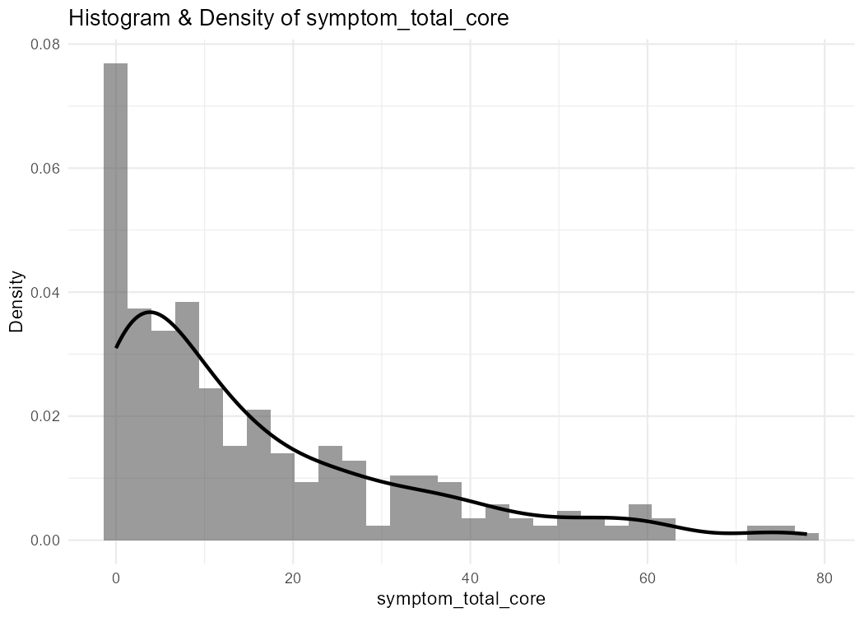
Figure S1. Distribution of the SBS-related symptom burden score.
Histogram with kernel density overlay showing the distribution of the total symptom burden score (range 0–78) in the study sample (N=319).

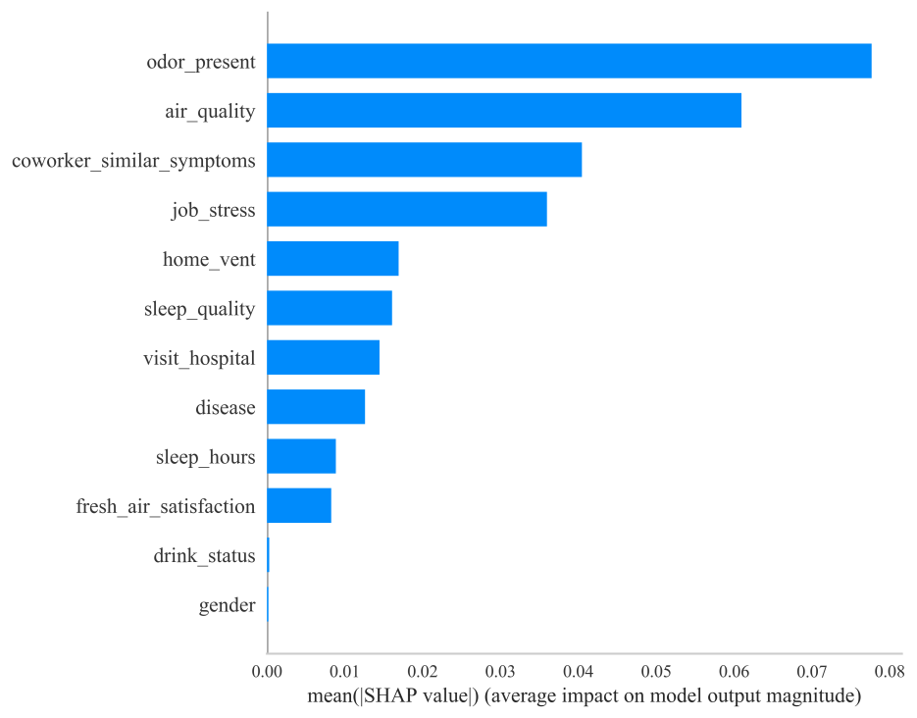
Figure S2. Global SHAP feature importance for the RFECV-selected predictors
Bar plot showing global feature importance ranked by mean absolute SHAP value (mean |SHAP|). Higher values indicate a larger average contribution to the model output. Gender and drink_status exhibited near-zero importance (mean |SHAP| ≈ 0) and were removed from the final feature set.

