Supplementary Appendix

Table S1 Associations between different stages of CKM syndrome with the risk of all-cause mortality and CVD mortality after excluding patients who died within 2 years of follow-up
 | Events/Total | Model 1 |  | Model 2 |  | Model 3
 | Events/Total | HR (95%CI) | P value | HR (95%CI) | P value | HR (95%CI) | P value
All-cause mortality | 1806/20705
CKM Stage 2 | 93/3362 | 1.00 (ref) |  | 1.00 (ref) |  | 1.00 (ref)
CKM Stage 3 | 725/8684 | 3.21 (2.59, 3.99) | <0.001 | 1.88 (1.5, 2.35) | <0.001 | 1.82 (1.45, 2.29) | <0.001
CKM Stage 4 | 988/8659 | 4.14 (3.35, 5.12) | <0.001 | 2.24 (1.79, 2.8) | <0.001 | 2.22 (1.77, 2.78) | <0.001
P for trend |  |  | <0.001 |  | <0.001 |  | <0.001
CVD mortality | 683/20705
CKM Stage 2 | 28/3362 | 1.00 (ref) |  | 1.00 (ref) |  | 1.00 (ref)
CKM Stage 3 | 256/8684 | 3.77 (2.55, 5.56) | <0.001 | 2.14 (1.43, 3.21) | <0.001 | 2.05 (1.37, 3.08) | <0.001
CKM Stage 4 | 399/8659 | 5.55 (3.78, 8.14) | <0.001 | 2.88 (1.93, 4.28) | <0.001 | 2.80 (1.87, 4.18) | <0.001
P for trend |  |  | <0.001 |  | <0.001 |  | <0.001
Model 1: Unadjusted.
Model 2: Adjusted for gender and age.
Model 3: Adjusted for gender, age, smoking, drinking, ALT, AST, TSH, WBC, Hb, PLT, antidiabetic therapy, antihypertensive therapy.

Table S2 Associations between different stages of CKM syndrome with the risk of all-cause mortality and CVD mortality after excluding patients with less than 2 years of follow-up
 | Events/Total | Model 1 |  | Model 2 |  | Model 3
 | Events/Total | HR (95%CI) | P value | HR (95%CI) | P value | HR (95%CI) | P value
All-cause mortality | 1806/16083
CKM Stage 2 | 93/2549 | 1.00 (ref) |  | 1.00 (ref) |  | 1.00 (ref)
CKM Stage 3 | 725/6697 | 3.21 (2.59, 3.99) | <0.001 | 1.88 (1.50, 2.35) | <0.001 | 1.82 (1.45, 2.29) | <0.001
CKM Stage 4 | 988/6837 | 4.14 (3.35, 5.12) | <0.001 | 2.24 (1.79, 2.80) | <0.001 | 2.22 (1.77, 2.78) | <0.001
P for trend |  |  | <0.001 |  | <0.001 |  | <0.001
CVD mortality | 683/16083
CKM Stage 2 | 28/2549 | 1.00 (ref) |  | 1.00 (ref) |  | 1.00 (ref)
CKM Stage 3 | 256/6697 | 3.77 (2.55, 5.56) | <0.001 | 2.14 (1.43, 3.21) | <0.001 | 2.05 (1.37, 3.08) | <0.001
CKM Stage 4 | 399/6837 | 5.55 (3.78, 8.14) | <0.001 | 2.88 (1.93, 4.28) | <0.001 | 2.80 (1.87, 4.18) | <0.001
P for trend |  |  | <0.001 |  | <0.001 |  | <0.001
Model 1: Unadjusted.
Model 2: Adjusted for gender and age.
Model 3: Adjusted for gender, age, smoking, drinking, ALT, AST, TSH, WBC, Hb, PLT, antidiabetic therapy, antihypertensive therapy.

Table S3 E-value and its upper limit of 95% CI for the effect of CKM_stage on mortality in fully-adjusted Cox Model
Outcome | Variable | AHR (95% CI) | E-value | E-value at the lower
 |  |  |  | limit of the 95% CI
All-cause mortality
 | CKM Stage 2 | Ref. | 1 | 1
 | CKM Stage 3 | 1.61 (1.36, 1.90) | 2.60 | 2.07
 | CKM Stage 4 | 1.93 (1.64, 2.28) | 3.28 | 2.66
CVD mortality
 | CKM Stage 2 | Ref. | 1 | 1
 | CKM Stage 3 | 1.79 (1.32, 2.42) | 2.97 | 1.97
 | CKM Stage 4 | 2.72 (2.02, 3.67) | 4.89 | 3.45
HR were adjusted for gender, age, smoking, drinking, ALT, AST, TSH, WBC, Hb, PLT, antidiabetic therapy, antihypertensive therapy.

Table S4 Associations between different stages of CKM syndrome with the risk of all-cause mortality
and CVD mortality after overlap weighting
 | Events/Total | HR (95%CI) | P value
All-cause mortality
CKM Stage 2 | 176/3445 | 1.00 (ref)
CKM Stage 3 | 1232/9191 | 1.72 (1.43, 2.06) | <0.001
CKM Stage 4 | 1611/9282 | 2.05 (1.71, 2.46) | <0.001
P for trend |  |  | <0.001
CVD mortality
CKM Stage 2 | 51/3445 | 1.00 (ref)
CKM Stage 3 | 424/9191 | 1.91 (1.37, 2.66) | <0.001
CKM Stage 4 | 713/9282 | 3.04 (2.20, 4.20) | <0.001
P for trend |  |  | <0.001
HR were adjusted for gender, age, smoking, drinking, ALT, AST, TSH, WBC, Hb, PLT, antidiabetic therapy, antihypertensive therapy.

Table S5 Comparison before and after missing data imputation
Variable | Before Multiple Imputation | After Multiple Imputation | P value | SMD
ALT, IU/L | 21.00 (15.00, 32.00) | 21.00 (15.00, 32.00) | 0.354 | 0.02
AST, IU/L | 21.00 (16.00, 28.00) | 21.00 (16.00, 29.00) | 0.471 | 0.018
WBC, ×10^9/L | 6.87 (5.66, 8.50) | 6.87 (5.65, 8.50) | 0.831 | 0.002
PLT, ×10^9/L | 207.00 (168.00, 251.00) | 207.00 (168.00, 251.00) | 0.661 | 0.009
HB, g/L | 130.00 (117.00, 141.00) | 130.00 (117.00, 142.00) | 0.439 | 0.009
TSH, μIU/ml | 1.60 (1.03, 2.40) | 1.60 (1.12, 2.23) | 0.810 | 0.063

Table S6 Associations between different stages of CKM syndrome with the risk of CVD mortality (Fine-Gray model)
 | Events/Total | Model 1 |  | Model 2 |  | Model 3
 | Events/Total | HR (95%CI) | P value | HR (95%CI) | P value | HR (95%CI) | P value
CVD mortality | 1188/21918
CKM Stage 2 | 51/3445 | 1.00 (ref) |  | 1.00 (ref) |  | 1.00 (ref)
CKM Stage 3 | 424/9191 | 3.16 (2.36, 4.23) | <0.001 | 1.82 (1.35, 2.46) | <0.001 | 1.76 (1.30, 2.38) | <0.001
CKM Stage 4 | 713/9282 | 5.13 (3.86, 6.82) | <0.001 | 2.73 (2.04, 3.67) | <0.001 | 2.70 (2.00, 3.64) | <0.001
P for trend |  |  | <0.001 |  | <0.001 |  | <0.001
Model 1: Unadjusted.
Model 2: Adjusted for gender and age.
Model 3: Adjusted for gender, age, smoking, drinking, ALT, AST, TSH, WBC, Hb, PLT, antidiabetic therapy, antihypertensive therapy.

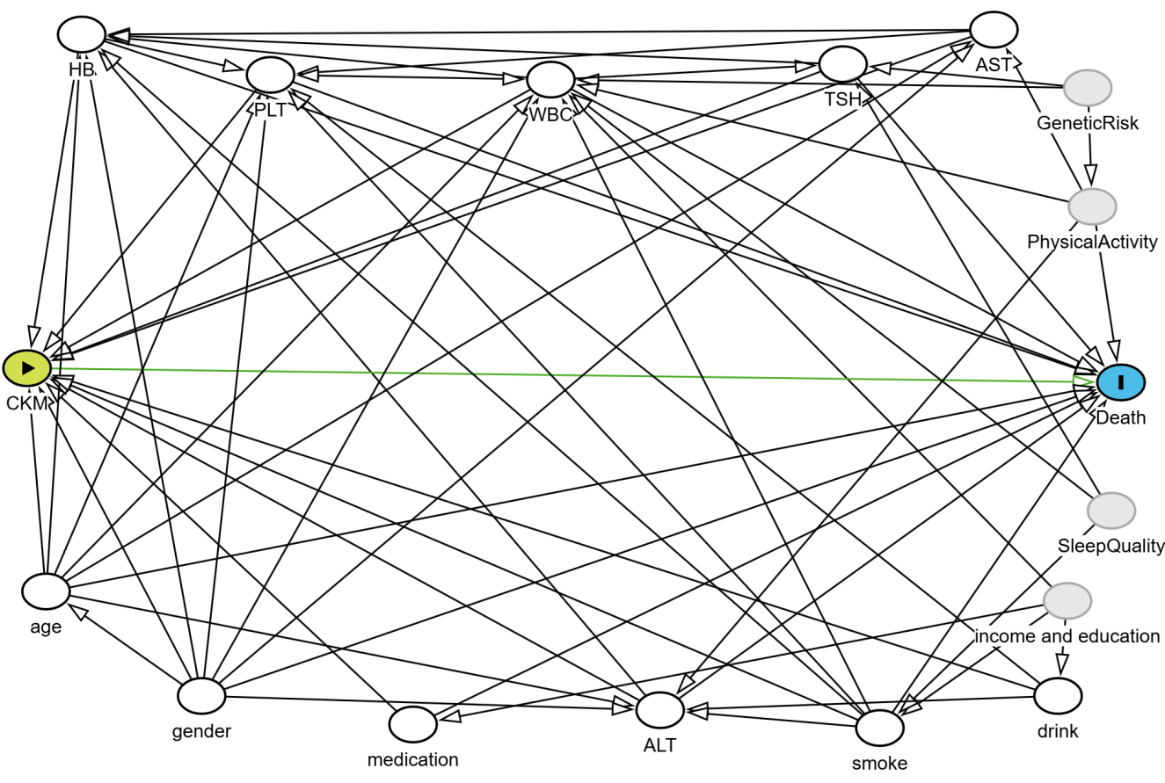

Fig S1. Directed acyclic graph of causal structure among study exposure, outcome, and confounders.Directed acyclic graph (DAG) illustrating the relationship between CKM stage and death. Pale grey nodes signify unobserved or latent variables; white nodes signify adjusted variable.

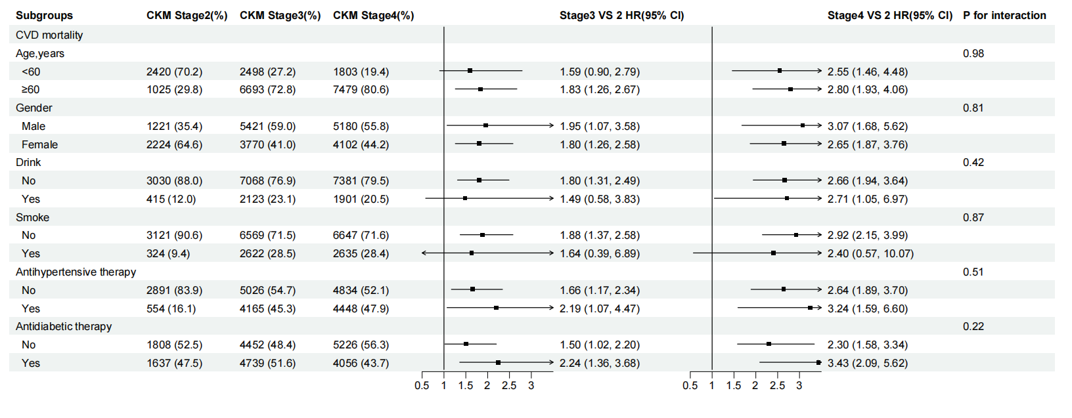
Fig S2. Forest plots of subgroup analyses for the association between CKM stages and CVD mortality. HRs were adjusted for gender, age, smoking, drinking, ALT, AST, TSH, WBC, Hb, PLT, antidiabetic therapy, antihypertensive therapy.

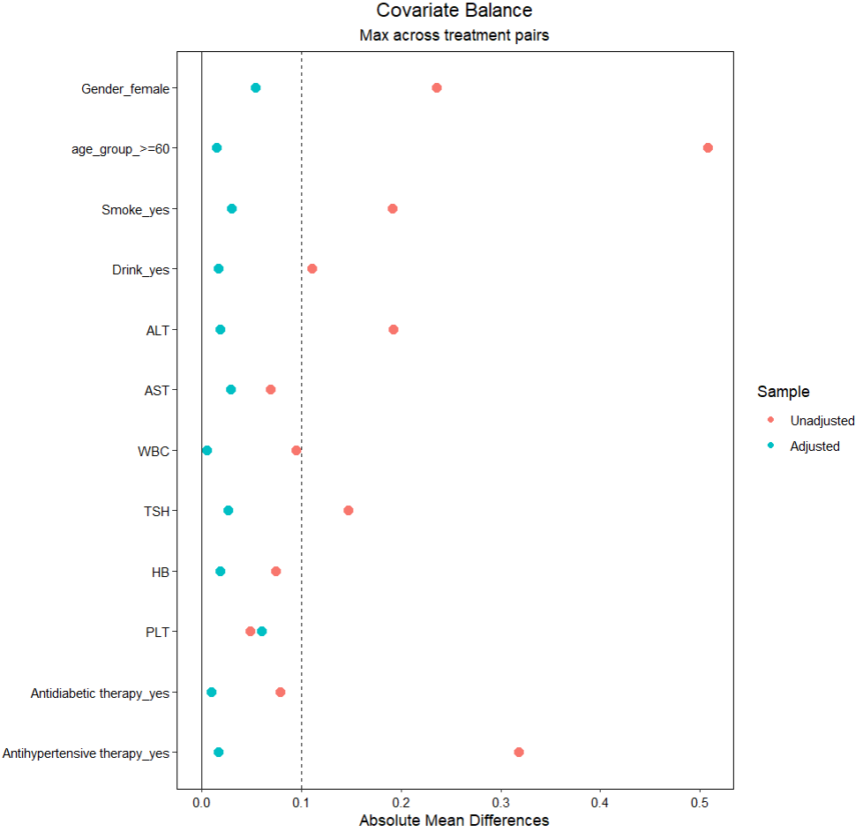
Fig S3. Standardized mean differences of covariates before and after overlap weighting (OW)

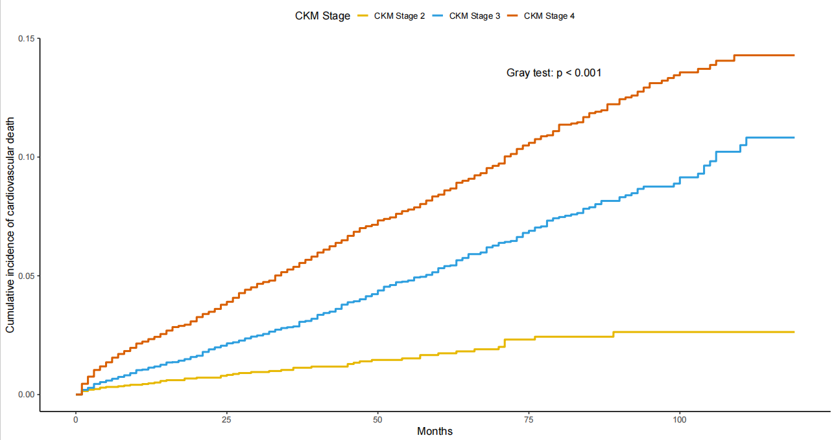
Fig S4. Cumulative incidence of cardiovascular disease mortality according to CKM syndrome stages estimated using the Fine–Gray competing risk model

