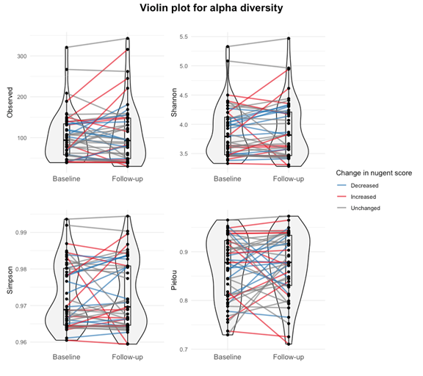
9. SUPPLEMENTARY
- Supplementary Figure 1. Differences in alpha-diversity before and after probiotic use Observed ASVs: No significant change (p>0.05) Shannon index: No significant change (p>0.05) Simpson index: No significant change (p>0.05) Pielou’s evenness: No significant change (p>0.05)

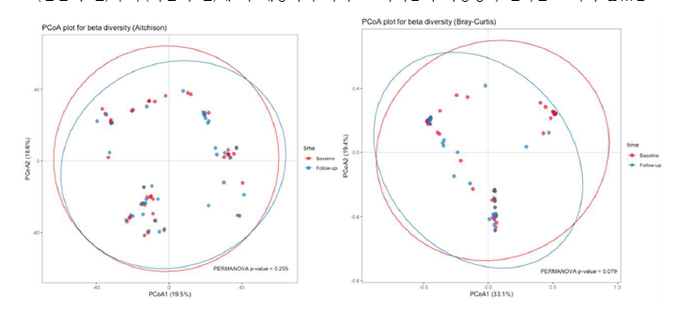
Supplementary Figure 2. Differences in beta-diversity before and after probiotic use

