Supplementary Material

Persistent Muscle Dysfunction and Symptom Burden in Post-COVID Syndrome: A Prospective Longitudinal Study

- Michael Wunderle^{1*}, Andrea Ribeiro¹, Isabelle Lethen¹, Christoph Schmaderer^{1,2,3}, Timon Wallraven¹
¹TUM University Clinic, Klinikum rechts der Isar, Department of Nephrology, Technical University of Munich, 81675 Munich, Germany
²German Centre for Infection Research (DZIF), Munich Partner Site, Munich, Germany
³Site Lead, VADYS-ME Research Program, TUM University Clinic, Munich

Of 102 PCS participants, 87 (85%) completed the 6-month follow-up (FU). Baseline (BL) comparisons between participants with and without FU revealed no statistically significant differences in handgrip strength or PROMs (all p > 0.05; Supplementary Table 1). A non-significant trend indicated that patients lost to FU were slightly less symptomatic at BL.
Variable | n (FU) | n (no FU) | Mean (FU) | SD (FU) | Mean (no FU) | SD (no FU) | p (Wilcoxon)
Fmean | 87 | 15 | 22.4 | 12.6 | 24.1 | 12.6 | 0.571
Fatigue Ratio | 87 | 15 | 1.27 | 0.24 | 1.20 | 0.11 | 0.271
Recovery | 87 | 15 | 0.93 | 0.20 | 1.01 | 0.18 | 0.099
PCS Severity Score | 87 | 15 | 37.3 | 10.6 | 34.5 | 10.2 | 0.424
C19-YRS | 84 | 8 | 33.2 | 14.0 | 27.4 | 15.7 | 0.325
GAD-7 | 86 | 14 | 6.00 | 4.18 | 5.57 | 5.26 | 0.451
PHQ-9 | 86 | 14 | 10.4 | 4.37 | 10.6 | 4.22 | 0.608
FSS | 87 | 14 | 5.67 | 1.31 | 5.63 | 1.47 | 0.953
Supplementary Table 1: BL comparison of PCS patients with vs. without FU. Wilcoxon rank-sum test comparing BL values of participants with vs. without FU. Abbreviations: SD = standard deviation.
Supplementary Figure 1 illustrates the distribution of individual change scores (Δ = FU – BL) for all analyzed outcomes. Each violin-box plot represents the full range and density of within-subject changes, with the dashed horizontal line marking no change (Δ = 0). Most distributions were approximately symmetric and centred close to zero, indicating that the small mean differences reported in Table 2 were not driven by extreme outliers. Slight positive shifts in recovery and small negative shifts in anxiety (GAD-7) and Fatigue severity (FSS) suggest mild but consistent improvement in these domains, whereas changes in handgrip strength and Fatigue Ratio were minimal.
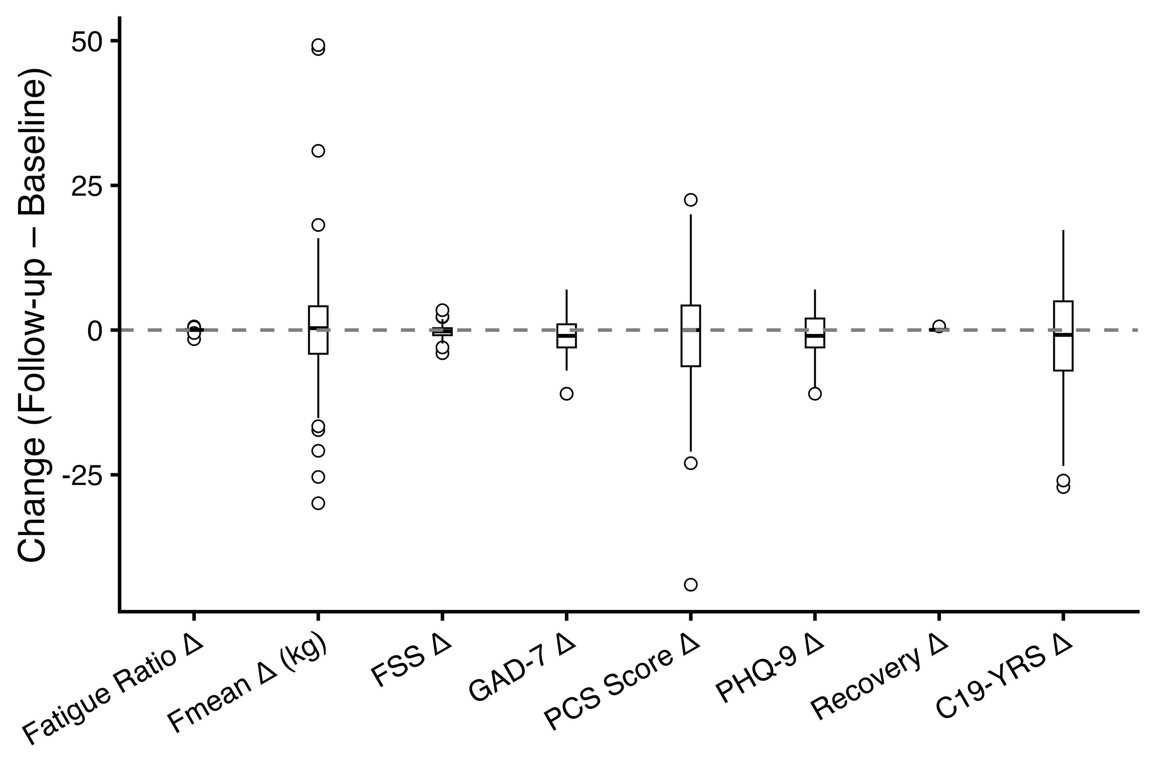
Supplementary figure 1: Distribution of individual change scores (Δ = FU – BL) across all outcomes in patients with PCS. Each boxplot shows the median (horizontal line), interquartile range (box), and density distribution of Δ values. The dashed line at 0 indicates no change. The figure illustrates the variability and direction of changes rather than statistical significance, which is reported in Table 2.
Changes in HGS parameters and changes in PROMs are shown in Supplementary Table 2. No significant correlations were found for either combination.
Δ(Objective) | Δ(PROM) | n | ρ (Spearman) | p-value | p (FDR)
ΔFatigue Ratio | ΔFSS | 80 | 0.12 | 0.289 | 0.856
ΔFmean | ΔFSS | 80 | -0.02 | 0.861 | 0.940
ΔRecovery | ΔFSS | 72 | 0.20 | 0.099 | 0.777
ΔFatigue Ratio | ΔGAD7 | 79 | -0.07 | 0.550 | 0.856
ΔFmean | ΔGAD7 | 79 | 0.07 | 0.520 | 0.856
ΔRecovery | ΔGAD7 | 71 | -0.17 | 0.155 | 0.777
ΔFatigue Ratio | ΔPCS | 82 | 0.05 | 0.625 | 0.856
ΔFmean | ΔPCS | 82 | -0.05 | 0.673 | 0.856
ΔRecovery | ΔPCS | 74 | -0.05 | 0.685 | 0.856
ΔFatigue Ratio | ΔPHQ9 | 79 | 0.05 | 0.678 | 0.856
ΔFmean | ΔPHQ9 | 79 | 0.06 | 0.602 | 0.856
ΔRecovery | ΔPHQ9 | 71 | -0.02 | 0.877 | 0.940
ΔFatigue Ratio | ΔYRS | 58 | -0.09 | 0.482 | 0.856
ΔFmean | ΔYRS | 58 | 0.00 | 0.995 | 0.995
ΔRecovery | ΔYRS | 55 | -0.21 | 0.132 | 0.777
Supplementary Table 2: Pairwise Spearman correlations between changes (Δ = FU – BL) in HGS measures and changes in PROMs. Correlations were computed with pairwise complete observations; p-values adjusted using the Benjamini-Hochberg procedure.
Univariate linear regression models (Supplementary Table 3) were fitted to examine whether BL muscle function predicted corresponding FU parameters. Fmean at BL strongly predicted FU handgrip strength (β = 0.55, p < 0.001), while higher BL recovery also predicted higher FU Fmean (β = 26.9, p < 0.001). BL fatigue ratio was inversely associated with FU Fmean (β = –11.3, p = 0.042) and FU fatigue ratio (β = 0.28, p = 0.001). Similarly, BL recovery predicted FU fatigue ratio (β = –0.41, p = 0.001).
FU outcome | BL predictor | β (Estimate) | SE | p-value | R²
Fmean | Fmean | 0.55 | 0.09 | <0.001 | 0.29
Fmean | Fatigue Ratio | -11.3 | 5.48 | 0.042 | 0.05
Fmean | Recovery | 26.9 | 7.11 | <0.001 | 0.16
Fatigue Ratio | Fmean | -0.005 | <0.01 | 0.005 | 0.09
Fatigue Ratio | Fatigue Ratio | 0.28 | 0.08 | 0.001 | 0.12
Fatigue Ratio | Recovery | -0.41 | 0.12 | 0.001 | 0.13
Recovery | Fmean | 0.002 | <0.01 | 0.161 | 0.03
Recovery | Fatigue Ratio | -0.019 | 0.06 | 0.757 | 0.00
Recovery | Recovery | 0.29 | 0.09 | 0.002 | 0.13
Supplementary Table 3: Univariate linear regression analyses predicting FU muscle function from BL measures in patients with PCS. Each model includes one predictor variable. β = unstandardized regression coefficient; SE = standard error; R² = explained variance.
Supplementary Table 4 summarizes the cross-sectional Spearman correlations (ρ) between HGS parameters and PROMs in the PCS cohort at BL and at six-month FU. Across both time points, lower handgrip strength and higher muscular fatigability were consistently associated with greater symptom severity as measured by the Fatigue Severity Scale (FSS), the C19-YRS Symptom Severity score, and the PHQ-9. Correlations with other PROMs were weaker and did not reach significance after correction for multiple testing (FDR).
Objective variable | PROM | n | ρ (Spearman) | p-value | p (FDR)
BL
Fmean | PCS Score | 102 | -0.28 | 0.005 | 0.013
Fatigue Ratio | PCS Score | 102 | 0.15 | 0.145 | 0.197
Recovery | PCS Score | 96 | -0.20 | 0.057 | 0.085
Fmean | C19-YRS | 92 | -0.30 | 0.004 | 0.011
Fatigue Ratio | C19-YRS | 92 | 0.31 | 0.003 | 0.011
Recovery | C19-YRS | 86 | -0.28 | 0.009 | 0.017
Fmean | GAD7 | 100 | -0.13 | 0.213 | 0.246
Fatigue Ratio | GAD7 | 100 | 0.11 | 0.288 | 0.309
Recovery | GAD7 | 94 | -0.13 | 0.200 | 0.246
Fmean | PHQ9 | 100 | -0.30 | 0.002 | 0.011
Fatigue Ratio | PHQ9 | 100 | 0.26 | 0.009 | 0.017
Recovery | PHQ9 | 94 | -0.20 | 0.053 | 0.085
Fmean | FSS | 101 | -0.31 | 0.001 | 0.011
Fatigue Ratio | FSS | 101 | 0.35 | <0.001 | 0.005
Recovery | FSS | 95 | -0.05 | 0.610 | 0.610
FU
Fmean | PCS Score | 82 | -0.33 | 0.003 | 0.039
Fatigue Ratio | PCS Score | 82 | 0.11 | 0.344 | 0.430
Recovery | PCS Score | 79 | -0.23 | 0.045 | 0.085
Fmean | C19-YRS | 60 | -0.18 | 0.177 | 0.241
Fatigue Ratio | C19-YRS | 60 | 0.07 | 0.584 | 0.631
Recovery | C19-YRS | 59 | -0.25 | 0.055 | 0.092
Fmean | GAD7 | 80 | -0.05 | 0.669 | 0.669
Fatigue Ratio | GAD7 | 80 | 0.06 | 0.588 | 0.631
Recovery | GAD7 | 77 | -0.23 | 0.042 | 0.085
Fmean | PHQ9 | 80 | -0.27 | 0.017 | 0.063
Fatigue Ratio | PHQ9 | 80 | 0.23 | 0.042 | 0.085
Recovery | PHQ9 | 77 | -0.24 | 0.035 | 0.085
Fmean | FSS | 80 | -0.30 | 0.006 | 0.047
Fatigue Ratio | FSS | 80 | 0.28 | 0.013 | 0.063
Recovery | FSS | 77 | -0.18 | 0.129 | 0.194
Supplementary Table 4: Spearman correlations (ρ) between HGS parameters and PROMs at BL and six-month FU in the PCS cohort. Negative ρ values indicate that lower physical performance is associated with higher symptom severity. p-values are corrected for multiple testing using the Benjamini–Hochberg false-discovery rate (FDR).
Univariate linear regression models (Supplementary Table 5) examined BL Fmean, fatigue ratio, and recovery as predictors of FU PROMs (FSS, PHQ-9, GAD-7, PCS Score, and C19-YRS). Lower BL Fmean predicted higher fatigue (p = 0.016), depressive symptoms (p = 0.002), PCS scores (p = 0.004), and C19-YRS severity (p = 0.015). Higher fatigue ratio was associated with greater fatigue (p = 0.006), depression (p = 0.035), and PCS symptom burden (p= 0.039). Higher recovery predicted fewer depressive symptoms (p = 0.015) and lower PCS scores (p = 0.043), with trends for fatigue and C19-YRS (both p < 0.06). No significant associations were found for anxiety (all p > 0.17).
FU PROM | BL predictor | β (95% CI) | p-value | R²
FSS (Fatigue) | Handgrip strength | -0.03 (-0.05, -0.01) | 0.016 | 0.07
 | Fatigue Ratio | 1.69 (0.51, 2.88) | 0.006 | 0.09
 | Recovery | -1.79 (-3.62, 0.04) | 0.059 | 0.05
PHQ-9 (Depression) | Handgrip strength | -0.12 (-0.20, -0.05) | 0.002 | 0.11
 | Fatigue Ratio | 4.23 (0.36, 8.10) | 0.035 | 0.05
 | Recovery | -6.97 (-12.5, -1.49) | 0.015 | 0.07
GAD-7 (Anxiety) | Handgrip strength | -0.05 (-0.12, 0.02) | 0.178 | 0.02
 | Fatigue Ratio | 1.31 (-2.24, 4.87) | 0.471 | 0.01
 | Recovery | -0.07 (-5.17, 5.02) | 0.977 | 0.00
PCS Score | Handgrip strength | -0.29 (-0.48, -0.10) | 0.004 | 0.10
 | Fatigue Ratio | 10.8 (0.72, 20.8) | 0.039 | 0.05
 | Recovery | -15.5 (-30.4, -0.7) | 0.043 | 0.05
C19-YRS | Handgrip strength | -0.34 (-0.60, -0.07) | 0.015 | 0.09
 | Fatigue Ratio | 11.6 (-1.6, 24.8) | 0.091 | 0.05
 | Recovery | -18.7 (-37.4, 0.10) | 0.056 | 0.06
Supplementary Table 5: Prediction of FU PROMs by BL muscle function parameters among patients with PCS. Values represent unstandardized regression coefficients (β) with 95% confidence intervals and p-values. R² denotes the proportion of variance explained by each model.
Multivariable linear regression models adjusted for age, sex, and the corresponding BL PROM were used to assess BL Fmean, fatigue ratio, and recovery as predictors of FU outcomes (Supplementary Table 6). Lower BL Fmean tended to predict higher fatigue (p = 0.052) and predicted depressive symptoms (p = 0.022), with trends for higher PCS and C19-YRS scores (p = 0.12 and p = 0.058, respectively). Higher fatigue ratio was associated with greater fatigue (p = 0.008) and showed trends for higher PCS symptom burden (p= 0.054) and depression (p = 0.071). Higher recovery predicted fewer depressive symptoms (p = 0.028) and showed trends for lower fatigue, PCS, and C19-YRS scores (all p < 0.08). No significant associations were observed for anxiety (all p > 0.49).
Outcome | Predictor | β [95% CI] | p-value | R²
FSS | Fmean | -0.03 [-0.06 – 0.00] | 0.052 | 0.07
 | Fatigue Ratio | 1.66 [0.44 – 2.88] | 0.008 | 0.11
 | Recovery | -1.72 [-3.61 – 0.17] | 0.074 | 0.06
PHQ-9 | Fmean | -0.11 [-0.20 – -0.02] | 0.022 | 0.17
 | Fatigue Ratio | 3.50 [-0.31 – 7.32] | 0.071 | 0.14
 | Recovery | -6.21 [-11.7 – -0.68] | 0.028 | 0.13
GAD-7 | Fmean | -0.03 [-0.12 – 0.06] | 0.492 | 0.05
 | Fatigue Ratio | 0.90 [-2.72 – 4.51] | 0.624 | 0.04
 | Recovery | 0.34 [-4.89 – 5.56] | 0.899 | 0.02
PCS Score | Fmean | -0.19 [-0.44 – 0.05] | 0.123 | 0.12
 | Fatigue Ratio | 9.80 [-0.17 – 19.8] | 0.054 | 0.13
 | Recovery | -13.7 [-28.6 – 1.19] | 0.071 | 0.12
C19-YRS | Fmean | -0.32 [-0.65 – 0.01] | 0.058 | 0.11
 | Fatigue Ratio | 9.99 [-3.61 – 23.6] | 0.147 | 0.09
 | Recovery | -17.7 [-37.1 – 1.68] | 0.073 | 0.08
Supplementary Table 6: Linear regression models adjusted for age, sex, and the corresponding BL PROM. Shown are unstandardized regression coefficients (β) with 95% confidence intervals (CI) and p-values.
No significant interaction effects between BL muscle function and CFS status were observed for any of the examined PROMs (Supplementary Table 7). This indicates that the associations between muscle function measures (Fmean, Ratigue Ratio, Recovery) and FU symptom scores did not differ between PCS patients with and without CFS.
Predictor (BL) | Outcome (FU) | β [95% CI] | p
Fmean | GAD7 | 0.10 [-0.03, 0.22] | 0.139
 | FSS | -0.03 [-0.09, 0.03] | 0.391
 | PCS Score | 0.11 [-0.25, 0.47] | 0.542
 | PHQ9 | 0.03 [-0.07, 0.12] | 0.557
 | C19-YRS | 0.06 [-0.32, 0.44] | 0.744
Fatigue Ratio | PCS Score | -12.8 [-42.0, 16.3] | 0.383
 | C19-YRS | -8.14 [-37.1, 20.8] | 0.575
 | PHQ9 | -4.41 [-13.8, 5.02] | 0.354
 | FSS | 0.83 [-1.82, 3.49] | 0.534
 | GAD7 | -0.82 [-19.9, 18.3] | 0.932
Recovery | PCS Score | 2.48 [-29.5, 34.5] | 0.878
 | C19-YRS | 2.07 [-53.7, 57.8] | 0.941
 | GAD7 | -4.10 [-15.0, 6.85] | 0.458
 | PHQ9 | -4.97 [-17.4, 7.43] | 0.427
 | FSS | -0.99 [-5.00, 3.01] | 0.622
Supplementary Table 7: Interaction effects of BL muscle function with CFS status on FU PROMs. Unstandardized regression coefficients (β) with 95% CIs from ANCOVA models adjusted for age, sex, and BL outcome.

Matched Analysis
Covariate balance was substantially improved after propensity score matching. Prior to matching, large imbalances were observed for age and the propensity score, whereas sex was already well balanced. After matching, standardized mean differences for all matching variables were reduced to values close to zero and remained well below the predefined threshold of 0.1, indicating excellent covariate balance between PCS patients and COVID-19 recovered controls (Supplementary Figure 2).
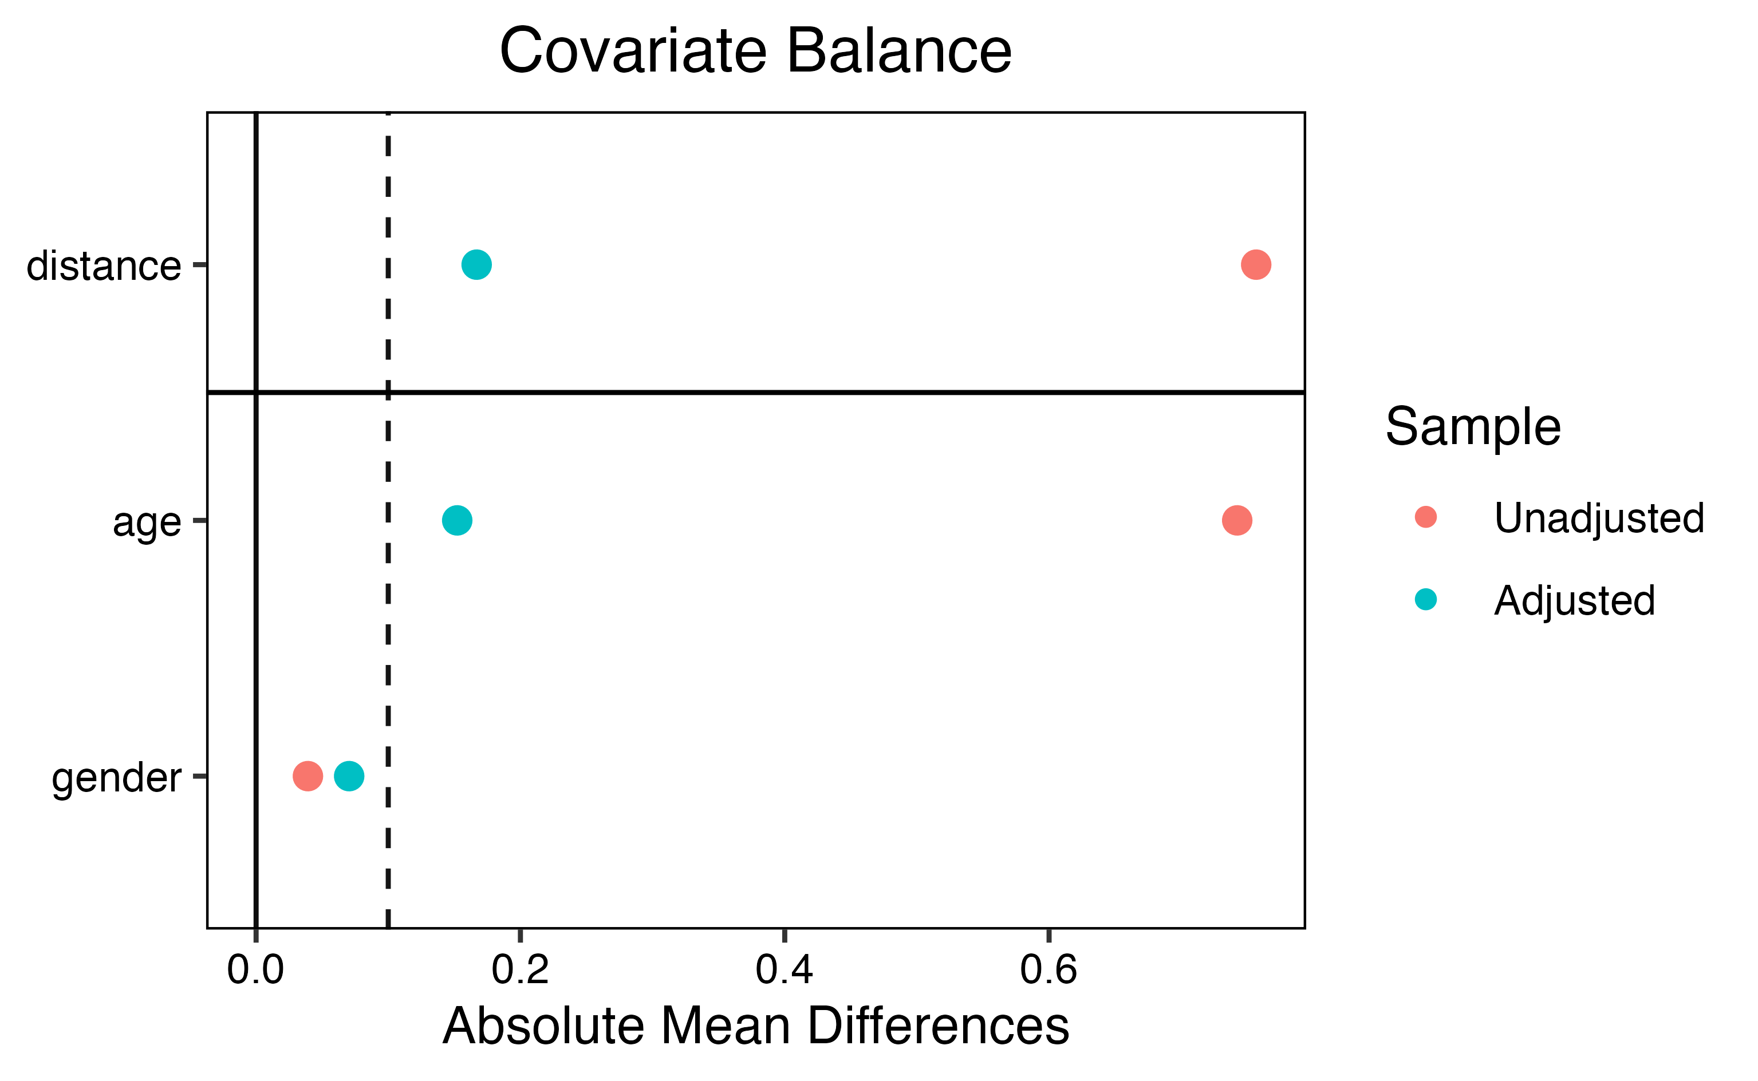
Supplementary Figure 2: Love plot showing standardized mean differences before and after matching. All matching covariates achieved adequate balance after matching (SMD < 0.1).
Weighted regression analyses corroborated the descriptive findings by formally quantifying group differences after accounting for the propensity score-based matching. For muscle function parameters, HGS was markedly reduced in PCS compared with recovered controls at both BL and FU, while Fatigue Ratio was significantly higher (Supplementary Table 8). Recovery was modestly but significantly lower in PCS relative to controls at both timepoints. No significant changes were observed between PCS BL and PCS FU for any muscle function parameter in the weighted models, consistent with the largely stable trajectories observed in the longitudinal analyses.
Outcome | Contrast | β (SE) | p-value
HGS | Recovered (BL) vs PCS (BL) | 9.51 (2.01) | <0.001
HGS | Recovered (BL) vs PCS (FU) | 8.17 (2.30) | <0.001
HGS | PCS (BL) vs PCS (FU) | -1.34 (2.34) | 0.57
Fatigue Ratio | Recovered (BL) vs PCS (BL) | -0.093 (0.034) | 0.007
Fatigue Ratio | Recovered (BL) vs PCS (FU) | -0.106 (0.033) | 0.002
Fatigue Ratio | PCS (BL) vs PCS (FU) | -0.013 (0.043) | 0.76
Recovery | Recovered (BL) vs PCS (BL) | 0.052 (0.026) | 0.048
Recovery | Recovered (BL) vs PCS (FU) | 0.052 (0.026) | 0.048
Recovery | PCS (BL) vs PCS (FU) | 0.00 (0.029) | 1.000
Supplementary Table 8 Weighted linear regression contrasts for Fmean, Fatigue Ratio, and Recovery comparing PCS at BL and FU with COVID-19–recovered controls assessed at BL. Models used ATT propensity score weights with robust HC3 standard errors. β denotes unstandardized regression coefficients.
For neuroaxonal injury markers in matched analysis, NFL and GFAP differed significantly between PCS and recovered controls at both BL and FU, whereas no significant differences were observed between PCS BL and PCS FU, indicating temporal stability of these markers within PCS over the FU period (Supplementary Table 9).
Outcome | Contrast | β (SE) | Ratio | p-value
NFL | Recovered (BL) vs PCS (BL) | -0.18 (0.07) | 0.83 | 0.016
NFL | Recovered (BL) vs PCS (FU) | -0.18 (0.07) | 0.83 | 0.016
NFL | PCS (BL) vs PCS (FU) | 0.00 (0.08) | 1.00 | 1.000
GFAP | Recovered (BL) vs PCS (BL) | -0.23 (0.08) | 0.80 | 0.007
GFAP | Recovered (BL) vs PCS (FU) | -0.23 (0.08) | 0.80 | 0.007
GFAP | PCS (BL) vs PCS (FU) | 0.00 (0.09) | 1.00 | 1.000
Supplementary Table 9 Weighted linear regression contrasts for NFL and GFAP comparing PCS at BL and FU with COVID-19-recovered controls assessed at BL. Models were fitted using ATT propensity score weights with robust HC3 standard errors. Estimates are shown on the log scale; ratios represent exponentiated coefficients.
In multivariable weighted regression models adjusting for eGFR, PCS status was independently associated with higher NFL and GFAP levels at FU compared with COVID-19-recovered controls (Supplementary Table 10). Higher eGFR was independently associated with lower levels of both biomarkers, confirming the relevance of renal function as a confounder in neuroaxonal injury marker analyses.
Outcome | Predictor | β (SE) | p-value
NFL (log) | PCS vs recovered | 0.19 (0.08) | 0.018
 | eGFR (per ml/min/1.73 m²) | -0.005 (0.0023) | 0.038
GFAP (log) | PCS vs recovered | 0.18 (0.08) | 0.036
 | eGFR (per ml/min/1.73 m²) | -0.008 (0.0023) | <0.001
Supplementary Table 10 Multivariable weighted linear regression models for neuroaxonal injury markers at FU. For PCS patients, FU values were analyzed, whereas BL values were used for COVID-19–recovered controls. Models were fitted on the log scale and adjusted for eGFR using ATT propensity score weights
Multivariable linear regression models were fitted on the log scale to compare FU values in patients with PCS with BL values in COVID-19–recovered controls (Supplementary Table 11). Models were adjusted for age, sex, and estimated glomerular filtration rate (eGFR). Regression coefficients (β) represent log-transformed effects; geometric mean ratios (GMRs) were calculated as exp(β).
Outcome | Predictor | β (SE) | p-value | GMR (95% CI)
NFL (log) | PCS vs recovered | 0.16 (0.06) | 0.008 | 1.17 (1.04–1.32)
 | Age (per year) | 0.011 (0.003) | 0.001 | 1.01 (1.00–1.02)
 | Male sex | -0.10 (0.06) | 0.126 | 0.91 (0.81–1.02)
 | eGFR (per ml/min/1.73 m²) | -0.001 (0.002) | 0.678 | 1.00 (0.99–1.00)
 | Model fit |  |  | Adjusted R² = 0.24
GFAP (log) | PCS vs recovered | 0.10 (0.07) | 0.183 | 1.10 (0.93–1.31)
 | Age (per year) | 0.010 (0.004) | 0.006 | 1.01 (1.00–1.02)
 | Male sex | -0.13 (0.07) | 0.082 | 0.88 (0.77–1.01)
 | eGFR (per ml/min/1.73 m²) | -0.003 (0.002) | 0.239 | 1.00 (0.99–1.01)
 | Model fit |  |  | Adjusted R² = 0.19
Supplementary Table 11 Values are regression coefficients (β) with standard errors (SE) from linear models fitted on the log scale. GMR = geometric mean ratio. For PCS patients, FU biomarker values were analyzed; for recovered controls, BL values were used. Sex was coded as male versus female (reference).
Exploratory correlation analyses revealed no significant associations between NFL and GFAP and HGS parameters, including Fmean, Fatigue Ratio, and Recovery, at either BL or FU (Supplementary Figure 3). Correlation coefficients were consistently small and did not reach statistical significance, indicating that circulating neuroaxonal injury markers were not directly related to peripheral muscle function in this PCS cohort.
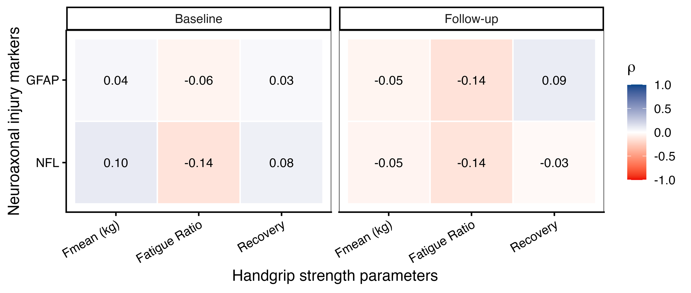
Supplementary Figure 3 Heatmaps display Spearman’s correlation coefficients (ρ) between serum neurofilament light chain (NFL) and glial fibrillary acidic protein (GFAP) and handgrip strength parameters (Fmean, fatigue ratio, and recovery) assessed at BL and six-month follow-up. Numbers indicate Spearman’s ρ; asterisks denote unadjusted significance (* p < 0.05).

