Supplementary Figure. 1. Pod pubescence color of eight soybean genotypes used in this study. Tawny pubescence: (a) SS2-2, (b) Sinpaldal, (c) IT109098, (d) Cheongja 3. Grey pubescence: (e) Jinpung, (f) Keunol, (g) Danbaek, (h) Taekwangkong.
Supplementary Figure 2. Temporal variation in leaf flavonol accumulation across developmental stages in soybean cv. Williams 82. Mean peak areas of individual flavonols detected by LC–MS are shown for leaves sampled from V4 to R6. Values represent means of three biological replicates.
Supplementary Figure 3. Spatial variation in leaf flavonol accumulation across nodal positions at the R4 stage in soybean cv. Williams 82. Mean peak areas of individual flavonols detected by LC–MS are presented on a log scale for upper, middle, and lower nodes. Values represent means of three biological replicates. Error bars indicate standard deviation.
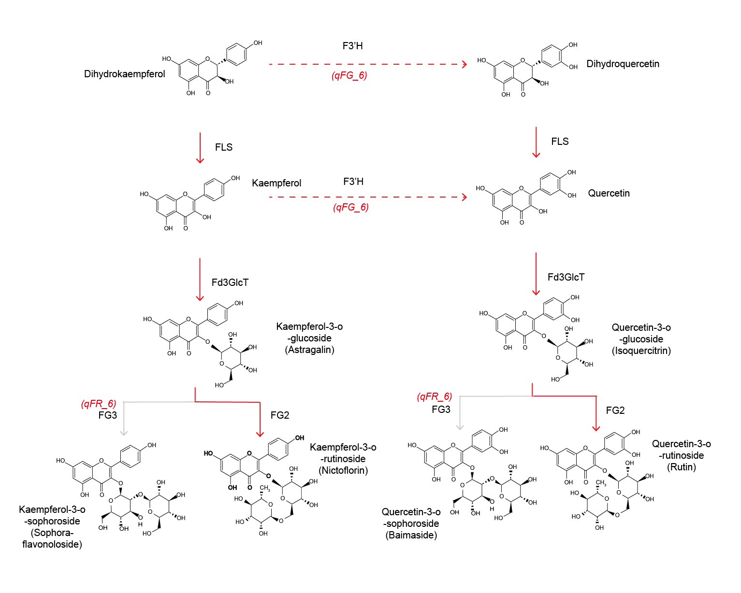
Figure S4. Simplified flavonol biosynthesis pathway illustrating the roles of F3'H and FG3 in rutinoside accumulation. F3'H converts dihydrokaempferol and dihydroquercetin to kaempferol and quercetin, respectively. Fd3GlcT subsequently adds a glucose moiety to form flavonol-3-O-glucosides, which are rhamnosylated by FG2 to produce rutinosides (nicotiflorin and rutin). FG3 catalyzes an additional 2″-glucosylation of rutinosides to form triglycosylated sophorosides; loss of FG3 activity therefore terminates glycosylation at the rutinoside stage. QTL intervals identified in this study (qFG_6 and qFR_6) are indicated in red.

