Supplementary
Supplementary Figure 1. Ten virtual trajectories generated to reconstruct missing segments in GPS data (ID: aygmcz8o).
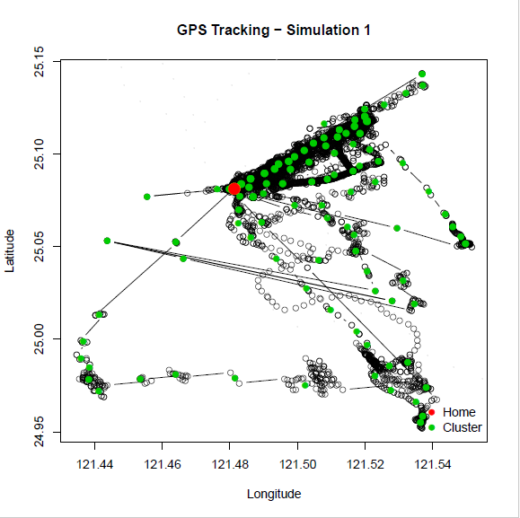 | 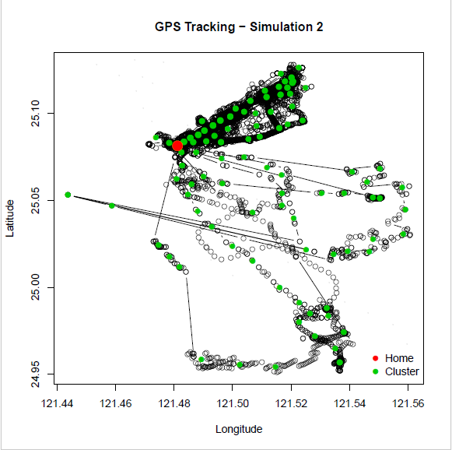 | 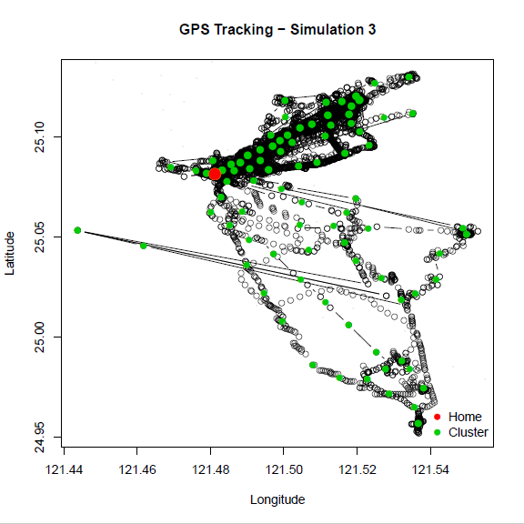 | 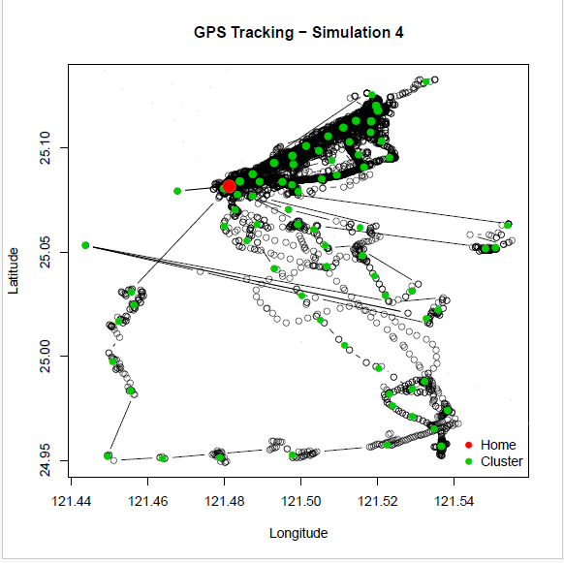 | 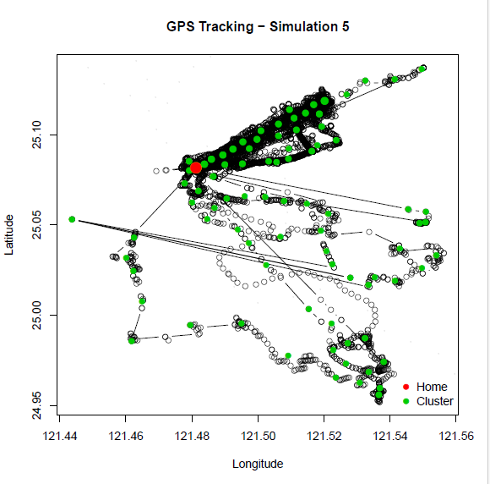
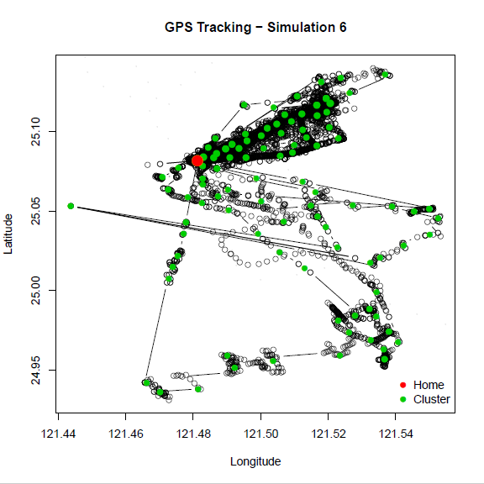 | 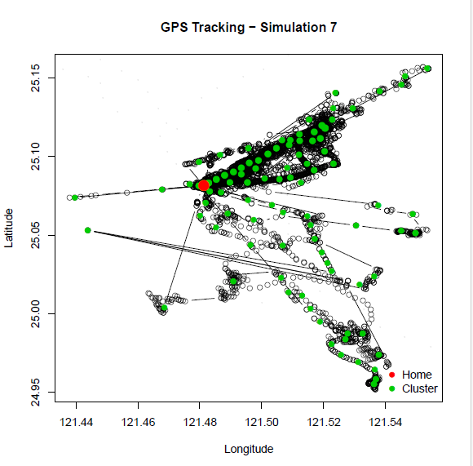 | 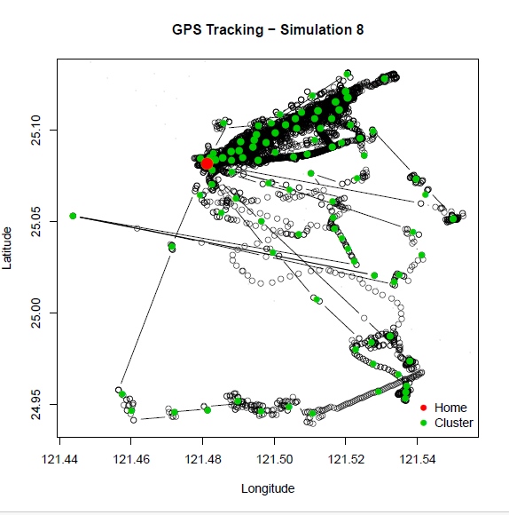 | 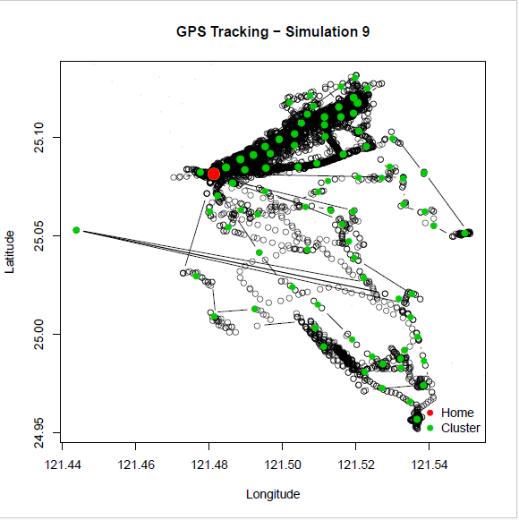 | 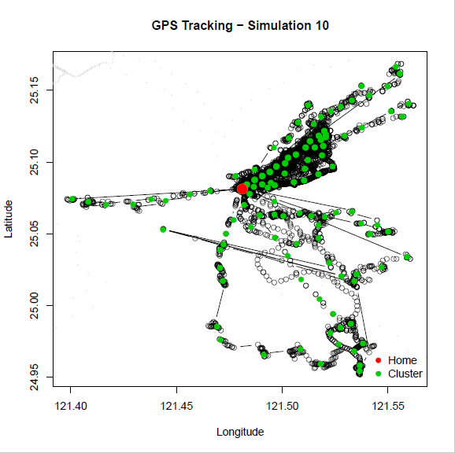
Supplementary Figure 2. Actual map of a study participant BP and MDD.
h9xrwbeq (BP group)
8ao1ft1b (MDD group)
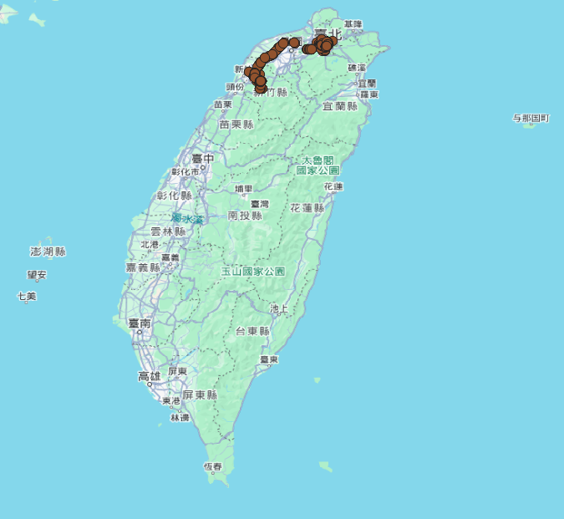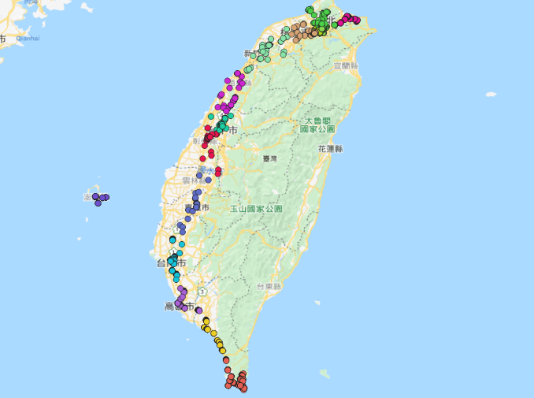

Supplementary Table 1. GPS features summary statistics.
 | Number | Minimum | Maximum | Mean | SD
Weekday-Sleep | 1015 | -20.85 | 11.63 | -0.27 | 5.44
Weekday-Morning | 990 | -20.47 | 10.30 | -0.25 | 4.31
Weekday-Afternoon | 990 | -19.30 | 10.68 | -0.30 | 4.40
Weekday-Night | 793 | -12.49 | 11.13 | 3.05 | 3.68

Supplementary Table 2. GLMM for EMA fatigue according to LV duration per day.
 |  | Model 1 |  | Model 2 |  | Model 3 |  | Model 4
fatigue | B (SE) |  | P | B (SE) | P | B (SE) | P | B (SE) | P
diagnosis = MDD | 0.054 (0.106) |  | 0.701 | 0.075 (0.100) | 0.577 | 0.080 (0.099) | 0.554 | 0.087 (0.099) | 0.488
diagnosis = BP | 0.207 (0.134) |  | 0.269 | 0.213 (0.135) | 0.214 | 0.219 (0.138) | 0.204 | 0.209 (0.134) | 0.192
Weekday Sleep | -0.001 (0.001) |  | 0.299
Weekday Morning |  |  |  | 0.002 (0.002) | 0.252
Weekday Afternoon |  |  |  |  |  | 0.002 (0.002) | 0.196
Weekday Evening |  |  |  |  |  |  |  | -0.001 (0.002) | 0.576
HC group is the reference group. Considering the time and the individual as random effects. Gender, age, and employment status were adjusted.

Supplementary Table 3. GLMM for EMA manic mood according to LV duration per day.
 |  | Model 1 |  | Model 2 |  | Model 3 |  | Model 4
manic mood |  | B (SE) | P | B (SE) | P | B (SE) | P | B (SE) | P
diagnosis = MDD |  | 0.046 (0.073) | 0.944 | 0.055 (0.068) | 0.931 | 0.048 (0.065) | 0.924 | 0.049 (0.065) | 0.923
diagnosis = BP |  | 0.373 (0.150) | 0.606 | 0.361 (0.146) | 0.598 | 0.339 (0.141) | 0.562 | 0.341 (0.143) | 0.564
Weekday Sleep | <-0.001 (0.001) |  | 0.941
Weekday Morning |  |  |  | <0.001 (0.001) | 0.911
Weekday Afternoon |  |  |  |  |  | <0.001 (0.002) | 0.910
Weekday Evening |  |  |  |  |  |  |  | 0.001 (0.002) | 0.628
HC group is reference group. Considering the time and the individual as random effects. Gender, age, and employment status were adjusted.

Supplementary Table 4. GLMM for EMA irritability according to LV duration per day.
 |  | Model 1 |  | Model 2 |  | Model 3 |  | Model 4
irritability |  | B (SE) | P | B (SE) | P | B (SE) | P | B (SE) | P
diagnosis = MDD | 0.186 (0.094) |  | 0.749 | 0.213 (0.089) | 0.806 | 0.188 (0.084) | 0.778 | 0.208 (0.086) | 0.797
diagnosis = BP | 0.358 (0.130) |  | 0.334 | 0.355 (0.132) | 0.404 | 0.339 (0.125) | 0.341 | 0.319 (0.129) | 0.387
Weekday Sleep | -0.001 (0.001) |  | 0.333
Weekday Morning |  |  |  | -0.001 (0.002) | 0.386
Weekday Afternoon |  |  |  |  |  | -0.002 (0.003) | 0.438
Weekday Evening |  |  |  |  |  |  |  | -0.001 (0.002) | 0.965
HC group is reference group. Considering the time and the individual as random effects. Gender, age, and employment status were adjusted.

