Supplementary Table 1. Characteristics Related to Sepsis
Variables | Total (n = 94) | Survivors (n = 66) | Non-survivors (n = 28) | p value
Source of infection† |  |  |  | p = 0.073
Renal/urinary | 49 (52.7%) | 37 (56.9%) | 12 (42.9%)
Pulmonary | 19 (20.4%) | 9 (13.8%) | 10 (35.7%)
Soft tissue | 8 (8.6%) | 8 (12.3%) | 0 (0.0%)
Gastrointestinal | 8 (8.6%) | 5 (7.7%) | 3 (10.7%)
Unknown | 5 (5.4%) | 4 (6.2%) | 1 (3.6%)
Hepatic/biliary | 3 (3.2%) | 2 (3.1%) | 1 (3.6%)
Neurologic | 1 (1.1%) | 0 (0.0%) | 1 (3.6%)
Documented source of infection† | 92 (97.9%) | 65 (98.5%) | 27 (96.4%) | p = 0.528
Sepsis severity† |  |  |  | p < 0.001
Mild | 28 (29.8%) | 28 (42.4%) | 0 (0.0%)
Moderate | 21 (22.3%) | 16 (24.2%) | 5 (17.9%)
Severe | 45 (47.9%) | 22 (33.3%) | 23 (82.1%)
SOFA, points* | 5.00 (3.00) | 4.00 (3.00) | 7.00 (3.00) | p < 0.001
qSOFA score† |  |  |  | p < 0.001
1 | 35 (37.2%) | 34 (51.5%) | 1 (3.6%)
2 | 45 (47.9%) | 30 (45.5%) | 15 (53.6%)
3 | 14 (14.9%) | 2 (3.0%) | 12 (42.9%)
* The data are presented as median (IQR); p-values obtained through Mann-Whitney U tests. † The data are presented as frequency (percentage); p-values obtained through chi-squared tests or Fisher’s exact test when appropriate. SOFA = Sequential Organ Failure Assessment; qSOFA = quick Sequential Organ Failure Assessment. A p-value <0.05 was considered as statistically significant.

Supplementary Table 2. Laboratory Parameters
Variables | Total (N = 94) | Survivors (n = 66) | Non-survivors (n = 28) | p value
Baseline SII | 3710.63 (6003.59) | 2681.96 (4472.46) | 6974.25 (10907.86) | p = 0.001
SII (day 3–7) | 2124.25 (2929.55) | 1207.21 (2141.13) | 3680.66 (4395.85) | p < 0.001
SII (day 7–14) | 1008.74 (2420.50) | 840 (1173.13) | 3549.72 (4522.43) | p = 0.006
SII (day 14–21) | 1234.43 (6112.09) | 1218.87 (1083.07) | 4601.99 (13035.00) | p = 0.400
SII (day 21–28) | 837.25 (248.09) | 837.25 (248.09) | N/A | N/A
Baseline leukocytes (×10⁹/L) | 14.36 (8.53) | 14.01 (8.40) | 15.19 (7.42) | p = 0.297
Leukocytes (day 3–7) | 10.7 (7.76) | 9.7 (7.35) | 14.98 (6.91) | p = 0.003
Leukocytes (day 7–14) | 10.46 (4.77) | 9.55 (4.44) | 13.10 (4.93) | p = 0.142
Leukocytes (day 14–21) | 11.06 (6.97) | 5.2 (1.46) | 16.91 (4.03) | p = 0.100
Leukocytes (day 21–28) | 7.91 (2.43) | 7.91 (2.43) | N/A | N/A
Baseline C-reactive protein (mg/L) | 21.27 (17.5) | 19.38 (17.03) | 22.61 (29.54) | p = 0.298
C-reactive protein (day 3–7) | 10.44 (11.54) | 9.75 (10.90) | 16.5 (20.75) | p = 0.030
C-reactive protein (day 7–14) | 3.85 (6.49) | 3.29 (4.32) | 16.34 (16.69) | p = 0.023
C-reactive protein (day 14–21) | 8.74 (8.35) | 4.03 (3.36) | 13.45 (9.83) | p = 0.400
C-reactive protein (day 21–28) | 6.60 (0.0) | 6.60 (0.0) | N/A | N/A
Baseline procalcitonin (ng/mL) | 9.48 (24.53) | 10.80 (20.55) | 6.80 (34.44) | p = 0.918
Procalcitonin (day 3–7) | 3.45 (11.97) | 3.55 (11.58) | 3.1 (17.31) | p = 0.884
Procalcitonin (day 7–14) | 1.42 (2.56) | 1.85 (2.97) | 1.29 (7.91) | p = 0.475
Procalcitonin (day 14–21) | 1.42 (3.6) | 0.52 (1.71) | 1.96 (9.01) | p = 0.200
Procalcitonin (day 21–28) | 0.56 (1.1) | 0.56 (1.12) | N/A | N/A
Baseline lactate (mmol/L) | 2.87 (2.6) | 2.5 (2.0) | 3.5 (2.9) | p = 0.037
Lactate (day 3–7) | 1.5 (1.2) | 1.4 (1.05) | 2.2 (2.0) | p < 0.001
Lactate (day 7–14) | 1.2 (1.05) | 1.1 (0.7) | 2.0 (3.2) | p = 0.022
Lactate (day 14–21) | 2.15 (3.57) | 0.9 (0.4) | 4.3 (1.6) | p = 0.100
Lactate (day 21–28) | 0.9 (0.2) | 0.9 (0.2) | N/A | N/A
Values are presented as median (interquartile range). p values were calculated using the Mann–Whitney U test for non-parametric continuous variables. SII = Systemic Immune-Inflammation Index; PCR = C-reactive protein; PCT = procalcitonin. 3–7 = between the 3rd and 7th day of hospitalization; 7–14 = between the 7th and 14th day; 14–21 = between the 14th and 21st day; 21–28 = between the 21st and 28th day of hospitalization. A p-value <0.05 was considered as statistically significant.

Supplementary Table 3. Hospitalization Parameters
Variables | Total (N = 94) | Survivors (n = 66) | Non-survivors (n = 28) | p value
Urinary index* | 0.24 (0.37) | 0.34 (0.5) | 0.17 (0.11) | p < 0.001
Length of hospital stay, days* | 6 (5) | 6 (3) | 5 (7) | p = 0.174
ICU admission† | 25 (26.6%) | 20 (30.3%) | 5 (17.9%) | p = 0.212
ICU duration stay, days* | 3.00 (1.25) | 3.00 (1.00) | 10.00 (5.00) | p = 0.325
Mechanical ventilation† | 5 (5.3%) | 2 (3.0%) | 3 (10.7%) | p = 0.129
Days on mechanical ventilation* | 9.50 (4.75) | 11.00 (0.00) | 8.00 (5.00) | p = 1.000
Acute kidney injury (KDIGO) † |  |  |  | p < 0.001
Stage 1 | 18 (19.1%) | 16 (24.2%) | 2 (7.1%)
Stage 2 | 27 (28.7%) | 12 (18.2%) | 15 (53.6%)
Stage 3 | 17 (18.1%) | 7 (10.6%) | 10 (35.7%)
Days with acute kidney injury* | 3 (4) | 1 (3) | 3.5 (2) | p < 0.001
Acute myocardial infarction† | 1 (1.1%) | 1 (1.5%) | 0 (0.0%) | p = 0.513
Acute respiratory distress syndrome (ARDS) † | 13 (13.8%) | 6 (9.1%) | 7 (25.0%) | p = 0.041
Days with ARDS* | 0 (0) | 0 (0) | 0 (0) | p = 0.025
Heart failure† | 1 (1.1%) | 1 (1.5%) | 0 (0.0%) | p = 0.513
Septic shock† | 43 (45.7%) | 21 (31.8%) | 22 (78.6%) | p < 0.001
Days with septic shock* | 0 (3) | 0 (1) | 3 (2) | p < 0.001
* The data are presented as median (IQR); p-values obtained through Mann-Whitney U tests. † The data are presented as frequency (percentage); p-values obtained through chi-squared tests or Fisher’s exact test when appropriate. ICU = intensive care unit; KDIGO = Kidney Disease: Improving Global Outcomes; ARDS = acute respiratory distress syndrome. A p-value <0.05 was considered as statistically significant.

Supplementary Table 4. Treatment During Hospital Stay
Variables | Total (N = 94) | Survivors (n = 66) | Non-survivors (n = 28) | p value
Type of antibiotic* |  |  |  | p = 0.381
Carbapenems | 38 (40.4%) | 26 (39.4%) | 12 (42.9%)
Cephalosporins | 20 (21.3%) | 15 (22.7%) | 5 (17.9%)
Penicillins | 1 (1.1%) | 1 (1.5%) | 0 (0.0%)
Quinolones | 15 (16.0%) | 6 (9.1%) | 9 (32.1%)
Vancomycin | 1 (1.1%) | 1 (1.5%) | 0 (0.0%)
Linezolid | 1 (1.1%) | 1 (1.1%) | 0 (0.0%)
Days of antibiotic use† | 6 (4) | 6 (3) | 4.5 (7) | p = 0.390
Vasopressor use* | 27 (28.7%) | 19 (28.8%) | 8 (28.6%) | p = 0.303
Days of vasopressor use† | 0 (1) | 0 (1) | 0 (2) | p = 0.902
* The data are presented as median (IQR); p-values obtained through Mann-Whitney U tests. † The data are presented as frequency (percentage); p-values obtained through chi-squared tests or Fisher’s exact test when appropriate. A p-value <0.05 was considered as statistically significant.

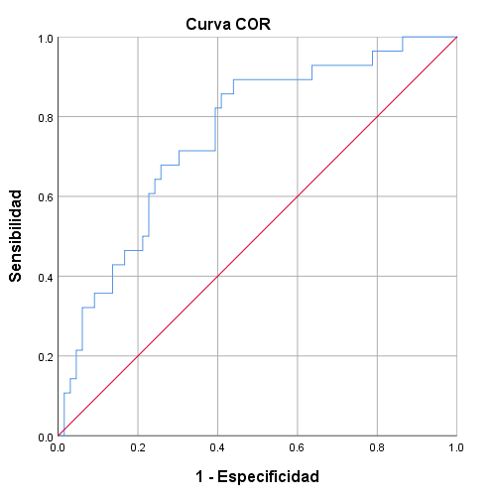
Supplementary Figure 1

Supplementary Figure 2
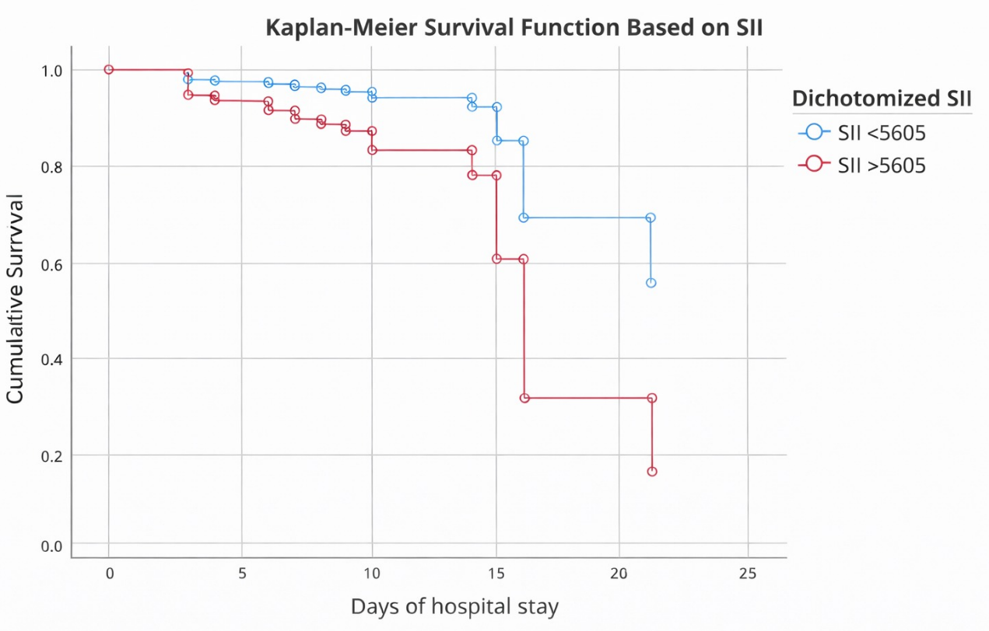

Supplementary Figure 3
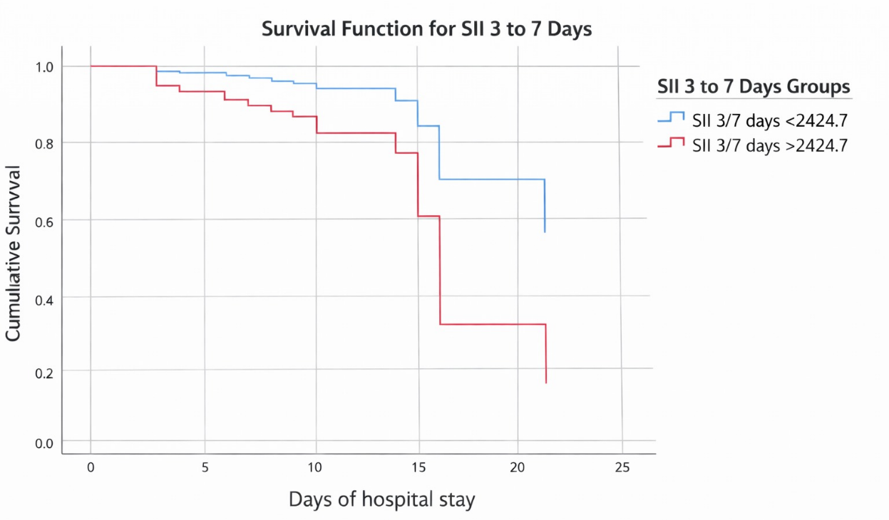

Supplementary Figure 4
