Supplementary Information

Fig. S1 A standard curve for the SjTR1-qPCR assay by testing a series of 10-fold diluted Schistosoma japonicum egg DNA to determine the cut-off Ct value. All error bars were calculated based on the Ct values of three replicates. R² represents the coefficient of determination, and E represents the reaction efficiency.

Fig. S2 Concentration analysis for original DNA extracted using the Maxwell kit- and NaOH-based extraction methods. A) The median concentrations of DNA samples (n = 554 each) isolated using the Maxwell kit- is higher than that extracted NaOH-based methods (P < 0.0001, Wilcoxon signed-rank test). B) There was a positive correlation in DNA concentration between the two methods (r = 0.3452, P < 0.0001, Spearman's rank correlation coefficient).
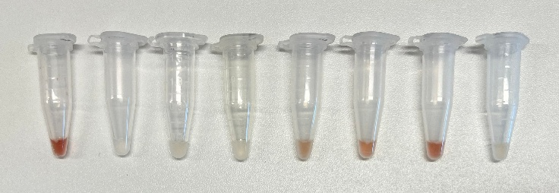
Fig. S3 An image showing eight DNA samples extracted using the NaOH-based method that tested positive upon retesting after being diluted 5-fold. Among these eight samples, four exhibited a brownish coloration.

