Supplementary Figures 1

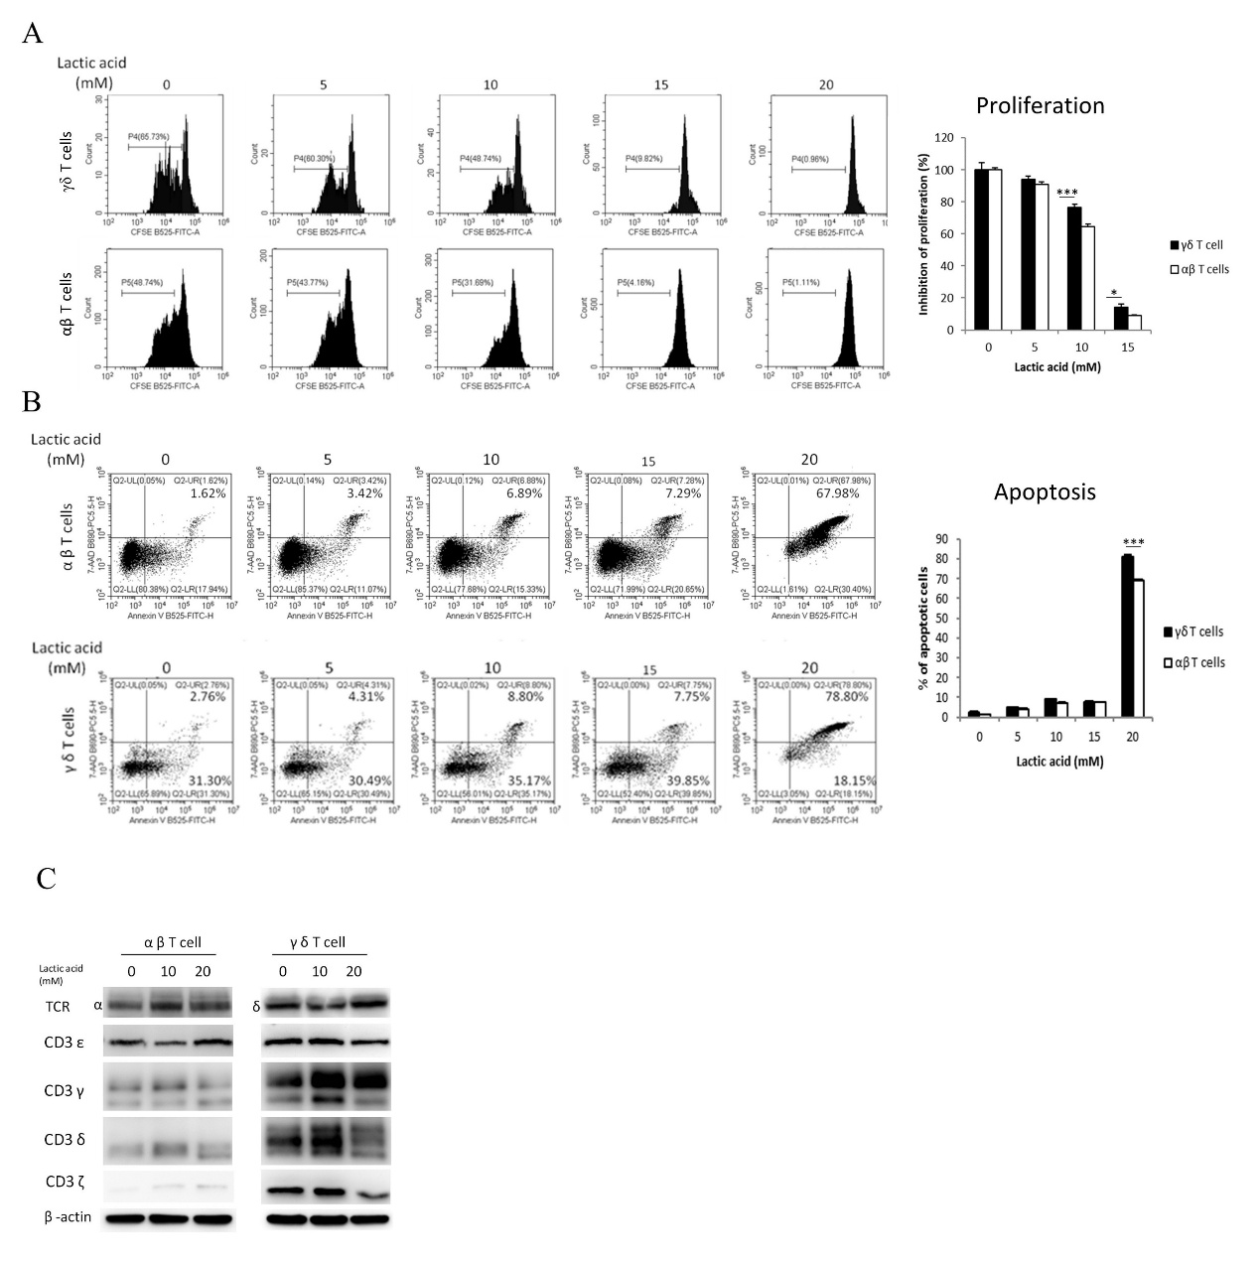

Supplementary Figure 1. Deciphering lactic acid treatment's impact on αβ- and γδ-T cell ratios. 2 × 10⁶ of PBMCs were stimulated with anti-CD3 and anti-CD28 antibody or zoledronic acid to expand αβ- and γδ-T cells separately for 7 days. The expanded T cells were treated with different concentrations of lactic acid. To evaluate the (A) The effect of lactic acid on the proliferation of αβ- and γδ-T cells. (B) The impact of lactic acid on the apoptosis of αβ- and γδ-T cells. (C) The influence of lactic acid on the expression of CD3 and TCR at αβ-T and γδ-T cells. Statistics were analyzed using a t-test. ***p<0.001

Supplementary Figure 2

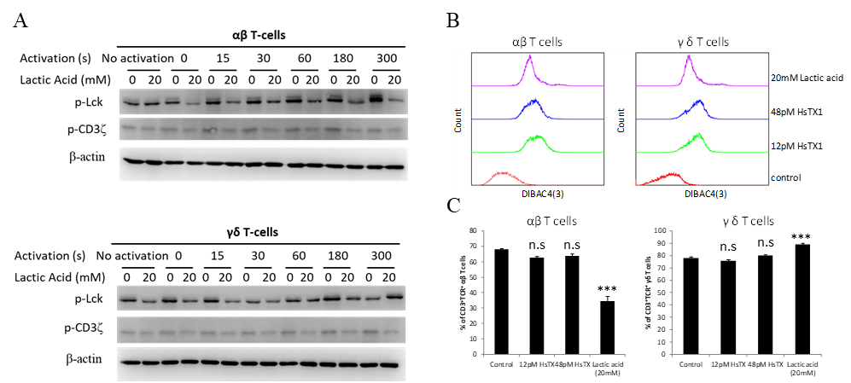
Supplementary Figure 2. Effect of lactic acid on TCR signaling of αβ and γδ T cells. (A) Effect of lactic acid on the early stage of TCR signaling in αβ and γδ T cells. Both 2×106 of rested αβ and γδ T cells were cultured in different doses of lactic acid-containing medium for 5 hours. The treated T cells were then activated by OKT-3/anti-mouse IgG complex. The total protein lysates were harvested at the designated time. The phosphorylation level of CD3ε and LCK was further analyzed by Western blot. (B) Effect of lactic acid on Kv 1.3 channel-mediated plasma membrane depolarization. Two million αβ- or γδ-T cells were cultured in 2mL of culture medium with lactic acid or various doses of HsTX1 overnight in 24-well plates pre-coated with anti-CD3. Cells cultured in normal medium were set as the control. T cell polarization was evaluated by DIBAC4 staining and flow cytometry. (C) Effect of KV 1.3 channel inhibition on cell surface TCR expression of αβ and γδ T cells. Statistics were analyzed using a t-test compared with the control group. ***p<0.001

