Table S1 Comprehensive Performance Evaluation of Each Model
Model | ACC | SEN | SPE | PPV | NPV | F1 | MCC | Brier | AUC
Train
RF | 0.7345 | 0.5548 | 0.8085 | 0.5436 | 0.8153 | 0.5492 | 0.3611 | 0.1783 | 0.7628
SVM | 0.7006 | 0.4041 | 0.8225 | 0.4836 | 0.7704 | 0.4403 | 0.24 | 0.2018 | 0.7126
BP | 0.6208 | 0.6438 | 0.6113 | 0.4052 | 0.8067 | 0.4974 | 0.2325 | 0.2272 | 0.6996
ELM | 0.6527 | 0.7329 | 0.6197 | 0.4421 | 0.8494 | 0.5515 | 0.3206 | 0.2109 | 0.7338
RBF | 0.7046 | 0.6575 | 0.7239 | 0.4948 | 0.8371 | 0.5647 | 0.3559 | 0.1968 | 0.7546
PLS | 0.6487 | 0.7192 | 0.6197 | 0.4375 | 0.8429 | 0.544 | 0.3083 | 0.2059 | 0.7549
GRU | 0.6766 | 0.7192 | 0.6592 | 0.4646 | 0.8509 | 0.5645 | 0.3455 | 0.1991 | 0.7617
LSTM | 0.6826 | 0.7123 | 0.6704 | 0.4706 | 0.85 | 0.5668 | 0.3503 | 0.2019 | 0.745
LR | 0.6567 | 0.7123 | 0.6338 | 0.4444 | 0.8427 | 0.5474 | 0.3153 | 0.206 | 0.7538
NB | 0.6307 | 0.7603 | 0.5775 | 0.4253 | 0.8542 | 0.5455 | 0.3072 | 0.2607 | 0.7205
KNN | 0.6188 | 0.5548 | 0.6451 | 0.3913 | 0.7789 | 0.4589 | 0.1844 | 0.2556 | 0.6474
DT | 0.6487 | 0.6233 | 0.6592 | 0.4292 | 0.8097 | 0.5084 | 0.2598 | 0.2355 | 0.6434
LSSVM | 0.2914 | 1 | 0 | 0.2914 | 0 | 0.4513 | 0 | 0.2719 | 0.6262
CNN | 0.7066 | 0.5548 | 0.769 | 0.4969 | 0.8077 | 0.5243 | 0.3141 | 0.22 | 0.7321
BiLSTM | 0.6906 | 0.6849 | 0.693 | 0.4785 | 0.8425 | 0.5634 | 0.3482 | 0.1959 | 0.764
Valid
RF | 0.7212 | 0.4662 | 0.8088 | 0.4559 | 0.8151 | 0.461 | 0.273 | 0.1844 | 0.7223
SVM | 0.7481 | 0.0301 | 0.9948 | 0.6667 | 0.749 | 0.0576 | 0.1018 | 0.243 | 0.7355
BP | 0.7519 | 0.0827 | 0.9819 | 0.6111 | 0.757 | 0.1457 | 0.1542 | 0.2361 | 0.7984
ELM | 0.7519 | 0.0752 | 0.9845 | 0.625 | 0.756 | 0.1342 | 0.1508 | 0.2422 | 0.5383
RBF | 0.75 | 0.0451 | 0.9922 | 0.6667 | 0.7515 | 0.0845 | 0.125 | 0.2377 | 0.539
PLS | 0.7538 | 0.0827 | 0.9845 | 0.6471 | 0.7575 | 0.1467 | 0.1649 | 0.2356 | 0.545
GRU | 0.7538 | 0.0677 | 0.9897 | 0.6923 | 0.7554 | 0.1233 | 0.1602 | 0.2362 | 0.7629
LSTM | 0.7558 | 0.0827 | 0.9871 | 0.6875 | 0.7579 | 0.1477 | 0.1763 | 0.2366 | 0.7677
LR | 0.7538 | 0.0827 | 0.9845 | 0.6471 | 0.7575 | 0.1467 | 0.1649 | 0.236 | 0.7661
NB | 0.6962 | 0.4286 | 0.7881 | 0.4101 | 0.8005 | 0.4191 | 0.2136 | 0.2163 | 0.6635
KNN | 0.7442 | 0.0677 | 0.9767 | 0.5 | 0.753 | 0.1192 | 0.106 | 0.2471 | 0.5895
DT | 0.6808 | 0.4737 | 0.7519 | 0.3962 | 0.8061 | 0.4315 | 0.2137 | 0.24 | 0.598
LSSVM | 0.2558 | 1 | 0 | 0.2558 | 0 | 0.4074 | 0 | 0.25 | 0.5236
CNN | 0.7154 | 0.3008 | 0.8579 | 0.4211 | 0.7812 | 0.3509 | 0.1791 | 0.2348 | 0.6644
BiLSTM | 0.75 | 0.0677 | 0.9845 | 0.6 | 0.7545 | 0.1216 | 0.136 | 0.2377 | 0.7532

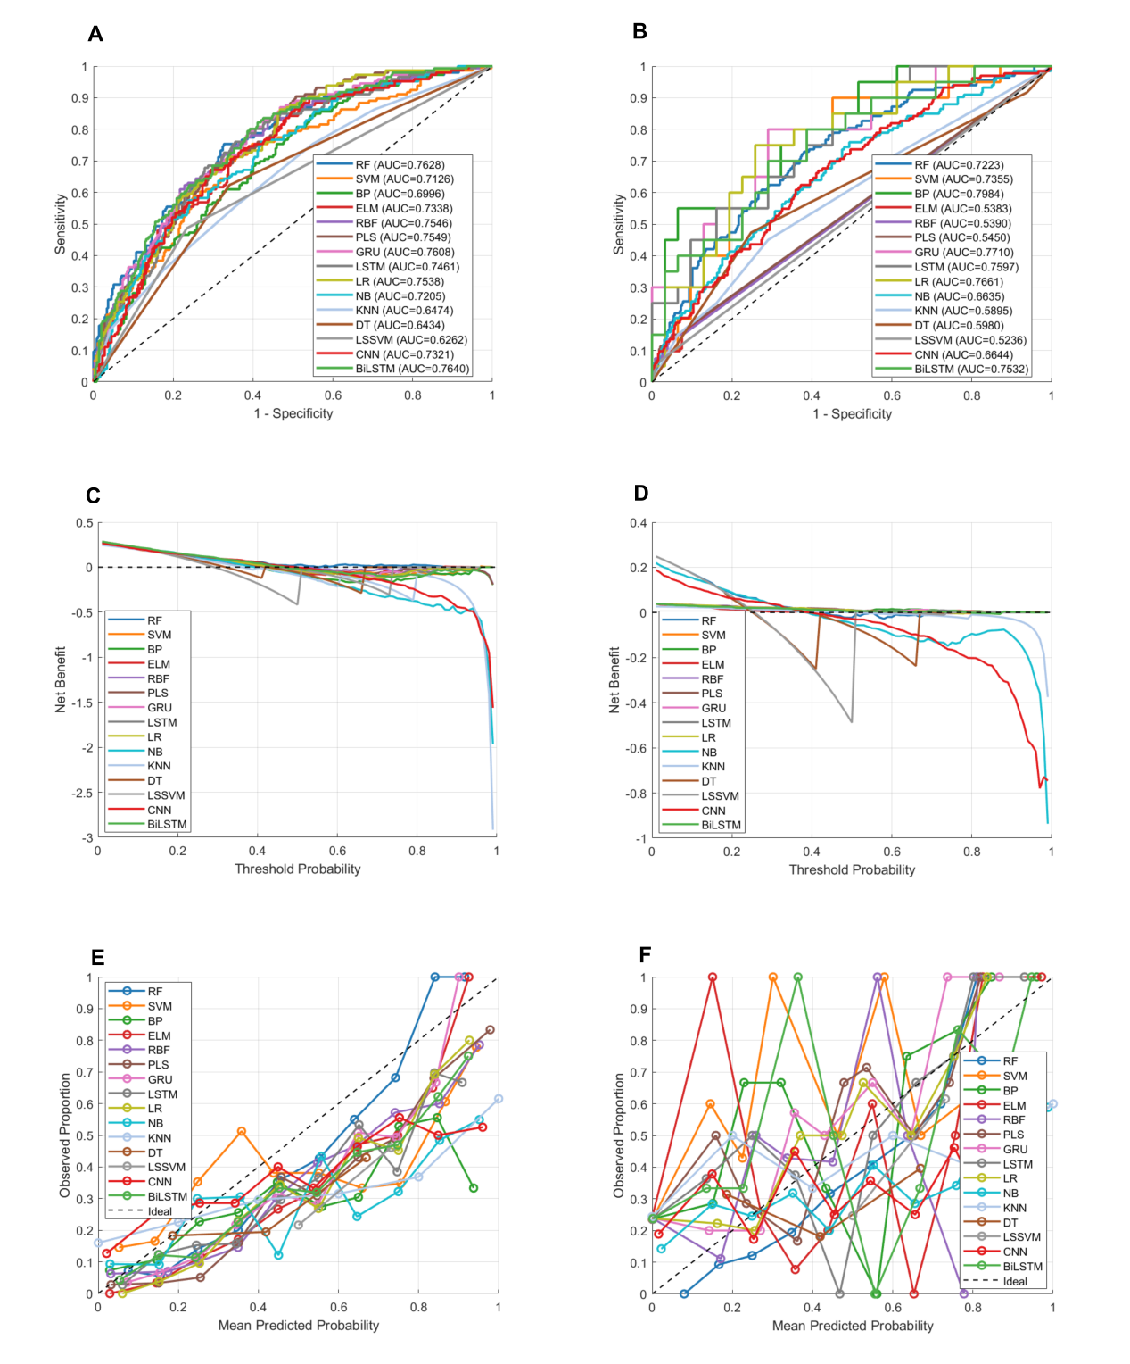

Figure S2 ROC curves, calibration curves, and decision curve analysis (DCA) of all models
A, Test set ROC comparison;B, External validation set ROC comparison;C, Test set DCA comparison ;D, External validation set DCA comparison;E,Test set Calibration Curve;F,External validation Calibration Curve

