GAZE–TARGET TEMPORAL COORDINATION - SUPPLEMENTARY RESULTS
METHOD - Gaze-target temporal coordination
To quantify the temporal relationship between the participants' gaze and the butterfly movements throughout each trial and condition, we performed additional cross-correlation analysis on position and velocity time series. The goal of cross-correlation analysis is to measure how similar two signals are when shifted in time relative to each other: for each possible time shift (or "lag"), we computed the correlation between the butterfly and gaze trajectories, then identified the lag yielding maximum correlation. This optimal lag indicates the temporal offset between the two signals, with positive values indicating that gaze lagged behind the butterfly (reactive tracking) and negative values indicating anticipatory movements where gaze preceded the target. Note that in our experiment, the butterfly movements were deliberately randomized to be unpredictable.
We computed cross-correlations separately for azimuth (horizontal) and elevation (vertical) angular positions, testing lags ranging from -1000 to +1000 ms. All cross-correlations were computed on zero-mean, unit-variance normalized signals to ensure comparable correlation magnitudes across trials. Missing samples were linearly interpolated to maintain temporal continuity. Lag values were converted to milliseconds. From these position-based signals, we derived a combined position lag as a correlation-weighted average of the azimuth and elevation velocity lags, where each component was weighted by its absolute peak correlation coefficient, providing a single measure of how rapidly participants adjusted their gaze speed in response to changes in butterfly motion. We additionally computed velocity-based lags to assess coordination of movement dynamics beyond spatial alignment; these analyses are reported in the Appendix.
Unlike discrete smooth pursuit latency measurements that capture only the initial motor delay, this cross-correlation approach quantifies the sustained temporal coordination throughout the entire tracking period, reflecting a combination of sensorimotor delays, predictive mechanisms, and strategic eye-hand coordination.

RESULTS - GAZE–TARGET TEMPORAL COORDINATION
The analyses found in the main manuscript focused on the spatial accuracy of gaze relative to the butterfly. We also explored the temporal dimension of gaze-target coupling, examining how quickly gaze movements followed changes in butterfly motion using cross-correlation lag analyses.
Temporal gaze-target coupling - cross-correlation lag analysis. Cross-correlation analysis showed that gaze tracking was reactive rather than anticipatory across all conditions and both groups: velocity lags and elevation lags were significantly greater than zero in the large majority of trials (one-sample Wilcoxon tests, p < .05 after Holm correction). Azimuth lags approached zero in catching conditions, suggesting near-synchronous horizontal gaze-target coupling during active interception. In the following sections, we present in detail results for combined position lag and elevation lags.

Combined position lag
As a reminder, the combined positioned lag corresponds to a correlation-weighted average of the azimuth and elevation velocity lags, where each component is weighted by its absolute peak correlation coefficient. This measure is used to estimate how rapidly participants adjusted their gaze speed in response to changes in butterfly motion.
Within-group analyses. For controls, the combined position lag showed a significant main effect of block type (F(2,22) = 3.47, p = .047, η²p = .22) and a significant scotoma × block type interaction (F(2,22) = 3.94, p = .033, η²p = .25; see Figure A bottom panel), but no significant effect of scotoma alone (F(1,12) = 4.03, p = .068) and no viewing × scotoma interaction. Pairwise block type comparisons did not survive Holm correction (all p ≥ .080).
For patients, no significant effects were found for either condition or block type (all Friedman p ≥ .18; see Figure 7 top panel). A notable degree of inter-individual variability was observed for binocular catching (median = 12.2 ms, IQR: −42.8 to +79.4 ms), with some patients showing anticipatory position lags (negative values) in this condition.

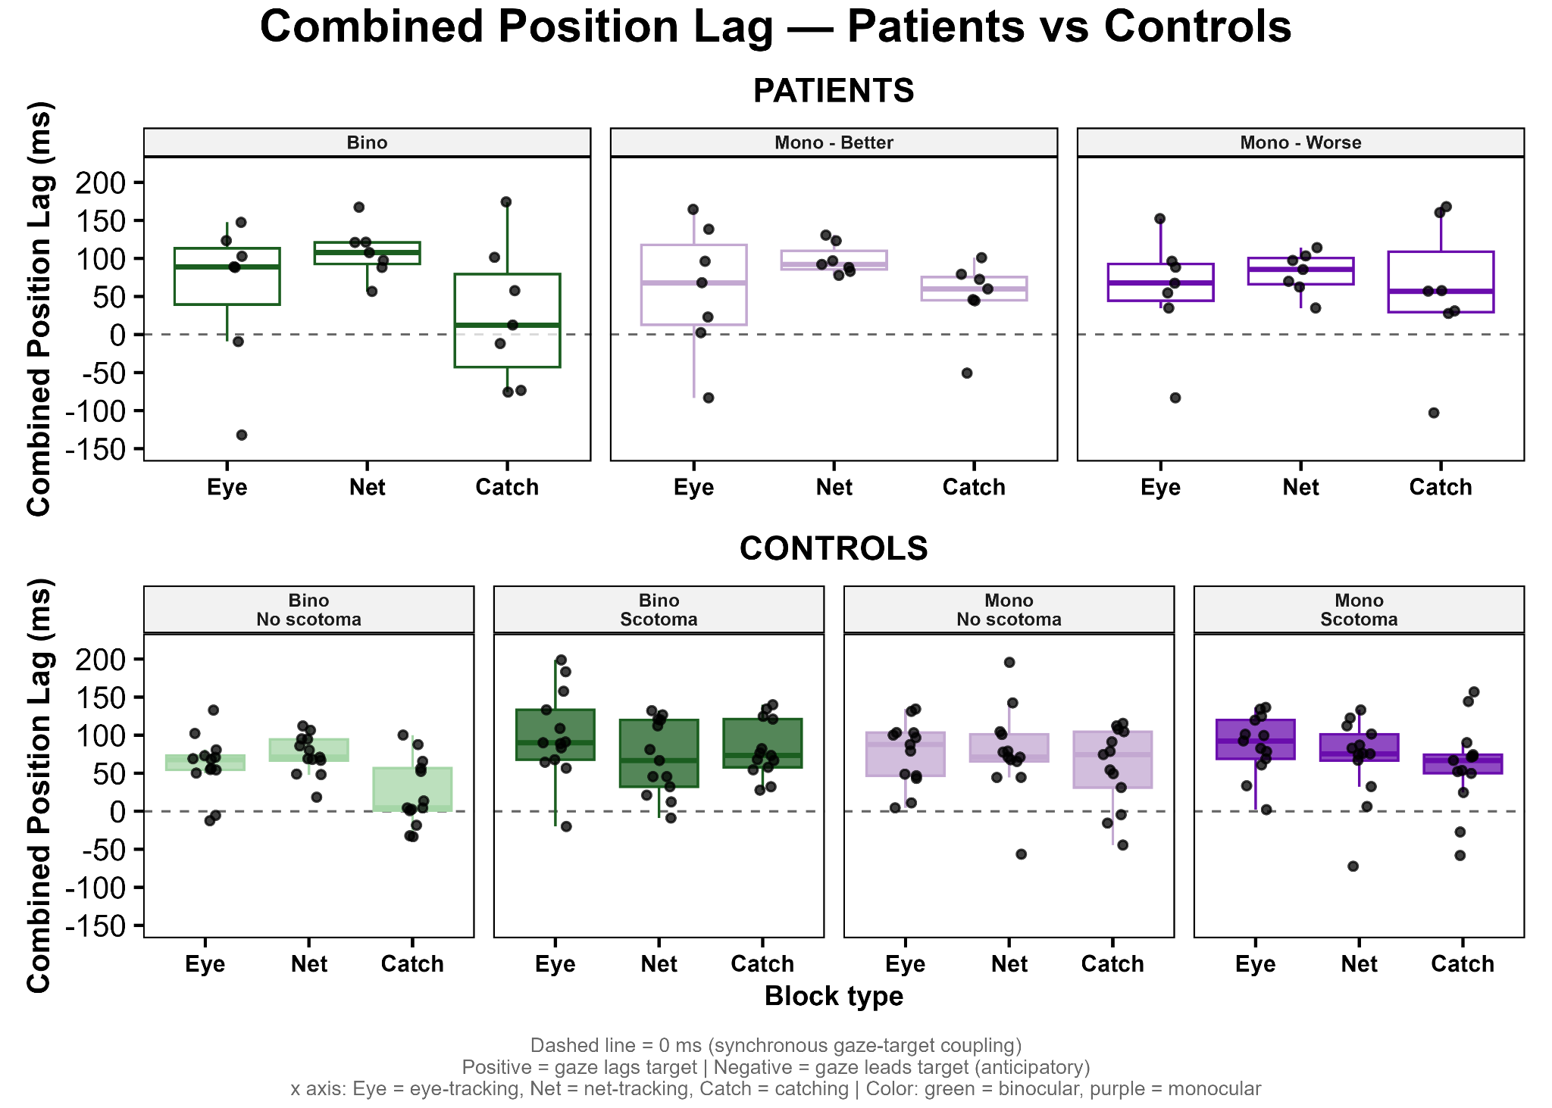
Figure A. Combined position lag in ms for patients (top panel) and controls (bottom panel), for each condition viewing condition and each block type. The dashed-line (0 ms) represents synchronous gaze-target coupling, while a positive value indicates a reactive gaze tracking and a negative value an anticipatory gaze tracking. Black dots represent individual means for each participant. Each boxplot shows the median threshold (dark internal horizontal line) and the first and third quartile (top and bottom edges of the box).

Between-group analyses. Between-group comparisons revealed a significant group × block type interaction (F(2,1383) = 6.03, p = .002), confirmed by the LRT (χ²(7) = 14.23, p = .047). The direction of this interaction was qualitatively reversed between groups: controls showed higher combined lags during eye-tracking than net-tracking (on average EMMs: 93.8 ms vs 69.4 ms), whereas patients showed the opposite pattern (58.6 ms vs 99.3 ms). Pairwise contrasts confirmed that these cross-over patterns were significant (eye-tracking vs net-tracking: estimate = 65.1 ms, p = .002; net-tracking vs catching: estimate = -62.5 ms, p = .004).

Elevation lags
To further characterize the directionality of temporal gaze-target coupling, we separately examined vertical (elevation) lags, and azimuth (horizontal) lags, which provide information about whether the group differences in combined lags are driven by a specific component of gaze motion.
Within-group analyses. For controls, elevation lag showed significant effects of scotoma (F(1,12) = 7.92 p = .016, η²p = .40; scotoma: M = 43.0 ms vs no scotoma: M = 33.7 ms) and block type (F(2,22) = 3.45, p = .048, η²p = .22; see Figure 8, bottom panel), though pairwise block type comparisons did not survive Holm correction (all p ≥ .191). No significant viewing × scotoma interaction was observed.
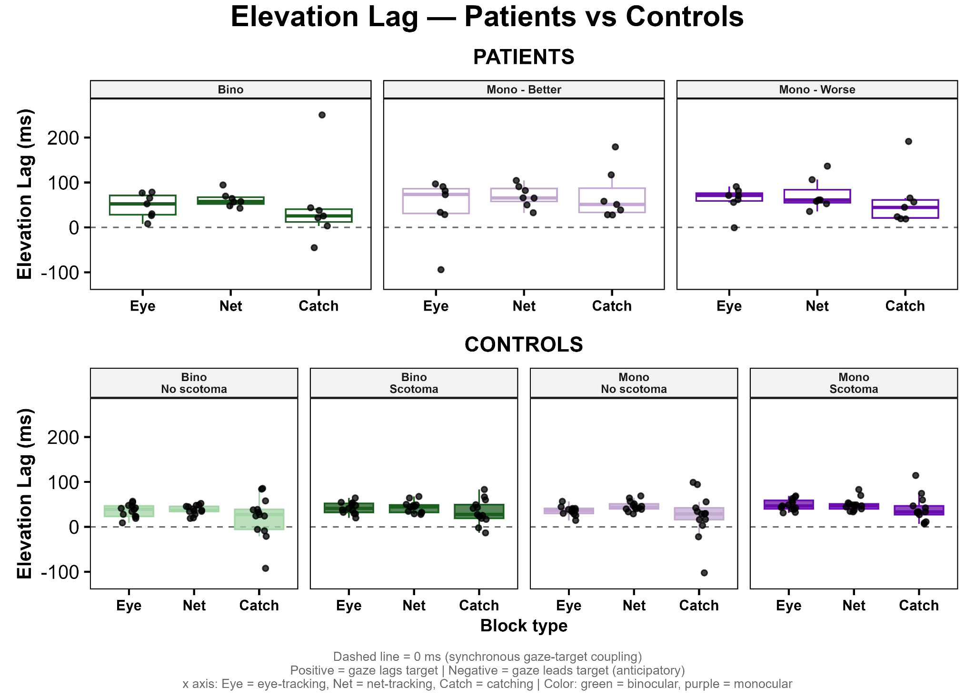
Figure B. Combined position lag in ms for patients (top panel) and controls (bottom panel), for each condition viewing condition and each block type. The dashed-line (0 ms) represents synchronous gaze-target coupling, while a positive value indicates a reactive gaze tracking and a negative value an anticipatory gaze tracking. Black dots represent individual means for each participant. Each boxplot shows the median threshold (dark internal horizontal line) and the first and third quartile (top and bottom edges of the box).

For patients, no significant effect of viewing condition was found on elevation lag (all Friedman p ≥ .10; see Figure B, top panel). A non-significant trend toward lower lag during catching relative to passive tracking was observed under binocular viewing (χ²(2) = 5.43, p = .066, W = .39), mirroring the pattern seen for combined position lag.
Between-group analyses. Between-group comparisons revealed a significant group main effect (F(1,23.8) = 6.16, p = .021), with patients showing consistently longer vertical tracking delays than controls across all conditions (EMMs: 51-67 ms vs 40-46 ms). This difference was not found for the azimuth lag, which could reflect the fact that 5/7 of our patients add their PRL on the lower left part of their visual field, with a larger displacement vertically than horizontally.

Velocity lag
To assess the coordination of movement dynamics beyond spatial alignment, we additionally analyzed velocity-based lags. Angular velocities were estimated using gradient computation on position data smoothed with a 5-sample moving average window. We then performed cross-correlation on these velocity signals with a restricted lag range of ±500 ms.
Within-group analyses. For controls, a 3-way repeated-measures ANOVA on mean velocity lag revealed significant main effects of viewing condition (F(1,11) = 12.0, p = .005, η²p = .50), scotoma condition (F(1,11) = 12.6, p = .004, η²p = .51), and block type (F(2,22) = 14.1, p < .001, η²p = .54), as well as significant interactions between viewing condition and block type (F(2,22) = 5.46, p = .011, η²p = .31) and between scotoma condition and block type (F(2,22) = 3.96, p = .033, η²p = .25; see Figure C, bottom panel). Monocular viewing increased velocity lag relative to binocular viewing (M = 70.9 ms vs 58.0 ms; t(11) = 3.47, p = .005), and the artificial scotoma increased lag relative to the no-scotoma condition (M = 71.1 ms vs 57.9 ms; t(11) = 3.55, p = .004). Critically, the catching task produced markedly shorter velocity lags than passive tracking (eye-tracking: M = 71.9 ms; net-tracking: M = 76.5 ms; catching: M = 44.9 ms; both comparisons p ≤ .006 after Holm correction), with eye-tracking and net-tracking not differing from each other (p = .078). The interactions reflected a particularly pronounced lag reduction in catching under optimal viewing conditions: the binocular no-scotoma catching condition yielded a near-zero lag (M = 14.5 ms) that was significantly lower than monocular scotoma catching conditions after Holm correction (both p ≤ .023), indicating that motor intention combined with full visual information almost eliminated gaze-target temporal disparity.
For patients, Friedman tests revealed no significant effect of viewing condition on velocity lag for any block type (eye-tracking: χ²(2) = 2.15, p = .341, W = .15; net-tracking: χ²(2) = 1.14, p = .565, W = .08; catching: χ²(2) = 0.86, p = .651, W = .06), nor any effect of block condition within any viewing condition (binocular: χ²(2) = 2.00, p = .368; monocular better eye: χ²(2) = 3.71, p = .156; monocular worse eye: χ²(2) = 0.29, p = .867). Unlike controls, patients showed no reduction in velocity lag during catching, maintaining consistently elevated lags across all conditions and tasks (medians ranging from 69 to 103 ms).

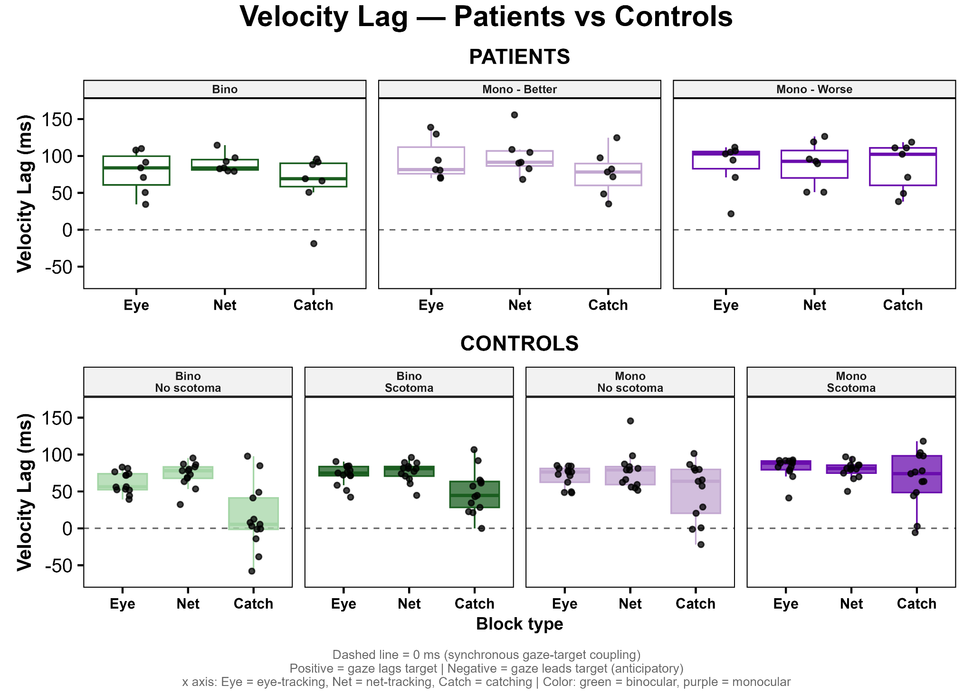
Figure C. Velocity lag for patients (top panel) and controls (bottom panel), for each condition viewing condition and each block type. The dashed-line (0 ms) represents synchronous gaze-target coupling, while a positive value indicates a reactive gaze tracking and a negative value an anticipatory gaze tracking. Black dots represent individual means for each participant. Each boxplot shows the median threshold (dark internal horizontal line) and the first and third quartile (top and bottom edges of the box).
Between-group analyses. Between-group comparisons using a linear mixed model revealed significant main effects of viewing (F(1,1385) = 7.84, p = .005) and block type (F(2,1385) = 8.72, p < .001), with no significant interactions involving group (all p ≥ .77; LRT: χ²(7) = 2.97, p = .888). Patients showed a trend toward higher velocity lags than controls (F(1,21.3) = 4.28, p = .051; EMMs: patients 77-92 ms vs controls 59–78 ms), though this did not reach significance, likely reflecting limited statistical power with n = 7 patients. The absence of group interactions on velocity lag, despite the striking descriptive difference in the catching condition, may also reflect high within-patient variability that reduces sensitivity in the mixed model.

Azimuth lags
Within-group analyses. For controls, azimuth lag showed a dominant block type effect (F(2,22) = 14.6, p < .001, η²p = .55), driven by a near-zero lag during catching (M = 5.1 ms) relative to passive tracking (eye-tracking: M = 38.2 ms; net-tracking: M = 41.8 ms; both p < .001 after Holm correction; see Figure D, bottom panel). No effect of viewing condition or scotoma was observed on horizontal tracking timing, and no significant interactions were found.
For patients, no significant effects of viewing condition were found on azimuth lag (all Friedman p ≥ .10). For the block type effect under binocular viewing, a significant Friedman test was observed (χ²(2) = 8.67, p = .013, W = .62), with the net-tracking to catching contrast surviving Holm correction (W = 28, p = .047, r = .89; medians: net-tracking 50.0 ms, catching 23.3 ms), replicating in the horizontal dimension the task-dependent lag reduction seen in controls, but only under binocular viewing.
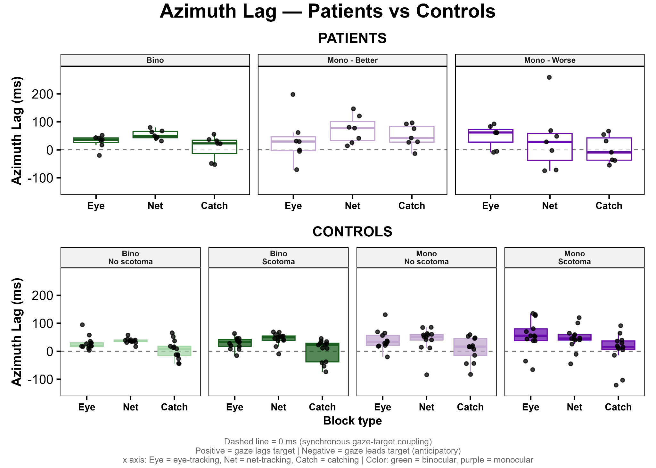
Figure D. Azimuth lag for patients (top panel) and controls (bottom panel), for each condition viewing condition and each block type. The dashed-line (0 ms) represents synchronous gaze-target coupling, while a positive value indicates a reactive gaze tracking and a negative value an anticipatory gaze tracking. Black dots represent individual means for each participant. Each boxplot shows the median threshold (dark internal horizontal line) and the first and third quartile (top and bottom edges of the box).
Between-group analyses. No group differences or interactions were significant for azimuth lag (all p ≥ .33; LRT: χ²(7) = 2.71, p = .911). The mixed model showed a singular fit, indicating that between-participant variance was negligible for horizontal lag and results should be interpreted cautiously.

