Supplementary Materials

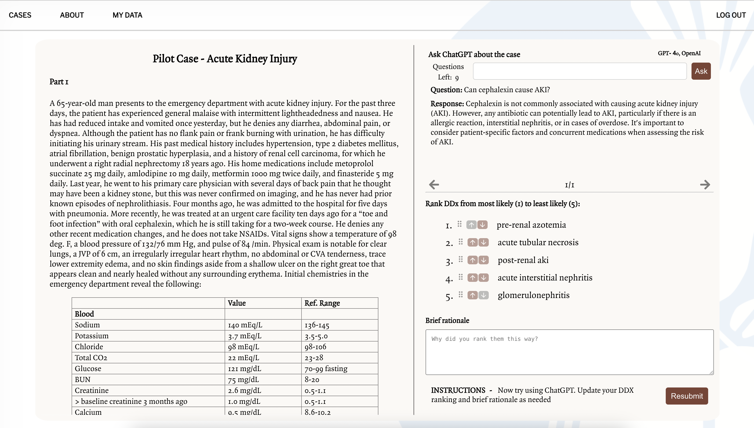

Figure S1. Custom Web Application for AI-integrated Clinical Reasoning

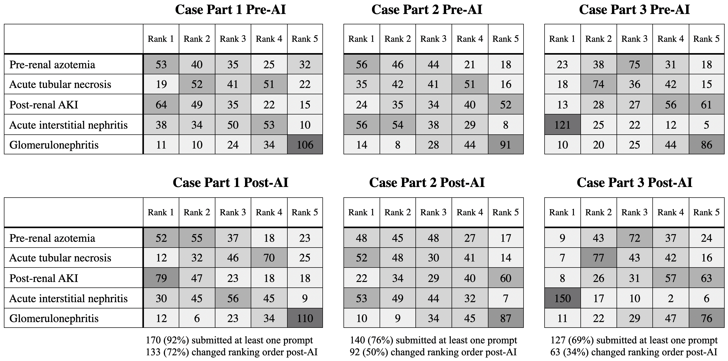

Figure S2. Frequency of Differential Diagnosis Rankings Pre- and Post-AI by Case Part

