Supplementary information
Title: A simulation to identify the optimal area to survey in the early stage of invasion by Solenopsis invicta
Biological invasions
Authors: Shumpei Hisamoto*, Koichi Goka & Yoshiko Sakamoto. *Corresponding author
Affiliation: National Institute for Environmental Studies, Onogawa 16-2, Tsukuba, Ibaraki, 305-8506, Japan
e-mail: *shumpei.hisamoto.research@gmail.com

S1 Prior dispersal probability
In this study, the prior dispersal probability was assumed to be a non-informative prior distribution, and $P\left(f\right)$ was fixed at 0.5. However, in the future, it may be possible to estimate the dispersal probability from the state of the colony. Therefore, we examined how dispersal probability$P(D)$, expected number of colonies $E_{1}$, and residual number of colonies in the residual area when no colonies are detected in the survey area, $R_{1},$ changed as a function of the change in $P\left(f\right)$. $P(D)$ decreased as $P\left(f\right)$ increased (Fig. S1a). For $E_{1}$ at a certain r, N at the peak value decreased as $P\left(f\right)$ increased (Fig. S1b). Therefore, $R_{1}$ also decreased as $P\left(f\right)$ increased (Fig. S1c).

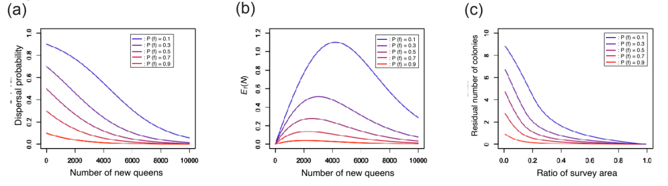
Figure S1 a Change in dispersal probability as a function of the number of new queens (N) with r and pe fixed at 0.5 and 0.001 respectively. b Expected number of colonies in the area not surveyed as a function of the number of new queens ($E_{1}\left(N\right)$) with r and $p_{e}$ fixed at 0.5 and 0.001 respectively. c Change in the residual number of colonies ($R_{1 }$) as a function of the ratio of the survey area (r) with $p_{e}$ fixed at 0.001

S2 Survey sections at Aomi
The simulation was constructed by referring to the survey sections used in the actual survey at Aomi. Information about the survey sections used in the simulation is given in Fig. S2 and Table S1. Basically, the survey areas were set within a radius of about 2 km around the point of detection. The survey sections that were too small to be used independently were integrated.

Table S1 Actual survey sections at Aomi.
Survey section ID | Area name
1 | Facilities of Tokyo metropolitan
2 | Facilities of Minato ward  Private facilities
3 | Odaiba liner terminal and warehouses
4 | Aomi container wharf
5 | Tokyo passenger ship terminal
6 | Oi container terminal
7 | Facilities around Oi container terminal
8 | Shinagawa container terminal
9 | Area around New marine disposal site
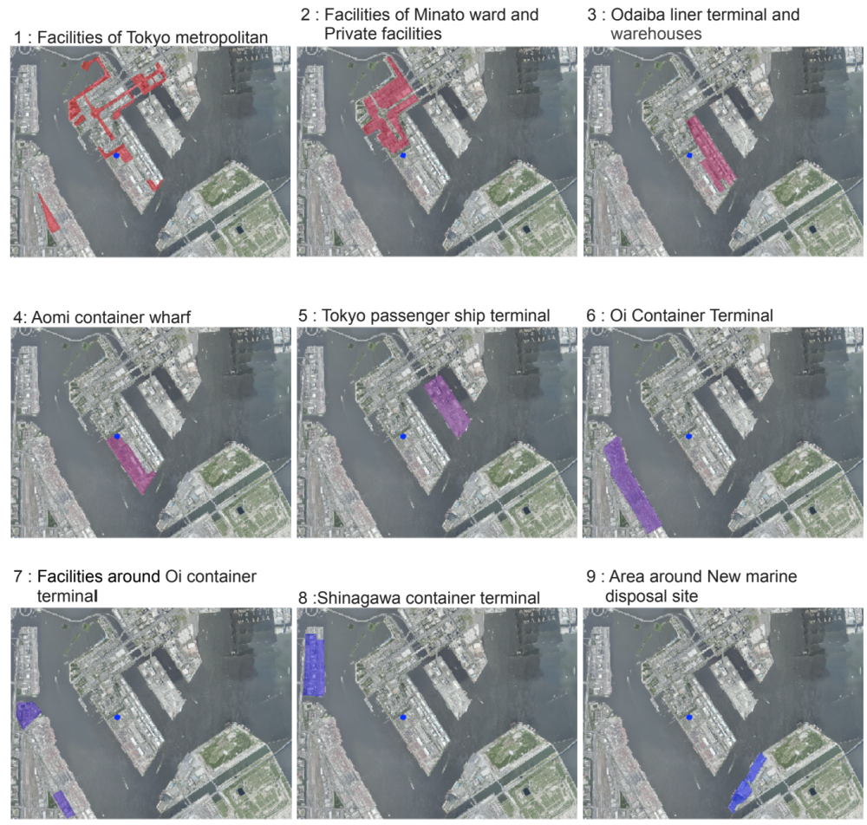
Figure S2 Each survey section at Aomi. Colored pixel represents survey sections, and a blue dot is the detected colony

S3 Why do the residual number of colonies converge on the same curve even when $p_{e}$ changes?
$R_{1}$converges to the same curve even if $p_{e}$ changes (Fig. 4d). This is because when r is fixed, the peak value of $E_{1}\left(N\right)$ is almost the same, even when $p_{e}$ changes (Fig. 3c). If Eq. 5 is analyzed, it becomes clear why the peak values hardly change. However, because Eq. 5 is a transcendental function, it is difficult to analyze it. Therefore, we performed the following analysis using the approximations. The probability that no dispersal has occurred when no colonies are present in the surveyed area (posterior probability) was calculated by the following equation:

$$P\left(f|S\right)=\frac{P\left(S|f\right)P(f)}{P(f)+(1-P(f))(1-rp_{e})^{N}}. (S1)$$

Because $P\left(S|f\right)$ and $P(f)$ are independent of $p_{e}$, $(1-rp_{e})^{N}$ determines the change of $P\left(f|S\right)$. $N_{a}$ and $N_{b}$ are the number of new queens such that $P\left(f|S\right)$ has the same value when$a$ and $b$, respectively, are substituted to $p_{e}$. In this case, the relationships between $N_{a}$ and $N_{b}$ are as follows:

$$(1-ra)^{N_{a}}=(1-rb)^{N_{b}} (S2)$$

$$N_{a}lm(1-ra){=N}_{b}lm(1-rb) (S3)$$

$$N_{a}{=N}_{b}\frac{lm(1-rb)}{lm(1-ra)}. (S4)$$

Because $p_{e}$ < 0.005, Eq. S4 can be approximated by a Taylor series expansion to the following equation:

$$N_{a}{=N}_{b}\frac{rb}{ra}. \left(S5\right)$$

$N_{a}$ can be represented by $N_{b}$, $a,$ and $b as follows$:

$$N_{a}{=N}_{b}\frac{b}{a}. \left(S6\right)$$

Therefore, $E_{1}\left(N_{a}\right)$ can be rearranged as follows:

$$E_{1}\left(N_{a}\right)=N_{a}\left(1-P\left(f|S\right)\right)\frac{a(1-r)}{1-ra} . \left(S7\right)$$

$$E_{1}\left(N_{a}\right)=N_{b}\frac{b}{a}\left(1-P\left(f|S\right)\right)\frac{a\left(1-r\right)}{1-rb}. \left(S8\right)$$
Because $p_{e}$ < 0.005,
$$(1-rb)≅(1-ra).. \left(S9\right)$$

$E_{1}\left(N_{a}\right)≅E_{1}\left(N_{b}\right). . \left(S10\right)$
This means that, independent of $p_{e}$, the values of $E_{1}\left(N\right)$ are almost equal when $P\left(f|S\right)$ has the same value. If the $P\left(S|f\right)$ at the peak value of $E_{1}\left(N\right)$ hardly changes independent of $p_{e}$, then $R_{1}$ converges to the same curve. Replacing $P\left(f|S\right)$ with the linear function $LP\left(x\right)$ where N is x leads to

$$LP\left(x\right)=cx+P\left(f\right) \left( LP\left(x\right) ≤ 1\right). \left(S11\right)$$

As $p_{e}$ changes, the slope coefficient, c, changes. Replacing $E_{1}\left(N\right)$ with $y\left(x\right)$ leads to a quadratic function on x.

$$y\left(x\right)=x\left(1-cx-P(f)\right)d. \left(S12\right)$$

Here, $d$ is a constant and represents $\frac{p_{e}\left(1-r\right)}{1-rp_{e}}$. $x_{max}$ corresponds to the maximum value of $y\left(x\right)$, and $LP\left(x_{max}\right)$ can be obtained as follows:

$max y\left(x\right) = y\left(x_{max}\right)$

$$y^{'}\left(x\right)=d\left(1-2cx-P\left(f\right)\right) \left(S13\right)$$

$$1-2cx_{max}-P\left(f\right)=0 \left(S14\right)$$

$$x_{max}=\frac{1-P(f)}{2c}. \left(S15\right)$$

$$LP\left(x_{max}\right)=c\frac{1-P(f)}{2c}+P(f) ( LP\left(x_{max}\right) ≥ 0) \left(S16\right)$$

$$LP\left(x_{max}\right)=\frac{1+P(f)}{2} ( LP\left(x_{max}\right) ≥ 0). \left(S17\right)$$

$LP\left(x_{max}\right)$ is independent of c and d. Therefore, the value of $P\left(f|S\right)$ associated with the maximum value of $E_{1}\left(N\right)$ remains almost the same, even when $p_{e}$ changes, and the peak value of $E_{1}\left(N\right)$ hardly changes at all when the values of $P\left(f|S\right)$ are the same. As a result, $R_{1}$ converges on the same curve, even when $p_{e}$ changes.

