Additional file 4: Postoperative VAS questionnaire, phase 1
ANCORA randomized controlled trial

Identification code: ______________________________________________
- Phase 1 - 24 hours: Date: ____/____/____ Time: ____________
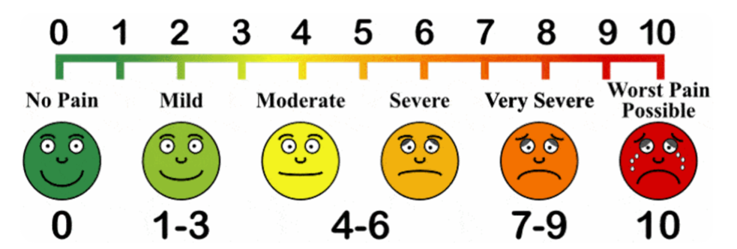
(Adapted from Anselmo-Lima and Sakano, 2015)

- Phase 2 - 48 hours: Date: ____/____/____ Time: ____________
(Adapted from Anselmo-Lima and Sakano, 2015)

- Phase 3 - 72 hours: Date: ____/____/____ Time: ____________
(Adapted from Anselmo-Lima and Sakano, 2015)

