Additional file 6: Postoperative VAS and complications questionnaire
ANCORA randomized controlled trial

Postoperative questionnaire, Phase 2
Identification code: ______________________________________________
Postoperative complications / Time | 24 hours | 48 hours | 72 hours | 14 days
CSF fistula
Surgical wound infection
Opioid use
Soft-tissue edema
Epidural hematoma
Other postoperative complications: ______________________________________________
Time after surgery completion until the patient woke up: ____________
ICU admission? yes ( ) no ( ) If yes, how many days? ____________
Length of ward stay: ____________
Phase 4 - 14th day: Date: ____/____/____ Time: ____________

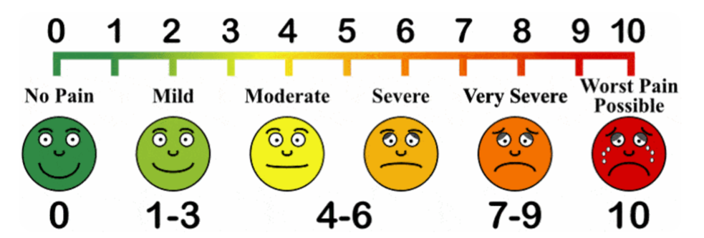
(Adapted from Anselmo-Lima and Sakano, 2015).

