Supplemental Material

Supplemental Table 1: Geometric means (GM) of maternal and breastmilk PFAS concentrations in ng/mL
 | Maternal plasma PFAS during pregnancy (2008–2011) |  | Maternal serum PFAS measured concurrently with children (2018–2021) |  | Breastmilk PFAS (2008–2011)
 | n | GM | n | GM | n | GM
PFOA | 189 | 1.34 | 199 | 0.53 | 114 | 0.03
PFOS | 189 | 3.90 | 199 | 1.70 | 114 | 0.04
PFHxS | 189 | 0.77 | 199 | 0.33 | 114 | 0.01
PFNA | 189 | 0.55 | 199 | 0.36 | 113 | 0.01
PFDA | 189 | 0.20 | 199 | 0.14 | - | -
∑PFAS | 189 | 7.13ª | 199 | 3.37ª | 113 | 0.09^{b}
ª Sum of PFOA, PFOS, PFHxS, PFNA, and PFDA concentrations
^{b} Sum of PFOA, PFOS, PFHxS, and PFNA concentrations

Supplemental Table 2: R² from bivariate linear regression models
 | PFOA | PFOS | PFHxS | PFNA | PFDA | ∑PFAS
Year of blood sampling | 0.04 | 0.03 | 0.04 | 0.08 | 0.08 | 0.07
Child age at blood sampling | 0.01 | 0.00 | 0.02 | 0.00 | 0.00 | 0.01
Child sex at birth | 0.01 | 0.00 | 0.00 | 0.00 | 0.00 | 0.00
Child birth order | 0.00 | 0.00 | 0.01 | 0.00 | 0.01 | 0.00
Maternal age during pregnancy | 0.01 | 0.02 | 0.03 | 0.00 | 0.04 | 0.03
Maternal plasma PFAS during pregnancy | 0.11 | 0.08 | 0.32 | 0.03 | 0.05 | 0.12
Maternal race | 0.03 | 0.01 | 0.03 | 0.00 | 0.01 | 0.03
Maternal education | 0.05 | 0.04 | 0.03 | 0.02 | 0.05 | 0.00
Household income | 0.00 | 0.00 | 0.02 | 0.01 | 0.00 | 0.00
Child breastfeeding duration | 0.02 | 0.03 | 0.00 | 0.00 | 0.03 | 0.01
Breastmilk PFAS concentrations | 0.10 | 0.07 | 0.19 | 0.01 | n/c | 0.08ª
PFAS cumulative intake from breastfeeding | 0.13 | 0.05 | 0.09 | 0.01 | n/c | 0.05ª
ª ∑PFAS excludes PFDA as it was not measured in breastmilk
n/c: not calculated because PFDA was not measured in breastmilk

Supplemental Table 3: R² from multivariable linear regression models
PFOA | PFOS | PFHxS | PFNA | PFDA | ∑PFASª
0.25 | 0.16 | 0.34 | 0.12 | 0.21 | 0.21

ª ∑PFAS excludes PFDA as it was not measured in breastmilk

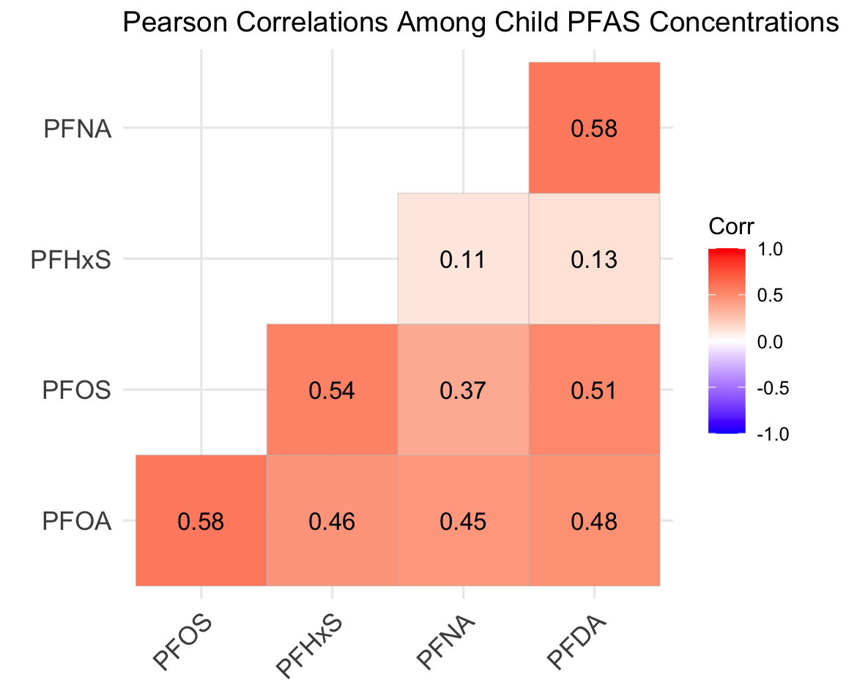
Supplemental Figure 1: Heatmap of Pearson correlation coefficients (r) between child serum PFAS concentrations (n = 182–204). All correlations were significant (p < 0.05).

