Concise, Scalable and Enantioselective Total Synthesis of Prostaglandins

Fuhao Zhang^{1,3}, Jingwen Zeng¹, Mohan Gao¹, Linzhou Wang¹, Gen-Qiang Chen^{1,2}*, Yixin Lu³, and Xumu Zhang^{1,2}*
¹Department of Chemistry and Shenzhen Grubbs Institute, Southern University of Science and Technology, Shenzhen, 518000, China;
²Med-X, Academy for Advanced Interdisciplinary Studies, Southern University of Science and Technology, Shenzhen, 518000, China;
³Department of Chemistry, National University of Singapore, Science Drive 3, 117543, Singapore;
E-mail: chengq@sustech.edu.cn, zhangxm@sustech.edu.cn.

Supporting Information

Contents

1. General information 2
2. Optimization of the reaction conditions for the asymmetric hydrogenation. 3
3. Detailed synthetic pathway 6
4. NMR spectra 38
5. HPLC spectra 80
6. Crystallographic information 85
7. References 88

1. General information
Unless otherwise mentioned, all experiments were carried out under an atmosphere of argon in an argon-filled glovebox or using standard Schlenk techniques. Solvents were dried with standard procedures and degassed with N₂. Flash silica gel column chromatography was performed using Tsingdao silica gel (60, particle size 300-400 mesh) and basic Al₂O₃ (particle size 300-400 mesh). PE refers to 40/60 petroleum ether. EA refers to EtOAc. DCM refers to CH₂Cl₂. NMR spectra were recorded on Bruker DPX 400 spectrometer at 400 MHz for ¹H NMR, 101 MHz for ¹³C NMR, 376 MHz for ¹⁹F NMR or Bruker DPX 600 spectrometer at 600 MHz for ¹H NMR, 151 MHz for ¹³C NMR and 565 MHz for ¹⁹F NMR in Methanol-d₄ or CDCl₃ with tetramethylsilane (TMS) as internal standard. Chemical shifts were reported in ppm and coupling constants were given in Hz. Chemical shifts were reported relative to TMS (0.00 ppm), CHCl₃ (7.26 ppm) or MeOH (3.31 ppm) for ¹H NMR and relative to CDCl₃ (77.0 ppm) or Methanol-d₄ (49.0 ppm) for ¹³C NMR.

2. Optimization of the reaction conditions for the asymmetric hydrogenation.
A. Procedure for preparing starting material
To a solution of commercially available S2 (16.5 g, 160 mmol) in anhydrous THF (270 mL) under Argon (Ar) at -78 ºC was added lithium diisopropylamide (LDA, 79.8 mL, 160 mmol, 2.0 M in THF) dropwise via syringe. The mixture was stirred for 30 min at -78 ºC. A solution of commercially available S1 (5.60 g, 53.2 mmol) in anhydrous THF (20 mL) was carefully added to the mixture dropwise via syringe. The reaction was instantly quenched with saturated aqueous NH₄Cl (30 mL) and filtered over a pad of silica gel. The filter liquor was extracted with ethyl acetate (3 × 100 mL). The combined organic layer was washed with brine, dried over anhydrous Na₂SO₄, and filtered. The solvent was removed under reduced pressure. The crude product was purified by column chromatography on silica gel (4:1 = PE:EA) to give 11 (as an approximately 1.3:1 mixture of ketone form and enol form, 6.09 g, 35.6 mmol, 67%) as light-yellow oil. Data for 11: R_{f} = 0.65 (2:1 = PE:EA). ¹H NMR (400 MHz, CDCl₃) δ 13.43 (d, J = 1.5 Hz, 1H), 6.87 (dq, J = 15.8, 6.9 Hz, 1.32H), 6.59 (dq, J = 15.5, 6.9 Hz, 1H), 6.15 (dq, J = 15.7, 1.7 Hz, 1.32H), 5.83 – 5.78 (m, 1H), 5.34 (s, 1H), 3.66 (s, 2.49H), 3.65 (s, 3H), 3.62 (s, 3.83H), 3.16 (s, 3.64H), 3.16 (s, 3H), 1.88 (dd, J = 6.9, 1.7 Hz, 4H), 1.82 (dd, J = 7.0, 1.7 Hz, 3H). ¹³C NMR (101 MHz, CDCl₃) δ 192.9, 172.7, 169.3, 168.27, 144.6, 134.9, 131.2, 126.6, 87.1, 61.2, 61.2, 45.3, 31.9, 31.7, 18.2, 18.0. HRMS (ESI) Calcd for C₈H₁₄NO₃ [M+H]⁺: 172.0968, found: 172.0967.
B. General procedure for preparing hydrogenation catalysts.
Figure S1. Chiral ligands
To a 2.0 mL vial was added the catalyst precursor [Ir(COD)Cl]₂ (3.3 mg, 5 × 10⁻³ mmol), ligands (10 × 10⁻³ mmol) (L1¹, L2, L3², L4², L5, L6³) and anhydrous ^{i}PrOH (1.0 mL) in an argon-filled glovebox. The mixture was stirred for 2.0 h at 25 ºC giving orange catalysts solution (10 μmol/mL) for later use.
C. General procedure for hydrogenation conditions screening (S/C = 1000).
To solution of substrate 11 (34 mg, 0.2 mmol) in solvent (2 mL) was added freshly prepared catalyst solution (20 μL, 10 μmol/mL) and base (0.01 mmol) in an argon-filled glovebox. The vial was transferred to an autoclave, which was then charged with 60 atm of H₂ and stirred at room temperature (RT) for 24 h. The hydrogen gas was released slowly and the reaction mixture was concentrated and filtered over a pad of silica gel to remove the metal complex. The enantiomeric excess of the product was determined by HPLC on Chiralpak OD-H column, hexane:isopropanol = 99:1; flow rate = 1.0 mL/min; UV detection at 220 nm; t_{R}(S) = 26.96 min (minor), t_{R}(R) = 37.49 min (major).

Table S1. Screening ligands, solvents and bases for asymmetric hydrogenation of Aª
entry | ligand | Base | solvent | conversion (%)^{b} | ee (%)^{c}
1 | L1 | K₂CO₃ | THF | ~45 | 86
2 | L2 | K₂CO₃ | THF | ~20 | 85
3 | L3 | K₂CO₃ | THF | ~35 | 82
4 | L4 | K₂CO₃ | THF | ~30 | 85
5 | L5 | K₂CO₃ | THF | ~35 | 83
6 | L6 | K₂CO₃ | THF | <5 | --
7 | L1 | K₂CO₃ | ^{i}PrOH | ~70^{d} | 87
8 | L1 | K₂CO₃ | toluene | ~20 | 94
9 | L1 | K₂CO₃ | CH₂Cl₂ | ~30 | 82
10 | L1 | K₂CO₃ | ethyl acetate | ~25 | 88
11 | L1 | K₂CO₃ | hexane | <5 | --
12 | L1 | Cs₂CO₃ | toluene | ~35 | 93
13 | L1 | KO^{t}Bu | toluene | ~90 | 93
14 | L1 | KOH | toluene | >99 | 87
15 | L1 | KOMe | toluene | ~95 | 94
ª Reaction conditions: 0.2 mmol scale, [substrate] = 0.1 M, 0.1 mol % [Ir(COD)Cl]₂/ligand, 5.0 mol % base, 2.0 mL of solvent, RT (25−30 °C). ^{b}Determined by ¹ H NMR analysis. ^{c}Determined by HPLC analysis. ^{d}Only trace amount product.

D. Optimized procedure for hydrogenation reaction.
Optimized procedure for hydrogenation reaction in 1.0 mmol scale with [Ir(COD)Cl]₂/L1 as catalyst: To a solution of 11 (171 mg, 1.0 mmol) in 10 mL toluene was added the freshly prepared catalyst solution (0.1 mL, 10 μmmol/mL) via syringe and KOMe (3.5 mg, 0.05 mmol) in an argon-filled glovebox. The reaction mixture was transferred to an autoclave, which was then charged with 60 atm of H₂ and stirred at room temperature for 24 h. The hydrogen gas was released slowly and the reaction mixture was concentrated and filtered over a pad of silica gel to remove the metal complex. The solvent was removed under reduced pressure to give crude product. The crude product was purified by silica gel column chromatography (1:1 = PE:EA) to give S3 (127 mg, 0.73 mmol, 73%) as colorless oil. Data for S3: R_{f} = 0.32 (1:1 = PE:EA). ¹H NMR (400 MHz, CDCl₃) δ 5.77 – 5.68 (m, 1H), 5.55 – 5.48 (m, 1H), 4.56 – 4.42 (m, 1H), 3.82 (d, J = 3.3 Hz, 1H), 3.66 (s, 3H), 3.17 (s, 3H), 2.74 – 2.49 (m, 2H), 1.69 – 1.67 (m, 3H). ¹³C NMR (101 MHz, CDCl₃) δ 173.5, 132.3, 127.1, 68.9, 61.4, 38.5, 31.9, 17.8. HRMS (ESI) Calcd for C₈H₁₅NO₃Na [M+Na]⁺: 196.0944, found: 196.0943. [α]: +44.7 (c = 1.0, CHCl₃). (lit.⁴: [α] = +48.4,c = 1.94, CHCl₃).

3. Detailed synthetic pathway
Figure S2. Synthesis of key intermediates

A. One-pot procedure for preparing 18
To a solution of 11 (3.5 g, 20.5 mmol) in 200 mL toluene was added the freshly prepared catalyst solution (2 mL, 10 μmmol/mL) via syringe and KOMe (71 mg, 1 mmol) in an argon-filled glovebox. The reaction mixture was transferred to an autoclave, which was then charged with 60 atm of H₂ and stirred at room temperature for 24 h. The hydrogen gas was released slowly and the reaction mixture was concentrated under reduced pressure to give crude reduced product which used for the next step directly without purification. The crude product was dissolved into 20 mL anhydrous DMF. Imidazole (2.7 g, 41 mmol) and TBSCl (4.5 g, 31 mmol) were added into the reaction mixture at 0 ºC. The reaction was quenched with saturated aqueous NaHCO₃ (30 mL) and extracted with DCM (3 × 50 mL). The combined organic layer was washed with brine, dried over anhydrous Na₂SO₄, and filtered. The solvent was removed under reduced pressure to give crude product. The crude product was purified by silica gel column chromatography (12:1 = PE:EA) to give 18 (4.1 g, 14.4 mmol, 70%) as colorless oil. Data for 18: R_{f} = 0.54 (8:1 = PE:EA). ¹H NMR (600 MHz, CDCl₃) δ 5.67 – 5.61 (m, 1H), 5.49 – 5.46 (m, 1H), 4.62 (q, J = 6.5 Hz, 1H), 3.68 (s, 3H), 3.16 (s, 3H), 2.92 – 2.68 (m, 1H), 2.37 (dd, J = 14.2, 4.0 Hz, 1H), 1.66 (d, J = 6.4 Hz, 3H), 0.85 (s, 9H), 0.03 (d, J = 4.4 Hz, 6H). ¹³C NMR (151 MHz, CDCl₃) δ 172.1, 134.0, 125.7, 70.7, 61.5, 40.8, 32.1, 26.0, 18.3, 17.7, -4.3, -4.8. HRMS (ESI) Calcd for C₁₄H₃₀NO₃Si [M+H]⁺: 288.1989, found: 288.1986. [α]: +25.5 (c = 1.0, CHCl₃).
To a solution of reported compound 19⁵ (24 g, 245 mmol) in anhydrous THF (100 mL) under Ar at -78 ºC was added ^{n}BuLi (102 mL, 2.4 M in hexane) dropwise via syringe. The mixture was warmed to -20 ºC after being stirred for 30 min at -78 ºC. A solution of 18 (20 g, 70 mmol) in anhydrous THF (50 mL) was added to the mixture dropwise via syringe. The mixture was stirred for 1 h. The reaction was quenched with saturated aqueous NH₄Cl (50 mL) and extracted with ethyl acetate (3 × 100 mL). The combined organic layer was washed with brine, dried over anhydrous Na₂SO₄, and filtered. The solvent was removed under reduced pressure to give brown oil. The crude product was purified by silica gel column chromatography (8:1 = PE:EA) to give 17 (21.8 g, 67.2 mmol, 96%) as light-yellow oil. Data for 17: R_{f} = 0.65 (8:1 = PE:EA). ¹H NMR (400 MHz, CDCl₃) δ 5.82 (s, 1H), 5.69 – 5.59 (m, 1H), 5.45 – 5.38 (m, 1H), 4.73 – 4.56 (m, 1H), 4.09 – 3.96 (m, 4H), 2.81 (dd, J = 14.9, 8.2 Hz, 1H), 2.62 (dd, J = 14.9, 4.9 Hz, 1H), 1.67 (dd, J = 6.7, 1.6 Hz, 3H), 0.85 (s, 9H), 0.03 (d, J = 11.5 Hz, 6H). ¹³C NMR (101 MHz, CDCl₃) δ 185.0, 133.0, 126.6, 92.6, 85.3, 82.7, 70.1, 64.6, 54.0, 25.7, 18.1, 17.5, -4.2, -5.1. HRMS (ESI) Calcd for C₁₇H₂₈O₄SiNa [M+Na]⁺: 347.1649, found: 347.1653. [α]: +2.7 (c = 1.0, CHCl₃).
B. Evaluation of substrates for Zhang enyne cycloisomerization
Figure S3. Evaluation of substrates for enyne cycloisomerization

In argon-filled glovebox, to a solution of 17 (17.3 g, 53.4 mmol) in degassed 1,2-dichloroethane (DCE) (900 mL) at room temperature was added [Rh(COD)Cl]₂ (1.3 g, 0.33 mmol), (S)-BINAP (3.3 g, 5.34 mmol) and AgSbF₆ (3.68 g, 6.41 mmol) successively. The mixture was stirred for 5 min at room temperature. The resulting mixture was filtered over a pad of silica gel then concentrated in vacuo. The crude residue was purified by silica gel column chromatography (8:1 = PE:EA) to give 16 (14.8 g, 45.4 mmol, 85%, 98% ee) as light yellow oil. The enantiomeric excess of the product was determined by HPLC on Chiralpak OD-H column, hexane:isopropanol = 99:1; flow rate = 1.0 mL/min; UV detection at 254 nm; t_{R} = 8.39 min (major), t_{R} = 10.25 min (minor). Data for 16: R_{f} = 0.62 (8:1 = PE:EA). ¹H NMR (600 MHz, CDCl₃) δ 6.30 (d, J = 7.4 Hz, 1H), 5.66 (d, J = 7.4 Hz, 1H), 5.61 (dt, J = 17.5, 9.1 Hz, 1H), 5.27 (d, J = 10.1 Hz, 1H), 5.21 (d, J = 17.0 Hz, 1H), 4.06 (q, J = 7.5 Hz, 1H), 4.01 – 3.90 (m, 4H), 3.24 (t, J = 7.6 Hz, 1H), 2.67 (dd, J = 17.9, 6.7 Hz, 1H), 2.35 (dd, J = 17.9, 8.4 Hz, 1H), 0.85 (s, 9H), 0.02 (s, 6H). ¹³C NMR (101 MHz, CDCl₃) δ 203.0, 142.5, 136.0, 134.7, 119.8, 96.8, 72.2, 65.2, 57.0, 48.1, 25.7, 18.0, -4.69, -4.74. HRMS (ESI) Calcd for C₁₇H₂₉O₄Si [M+H]⁺: 325.1830, found: 325.1828. [α]: –104.5 (c = 1.0, CHCl₃).
C. One pot procedure for preparing key intermediate 12
To a solution of 16 (200 mg, 0.61 mmol) and Ph₂SiH₂ (123 mg, 0.67 mmol) in anhydrous and degassed THF (10 mL) under Ar was added Pd(PPh₃)₄ (14 mg , 0.012 mmol) and anhydrous ZnCl₂ (91 mg, 0.67 mmol). The mixture was warmed to 50 ºC and stirred at the same temperature. H₂O (11 μL, 0.61 mmol) was then added to the reaction. After 5 min, the reaction was cooled to -78 ºC and LiHBEt₃ (1.83 mL, 1.0 M in THF) was added dropwise via syringe. The mixture was stirred for 1 h at the same temperature. The reaction was then quenched with 1 N HCl (5 mL) and warmed to room temperature. After being stirred for 2 h at the same temperature, the reaction was then quenched with saturated aqueous NaHCO₃ (10 mL) and extracted with THF (5 × 10 mL). The combined organic layer was dried over anhydrous Na₂SO₄, and filtered. The solvent was removed under reduced pressure to afford crude residue which was purified by basic Al₂O₃ column chromatography (EA:MeOH = 20:1) to give 12 (as an approximately 1.4:1 mixture of diastereoisomers, 78 mg, 0.45 mmol, 74%) as yellow oil. Data for 12: R_{f} = 0.40 (1:1 = PE:EA). ¹H NMR (600 MHz, CDCl₃) δ 5.75 – 5.64 (m, 4H), 5.57 (d, J = 5.7 Hz, 1H), 5.15 – 5.06 (m, 5H), 4.67 (td, J = 6.6, 3.2 Hz, 1.42 H), 4.63 (td, J = 7.2, 3.5 Hz, 1H), 3.95 (q, J = 5.9 Hz, 2.53H), 2.77 (q, J = 6.9 Hz, 1.27H), 2.67 (br, 1.52H), 2.58 – 2.45 (m, 2.71H), 2.35 (dq, J = 14.4, 7.0 Hz, 2.80H), 2.30 – 2.21 (m, 2.73H), 2.14 – 2.10 (m, 1.79H), 2.09 – 1.99 (m, 5.19H), 1.83 – 1.79 (m, 1.66H), 1.64 (br, 4H). ¹³C NMR (151 MHz, CDCl₃) δ 139.5, 138.7, 116.4, 115.6, 101.1, 99.9, 84.4, 81.2, 78.6, 78.4, 58.9, 58.6, 46.5, 45.4, 42.6, 39.6, 39.5. HRMS (ESI) Calcd for C₉H₁₄O₃Na [M+Na]⁺: 193.0835, found: 193.0834. [α]: –23.5 (c = 1.0, CH₂Cl₂).
D. One pot procedure for preparing key intermediate 20
To a solution of 16 (200 mg, 0.61 mmol) and Ph₂SiH₂ (123 mg, 0.67 mmol) in anhydrous and degassed THF (10 mL) under Ar was added Pd(PPh₃)₄ (14 mg , 0.012 mmol) and anhydrous ZnCl₂ (91 mg, 0.67 mmol). The mixture was warmed to 50 ºC and was stirred at the same temperature until complete consumption of the starting material. H₂O (11 μL, 0.61 mmol) was then added to the reaction. After 5 min, the reaction was cooled to -78 ºC and LiBHEt₃ (1.83 mL, 1.0 M in THF) was added dropwise via syringe. The mixture was stirred for 1 h at the same temperature. The reaction was then quenched with H₂O (0.1 mL, 6.1 mmol) and warmed to room temperature. After being stirred for 2 h at the same temperature, the reaction solvent was removed under reduced pressure and dried under high vacuum. The residue was then dissolved in anhydrous THF (10 mL). Anhydrous Na₂SO₄ (200 mg), KF (117 mg, 3.05 mmol) and TBAF (3.1 mL, 1.0 M in THF) were added to the reaction. The mixture was stirred for 12 h at room temperature. Reaction solvent was removed under reduced pressure to afford a crude residue which was purified by silica gel column chromatography (1:1 = PE:EA) to give 20 (94 mg, 0.43 mmol, 71%) as colorless oil. Data for 20: R_{f} = 0.40 (1:1 = PE:EA). ¹H NMR (400 MHz, CDCl₃) δ 5.62 (m, 1H), 5.14 – 5.04 (m, 2H), 4.89 (dd, J = 5.1, 3.0 Hz, 1H), 4.22 (t, J = 5.1 Hz, 1H), 4.05 – 3.93 (m, 2H), 3.91 – 3.80 (m, 3H), 3.10 (br, 1H), 2.54 (br, 1H), 2.33 – 2.20 (m, 2H), 1.95 – 1.81 (m, 2H), 1.79 – 1.68 (m, 2H). ¹³C NMR (101 MHz, CDCl₃) δ 139.1, 116.6, 103.8, 77.3, 72.3, 65.1, 64.6, 57.6, 44.9, 41.8, 31.1. HRMS (ESI) Calcd for C₁₁H₁₈O₄Na [M+Na]⁺: 237.1097, found: 237.1095. [α]: +13.0 (c = 1.0, MeOH).
E. Stepwise procedures for preparing key intermediate 20
To a solution of 16 (24.2 g, 74.7 mmol) and Sn^{n}Bu₃H (13.6 g, 127 mmol) in anhydrous and degassed THF (200 mL) under Ar was added Pd(PPh₃)₄ (1.7 g , 1.5 mmol) and anhydrous ZnCl₂ (11.2g, 82.2 mmol). The mixture was warmed to 50 ºC and was stirred at the same temperature until complete consumption of the starting material. The reaction was quenched with saturated aqueous NH₄Cl (30 mL) and extracted with ethyl acetate (3 × 100 mL). The combined organic layer was washed with brine, dried over anhydrous Na₂SO₄, and filtered. The solvent was removed under reduced pressure to afford a crude residue. The crude product was purified by silica gel column chromatography (10:1 = PE:EA) to give S4 (20.2 g, 62 mmol, 83%) as yellow oil. Data for S4: R_{f} = 0.62 (8:1 = PE:EA). ¹H NMR (600 MHz, CDCl₃) δ 5.74 – 5.68 (m, 1H), 5.23 – 5.13 (m, 2H), 5.09 (s, 1H), 4.02 (q, J = 7.3 Hz, 1H), 3.94 – 3.76 (m, 4H), 2.61 (dd, J = 18.3, 6.9 Hz, 1H), 2.50 (q, J = 9.1 Hz, 1H), 2.23 – 2.17 (m, 2H), 2.01 – 1.92 (m, 1H), 1.79 – 1.76 (m, 1H), 0.84 (s, 9H), 0.01 (d, J = 4.0 Hz, 6H). ¹³C NMR (151 MHz, CDCl₃) δ 214.6, 137.8, 117.7, 102.2, 72.8, 64.7, 64.5, 55.5, 49.6, 46.8, 32.1, 25.6, 18.0, -4.8. HRMS (ESI) Calcd for C₁₇H₃₁O₄Si [M+H]⁺: 327.1986, found: 327.1984. [α]: –68.6 (c = 1.0, CHCl₃).
To a solution of S4 (20.8 g, 63.8 mmol) (2.10 g, 6.44 mmol) in anhydrous THF (200 mL) under Ar at -78 ºC was added LiBHEt₃ (95.7 mL, 1 M in THF) dropwise via syringe. The mixture was stirred for 1 h at the same temperature. The reaction was quenched with saturated aqueous NH₄Cl (100 mL) and extracted with ethyl acetate (3 × 100 mL). The combined organic layer was washed with brine, dried over anhydrous Na₂SO₄, and filtered. The solvent was removed under reduced pressure to afford crude residue. The crude residue was purified by silica gel column chromatography (6:1 = PE:EA) to give S5 (17.8 g, 54.2 mmol, 85%) as colorless oil. Data for S5: R_{f} = 0.45 (4:1 = PE:EA). ¹H NMR (400 MHz, CDCl₃) δ 5.61 – 5.48 (m, 1H), 5.11 – 5.05 (m, 1H), 5.04 (s, 1H), 4.91 (dd, J = 5.0, 3.6 Hz, 1H), 4.16 (td, J = 5.8, 2.6 Hz, 1H), 4.03 – 3.93 (m, 2H), 3.91 – 3.80 (m, 3H), 2.31 – 2.19 (m, 2H), 1.97 – 1.89 (m, 1H), 1.84 – 1.79 (m, 1H), 1.73 – 1.63 (m, 2H), 0.85 (s, 9H), 0.01 (d, J = 2.2 Hz, 6H). ¹³C NMR (101 MHz, CDCl₃) δ 139.3, 116.6, 103.9, 77.7, 71.9, 65.0, 64.6, 56.8, 44.2, 42.8, 31.1, 25.8, 18.0, -4.6, -4.7. HRMS (ESI) Calcd for C₁₇H₃₂O₄SiNa [M+Na]⁺: 351.1962, found: 351.1959. [α]: +7.4 (c = 1.0, MeOH).
To a solution of S5 (28.1 g, 85.1 mmol) in THF (100 mL) at room temperature was added TBAF (128 mL, 1.0 M in THF) dropwise via syringe. The mixture was stirred until complete consumption of the starting material. Reaction solvent was removed under reduced pressure to afford crude residue which was purified by silica gel column chromatography (1:1 = PE:EA) to give 20 (17.9 g, 83.4 mmol, 98%) as yellow oil.
F. Derivatization of (±)-S5 for X-ray diffraction
Figure S4. Derivatization of (±)-S5 for X-ray diffraction
To a solution of (±)-S5 (100 mg, 0.3 mmol) in DCM (50 mL) at 0 ºC was added NEt₃ (61 mg, 0.6 mmol), 4-nitrobenzoyl chloride (83 mg, 0.45 mmol) and DMAP (4 mg, 0.03 mmol). The mixture was warmed to RT and stirred for 5 h. The reaction was quenched with saturated aqueous NaHCO₃ (10 mL) and extracted with DCM (3 × 10 mL). The combined organic layer was washed with brine, dried over anhydrous Na₂SO₄, and filtered. The solvent was removed under reduced pressure to afford crude residue. The crude product was purified by silica gel column chromatography (10:1 = PE:EA) to give (±)-S15 (117 mg, 0.24 mmol, 84%) as yellow oil. Data for (±)-S15: R_{f} = 0.63 (8:1 = PE:EA). ¹H NMR (400 MHz, CDCl₃) δ 8.32 – 8.24 (m, 2H), 8.24 – 8.17 (m, 2H), ), 5.69 – 5.59 (m, 1H), 5.46 – 5.37 (m, 1H), 5.22 – 5.12 (m, 2H), 4.87 (t, J = 4.6 Hz, 1H), ), 4.00 – 3.95 (m, 1H), 3.91 – 3.74 (m, 4H), 2.60 – 2.42 (m, 2H), 2.05 – 1.88 (m, 2H), 1.83 – 1.74 (m, 2H), 0.80 (s, 9H), -0.02 (d, J = 12.5 Hz, 6H). ¹³C NMR (101 MHz, CDCl₃) δ 164.2, 150.4, 138.7, 136.1, 130.7, 123.5, 117.7, 103.0, 76.73, 76.7, 64.8, 64.7, 57.6, 42.4, 42.3, 31.2, 25.7, 17.9, -4.6, -4.8. HRMS (ESI) Calcd for C₂₄H₃₆NO₇Si [M+H]⁺: 478.2256, found: 478.2251.
To a solution of (±)-S15 (117 mg, 0.24 mmol) in MeOH (50 mL) at 0 ºC was added one drop of AcCl. The mixture was warmed to RT and stirred for 1 h. The reaction was quenched with saturated aqueous NaHCO₃ (10 mL) and extracted with ethyl acetate (3 × 10 mL). The combined organic layer was washed with brine, dried over anhydrous Na₂SO₄, and filtered. The solvent was removed under reduced pressure to provide a crude residue. The crude product was purified by silica gel column chromatography (8:1 = PE:EA) to give (±)-S16 (76 mg, 0.21 mmol, 82%) as yellow oil. Data for (±)-S16: R_{f} = 0.42 (4:1 = PE:EA). ¹H NMR (600 MHz, CDCl₃) δ 8.28 (d, J = 8.7 Hz, 2H), 8.19 (d, J = 8.7 Hz, 2H), 5.68 (dt, J = 17.2, 9.6 Hz, 1H), 5.42 (t, J = 5.0 Hz, 1H), 5.31 – 5.20 (m, 2H), 4.41 (t, J = 5.7 Hz, 1H), 4.03 (q, J = 7.5 Hz, 1H), 3.24 (s, 3H), 3.22 (s, 3H), 2.67 – 2.62 (m, 1H), 2.45 (dt, J = 12.1, 8.4 Hz, 1H), 2.00 (br, 1H), 1.97 – 1.91 (m, 1H), 1.85 – 1.73 (m, 3H). ¹³C NMR (101 MHz, CDCl₃) δ 164.1, 150.5, 138.4, 135.8, 130.6, 123.6, 118.4, 102.8, 76.6, 76.0, 57.5, 53.2, 52.6, 43.1, 41.1, 30.1. HRMS (ESI) Calcd for C₁₈H₂₃NO₇ [M]⁻: 365.1480, found: 365.1474.
To a solution of (±)-S16 (76 mg, 0.21 mmol) in DCM (5 mL) at 0 ºC was added NEt₃ (43 mg, 0.42 mmol), 4-nitrobenzene-1-sulfonyl chloride (69 mg, 0.31 mmol). The mixture was warmed to RT and stirred for 10 h. The reaction was then quenched with saturated aqueous NaHCO₃ (10 mL) and extracted with DCM (3 × 10 mL). The combined organic layer was washed with brine, dried over anhydrous Na₂SO₄, and filtered. The solvent was removed under reduced pressure to provide crude residue. The crude product was purified by silica gel column chromatography (10:1 = PE:EA) to give (±)-21 (85 mg, 0.15 mmol, 75%) as white solid. The single crystal was cultured in hexane and ethyl acetate. Data for (±)-21: R_{f} = 0.45 (4:1 = PE:EA). ¹H NMR (400 MHz, CDCl₃) δ 8.35 – 8.34 (m, 1H), 8.33 – 8.32 (m, 2H), 8.30 – 8.29 (m, 1H), 8.21 – 8.14 (m, 2H), 8.06 – 8.00 (m, 2H), 5.57 – 5.39 (m, 2H), 5.15 – 5.03 (m, 2H), 4.77 – 4.73 (m, 1H), 4.37 (t, J = 5.5 Hz, 1H), 3.22 (s, 6H), 2.78 – 2.72 (m, 1H), 2.61 – 2.54 (m, 1H), 2.16 (dd, J = 16.4, 3.0 Hz, 1H), 1.97 – 1.87 (m, 1H), 1.82 – 1.70 (m, 2H), 1.61 (s, 1H). ¹³C NMR (101 MHz, CDCl₃) δ 163.9, 150.7, 142.2, 135.6, 135.3, 130.7, 129.2, 124.3, 123.7, 119.3, 102.7, 86.3, 76.0, 54.4, 53.5, 52.8, 43.1, 39.4, 29.8. HRMS (ESI) Calcd for C₂₄H₂₆N₂O₁₁SNa [M+Na]⁺: 573.1150, found: 573.1155.

G. Synthesis of the ω chains
Figure S5. Synthesis of the ω chains

To a solution of 22 (2.6 g, 20 mmol, prepared from comercially available 1-heptene following reported procedure⁶) in 25 mL ^{i}PrOH was added the freshly prepared catalyst solution (0.2 mL, 100 μmmol/mL, prepared from [Ir(COD)Cl]₂ and L2 following the general procedure) via syringe and K₂CO₃ (28 mg, 0.2 mmol) in an argon-filled glovebox. The reaction mixture was transferred to an autoclave, which was then charged with 50 atm of H₂ and stirred at room temperature for 24 h. The hydrogen gas was released slowly and the reaction mixture was concentrated. The crude product was purified by silica gel column chromatography (2:1 = PE:EA) to give 24 (2.58 g, 19.6 mmol, 98%, 98% ee) as colorless oil. The enantiomeric excess was determined based on the corresponding mono p-toluenesulfonyl derivative in the next step. Data for 24: R_{f} = 0.32 (2:1 = PE:EA). ¹H NMR (400 MHz, CDCl₃) δ 3.79 – 3.54 (m, 2H), 3.42 – 3.38 (m, 1H), 2.96 (br, 2H), 1.52 – 1.36 (m, 3H), 1.34 – 1.25 (m, 5H), 0.88 (t, J = 6.8 Hz, 3H). ¹³C NMR (101 MHz, CDCl₃) δ 72.3, 66.7, 33.1, 31.8, 25.2, 22.5, 14.0. HRMS (ESI) Calcd for C₇H₁₆O₂Na [M+Na]⁺: 155.1043, found: 155.1045. [α]: –17.2 (c = 1.0, EtOH). (lit.⁷ [α] = –17.5,c = 2.92, EtOH).
Following literature-known procedure: to a solution of 24 (2.0 g, 15.2 mmol) in DCM (30 mL) at 0 ºC was added pyridine (1.8 g, 22.8 mmol), Tosyl chloride (TsCl) (3.15 g, 16.7 mmol). The mixture was warmed to RT and stirred for 24 h. The reaction was quenched with saturated aqueous NaHCO₃ (10 mL) and extracted with ethyl acetate (3 × 30 mL). The combined organic layer was washed with brine, dried over anhydrous Na₂SO₄, and filtered. The solvent was removed under reduced pressure to provide crude residue. The crude product was purified by silica gel column chromatography (8:1 = PE:EA) to give S17 (3.68 g, 12.9 mmol, 85%) as colorless oil. The enantiomeric excess was determined by HPLC on Chiralpak OD-H column, hexane:isopropanol = 96:4; flow rate = 1.0 mL/min; UV detection at 220 nm; t_{R}(R) = 17.2 min (minor), t_{R}(S) = 18.8 min (major). Data for S17: R_{f} = 0.53 (8:1 = PE:EA). ¹H NMR (400 MHz, CDCl₃) δ 7.9 – 7.7 (m, 2H), 7.4 (d, J = 8.0 Hz, 2H), 4.0 (dd, J = 9.7, 2.6 Hz, 1H), 3.9 – 3.8 (m, 2H), 2.5 (s, 3H), 2.1 (d, J = 4.6 Hz, 1H), 1.5 – 1.4 (m, 3H), 1.3 – 1.25 (m, 5H), 0.9 (t, J = 6.9 Hz, 3H).⁸
To a solution of NaOH (2.1 g, 52.5 mmol) in Et₂O (30 mL) at 0 ºC was added S17 (3.0 g, 10.5 mmol) in Et₂O (10 mL) dropwise. The mixture was warmed to RT and stirred for 48 h. The reaction was quenched with H₂O (10 mL) and extracted with Et₂O (3 × 30 mL). The combined organic layer was washed with brine, dried over anhydrous Na₂SO₄, and filtered. The solvent was removed under reduced pressure very carefully due to extremely volatile nature of epoxide 26. The crude epoxide 26 was used for the next step without further purification. According to reported procedure⁹, to a solution of (Me)₃S⁺I⁻ (10.7 g, 52.5 mmol) in anhydrous THF (100 mL) under Ar at -20 ºC was added ^{n}BuLi (21.9 mL, 2.4 M in hexane) dropwise via syringe. The mixture was stirred for 30 min at the same temperature. A solution of crude 26 (from the former step) in anhydrous THF (20 mL) was then added to the mixture dropwise via syringe. The mixture was stirred at -20 ºC for 30 min and then at room temperature for 3 h. The reaction was quenched with saturated aqueous NH₄Cl (30 mL) and filtered over a pad of celite. The filter liquor was extracted with ethyl acetate (3 × 50 mL). The combined organic layer was washed with brine, dried over anhydrous Na₂SO₄, and filtered. The solvent was removed under reduced pressure very carefully due to extremely volatile nature of 28. The crude residue was purified by silica gel column chromatography (20:1 = PE:EA) to give 28 (1 g, 7.8 mmol, 74% two steps) as colorless oil. Data for 28: R_{f} = 0.63 (8:1 = PE:EA). ¹H NMR (400 MHz, CDCl₃) δ 5.86 – 5.78 (m, 1H), 5.17 (dt, J = 17.2, 1.4 Hz, 1H), 5.05 (dt, J = 10.4, 1.3 Hz, 1H), 4.04 (q, J = 6.3 Hz, 1H), 2.27 (br, 1H), 1.55 – 1.42 (m, 2H), 1.38 – 1.23 (m, 6H), 0.86 (t, J = 6.9 Hz, 3H). ¹³C NMR (101 MHz, CDCl₃) δ 141.3, 114.5, 73.3, 37.0, 31.7, 25.0, 22.6, 14.0. HRMS (ESI) Calcd for C₈H₁₅ [M-H₂O+H]⁺: 111.1168, found: 111.1173. [α]: +18.3 (c = 1.0, EtOH). (lit.¹⁰ [α] = +19, c = 0.21, EtOH).
To a solution of 23 (1.64 g, 10 mmol, prepared from commercially available 4-phenyl-1-buten following reported procedure⁶) in 25 mL ^{i}PrOH was added the freshly prepared catalyst solution (0.1 mL, 100 μmmol/mL, prepared from [Ir(COD)Cl]₂ and L1 following the general procedure) via syringe and K₂CO₃ (14 mg, 0.1 mmol) in an argon-filled glovebox. The reaction mixture was transferred to an autoclave, which was then charged with 50 atm of H₂ and stirred at room temperature for 24 h. The hydrogen gas was released slowly and the reaction mixture was concentrated. The crude product was purified by silica gel column chromatography (2:1 = PE:EA) to give 25 (1.56 g, 9.3 mmol, 95%, 93% ee) as colorless oil. The enantiomeric excess was determined by HPLC on Chiralpak OD-H column, hexane:isopropanol = 85:15; flow rate = 1.0 mL/min; UV detection at 220 nm; t_{R}(R) = 8.45 min (minor), t_{R}(S) = 10.97 min (major). Data for 25: R_{f} = 0.32 (2:1 = PE:EA). ¹H NMR (400 MHz, CDCl₃) δ 7.30 – 7.22 (m, 2H), 7.22 – 7.11 (m, 3H), 3.83 – 3.47 (m, 4H), 3.44 – 3.39 (m, 1H), 2.82 – 2.74 (m, 1H), 2.69 – 2.61 (m, 1H), 1.83 – 1.56 (m, 2H). ¹³C NMR (101 MHz, CDCl₃) δ 141.7, 128.4, 128.3, 125.9, 71.5, 66.6, 34.5, 31.7. HRMS (ESI) Calcd for C₁₀H₁₄O₂Na [M+Na]⁺: 189.0886, found: 189.0889. [α]: –26.4 (c = 1.0, EtOH). (lit.¹¹: [α] = –34, c = 1.33, EtOH).
To a solution of 25 (1.0 g, 6 mmol) in DCM (10 mL) at 0 ºC was added pyridine (0.71 g, 9 mmol), TsCl (1.25 g, 6.6 mmol). The mixture was warmed to RT and stirred for 24 h. The reaction was quenched with saturated aqueous NaHCO₃ (10 mL) and extracted with DCM (3 × 10 mL). The combined organic layer was washed with brine, dried over anhydrous Na₂SO₄, and filtered. The solvent was removed under reduced pressure to provide a crude mono-tosylated product. To a solution of NaOH (1.2 g, 30 mmol) in Et₂O (10 mL) at 0 ºC was added crude mono-tosylated product in Et₂O (10 mL) dropwise. The mixture was warmed to RT and stirred for 48 h. The reaction was quenched with H₂O (10 mL) and extracted with Et₂O (3 × 10 mL). The combined organic layer was washed with brine, dried over anhydrous Na₂SO₄. The solvent was removed under reduced to afford crude product which was purified by silica gel column chromatography (20:1 = PE:EA) to give 27 (693mg, 4.7 mmol, 78% two steps) as colorless oil. Data for 27: R_{f} = 0.47 (20:1 = PE:EA). ¹H NMR (400 MHz, CDCl₃) δ 7.32 – 7.23 (m, 2H), 7.20 – 7.16 (m, 3H), 2.95 – 2.90 (m, 1H), 2.85 – 2.69 (m, 3H), 2.44 (dd, J = 5.0, 2.7 Hz, 1H), 1.89 – 1.75 (m, 2H). ¹³C NMR (101 MHz, CDCl₃) δ 141.1, 128.3, 128.2, 125.9, 51.6, 47.1, 34.1, 32.1. HRMS (ESI) Calcd for C₁₀H₁₁ [M-H₂O+H]⁺: 131.0855, found: 131.0858. [α]: –19.1 (c = 1.0, CHCl₃).
Using the same procedure as that used for preparing compound 28, epoxide 27 produced 29 (92% yield) as colorless oil after silica gel column chromatography. Data for 29: R_{f} = 0.46 (8:1 = PE:EA). ¹H NMR (400 MHz, CDCl₃) δ 7.35 – 7.27 (m, 2H), 7.25 – 7.14 (m, 3H), 5.97 – 5.94 (m, 1H), 5.30 – 5.24 (m, 1H), 5.18 – 5.14 (m, 1H), 4.16 – 4.11 (m, 1H), 2.82 – 2.69 (m, 2H), 1.92 – 1.84 (m, 2H). ¹³C NMR (101 MHz, CDCl₃) δ 141.9, 141.1, 128.5, 128.4, 125.9, 114.9, 72.5, 38.5, 31.6. HRMS (ESI) Calcd for C₁₁H₁₃ [M-H₂O+H]⁺: 145.1012, found: 145.1014. [α]: –7.2 (c = 1.0, CHCl₃). (lit.¹²: [α]= –6, c = 1.0, CHCl₃).
Following the well-developed procedure¹³⁻¹⁶, to freshly activated 4 Å molecular sieves (2.8 g) in anhydrous DCM (20 mL) was added L-(+)-diethyl tartrate (1.2 g, 5.9 mmol) in anhydrous DCM (10 mL). The solution was cooled to -20 ºC and Ti(O^{i}Pr)₄ (1.4 g, 4.9 mmol) was added followed by TBHP (5.0 M solution in decane, 3.9 mL, 19.7 mmol). The reaction was stirred for 20 min and then anhydrous DCM (5 mL) solution of reported compound 30¹⁷ (1.4 g, 9.9 mmol) was added in to the reaction mixture. After 2 h, the reaction was quenched with 6:1 mixture of acetone: water (5 mL) and stirred for 1 h at room temperature. The reaction mixture was filtered through a pad of celite and rinsed with ethyl acetate. The layers were separated and the aqueous layer was extracted with ethyl acetate. The combined organic layer was washed with brine, dried over anhydrous Na₂SO₄, and concentrated. The crude product was purified by silica gel column chromatography (10:1 = PE:EA) to give 31 (1.4 g, 9.1 mmol, 92%) as colorless solid. Data for 31: R_{f} = 0.37 (8:1 = PE:EA). ¹H NMR (600 MHz, CDCl₃) δ 3.81 (dd, J = 12.2, 4.1 Hz, 1H), 3.65 (dd, J = 12.2, 6.8 Hz, 1H), 2.95 (dd, J = 6.8, 4.2 Hz, 1H), 2.42 (br, 1H),1.64 – 1.55 (m, 1H), 1.45 – 1.33 (m, 3H), 1.31 – 1.24 (m, 7H), 0.87 (t, J = 7.1 Hz, 3H). ¹³C NMR (151 MHz, CDCl₃) δ 63.0, 61.5, 61.4, 38.4, 31.7, 24.7, 22.5, 16.7, 13.9. HRMS (ESI) Calcd for C₉H₁₉O₂ [M+H]⁺: 159.1380, found: 159.1379. [α]: –5.3 (c = 1.0, CHCl₃). (lit.¹⁸: [α] D = –6.2, c = 1.48, CHCl₃).
According to reported procedure¹⁹, to a stirred solution of epoxy alcohol 31 (1.4 g, 8.9 mmol) in anhydrous MTBE:CH₃CN (5:3, 20 ml) was added Ph₃P (7.0 g, 26.6mmol), pyridine (2.7 g, 33.7 mmol) and I₂ (4.5 g, 17.7 mmol) sequentially at 0 ºC. After being stirred for 2 h at 0 ºC, H₂O (160 µl, 8.9 mmol) was added into the reaction mixture. The mixture was refluxed for 6 h at 40 ºC, then 20% aqueous Na₂S₂O₃ (20 ml) and saturated aqueous NaHCO₃ (20 ml) were added to quench the reaction and the organic layer was extracted with MTBE (3 × 20 ml). The combined organic layer was washed with brine, dried over anhydrous Na₂SO₄, and filtered. The solvent was removed under reduced pressure very carefully due to extremely volatile nature of 32. The crude product was purified by silica gel column chromatography (30:1 = PE:EA) to give 32 (970 mg, 6.8 mmol, 77%) as colorless oil. Data for 32: R_{f} = 0.55 (16:1 = PE:EA). ¹H NMR (400 MHz, CDCl₃) δ 5.91 (dd, J = 17.4, 10.8 Hz, 1H), 5.19 (dd, J = 17.4, 1.3 Hz, 1H), 5.03 (dd, J = 10.8, 1.3 Hz, 1H), 1.54 – 1.48 (m, 3H), 1.32 – 1.26 (m, 8H), 0.87 (t, J = 6.9 Hz, 3H). ¹³C NMR (101 MHz, CDCl₃) δ 145.3, 111.4, 73.3, 42.3, 32.2, 27.6, 23.5, 22.6, 14.0. HRMS (ESI) Calcd for C₉H₁₇ [M-H₂O+H]⁺: 125.1325, found: 125.1328. [α]: +7.2, (c = 1.0, CHCl₃).
According to reported literature²⁰, this reaction undergo a epoide ring-opening reaction and a intramolecular substitution reaction. To a solution of commercially available 34 (100 g, 617 mmol) and epichlorohydrin (143 g, 1.5 mol) in 2-butanone (700 mL) at 0 ºC was added K₂CO₃ (170 g, 1234 mmol). Then the mixture was refluxed for 12 h. The reaction was quenched with water (500 mL) and extracted with ethyl acetate (3 × 500 mL). The combined organic layer was washed brine, dried over anhydrous MgSO₄, and filtered. The solvent was removed under reduced pressure. The crude product was purified by silica gel column chromatography (16:1 = PE:EA) to give 36 (112 g, 512 mmol, 83%) as colorless oil. Data for 36: R_{f} = 0.57 (8:1 = PE:EA). ¹H NMR (600 MHz, CDCl₃) δ 7.39 (t, J = 8.0 Hz, 1H), 7.22 (d, J = 7.7 Hz, 1H), 7.15 (s, 1H), 7.09 (dd, J = 8.3, 2.4 Hz, 1H), 4.29 (dd, J = 11.0, 2.9 Hz, 1H), 3.95 (dd, J = 11.0, 5.9 Hz, 1H), 3.37 – 3.35 (m, 1H), 2.99 – 2.86 (m, 1H), 2.76 (dd, J = 4.9, 2.6 Hz, 1H). ¹³C NMR (151 MHz, CDCl₃) δ 158.6, 131.8 (q, J = 32.4 Hz), 130.0, 123.9 (q, J = 272.4 Hz), 118.1, 117.9 (q, J = 3.4 Hz), 111.4 (q, J = 4.2 Hz), 69.0, 49.9, 44.4. ¹⁹F NMR (565 MHz, CDCl₃) δ -62.7. HRMS (ESI) Calcd for C₁₀H₈F₃O [M-H₂O+H]⁺: 201.0522, found: 201.0525. [α]: –5.0, (c = 1.0, CHCl₃).
Using the same procedure (scaled up proportionally) as that used for preparing 28, epoxide 36 (15.0 g, 68.8 mmol) produced 38 (17.2 g, 84.1 mmol, 91%) as colorless oil after silica gel column chromatography (10:1 = PE:EA). Data for 38: R_{f} = 0.46 (8:1 = PE:EA). ¹H NMR (400 MHz, CDCl₃) δ 7.39 (t, J = 8.0 Hz, 1H), 7.23 (d, J = 7.7 Hz, 1H), 7.15 (s, 1H), 7.09 (dd, J = 8.3, 2.4 Hz, 1H), 6.00 – 5.92 (m, 1H), 5.47 (dt, J = 17.3, 1.4 Hz, 1H), 5.31 (dt, J = 10.6, 1.3 Hz, 1H), 4.59 – 4.54 (m, 1H), 4.05 (dd, J = 9.4, 3.4 Hz, 1H), 3.93 (dd, J = 9.4, 7.5 Hz, 1H), 2.44 (d, J = 3.9 Hz, 1H). ¹³C NMR (101 MHz, CDCl₃) δ 158.6, 135.8, 131.8 (q, J = 32.4 Hz), 130.0, 123.9 (q, J = 272.3 Hz), 118.0, 117.8 (q, J = 3.8 Hz), 117.3, 111.4 (q, J = 3.8 Hz), 71.8, 71.0. ¹⁹F NMR (565 MHz, CDCl₃) δ -62.73. HRMS (ESI) Calcd for C₁₁H₁₀F₃O [M-H₂O+H]⁺: 215.0678, found: 215.0681. [α]: –7.6 (c = 1.0, CHCl₃).
Using the same procedure as that used for preparing 36, 33 (2.0 g, 15.6 mmol) produced 35 (2.3 g, 12.6 mmol, 81%) as colorless oil after silica gel column chromatography (10:1 = PE:EA). Data for 35: R_{f} = 0.45 (8:1 = PE:EA). ¹H NMR (400 MHz, CDCl₃) δ 7.17 (t, J = 8.1 Hz, 1H), 6.94 – 6.93 (m, 1H), 6.90 (t, J = 2.2 Hz, 1H), 6.80 – 6.77 (m, 1H), 4.20 (dd, J = 11.0, 2.9 Hz, 1H), 3.85 (dd, J = 11.0, 5.9 Hz, 1H), 3.33 – 3.29 (m, 1H), 2.87 (dd, J = 4.8, 4.2 Hz, 1H), 2.71 (dd, J = 4.9, 2.7 Hz, 1H). ¹³C NMR (101 MHz, CDCl₃) δ 159.0, 134.6, 130.1, 121.2, 114.9, 112.9, 68.8, 49.7, 44.3. HRMS (ESI) Calcd for C₉H₈ClO [M-H₂O+H]⁺: 167.0258, found: 167.0261. [α]: –7.6 (c = 1.0, EtOH) (lit.²¹: [α] D = –9.1, c = 1.91, EtOH).
Using the same procedure (scaled up proportionally) as that used for preparing 28, epoxide 35 (5.0 g, 27.2 mmol) produced 37 (4.9 g, 24. 5 mmol, 90%) as colorless oil after silica gel column chromatography (10:1 = PE:EA). Data for 37: R_{f} = 0.46 (8:1 = PE:EA). ¹H NMR (400 MHz, CDCl₃) δ 7.19 (t, J = 8.1 Hz, 1H), 6.96 – 6.94 (m, 1H), 6.91 (t, J = 2.2 Hz, 1H), 6.82 – 6.79 (m, 1H), 5.98 – 5.89 (m, 1H), 5.45 (dt, J = 17.3, 1.4 Hz, 1H), 5.29 (dt, J = 10.6, 1.3 Hz, 1H), 4.62 – 4.47 (m, 1H), 3.99 (dd, J = 9.4, 3.5 Hz, 1H), 3.87 (dd, J = 9.4, 7.6 Hz, 1H), 2.58 (d, J = 3.7 Hz, 1H). ¹³C NMR (101 MHz, CDCl₃) δ 159.1, 135.8, 134.8, 130.2, 121.4, 117.3, 115.0, 113.0, 71.8, 71.0. HRMS (ESI) Calcd for C₁₀H₁₀ClO [M-H₂O+H]⁺: 181.0415, found: 181.0417. [α]: –10.5 (c = 1.0, CHCl₃)

H. Synthesis of prostaglandins from key intermediates
Figure S6. Synthesis of prostaglandins from key intermediates
In argon-filled glovebox, compound 12 (40 mg, 0.23 mmol), 28 (295 mg, 2.3 mmol) and Hoveyda-Grubbs 2nd catalyst (29 mg, 0.047 mmol) were dissolved in degassed DCM (1 mL) in three flasks, respectively. The solution of 12 was heat to 40 ºC. The solution of 28 and Hoveyda-Grubbs 2nd catalyst were added every 5 min into the solution of 12 via respective syringe at the same time (5 portions, 0.2 mL each time). The mixture was stirred for 5 min after complete adding of 28 and Hoveyda-Grubbs 2nd catalyst. The solvent was removed under reduced pressure. The resulted crude residue was purified by silica gel column chromatography (1:1 = PE:EA) to obtain 15 (42 mg, 0.16 mmol, 66%, as an approximately 1.3:1 mixture of diastereoisomers) as light black oil. Data for 15: R_{f} = 0.43 (ethyl acetate). ¹H NMR (400 MHz, CDCl₃) δ 5.64 (dd, J = 4.7, 1.9 Hz, 1.24H), 5.60 – 5.49 (m, 3.23H), 5.47 – 5.41 (m, 2.17H), 4.59 (td, J = 6.7, 3.7 Hz, 1.3H), 4.54 (td, J = 7.2, 4.2 Hz, 1H), 4.05 – 3.99 (m, 2.38H), 3.92 – 3.75 (m, 3.40H), 3.59 (br, 1.27H), 3.01 (br, 2H), 2.70 (q, J = 8.1 Hz, 1H), 2.43 – 2.32 (m, 4.59H), 2.16 – 2.06 (m, 2.49H), 2.04 – 1.91 (m, 4.53H), 1.74 – 1.68 (m, 1.27H), 1.57 – 1.53 (m, 2.36H), 1.49 – 1.40 (m, 2.38H), 1.34 – 1.25 (m, 12.33H), 0.98 – 0.79 (m, 6.79H). ¹³C NMR (101 MHz, CDCl₃) δ 135.6, 135.1, 132.7, 131.9, 100.7, 99.7, 83.3, 80.3, 78.0, 77.9, 73.1, 73.0, 57.1, 56.7, 46.4, 45.6, 42.4, 39.7, 38.9, 38.6, 37.0, 31.7, 31.67, 25.2, 25.1, 22.6, 14.0. HRMS (ESI) Calcd for C₁₅H₂₆O₄Na [M+Na]⁺: 293.1723, found: 293.1718. [α]: –1.5 (c = 1.0, MeOH).
To a suspension of commercially available 39 (921 mg, 2.07 mmol) in anhydrous THF (10 mL) at 0 ºC under Ar was added KO^{t}Bu (466 mg, 4.15 mmol) in one portion. The orange mixture was stirred for 40 min at the same temperature. A solution of 15 (70 mg, 0.26 mmol) in anhydrous THF (4.0 ml) was added dropwise via syringe at 0 ºC. The mixture was warmed to room temperature and stirred for 2 h. The reaction was quenched with H₂O (25 ml) and washed with Et₂O (10 ml). The aqueous phase was made acidic with 1 M HCl (4.5 ml) and extracted with DCM (5 × 10 ml). The combined organic phases were dried over anhydrous Na₂SO₄, filtered, and concentrated to give the crude residue. The crude product was purified by silica gel column chromatography (ethyl acetate) to give PGF_{2α} (51 mg, 0.143 mmol, 55%) as colorless oil. Data for PGF_{2α}: R_{f} = 0.53 (20:1 = EA:MeOH); ¹H NMR (600 MHz, CDCl₃) δ 5.56 (dd, J = 15.3, 7.0 Hz, 1H), 5.52 – 5.42 (m, 2H), 5.39 – 5.32 (m, 1H), 4.17 – 4.15 (m, 1H), 4.09 (q, J = 6.7 Hz, 1H), 3.98 – 3.90 (m, 1H), 2.34 – 2.32 (m, 3H), 2.26 – 2.19 (m, 2H), 2.13 – 2.09 (m, 3H), 1.74 (d, J = 14.6 Hz, 1H), 1.70 – 1.64 (m, 2H), 1.60 – 1.54 (m, 1H), 1.51 – 1.43 (m, 2H), 1.32 – 1.26 (s, 6H), 0.88 (t, J = 6.7 Hz, 3H). ¹³C NMR (151 MHz, CDCl₃) δ 177.4, 135.2, 132.9, 129.5, 129.2, 77.4, 73.2, 72.2, 55.2, 50.0, 42.7, 36.8, 33.0, 31.7, 26.3, 25.2, 25.15, 24.5, 22.6, 14.0. HRMS (ESI) Calcd for C₂₀H₃₃O₅ [M-H]–: 353.2333, found: 353.2337. [α]: +23.5 (c = 1.0, THF). ¹H NMR, ¹³C NMR data and optical rotation were consistent with those reported in literatures²²⁻²⁶ (lit.²³ [α] = + 23.27, c = 0.47, THF; lit.²² [α] = + 23.5, c = 1.00, THF; lit.²⁴ [α] = + 24.9, c = 0.57, THF; lit.²⁵ [α] = + 23.8, c = 1.00, THF; lit.²⁵ [α]= + 23.5, c = 1.00, THF).
Using the same procedure as that used for preparing 15, in argon-filled glovebox, compound 12 (32 mg, 0.188 mmol), 29 (610 mg, 3.76 mmol) and Hoveyda-Grubbs 2nd catalyst (23.5 mg, 0.038 mmol) were dissolved in degassed DCM (1 mL) in three flasks, respectively. The solution of 12 was heat to 40 ºC. The solution of 29 and Hoveyda-Grubbs 2nd catalyst were added every 5 min into the solution of 12 via respective syringe at the same time (5 portions, 0.2 mL each time). The mixture was stirred for 5 min after complete adding of 29 and Hoveyda-Grubbs 2nd catalyst. The solvent was removed under reduced pressure. The resulted crude residue was purified by silica gel column chromatography (1:1 = PE:EA) to obtain S18 (as an approximately 2:1 mixture of diastereoisomers, 35 mg, 0.116 mmol, 62%) as light black oil. Data for S18: R_{f} = 0.47 (ethyl acetate). ¹H NMR (600 MHz, Methanol-d₄) δ 7.25 (t, J = 7.6 Hz, 5.73H), 7.19 (d, J = 7.3 Hz, 5.80H), 7.14 (t, J = 7.3 Hz, 2.86H), 5.66 – 5.52 (m, 8H), 5.50 – 5.47 (m, 1.20H), 4.53 (td, J = 7.0, 4.2 Hz, 2H), 4.45 (td, J = 7.5, 5.2 Hz, 1H), 4.02 (q, J = 6.7, 6.3 Hz, 3H), 3.87 – 3.79 (m, 2H), 3.76 (td, J = 9.3, 7.0 Hz, 1H), 2.71 – 2.61 (m, 7.10H), 2.49 – 2.31 (m, 6.14.14H), 2.14 – 2.06 (m, 3H), 1.99 – 1.94 (m, 4H), 1.93 – 1.81 (m, 5H), 1.81 – 1.73 (m, 3H), 1.65 – 1.60 (m, 2H). ¹³C NMR (151 MHz, Methanol-d₄) δ 143.5, 143.4, 135.8, 135.6, 133.7, 132.9, 129.5, 129.4, 126.8, 101.7, 100.8, 82.7, 80.7, 78.6, 78.2, 73.0, 72.9, 57.8, 57.0, 47.0, 46.6, 43.5, 41.3, 40.3, 40.2, 40.1, 39.0, 32.9, 32.8. HRMS (ESI) Calcd for C₁₈H₂₄O₄Na [M+Na]⁺: 327.1567, found: 327.1566. ([α]: –2.7, c = 0.22, CH₂Cl₂).
To a solution of S18 (27 mg, 0.089 mmol) in ethanol (2.5 mL) at room temperature was added Pd/C (5%, 5 mg) and 1M NaOH (47 μL) aqueous solution. The flask was changed air to hydrogen gas with hydrogen gas balloon (1 atm) and stirred for 3.3 h. Careful monitoring of the reaction by TLC when was carried out. The reaction mixture was instantly quenched with H₂O and filtered over a pad of celite once finished then extracted with ethyl acetate (3 × 50 mL). The combined organic layer was removed under reduced pressure to provide a crude reduced product. To a suspension of 39 (311 mg, 0.7 mmol) in anhydrous THF (5 mL) at 0 ºC under Ar was added KO^{t}Bu (157 mg, 1.4 mmol) in one portion. The orange mixture was stirred for 40 min at the same temperature. A solution of the crude reduced product in anhydrous THF (2.0 ml) was added into the orange mixture dropwise via syringe at 0 ºC. The mixture was then warmed to room temperature and stirred for 2 h. The reaction was quenched with H₂O (5 ml) and washed with Et₂O (10 ml). The aqueous phase was acidized with 1 M HCl (2 ml) and extracted with DCM (5 × 10 ml). The combined organic phases were dried over anhydrous Na₂SO₄, filtered, and concentrated to give the crude residue. The crude product was purified by silica gel column chromatography (ethyl acetate) to give S19 (17 mg, 0.045 mmol, 51%) as colorless oil. Data for S19: R_{f} = 0.51 (20:1 = EA:MeOH). ¹H NMR (400 MHz, CDCl₃) δ 7.31 – 7.24 (m, 2H), 7.22 – 7.11 (m, 3H), 5.53 – 5.42 (m, 1H), 5.42 – 5.30 (m, 1H), 4.20 – 4.14 (m, 1H), 3.97 – 3.88 (m, 1H), 3.69 (p, J = 5.7 Hz, 1H), 2.79 (dt, J = 15.2, 7.3 Hz, 1H), 2.64 (dt, J = 13.8, 7.9 Hz, 1H), 2.33 (t, J = 6.7 Hz, 2H), 2.24 (t, J = 7.3 Hz, 2H), 2.13 (q, J = 7.2 Hz, 2H), 1.94 – 1.81 (m, 2H), 1.81 – 1.73 (m, 2H), 1.72 – 1.65 (m, 3H), 1.63 – 1.46 (m, 3H), 1.39 – 1.32 (m, 2H). ¹³C NMR (151 MHz, CDCl₃) δ 177.3, 142.1, 129.5, 129.4, 128.4, 125.8, 78.5, 74.4, 71.5, 52.4, 51.7, 42.5, 38.7, 35.2, 33.0, 32.1, 29.0, 26.6, 26.3, 24.6. HRMS (ESI) Calcd for C₂₃H₃₃O₅ [M-H]–: 389.2333, found: 389.2333. [α]: +29.3 (c = 1.0, MeOH). ¹H NMR, ¹³C NMR data and optical rotation were consistent with those reported in literatures^{23,27,28} (lit.²³ [α] = +30.84, c = 0.43, MeOH; lit.²⁸ [α] = +29.7, c = 1.0, MeOH; lit.²⁷ [α] = +29.0, c = 1.0, MeOH).
To a solution of S19 (30 mg, 0.077 mmol) in DMF (0.5 mL) was added Cs₂CO₃ (50 mg, 0.153 mmol) and 2-iodopropane (20 mg, 0.117 mmol). The reaction mixture was stirred at room temperature for 24 h. The reaction was quenched with H₂O (10 mL) and extracted with Et₂O (3 × 10 mL). The combined organic layer was washed with brine, dried over anhydrous Na₂SO₄, and filtered. The solvent was removed under reduced pressure to give crude residue. The residue was purified by silica gel column chromatography (1:2 = PE:EA) to give latanoprost (20 mg, 0.048 mmol, 62%) as clear colorless oil. Data for lantanoprost: R_{f} = 0.55 (1:1 = PE:EA). ¹H NMR (600 MHz, CDCl₃) δ 7.23 – 7.18 (m, 2H), 7.13 – 7.10 (m, 3H), 5.41 – 5.37 (m, 1H), 5.35 – 5.26 (m, 1H), 4.92 (hept, J = 6.3 Hz, 1H), 4.09 (br, 1H), 3.87 (br, 1H), 3.59 (dt, J = 11.8, 5.8 Hz, 1H), 2.75 – 2.70 (m, 1H), 2.63 – 2.58 (m, 1H), 2.44 (br, 1H), 2.33 – 2.10 (m, 5H), 2.10 – 2.01 (m, 2H), 1.84 – 1.76 (m, 3H), 1.74 – 1.67(m, 2H), 1.65 – 1.58 (m, 3H), 1.57 – 1.51 (m, 2H), 1.48 – 1.42 (m, 1H), 1.33 – 1.24 (m, 2H), 1.15 (d, J = 6.3 Hz, 6H). ¹³C NMR (151 MHz, CDCl₃) δ 173.5, 142.1, 129.6, 129.4, 128.4, 125.8, 78.8, 74.7, 71.3, 67.6, 52.8, 51.9, 42.5, 39.0, 35.8, 34.0, 32.1, 29.6, 26.9, 26.6, 24.9, 21.8. HRMS (ESI) Calcd for C₂₆H₄₁O₅ [M+H]⁺: 433.2949, found: 433.2947. [α]: +32.7 (c = 0.8, MeCN). (lit.²³ [α] = +33.7, c = 0.46, MeCN; lit.²⁷ [α] = +33.0, c = 1.0, MeCN; lit.²⁸: [α] = +32.0, c = 1.0, CHCl₃).
Using the same procedure as that used for preparing 15, in an argon-filled glovebox, compound 12 (40 mg, 0.235 mmol), 32 (267 mg, 1.88 mmol) and Hoveyda-Grubbs 2nd catalyst (29 mg, 0.047 mmol) were dissolved in degassed DCM (1 mL) in three flasks, respectively. The solution of 12 was heat to 40 ºC. The solution of 32 and Hoveyda-Grubbs 2nd catalyst were added every 5 min into the solution of 12 via respective syringe at the same time (5 portions, 0.2 mL each time). The mixture was stirred for 10 min after complete adding of 32 and Hoveyda-Grubbs 2nd catalyst. The solvent was removed under reduced pressure to give crude residue. The crude residue was purified by silica gel column chromatography (1:1 = PE:EA) to obtain S20 (as an approximately 1.17:1 mixture of diastereoisomers, 50 mg, 0.176 mmol, 75%) as light black oil. Data for S20: R_{f} = 0.42 (ethyl acetate). ¹H NMR (600 MHz, CDCl₃) δ 5.66 – 5.57 (m, 3.18H), 5.53 (d, J = 5.5 Hz, 1H), 5.45 – 5.40 (m, 1.88H), 4.62 – 4.59 (m, 1.17H), 4.57 – 4.54 (m, 1H), 3.86 – 3.81 (m, 2.31H), 2.71 (q, J = 7.5 Hz, 1H), 2.44 – 2.32 (m, 5H), 2.22 – 2.08 (m, 2.35H), 2.08 – 1.91 (m, 4.47H), 1.75 – 1.70 (m, 1.35H), 1.54 – 1.43 (m, 4.29H), 1.30 – 1.24 (m, 17.54H), 0.87 (t, J = 7.0 Hz, 6.54H). ¹³C NMR (151 MHz, CDCl₃) δ 139.2, 138.5, 128.7, 127.8, 100.8, 99.7, 83.7, 80.6, 78.5, 78.2, 72.8, 72.78, 57.1, 56.9, 46.7, 45.7, 42.8, 42.5, 39.7, 39.1, 39.0, 32.23, 32.2, 27.1, 23.8, 22.6, 14.0. HRMS (ESI) Calcd for C₁₆H₂₇O₃ [M-H₂O+H]⁺: 267.1955, found: 267.1954.
To a suspension of 39 (750 mg, 1.69 mmol) in anhydrous THF (10 mL) at 0 ºC under Ar was added KO^{t}Bu (379 mg, 3.38 mmol) in one portion. The orange mixture was stirred for 40 min at the same temperature. A solution of S20 (60 mg, 0.35 mmol) in anhydrous THF (5.0 ml) was added dropwise via syringe at 0 ºC. The mixture was warmed to room temperature and stirred for 2 h. The reaction was quenched with H₂O (20 ml) and washed with Et₂O (10 ml). The aqueous phase was made acidic with 1 M HCl (4 ml) and extracted with DCM (5 × 10 ml). The combined organic phases were dried over anhydrous Na₂SO₄, filtered and concentrated to afford the crude residue. The crude product was purified by silica gel column chromatography (ethyl acetate) to give carboprost (56 mg, 0.143 mmol, 72%) as colorless oil. Data for carboprost: R_{f} = 0.54 (20:1 = EA:MeOH). ¹H NMR (600 MHz, CDCl₃) δ 5.62 (d, J = 15.5 Hz, 1H), 5.49 – 5.41 (m, 2H), 5.34 (q, J = 7.6 Hz, 1H), 4.72 (br, 4H), 4.22 – 4.10 (m, 1H), 3.98– 3.90 (m, 1H), 2.32 – 2.30 (m, 3H), 2.24 – 2.06 (m, 5H), 1.75 (d, J = 14.1 Hz, 1H), 1.71 – 1.60 (m, 2H), 1.56 – 1.48 (m, 2H), 1.46 – 1.43 (m, 1H), 1.35 – 1.20 (m, 9H), 0.87 (t, J = 6.9 Hz, 3H). ¹³C NMR (151 MHz, CDCl₃) δ 177.2, 138.8, 129.5, 129.2, 128.8, 76.8, 73.4, 72.6, 55.5, 50.7, HRMS (ESI) Calcd for C₂₁H₃₆O₅ Na [M+Na]⁺: 391.2455, found: 391.2452. [α]: +22.7 (c = 1.0, CHCl₃).
Using the same procedure as that used for preparing 15, in an argon-filled glovebox, compound 12 (40 mg, 0.235 mmol), 37 (546 mg, 2.35 mmol) and Hoveyda-Grubbs 2nd catalyst (29 mg, 0.047 mmol) were dissolved in degassed DCM (1 mL) in three flasks, respectively. The solution of 12 was heat to 40 ºC. The solution of 37 and Hoveyda-Grubbs 2nd catalyst were added every 5 min into the solution of 12 via respective syringe at the same time (5 portions, 0.2 mL each time). The solvent was removed instantly under reduced pressure after complete addition of 37 and Hoveyda-Grubbs 2nd catalyst to afford crude residue. The crude residue was purified by silica gel column chromatography (1:1 = PE:EA) to obtain S21 (as an approximately 1.2:1 mixture of diastereoisomers, 43 mg, 0.162 mmol, 69%) as light black oil. Data for S21: R_{f} = 0.42 (ethyl acetate). ¹H NMR (600 MHz, CDCl₃) δ 7.15 (t, J = 8.1 Hz, 1H), 6.93 – 6.85 (m, 2H), 6.76 (d, J = 8.3 Hz, 1H), 5.69 – 5.49 (m, 3H), 5.30 (br, 0.38H), 4.69 (br, 1H), 4.57 – 4.41 (m, 2H), 4.31 – 4.04 (m, 1.53H), 3.90 – 3.75 (m, 3H), 3.27 (br, 0.52H), 2.72 (q, J = 7.6 Hz, 0.45H), 2.42 – 2.26 (m, 2H), 2.14 – 2.02 (m, 1H), 2.00 – 1.84 (m, 2H), 1.69 – 1.66 (m, 0.57H). ¹³C NMR (151 MHz, CDCl₃) δ 159.22, 159.2, 135.3, 134.7, 134.5, 130.3, 130.2, 129.8, 121.23, 121.2, 115.1, 115.0, 113.1, 100.5, 99.5, 82.8, 80.0, 77.6, 77.5, 71.8, 71.7, 70.8, 70.7, 56.8, 56.4, 46.0, 45.3, 42.3, 39.6, 38.7, 38.3. HRMS (ESI) Calcd for C₁₇H₂₀ClO₄ [M-H2O+H]⁺ 323.1045, found: 323.1043. [α]: –15.0 (c = 1.0, DCM).
To a suspension of 39 (785 mg, 1.77 mmol) in anhydrous THF (10 mL) at 0 ºC under Ar was added KO^{t}Bu (397 mg, 3.54 mmol) in one portion. The orange mixture was stirred for 40 min at the same temperature. A solution of S21 (80 mg, 0.22 mmol) in anhydrous THF (5.0 ml) was added dropwise via syringe at 0 ºC. The mixture was warmed to room temperature and stirred for 2 h. After complete consumption of the starting material, the reaction was quenched with H₂O (10 ml) and washed with Et₂O (10 ml). The aqueous phase was acidized with 1 M HCl (4 ml) and extracted with DCM (5 × 10 ml). The combined organic phase was dried over anhydrous Na₂SO₄, filtered, and concentrated to give the crude residue. The crude product was purified by silica gel column chromatography (ethyl acetate) to give cloprostenol (65 mg, 0.152 mmol, 69%) as colorless oil. Data for cloprostenol: R_{f} = 0.55 (20:1 = EA:MeOH). ¹H NMR (600 MHz, CDCl₃) δ 7.17 (t, J = 8.1 Hz, 1H), 6.92 (d, J = 7.9 Hz, 1H), 6.90 (t, J = 2.1 Hz, 1H), 6.79 (dd, J = 8.3, 2.2 Hz, 1H), 5.73 – 5.62 (m, 2H), 5.47 – 5.40 (m, 1H), 5.38 – 5.30 (m, 1H), 4.56 – 4.51 (m, 1H), 4.17 – 4.15 (m, 1H), 3.97 – 3.88 (m, 3H), 2.39– 2.35 (m, 1H), 2.31 (t, J = 6.6 Hz, 2H), 2.27– 2.22 (m, 1H), 2.20– 2.16 (m, 1H), 2.13 – 2.07 (m, 3H), 1.75 (dd, J = 14.8, 3.1 Hz, 1H), 1.68 – 1.56 (m, 2H), 1.51 – 1.45 (m, 1H). ¹³C NMR (151 MHz, CDCl₃) δ 177.3, 159.2, 135.2, 134.9, 130.3, 129.7, 129.0, 121.3, 115.1, 113.1, 77.5, 72.5, 71.8, 70.8, 55.5, 50.2, 42.8, 32.8, 26.2, 25.2, 24.4. HRMS (ESI) Calcd for C₂₂H₂₈ClO₆ [M-H]–: 423.1580, found: 423.1580. [α]: +18.8 (c = 1.0, CHCl₃). ¹H NMR, ¹³C NMR data and optical rotation were consistent with those reported in literatures^{29,30} (lit.²⁹: [α] 20 546 = +27, c = 1.0, CHCl₃; lit.³⁰ [α] = +26, c = 1.5, CHCl₃).
Using the same procedure as that used for preparing 15, in an argon-filled glovebox, compound 12 (40 mg, 0.235 mmol), 38 (546 mg, 2.35 mmol) and Hoveyda-Grubbs 2nd catalyst (29 mg, 0.047 mmol) were dissolved in degassed DCM (1 mL) in three flasks, respectively. The solution of 12 was heat to 40 ºC. The solution of 38 and Hoveyda-Grubbs 2nd catalyst were added every 5 min into the solution of 12 via respective syringe at the same time (5 portions, 0.2 mL each time), with careful monitoring of the reaction by TLC when was carried out. The solvent was removed instantly under reduced pressure after complete adding of 38 and Hoveyda-Grubbs 2nd catalyst to afford crude residue. The crude residue was purified by silica gel column chromatography (1:1 = PE:EA) to obtain S22 (as an approximately 1.2:1 mixture of diastereoisomers, 54 mg, 0.145 mmol, 62%) as a colorless oil. Data for S22: R_{f} = 0.42 (ethyl acetate). ¹H NMR (600 MHz, CDCl₃) δ 7.34 (t, J = 8.0 Hz, 1H), 7.18 (d, J = 7.6 Hz, 1H), 7.11 (s, 1H), 7.05 (d, J = 8.2 Hz, 1H), 5.73 – 5.47 (m, 3H), 5.20 (br, 0.44H), 4.81 – 4.35 (m, 3H), 4.15 – 4.00 (m, 1.41H), 3.97 – 3.80 (m, 3H), 3.02 (br, 0.64H), 2.75 (q, J = 7.8 Hz, 0.49H), 2.45 – 2.28 (m, 3H), 2.21 – 2.04 (m, 1H), 2.02 – 1.83 (m, 2H), 1.72 – 1.67 (m, 1H). ¹³C NMR (151 MHz, CDCl₃) δ 158.6, 158.2, 135.5, 134.7, 131.8 (q, J = 31.8 Hz), 130.2, 130.0, 129.8, 123.9 (q, J = 272.5 Hz), 118.1, 117.8 (m), 111.5 (m), 100.6, 99.6, 83.0, 80.1, 77.7, 77.6, 71.8, 71.79, 70.9, 70.8, 57.0, 56.5, 46.1, 45.4, 42.4, 39.6, 38.8, 38.3. ¹⁹F NMR (565 MHz, CDCl₃) δ -62.6. HRMS (ESI) Calcd for C₁₈H₂₀F₃O₄ [M-H₂O+H]⁺: 357.1308, found: 357.1304. [α]: –13.1 (c = 1.0, DCM ).
To a suspension of 39 (664 mg, 1.50 mmol) in anhydrous THF (10 mL) at 0 ºC under Ar was added KO^{t}Bu (336 mg, 2.99 mmol) in one portion. The orange mixture was stirred for 40 min at the same temperature. A solution of S22 (70 mg, 0.187 mmol) in anhydrous THF (5.0 ml) was added dropwise via syringe at 0 ºC. The mixture was warmed to room temperature and stirred for 2 h. The reaction was quenched with H₂O (10 ml) and washed with Et₂O (10 ml). The aqueous phase was made acidic with 1 M HCl (4 ml) and extracted with DCM (5 × 10 ml). The combined organic phases were dried over anhydrous Na₂SO₄, filtered, and concentrated to give the crude residue. The crude product was purified by silica gel column chromatography (ethyl acetate) to give fluprostenol (75 mg, 0.151 mmol, 81%) as colorless oil.
I. Scalable synthetic pathway for preparing fluprostenol
In an argon-filled glovebox, compound 20 (2.0 g, 9.34 mmol), 38 (6.5 g, 28 mmol) and Hoveyda-Grubbs 2nd catalyst (407 mg, 0.65 mmol) were dissolved in degassed DCM (10 mL) in three flasks, respectively. The solution of 20 was heat to 40 ºC. The solution of 38 were added every 5 min into the solution of 20 via syringe (10 portions, 1 mL each time) and Hoveyda-Grubbs 2nd catalyst were added every 10 min into the solution of 20 via syringe at the same time (5 portions, 2 mL each time). The mixture was stirred for 10 min after complete adding of 38 and Hoveyda-Grubbs 2nd catalyst. The solvent was removed under reduced pressure to give crude residue. The crude residue was purified by silica gel column chromatography (1:1 = PE:EA) to recover starting material 20 (256 mg, 1.2 mmol) and obtain 41 as light black oil (3.16 g, 7.57 mmol, 81%, 93% (brsm.)) and. Data for 41: R_{f} = 0.42 (ethyl acetate). ¹H NMR (600 MHz, CDCl₃) δ 7.38 (t, J = 8.0 Hz, 1H), 7.21 (d, J = 7.6 Hz, 1H), 7.14 (s, 1H), 7.08 (d, J = 8.2 Hz, 1H), 5.72 – 5.60 (m, 2H), 4.88 (t, J = 3.8 Hz, 1H), 4.57 – 4.43 (m, 1H), 4.22 (s, 1H), 4.03 – 3.93 (m, 4H), 3.89 – 3.83 (m, 3H), 3.15 (br, 3H), 2.36 – 2.31 (m, 2H), 1.87 – 1.82 (m, 2H), 1.75 – 1.70 (m, J = 15.5, 8.0 Hz, 2H). ¹³C NMR (151 MHz, CDCl₃) δ 158.6, 135.0, 131.89 (q, J = 32.4 Hz), 130.3, 130.0, 123.87 (q, J = 272.3 Hz), 118.0, 117.8 (q, J = 3.7 Hz), 111.6 (q, J = 3.1 Hz), 103.7, 77.1, 72.0, 72.0, 70.8, 65.2, 64.6, 56.0, 44.9, 41.8, 31.1. ¹⁹F NMR (376 MHz, CDCl₃) δ -62.68. HRMS (ESI) Calcd for C₂₀H₂₅F₃O₆Na [M+Na]⁺: 441.1495, found: 441.1492. [α]: –10.8 (c = 1.0, CHCl₃).
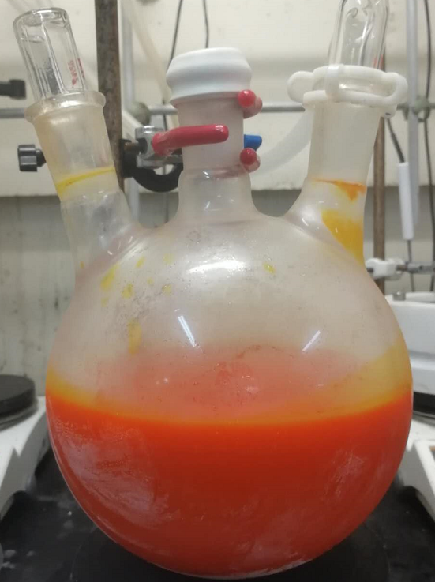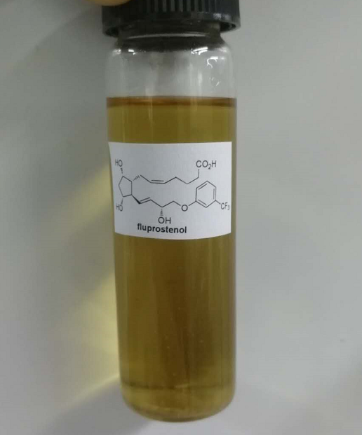

Procedure on a 20-gram scale for preparing fluprostenol from 41: To a solution of 41 (26 g, 62.2 mmol) in THF (300 mL) was added 1 N HCl (300 mL). The mixture was stirred at room temperature until complete consumption of the starting material. The reaction was quenched with saturated aqueous NaHCO₃ (300 mL) and extracted with ethyl acetate (3 × 100 mL). The combined organic layer was washed with brine, dried over anhydrous Na₂SO₄, and filtered. The solvent was removed under reduced pressure to give the crude hemiacetal product. The crude product was used directly without purification. To a suspension of 39 (220 g, 498 mmol) in anhydrous THF (900 mL) at 0 ºC under Ar was added KO^{t}Bu (111 g, 995 mmol) in one portion. The orange mixture was stirred for 40 min at the same temperature. A solution of the crude hemiacetal product in anhydrous THF (100 ml) was added dropwise via syringe at 0 ºC. The mixture was warmed to room temperature and stirred for 2 h. The reaction was quenched with H₂O (250 ml) and washed with Et₂O (250 ml). The aqueous phase was made acidic with 2 M HCl (500 ml) and extracted with DCM (5 × 10 ml). The combined organic phases were dried over anhydrous Na₂SO₄, filtered, and concentrated to give the crude residue. The crude product was purified by silica gel column chromatography (ethyl acetate) to give fluprostenol (23.1 g, 50.3 mmol, 81%) as light brown oil. Data for fluprostenol: R_{f} = 0.53 (20:1 = EA:methanol). ¹H NMR (600 MHz, CDCl₃) δ 7.34 (t, J = 7.7 Hz, 1H), 7.17 (d, J = 7.6 Hz, 1H), 7.11 (s, 1H), 7.05 (d, J = 8.0 Hz, 1H), 5.68 – 5.65 (m, 2H), 5.43 – 5.37 (m, 1H), 5.32 – 5.26 (m, 1H), 4.56 – 4.46 (m, 1H), 4.17 – 4.10 (m, 1H), 4.04 – 3.87 (m, 3H), 2.36 (s, 1H), 2.26 (t, J = 6.7 Hz, 3H), 2.21 – 2.15 (m, 1H), 2.12 – 2.00 (m, 3H), 1.71 (d, J = 13.5 Hz, 1H), 1.67 – 1.56 (m, 2H), 1.50 – 1.42 (m, 1H). ¹³C NMR (151 MHz, CDCl₃) δ 177.6, 158.6, 135.4, 131.8 (q, J = 32.2 Hz), 130.1, 130.0, 129.5, 129.0, 123.9 (q, J = 272.4 Hz), 118.0, 117.7 (q, J = 4.2 Hz), 111.5 (q, J = 4.3 Hz), 77.3, 72.3, 71.7, 71.0, 55.2, 49.8, 42.6, 32.9, 26.2, 25.1, 24.3. ¹⁹F NMR (565 MHz, CDCl₃) δ -62.6. HRMS (ESI) Calcd for C₂₃H₂₉F₃O₆Na [M+Na]⁺: 481.1808, found: 481.1807. [α]: +19.2 (c = 1.0, CHCl₃). ¹H NMR, ¹³C NMR data and optical rotation were consistent with those reported in literatures³¹ (lit.³¹ [α] = +21.1, c = 1.0, CHCl₃).
To a solution of fluprostenol (42) (60 mg, 0.131 mmol) in DMF (1 mL) was added Cs₂CO₃ (64 mg, 0.2 mmol) and 2-iodopropane (45 mg, 0.262 mmol). The reaction mixture was stirred at room temperature for 24 h. The reaction was quenched with H₂O (10 mL) and extracted with Et₂O (3 × 10 mL). The combined organic layer was washed with brine, dried over anhydrous Na₂SO₄, and filtered. The solvent was removed under reduced pressure to give crude residue. The crude residue was purified by silica gel column chromatography (1:2 = PE:EA) to give travoprost (49 mg, 0.097 mmol, 74%) as colorless oil. Data for travoprost: R_{f} = 0.53 (1:1 = PE:EA).¹H NMR (600 MHz, CDCl₃) δ 7.37 (t, J = 8.0 Hz, 1H), 7.20 (d, J = 7.7 Hz, 1H), 7.13 (s, 1H), 7.07 (dd, J = 8.3, 2.0 Hz, 1H), 5.75 – 5.60 (m, 2H), 5.49 – 5.30 (m, 2H), 4.96 (hept, J = 6.3 Hz, 1H), 4.56 – 4.44 (m, 1H), 4.15 (t, J = 4.2 Hz, 1H), 4.03 – 3.90 (m, 3H), 2.97 (br, 3H), 2.38 (dt, J = 13.3, 6.9 Hz, 1H), 2.29 – 2.20 (m, 4H), 2.13 – 2.01 (m, 3H), 1.74 (dd, J = 14.8, 3.0 Hz, 1H), 1.67 – 1.60 (m, 2H), 1.53 – 1.48 (m, 1H), 1.19 (d, J = 6.3 Hz, 6H). ¹³C NMR (151 MHz, CDCl₃) δ 173.5, 158.7, 135.5, 131.8 (q, J = 32.4 Hz), 130.0, 123.0, 129.8, 128.9, 123.9 (q, J = 272.1 Hz), 118.0, 117.7 (q, J = 4.2 Hz), 111.5 (q, J = 3.8 Hz), 77.6, 72.5, 72.0, 70.9, 67.7, 55.6, 50.0, 42.8, 34.0, 26.5, 25.4, 24.8, 21.8, 21.7. ¹⁹F NMR (565 MHz, CDCl₃) δ -62.7. HRMS (ESI) Calcd for C₂₆H₃₅F₃O₆Na [M+Na]⁺: 523.2278, found: 523.2277. [α]: +13.7 (c = 1.0, CH₂Cl₂). ¹H NMR, ¹³C NMR data and optical rotation were consistent with those reported in literatures^{31,32} (lit.³¹: [α] = +16.3, c = 1.0, DCM; lit.³² [α] = +14.6, c = 1.0, DCM).
J. Formal synthesis of prostaglandin E₂
Figure S7. Formal synthesis of prostaglandin E₂
To a solution of 16 (200 mg, 0.61 mmol) and Ph₂SiH₂ (123 mg, 0.67 mmol) in anhydrous and degassed THF (10 mL) under Ar was added Pd(PPh₃)₄ (14 mg , 0.012 mmol) and anhydrous ZnCl₂ (91 mg, 0.67 mmol). The mixture was warmed to 50 ºC and was stirred until complete consumption of the starting material. The reaction was then quenched with 1 N HCl (10 mL) and warmed to room temperature. After being stirred for 4 h at the same temperature, the reaction was then quenched with saturated aqueous NaHCO₃ (10 mL) and extracted with THF (5 × 10 mL). The combined organic layer was dried over anhydrous Na₂SO₄, and filtered. The solvent was removed under reduced pressure to afford crude residue which was purified by basic Al₂O₃ silica gel column chromatography (2:1 = PE:EA to give 43 (82 mg, 0.487 mmol, 79%) as yellow oil. Data for 43: R_{f} = 0.43 (1:1 = PE:EA). ¹H NMR (600 MHz, CDCl₃) δ 9.73 (s, 1H), 5.76 – 5.70(m, 1H), 5.25 (s, 1H), 5.22 (d, J = 7.9 Hz, 1H), 4.18 (q, J = 8.2 Hz, 1H), 2.84 – 2.77 (m, 2H), 2.70 (dd, J = 18.7, 5.0 Hz, 1H), 2.56 – 2.45 (m, 2H), 2.41 (dd, J = 18.6, 9.4 Hz, 1H), 2.25 (br, 1H). ¹³C NMR (151 MHz, CDCl₃) δ 212.5, 199.3, 136.8, 119.4, 72.0, 55.3, 49.0, 45.2, 41.2. HRMS (ESI) Calcd for C₉H1₂O₃Na [M+Na]⁺: 191.0679, found: 191.0679. [α]: –126.3 (c = 1.0, CHCl₃).
In an argon-filled glovebox, compound 43 (54 mg, 0.32 mmol), 28 (380 mg, 3.21 mmol) and Hoveyda-Grubbs 2nd catalyst (40 mg, 0.064 mmol) were dissolved in degassed DCM (1 mL) in three flasks, respectively. The solution of 43 was heat to 40 ºC. The solution of 28 and Hoveyda-Grubbs 2nd catalyst were added every 5 min into the solution of 43 via respective syringe at the same time (5 portions, 0.2 mL each time). The mixture was stirred for 5 min after complete adding of 28 and Hoveyda-Grubbs 2nd catalyst. The solvent was removed under reduced pressure. The resulted crude residue was purified by silica gel column chromatography (1:1 = PE:EA) to obtain 44 (57 mg, 0.21 mmol, 67%) as light black oil. Data for 44: R_{f} = 0.38 (1:1 = PE:EA). ¹H NMR (400 MHz, CDCl₃) δ 9.71 (s, 1H), 5.66 – 5.45 (m, 2H), 4.13 – 4.03 (m, 2H), 3.09 (br, 1H), 2.78 (dd, J = 18.6, 5.3 Hz, 2H), 2.63 (dd, J = 18.6, 5.3 Hz, 1H), 2.54 – 2.30 (m, 3H), 1.57 – 1.49 (m, 2H), 1.35 – 1.20 (m, 6H), 0.87 (t, J = 6.6 Hz, 3H). ¹³C NMR (101 MHz, CDCl₃) δ 212.7, 199.5, 137.6, 130.8, 72.9, 71.9, 54.4, 49.2, 45.0, 41.2, 37.1, 31.6, 25.1, 22.5, 13.9. HRMS (ESI) Calcd for C₁₅H₂₃O₄ [M-H]–: 267.1602, found: 267.1599. [α]: –72.1 (c = 1.0, CHCl₃).
To a suspension of MePPh₃P⁺Br⁻ (120 mg, 0.34 mmol) in anhydrous THF (5 mL) at 0 ºC under Ar was added KO^{t}Bu (37 mg, 0.34 mmol) in one portion. The yellow mixture was stirred for 1 h at the room temperature. The reaction mixture was then cooled to 0 ºC and added a solution of 44 (30 mg, 0.11 mmol) in anhydrous THF (5.0 ml) via syringe. The mixture was warmed to room temperature and stirred until complete consumption of the starting material. The reaction was quenched with aqueous NH₄Cl (10 mL). The aqueous phase extracted with Et₂O (3 × 10 ml). The combined organic phases were dried over anhydrous Na₂SO₄, filtered, and concentrated to give the crude residue. The crude product was purified by column (1:1 = PE:EA) to obtain 45 (16 mg, 0.06 mmol, 53%) as colorless oil. Data for 45: R_{f} = 0.42 (1:1 = PE:EA). ¹H NMR (600 MHz, CDCl₃) δ 5.73 – 5.58 (m, 2H), 5.51 (dd, J = 15.2, 8.9 Hz, 1H), 5.08 – 4.95 (m, 2H), 4.12 – 4.04 (m, 2H), 3.56 (br, 1H), 2.77 – 2.70 (m, 1H), 2.46 – 2.37 (m, 2H), 2.32 – 2.25 (m, 1H), 2.19 (dd, J = 18.5, 9.8 Hz, 1H), 2.10 (dt, J = 11.6, 5.3 Hz, 1H), 1.84 (br, 1H), 1.60 – 1.56 (m, 1H), 1.52 – 1.47 (m, 1H), 1.32 – 1.28 (m, 6H), 0.88 (d, J = 5.1 Hz, 3H). ¹³C NMR (101 MHz, CDCl₃) δ 213.8, 137.1, 134.6, 131.4, 117.6, 73.1, 71.9, 54.2, 53.6, 45.9, 37.3, 31.6, 31.5, 25.1, 22.6, 14.0. HRMS (ESI) Calcd for C₁₆H₂₅O₃ [M-H]–: 265.1809, found: 265.1806. [α]: –82.1 (c = 1.0, CHCl₃). ¹H NMR, ¹³C NMR data and optical rotation were consistent with those reported in literatures literature³³ (lit.³³ [α] = –78.3, c = 0.59, CHCl₃).

4. NMR spectra
¹H NMR (400 MHz, CDCl₃) of compound 11
¹³C NMR (101 MHz, CDCl₃) of compound 11

¹H NMR (400 MHz, CDCl₃) of compound S3
¹³C NMR (101 MHz, CDCl3) of compound S3

¹H NMR (600 MHz, CDCl₃) of compound 18
¹³C NMR (151 MHz, CDCl₃) of compound 18

¹H NMR (400 MHz, CDCl₃) of compound 17
¹³C NMR (101 MHz, CDCl₃) of compound 17

¹H NMR (600 MHz, CDCl₃) of compound 16
¹³C NMR (101 MHz, CDCl₃) of compound 16

¹H NMR (600 MHz, CDCl₃) of compound 12
¹³C NMR (151 MHz, CDCl₃) of compound 12

¹H NMR (400 MHz, CDCl3) of compound 20
¹³C NMR (101 MHz, CDCl₃) of compound 20

¹H NMR (600 MHz, CDCl₃) of compound S4
¹³C NMR (151 MHz, CDCl₃) of compound S4

¹H NMR (400 MHz, CDCl₃) of compound S5
¹³C NMR (101 MHz, CDCl₃) of compound S5

¹H NMR (400 MHz, CDCl₃) of compound (±)-S15
¹³C NMR (101 MHz, CDCl₃) of compound (±)-S15

¹H NMR (600 MHz, CDCl₃) of compound (±)-S16
¹³C NMR (101 MHz, CDCl₃) of compound (±)-S16

¹H NMR (400 MHz, CDCl₃) of compound (±)-S21
¹³C NMR (101 MHz, CDCl₃) of compound (±)-S21

¹H NMR (400 MHz, CDCl₃) of compound S17
¹H NMR (400 MHz, CDCl₃) of compound 28

¹³C NMR (101 MHz, CDCl₃) of compound 28
¹H NMR (400 MHz, CDCl₃) of compound 25

¹³C NMR (101 MHz, CDCl₃) of compound 25
¹H NMR (400 MHz, CDCl₃) of compound 27

¹³C NMR (101 MHz, CDCl₃) of compound 27
¹H NMR (400 MHz, CDCl₃) of compound 29

¹³C NMR (101 MHz, CDCl₃) of compound 29
¹H NMR (600 MHz, CDCl₃) of compound 31

¹³C NMR (151 MHz, CDCl₃) of compound 31
¹H NMR (400 MHz, CDCl₃) of compound 32

¹³C NMR (101 MHz, CDCl₃) of compound 32
¹H NMR (600 MHz, CDCl₃) of compound 36

¹³C NMR (151 MHz, CDCl₃) of compound 36
¹⁹F NMR (565 MHz, CDCl₃) of compound 36

¹H NMR (400 MHz, CDCl₃) of compound 38
¹³C NMR (101 MHz, CDCl₃) of compound 38

¹⁹F NMR (565 MHz, CDCl₃) of compound 38
¹H NMR (400 MHz, CDCl₃) of compound 35

¹³C NMR (101 MHz, CDCl₃) of compound 35
¹H NMR (400 MHz, CDCl₃) of compound 37

¹³C NMR (101 MHz, CDCl₃) of compound 37
¹H NMR (400 MHz, CDCl₃) of compound 15

¹³C NMR (101 MHz, CDCl₃) of compound 15
¹H NMR (600 MHz, CDCl₃) of compound PGF_{2α}

¹³C NMR (151 MHz, CDCl₃) of compound PGF_{2α}
¹H NMR (600 MHz, Methanol-d₄) of compound S18

¹³C NMR (151 MHz, Methanol-d₄) of compound S18
¹H NMR (400 MHz, CDCl₃) of compound S19

¹³C NMR (151 MHz, CDCl₃) of compound S19
¹H NMR (600 MHz, CDCl₃) of compound lantanoprost

¹³C NMR (151 MHz, CDCl₃) of compound lantanoprost
¹H NMR (600 MHz, CDCl₃) of compound S20

¹³C NMR (151 MHz, CDCl₃) of compound S20
¹H NMR (600 MHz, CDCl₃) of compound 5

¹³C NMR (151 MHz, CDCl₃) of compound 5
¹H NMR (600 MHz, CDCl₃) of compound S21

¹³C NMR (151 MHz, CDCl₃) of compound S21
¹H NMR (600 MHz, CDCl₃) of compound cloprostenol

¹³C NMR (151 MHz, CDCl₃) of compound cloprostenol
¹H NMR (600 MHz, CDCl₃) of compound S22

¹³C NMR (151 MHz, CDCl₃) of compound S22
¹⁹F NMR (565 MHz, CDCl₃) of compound S22

¹H NMR (600 MHz, CDCl₃) of compound 41
¹³C NMR (151 MHz, CDCl₃) of compound 41

¹⁹F NMR (376 MHz, CDCl₃) of compound 41
¹H NMR (600 MHz, CDCl₃) of compound fluprostenol

¹³C NMR (151 MHz, CDCl₃) of compound fluprostenol
¹⁹F NMR (565 MHz, CDCl₃) of compound fluprostenol

¹H NMR (600 MHz, CDCl₃) of compound travoprost
¹³C NMR (151 MHz, CDCl₃) of compound travoprost

¹⁹F NMR (565 MHz, CDCl₃) of compound travoprost
¹H NMR (600 MHz, CDCl₃) of compound 43

¹³C NMR (151 MHz, CDCl₃) of compound 43
¹H NMR (400 MHz, CDCl₃) of compound 44

¹³C NMR (101 MHz, CDCl₃) of compound 44
¹H NMR (600 MHz, CDCl₃) of compound 45

¹³C NMR (101 MHz, CDCl₃) of compound 45

5. HPLC spectra
HPLC spectra for compound S3
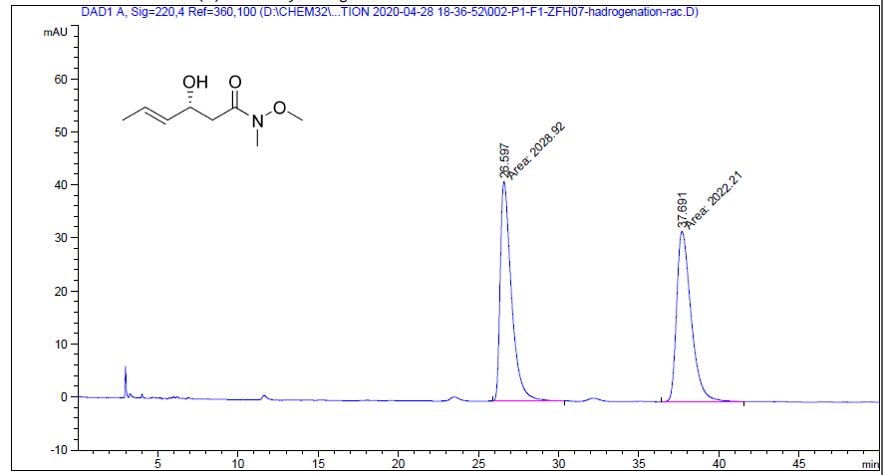
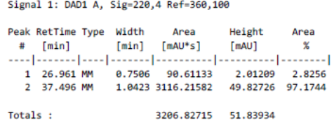
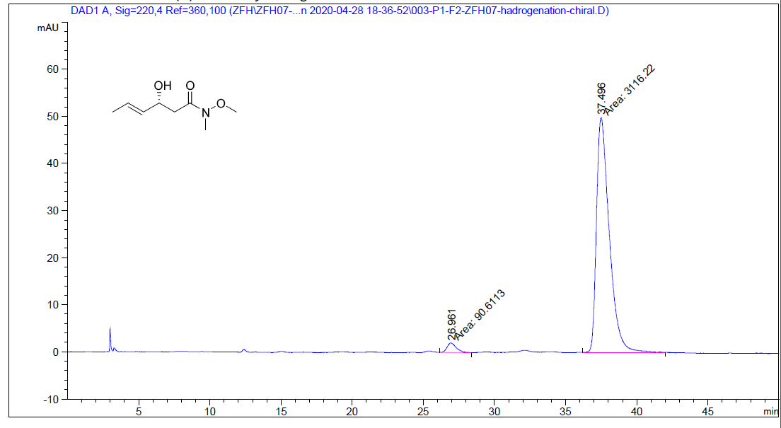
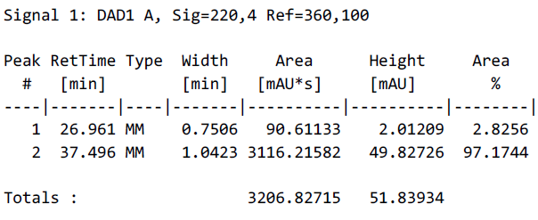
HPLC spectra for compound S17
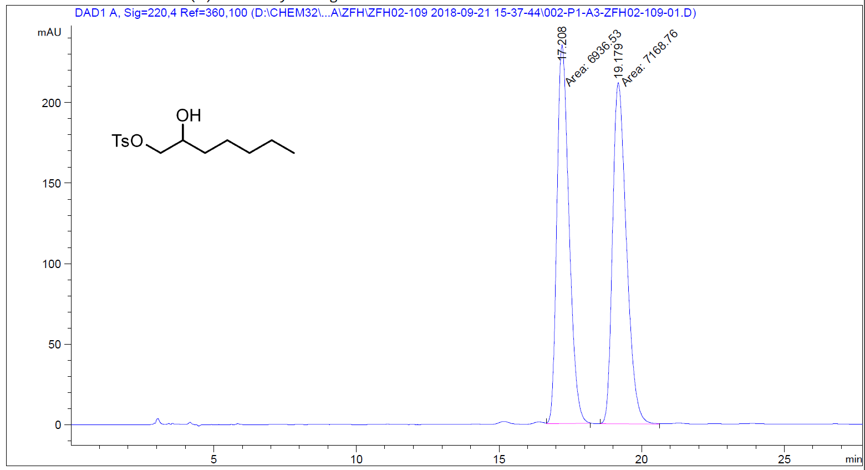
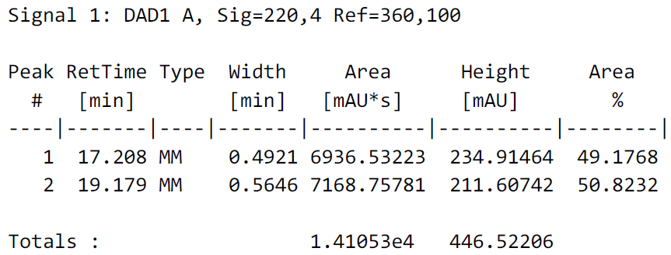
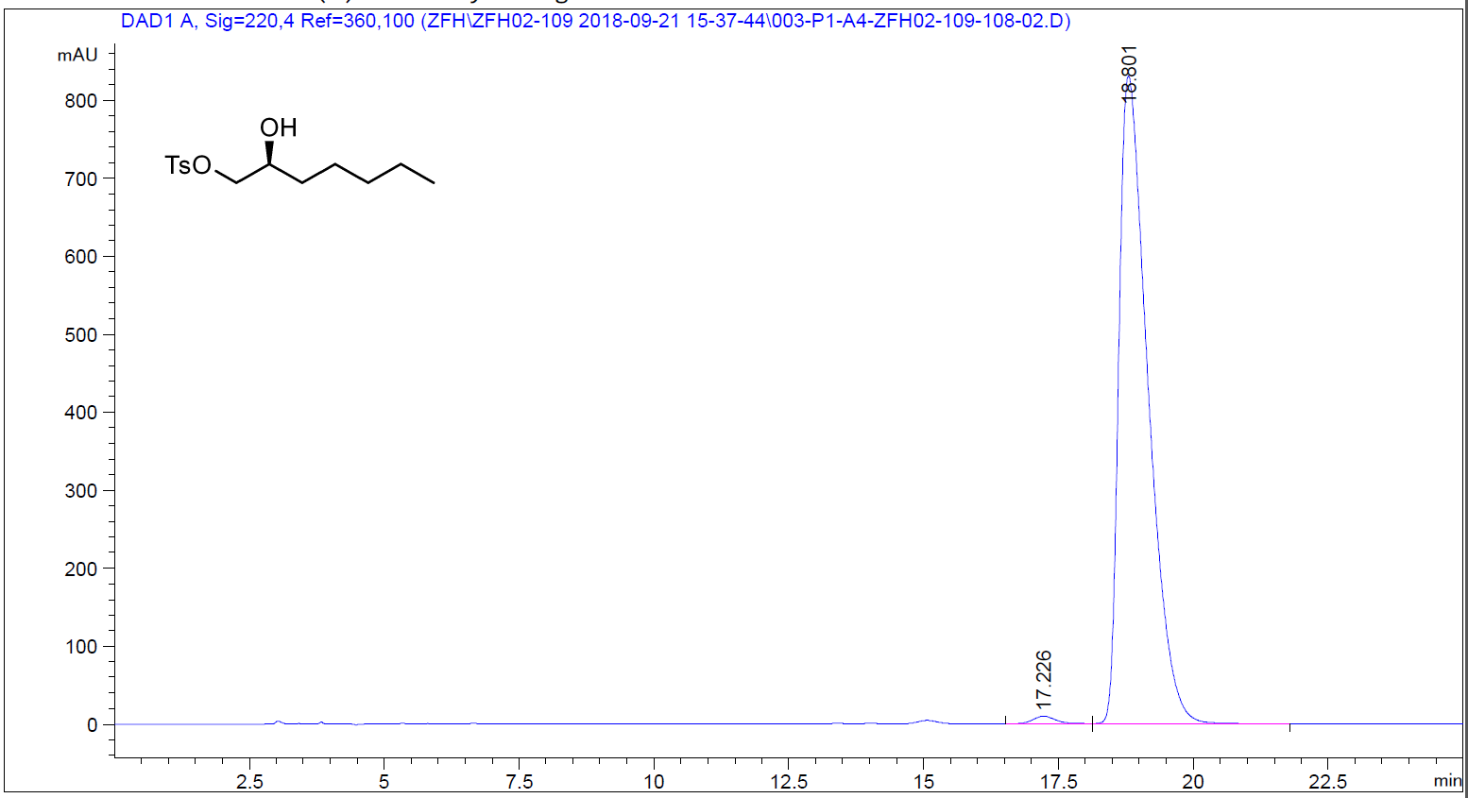
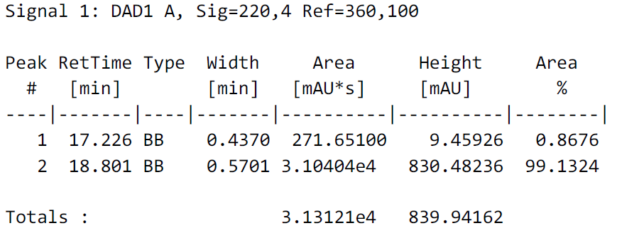

HPLC spectra for compound 25
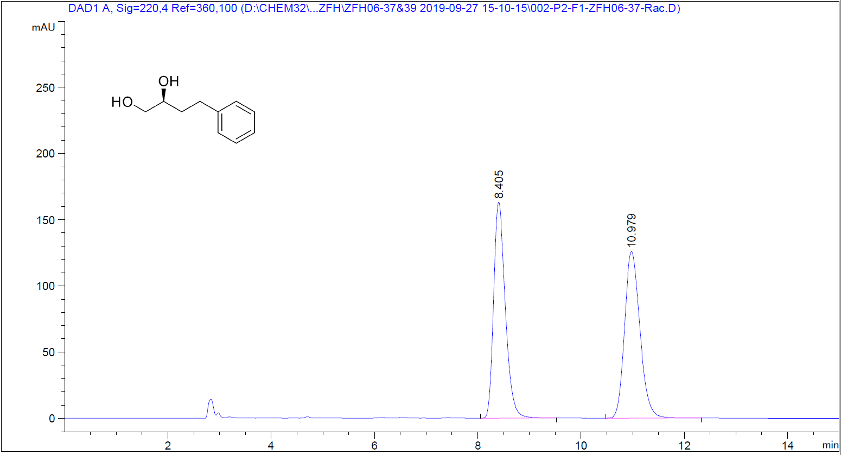
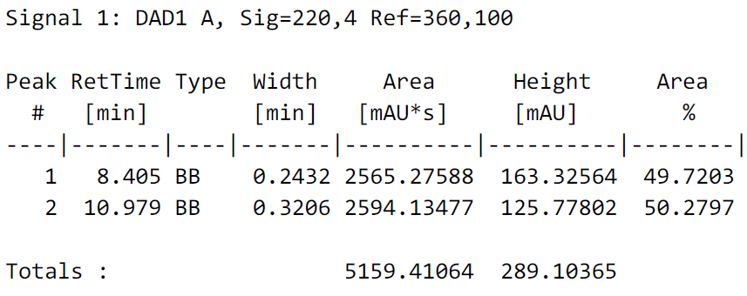
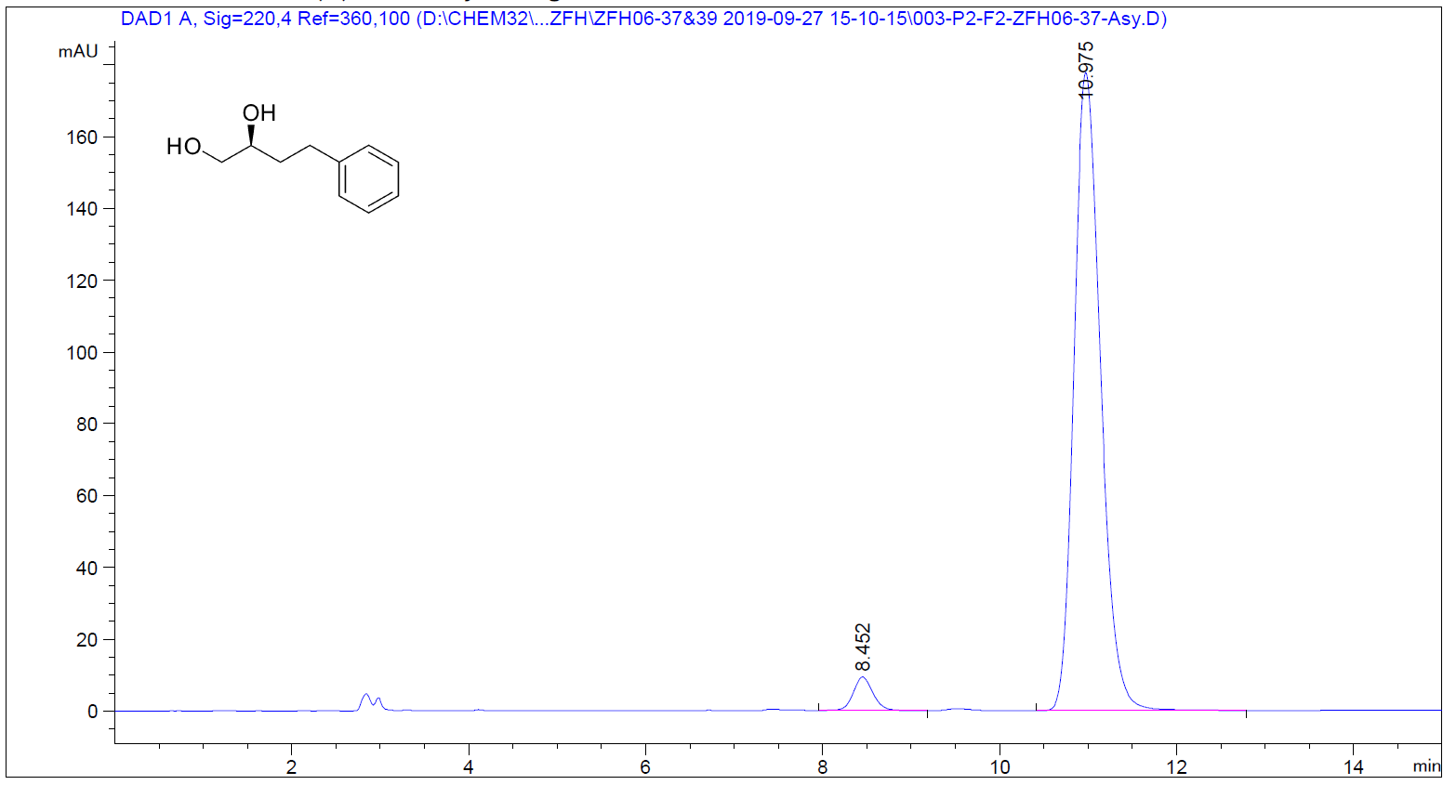
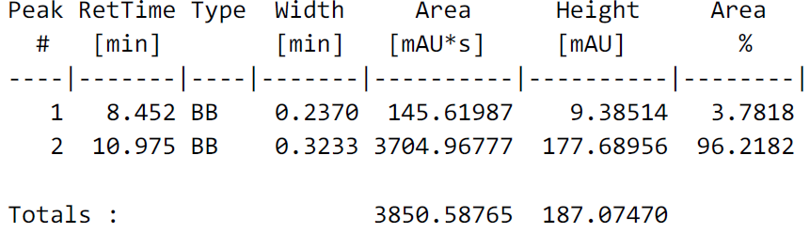

HPLC spectra for compound 16
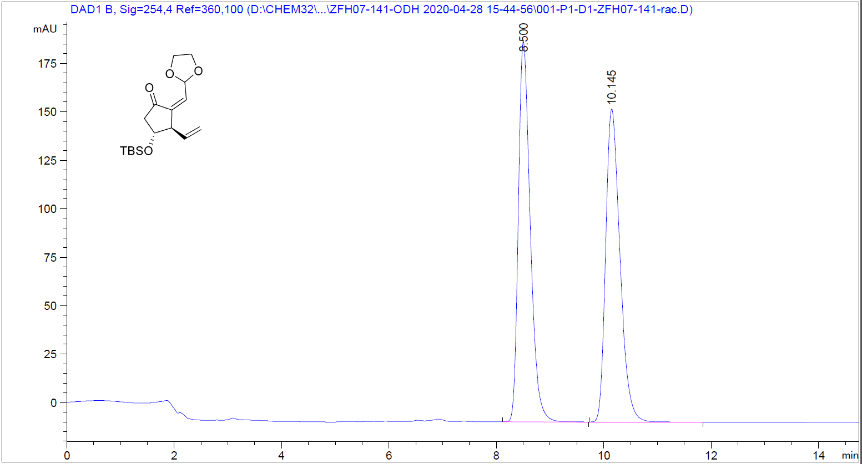
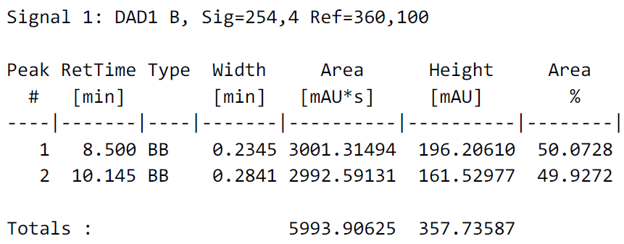
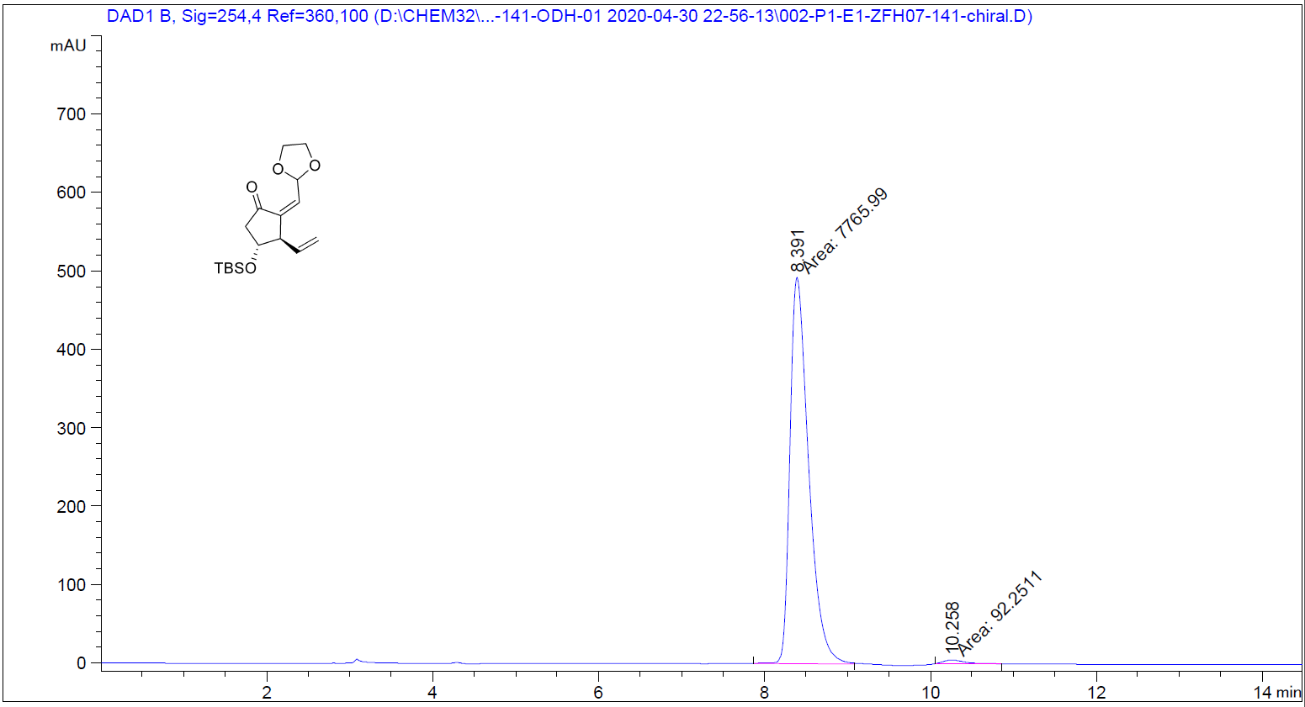
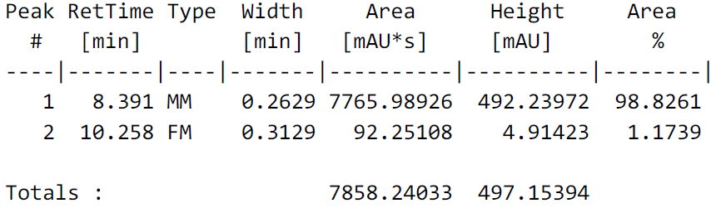

6. Crystallographic information
The crystal data of compound (±)-21 has been deposited in CCDC with number 2013314.
Table S1 Crystal data and structure refinement for CCDC 2013314.
Identification code | CCDC 2013314
Empirical formula | C₂₄H₂₆N₂O₁₁S
Formula weight | 550.53
Temperature/K | 150.0
Crystal system | triclinic
Space group | P-1
a/Å | 7.3839(10)
b/Å | 11.8686(15)
c/Å | 14.4460(19)
α/° | 91.348(3)
β/° | 92.268(4)
γ/° | 93.929(3)
Volume/Å³ | 1261.6(3)
Z | 2
ρ_{calc}g/cm³ | 1.449
μ/mm⁻¹ | 1.718
F(000) | 576.0
Crystal size/mm³ | 0.3 × 0.3 × 0.25
Radiation | CuKα (λ = 1.54178)
2Θ range for data collection/° | 9.538 to 144.792
Index ranges | -9 ≤ h ≤ 9, -14 ≤ k ≤ 14, -17 ≤ l ≤ 17
Reflections collected | 34066
Independent reflections | 4901 [R_{int} = 0.0397, R_{sigma} = 0.0213]
Data/restraints/parameters | 4901/0/345
Goodness-of-fit on F² | 1.055
Final R indexes [I>=2σ (I)] | R₁ = 0.0350, wR₂ = 0.0921
Final R indexes [all data] | R₁ = 0.0359, wR₂ = 0.0928
Largest diff. peak/hole / e Å⁻³ | 0.26/-0.42

Table S2. Fractional Atomic Coordinates ( × 10⁴) and Equivalent Isotropic Displacement Parameters (Å2 × 10³) for CCDC 1821575. U_{eq} is defined as 1/3 of of the trace of the orthogonalised U_{IJ} tensor.
Atom | x | y | z | U(eq)
O1 | 2982(2) | 1858.7(15) | 5598.3(6) | 28.8(3)
O2 | 6288(2) | 5939.4(14) | 5880.9(6) | 27.1(3)
O3 | 8856(2) | 3312.7(15) | 6241.0(6) | 30.2(3)
O4 | 2357.2(18) | 2979.6(13) | 6852.6(5) | 22.0(3)
C1 | 7740(3) | 2261(2) | 6109.3(8) | 22.7(4)
C2 | 8359(3) | 963(2) | 6147.3(8) | 29.9(5)
C3 | 7132(3) | -53(2) | 6015.6(9) | 33.1(5)
C4 | 5279(3) | 166(2) | 5838.5(9) | 31.8(5)
C5 | 4732(3) | 1463(2) | 5786.6(8) | 24.2(4)
C6 | 5908(3) | 2502.0(19) | 5918.5(7) | 19.9(4)
C7 | 4855(3) | 3776.3(19) | 5826.2(7) | 19.7(4)
C8 | 3115(3) | 3256(2) | 5487.0(8) | 25.5(4)
C9 | 5934(3) | 4850(2) | 5486.8(8) | 25.9(4)
C10 | 4420(2) | 4493.4(18) | 6393.3(7) | 18.4(4)
C11 | 5333(2) | 5696(2) | 6391.7(8) | 21.3(4)
C12 | 5271(3) | 6561.0(19) | 6859.2(9) | 24.5(4)
C13 | 4233(3) | 6168(2) | 7343.8(8) | 23.3(4)
C14 | 3268(2) | 4982(2) | 7354.8(8) | 21.6(4)
C15 | 3339(2) | 4140.6(18) | 6875.3(8) | 18.4(4)
O5 | 275(2) | 2601.3(15) | 7817.4(6) | 30.9(3)
O6 | -1436.5(18) | 3135.2(14) | 8601.0(6) | 25.3(3)
C16 | -1818(3) | 4457(2) | 7764.6(9) | 31.1(5)
C17 | -883(3) | 3317(2) | 8050.3(8) | 23.4(4)
C18 | -701(3) | 1964(2) | 8890.0(9) | 28.6(4)
C19 | -1459(4) | 1974(3) | 9504.7(10) | 41.9(6)
C20 | 2605.9(19) | 8478.6(11) | 8478.0(10) | 31.5(3)
C21 | 1579.3(19) | 3176.3(12) | 8412.9(10) | 31.0(3)
C22 | 1226(2) | 2789.0(13) | 9384.7(10) | 35.4(3)
C23 | 2071(3) | 1371.1(19) | 10412.1(15) | 63.8(6)
C24 | -1749(2) | 1912.4(14) | 9045.5(13) | 44.2(4)
C20 | 2605.9(19) | 8478.6(11) | 8478.0(10) | 31.5(3)
C21 | 1579.3(19) | 3176.3(12) | 8412.9(10) | 31.0(3)
C22 | 1226(2) | 2789.0(13) | 9384.7(10) | 35.4(3)
C23 | 2071(3) | 1371.1(19) | 10412.1(15) | 63.8(6)
C24 | -1749(2) | 1912.4(14) | 9045.5(13) | 44.2(4)
C20 | 2605.9(19) | 8478.6(11) | 8478.0(10) | 31.5(3)

7. References
1. Wu, W. et al. Iridium Catalysts with f-Amphox Ligands: Asymmetric Hydrogenation of Simple Ketones. Org. Lett. 18, 2938-2941, (2016).
2. Yu, J. et al. Readily Accessible and Highly Efficient Ferrocene-Based Amino-Phosphine-Alcohol (f-Amphol) Ligands for Iridium-Catalyzed Asymmetric Hydrogenation of Simple Ketones. Chem. Eur. J. 23, 970-975, (2017).
3. Yu, J. et al. Iridium-Catalyzed Asymmetric Hydrogenation of Ketones with Accessible and Modular Ferrocene-Based Amino-phosphine Acid (f-Ampha) Ligands. Org. Lett. 19, 690-693, (2017).
4. Smith, A. B., 3rd & Simov, V. Total synthesis of the marine natural product (-)-clavosolide A. A showcase for the Petasis-Ferrier union/rearrangement tactic. Org. Lett. 8, 3315-3318, (2006).
5. Chemler, S. R. & Roush, W. R. Stereochemistry of the allylation and crotylation reactions of alpha-methyl-beta-hydroxy aldehydes with allyl- and crotyltrifluorosilanes. Synthesis of anti,anti-dipropionate stereotriads and stereodivergent pathways for the reactions with 2,3-anti- and 2,3-syn-alpha-methyl-beta-hydroxy aldehydes. J. Org. Chem. 68, 1319-1333, (2003).
6. Saxena, A., Perez, F. & Krische, M. J. Ruthenium(0) Catalyzed Endiyne-alpha-Ketol [4 + 2] Cycloaddition: Convergent Assembly of Type II Polyketide Substructures via C-C Bond Forming Transfer Hydrogenation. J. Am. Chem. Soc. 137, 5883-5886, (2015).
7. Jeżewski, A., Chajewska, K., Wielogórski, Z. & Jurczak, J. The asymmetric ene reaction of N-glyoxyloyl-(2R)-bornane-10,2-sultam with 1-pentene and 1-hexene. Tetrahedron: Asymmetry 8, 1741-1749, (1997).
8. Hale, K. J. et al. Synthesis of the C(7)-C(22) sector of (+)-acutiphycin via O-directed double free radical alkyne hydrostannation with Ph3SnH/Et3B, double I-Sn exchange, and double Stille coupling. Org. Lett. 16, 1168-1171, (2014).
9. Alcaraz, L. et al. Novel conversion of epoxides to one carbon homologated allylic alcohols by dimethylsulfonium methylide. Tetrahedron Lett. 35, 5449-5452, (1994).
10. Ichikawa, A. & Ono, H. Preparation of single-enantiomer semiochemicals using 2-methoxy-2-(1-naphthyl)propionic acid and 2-methoxy-2-(9-phenanthryl)propionic acid. Tetrahedron-Asymmetry 16, 2559-2568, (2005).
11. Wang, F.-D. & Yue, J.-M. A Total Synthesis of (+)- and (-)-Dihydrokavain with a Sonochemical Blaise Reaction as the Key Step. European J. Org. Chem. 2005, 2575-2579, (2005).
12. Doherty, W. & Evans, P. Aminooxylation Horner-Wadsworth-Emmons Sequence for the Synthesis of Enantioenriched gamma-Functionalized Vinyl Sulfones. J. Org. Chem. 81, 1416-1424, (2016).
13. Hedtmann, U. et al. Seitenkettenhomologe des 20-Hydroxyecdysons: Synthese, Konfigurationsbestimmung und biochemische Charakterisierung. Angew. Chem., Int. Ed. 101, 1543-1546, (1989).
14. Nishizawa, M., Asai, Y. & Imagawa, H. TiCl4 induced anti-Markovnikov rearrangement. Org. Lett. 8, 5793-5796, (2006).
15. Chang, C. F., Stefan, E. & Taylor, R. E. Total Synthesis and Structural Reassignment of Lyngbyaloside C Highlighted by Intermolecular Ketene Esterification. Chem. Eur. J. 21, 10681-10686, (2015).
16. Martı́n, R., Islas, G., Moyano, A., Pericàs, M. A. & Riera, A. A new method for the enantioselective synthesis of N-Boc-α,α-disubstituted α-amino acids. Tetrahedron 57, 6367-6374, (2001).
17. Lightburn, T. E., De Paolis, O. A., Cheng, K. H. & Tan, K. L. Regioselective hydroformylation of allylic alcohols. Org. Lett. 13, 2686-2689, (2011).
18. S Yadav, J., Deshpande, P. K. & V M Sharma, G. An effective practical method for the synthesis of chiral propargyl alcohols. Tetrahedron 46, 7033-7046, (1990).
19. Dorta, R. L., Rodríguez, M. S., Salazar, J. & Suárez, E. 1,3-Transposition of primary allylic alcohols: Synthesis of optically active secondary and tertiary allylic alcohols. Tetrahedron Lett. 38, 4675-4678, (1997).
20. McClure, D. E., Arison, B. H. & Baldwin, J. J. Mode of nucleophilic addition to epichlorohydrin and related species: chiral aryloxymethyloxiranes. J. Am. Chem. Soc. 101, 3666-3668, (1979).
21. Bredikhin, A. A. et al. Jacobsen-type enantioselective hydrolysis of aryl glycidyl ethers.31P NMR analysis of the enantiomeric composition of oxiranes. Russ. Chem. Bull. 53, 213-218, (2004).
22. Coulthard, G., Erb, W. & Aggarwal, V. K. Stereocontrolled organocatalytic synthesis of prostaglandin PGF_{2α} in seven steps. Nature 489, 278-281, (2012).
23. Zhu, K., Hu, S., Liu, M., Peng, H. & Chen, F. E. Access to a Key Building Block for the Prostaglandin Family via Stereocontrolled Organocatalytic Baeyer-Villiger Oxidation. Angew. Chem., Int. Ed. 58, 9923-9927, (2019).
24. Sheddan, N. A. & Mulzer, J. Cross metathesis as a general strategy for the synthesis of prostacyclin and prostaglandin analogues. Org. Lett. 8, 3101-3104, (2006).
25. Corey, E. J., Schaaf, T. K., Huber, W., Koelliker, U. & Weinshenker, N. M. Total synthesis of prostaglandins F2-alpha and E2 as the naturally occurring forms. J. Am. Chem. Soc. 92, 397-398, (1970).
26. Parve, O. et al. Lipase-catalysed acylation of prostanoids. Bioorg. & Med. Chem. Lett. 9, 1853-1858, (1999).
27. Prevost, S. et al. Synthesis of Prostaglandin Analogues, Latanoprost and Bimatoprost, Using Organocatalysis via a Key Bicyclic Enal Intermediate. Org. Lett. 17, 504-507, (2015).
28. Martynow, J. G. et al. A new synthetic approach to high-purity (15R)-latanoprost. Eur. J. Org. Chem. 2007, 689-703, (2007).
29. Parve, O. et al. The tetrahydropyranyl-protected mandelic acid: a novel versatile chiral derivatising agent. Tetrahedron: Asymmetry 9, 885-896, (1998).
30. Chen, Y., Yan, H., Chen, H. X., Weng, J. & Lu, G. An Improved and Efficient Process for the Preparation of (+)-cloprostenol. Chirality 27, 392-396, (2015).
31. Dams, I. et al. A novel convergent synthesis of the potent antiglaucoma agent travoprost. Tetrahedron 69, 1634-1648, (2013).
32. Boulton, L. T. et al. Synthesis of the Potent Antiglaucoma Agent, Travoprost. Org. Process Res. & Dev. 6, 138-145, (2002).
33. Xu, C., Shen, X. & Hoveyda, A. H. In Situ Methylene Capping: A General Strategy for Efficient Stereoretentive Catalytic Olefin Metathesis. The Concept, ethodological Implications, and Applications to Synthesis of Biologically Active Compounds. J. Am. Chem. Soc. 139, 10919-10928, (2017).

