Supplemental Information

Occurrence-based models reveal greater spatial details in tropical species richness

All data are publicly available in the Zenodo repository at https://doi.org/10.5281/zenodo.18713462.

Tab. S1: Species occurrence data.
Group | Taxonomic group | Number of species | Number of clean records with valid names | Total number of records
Amphibians | Amphibia | 5,562 | 226,482 | 842,999
Annelids (worms) | Annelida | 221 | 1,360 | 4,922
Ants | Formicidae | 8,442 | 301,666 | 1,292,850
Bees | Apoidea (Apidae, Colletidae, Halictidae, Megachilidae) | 3,775 | 92,472 | 791,923
Spiders | Araneae | 11,814 | 57,952 | 89,270
Asteraceae (daisy family) | Asteraceae | 12,571 | 568,291 | 775,245
Birds | Aves | 9,673 | 773,192 | 1,611,877
Cockroaches and termites | Blattodea | 1,805 | 23,793 | 59,158
Beetles | Coleoptera | 50,630 | 442,384 | 2,297,005
Flies | Diptera | 21,556 | 193,384 | 1,614,822
Dragonflies and damselflies | Odonata | 4,257 | 292,646 | 558,202
Legumes (bean family) | Fabaceae | 12,575 | 968,894 | 1,454,840
Snails and slugs | Gastropoda | 8,578 | 79,023 | 127,553
True bugs (including aphids, cicadas, and bed bugs) | Hemiptera | 15,493 | 174,228 | 621,903
Butterflies and moths | Lepidoptera | 56,944 | 1,706,787 | 5,824,077
Mammals | Mammalia | 4,486 | 280,814 | 1,102,488
Orchids | Orchidaceae | 16,831 | 233,738 | 338,794
Grasshoppers, crickets, and other katydids | Orthoptera | 5,502 | 79,595 | 131,498
Grasses | Poaceae | 6,845 | 608,780 | 939,105
Ferns and allies | Polypodiopsida | 9,670 | 568,096 | 876,014
Reptiles (snakes, lizards, turtles, and crocodiles) | Reptiles (Squamata, Crocodylia, Testudines) | 7,504 | 315,229 | 861,225
Rubiaceae (coffee family) | Rubiaceae | 11,055 | 520,707 | 848,475
Caddisflies | Trichoptera | 3,343 | 17,171 | 77,896
Wasps, hornets, and yellow jackets | Braconidae, Crabronidae, Eumenidae, Mutillidae, Pompilidae, Vespidae | 11,096 | 92,501 | 222,879
All groups | All groups | 300,228 | 8,619,185 | 23,365,020

Tab. S2. R² between the species richness values ​​estimated by the model (best fit model, DNN) and those observed in the data, during cross-validation per group in three hexagon sizes.
 | R²
 | ~86km² | ~43km³ | ~21km⁴
All groups | 0.81 | 0.92 | 0.77
Amphibia | 0.70 | 0.88 | 0.78
Aves | 0.78 | 0.97 | 0.80
Mammalia | 0.78 | 0.98 | 0.84
Reptiles | 0.81 | 0.98 | 0.82
Angiosperms | 0.72 | 0.86 | 0.72
Ferns | 0.52 | 0.63 | 0.53
Bees | 0.71 | 0.85 | 0.71
Blattodea | 0.80 | 0.99 | 0.89
Coleptera | 0.55 | 0.68 | 0.57
Diptera | 0.69 | 0.78 | 0.70
Formicidae | 0.77 | 0.86 | 0.77
Gastropoda | 0.55 | 0.63 | 0.54
Hemiptera | 0.63 | 0.70 | 0.57
Lepdoptera | 0.59 | 0.69 | 0.56
Odonata | 0.71 | 0.85 | 0.68
Orthoptera | 0.71 | 0.79 | 0.71
Areneae | 0.58 | 0.64 | 0.54
Trichoptera | 0.52 | 0.60 | 0.49
Wasps | 0.75 | 0.88 | 0.76

Tab. S3. R² between the species richness values ​​estimated by the model (best fit model, DNN) and those observed in the data, during cross-validation per group in three minimum number of samples by hexagon.
 | R²
 | 50 | 100 | 200
All groups | 0.66 | 0.92 | 0.76
Amphibia | 0.66 | 0.88 | 0.77
Aves | 0.79 | 0.97 | 0.82
Mammalia | 0.72 | 0.98 | 0.80
Reptiles | 0.74 | 0.98 | 0.83
Angiosperms | 0.69 | 0.86 | 0.70
Ferns | 0.53 | 0.63 | 0.51
Bees | 0.71 | 0.85 | 0.74
Blattodea | 0.73 | 0.99 | 0.83
Coleptera | 0.53 | 0.68 | 0.55
Diptera | 0.66 | 0.78 | 0.66
Formicidae | 0.65 | 0.86 | 0.73
Gastropoda | 0.49 | 0.63 | 0.52
Hemiptera | 0.60 | 0.70 | 0.57
Lepdoptera | 0.55 | 0.69 | 0.56
Odonata | 0.60 | 0.85 | 0.73
Orthoptera | 0.66 | 0.79 | 0.68
Areneae | 0.47 | 0.64 | 0.57
Trichoptera | 0.44 | 0.60 | 0.50
Wasps | 0.64 | 0.88 | 0.71

Tab. S4. Proportion of explanation of each PCA axis of the climate variables.
Component | 1 | 2 | 3 | 4 | 5 | 6 | 7 | 8 | 9 | 10 | 11 | 12 | 13 | 14 | 15 | 16 | 17 | 18 | 19
Standard deviation | 3.02 | 2.24 | 1.20 | 1.17 | 0.84 | 0.71 | 0.54 | 0.51 | 0.39 | 0.28 | 0.20 | 0.15 | 0.10 | 0.08 | 0.08 | 0.06 | 0.04 | 0.02 | 0.00
Proportion of Variance | 0.48 | 0.26 | 0.08 | 0.07 | 0.04 | 0.03 | 0.02 | 0.01 | 0.01 | 0.00 | 0.00 | 0.00 | 0.00 | 0.00 | 0.00 | 0.00 | 0.00 | 0.00 | 0.00
Cumulative Proportion | 0.48 | 0.74 | 0.82 | 0.89 | 0.93 | 0.95 | 0.97 | 0.98 | 0.99 | 1.00 | 1.00 | 1.00 | 1.00 | 1.00 | 1.00 | 1.00 | 1.00 | 1.00 | 1.00

Tab. S5. Proportion of explanation of each PCA axis of the CVI variables.
Component | 1 | 2 | 3
Standard deviation | 1.46 | 0.80 | 0.50
Proportion of Variance | 0.71 | 0.21 | 0.08
Cumulative Proportion | 0.71 | 0.92 | 1.00
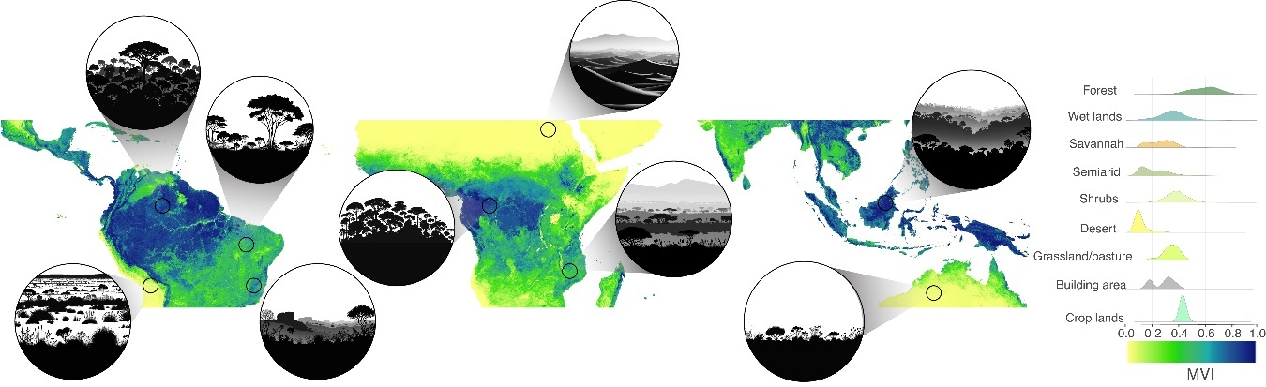
Fig. S1. Composite Vegetation Index (CVI). Circles represent examples of vegetation types and structure at different CVI values. The graph shows the range of CVI values across different land-cover and land-use types.

Tab. S6: Multiple comparison of means by Tukey's test between pairs of land cover and land use classes.
Class | Class | meandiff | p-adj
Wet lands | Desert | -0.27 | <0.0001
Wet lands | Forest | 0.07 | <0.0001
Wet lands | Savannah | -0.04 | <0.0001
Wet lands | Semiarid | -0.23 | <0.0001
Wet lands | Shrubs | -0.15 | <0.0001
Wet lands | Water | -0.14 | <0.0001
Wet lands | Croplands | -0.11 | <0.0001
Wet lands | Building areas | -0.08 | <0.0001
Wet lands | Grass land | -0.06 | <0.0001
Desert | Forest | 0.34 | <0.0001
Desert | Savannah | 0.23 | <0.0001
Desert | Semiarid | 0.03 | <0.0001
Desert | Shrubs | 0.12 | <0.0001
Desert | Water | 0.13 | <0.0001
Desert | Croplands | 0.16 | <0.0001
Desert | Building areas | 0.19 | <0.0001
Desert | Grass land | 0.20 | <0.0001
Forest | Savannah | -0.11 | <0.0001
Forest | Semiarid | -0.30 | <0.0001
Forest | Shrubs | -0.22 | <0.0001
Forest | Water | -0.21 | <0.0001
Forest | Croplands | -0.18 | <0.0001
Forest | Building areas | -0.15 | <0.0001
Forest | Grass land | -0.13 | <0.0001
Savannah | Semiarid | -0.19 | <0.0001
Savannah | Shrubs | -0.11 | <0.0001
Savannah | Water | -0.10 | <0.0001
Savannah | Croplands | -0.07 | <0.0001
Savannah | Building areas | -0.04 | <0.0001
Savannah | Grass land | -0.02 | <0.0001
Semiarid | Shrubs | 0.08 | <0.0001
Semiarid | Water | 0.10 | <0.0001
Semiarid | Croplands | 0.12 | <0.0001
Semiarid | Building areas | 0.16 | <0.0001
Semiarid | Grass land | 0.17 | <0.0001
Shrubs | Water | 0.01 | <0.0001
Shrubs | Croplands | 0.04 | <0.0001
Shrubs | Building areas | 0.07 | <0.0001
Shrubs | Grass land | 0.09 | <0.0001
Water | Croplands | 0.03 | <0.0001
Water | Building areas | 0.06 | <0.0001
Water | Grass land | 0.08 | <0.0001
Croplands | Building areas | 0.03 | <0.0001
Croplands | Grass land | 0.05 | <0.0001
Building areas | Grass land | 0.02 | <0.0001

Tab. S7. R² between the species richness values ​​estimated by the model (best fit model, DNN) and those observed in the data, during cross-validation per group in three values of kernel search radius in sampling effort estimates.
 | R²
 | 50 km | 100 km | 200 km
All groups | 0.85 | 0.92 | 0.85
Amphibia | 0.80 | 0.88 | 0.81
Aves | 0.91 | 0.97 | 0.89
Mammalia | 0.88 | 0.98 | 0.93
Reptiles | 0.90 | 0.98 | 0.91
Angiosperms | 0.81 | 0.86 | 0.83
Ferns | 0.57 | 0.63 | 0.58
Bees | 0.80 | 0.85 | 0.82
Blattodea | 0.89 | 0.99 | 0.92
Coleptera | 0.61 | 0.68 | 0.65
Diptera | 0.70 | 0.78 | 0.75
Formicidae | 0.78 | 0.86 | 0.83
Gastropoda | 0.58 | 0.63 | 0.60
Hemiptera | 0.64 | 0.70 | 0.64
Lepdoptera | 0.62 | 0.69 | 0.67
Odonata | 0.77 | 0.85 | 0.78
Orthoptera | 0.75 | 0.79 | 0.73
Areneae | 0.58 | 0.64 | 0.61
Trichoptera | 0.56 | 0.60 | 0.56
Wasps | 0.83 | 0.88 | 0.83

Tab. S8. Cross-validation. MSE values for each algorithm and the R² of the relationship between observed and predicted values for the algorithm with the lowest MSE, considering the relationship with sampling effort.
Algorithm | Species richness
DNN | 2.79
GAM | 30.48
MARS | 9.87
RF | 3.99
GLM | 5.81
LASSO | 16.00
SVM | 11.08
DNN R² | 0.92
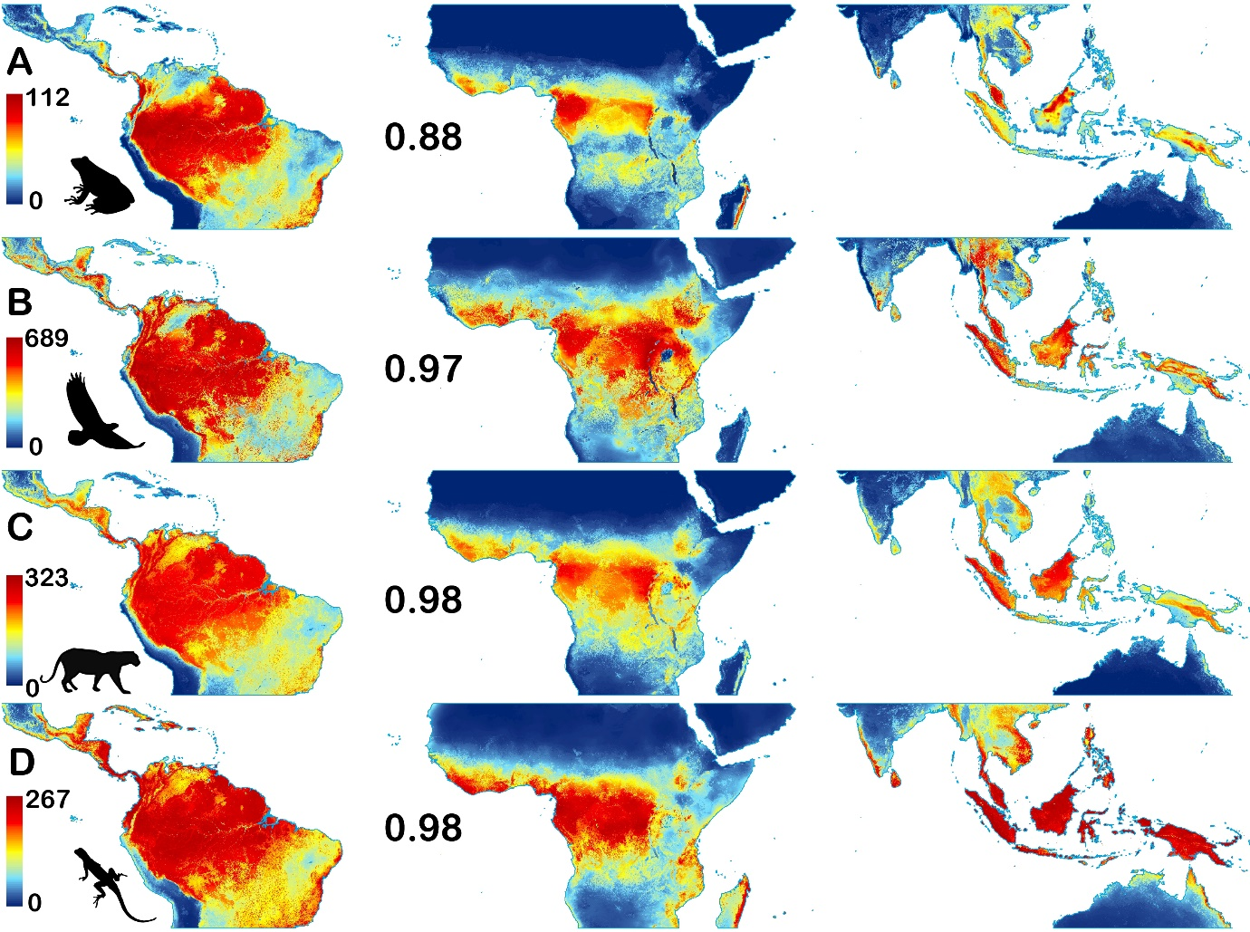
Fig.S2: Vertebrates groups species richness model. A: Amphibia; B: Aves; C: Mammalia; D: Reptiles. The number indicates the R² between the species richness values ​​estimated by the model and those observed in the data during cross-validation.

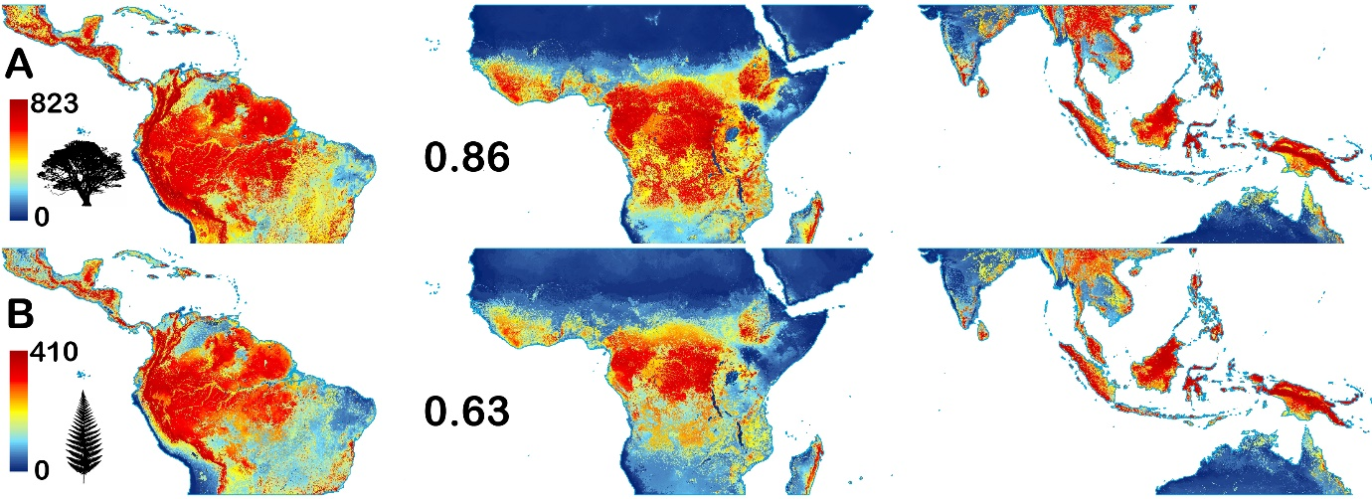
Fig.S3: Plants groups species richness model. A: Angiosperms; B: Ferns. The number indicates the R² between the species richness values ​​estimated by the model and those observed in the data during cross-validation.

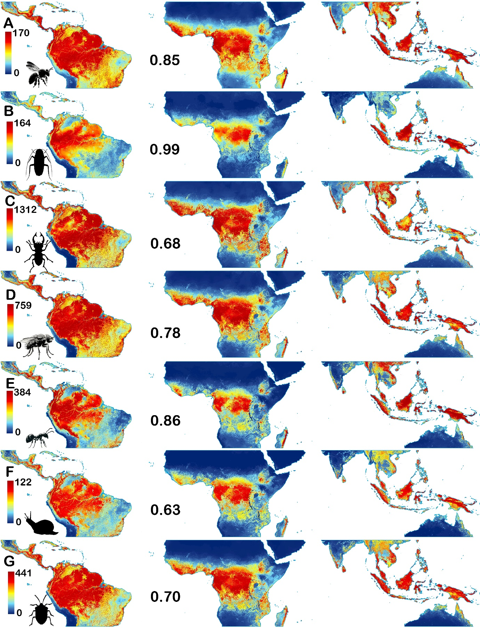
Fig.S4: Invertebrates groups species richness model. A: Bees; B: Blattodea; C: Coleptera; D: Diptera; E: Formicidae; F: Gastropoda; G: Hemiptera. The number indicates the R² between the species richness values ​​estimated by the model and those observed in the data during cross-validation.

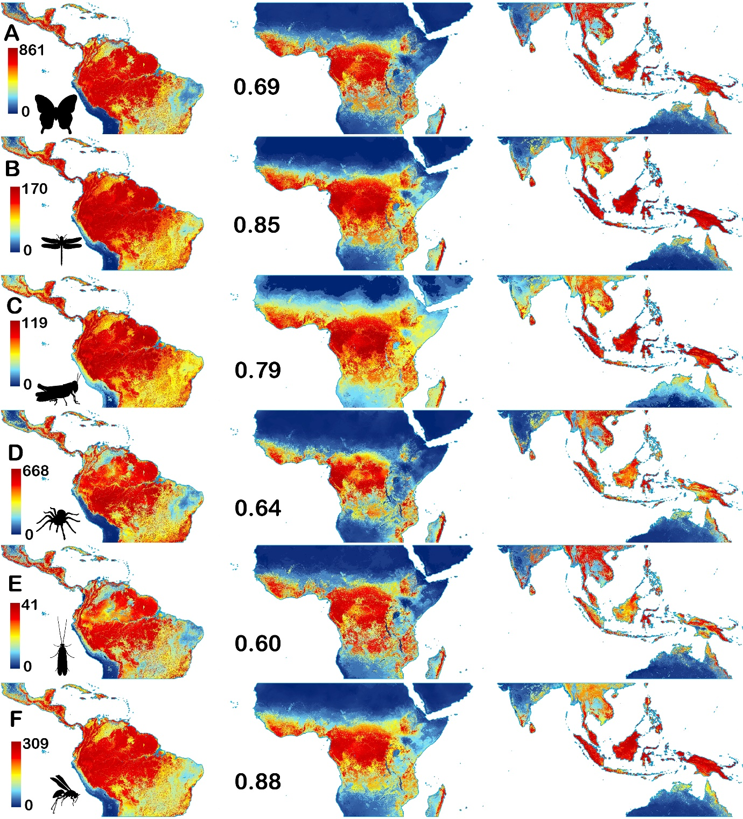
Fig.S5: Invertebrates groups species richness model. A: Lepdoptera; B: Odonata; C: Orthoptera; D: Areneae; E: Trichoptera; F: Wasps. The number indicates the R² between the species richness values ​​estimated by the model and those observed in the data during cross-validation.

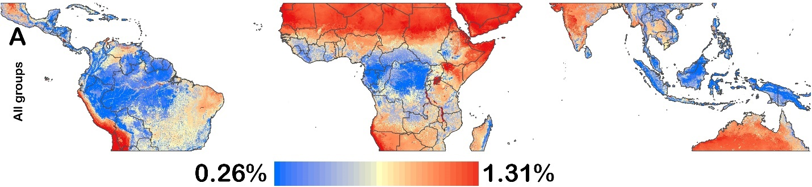
Fig. S6. Monte Carlo simulation of biodiversity models. Spatial patterns of variation in model outputs derived from Monte Carlo simulations (100 iterations) under controlled perturbations (±30% variance) of predictor variables.

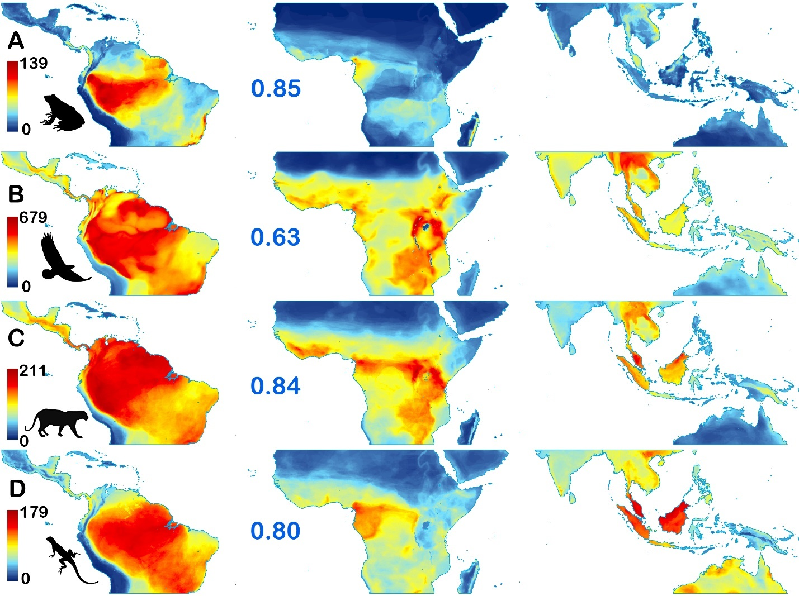
Fig. S7. Species richness maps from IUCN polygon data. A: Amphibia; B: Aves; C: Mammalia and D: Reptiles. The number indicates the R² between the species richness values ​​estimated by the model and those in polygon-based maps.

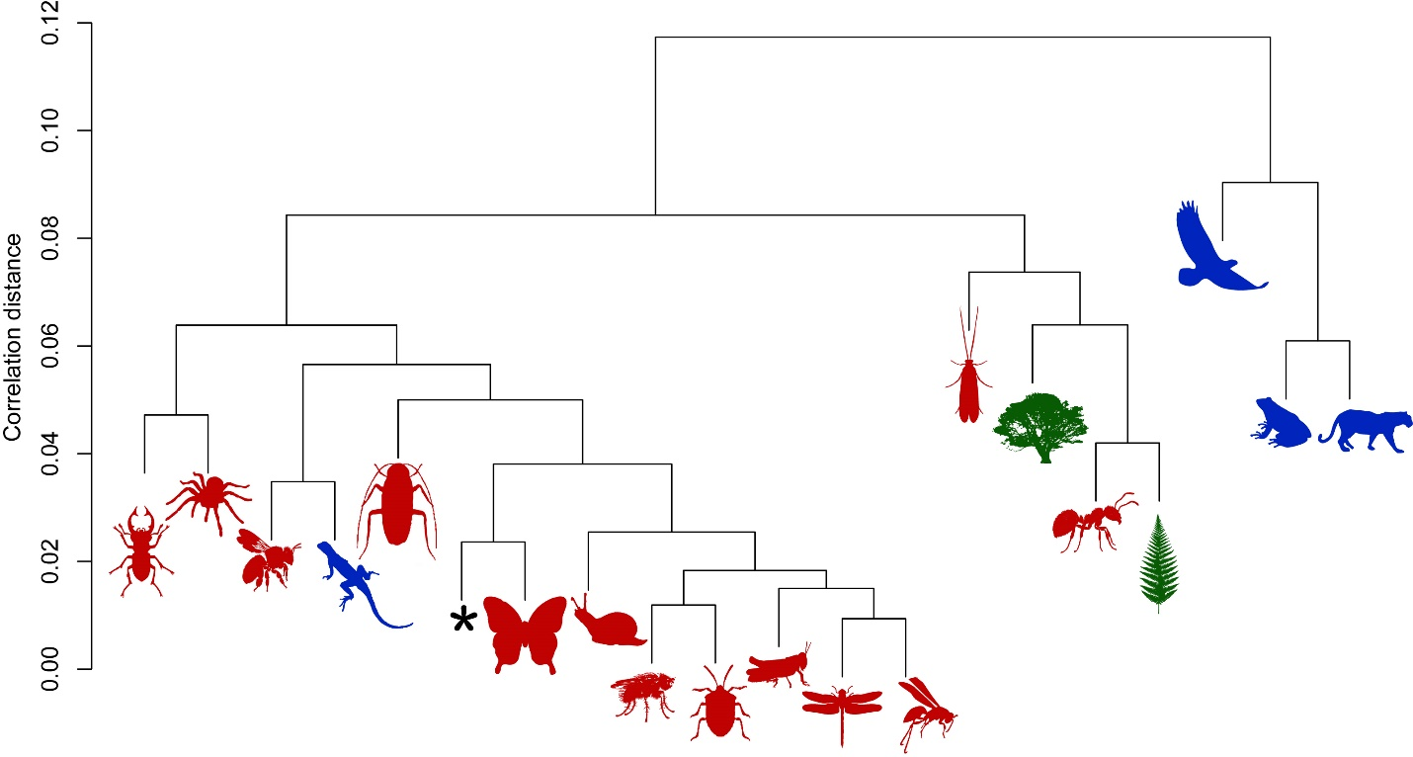
Fig. S8. Dendrogram of correlation distance corrected for spatial autocorrelation. Red indicates vertebrate groups, green plants, and blue vertebrates; the black asterisk indicates the model with all groups.

