S1.

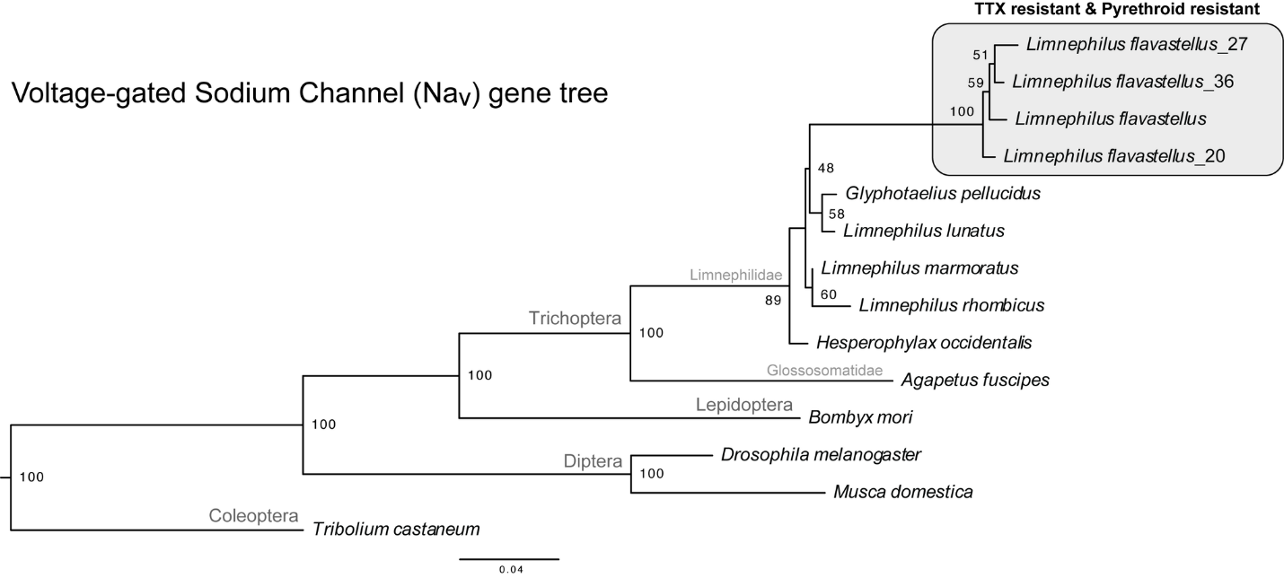
Figure S1. Phylogeny of the voltage-gated sodium channel gene (Na_{v}) for focal insect lineages. Gene tree constructed from genomes or transcriptomes of the full coding sequence of the sodium channel gene, using maximum likelihood in IQ-Tree with ultrafast bootstrap approximation. Branch lengths proportional to genetic distances separating lineages; nodal support (bootstrap percentage) along nodes; clade names in gray. Note the long branch separating of the TTX and pyrethroid resistant caddisfly, Limnephilus flavastellus, from other caddisflies.

