Supplementary Figure 1: Total Metal and pesticide uptake dynamics in the plant under different treatments. a. Total iron uptake, b. Total copper uptake, c.Total manganese uptake, d. Total lead uptake, e. Total chromium uptake, f. Total cypermethrin uptake, and g. Total chlorpyrifos uptake.

Supplementary Figure 2: NPK-uptake in marigold roots and shoots under different treatments. a. Total nitrogen uptake in shoot, b. Total nitrogen uptake in root, c. Total phosphorous uptake in shoot, d. Total phosphorous uptake in root, e. Total potassium uptake in shoot, and f. Total potassium uptake in root

Supplementary Figure 3: Bioconcentration factor of metals and pesticides in marigold. a. Bioconcentration factor of iron (Fe-BCf), b. Bioconcentration factor of copper (Cu-BCf), c. Bioconcentration factor of manganese (Mn-BCf), d. Bioconcentration factor of lead (Pb-BCf), and e. Bioconcentration factor chromium (Cr-BCf), f. Bioconcentration factor chlorpyrifos (CPR-BCf), and g. Bioconcentration factor cypermethrin (CPM-BCf).

Supplementary Figure 4: Enrichment coefficient of metals and pesticides in marigold. a. Enrichment factor of Iron (Fe-ECf), b. Enrichment factor of copper (Cu-ECf), c. Enrichment factor of manganese (Mn-ECf), d. Enrichment factor of lead (Pb-ECf), e. Enrichment factor of chromium (Cr-ECf), f. Enrichment factor of chlorpyrifos (CPR-ECf), and g. Enrichment factor of cypermethrin (CPM-ECf).

Supplementary Figure 5: Shelf life of the Marigold flowers under various treatments

Supplementary Figure 6: PCA score plots: treatment clustering across soil, contamination, plant transfer, and integrated datasets
Supplementary Figure 7: PC 1 and PC2 loading heatmap (positive: positively associated with PC axis; negative: inversely associated)

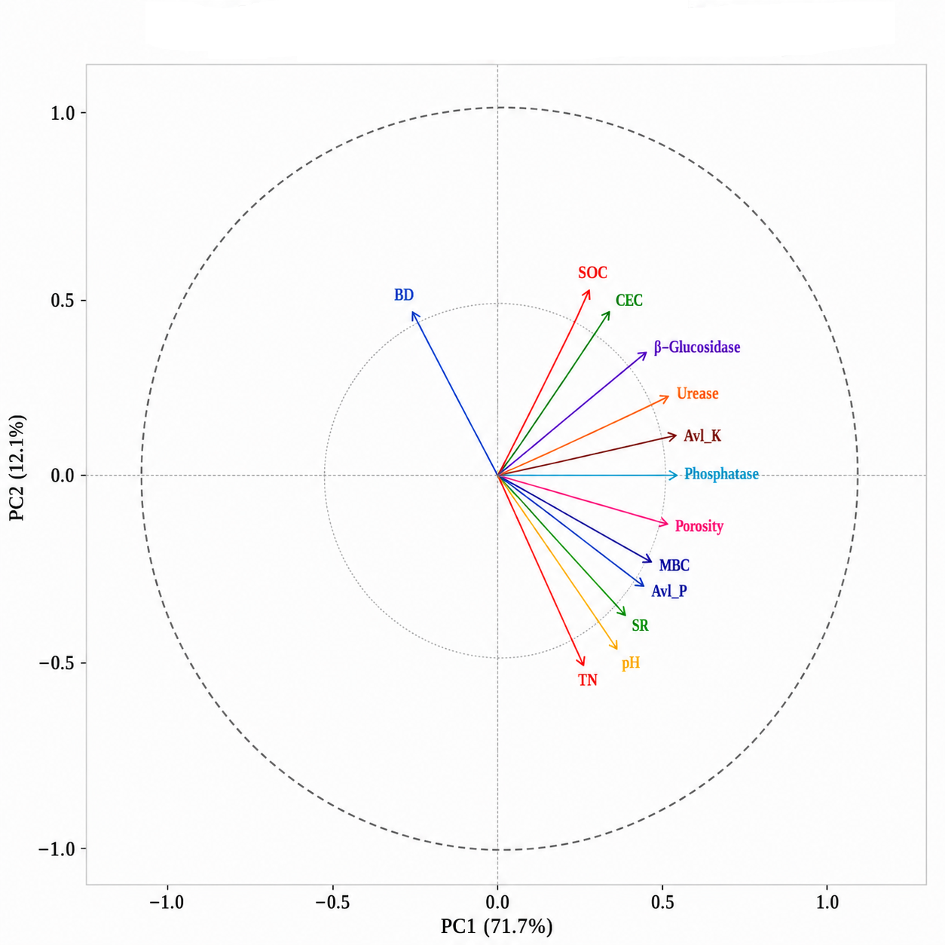
Supplementary Figure 8: Variable correlation circle-soil health parameters

Supplementary Figure 9: Hierarchical clustering dendrogram and PC1 treatment rankings
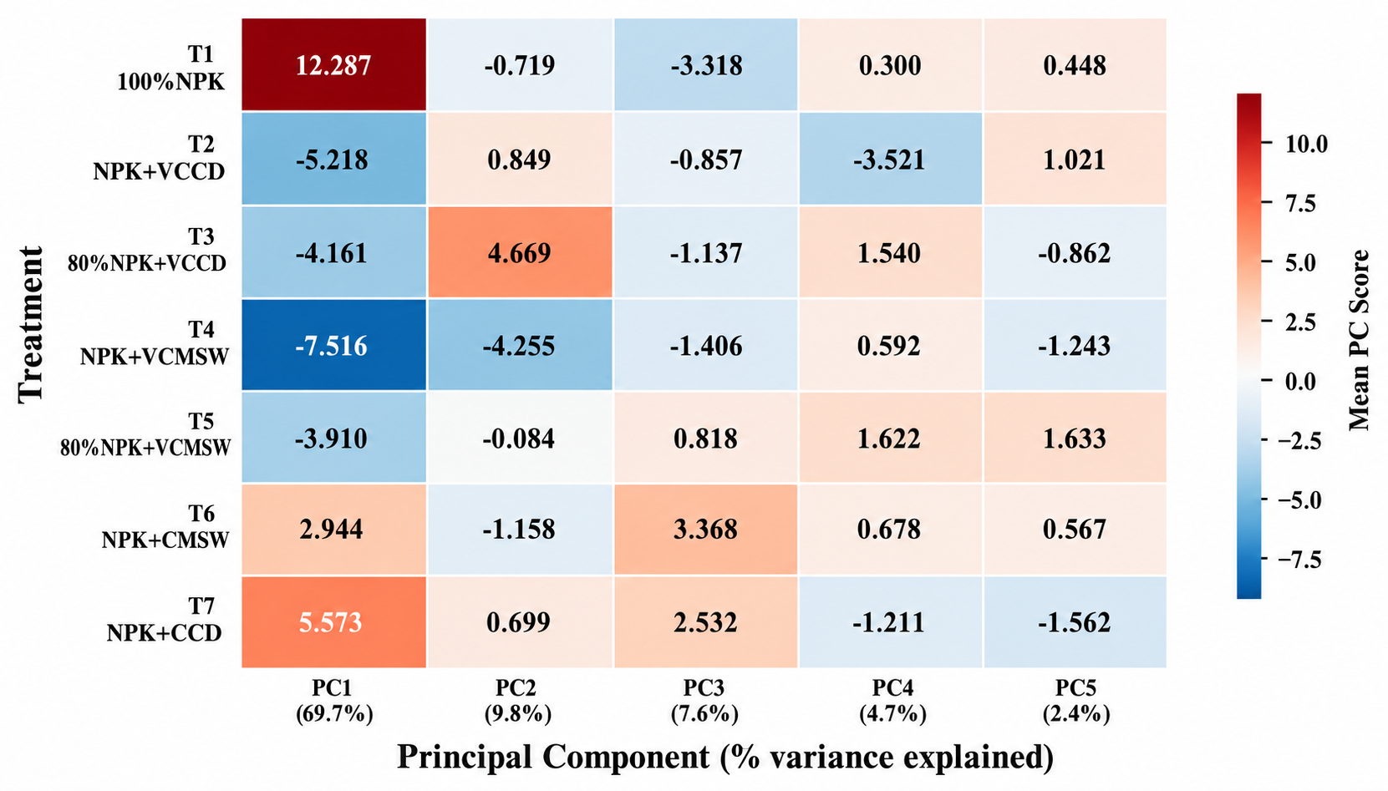
Supplementary Figure 10: Mean PC scores per treatment-integrated dataset (positive: align with PC positive pole; negative: align with PC negative pole).

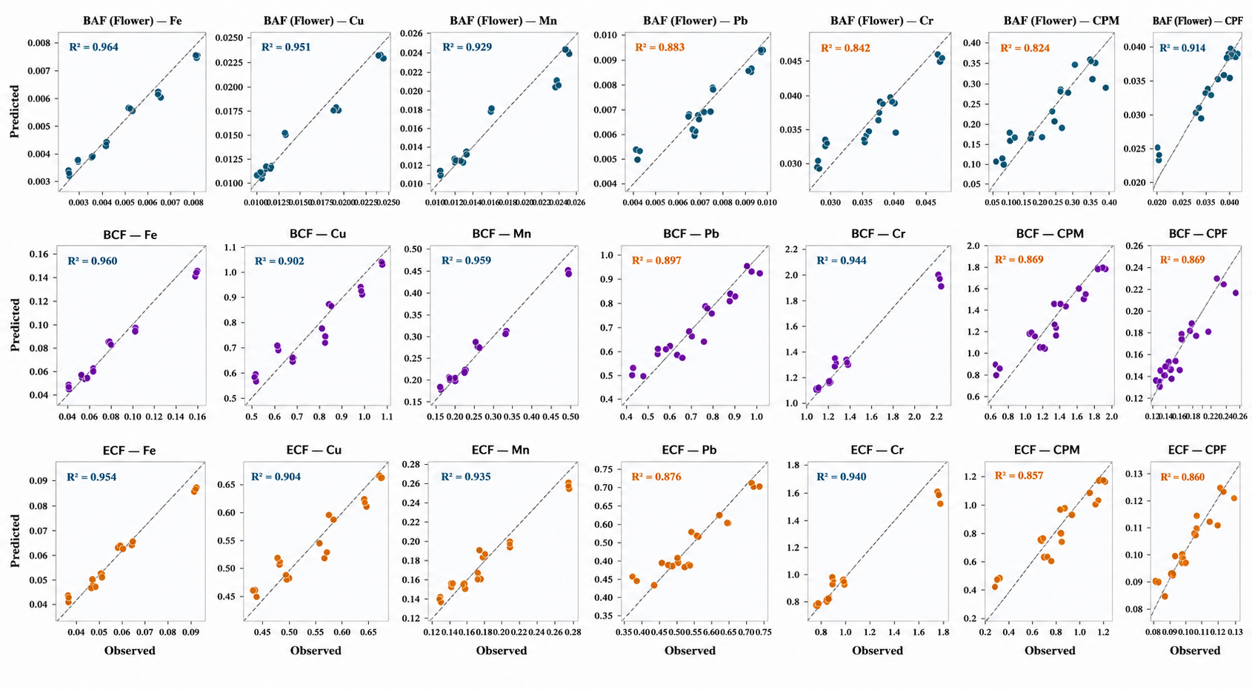
Supplementary Figure 11: Random forest model performance: observed vs predicted values (Leave-One-Out Cross-Validation, N=21)

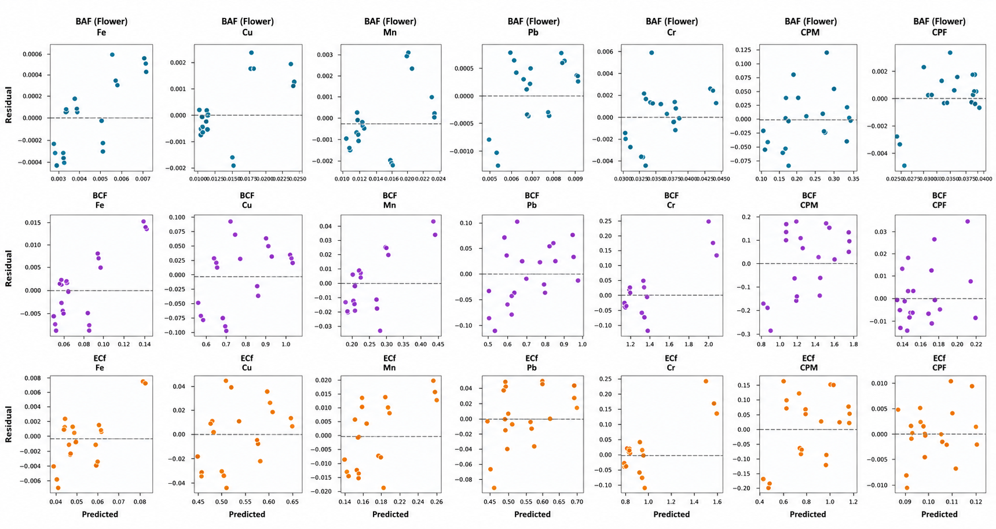
Supplementary Figure 12: Residual plots (observed -predicted)-LOO-CV (Random scatter around zero confirms model adequacy)

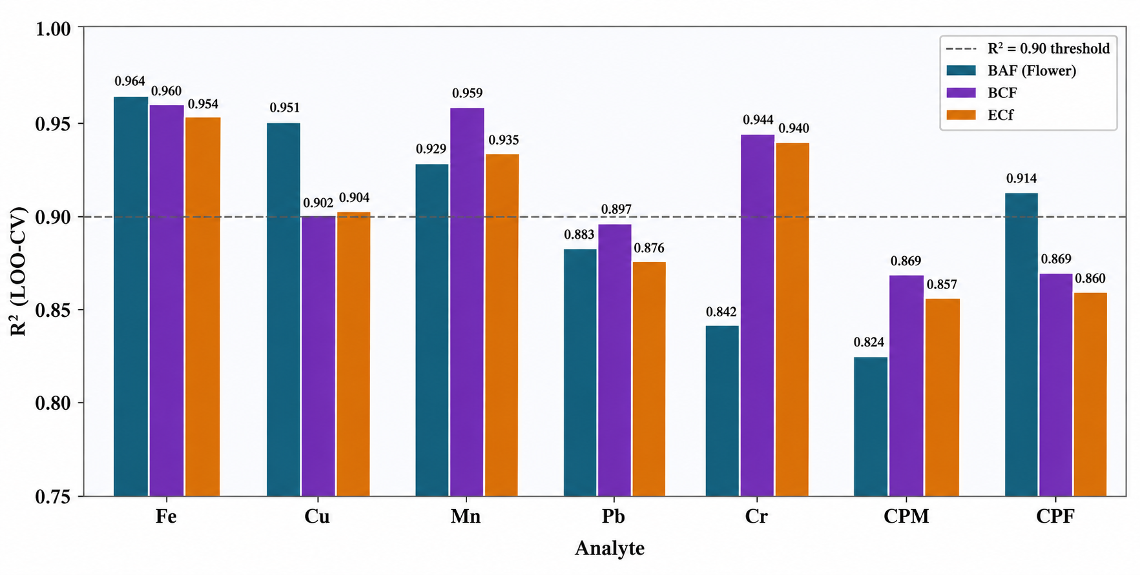
Supplementary Figure 13: Random forest model performance (R², LOO-CV) by analyst and index type.

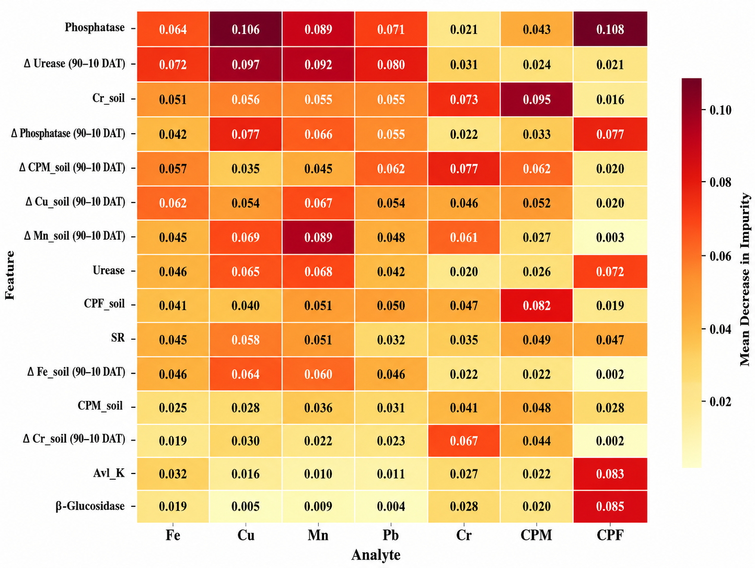
Supplementary Figure 14: Feature importance Heat Map –BAF (flower) Models (Top 15 predictors by mean importance across all analysts)

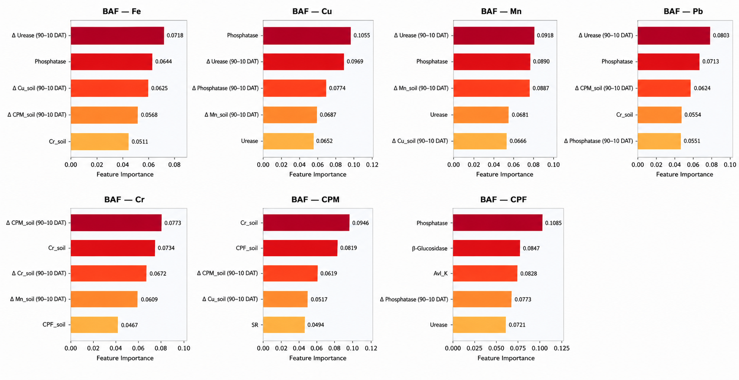
Supplementary Figure 15: Top 5 predictor features for BAF (flower) by analyte (Random Forest, n=500 trees)

Supplementary Figure 16: Distribution of BAF, BCF, and ECF indices by treatments

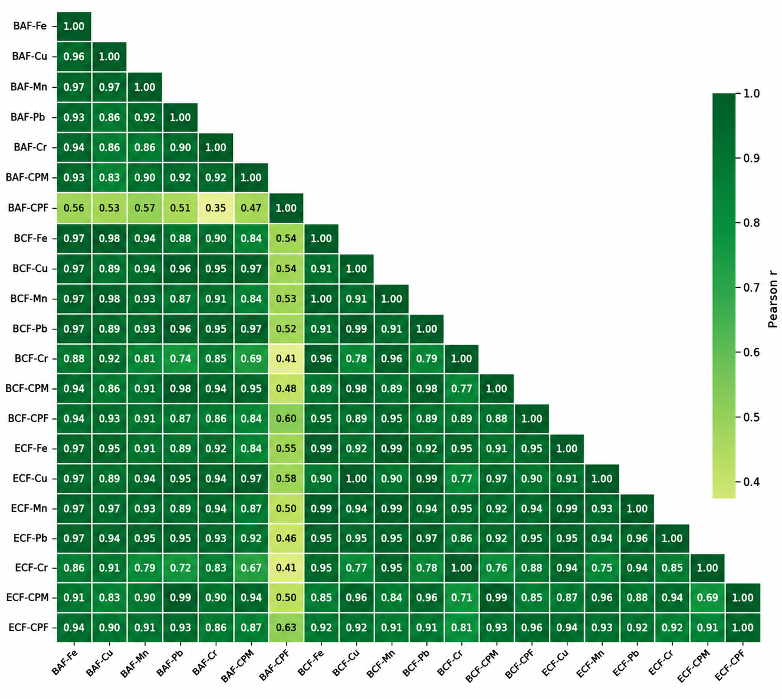
Supplementary Figure 17: Pairwise Pearson correlation matrix among BAF, BCF, and ECF

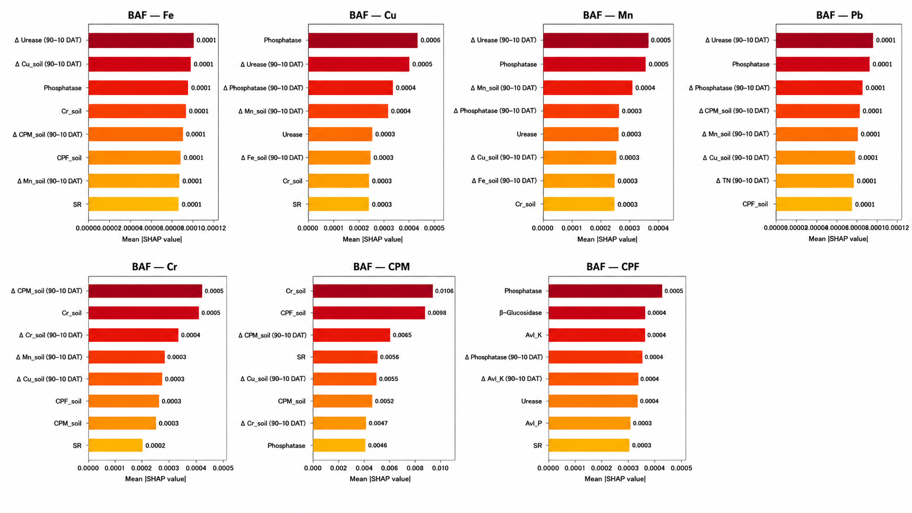
Supplementary Figure 18: SHAP feature importance – BAF (flower) model

Supplementary Table 1: Assessment of Crop Growth, Leaf Traits, and Biochemical Composition of Marigolds (Tagetes spp.) Leaves
 | Crop Growth Rate | Leaf no. (no./plant) |  | Leaf Area Index |  | Total chlorophyll (mg/g) |  | Total Carotenoid (µg/ml)
Treatment |  | 45 DAT | 90 DAT | 45 DAT | 90 DAT | 45 DAT | 90 DAT | 45 DAT | 90 DAT
 | Mean±Std | Mean±Std | Mean±Std | Mean±Std | Mean±Std | Mean±Std | Mean±Std | Mean±Std | Mean±Std
T1 – 100%NPK | 2.21±0.76 | 54.3±3.5 | 63.0±1.0 | 0.596±0.016 | 0.610±0.003 | 23.20±0.01 | 18.49±0.03 | 1541.63±1.59 | 1415.5±1.9
T2 – 100% NPK + VC_{CD} | 5.30±0.00 | 58.7±3.8 | 117.0±2.0 | 0.955±0.015 | 1.055±0.015 | 27.84±0.06 | 22.83±0.03 | 1817.43±1.30 | 1239.6±5.0
T3 – 80% NPK + VC_{CD} | 5.30±0.00 | 51.7±2.7 | 108.7±2.1 | 0.778±0.001 | 0.848±0.010 | 27.38±0.04 | 21.85±0.01 | 1926.92±4.24 | 1305.0±2.8
T4 – 100% NPK + VC_{MSW} | 7.95±0.00 | 72.0±4.2 | 117.3±2.1 | 0.740±0.008 | 0.758±0.004 | 29.40±0.01 | 23.74±0.00 | 1989.41±2.13 | 1899.0±1.3
T5 – 80% NPK + VC_{MSW} | 5.65±0.61 | 89.3±3.0 | 115.3±1.5 | 0.674±0.002 | 0.707±0.045 | 29.18±0.03 | 23.08±0.03 | 2127.19±2.25 | 1320.4±2.1
T6 – 100% NPK + C_{MSW} | 3.53±1.53 | 69.0±2.9 | 85.0±2.6 | 0.637±0.001 | 0.686±0.005 | 26.58±0.03 | 20.70±0.04 | 2550.84±1.23 | 1002.9±1.3
T7– 100% NPK + C_{CD} | 2.30±0.61 | 70.7±2.6 | 73.3±19.6 | 0.632±0.002 | 0.683±0.002 | 25.63±0.04 | 19.76±0.06 | 2242.38±5.55 | 1107.5±0.5
 | P<0.001 | p treatment<0.001 |  | p treatment<0.001 |  | p treatment<0.001 |  | p treatment<0.001
 | LSD=0.59 | p days<0.05 |  | p days<0.05 |  | p days<0.05 |  | p days<0.001
 |  | p (treatment*days) <0.001 |  | p (treatment*days) <0.001 |  | p (treatment*days) <0.001 |  | p (treatment*days) <0.001
 |  | LSD= 3.57 |  | LSD= 0.0085 |  | LSD= 0.170 |  | LSD= 1.61

Supplementary Table 2: Assessment of Flowering Characteristics and Carotenoid Content in Flowers (Mean±Std)
 | Rate of flowering | Flower no. |  | Flower wt. (g/flower) |  | Flower yield (g/plant) |  | Flower Dimeter (cm/flower) |  | Total carotenoid (mg/100 g)
Treatment |  | 45 DAT | 90 DAT | 45 DAT | 90 DAT | 45 DAT | 90 DAT | 45 DAT | 90 DAT | 45 DAT | 90 DAT
 | Mean±Std | Mean±Std | Mean±Std | Mean±Std | Mean±Std | Mean±Std | Mean±Std | Mean±Std | Mean±Std | Mean±Std | Mean±Std
T1 – 100%NPK | 0.104±0.013 | 9.7±0.6 | 14.3±1.2 | 2.50±0.2 | 5.4±0.3 | 24.14±1.7 | 77.0±2.5 | 5.4±0.2 | 5.50±0.1 | 172.4±0.2 | 173.2±0.22
T2 – 100% NPK + VC_{CD} | 0.170±0.026 | 14.7±0.6 | 22.3±0.6 | 5.33±0.1 | 8.0±0.1 | 78.23±2.9 | 178.3±4.4 | 6.7±0.2 | 6.80±0.1 | 245.9±0.2 | 246.6±0.04
T3 – 80% NPK + VC_{CD} | 0.133±0.022 | 13.3±0.6 | 19.3±0.6 | 4.45±0.2 | 7.9±0.0 | 59.26±2.8 | 153.5±4.6 | 6.4±0.5 | 6.7±0.1 | 239.1±0.4 | 240.7±0.16
T4 – 100% NPK + VC_{MSW} | 0.200±0.022 | 12.7±0.6 | 21.7±0.6 | 4.40±0.1 | 8.6±0.1 | 55.83±4.2 | 186.5±5.9 | 6.2±0.3 | 6.4±0.1 | 272.2±0.2 | 273.6±0.15
T5 – 80% NPK + VC_{MSW} | 0.178±0.044 | 12.0±1.0 | 20.0±1.0 | 4.07±0.1 | 8.2±0.0 | 48.82±3.2 | 164.9±8.3 | 6.0±0.7 | 6.2±0.1 | 251.4±0.6 | 251.8±0.03
T6 – 100% NPK + C_{MSW} | 0.126±0.034 | 10.3±0.6 | 16.0±1.0 | 3.98±0.0 | 6.9±0.0 | 41.17±2.4 | 110.0±7.5 | 5.9±0.3 | 6.0±0.1 | 185.5±0.1 | 186.7±0.02
T7– 100% NPK + C_{CD} | 0.111±0.022 | 10.7±1.2 | 15.7±1.2 | 3.03±0.9 | 6.7±0.1 | 31.77±6.8 | 105.2±6.4 | 5.6±0.4 | 5.7±0.1 | 192.0±0.1 | 193.4±0.03
 | p<0.001 | p_{treatment} <0.001 |  | p_{treatment} <0.001 |  | p_{treatment} <0.001 |  | p_{treatment} <0.001 |  | p_{treatment} <0.001
 | LSD=0.023 | p_{days} <0.001 |  | p_{days} <0.001 |  | p_{days} <0.001 |  | p_{days} <0.05 |  | p_{days} <0.001
 |  | p_{(treatment*days)} <0.001 |  | p_{(treatment*days)} <0.001 |  | p_{(treatment*days)} <0.001 |  | p _{(treatment*days)} =NS |  | p _{(treatment*days)} <0.001
 |  | LSD= 0.480 |  | LSD= 0.155 |  | LSD= 2.86 |  | LSD= 0.165 |  | LSD= 0.142

