Supplemental Information
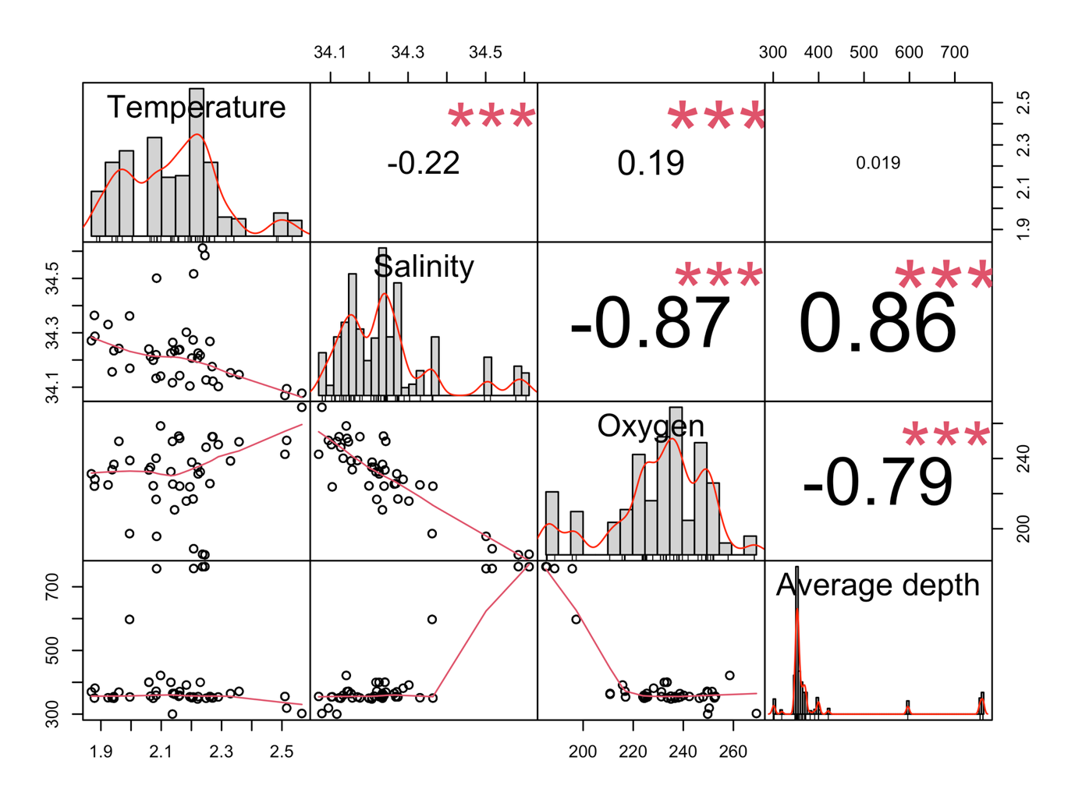
Figure SI1. Pairs plot of candidate mean-model covariates: temperature, salinity, dissolved oxygen, and average sampling depth. Histograms are shown on the diagonal and pairwise correlations are shown in the upper panels.
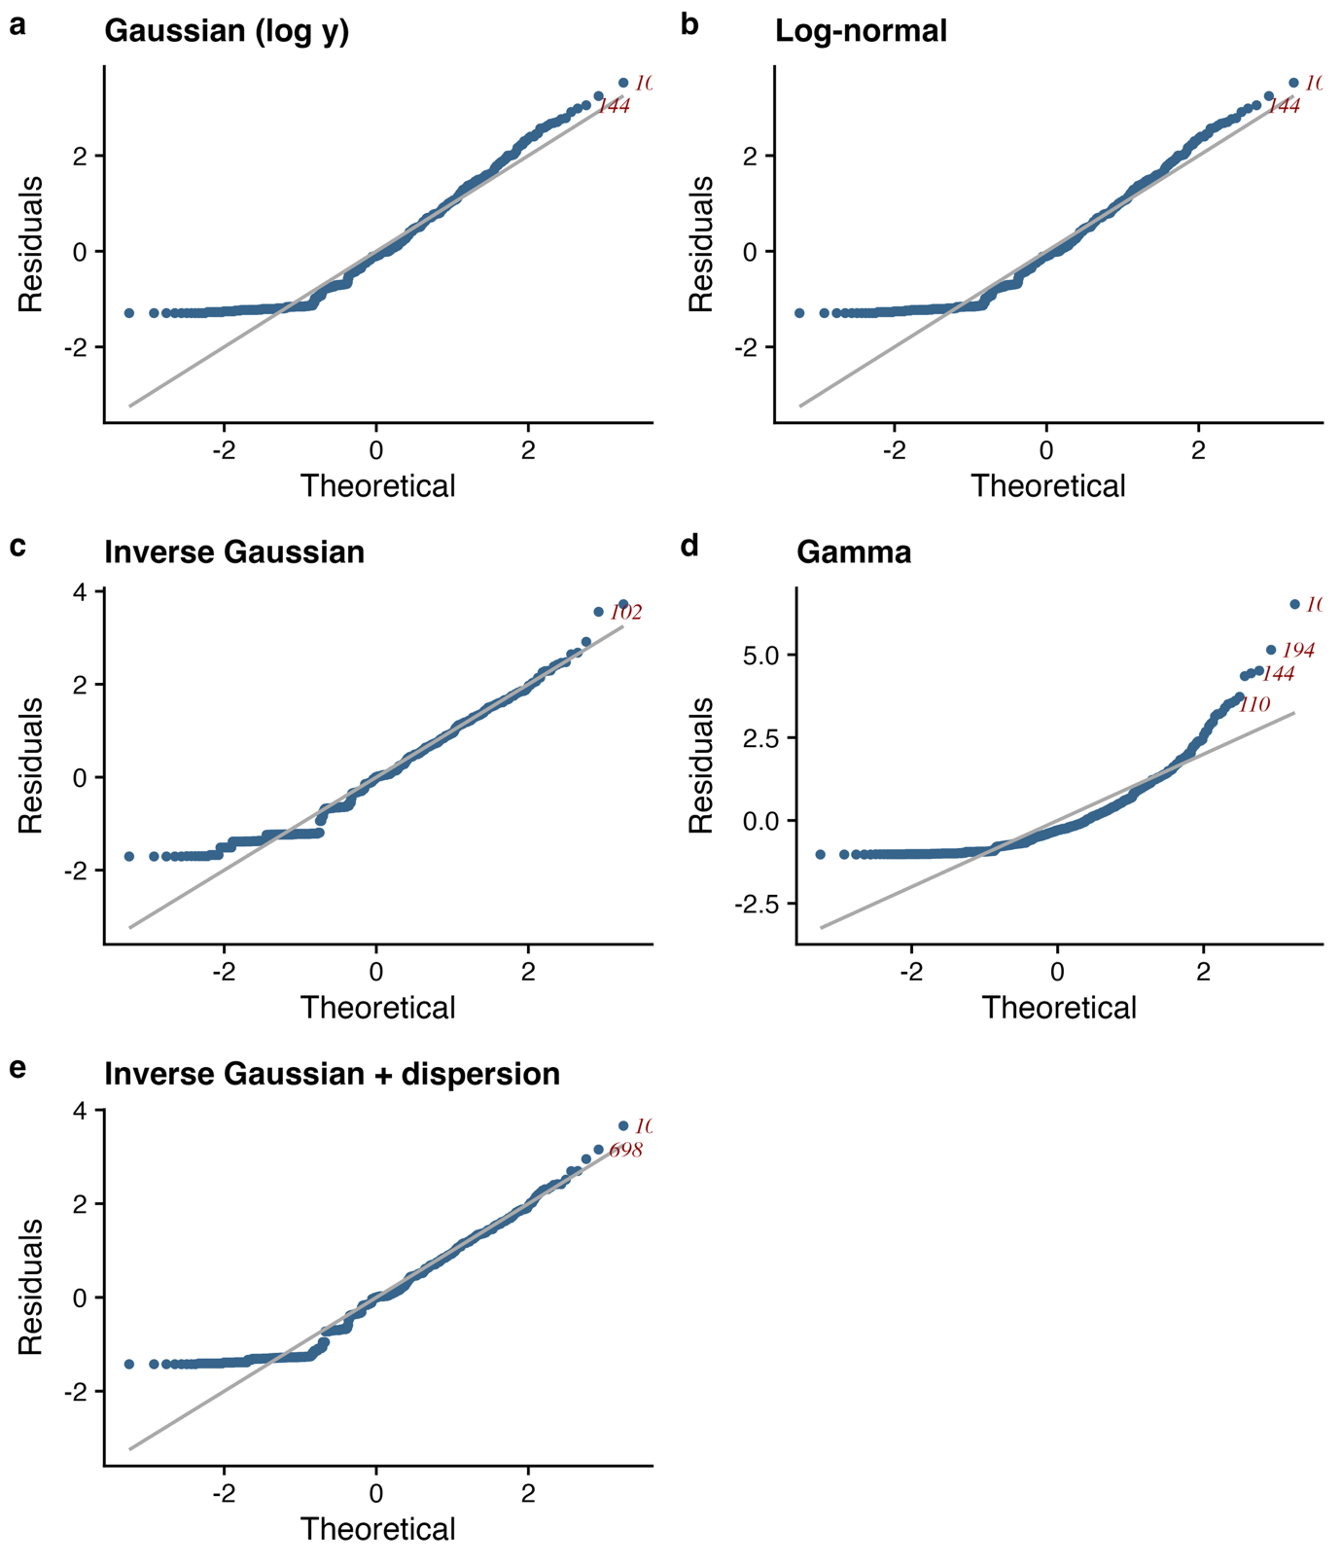
Figure SI2. QQ-plots of normalized quantile residuals for the five fitted models: (a) Gaussian model fitted to log-transformed volumetric abundance, (b) log-normal model, (c) inverse Gaussian model, (d) Gamma model, and (e) inverse Gaussian model with dispersion modeled as a function of normalized bin width.

Table SI1. Most influential observations from the leave-one-out sensitivity analysis of the final inverse Gaussian model with dispersion modeled as a function of normalized bin width. Observations are ranked by the maximum standardized change in model coefficients after deletion. The table reports the observation identifier, species, volumetric abundance, residual from the full-data model, the maximum standardized coefficient change, the p-value of the temperature-by-depth interaction after deletion, and whether deletion reduced the interaction p-value below 0.05.
Row  ID | Species | Abundance (ind. m⁻³) | Full-model residual | Max. standardized coefficient change | Interaction p-value after deletion | Deletion made interaction significant
698 | Rhincalanus gigas | 0.77 | 3.1548 | 1.0004 | 0.2289 | No
305 | Rhincalanus gigas | 0.951 | 2.4008 | 0.6217 | 0.0285 | Yes
102 | Calanus simillimus | 3.985 | 3.661 | 0.5152 | 0.0836 | No
144 | Calanus simillimus | 2.496 | 2.6939 | 0.39 | 0.0865 | No
194 | Rhincalanus gigas | 3.134 | 2.9518 | 0.3548 | 0.0891 | No
809 | Rhincalanus gigas | 0.167 | 1.8439 | 0.338 | 0.0261 | Yes
808 | Rhincalanus gigas | 0.135 | 1.621 | 0.2513 | 0.034 | Yes
811 | Rhincalanus gigas | 0.125 | 1.5426 | 0.2246 | 0.0368 | Yes
812 | Rhincalanus gigas | 0.115 | 1.4589 | 0.1981 | 0.0397 | Yes
437 | Calanus simillimus | 1.699 | 2.3485 | 0.188 | 0.0838 | No
119 | Rhincalanus gigas | 1.402 | 2.5121 | 0.1715 | 0.0687 | No
810 | Rhincalanus gigas | 0.104 | 1.3594 | 0.169 | 0.0432 | Yes
791 | Calanus simillimus | 0.104 | 1.3594 | 0.169 | 0.0432 | Yes
313 | Calanus simillimus | 2.027 | 2.6971 | 0.1632 | 0.0707 | No
94 | Rhincalanus gigas | 1.3 | 2.1465 | 0.154 | 0.0789 | No
110 | Metridia lucens | 1.255 | 2.4148 | 0.1522 | 0.0682 | No
454 | Rhincalanus gigas | 1.373 | 2.1919 | 0.1476 | 0.0797 | No
162 | Rhincalanus gigas | 1.018 | 2.0146 | 0.1383 | 0.0725 | No
120 | Rhincalanus gigas | 1.107 | 2.3087 | 0.1327 | 0.0678 | No
292 | Calanus simillimus | 0.296 | 1.4513 | 0.1279 | 0.0553 | No
118 | Rhincalanus gigas | 1.07 | 2.2807 | 0.1279 | 0.0676 | No
303 | Rhincalanus gigas | 0.285 | 1.424 | 0.1209 | 0.0559 | No
594 | Metridia lucens | 0.117 | 1.5121 | 0.1148 | 0.0676 | No
803 | Rhincalanus gigas | 0.083 | 1.1409 | 0.114 | 0.0503 | No
173 | Calanus simillimus | 1.077 | 2.0816 | 0.1087 | 0.0724 | No

