Voluntary Attention Regulates Acute Immune Responses in Humans

Supplementary information

General note: visualizing within-subject effect magnitude
Throughout the paper and supplementary analyses, we chose to visualize the within-participant effect magnitude using a scatterplot with a unit-slope (x=y) reference line. In these plots, each dot represents one participant’s responses under two conditions (e.g., internal attention, x-axis, green; distraction, y-axis, pink). The diagonal line indicates equal response across conditions. The extent to which data points fall consistently on one side of the line reflects the proportion of participants showing the same directional effect, illustrating both the consistency and robustness of the within-subject effect magnitude.
Significant and highly consistent effect (all participants fall on one side of the diagonal)
Non-significant effect (participants spread equally on both sides of the diagonal)
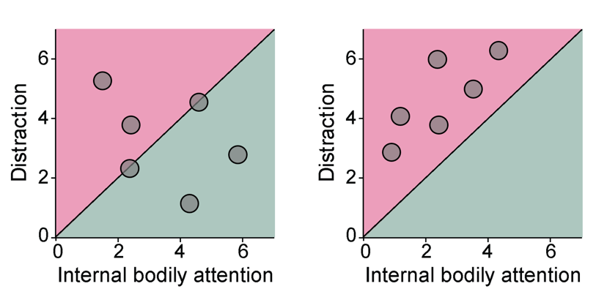

Next to these figures, you will find paired dot-plots illustrating the same data, with grey lines connecting within-subject responses. For clarity, the mean response in each condition is marked with black diamonds and error bars indicate SEM. Bold black lines connect the means across conditions to depict the overall trend between conditions.

Section S1: Voluntary attention vs. distraction regulates acute cutaneous inflammation
in vivo (Experiments 1 and 2) – Extended information and Statistics
The regulatory effect of internal attention versus distraction was tested in two independent cohorts (Experiments 1 and 2; see Methods). The main text presents results from Experiment 1, which were replicated and extended in Experiment 2 (Fig. S1.1). In Experiment 2, visual input and task demands were matched across conditions, replacing video distractors used in Experiment 1. This design isolated the role of attentional engagement itself in inflammatory regulation. Detailed statistics for both experiments are provided in Tables S1.1-S1.4, including within-participant comparisons of inflammatory responses at the 20-min peak (Table S1.1), across the full time-course (Tables S1.2-1.3), and analyses of response resolution (Table S1.4).
Fig. S1.1. Voluntary attention versus distraction regulates acute cutaneous inflammation under matched visual input and task demands (Exp. 2).
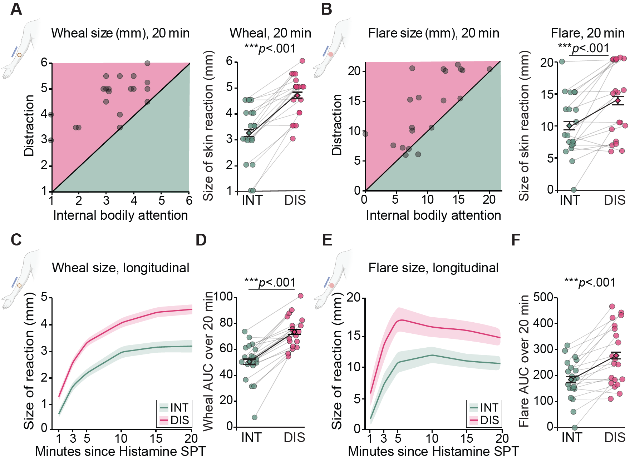
(A-B) Wheal (A) and flare (B) responses at 20 min. Scatter and paired dot plots visualize within-participant inflammatory responses under internal attention (INT, green, x-axis) versus distraction (DIS, pink, y-axis); points above the diagonal indicate larger responses under distraction; paired plots show the same pattern, illustrating the consistency of this effect across participants. (C-F) Time courses and area under the curve (AUC) analyses reveal smaller inflammatory responses under internal attention for both wheal (C,D) and flare (E,F). A significant Time x Condition interaction for wheal size over time, as well as a significant mixed-effects slope analysis of the resolution phase, indicated a faster decline toward baseline. Post-hoc paired comparisons confirmed increasing differences over time (Tables S1.1-S1.4). N=20.

Table S1.1. Wheal and flare responses at the 20-min peak are more regulated under internal attention than distraction, as reflected in paired comparisons within participants.
Exp | Inflammatory response parameter | Internal attention  M±SD (mm) | Distraction  M±SD (mm) | t(df) | p | Cohen’s d | 95% CI
Exp.1 (N=37) | Wheal | 3.5±1.1 | 5.0±0.7 | 7.9(36) | <.001 | 1.30 | [0.86,1.73]
Exp.1 (N=37) | Flare | 10.6±8.3 | 14.0±8.0 | 2.5(36) | .015 | 0.42 | [0.08,0.75]
Exp.2 (N=20) | Wheal | 3.2±1.1 | 4.7±0.8 | 8.0(19) | <.001 | 1.79 | [1.07,2.50]
Exp.2 (N=20) | Flare | 10.0±4.8 | 14.0±5.7 | 4.4(19) | <.001 | 0.98 | [0.43,1.51]

Table S1.2. Inflammatory responses follow different time courses under internal attention compared to distraction, as reflected by repeated-measures ANOVA.
Exp | Para-meter | Condition |  |  | Time |  |  | Time x Condition
Exp | Para-meter | F(df) | p | ηp² | F(df) | p | ηp² | F(df) | p | ηp²
Exp.1 (N=37) | Wheal | 50.9  (1,36) | <.001 | 0.6 | 277.8  (2.4,85.2) | <.001 | 0.9 | 8.7 (2.3,81.6) | <.001 | 0.2
Exp.1 (N=37) | Flare | 8.7 (1,36) | .006 | 0.2 | 7.4  (1.9,67.6) | .002 | 0.2 | 1.3  (3.1,110.3) | .284
Exp.2 (N=20) | Wheal | 67.3  (1,19) | <.001 | 0.8 | 120.2  (2.2,41.5) | <.001 | 0.9 | 4.6  (3,57.7) | .006 | 0.2
Exp.2 (N=20) | Flare | 28.2  (1,19) | <.001 | 0.6 | 17.2  (2.6,49.6) | <.001 | 0.5 | 1.0  (2.7,51.1) | .41
ηp² - partial η², reflecting effect size of the repeated measures ANOVA.

Note that flare responses showed significant main effects of Condition (green-shaded cells), reflecting consistent differences between attention and distraction throughout the time course. In contrast, wheal responses exhibited significant Condition × Time interactions in both experiments (blue-shaded cells), indicating differences in the response trajectory over time. To follow up on these effects, we conducted post-hoc paired t-tests (Table S1.3). For visualization of response trajectories see Fig. 1.1C,F (Exp.1) and S1.1C,E (Exp.2).

Table S1.3. Wheal response trajectories diverge over time, showing smaller magnitudes and a faster return to baseline under internal attention than distraction.
Experiment | Time | Internal attention  M±SD (mm) | Distraction  M±SD (mm) | t(df) | p | Cohen’s d | 95% CI
Exp.1 (N=37) | 1 min | 0.8±0.7 | 1.1±0.9 | 1.6(36) | .105 | 0.27 | [-0.06,0.6]
Exp.1 (N=37) | 3 min | 2.3±0.7 | 2.9±0.7 | 3.9(36) | <.001 | 0.65 | [0.29,1.00]
Exp.1 (N=37) | 5 min | 3.0±0.7 | 3.6±0.9 | 3.9(36) | <.001 | 0.65 | [0.29,1.00]
Exp.1 (N=37) | 10 min | 3.6±0.8 | 4.4±0.8 | 5.1(36) | <.001 | 0.85 | [0.47,1.22]
Exp.1 (N=37) | 15 min | 3.7±0.8 | 4.7±0.7 | 6.7(36) | <.001 | 1.10 | [0.68,1.50]
 | 20 min | 3.5±1.1 | 5.0±0.7 | 7.9(36) | <.001 | 1.30 | [0.86,1.73]
Exp.2 (N=20) | 1 min | 0.6±0.6 | 1.2±0.7 | 3.3(19) | .004 | 0.75 | [0.24,1.23]
Exp.2 (N=20) | 3 min | 1.7±0.7 | 2.6±0.7 | 4.8(19) | <.001 | 1.07 | [0.51,1.62]
Exp.2 (N=20) | 5 min | 2.2±0.7 | 3.4±0.6 | 7.5(19) | <.001 | 1.68 | [0.98,2.36]
Exp.2 (N=20) | 10 min | 3.0±1.0 | 4.1±0.8 | 5.9(19) | <.001 | 1.31 | [0.70,1.91]
Exp.2 (N=20) | 15 min | 3.2±0.9 | 4.5±0.9 | 8.4(19) | <.001 | 1.88 | [1.14,2.61]
 | 20 min | 3.2±1.1 | 4.7±0.8 | 8.0(19) | <.001 | 1.79 | [1.07,2.50]
Note increasing t values and effect sizes over time, reflecting growing differences between conditions.

Table S1.4. Area under the curve (AUC) analyses show smaller cumulative inflammatory responses under internal attention for both wheal and flare.
Exp | Param-eter | Internal attention  M±SD (mm) | Distraction  M±SD (mm) | t(df) | p | Cohen’s d | 95% CI
Exp.1 (N=37) | Wheal | 61.2±12 | 77.4±13.4 | 6.7(36) | <.001 | 1.11 | [0.69,1.51]
Exp.1 (N=37) | Flare | 239.1±138.7 | 304±145.7 | 2.6(36) | .012 | 0.44 | [0.10,0.77]
Exp.2 (N=20) | Wheal | 50.5±15.0 | 73.4±12.0 | 8.3(19) | <.001 | 1.86 | [1.12,2.58]
Exp.2 (N=20) | Flare | 184.9±78.2 | 277.3±115.7 | 5.2(19) | <.001 | 1.17 | [0.59,1.73]

Section S2: Analyses of wheal response resolution (Experiments 1 and 2)
To assess recovery, we first examined whether wheal size stabilized or declined during the final phase of the response. For each participant, wheal change from 15-20 minutes was coded as either stable/decreasing or increasing, and conditions were compared using McNemar’s test. In Experiment 1, a markedly higher proportion of participants showed stable or declining wheal under internal attention (89.2%) than distraction (46%; p=.0004, 95% CI [24.1%, 62.4%]; Fig. 1D). In Experiment 2, this categorical comparison showed the same pattern but did not reach significance, likely reflecting reduced power.
We then tested recovery more formally using linear mixed-effects models restricted to the 10-20 min resolution phase. In both experiments, the significant Time × Condition interaction (Table S2.1) confirmed that wheal trajectories differed between conditions. Condition-specific slopes showed that wheal size continued to rise under distraction but flattened under internal attention, consistent with stabilization and faster recovery (Table S2.2). Thus, both categorical and model-based analyses converge to indicate faster inflammatory resolution under internal attention.

Table S2.1. Mixed-effects model of wheal resolution.
Experiment |  | Estimate | SE | t | p
Exp.1 | Intercept | 3.816 | 0.167 | 22.79 | <.001
Exp.1 | Time | 0.012 | 0.021 | 1.767 | .079
Exp.1 | Condition | 0.003 | 0.167 | 0.017 | .987
Exp.1 | Time x Condition | 0.036 | 0.011 | 3.356 | <.001
Exp.2 | Intercept | 3.243 | 0.198 | 16.349 | <.001
Exp.2 | Time | 0.037 | 0.009 | 4.141 | <.001
Exp.2 | Condition | 0.443 | 0.128 | 3.463 | <.001
Exp.2 | Time x Condition | 0.014 | 0.007 | 2.102 | .04

Table S2.2. Condition-specific slope estimates: faster wheal resolution under attention.
Experiment | Condition | Time (slope) | 95% CI
Exp.1 | Distraction | 0.057 | [0.026, 0.089]
Exp.1 | Internal attention | -0.015 | [-0.047, 0.017]
Exp.2 | Distraction | 0.051 | [0.029, 0.073]
Exp.2 | Internal attention | 0.023 | [4.951×10⁻⁴,0.045]

Section S3: Verifying attention manipulation success (Experiments 1 and 2)

Fig. S3.1. Subjective and objective manipulation checks.
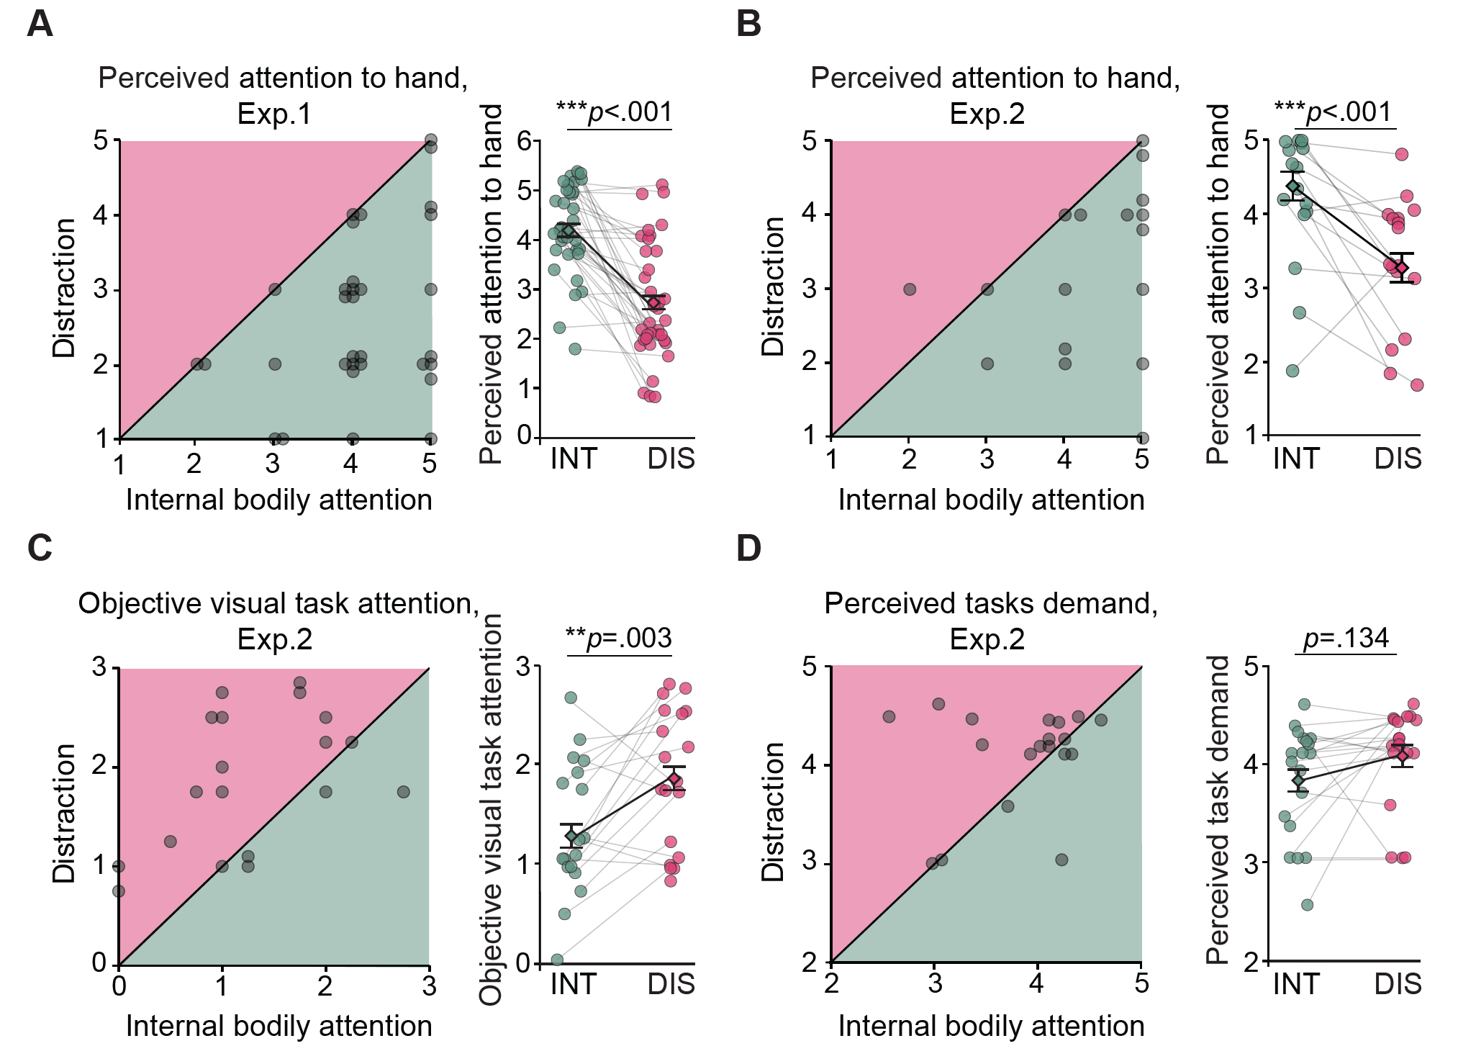
(A-B) Reported attention to hand in Exp.1 (distraction as videoclips, N=37) and Exp. 2 (distraction as visual shape task, N=20). Scatterplots (left) and paired dot plots (right) show consistently greater perceived attention to hand under internal attention (green) vs. distraction (pink). (C) Objective shapes task scores in Exp.2 confirmed that shape-related attention scores were significantly higher in the distraction condition compared to internal attention. (D) Perceived task demand (log-transformed) showed no significant differences in reported cognitive load between internal and distraction conditions. (Table S3.1).

Table S3.1. Subjective and objective manipulation checks.
Experiment | Measure | Internal attention  M±SD (mm) | Distraction  M±SD (mm) | t(df) | p | Cohen’s d | 95% CI
Exp.1 (N=37) | Reported attention to hand | 4.2±0.9 | 2.7±1.2 | 7.8(36) | <.001 | 1.28 | [0.83, 1.71]
Exp.2 (N=19) | Reported attention to hand | 4.4±0.9 | 3.3±1.1 | 4.0(18) | <.001 | 0.92 | [0.37, 1.46]
Exp.2 (N=19) | Objective visual task score | 1.3±0.7 | 1.8±0.7 | 3.5(18) | .003 | 0.80 | [0.27, 1.31]
Exp.2 (N=19) | Perceived task demands | 3.8±0.6 | 4.1±0.5 | 1.6(18) | .134 | 0.36 | [-0.11, 0.82]

Section S4: Perceived inflammation-related sensations (Experiments 1 and 2)
In Experiment 2, perceived inflammation-related sensations were quantified using numerical ratings (visual analog scale 1-100) of several sensations including itch and burning. Their composite score was compared between conditions. Perceived inflammation-related sensations were significantly stronger under internal attention than distraction (Fig. S4.1).

Fig. S4.1. Perceived inflammation-related sensations are stronger under internal attention than distraction.
Scatterplot and dot plot demonstrate greater perceived inflammation-related sensations (itch, burning) in internal attention (green) versus distraction (pink) (51.4 ± 27.3 versus 37.0 ± 21.7, t(18)=2.64, p=.017, Cohen’s d=0.61, 95% CI [0.11, 1.09]) N=19.

Of note, in Experiment 1 participants provided open-ended reports rather than numerical ratings. A similar pattern emerged: 54.4% reported stronger sensations at the test site during internal attention, with an additional 16.2% describing stronger general bodily sensations, compared with 10.8% and 2%, respectively, under distraction. Twenty-seven percent reported no perceptual difference between conditions.

Section S5: Inflammatory responses and manipulation check (Experiment 3: lidocaine)
Fig. S5.1. Reported attention during sensory attenuation (lidocaine).
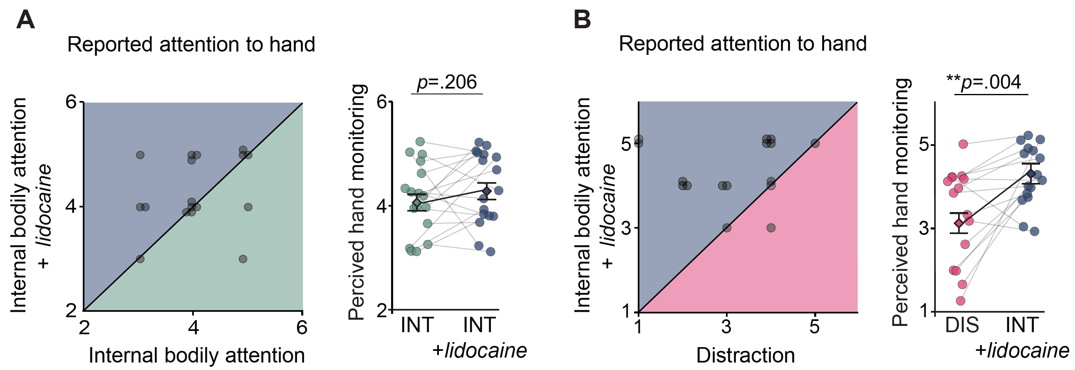
(A) Scatterplot and paired dot plot demonstrate no significant difference in reported hand attention in internal attention (green) and internal attention with lidocaine (blue) (4.1±0.8 versus 4.4±0.7, t(16)=1.3, p=.206, Cohen’s d=0.32, 95% CI [-0.17,0.80]). (B) Greater reported hand attention in internal attention with lidocaine (blue) vs. distraction (pink) (4.4±0.7 versus 3.1±1.2, t(15)=3.5, p=.004, Cohen’s d=0.86, 95% CI [0.28,1.43]). N=16.

Table S5.1. Wheal response at the 20-min peak is more regulated under intact internal attention than internal attention with lidocaine and distraction, as reflected in paired comparisons within participants.
Compa-rison | Internal attention  M±SD (mm) | Internal attention  + lidocaine  M±SD (mm) | Distraction  M±SD (mm) | t(df) | p | Coh-en’s d | 95% CI
INT, INT+lido | 3.2±1.0 | 4.0±0.6 | 4.9±1.0 | 4.3(16) | <.001 | 1.04 | [0.44, 1.63]
DIS, INT+lido | 3.2±1.0 | 4.0±0.6 | 4.9±1.0 | 4.9(16) | <.001 | 1.19 | [0.55, 1.80]
INT= internal attention, INT+lido=internal attention with lidocaine, DIS=distraction. N=17.

Table S5.2. Wheal response follow different time courses under internal attention with lidocaine compared to intact internal attention and distraction, as reflected by repeated-measures ANOVA.
Comparison | Condition |  |  | Time |  |  | Time x Condition
Comparison | F(df) | p | ηp² | F(df) | p | ηp² | F(df) | p | ηp²
INT+lidocaine, INT | 2.5  (1,16) | .133 | 0.14 | 149  (2.3,37.6) | <.001 | 0.9 | 3.8(2.6,41) | .023 | 0.19
INT+lidocaine, DIS | 26.6  (1,16) | <.001 | 0.62 | 173.8  (2.1,33.9) | <.001 | 0.9 | 0.86(2.7,43) | 0.86 | 0.46
INT= internal attention, INT+lidocaine=internal attention with lidocaine, DIS=distraction. ηp² - partial η², reflecting effect size of the repeated measures ANOVA. N=17.
Following a significant Time x Condition interaction in the repeated-measures ANOVA for wheal responses under lidocaine vs. intact internal attention (Table S5.2, blue-shaded cell, Fig. 2E), we detail below the post-hoc paired t-test results. Note that this interaction was not significant for lidocaine vs. distraction (Table S5.2), thus no post-hoc tests were conducted.

Table S5.3. Wheal response over time showed smaller magnitude under intact internal attention compared to internal attention with lidocaine.
Time | Internal attention with lidocaine  M±SD (mm) | Intact internal attention  M±SD (mm) | t(df) | p | Cohen’s d | 95% CI
1 min | 0.6±0.7 | 0.7±0.7 | -0.3(16) | .74
3 min | 2.2±0.7 | 2.1±0.7 | 0.8(16) | .448
5 min | 2.8±0.7 | 2.7±0.7 | 0.8(16) | .442
10 min | 3.4±0.5 | 3.5±0.8 | -0.3(16) | .768
15 min | 3.8±0.5 | 3.5±0.8 | 1.9(16) | .074 | 0.46 | [-0.04,0.96]
20 min | 4 ± 0.6 | 3.1±1.0 | 4.3(16) | <.001 | 1.04 | [0.44,1.63]
N=17.
To assess recovery patterns under sensory attenuation, we applied the same approach described in Section S2. For each participant, a dichotomous variable was created at the last time interval (15-20 min): a decrease or no change in wheal size was coded as 1, and an increase as 0. We then compared the experimental conditions (internal attention with lidocaine, intact internal attention, distraction) using McNemar’s test. Results are presented in Table S5.4, with visualization in the main text Fig. 2F.
Table S5.4. Significantly slower wheal recovery when sensory signaling attenuated.
Comparison | Intact internal attention (%) | Internal attention with lidocaine (%) | Distraction  (%) | Difference (%) | 95% CI of difference (%) | p
INT+ lido, INT | 100 | 64.7 | 41.2 | 35.3 | [12.6,58.0] | .031
INT+ lido, DIS | 100 | 64.7 | 41.2 | 23.5 | [-58.2,11.2] | .344
INT= internal attention, INT+lido=internal attention with lidocaine, DIS=distraction. N=17.

Section S6: Sympathetic indices and state anxiety (Experiments 1 and 2)
Table S6.1. Sympathetic indices comparison between internal bodily attention and distraction (Exp. 1 and 2).
Parameter | Internal attention  M±SD | Distraction  M±SD | t(df) | p | Cohen’s d | 95% CI
Skin conductance | 0.2±0.4 | 0.2±0.4 | -0.4(52) | .707 | 0.05 | [-0.22, 0.32]
Heart rate  (Beats per minute) | 74.6±11.3 | 74.9±11.2 | -0.2(53) | .828 | 0.03 | [-0.24, 0.30]
Skin temperature | 30.9±1.1 | 30.9±1.05 | -0.1(43) | .923 | 0.02 | [-0.28, 0.31]
Perceived anxiety (before-after) | -0.06±0.4 | -0.09±0.4 | 0.4(55) | .685 | 0.06 | [-0.21, 0.32]
N=49.

Section S7: Participants’ accuracy in identifying the study purpose

Table S7.1. Participants’ guesses about the study purpose were largely wrong.
Category | N | %
Correct: attention and immune response / allergy test | 8 | 14
Attention and general physiology / performance (e.g., concentration, divided attention) | 11 | 19.3
Cognition / psychological states and bodily or task outcomes (e.g., manipulation of sensations, stress, general psychological effects) | 7 | 12.3
Environment and sensory context (e.g., videos, visual stimuli, body awareness) | 23 | 40.4
Irrelevant / uninterpretable (e.g., “it was interesting”) | 8 | 14
Responses were coded into thematic categorie³⁴. A total of 14% of participants correctly identified the study’s aim (attention-immune link). Their physiological response patterns did not differ from the rest of the sample.
Section S8: Non-parametric tests
Table S8 | Non-parametric tests (Wilcoxon-Rank) for study’s variables that deviated from Shapiro-Wilk test of normality
Exp. | Parameter | Internal attention  M±SD | Distrac-tion  M±SD | Internal attention with lidocaine  M±SD | Z | p | Rank-Biserial Correlation (effect size) | 95%  CI
Exp.1  (N=37) | Wheal  (mm, 1m) | 0.8±0.7 | 1.1±0.9 |  | 1.3 | .182 | 0.28 | [-0.13, 0.61]
Exp.1  (N=37) | Wheal  (mm, 5m) | 3±0.7 | 3.6±0.9 |  | 3.5 | <.001 | 0.74 | [0.49, 0.88]
Exp.1  (N=37) | Wheal  (mm, 10m) | 3.6±0.8 | 4.4±0.8 |  | 4.2 | <.001 | 0.92 | [0.82, 0.96]
Exp.1  (N=37) | Wheal  (mm, 15m) | 3.7±0.8 | 4.7±0.7 |  | 4.9 | <.001 | 1.0 | [1.0,  1.0]
Exp.1  (N=37) | Wheal  (mm, 20m) | 3.5 ± 1.1 | 5.0±0.7 |  | 5 | <.001 | 1.0 | [1.0,  1.0]
Exp.1  (N=37) | Wheal AUC | 61.2 ± 12 | 77.4 ± 13.4 |  | 5.1 | <.001 | 0.96 | [0.91,  0.98]
Exp.2 (N=20) | Wheal  (mm, 1m) | 0.6±0.6 | 1.2±0.7 |  | 2.5 | .015 | 0.74 | [0.35, 0.91]
Exp.2 (N=20) | Wheal  (mm, 5m) | 2.2±0.7 | 3.4±0.6 |  | 3.7 | <.001 | 1.0 | [1.0,  1.0]
Exp.2 (N=20) | Wheal  (mm, 10m) | 3±1 | 4.1±0.8 |  | 3.5 | <.001 | 1.0 | [1.0,  1.0]
Exp.3 (N=17) | Reported attention to hand | 4.1 ± 0.8 |  | 4.4 ± 0.7 | 1.2 | .235 | 0.44 | [-0.25, 0.84]
Exp. 1+2 | Perceived anxiety (N=56) | 3.4±0.5 | 3.5±0.8 |  | 0.2 | .89 | 0.03 | [-0.31, 0.36]
Exp. 1+2 | HRV (CVrr) (N=49) | 0.08±0.02 | 0.07±0.02 |  | 2.4 | .013 | 0.40 | [0.10, 0.63]

Section S9: Individual differences and attentional qualities show limited influence
on attentional immune regulation
The effect of attentional immune regulation was highly robust, with 90% of participants demonstrating the effect across two independent cohorts, and no participant showed the opposite pattern (i.e., a larger immune response under internal attention; Fig.1, Fig. S1.1). While the within-subject design inherently controls for stable individual differences, we examined whether such differences may modulate the magnitude of the effect.
Analyses were conducted on the combined sample from Experiments 1 and 2 (N=57; 70.2% women, M_{age}=26.6±3.6), with individual-difference factors included as between-subject variables in repeated-measures ANOVAs of attentional modulation of inflammatory responses. All main effects and interactions of condition and time were consistent with the primary analyses, and therefore are not repeated here.
Demographic factors (sex, age). Sex did not significantly influence the wheal response
(all p >.128, Table S9.1). For flare, a trend-level Sex x Condition interaction (p=.054) was observed. Post-hoc comparisons indicated that attentional modulation was significant in both men and women, but the effect was stronger in men (women: t=-3.0, p=0.017; men: t=-4.3, p<.001). Age did not significantly modulate attentional effects on wheal (all p > .369) or flare (all p > .176; Table S9.2).

Table S9.1. Effects of sex on attentional modulation of inflammatory responses.
Parameter | Sex  main effect |  | Sex x Condition |  | Sex x Time |  | Sex x Time  x Condition
Parameter | F(df) | p | F(df) | p | F(df) | p | F(df) | p
Wheal (mm) | 0.35 (1,55) | .559 | 0.00 (1,55) | .944 | 2.02 (2.4,130.1) | .128 | 0.88 (2.5,137.0) | .435
Flare (mm) | 1.57 (1,55) | .216 | 3.88 (1,55) | .054 | 0.75 (2.0,112.1) | .475 | 1.89 (3.1,171.1) | .130

Table S9.2. Effects of age on attentional modulation of inflammatory responses.
Parameter | Age  main effect |  | Age x Condition |  | Age x Time |  | Age x Time  x Condition
Parameter | F(df) | p | F(df) | p | F(df) | p | F(df) | p
Wheal (mm) | 0.10  (1,55) | .756 | 0.82  (1,55) | .369 | 0.73  (2.4, 131.8) | .507 | 0.46  (2.5,139.5) | .676
Flare (mm) | 1.2  (1,55) | .271 | 0.03  (1,55) | .871 | 0.32  (2.0,111.5) | .733 | 1.67  (3.1,167.9) | .176

Qualitative differences in internal attention. We next examined whether variability in how participants engaged with internal attention contributed to immune responses. Internal attention can take multiple forms, ranging from evaluative or stress-related engagement (e.g., worry, tension) to more non-judgmental, acceptance-based engagement. To capture these dimensions, we examined two candidate factors.
Stress-related engagement was captured by the change in state anxiety (STAI¹; post - pre) during the attention condition, and acceptance-based engagement was defined as the mean of three items reflecting bodily attention and attunement (“I felt present in my body”, “I listened to what my body was telling me”, “I was attuned to the sensations elicited”; items adapted from ²) during the attention condition. Participants were divided into high and low levels of each measure and examined as between-subject factors in analyses of inflammatory responses, both within the attention condition and across conditions.
Stress-related engagement did not modulate wheal or flare responses, either within the attention condition or across conditions (all p > .213; Tables S9.3-S9.4).
Table SX.3. Effects of stress-related engagement within the attention condition.
Parameter | Stress engagement  main effect |  | Stress engagement  x Time
Parameter | F(df) | p | F(df) | p
Wheal (mm) | 0.15 (1,54) | .702 | 0.32 (2.8,150.6) | .793
Flare (mm) | 0.23 (1.54) | .634 | 0.11 (2.5,133.1) | .927

Table SX.4. Effects of stress-related engagement across conditions.
Parameter | Stress engagement |  | Stress engagement  x Condition |  | Stress engagement  x Time |  | Stress engagement  x Time x Condition
Parameter | F(df) | p | F(df) | p | F(df) | p | F(df) | p
Wheal | 0.11 (1,54) | .747 | 1.59 (1,54) | .213 | 0.32 (2.4,129.6) | .768 | 0.44  (2.5,135.1) | .690
Flare | 0.29 (1,54) | .595 | 0.00 (1,54) | .963 | 0.14 (2.0,109.9) | .871 | 0.43  (12.1,27.9) | .737

Acceptance-based engagement did not significantly influence the wheal response, either within the attention condition (all p >.386) or across conditions (all p>.162). For flare, a significant Engagement × Time interaction was observed within the attention condition (p=.011; Table S9.5). Post-hoc comparisons indicated smaller, more regulated responses in the first minute of the effect in participants reporting higher acceptance engagement (p=.015), but not in other timepoints (all p >.122; Table S9.6). Across conditions, acceptance-based engagement also modulated flare trajectories, with a significant Engagement × Time interaction (p=.011), with a similar pattern as reported above. In addition, a Condition × Engagement interaction (p=.028) was observed, with post-hoc comparisons indicating that attentional modulation was significant in both high- and low-acceptance groups, but the effect was stronger among participants reporting higher acceptance-based engagement (low group: p=0.017; high group: p<.001; Tables S9.7-S9.8).

Table S9.5. Effects of acceptance-based engagement within the attention condition.
Parameter | Acceptance-based engagement |  | Acceptance-based engagement x Time
Parameter | F(df) | p | F(df) | p
Wheal (mm) | 0.24 (1,55) | .624 | 1.01 (2.8,154.4) | .386
Flare (mm) | 0.26 (1,55) | .612 | 4.15 (2.5,139.4) | .011  ηp²=0.07
ηp² - partial η², reflecting effect size of the repeated measures ANOVA.

Table S9.6. Post-hoc comparisons for acceptance-based engagement x time interaction on flare responses within internal attention condition.
Time | Low acceptance engagement  M±SD (mm) | High acceptance engagement  M±SD (mm) | U | p | Rank-Biserial Correlation (effect size) | 95% CI
1 min | 8.8±9.8 | 3.1±6.3 | 537.0 | .015 | 0.33 | [0.04, 0.57]
3 min | 12.7±9.2 | 9.4±9.3 | 469.5 | .284 | 0.17 | [-0.14, 0.44]
5 min | 13.4±8.9 | 14.1±7.7 | 346.5 | .369 | 0.14 | [-0.42, 0.16]
10 min | 11.5±8.1 | 13.7±6.4 | 306.0 | .122 | 0.24 | [-0.50, 0.06]
15 min | 10.6±8.5 | 11.4±5.6 | 331.5 | .254 | 0.18 | [-0.45, 0.12]
20 min | 10.3±8.3 | 10.5±6.0 | 363.5 | .531 | 0.10 | [-0.38, 0.20]
Normality tests indicated a deviation from normality (Shapiro-Wilk, p<.021), therefore Mann-Whitney tests are reported.

Table S9.7. Effects of acceptance-based engagement across conditions.
Parameter | Acceptance engagement |  | Acceptance engagement  x Condition |  | Acceptance engagement  x Time |  | Acceptance engagement x Time x Condition
Parameter | F(df) | p | F(df) | p | F(df) | p | F(df) | p
Wheal | 2.01 (1,55) | .162 | 1.45 (1,55) | .233 | 0.54 (2.4,131.6) | .617 | 1.69  (2.5,138.3) | .181
Flare | 0.42 (1,55) | .518 | 5.12 (1,55) | .028  ηp²=0.09 | 4.57 (2.1,116.9) | .011  ηp²=0.08 | 0.72  (3.1,168.6) | .544
ηp² - partial η², reflecting effect size of the repeated measures ANOVA.

Table S9.8. Post-hoc comparisons for the acceptance-based engagement × condition interaction on flare responses across conditions.
Group | Internal attention  M±SD (AUC) | Distraction  M±SD (AUC) | t(df) | W | p | Effect size | 95% CI
Low acceptance engagement | 217.6±142.1 | 263.3±128.5 |  | 127.0 | .017 | 0.49  (Rank-biserial Correlation) | [0.13, 0.73]
High acceptance engagement | 223.1±98.3 | 332.0±136.5 | 4.9 (25) |  | <.001 | 0.96  (Cohen’s d) | [0.49, 1.42]
Tests were selected based on normality (Shapiro-Wilk). The low-acceptance group deviated from normality (p=.028; Mann-Whitney tests reported), whereas the high-acceptance group did not (p=.946).

